**Submitted By :**

Raheel Javed

**Assignment :**

**Adaptive Control Systems**

**“ Model Identification of Separately Excited Armature Controlled DC Motor ”**

**Modelling of Plant:**

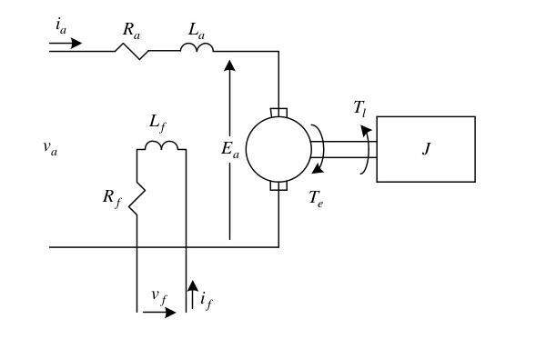

Figure 1: Separately excited DC motor

Fig. 1 shows circuit diagram of a separately excited DC motor. The field circuit consists of a voltage source $v_{f}$, field coil resistance $R_{f}$ and coil inductance $L_{f}$. For an armature controlled motor voltage $v_{f}$ is held constant. The armature circuit consists of armature voltage $v_{a}$, coil resistance $R_{a}$, armature winding inductance $L_{a}$ and back EMF $E_{a}$ generated at rotor terminals. The remaining parameters are:

$T_{e}=$ Torque generated by motor $T_{l} =$ Load torque

$J_{o}=$ Inertia of motor, load combination referred to the shaft

Writing KVL for armature circuit,

$$L_{a}\frac{di_{a}}{dt}+ Ri_{a}+E_{a}= v_{a}$$

Where,

$i_{a}=$ Armature current and $E_{a}$ can be written as,

$$E_{a}=K_{b}\frac{dθ}{dt}$$

Where,

$K_{b}=$ Back EMF constant $θ=$ Shaft angle

So,

|  |  |  |
| --- | --- | --- |
|  | $$L_{a}\frac{di_{a}}{dt}+ Ri_{a}+K_{b}\frac{dθ}{dt}= v_{a}$$ |  |

Writing equation for torque equilibrium,

$$J_{o}\frac{d^{2}θ}{dt^{2}}+T_{l}= T_{e}$$

Or,

|  |  |  |
| --- | --- | --- |
|  | $$J_{o}\frac{d^{2}θ}{dt^{2}}+b_{o}\frac{dθ}{dt}= K_{t}i_{a}$$ |  |

Where,

$b_{o}=$ Viscous friction coefficient of motor, load combination referred to the shaft

$K_{t}=$ Torque constant of motor

From equations (a), (b) and using,

$$x_{1}=i_{a} , x_{2}=θ , x_{3}= θ^{.}, u=v_{a}$$

The state space representation of armature controlled DC motor is given as,

$$x^{.}=Ax+Bu$$

Where,

$$A=\left[\begin{matrix}-\frac{R_{a}}{L_{a}} & 0 & -\frac{K_{b}}{L_{a}} \\ 0 & 0 & 1 \\ \frac{K_{t}}{J_{o}} & 0 & -\frac{b_{o}}{J_{o}}\end{matrix}\right]$$

$$B= \left[\begin{matrix}\frac{1}{L_{a}} \\ 0 \\ 0\end{matrix}\right]$$

**Observer-Like Estimator:**

Assuming that all the states of system are measurable and available the structure of estimator can be given as,

$$x^{^ .}=A^{^} x+B^{^} u+A_{m}(x^{^}- x)$$

Where,

$x^{^} ∈R^{3}$ and $u$ is a scalar. Error dynamics can be given as,

$$e^{.}=ϕ x+ φ u+A_{m} e$$

Where,

$$e=x^{^}-x, ϕ=A^{^}-A, φ=B^{^}-B$$

If lyapunov function is chosen as,

$$V=e^{T}Pe+Trace\left(ϕ^{T}ϕ+φ^{T}φ\right), P>0$$

Then, using substitution and,

$$Trace\left(ab^{T}\right) = b^{T}a$$

Where, $a$ and $b$ are column vectors.

We have,

$$A^{^.}=ϕ^{.}= -Pex^{T}$$

$$B^{^.}= φ^{.}= -Peu$$

$$V^{.}=e^{T}(A_{m}^{T}P+PA_{m} )e$$

For $V^{.}$ To be semi negative definite $A_{m}$ should be chosen stable and $P>0$ such that,

$$A_{m}^{T}P+PA_{m} <0$$

This guarantees the convergence of $e→ 0$ as $t→∞$ by Barbalet’s Lemma which states that $e→ 0$ as $t→∞$ if energy of error is bounded ($e ∈L_{2}$) and is uniformly continuous ($e^{.}<∞$). The convergence of parameters is not guaranteed but the probability of convergence is high for persistent excitation. The convergence of parameters is also dependent upon selection of $A_{m}$ and $P$.

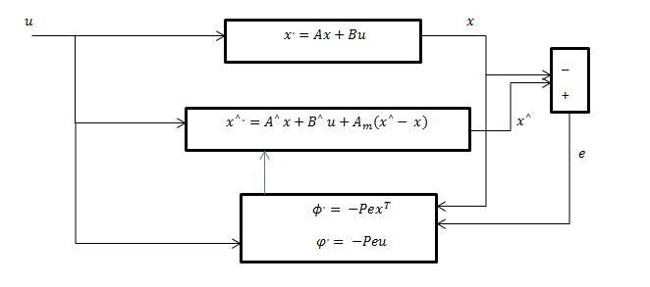

Figure 2: Block diagram implementation of observer-like estimator

**Design of Estimator:**

* There 5 parameters that are unknown which include 4 entries of $A$ matrix and 1 entry of $B$ matrix.
* Choose a stable $A_{m}$ matrix of size 3x3.
* Solve the LMI for $P.$ Size of P is 3x3 and P is symmetric positive definite.
* Let $A^{^}\left(1, 1\right)=a1, { A}^{^}\left(1, 3\right)=a2, A^{^}\left(3, 1\right)=a3, A^{^}\left(3, 3\right)=a4 and B^{^}\left(1\right)=b$
* Then,
$$a1^{.}=\left(-Pex^{T}\right)\left(1, 1\right), a2^{.}=\left(-Pex^{T}\right)\left(1, 3\right), a3^{.}=\left(-Pex^{T}\right)\left(3, 1\right), a4^{.}=\left(-Pex^{T}\right)\left(3, 3\right), b^{.}=(-Peu)(1)$$

* Fig. 2 shows the implementation of estimator with the help of block diagram.

**Matlab Implementation:**

**Code:**

**Function to Solve Differential Equations:**

function dy=AC_MI(t, y, A, B, ut, tu, Am, P)

dy=zeros(11, 1);

dx=zeros(3, 1); %Derivative of system states

dx_=zeros(3, 1); %Derivative of estimator states

da=zeros(4, 1); %Derivative unknown A parameters

db=zeros(1, 1); %Derivative of unknown B parameters

x=zeros(3, 1);

x_=zeros(3, 1);

a=zeros(4, 1);

b=zeros(1, 1);

for i=1:3

dx(i)=dy(i);

x(i)=y(i);

end

for i=1:3

dx_(i)=dy(3+i);

x_(i)=y(3+i);

end

for i=1:4

da(i)=dy(6+i);

a(i)=y(6+i);

end

db=dy(11);

b=y(11);

A_=[a(1) 0 a(2); 0 0 1; a(3) 0 a(4)];

B_=[b; 0; 0];

u=interp1(tu, ut, t);

dx=A*x+B*u; %System Model

dx_=A_*x+B_*u+Am*(x_-x); %Estimator Model

Temp1=-P*(x_-x)*x'; %Adaptation law for A parameters

da(1)=Temp1(1, 1);

da(2)=Temp1(1, 3);

da(3)=Temp1(3, 1);

da(4)=Temp1(3, 3);

Temp2=-P*(x_-x)*u; %Adaptation law for B parameter

db=Temp2(1);

dy(1:3)=dx;

dy(4:6)=dx_;

dy(7:10)=da;

dy(11)=db;

end

**Main Routine:**

clear

clc

close all

ts=1:0.1:2000; %Time for solution

tu=ts;

ut=20*sin(2*3.142*8*tu); %Input signal

Am=blkdiag(-1, -3, -2); %Am matrix calculation

setlmis([]); %Solution of LMI for P

P=lmivar(1, [3, 1]);

lmiterm([1 1 1 P], Am', 1, 's');

lmiterm([-2 1 1 P], 1, 1);

lmisys=getlmis;

[T, X]=feasp(lmisys);

P=dec2mat(lmisys, X, P);

%System Parameters

R=2; %Ohms

L=0.5; %Henrys

Kt=0.1;

Kb=0.1;

b=0.2; %Nms

J=0.02; %kg.m^2/s^2

A=[-R/L 0 -Kb/L; 0 0 1; Kt/J 0 -b/J]

B=[1/L; 0; 0]

%Solution of differential equations

yo(1:11)=zeros(1, 11);

[tss, y] = ode45(@(t, y) AC_MI(t, y, A, B, ut, tu, Am, P), ts, yo);

%Final value of found parameters

N=size(tss);

n=max(N);

a1=y(n, 7)

a2=y(n, 8)

a3=y(n, 9)

a4=y(n, 10)

b1=y(n, 11)

%Plots of parameters and errors vs time

figure

plot(tss, y(:, 4)-y(:, 1));

title('Error for state x1')

xlabel('Time (sec)')

ylabel('e1')

figure

plot(tss, y(:, 5)-y(:, 2));

title('Error for state x2')

xlabel('Time (sec)')

ylabel('e2')

grid

figure

plot(tss, y(:, 6)-y(:, 3));

title('Error for state x3')

xlabel('Time (sec)')

ylabel('e3')

grid

figure

plot(tss, y(:, 7));

title('Parameter a1')

xlabel('Time (sec)')

grid

figure

plot(tss, y(:, 8));

title('Parameter a2')

xlabel('Time (sec)')

grid

figure

plot(tss, y(:, 9));

title('Parameter a3')

xlabel('Time (sec)')

grid

figure

plot(tss, y(:, 10));

title('Parameter a4')

xlabel('Time (sec)')

grid

figure

plot(tss, y(:, 11));

title('Parameter b')

xlabel('Time (sec)')

grid

**Simulation Results:**

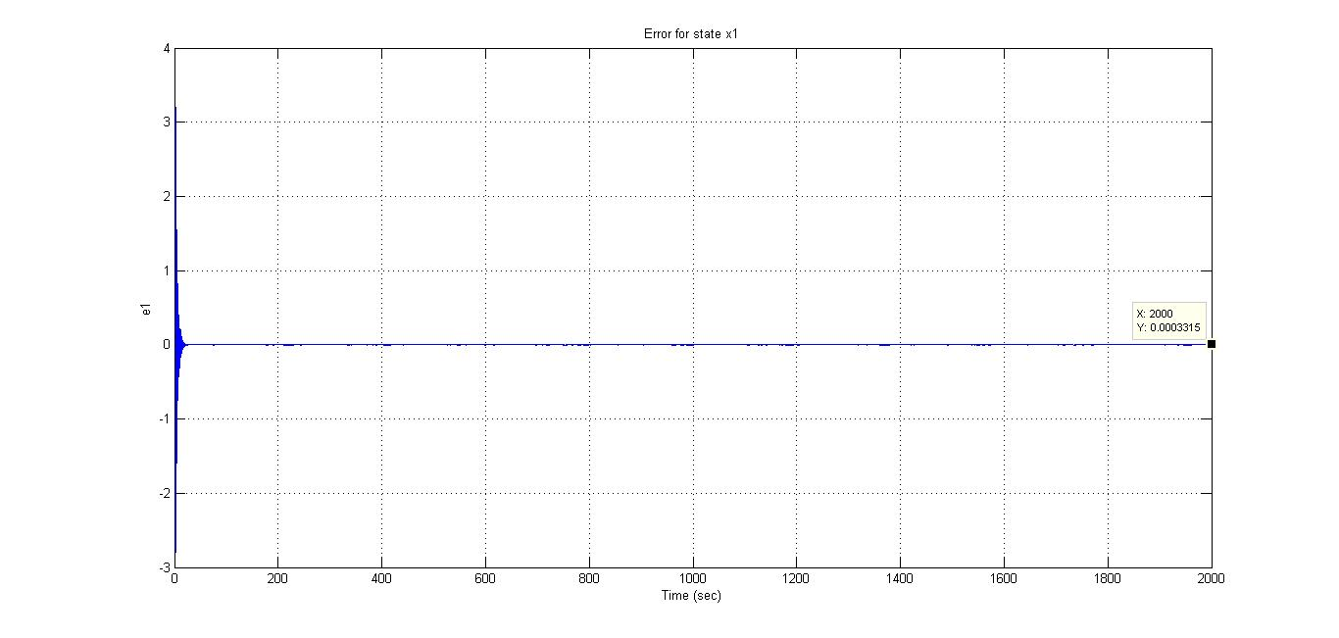

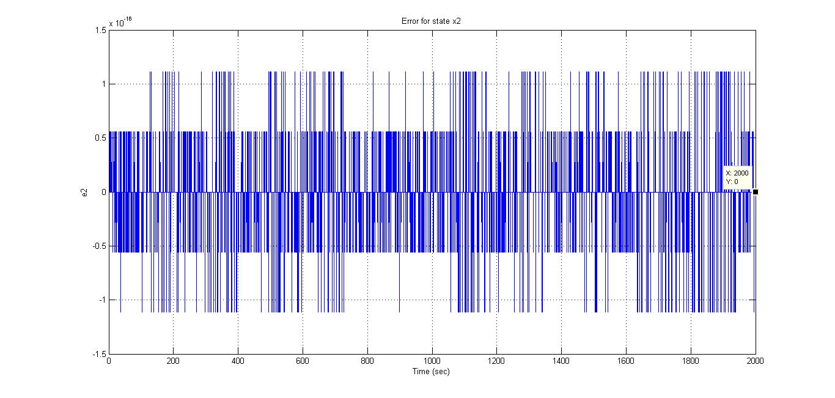

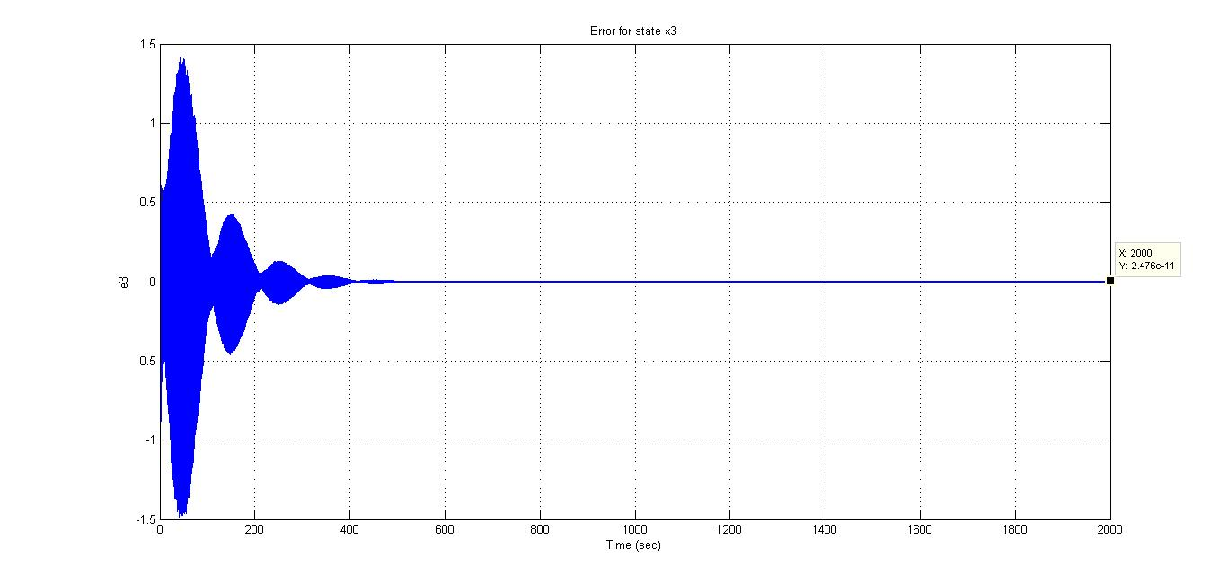

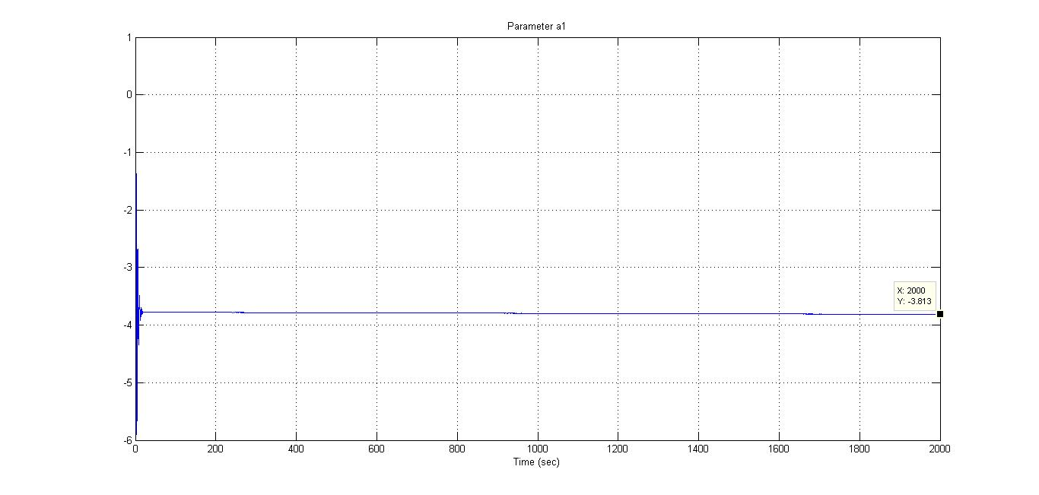

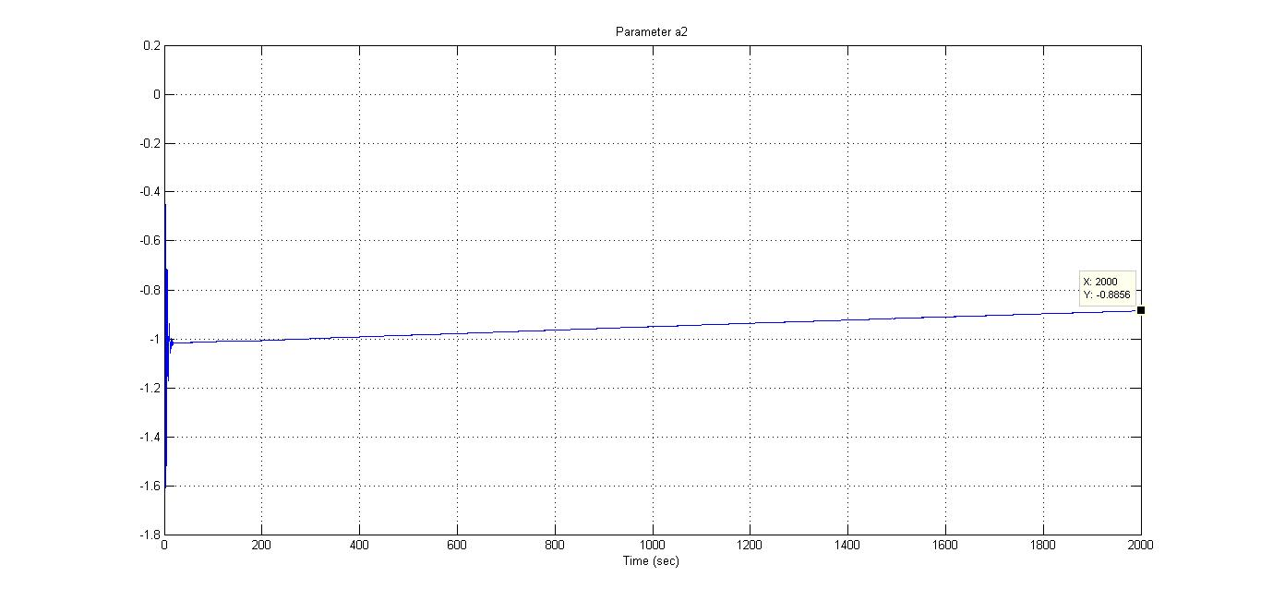

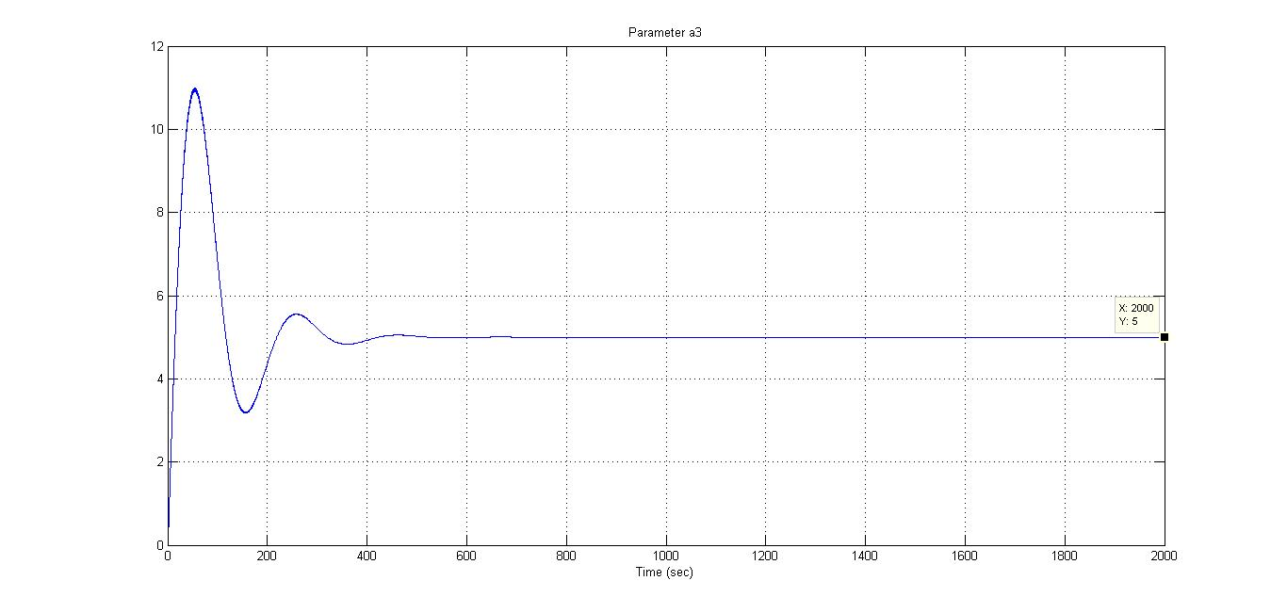

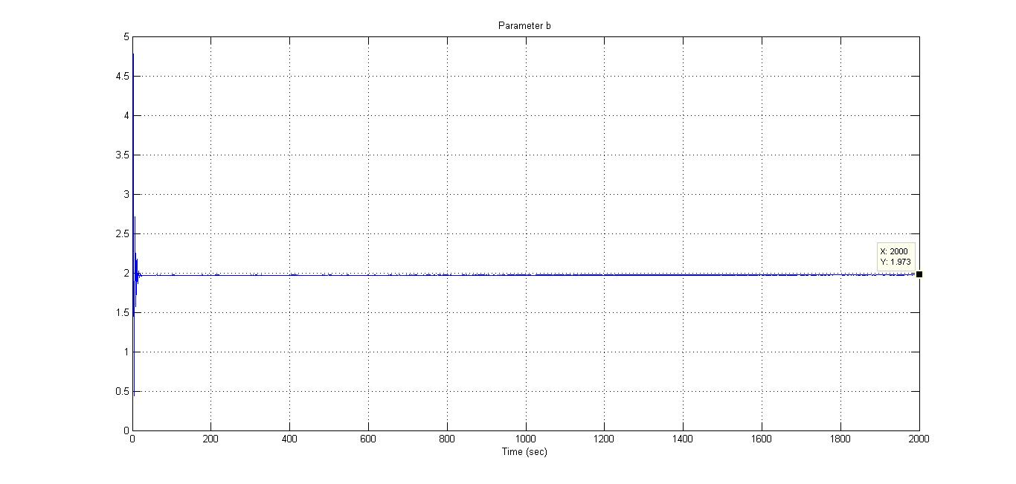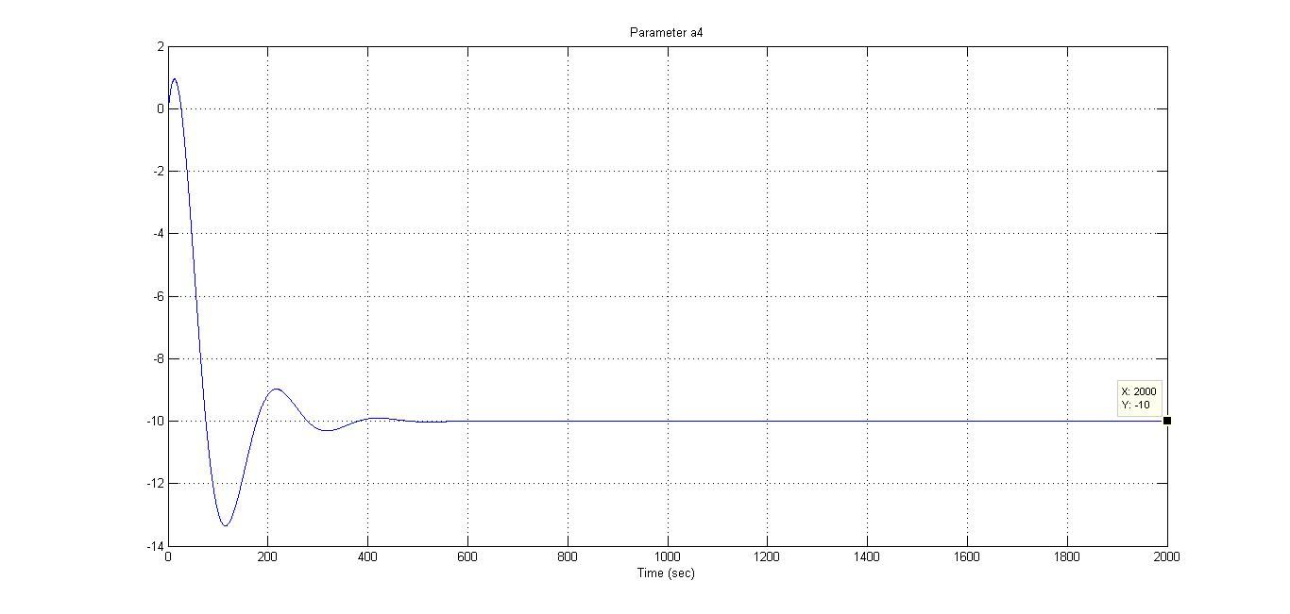

**Comments:**

* All states errors converge to zero.
* Two parameters $a3$ and $a4$ converge to their true value.
* Parameter b converges but there is a small error between true and converged value.
* Parameters $a1$ and $a2$ are converging but need more time.
* Convergence of parameters increases for more time, high input amplitude, a specific range of input frequencies and smaller magnitude of $A_{m}$ entries.