PROJECT DOCUMENTATION
AI-Based Cyber Attack Detection
and Hacking Risk Prediction System
Design, machine-learning model, user guide and test results

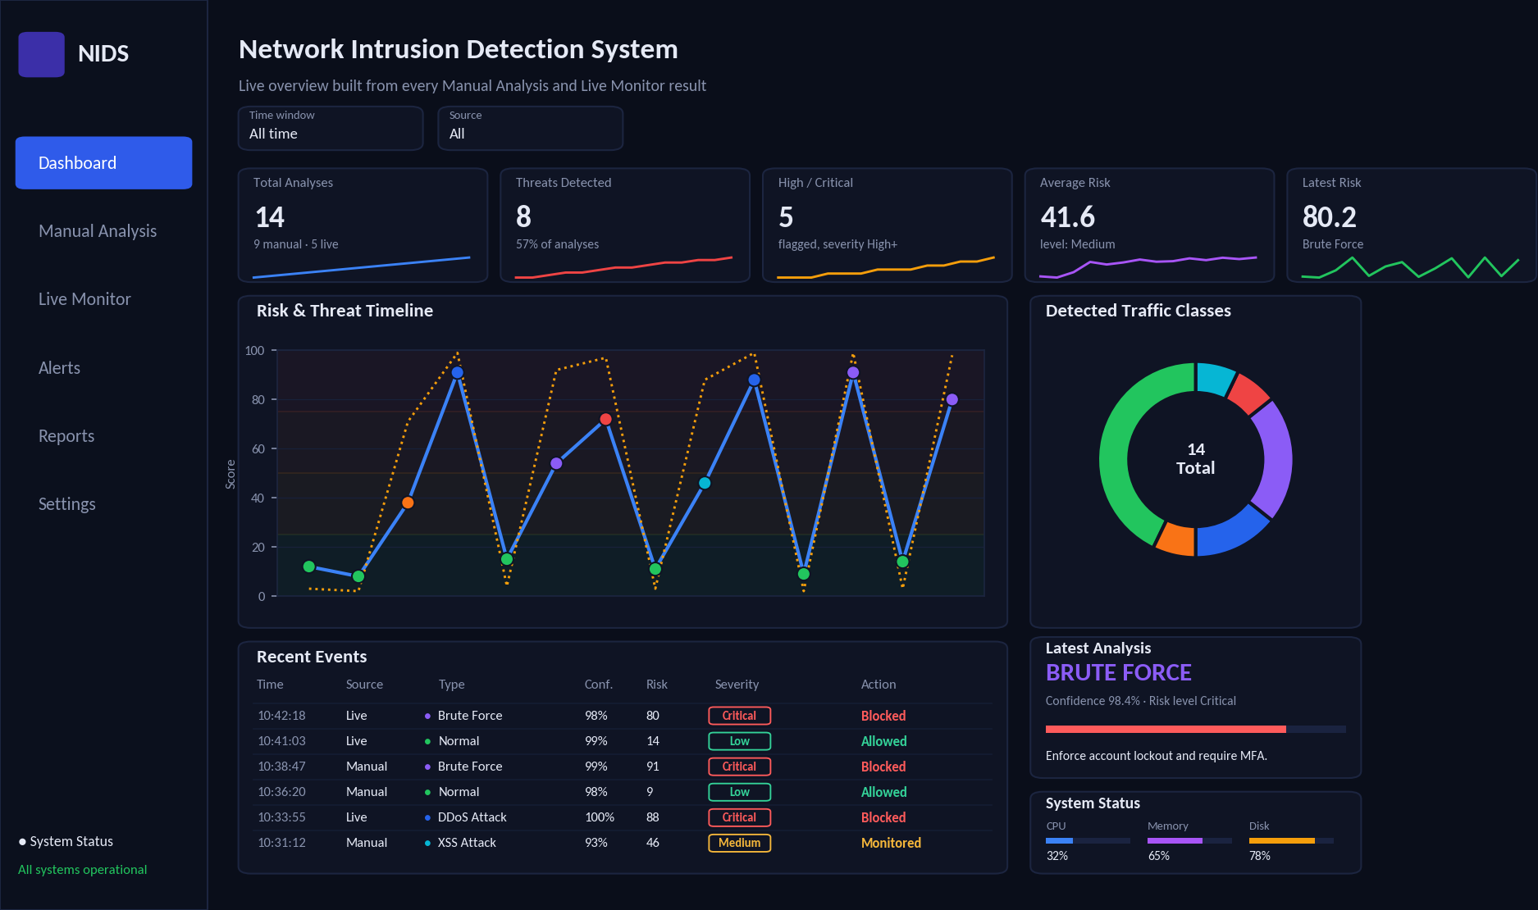
Illustrative rendering of the application dashboard
Python · Streamlit · scikit-learn · Plotly
Version 1.0 · October 2026

Document Information
Item | Detail
Title | AI-Based Cyber Attack Detection and Hacking Risk Prediction System
Document type | Project documentation: design, machine-learning model and user guide
Version | 1.0
Date | October 2026
Technology | Python, Streamlit, scikit-learn, Plotly, psutil, ReportLab
Audience | Evaluators, students, security analysts, administrators

Version | Date | Description
1.0 | October 2026 | First complete release of the project documentation.

Executive Summary
Cyber attacks are fast and varied, while the people who must defend against them are few. This project provides a decision-support application that examines packet information, network information and security settings, predicts which type of attack the activity resembles, and expresses the overall hacking risk as a score from 0 to 100.
The application runs in a web browser and offers two modes: Manual Analysis, where all details are entered by the user, and Live Monitor, where the application measures the user’s own computer. A dark, professional dashboard summarises every analysis with trends, class distribution, alerts and the latest verdict, and any result can be exported as a PDF report.
Behind the interface is a machine-learning model that combines feature engineering, an anomaly detector, six learning algorithms (Random Forest, Extra-Trees, Gradient Boosting, Support Vector Machine, Logistic Regression and a neural network) and a stacking ensemble, plus a separate model for the risk score. On a held-out test set of 3,000 synthetic records it reached 97.9% accuracy and a macro F1 of 0.9743.
How to read this document
Chapters 1–5 explain the purpose, concepts, architecture and interface for any reader.
Chapters 6–9 describe the data and the model; Chapters 10–15 cover scoring, testing, installation and limitations. Appendices contain a glossary and repeatable test data.

Table of Contents
1. Introduction 4
2. Background: Cyber Attacks and Hacking Risk 5
3. System Overview 6
4. System Architecture 8
5. User Interface Guide 9
6. Input Parameters 12
7. The Dataset 13
8. Machine-Learning Methodology 16
9. Evaluation and Results 18
10. Risk Levels, Alerts and Responses 22
11. Live Monitoring Internals 23
12. Reporting 24
13. Testing and Validation 25
14. Installation and Operation 26
15. Security, Limitations and Future Work 27
16. Conclusion 28
Appendix A. Glossary 29
Appendix B. Test Data for the Brute-Force Scenario (TC-7) 29
List of Figures
Figure 1: Layered architecture of the system 8
Figure 2: Data flow for the two operating modes 8
Figure 3: Reference dashboard design used as visual inspiration 9
Figure 4: Dashboard layout (illustrative rendering with sample data) 10
Figure 5: Manual Analysis page: form groups and result panel (illustrative rendering) 11
Figure 6: Live Monitor page (illustrative rendering) 11
Figure 7: Number of records per class 13
Figure 8: Distribution of four key measurements by class (log scale) 15
Figure 9: Typical (median) level of ten measurements for each class 15
Figure 10: Building blocks of the risk score 15
Figure 11: Machine-learning pipeline 16
Figure 12: Stacking ensemble 18
Figure 13: Macro F1 of each model (cross-validation and hold-out test) 19
Figure 14: Precision, recall and F1 by class 20
Figure 15: Confusion matrix on the test set (counts and share of each actual class) 20
Figure 16: One-vs-rest ROC curves for every class 21
Figure 17: Twelve most important inputs according to the Random Forest 21
Figure 18: Predicted versus actual risk score on test records 22
Figure 19: Risk levels and the response assigned to flagged results 22
Figure 20: Workflow of a live scan 23
Figure 21: Sample generated PDF report (two pages) for a brute-force analysis 24
Figure 22: Class probabilities for each scenario test case 26
List of Tables
Table 1: What is and is not covered by the system 5
Table 2: The six traffic classes recognised by the system 6
Table 3: Comparison of Manual Analysis and Live Monitor 7
Table 4: Technologies used 7
Table 5: Files that make up the project 7
Table 6: Main components and what they do 9
Table 7: The six pages of the application 9
Table 8: Dashboard elements 10
Table 9: Settings 12
Table 10: Input parameters and their live-mode source 12
Table 11: Records and mean risk score per class 13
Table 12: Defining behaviour of each class in the dataset 14
Table 13: Concepts and where they appear 16
Table 14: Derived features 17
Table 15: Algorithms combined in the classifier 17
Table 16: Evaluation metrics 18
Table 17: Hold-out test results of every model 19
Table 18: Summary of the final classifier on the 3,000 test records 19
Table 19: Precision, recall and F1 per class (test set) 20
Table 20: Rules for assigning the response 22
Table 21: Examples of recommendations by class 23
Table 22: Measurements taken from the computer 23
Table 23: Levels of testing 25
Table 24: Scenario test cases and results 25
Table 25: Functional test checklist 26
Table 26: System requirements 27
Table 27: Common problems and remedies 27
Table 28: Limitations and their implications 28
Table 29: Terms used in this document 29
Table 30: Input values for TC-7 29

1. Introduction

1.1 Purpose of this document
This document describes the AI-Based Cyber Attack Detection and Hacking Risk Prediction System in plain language first, and in technical detail where it matters. It explains what the application does, how it is built, how its machine-learning model was created and tested, how to operate it, and where its limits are. The document contains no program code. A reader who has never seen the project should be able to understand the application and how it works after reading it.

1.2 Background and motivation
Cyber attacks are frequent, fast and increasingly automated. Traditional defences such as firewalls and signature-based intrusion detection systems recognise attacks they have been told about, but they struggle with variations, and security teams are often overwhelmed by the number of alerts. Small organisations, students and individual users rarely have a dedicated security operations centre at all.
This project explores how machine learning can help. By looking at measurable properties of network traffic and at the security settings of a computer, a trained model can estimate what kind of activity is taking place and express the overall danger as a single score that anyone can understand.

1.3 Problem statement
Network and host data is detailed and arrives faster than any person can read it. The danger to a computer depends on what is happening (is someone attacking?) and on how well the computer is protected (patched, firewalled, using multi-factor authentication?). Results must also be understandable to non-specialists and available as a professional, shareable report.

1.4 Objectives
- Accept packet information, network information and security-posture details as input.
- Predict which type of cyber attack (if any) the data most resembles, together with a confidence value.
- Predict a hacking-risk score from 0 to 100 and translate it into Low, Medium, High or Critical.
- Provide two ways of working: manual entry of all details, and automatic monitoring of the user’s own computer.
- Present everything in a professional, interactive dashboard in the style of a security operations tool.
- Train the prediction model on a dataset using several machine-learning algorithms and concepts, and generate a professional PDF report for every analysis.

1.5 Scope
Table 1: What is and is not covered by the system
Included | Not included
Classification of six traffic classes: Normal, DDoS, Port Scan, SQL Injection, XSS and Brute Force | Capturing and inspecting raw network packets (deep packet inspection)
Hacking-risk score that combines attack activity and security posture | Automatically blocking traffic or changing firewall rules
Manual analysis form and live monitoring of the local computer | Monitoring other computers across a network
Interactive dashboard, alert list, history and settings | Reading operating-system login logs or web-server payloads in live mode
PDF report generation and CSV export of alerts | Multi-user accounts, databases or cloud services

Important note about the “Action” column
The system assigns a response level (Blocked, Monitored, Logged or Allowed) to each result. This is decision support: the application does not itself change firewall rules or end connections. The label tells an administrator how urgently to act.

1.6 Intended audience
The document is written for evaluators, students, security analysts and administrators. Chapters 1 to 5 suit any reader; Chapters 6 to 9 describe the data and model in depth; Chapters 10 to 15 cover scoring, testing, installation and limitations.

2. Background: Cyber Attacks and Hacking Risk

2.1 What is intrusion detection?
An intrusion detection system (IDS) watches activity and raises an alert when something looks malicious. A network IDS studies traffic moving between computers; a host IDS studies what happens inside one computer. There are three broad approaches:
- Signature-based: compares activity with a list of known attack patterns. Fast and precise, but blind to new variants.
- Anomaly-based: learns what normal looks like and flags deviations. Can find new attacks, but may raise false alarms.
- Machine-learning based: learns the difference between normal and attack behaviour from labelled examples.
This project combines the last two: a supervised classifier learns the known attack types, and an unsupervised anomaly detector trained only on normal traffic adds a second opinion about how unusual an event is.

2.2 Attack types covered by the system
Table 2: The six traffic classes recognised by the system
Class | What it is | Typical measurable signs | Why it matters
Normal | Everyday, legitimate use such as browsing, email or file transfer. | Moderate packet rates, few connections, completed connections, almost no failed logins. | Baseline against which attacks are judged.
DDoS Attack | Distributed denial of service: a flood of requests that exhausts a server or network so real users are locked out. | Very high packets per second, hundreds or thousands of connections, many half-open connections. | Causes outages and financial loss.
Port Scan | An attacker probes many ports to discover which services are open before choosing how to attack. | Many different destination ports, tiny packets, rejected or unanswered connections. | Usually the first step of a larger attack.
SQL Injection | Malicious database commands hidden inside a web request to read or alter stored data. | Web service, larger requests, many SQL-like keywords in the payload. | Can expose or destroy sensitive data.
XSS Attack | Cross-site scripting: harmful script code inserted into a web page that then runs in other users’ browsers. | Web service, script-like tokens in the payload. | Enables session theft and impersonation.
Brute Force | Automated guessing of passwords until one works. | Many failed logins and login attempts against services such as SSH, FTP or SMB. | Leads to unauthorised access.

2.3 What is “hacking risk”?
Detecting an attack is only half of the picture. Imagine a burglar trying door handles in your street: that is the threat activity. Whether he gets in depends on whether your doors are locked: that is your exposure. The hacking-risk score used in this project follows the same logic. It rises when attack-like behaviour is detected, and it rises further when the computer is poorly protected (many open ports, outdated software, no firewall, no multi-factor authentication, long time since the last security update).

2.4 Why machine learning?
A rule such as “more than 1,000 packets per second means an attack” fails as soon as a legitimate backup job exceeds it, or an attacker slows down. Machine-learning models weigh dozens of measurements at once and learn where the real boundaries lie. They also provide probabilities rather than a hard yes/no, which lets the application show how certain it is. The trade-off is that a model is only as good as the data it learned from, a point revisited in Chapters 7 and 15.

3. System Overview

3.1 Key features
- Two operating modes: Manual Analysis (user enters every detail) and Live Monitor (the application collects the details from the user’s own computer).
- Attack prediction among six classes, with a confidence value and the full probability for every class.
- Hacking-risk score from 0 to 100 with four named levels.
- Interactive dashboard with filters, trend lines, class distribution, an events table and a latest-analysis panel, all driven by real results.
- Alerts page with filtering and CSV export.
- Professional PDF report for any analysis.
- Persistent history that survives restarting the application.
- Graceful fallback: if the trained model is not available the application still runs using a built-in rule-based demonstration engine.

3.2 The two operating modes
Table 3: Comparison of Manual Analysis and Live Monitor
Aspect | Manual Analysis | Live Monitor
Data source | Typed in by the user (for example from a packet capture, firewall log or a test scenario). | Measured automatically from the local computer.
Effort | User completes a form of about 24 parameters. | One click on Scan Now, or continuous with Auto-refresh.
Best for | Investigating a specific incident, teaching, testing the model with designed scenarios. | Ongoing awareness of the health of the computer running the application.
Limitations | Quality depends on the values entered. | Cannot see login logs or web payloads, so those inputs are set to zero (see Chapter 6).

3.3 Technology stack
Table 4: Technologies used
Component | Technology | Role in the project
Programming language | Python 3 | All application and model code.
User interface | Streamlit | Builds the interactive web interface that opens in a browser.
Charts | Plotly | Timeline, donut, gauge and probability charts.
Data handling | pandas, NumPy | Tables, calculations and filtering of results.
Machine learning | scikit-learn, joblib | Training, evaluation and saving of the model.
System monitoring | psutil | Reads network counters, connections and resource use from the computer.
PDF reports | ReportLab | Creates the formatted PDF document.

3.4 Project files
Table 5: Files that make up the project
File | Purpose
app.py | The complete user interface and application logic.
Model.py | Dataset generation, model training and evaluation, and the prediction function used by the application.
cyber_attack_dataset.csv | The labelled training and testing dataset (15,000 records).
cyber_model.joblib | The trained model. Created when Model.py is run.
model_report.json, confusion_matrix.png | Evaluation results written after training.
analysis_history.jsonl | Stored results of every analysis. Created automatically while the application is used.

4. System Architecture

4.1 Layered architecture
The system is organised in four layers. Each layer talks only to its neighbours, which keeps the design easy to understand and to extend.
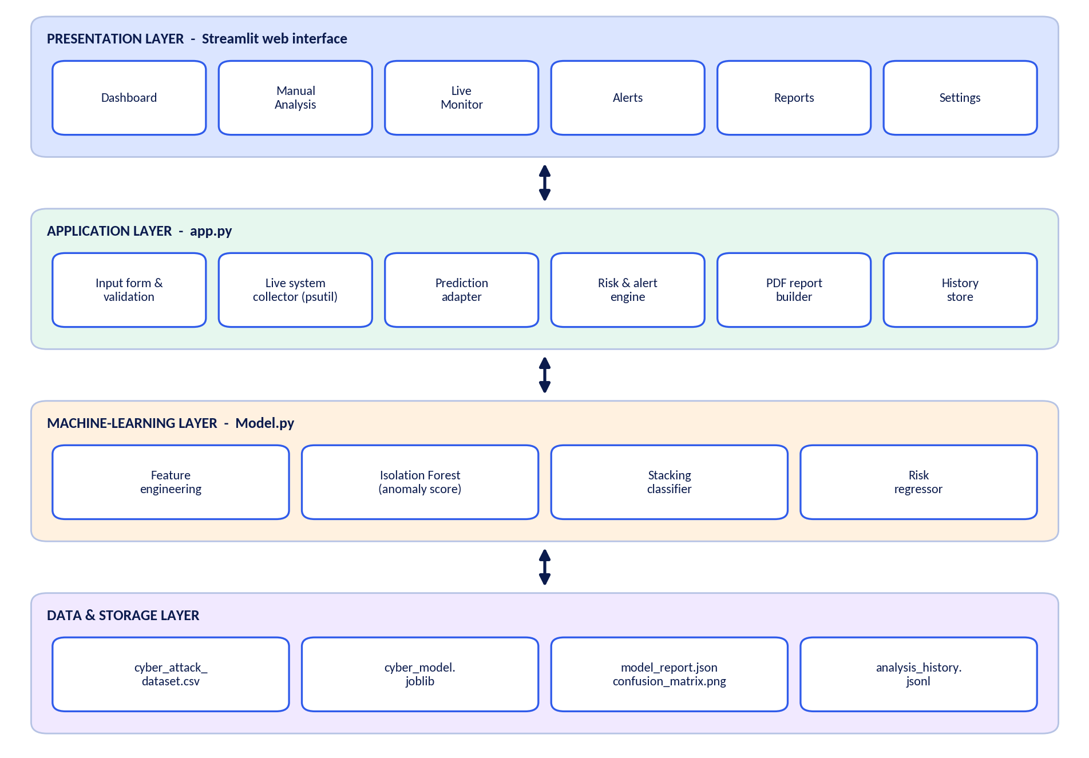
Figure 1: Layered architecture of the system
- Presentation layer: the six pages the user sees in the browser.
- Application layer (app.py): validates inputs, collects live data, calls the model, decides severity and action, stores results and builds reports.
- Machine-learning layer (Model.py): transforms the inputs into model features, produces class probabilities and the risk score.
- Data and storage layer: the dataset, the saved model, evaluation outputs and the history file.

4.2 Data flow
Both operating modes end in the same place. Whether the 24 parameters were typed in or measured automatically, they are packed into one feature vector, handed to the prediction engine, and the result is recorded. From that single record the dashboard, the alert list and the PDF report are all produced, which is why every analysis is immediately visible everywhere in the application.
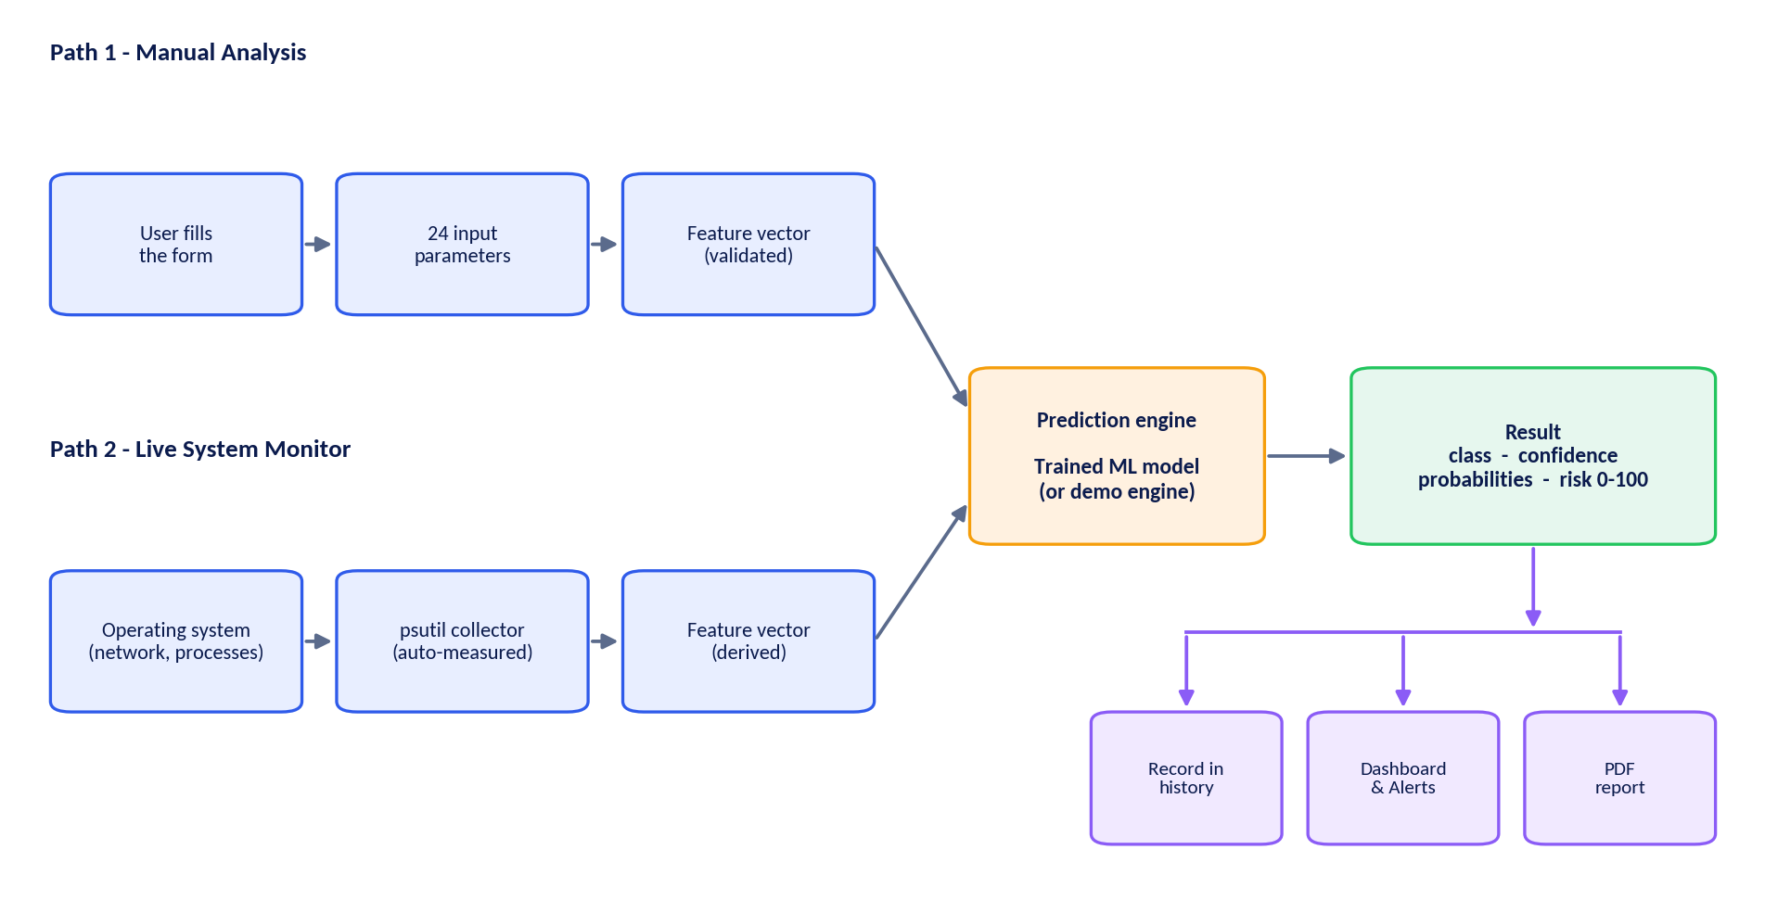
Figure 2: Data flow for the two operating modes

4.3 Component responsibilities
Table 6: Main components and what they do
Component | Responsibility
Input form and validation | Presents grouped fields with sensible limits so impossible values cannot be entered.
Live system collector | Measures network counters between two scans, reads the connection table and listening ports, and converts them into the model’s parameters.
Prediction adapter | Calls the trained model; if it is unavailable, falls back to the demonstration engine; adds timestamp and risk level.
Risk and alert engine | Applies the confidence threshold, decides whether a result is a threat and assigns the response level.
History store | Keeps every result in memory and appends it to a file so it survives a restart (latest 2,000 results are kept).
PDF report builder | Creates a formatted report from one result.

4.4 Prediction engine and fallback
When the application starts it looks for Model.py in the same folder. If the model is found, the sidebar shows Engine: ML Model. If not, the sidebar shows Engine: Demo Engine and a transparent rule-based scoring is used so that the whole interface can still be explored. The demonstration engine is meant for testing the interface only; its figures should not be treated as results of the trained model.
Every result keeps its time, source, class, confidence, all class probabilities, risk score, addresses, response action and all input parameters, which is what allows a PDF report to be regenerated later from the history.

5. User Interface Guide

5.1 Design approach
The interface follows the visual language of professional security operations tools: a dark theme that is comfortable for long monitoring sessions, a navigation sidebar, summary cards at the top and detail panels below. Colours carry meaning: green for normal or low risk, amber for medium, orange for high and red for critical. Figure 3 shows the reference dashboard design that inspired the layout.
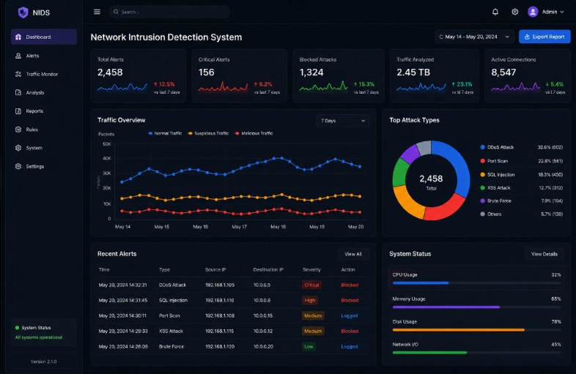
Figure 3: Reference dashboard design used as visual inspiration

5.2 Navigation
Table 7: The six pages of the application
Page | Purpose
Dashboard | Overview of all analyses with filters, indicators, charts and the latest verdict.
Manual Analysis | Enter details by hand, predict, view results and download a PDF.
Live Monitor | Scan this computer automatically, once or continuously.
Alerts | List, filter and export detected threats.
Reports | Review the latest result, download its PDF and browse the analysis history.
Settings | Analyst name, alert threshold, assumed security posture and clearing of history.

5.3 Dashboard
The dashboard is built entirely from the analyses the user has performed. When the application is used for the first time it is empty and offers shortcuts to the two analysis pages. As soon as an analysis is completed, every element below updates.
Figure 4: Dashboard layout (illustrative rendering with sample data)
Table 8: Dashboard elements
Element | What it shows
Filters | Time window (last hour, 24 hours, 7 days, all time), source (All, Manual, Live) and a switch to show threats only in the events table.
Summary cards | Total analyses (manual versus live), threats detected, High/Critical count, average risk and latest risk, each with a small trend line.
Risk and Threat Timeline | One point per analysis. The line is the risk score, point colours show the detected class, and the dotted line is the probability that the activity is an attack.
Detected Traffic Classes | Donut chart of how many analyses fell into each class.
Recent Events | Latest events with time, source, class, confidence, addresses, risk, severity and action.
Latest Analysis | Verdict, confidence, risk bar and the first recommended action, with a button to open the full report.
System Status | Live CPU, memory and disk usage of the computer.

5.4 Manual Analysis
The form is divided into four groups so that it can be completed methodically. Every field has limits and sensible defaults, and the most technical fields explain themselves through tooltips.
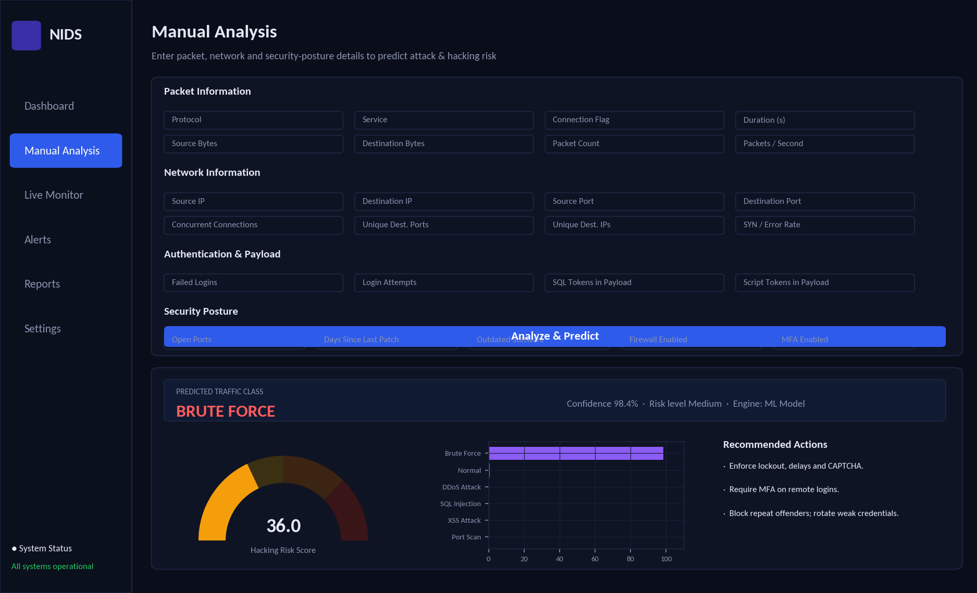
Figure 5: Manual Analysis page: form groups and result panel (illustrative rendering)
- Open Manual Analysis from the sidebar.
- Complete the four groups: Packet Information, Network Information, Authentication & Payload and Security Posture.
- Click Analyze & Predict. A short progress indicator appears while the model runs.
- Read the result banner (predicted class, confidence, risk level), the risk gauge, the probability chart and the recommended actions.
- Click Download PDF Report to save a report, or View on Dashboard to see the result in context.

5.5 Live Monitor
The Live Monitor measures the computer the application is running on. Press Scan Now for a single measurement, or switch on Auto-refresh and choose an interval between 2 and 30 seconds for continuous monitoring. Each scan creates a new record, updates the live chart of risk and network throughput, and appears on the dashboard. The collected parameters can be inspected in an expandable panel so the user can see exactly what was sent to the model.
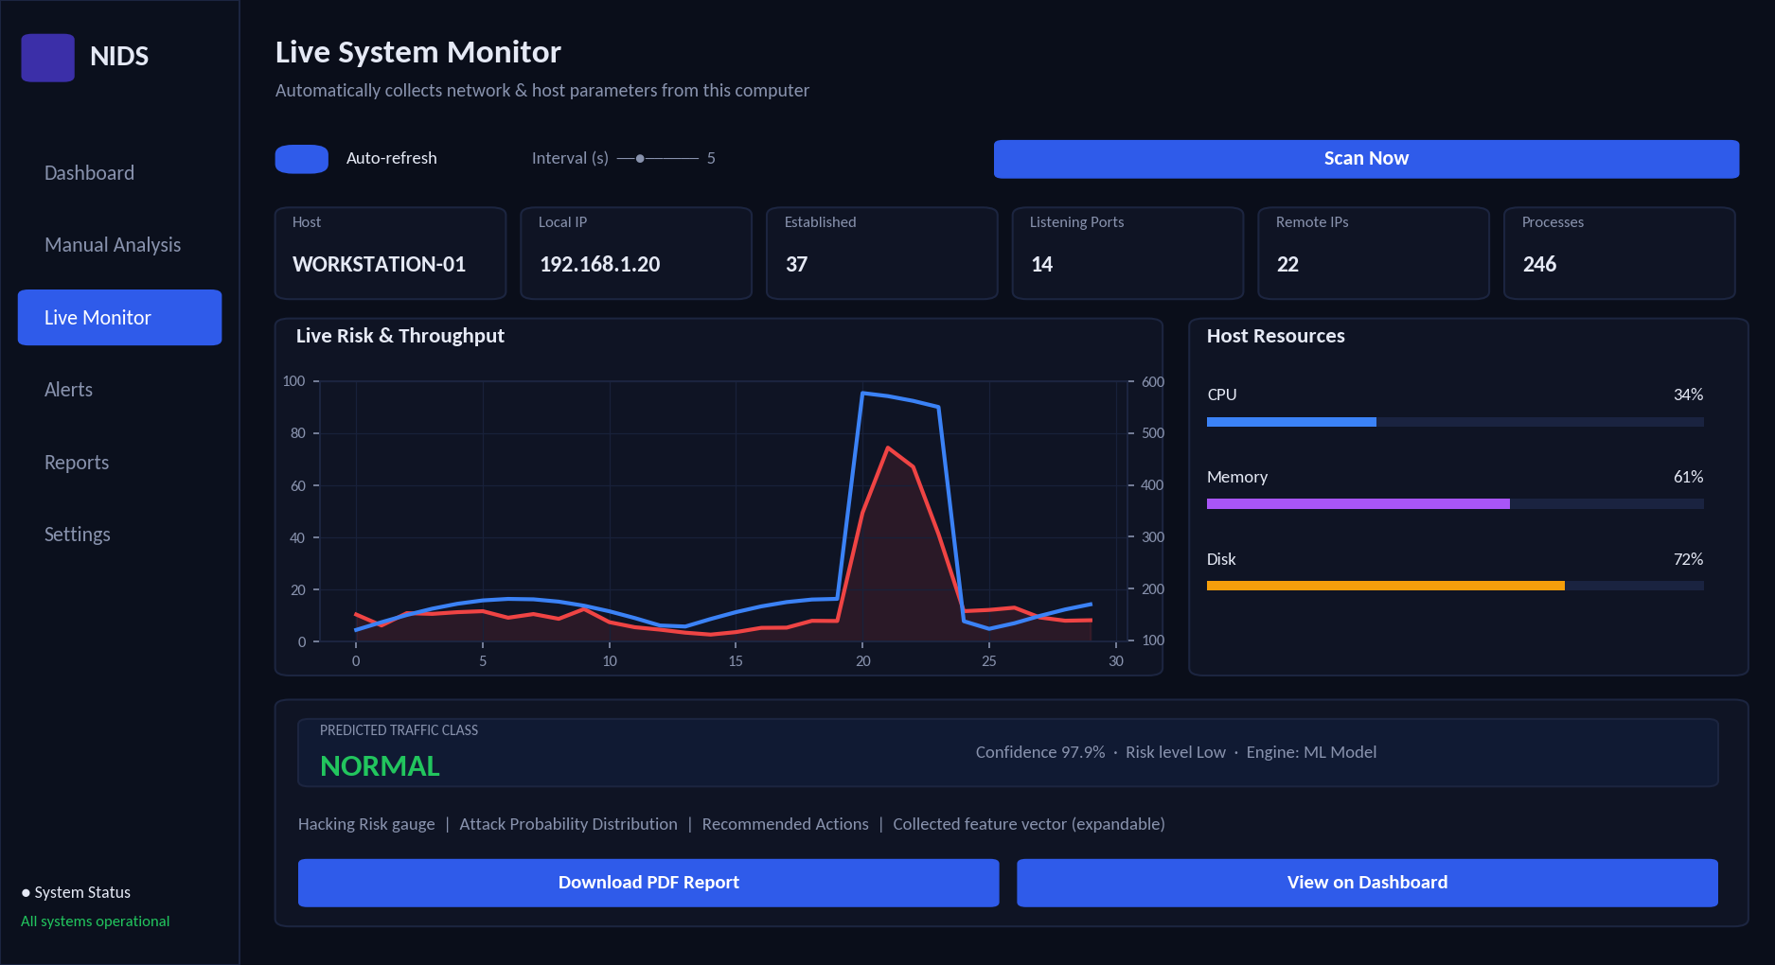
Figure 6: Live Monitor page (illustrative rendering)

5.6 Alerts, Reports and Settings
Alerts lists detected threats and can be filtered by severity, attack type and source; normal events can be included with a switch, and the filtered list can be exported to CSV. Reports shows the latest result with its charts, a PDF download button and the history of all analyses. Settings holds the options in Table 9.
Table 9: Settings
Setting | Meaning
Analyst name | Printed on every PDF report.
Alert confidence threshold | Minimum confidence (default 60%) for a non-normal result to be flagged as a threat.
Firewall, MFA, outdated software, days since patch | Assumed security posture of this computer, used by the Live Monitor because these facts cannot be read reliably on every operating system.
Clear analysis history | Deletes all stored results and the history file.

6. Input Parameters

6.1 The 24 parameters
The model receives 24 parameters in four groups. Table 10 explains each one and shows how the Live Monitor obtains it automatically.
Table 10: Input parameters and their live-mode source
Parameter | Meaning | Value in Live Monitor
Packet information
protocol_type | Transport protocol: tcp, udp or icmp. | Always tcp
service | Application service such as http, https, ssh, ftp, dns, smtp, telnet, smb or other. | other
flag | State of the connection: SF (normal), S0 (no reply), REJ (rejected), RSTO (reset), SH, OTH. | S0 if over 30% of connections are half-open, else SF
duration | Length of the observation in seconds. | Time between two scans
src_bytes / dst_bytes | Bytes sent / received. | Bytes sent / received by this computer during the interval
packet_count | Number of packets. | Packets sent plus received
packets_per_sec | Packet rate. | Packets divided by the interval
Network information
src_port / dst_port | Source and destination port numbers. | 0 (not applicable)
unique_dst_ports | Number of different destination ports contacted. | Distinct remote ports in open connections
unique_dst_ips | Number of different destination addresses. | Distinct remote addresses
conn_count | Simultaneous connections. | Size of the connection table
syn_error_rate | Share of half-open or failed connection attempts. | Half-open connections divided by all connections
error_rate | Share of packets with errors or drops. | Network-card errors and drops divided by packets
Authentication and payload
failed_logins / login_attempts | Failed and total login attempts. | 0 (login logs are not read)
payload_sql_tokens / payload_script_tokens | Count of SQL-like and script-like keywords found in request content. | 0 (content is not inspected)
Security posture
open_ports | Number of ports accepting connections. | Count of listening ports
outdated_software, firewall_enabled, mfa_enabled | Yes/no facts about the protection level. | From Settings
days_since_patch | Days since the last security update. | From Settings

6.2 Consequences for live monitoring
Because login logs and request content are not available to a normal desktop application, the Live Monitor can reliably detect network-level behaviour such as floods and scanning, while attacks that depend on those two inputs (brute force, SQL injection, XSS) are best investigated through Manual Analysis. This limitation is stated again in Chapter 15.

7. The Dataset

7.1 Why a synthetic dataset?
Real network captures are large, often private, and need extensive cleaning before they match an application’s input format. For this project a dataset was generated by program so that it matches the 24 parameters exactly, can be recreated at any time with the same result, and contains deliberately controlled behaviour for each attack class. The generator is part of Model.py, so the dataset can also be regenerated or enlarged.
Honest limitation
Synthetic data represents what the designers believe attacks look like. Results measured on it show that the pipeline works; they do not guarantee the same accuracy on real-world traffic. Chapter 15 describes how to retrain on real datasets.

7.2 Structure
The dataset (cyber_attack_dataset.csv) holds 15,000 records. Each record has the 24 input parameters, a label (one of the six classes) and a risk_score between 0 and 100 used to train the risk model. It is split 80% for training (12,000 records) and 20% for testing (3,000 records). The split keeps the same class proportions in both parts, and the test records are never shown to the model during training.

7.3 Class distribution
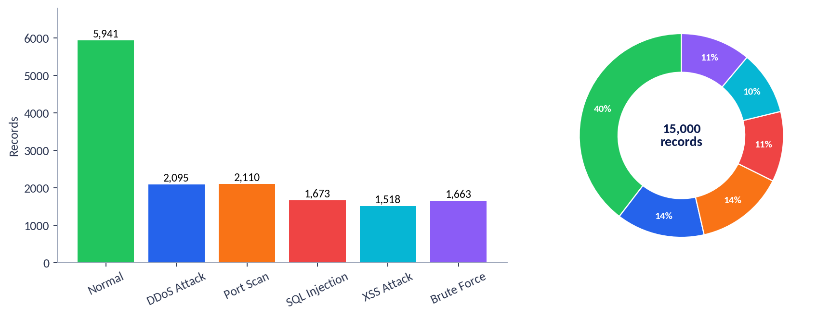
Figure 7: Number of records per class
Table 11: Records and mean risk score per class
Class | Records | Share | Mean risk score
Normal | 5,941 | 39.6% | 5.1
DDoS Attack | 2,095 | 14.0% | 35.7
Port Scan | 2,110 | 14.1% | 31.3
SQL Injection | 1,673 | 11.2% | 49.4
XSS Attack | 1,518 | 10.1% | 37.7
Brute Force | 1,663 | 11.1% | 35.8

Normal traffic is the largest class (about 40%), mirroring the fact that most real traffic is harmless. Because the classes are not equally sized, the training process compensates with class weights (Section 8.8).

7.4 How each class was generated
Table 12: Defining behaviour of each class in the dataset
Class | Main characteristics built into the data
Normal | Mostly completed tcp/udp connections to common services; moderate rates. About 10% are heavy but legitimate traffic (backups, flash crowds) and 5% have a few failed logins (forgotten passwords).
DDoS Attack | Packet rates from hundreds up to tens of thousands per second, hundreds to thousands of connections, high half-open connection share; includes UDP floods and a low-rate variant.
Port Scan | Dozens to hundreds of distinct destination ports, very small packets, rejected or reset connections; includes slow, stealthy scans.
SQL Injection | Web services, larger requests, several SQL-like tokens; 12% are obfuscated so token counts look almost normal.
XSS Attack | Same as SQL injection but with script-like tokens.
Brute Force | Many failed logins and attempts against ssh, ftp, smb, telnet or web logins; includes low-and-slow guessing that resembles forgotten passwords.

7.5 Realism: overlap and noise
A dataset in which classes never overlap would give a perfect score and teach nothing. Three techniques make this one realistic: (1) overlapping variants such as stealth scans and obfuscated payloads that resemble normal traffic; (2) legitimate heavy traffic that looks like an attack on some measurements; and (3) label noise, where 1.5% of records are deliberately given a wrong label to simulate human annotation errors.

7.6 How the classes differ
Figure 8 shows four measurements by class on a logarithmic scale. Packet rate separates floods; destination ports separate scans; failed logins separate brute force; and payload tokens separate the two web attacks. Figure 9 summarises the typical level of ten measurements per class; warm colours mean high relative values.
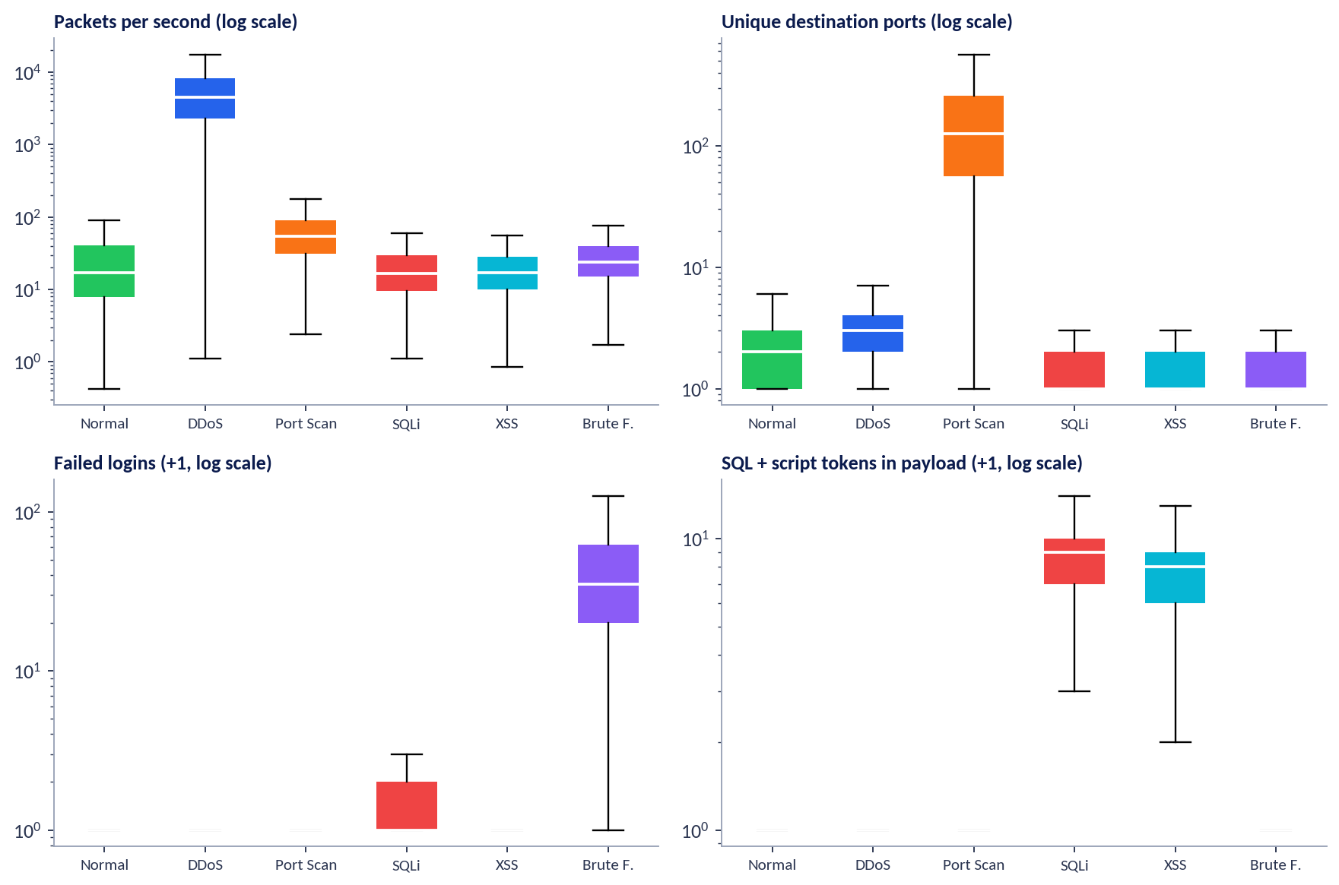
Figure 8: Distribution of four key measurements by class (log scale)
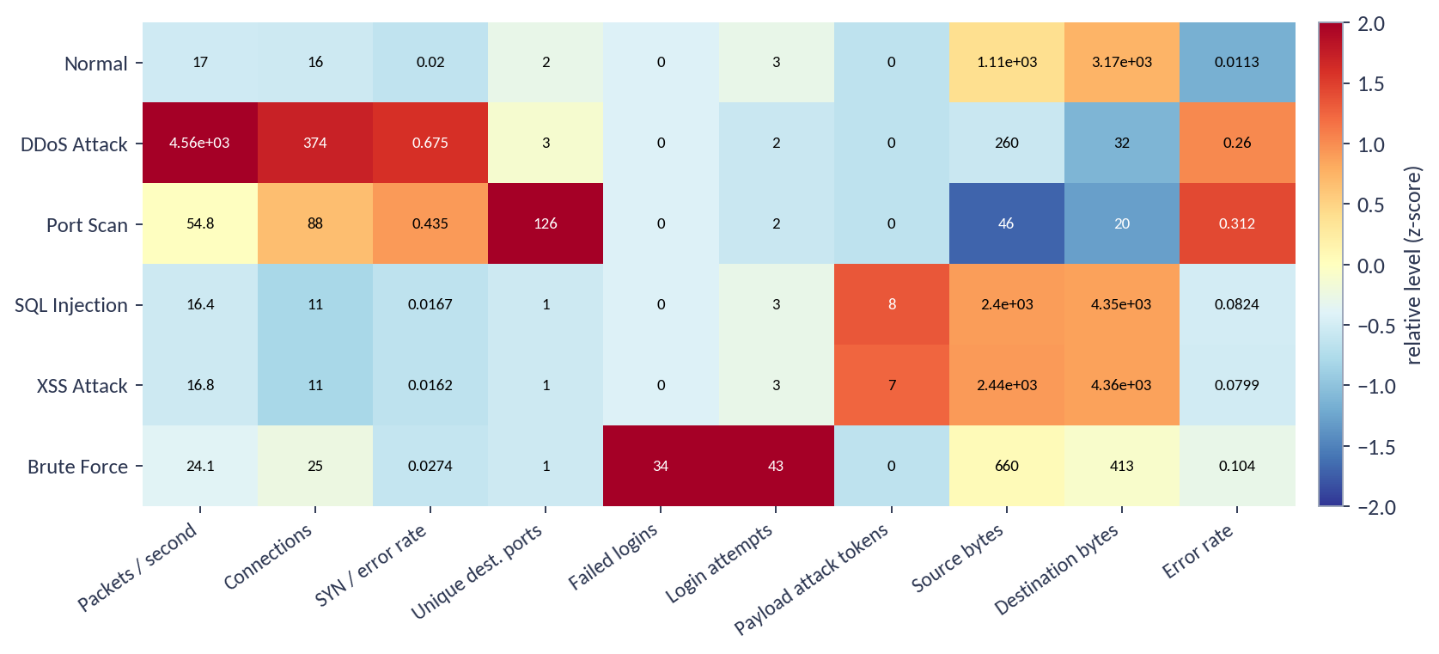
Figure 9: Typical (median) level of ten measurements for each class

7.7 The risk-score target
Each record also carries a risk score. It is the sum of an attack-severity part, scaled by how intense the attack is (for example, a faster flood scores higher), and a security-posture part of up to 40 points. Normal traffic receives only a reduced share of the posture part, so a well-protected computer with normal traffic scores close to zero, while a poorly protected computer under attack scores high.
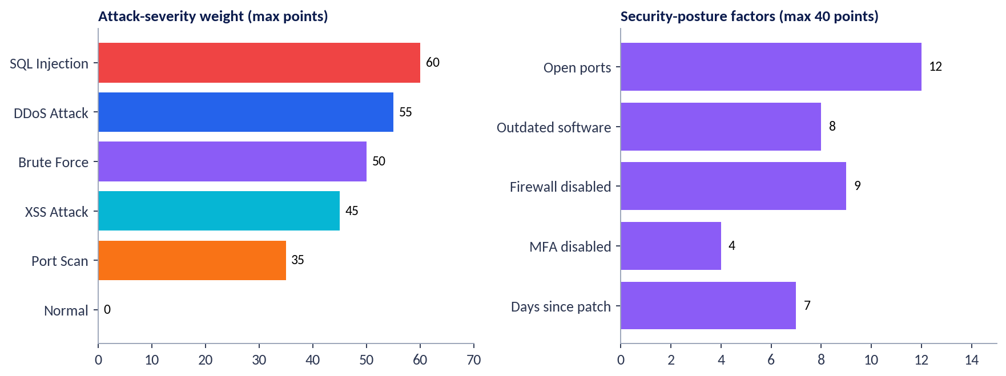
Figure 10: Building blocks of the risk score

7.8 Using real data
The training code accepts any table that contains the same 24 columns plus label and risk_score. Public intrusion datasets such as CIC-IDS2017 or NSL-KDD can be converted to this format by renaming and deriving columns; the model would then be retrained by simply running Model.py again. This is the recommended next step for any serious deployment.

8. Machine-Learning Methodology

8.1 Overview
The model is built as a pipeline in which each stage prepares data for the next. Two separate learning tasks share the same preparation: classification (which attack?) and regression (how high is the risk?).
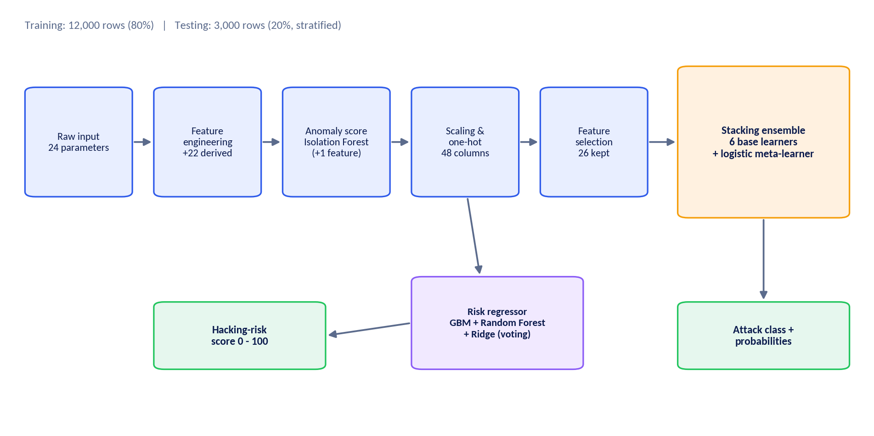
Figure 11: Machine-learning pipeline

8.2 Machine-learning concepts used
Table 13: Concepts and where they appear
Concept | How it is used in this project
Unsupervised learning | Isolation Forest trained on normal traffic only produces an anomaly score.
Scaling and encoding | Numbers are standardised; text categories are converted to yes/no columns.
Feature selection | Extra-Trees importance removes columns that add little information (26 of 48 kept).
Ensemble learning | Random Forest and Extra-Trees (bagging) and Gradient Boosting (boosting).
Algorithm diversity | Support Vector Machine, Logistic Regression and Neural Network complement the tree models.
Stacking | A meta-learner combines the six models using out-of-fold predictions.
Class-imbalance handling | Balanced class weights.
Cross-validation | Stratified k-fold comparison of the base models.
Hyper-parameter tuning | Optional randomised search for the boosting model.
Regression ensemble | Voting of Gradient Boosting, Random Forest and Ridge predicts the risk score.

8.3 Feature engineering
Raw measurements are often awkward for algorithms: packet counts range from 1 to 20,000, so a few huge values would dominate. Feature engineering reshapes them into more informative forms.
Table 14: Derived features
Group | Derived features | Purpose
Logarithmic scaling | Duration, bytes, packets, packet rate, connections, ports, addresses, failed logins, attempts, SQL tokens, script tokens | Compress very large ranges so small differences still matter.
Ratios | Bytes sent versus received, bytes per packet, ports per connection, share of failed logins | Express behaviour independent of volume.
Payload summary | Total attack tokens and the signed difference between SQL and script tokens | Separate SQL injection from XSS.
Port features | Whether the destination is a well-known port; normalised port numbers | Capture the type of service targeted.
Posture score | Combined 0–40 exposure score | Summarise how well protected the host is.
Anomaly score | Output of the Isolation Forest | How unusual the event is compared with normal traffic.

8.4 Anomaly detection with Isolation Forest
An Isolation Forest isolates data points by repeatedly splitting the data at random. Unusual points are separated after very few splits, ordinary points need many. The detector is trained only on normal traffic; afterwards, a higher score simply means “this does not look like normal behaviour”. The score is added as an extra input to the classifier, so the classifier benefits from knowing how strange an event is, even for attacks that resemble no training example closely.

8.5 Preprocessing and feature selection
Numeric columns are standardised so that no measurement dominates only because of its units, and the three text columns (protocol, service, flag) are converted into 18 yes/no columns, giving 48 columns in total. A feature-selection step based on Extra-Trees importance then removes columns contributing little, keeping 26. This reduces noise and training time.

8.6 The base learners
Table 15: Algorithms combined in the classifier
Algorithm | Family | Idea in one sentence | Key setting
Random Forest | Bagging of decision trees | Many trees vote, each trained on a different random sample. | 150 trees, balanced weights
Extra-Trees | Randomised bagging | Like a forest but with random split points, giving more diversity. | 150 trees, balanced weights
Gradient Boosting | Boosting | Trees are added one at a time, each correcting the previous errors. | 150 rounds, learning rate 0.08
Support Vector Machine | Kernel method | Finds the best curved boundary between classes. | RBF kernel, C = 3, balanced weights
Logistic Regression | Linear model | Weighs each feature to compute class probabilities; simple and fast. | C = 2, balanced weights
Neural Network (MLP) | Deep-learning family | Layers of connected units learn non-linear combinations. | Two layers (64, 32), early stopping

8.7 Stacking
Rather than choosing one winner, stacking lets the models cooperate. Each base learner makes predictions on data it has not been trained on (using 5-fold cross-validation). Those predictions become the inputs of a final, simple model, a logistic regression called the meta-learner, which learns how much to trust each base learner for each class. Because the base learners make different kinds of mistakes, the combination is usually more stable than any single member.
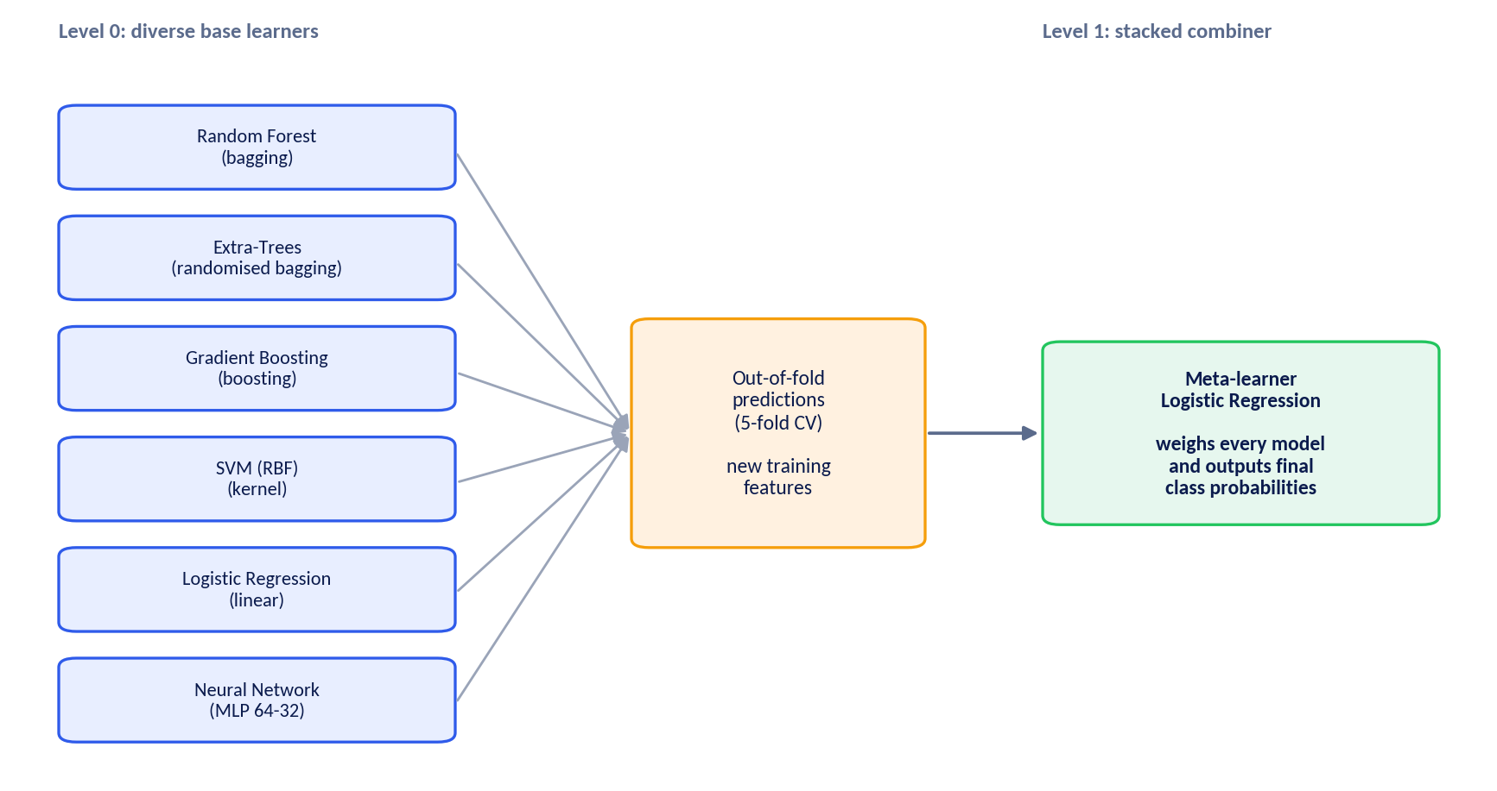
Figure 12: Stacking ensemble

8.8 Controlling imbalance and over-fitting
- Class weights give rarer classes a proportionally larger influence during training.
- Out-of-fold predictions in stacking prevent the meta-learner from learning from predictions that were made on training data.
- Early stopping halts the neural network when its validation score stops improving.
- A separate test set (20%) is used once, after all choices are made, to report honest performance.

8.9 Cross-validation and tuning
To compare the base learners fairly, each is evaluated with stratified three-fold cross-validation on the training data: the data is divided into three parts, each part takes a turn as the validation set, and the scores are averaged. An optional tuning mode runs a randomised search over learning rate, tree depth, number of rounds, regularisation and leaf size for the boosting model and uses the best combination found.

8.10 Predicting the hacking-risk score
A second model predicts the 0–100 risk score from the same prepared features. It is a voting ensemble of Gradient Boosting, Random Forest and Ridge regression whose predictions are averaged with weights 2 : 2 : 1, and the result is limited to the range 0–100. Predicting the score directly, instead of calculating it with a fixed formula, lets the model learn how attack intensity and exposure interact.

8.11 What happens when a prediction is requested
- The 24 parameters arrive from the form or the live collector; missing values receive safe defaults.
- Derived features and the anomaly score are calculated.
- The classifier returns a probability for each of the six classes; the highest becomes the predicted class and its probability the confidence.
- The risk regressor returns the 0–100 score, which is converted to Low, Medium, High or Critical.

9. Evaluation and Results

9.1 Metrics used
Table 16: Evaluation metrics
Metric | Plain-language meaning
Accuracy | Share of all test records classified correctly.
Precision | When the model says “attack X”, how often is it right?
Recall | Of all real attacks of type X, how many were found?
ROC-AUC | Ability to rank true cases above false ones; 1.0 is perfect, 0.5 is guessing.
Log-loss | Quality of the probabilities themselves; lower is better.
MAE and R² | For the risk score: average error in points, and share of variation explained.

9.2 Comparison of the algorithms
Table 17: Hold-out test results of every model
Model | Accuracy | Macro F1 | Cross-validated F1 (training)
Random Forest | 0.9770 | 0.9723 | 0.9713
Extra-Trees | 0.9777 | 0.9731 | 0.9710
Gradient Boosting | 0.9790 | 0.9738 | 0.9714
SVM (RBF) | 0.9780 | 0.9725 | 0.9706
Logistic Regression | 0.9783 | 0.9737 | 0.9672
Neural Network | 0.9783 | 0.9735 | 0.9721
Stacking ensemble | 0.9790 | 0.9743 | n/a

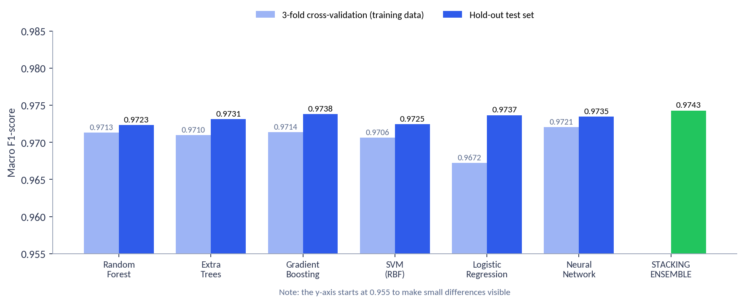
Figure 13: Macro F1 of each model (cross-validation and hold-out test)
All six algorithms reach very similar scores, between 0.972 and 0.974 macro F1. This is expected for a dataset whose classes are separated by clear patterns, and it is reassuring because it shows that the result does not depend on one particular algorithm. The stacking ensemble matches the best individual model; its practical advantage is more reliable probabilities and the fact that it does not depend on any single algorithm’s weaknesses.

9.3 Final performance of the stacked classifier
Table 18: Summary of the final classifier on the 3,000 test records
Measure | Value
Accuracy | 97.9%
Macro precision | 0.9784
Macro recall | 0.9705
Macro F1-score | 0.9743
ROC-AUC (one-vs-rest, macro) | 0.9899
Log-loss | 0.1179
Accuracy on training data | 99.5%

The gap between training accuracy (99.5%) and test accuracy (97.9%) is about two percentage points. A small gap is normal; it shows the model fits its training data slightly better than new data, but it has not memorised it.

9.4 Results per class
Table 19: Precision, recall and F1 per class (test set)
Class | Precision | Recall | F1-score | Test records
Normal | 0.9793 | 0.9966 | 0.9879 | 1188
DDoS Attack | 0.9879 | 0.9761 | 0.9820 | 419
Port Scan | 0.9788 | 0.9858 | 0.9823 | 422
SQL Injection | 0.9582 | 0.9582 | 0.9582 | 335
XSS Attack | 0.9722 | 0.9211 | 0.9459 | 304
Brute Force | 0.9939 | 0.9849 | 0.9894 | 332

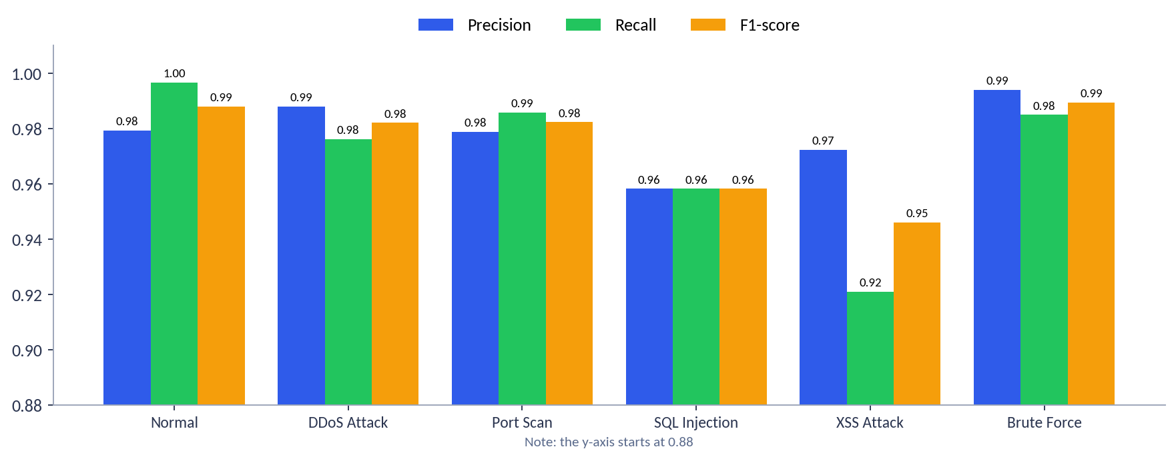
Figure 14: Precision, recall and F1 by class

9.5 Confusion matrix
A confusion matrix shows, for each actual class (rows), how the model’s predictions (columns) were distributed. Perfect results would put every count on the diagonal.
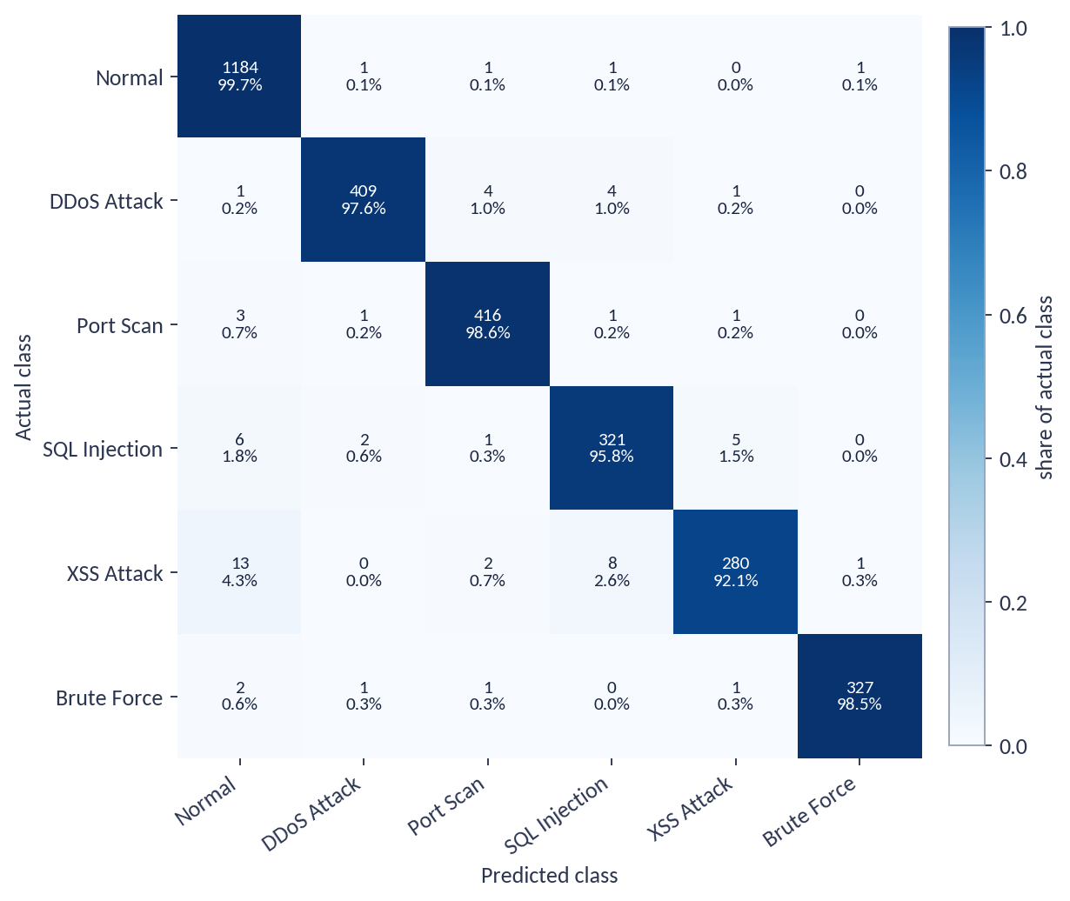
Figure 15: Confusion matrix on the test set (counts and share of each actual class)
The largest confusions are: XSS Attack predicted as Normal (13 records); XSS Attack predicted as SQL Injection (8 records); SQL Injection predicted as Normal (6 records); SQL Injection predicted as XSS Attack (5 records). These match expectation: SQL injection and XSS share the same web service and differ only in their payload tokens, and obfuscated payloads are deliberately built to look nearly normal.

9.6 ROC curves
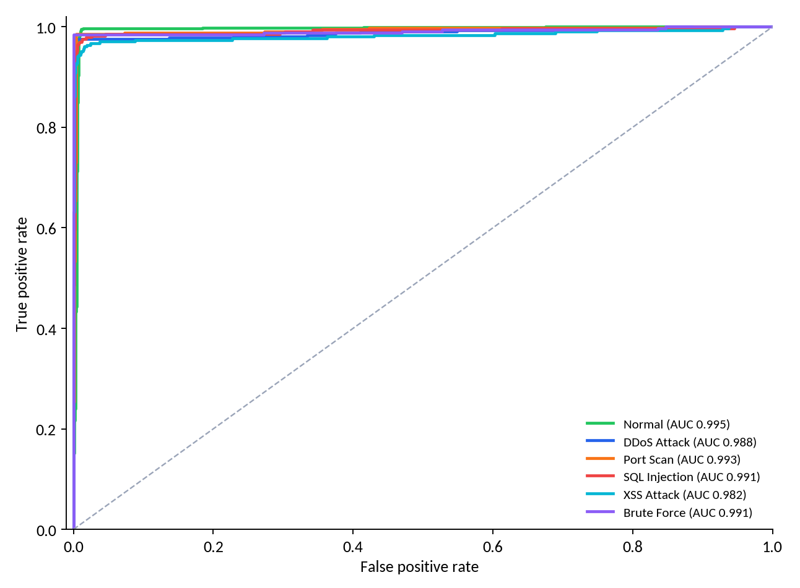
Figure 16: One-vs-rest ROC curves for every class
Every class reaches an area under the curve of at least 0.982. The lowest value belongs to XSS Attack, the class with the fewest training examples and the most overlap.

9.7 Which inputs matter most?
The Random Forest can report how much each input contributed to its decisions. The most influential inputs combine packet volume, payload tokens, destination ports, login attempts and the share of half-open connections. This agrees with the attack descriptions in Chapter 2, which is a useful sanity check: the model relies on the signals a security expert would expect.
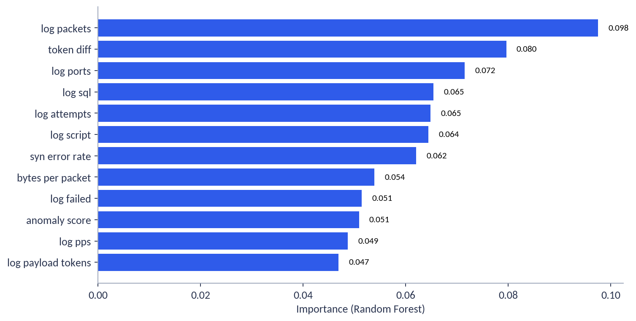
Figure 17: Twelve most important inputs according to the Random Forest

9.8 Risk-score regression
On the test set the risk model has a mean absolute error of 2.44 points on the 0–100 scale and an R² of 0.968, meaning it explains about 97% of the variation in the risk score.
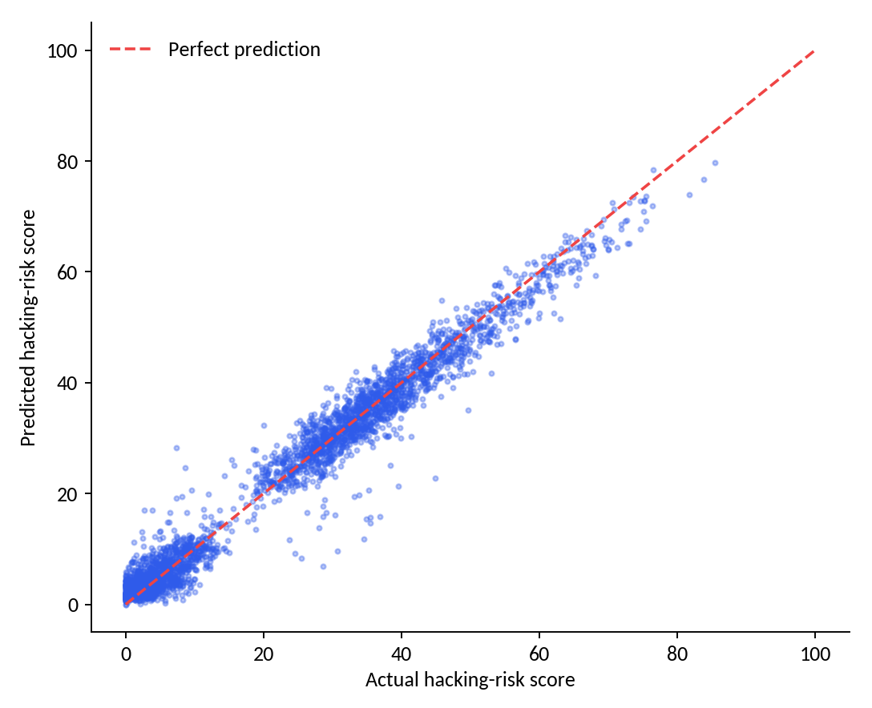
Figure 18: Predicted versus actual risk score on test records

9.9 Interpretation and caveats
- The scores are measured on synthetic data. They demonstrate that the whole pipeline works and that the algorithms agree with each other, not that real-world accuracy will be 98%.
- Differences between algorithms are within normal run-to-run variation; no claim is made that stacking is dramatically better.
- XSS Attack is the weakest class, largely because of the obfuscated variants; this is a realistic weakness of token-based detection.

10. Risk Levels, Alerts and Responses

10.1 Risk levels
The 0–100 score is divided into four named levels so that it can be understood at a glance. Figure 19 shows the scale together with the response normally assigned to a flagged result.
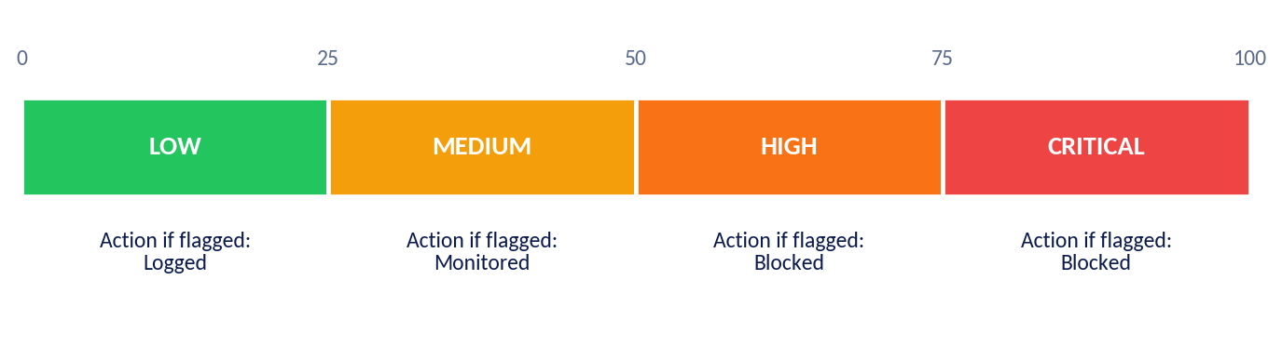
Figure 19: Risk levels and the response assigned to flagged results

10.2 When is a result a threat?
A result is flagged as a threat when two conditions are met: the predicted class is not Normal, and the model’s confidence reaches the alert threshold set in Settings (60% by default). A result that names an attack class with low confidence is still stored, but it is not counted as a threat and is shown as Allowed, which avoids raising alarms on uncertain predictions.

10.3 Response assignment
Table 20: Rules for assigning the response
Situation | Response | Meaning
Flagged, risk level High or Critical | Blocked | Highest urgency: block the source or isolate the target.
Flagged, risk level Medium | Monitored | Watch closely and prepare to act.
Flagged, risk level Low | Logged | Record for later review.
Not flagged | Allowed | No action needed.

10.4 Recommended actions
Every result is accompanied by practical recommendations that depend on the predicted class, shown on the result page, in the Latest Analysis panel and in the PDF report.
Table 21: Examples of recommendations by class
Class | Recommendations (summary)
DDoS Attack | Enable rate limiting and SYN-cookie protection; use upstream scrubbing; block offending source ranges.
Port Scan | Close unused ports; auto-block repeated scanners; restrict management ports to a VPN or allow-list.
SQL Injection | Use parameterised queries; deploy a web application firewall; give database accounts minimal privileges.
XSS Attack | Encode output; apply a strict content-security policy; sanitise user-supplied HTML.
Brute Force | Lock accounts after repeated failures; require multi-factor authentication; rotate weak credentials.
Normal | No malicious pattern; keep systems patched and review posture regularly.

11. Live Monitoring Internals

11.1 Workflow
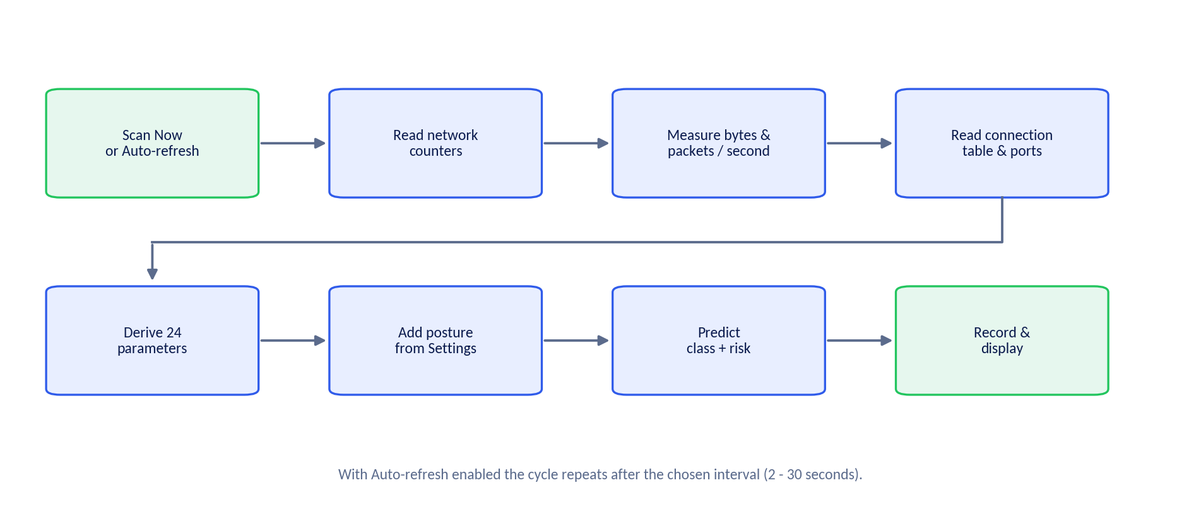
Figure 20: Workflow of a live scan

11.2 What is measured
Table 22: Measurements taken from the computer
Measurement | Source | Used for
Bytes and packets sent and received, errors and drops | Network-interface counters, compared between two moments | Traffic volume, packet rate, error rate
Connection table (established, half-open, waiting) | Operating-system connection list | Connection count, half-open share, unique remote addresses and ports
Listening ports | Operating-system connection list | Open-ports count
CPU, memory and disk use; number of processes | Operating-system statistics | Host-resource panel (not model inputs)

11.3 Permissions and limitations
- On some systems the connection list can only be read with administrator privileges. Without them, connection-based values may be low or zero.
- Only this computer is observed; the first scan of a session waits briefly to obtain a baseline measurement.
- The security-posture facts come from the Settings page, because reliably reading firewall, update and MFA status differs for every operating system.

12. Reporting

12.1 The PDF report
Any result can be turned into a formatted A4 report with one click. The report is intended to be shared with colleagues or attached to an incident record. It contains the following sections:
- Header: title, generation time, analyst name, data source and which engine produced the result.
- 1. Executive summary: predicted class, confidence, risk score, risk level and host.
- 2. Attack probability distribution: probability of every class, sorted.
- 3. Analysed parameters: every input value that was used.
- 4. Recommended mitigation: actions matching the predicted class.
- Disclaimer: predictions are probabilistic and must be validated by a qualified analyst.
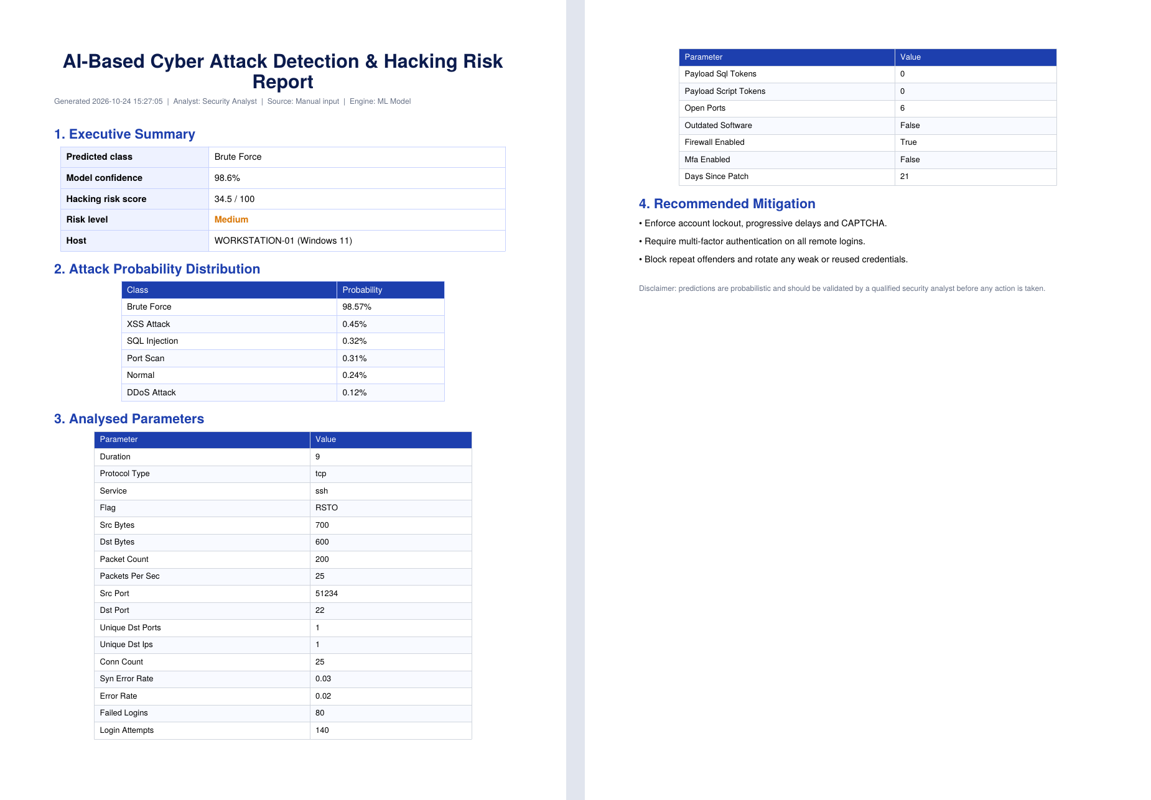
Figure 21: Sample generated PDF report (two pages) for a brute-force analysis
The Alerts page also exports the filtered alert list as CSV, and after training Model.py writes an evaluation report (model_report.json) and a confusion-matrix image.

13. Testing and Validation

13.1 Test strategy
Table 23: Levels of testing
Level | What is checked | How
Model evaluation | Accuracy, recall, probability quality and generalisation | Hold-out test set and cross-validation (Chapter 9)
Scenario tests | Designed attack and normal situations give the expected class | Eight hand-built cases (Table 24)
Functional tests | Every page, button, filter and export behaves as designed | Acceptance checklist (Table 25)
Integration tests | A result from either mode appears on the dashboard, alerts and reports | Run an analysis, then inspect all pages

13.2 Scenario test cases
Eight scenarios were built by hand, covering every class, and run through the trained model. They are independent of the dataset: the inputs were written from the attack descriptions, not copied from the data.
Table 24: Scenario test cases and results
ID | Scenario | Key inputs | Expected | Predicted | Conf. | Risk
TC-1 | Normal browsing | Secure web browsing, 18 packets/s, 12 connections | Normal | Normal | 98.2% | 4.3
TC-2 | SYN flood | 22,000 packets/s, 1,800 connections, 85% half-open, flag S0 | DDoS Attack | DDoS Attack | 97.7% | 45.3
TC-3 | Port sweep | 420 different ports, tiny packets, rejected connections | Port Scan | Port Scan | 98.2% | 35.8
TC-4 | SQL injection | Web service, 9 SQL tokens in the payload | SQL Injection | SQL Injection | 98.4% | 51.9
TC-5 | XSS payload | Secure web service, 8 script tokens in the payload | XSS Attack | XSS Attack | 96.9% | 37.0
TC-6 | SSH brute force | SSH, 80 failed of 140 login attempts | Brute Force | Brute Force | 98.6% | 34.5
TC-7 | Brute force, hardened host | As TC-6; 6 open ports, patched 21 days ago, firewall on | Brute Force | Brute Force | 98.6% | 34.5
TC-8 | Brute force, weak host | As TC-6; 20 open ports, patch 120 days old, outdated software, firewall off | Brute Force | Brute Force | 98.4% | 58.1

All eight scenarios were classified as expected, with confidence between 96.9% and 98.6%. The hand-built examples sit comfortably inside the regions the model learned, so they confirm normal operation; they are not a stress test of borderline cases.
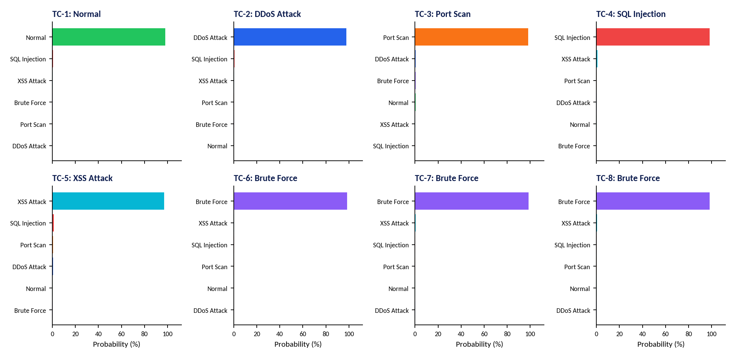
Figure 22: Class probabilities for each scenario test case

13.3 Worked example: effect of security posture
Cases TC-7 and TC-8 use the identical attack traffic and differ only in the security posture of the target. The predicted class and confidence are essentially the same (Brute Force, about 98%), but the risk score rises from 34.5 (Medium) on the hardened host to 58.1 (High) on the weak host. This is exactly the behaviour intended: the type of attack stays the same, but the danger to the target grows with its exposure. Appendix B lists the full input values of TC-7 so the test can be repeated in the Manual Analysis page.

13.4 Acceptance checklist for the interface
Table 25: Functional test checklist
Area | Action | Expected behaviour
Dashboard | Open with no history | Empty indicators and shortcut buttons to both analysis pages.
Manual Analysis | Enter Appendix B values and click Analyze & Predict | Class Brute Force, risk about 35 (Medium), recommendations and probability chart shown.
Integration | Click View on Dashboard | Total analyses increases by one; the event appears in Recent Events.
Filters | Switch Source to Manual, then Live | Cards, charts and table change to the selected source only.
Live Monitor | Click Scan Now | Host panel, resource bars and a new Live record appear.
Auto-refresh | Switch on, interval 5 s | A new record is created about every 5 seconds; leaving the page stops it.
Alerts | Filter by severity; export CSV | List reduces to the selection; CSV contains the same rows.
PDF | Download from Manual or Live page | A report opens with the sections listed in Section 12.1.
Persistence | Stop and restart the application | Previous analyses are still shown on the dashboard.
Settings | Raise the alert threshold to 99% and analyse an attack | Result is stored but not flagged and shows Allowed.
Clear history | Use Clear analysis history | Dashboard returns to the empty state.

14. Installation and Operation

14.1 Requirements
The application runs on an ordinary computer and needs only the software listed in Table 26.
Table 26: System requirements
Item | Requirement
Operating system | Windows, Linux or macOS.
Python | Version 3.9 or newer, 64-bit.
Libraries | Streamlit (1.50 or newer), Plotly, pandas, NumPy, psutil, ReportLab, scikit-learn, joblib and matplotlib.
Hardware | Any modern computer; training takes about two minutes on a single processor core.
Browser | Any current browser; the application opens automatically.

14.2 Setup procedure
- Create one project folder and place app.py, Model.py and cyber_attack_dataset.csv in it.
- Open a terminal in that folder and create a virtual environment so the project’s libraries do not interfere with other software; activate it.
- Install the libraries listed in Table 26. On an unstable connection install them one at a time and allow extra retries.
- Run Model.py once. It trains and tests the model, prints the results and saves the trained model and evaluation files. A faster, smaller training mode is available for a quick test.
- Start the application by running app.py with Streamlit. The browser opens the dashboard; the sidebar should state Engine: ML Model.

14.3 Troubleshooting
Table 27: Common problems and remedies
Symptom | Likely cause | Remedy
Library installation stops with “connection interrupted” | Unstable network, or antivirus scanning a half-downloaded file | Clear the package cache, install one library at a time with more retries, pause real-time scanning briefly, or use another network.
Sidebar shows “Demo Engine” | Model.py is not in the same folder as app.py, or failed to load | Place both files together and run Model.py once.
Model fails to load after a library upgrade | Saved model was created with another library version | Delete the saved model file and run Model.py again.
Live Monitor shows few or zero connections | Operating system restricts the connection list | Run the terminal as administrator (Windows) or with elevated rights (Linux, macOS).
Command “streamlit” not recognised | Virtual environment not activated or path not set | Activate the environment, or start Streamlit through Python’s module option.
Port already in use | Another instance is running | Start the application on a different port.

15. Security, Limitations and Future Work

15.1 Responsible use
The application is a defensive tool. It should only be used to monitor computers and networks that the user owns or is authorised to assess. Manual Analysis processes values entered by the user and does not interact with any remote system.

15.2 Data handling
All processing happens on the local computer. No data is sent to external services. The only stored user data is the history file next to the application, which contains the parameters and results of past analyses, including any IP addresses typed into the form. It can be removed at any time with Clear analysis history or by deleting the file. Text typed into the form is escaped before it is shown, so it cannot alter the appearance of the page.

15.3 Known limitations
Table 28: Limitations and their implications
Limitation | Implication
Model trained on synthetic data | Reported accuracy is not a prediction of real-world accuracy; retraining on real data is recommended.
Six classes only | Attacks outside these classes (for example malware command-and-control) will be assigned to the closest class or to Normal.
Live mode lacks login and payload data | Brute force, SQL injection and XSS cannot be detected live; use Manual Analysis.
Posture values come from Settings | Live risk is only as accurate as the assumptions entered.
Aggregate view of traffic | The system judges summary statistics for a time window, not individual packets.
No automatic enforcement | The “Blocked” response is a recommendation; a person or another system must act on it.

15.4 Future enhancements
- Retrain and validate on real labelled datasets such as CIC-IDS2017 and compare results.
- Add packet capture and flow extraction so live mode can see real traffic of the whole network.
- Read operating-system security logs to supply failed-login counts to the live monitor.
- Add explanations for each prediction (which inputs pushed the decision) and drift detection to know when to retrain.
- Integrate with firewalls or ticketing systems, add user accounts and a database for team use.
- Add more attack classes, such as malware beaconing and data exfiltration.

16. Conclusion
The AI-Based Cyber Attack Detection and Hacking Risk Prediction System turns raw network and security information into three things a person can act on: the likely type of attack, a confidence value, and a 0–100 hacking-risk score with plain-language recommendations. It offers two ways of working, manual and live; a professional dashboard that reflects every analysis; and PDF reporting.
The model combines feature engineering, anomaly detection, six different learning algorithms, stacking and a dedicated risk regressor. On the held-out part of the synthetic dataset it achieved 97.9% accuracy and a macro F1 of 0.9743, and it classified all eight hand-built test scenarios as expected. These results show that the design works end to end; the clear next step for production use is retraining on real network data, which the project’s structure supports without changing the interface.

References
- Sharafaldin, I., Lashkari, A. H. and Ghorbani, A. A. (2018). Toward generating a new intrusion detection dataset and intrusion traffic characterization. ICISSP.
- Tavallaee, M., Bagheri, E., Lu, W. and Ghorbani, A. A. (2009). A detailed analysis of the KDD CUP 99 data set. IEEE CISDA.
- Liu, F. T., Ting, K. M. and Zhou, Z.-H. (2008). Isolation Forest. IEEE ICDM.
- Wolpert, D. H. (1992). Stacked generalization. Neural Networks, 5(2).
- Breiman, L. (2001). Random Forests. Machine Learning, 45(1).
- Pedregosa, F. et al. (2011). Scikit-learn: Machine learning in Python. Journal of Machine Learning Research, 12.
- Scarfone, K. and Mell, P. (2007). Guide to Intrusion Detection and Prevention Systems (IDPS), NIST Special Publication 800-94.

Appendix A. Glossary
Table 29: Terms used in this document
Term | Definition
Brute force | Trying many passwords automatically until one works.
Cross-validation | Evaluating a model several times on different portions of the data to get a stable estimate.
DDoS | Distributed denial of service: flooding a target with traffic to make it unavailable.
Feature | One measurable input to the model.
Feature engineering | Creating more useful inputs from raw measurements.
F1-score | Balance of precision and recall.
Isolation Forest | An unsupervised method that finds unusual records by how quickly they can be separated from the rest.
MFA | Multi-factor authentication: requiring more than a password to log in.
Over-fitting | Learning the training data so closely that new data is handled poorly.
Precision / recall | How often a positive prediction is correct / how many real cases were found.
SQL injection | Inserting database commands into a web input to manipulate a database.
Stacking | Combining several models by training a final model on their predictions.
XSS | Cross-site scripting: injecting script code into a web page seen by other users.

Appendix B. Test Data for the Brute-Force Scenario (TC-7)
Enter these values in Manual Analysis to reproduce test case TC-7. The expected outcome is the class Brute Force with confidence above 95% and a risk score of about 35 (Medium).
Table 30: Input values for TC-7
Group | Field | Value
Packet information | Protocol / Service / Flag | tcp / ssh / RSTO
 | Duration (s) / Source bytes / Destination bytes | 9 / 700 / 600
 | Packet count / Packets per second | 200 / 25
Network information | Source IP / Destination IP | 203.0.113.45 / 10.0.0.5
 | Source port / Destination port | 51234 / 22
 | Concurrent connections / Unique destination ports / IPs | 25 / 1 / 1
 | SYN / error rate | 0.03
Authentication and payload | Failed logins / Login attempts | 80 / 140
 | SQL tokens / Script tokens | 0 / 0
Security posture | Open ports / Days since last patch | 6 / 21
 | Outdated software / Firewall / MFA | Off / On / Off

For TC-8 (weak host) change only the posture group: open ports 20, days since last patch 120, outdated software on, firewall off, MFA off. The class remains Brute Force and the risk score rises to the High range.

