**.DECCAN COLLEGE OF ENGINEERING AND TECHNOLOGY**

**(AFFILIATED TO OSMANIA UNIVERSITY, HYDERABAD)**

**DEPARTMENT OF INFORMATION TECHNOLOGY**



**A Mini Project report on**

**Attendance Administrator**

**Submitted for the Mini project of B. E V Sem (CBCS)**

**BY**

**MOHD ABDUL RAHEEM – 160316737056**

**MOHD AFZAL KHAN-160316737029**

**Under the guidance of**

**Mr. Feroz Amer**

**Dept. of Information Technology**

**DCET, Hyderabad.**

**C E R T I F I C A T E**

This is to certify that ……………………………………….. of B.E Semester- III, I.T branch bearing roll numbers ……………… ,……………… has successfully completed the MINI PROJECT- I work during the academic year 2017 – 2018

Internal Guide Head of the Department

**Mr. Feroz Amer Dr. Syed Razi Uddin**

Associate Professor HOD

Dept. Of IT Dept. Of IT

DCET, Hyderabad. DCET, Hyderabad.

**D E C L A R A T I O N**

This is to certify that the work reported in the present project entitled “Attendance Administrator” is a record of work done by us in the Department of Information Technology, Deccan College of Engineering and Technology, Osmania University. The reports are based on the project work done entirely by us and not copied from any other source.

**MOHD ABDUL RAHEEM – 160316737056**

**MOHD AFZAL KHAN-160316737029**

**A C K N O W L E D G E M E N T**

I would like to express my sincere gratitude and indebtedness to my project supervisor.

**Mr. FEROZ AMER** for his valuable suggestions and interest throughout the course of the project.

I am thankful to Head of Department **Dr. SYED RAZI UDDIN** for providing excellent infrastructure and a nice atmosphere for complementing this project.

I convey my heartfelt thanks to the lab staff for allowing me to use the required equipment whenever needed.

Finally, I would like to take this opportunity to thanks my family for their support through the work. I sincerely acknowledge and thanks who gave directly or indirectly their support in this project work.

**MOHD ABDUL RAHEEM – 160316737056**

**MOHD AFZAL KHAN-160316737029**

**L I S T O F FIGURES**

|  |  |  |
| --- | --- | --- |
| **FIGURE** | **NAME** | **PAGE NO.** |
| Figure 4.1 | ARCHITECTURE | 22 |

**A B S T R A C T**

**ATTENDACE ADMINISTRATOR**

**Introduction**

* **Attendance** is the concept of people, individually or as a group, appearing at a location for a previously scheduled events.
* Measuring attendance is a significant concern for many organizations such as in class rooms and in work organizations.
* The reason behind maintaining a record of ones appearance in class rooms, a Poor attendance by a student in a class may affect their grades or other evaluations.
* For students in elementary schools and high schools, laws may require compulsory attendance, while students at higher levels of education may be penalized by professors or the institution for lack of attendance.
* We still use the traditional method for maintaining attendance i.e. with pen and paper.
* This method is being used since many decades.
* So we decided to modernize this method of calculating attendance by making a software that not only maintains the attendance but also gives us much more information when needed.

**Existing device**

* Basically the traditional method uses pen and paper which lacks in efficiency.
* While some uses excel sheets to store information

**Drawbacks of existing device**

* This method is time consuming and requires a lot of maintenance.
* Paper is used which comes from trees which eventually results in harming of nature.
* Lack of accuracy is observed.



**Proposed System**

In addition to the basic feature of storing and maintaining attendance .followed conveniences are also included.

* The interface of the software is user friendly and easy to understand.
* Apart from storing attendance, this software is designed to calculate the percentage of the attendance based on the number of events occurred and the presence of one individual in those events.
* Accuracy could be 100%, as it is done by a machine.
* Efficiency is obtained, as it is less time consuming and accurate.
* Paper is saved which promotes nature.

**Software Requirements:-**

* Operating system:-Windows Xp or Above.
* Any Browser: - Google Chrome, UC Browser…etc.

**Hardware Requirements:-**

1. Computer 386 and upward for better Efficient performance
2. Power Required 63. watt
3. CPU 80386 and upward
4. CPU clock speed processor Compatible(up to 66 MHZ)
5. Memory size: 1gb on system board
6. Mass storage Device: 50gb
7. Keyboard Up to 105keys

**Technologies Used:-**

* Structured query language (SQL).
* C#.Net By Microsoft.
* Hyper Text Markup Language(HTML)
* Cascading Style Sheets(CSS)

**T A B L E O F C O N T E N T S**

Certificate…………………………………………………………………………………………..i

Declaration………………………………………………………………………………………...ii

Acknowledgements………………………………………………………………………………iii

List of Tables…………………………………………………………………………………..…iv

List of Figures……………………………………………………………………………………..v

Abstract…………………………………………………………………………………………...vi

**CHAPTER-I**

1. INTRODUCTION 1

**CHAPTER II**

2. LITERATURE SURVEY 3

**CHAPTER III**

3. SYSTEM ANALYSIS 7

3.1 Objective 7

3.2 Problem specification

3.3 Proposed System 8

3.4 Applications 8

3.5 Modules and their functionalities

3.7 Software and Hardware Requirements

**CHAPTER IV**

4. DESIGN 22

4.1 Architecture

**CHAPTER V**

5. IMPLEMENTATION 24

5.1 Partial code

5.2 Screen shots

**CHAPTER VI**

6. CONCLUSION AND FUTURE ENHANCEMENT 25

6.1 Conclusion 25

6.2 Future Enhancement 25

**CHAPTER VII**

7. REFERENCES

**CHAPTER – i**

**1. INTRODUCTION**

In the present world we all gather every now and then to attend various events for various occasions, some are unprofessional and professional events. In all these events the appearance of all the individuals holds and important role ,where in unprofessional events like family gatherings functions and parties holds emotional individual role and such events aren’t supposed to be held count for where as in professional events such as schooling, graduation, office …etc. ,the appearance of every individual counts under professional courtesy.

So under maintaining the record of appearance of every individual we came up with certain techniques, Such techniques are used in many organisations to maintain the record .one such method we use is using pen paper and by calling each individual by their identification and marked on the paper using tabular method .This technique lacks in efficiency as it requires paper which contributes in global pollution and also require a lot of man power. This is where we come in picture in order to modernize this method by making a software.

**How It Works**

The software is installed into the laptop of the administrator who is responsible for maintaining this record in which he fills out the information required before proceeding. In the fill out form he needs to specify the name of the event, no of people whose records is to maintained and identification number of each and every individual ,In this the names of the individual and their attributes are optional. Then whenever the admin needs to store information he opens the software logs into his account and starts the procedure where he needs to mark the individual as present or absent accordingly. This information is stored permanently in the data base and could be retrieved when needed

**Aim**

The main objectives of our work are:

* Data of student has been computerized without using any manual effort.
* Rapid access to any information regarding the students attendance.

**CHAPTER II**

**2. LITERATURE survey**

**CASE-1. “**Web Based Student Information Management” , S.R.Bharamagoudar

This paper assist in automating the existing manual system. It can be monitored and controlled remotely. This paper provides accurate information always. All years together gathered information can be saved and can be accessed at any time. The purpose is to design a college website which contains up to date information of the college. That should improve efficiency of college record management.

**CASE-2.** “Attendance Management System G.Gangagowri

This system is used Way to SMS software. This software is used to send SMS easily to their parent’s. This system can store their data about the students and those cares absent student details. It is an efficient method to store the attendance in the Web Site rather than wasting the paper. It also updates the student report directly on the server reducing the faculty’s time on logging from the computer.

**CASE-3.** “Web Based Coaching Institute Management System”, Mayuri Kamble

“Coaching Institute Management System” software developed for an institute has been designed to achieve maximum efficiency and reduce the time taken to handle the storing activity. It is designed to replace an existing manual record system thereby reducing time taken for calculations and for storing data. The system is strong enough to withstand regressive daily operations under conditions where the database is maintained and cleared over a certain time of span. The implementation of the system in the organization will considerably reduce data entry, time and also provide readily calculated reports.

**Languages Used**

* **ASP.NET**

Asp.net is an open source server-side web application framework designed for web development to produce dynamic web pages .It was developed by Microsoft to allow programmers to build dynamic web sites, web applications and web services.

It was first released in January 2002 with version 1.0 of the .Net framework and is the successor to Microsoft’s Active server pages (ASP) Technology.

Active Server Pages (ASP) later known as classic Asp or asp classic is Microsoft’s first server-side script engine for dynamically generated web pages.

NET languages come in different flavors such as: C#.NET, VB.NET, Managed C++, F#.

One flavor that I chose is c#.Net.

* **C#**

C# (pronounced as C sharp) is a general-purpose multi-paradigm programming language comprising of strong typing, imperative, declarative, functional, generic object-oriented and component-oriented programing disciplines. It was developed around 2000 by Microsoft within its .Net.

* **SQL**

Structured Query Language (SQL) is a standard computer language for relational database management and data manipulation. SQL is used to query, insert, update and modify data. Most relational databases support SQL, which is an added benefit for database administrators (DBAs), as they are often required to support databases across several different platforms.

* **HTML**

Hypertext Markup Language (HTML) is the standard markup language for creating web pages and web applications. With Cascading Style Sheets (CSS) and JavaScript, it forms a triad of cornerstone technologies for the World Wide Web. Web browsers receive

HTML documents from a web server or from local storage and render them into multimedia web pages.

HTML describes the structure of a web page semantically and originally included cues for the appearance of the document. Html helps in creating tables, list of elements, posting pictures etc.HTML documents are required to start with a Document Type Declaration (informally, a "doctype") In browsers, the doctype helps to define the rendering mode—particularly whether to use quirks mode.HTML documents imply a structure of nested [HTML elements](https://en.wikipedia.org/wiki/HTML_element). These are indicated in the document by HTML “Tags”, enclosed in angle brackets thus: <p>in the simple, general case, the extent of an element is indicated by a pair of tags: a "start tag" <p> and "end tag" </p>. The text content of the element, if any, is placed between these tags. Tags may also enclose further tag markup between the start and end, including a mixture of tags and text. This indicates further (nested) elements, as children of the parent element. The start tag may also include attributes within the tag. These indicate other information, such as identifiers for sections within the document, identifiers used to bind style information to the presentation of the document, and for some tags such as the <img> used to embed images, the reference to the image resource. Some elements, such as the [line break](https://en.wikipedia.org/wiki/Line_breaking_character) <br>, do not permit any embedded content, either text or further tags. These require only a single empty tag (akin to a start tag) and do not use an end tag. Many tags, particularly the closing end tag for the very commonly used paragraph element <p>, are optional. An HTML browser or other agent can infer the closure for the end of an element from the context and the structural rules defined by the HTML standard. These rules are complex and not widely understood by most HTML coders.The general form of an HTML element is therefore: <tag attribute1="value1" attribute2="value2">''content''</tag>. Some HTML elements are defined as empty elements and take the form <tag attribute1="value1" attribute2="value2">. Empty elements may enclose no content, for instance, the <br> tag or the inline <img> tag. The name of an HTML element is the name used in the tags. Note that the end tag's name is preceded by a slash character, "/", and that in empty elements the end tag is neither required nor allowed. If attributes are not mentioned, default values are used in each case.

* **CSS**

Short for Cascading Style Sheets, a new feature being added to HTML that give both Web site developers and users more control over home pages are displayed.

With css, designers and users can create style sheets that define how different elements, such as headers and links, appear. These style sheets can then be applied to any Web page.

The term cascading derives from the fact that multiple style sheets can be applied

To the same Web page. CSS was developed the W3C.

Each web browser uses a [layout engine](https://en.wikipedia.org/wiki/Web_browser_engine) to render web pages, and support for CSS functionality is not consistent between them. Because browsers do not parse CSS perfectly, multiple coding techniques have been developed to target specific browsers with workarounds (commonly known as [CSS hacks](https://en.wikipedia.org/wiki/CSS_hacks) or CSS filters). Adoption of new functionality in CSS can be hindered by lack of support in major browsers. For example, Internet Explorer was slow to add support for many CSS 3 features, which slowed adoption of those features and damaged the browser's reputation among developers.[[58]](https://en.wikipedia.org/wiki/Cascading_Style_Sheets#cite_note-58) In order to ensure a consistent experience for their users, web developers often test their sites across multiple operating systems, browsers, and browser versions, increasing development time and complexity. Tools such as [Browser Stack](https://en.wikipedia.org/wiki/BrowserStack) have been built to reduce the complexity of maintaining these environments.

In addition to these testing tools, many sites maintain lists of browser support for specific CSS properties, including [CanIUse](http://caniuse.com/) and the [Mozilla Developer Network](https://en.wikipedia.org/wiki/Mozilla_Developer_Network). Additionally, the CSS 3 defines feature queries, which provide a @supports directive that will allow developers to target browsers with support for certain functionality directly within their CSS.[[59]](https://en.wikipedia.org/wiki/Cascading_Style_Sheets#cite_note-59) CSS that is not supported by older browsers can also sometimes is patched in using JavaScript [polyfills](https://en.wikipedia.org/wiki/Polyester_Fiberfill) , which are pieces of JavaScript code designed to make browsers behave consistently.

**CHAPTER – III**

**SYSTEM ANALYSIS**

**3.1 OBJECTIVES**

The main objectives of our work are:

* Data of student has been computerized without using any manual effort. .
* Easy to generate the report.
* Rapid access to any information regarding the students’ attendance.

**3.2 PROBLEMS SPECIFICATION**

The Existing system is a manual entry for the User. Here the attendance will be carried out in the hand written registers. Maintaining the records for the Faculty is a tedious job. The retrieval of the information is not as easy as the records are maintained in the registers.

**3.3 PROPOSED SYSTEM**

In order to overcome the drawbacks in existing system, a Web application has developed for daily attendance of students. The system consists of one User who is supposed to be a faculty who is provided with certain features of creating different classes manipulating data inside classes, taking attendance of different sessions. Faculty user can able to update an Attendance which has been taken in tabular format and stored in the data base. It is made easy to access the attendance information of a particular student. This application is helpful in evaluating the attendance eligibility of a student. The purpose is to computerize the tradition way of taking attendance and generating of report automatically at the end or between of the session.

**3.4 APPLICATIONS**

* This software can be used in any organization like schools, colleges, for accurate record maintenance
* It’s very accurate and there is no or minimal chance for manipulation
* It requires very less man power and it also helps in saving the environment by excluding use of paper

**3.5 MODULES AND THEIR FUNCTIONALITIES**

**LOGIN PAGE**

The login page consists of two input fields where the user is guided to enter their username and password. If they are new users they are also provided with register link that redirects to the register page.

**REGISTER PAGE:-**

Register page consists of three input fields where the user is asked to enter their user name and password convenient to him.

**HOME PAGE:-**

Home page consists of different tabs that allows the user certain services under each tab.

The tabs are as follows

**Create a new class.**

**Add students to a class**

**Modify data in the existing class**

**Take attendance.**

**CREATE A NEWCLASS**

When user clicks this tab the user is asked to enter a name for the class which is to be unique to the existing classes.

**ADD STUDENTS TO A CLASS**

When the user creates a class, a class is generated but contains no students. So the user is supposed to come under this tab.

The tab redirects to a page where the user is asked to enter “Roll No” and “Name “of the students uniformly one after the other.

**MODIFY STUDENTS DATA IN EXISTING CLASSES**

Under this tab the user is provided with data alteration features like deleting a student of class in case of Typos error.

**TAKE ATTENDANCE:-**

Under this tab the user is asked to enter the class name for which he needs to add details then is redirected to a page where the roll no and names of the students under that class are displayed in a tabular format with an extra column named status, each row of that column consist two buttons present and absent, the user is supposed to click each provided options accordingly.

**3.6 SOFTWARE REQUIREMENTS**

* Operating system:-Windows Xp or Above.
* Web browser:-opera, chrome…etc.
* Connection to Server Wireless or Wired.

**HARDWARE REQUIREMENTS**

1. Computer 386 and upward for better Efficient performance
2. Power Required 63.5watt
3. CPU 80386 and upward
4. CPU clock speed processor Compatible(up to 66 MHZ)
5. Memory size: 1gb on system board
6. Mass storage Device: 50gb
7. Keyboard Up to 105keys
8. Monitor: VGA or(SVGA\Color)

**CHAPTER - IV**

**4. DESIGN**

**4.1ARCHITECTURE**

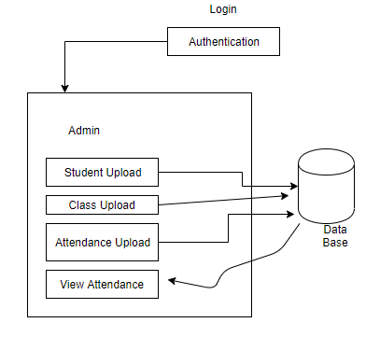

**CHAPTER – V**

**IMPLEMENTATION**

**5.1 PARTIAL CODE**

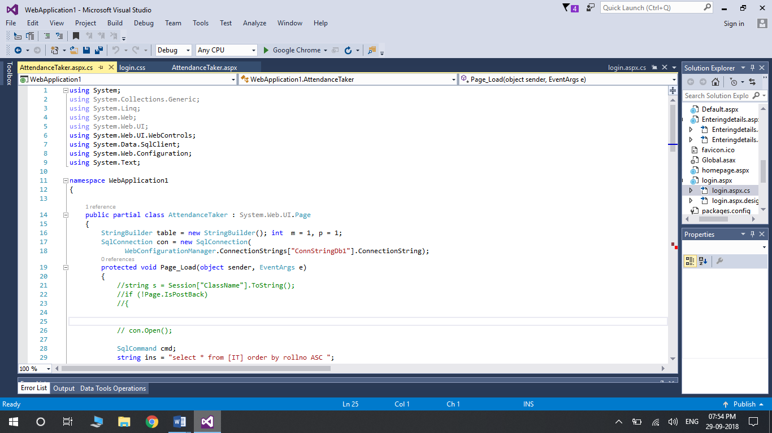

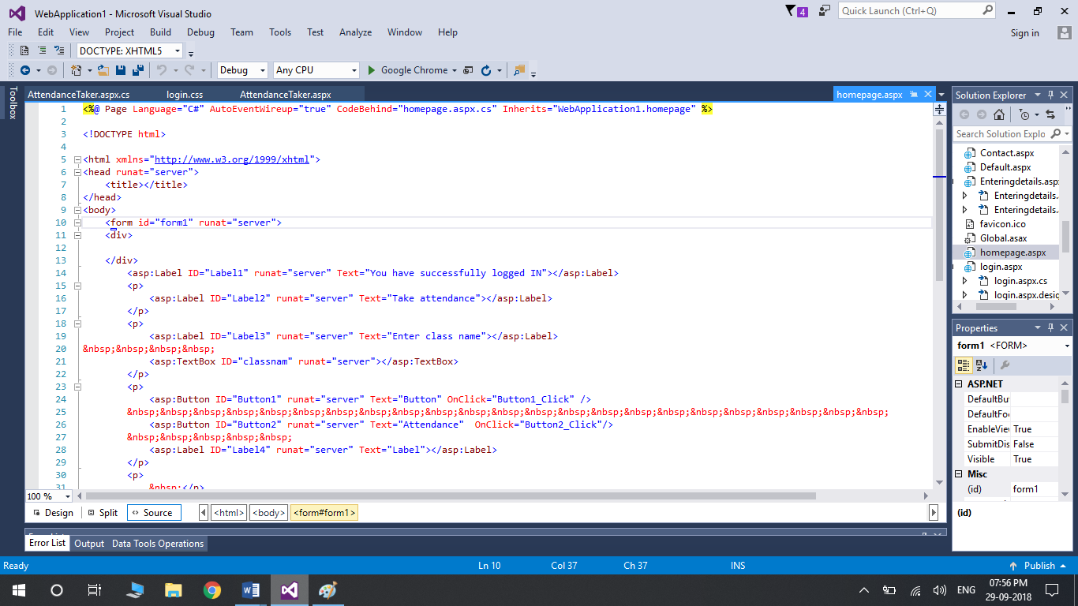

**5.2 SCREEN SHOTS**

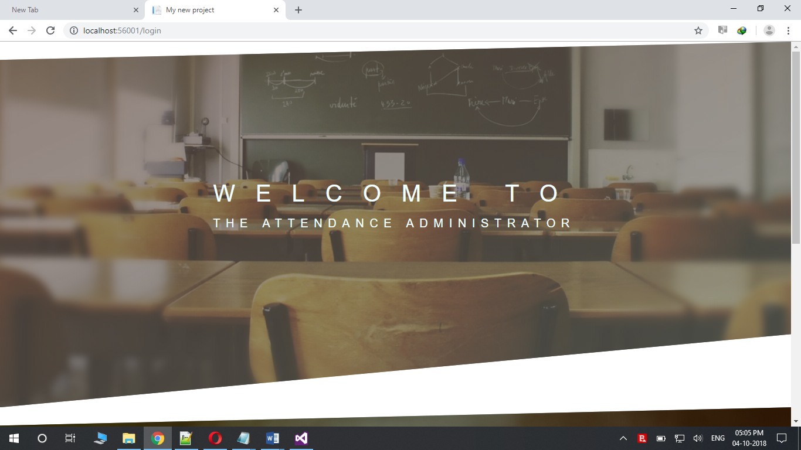

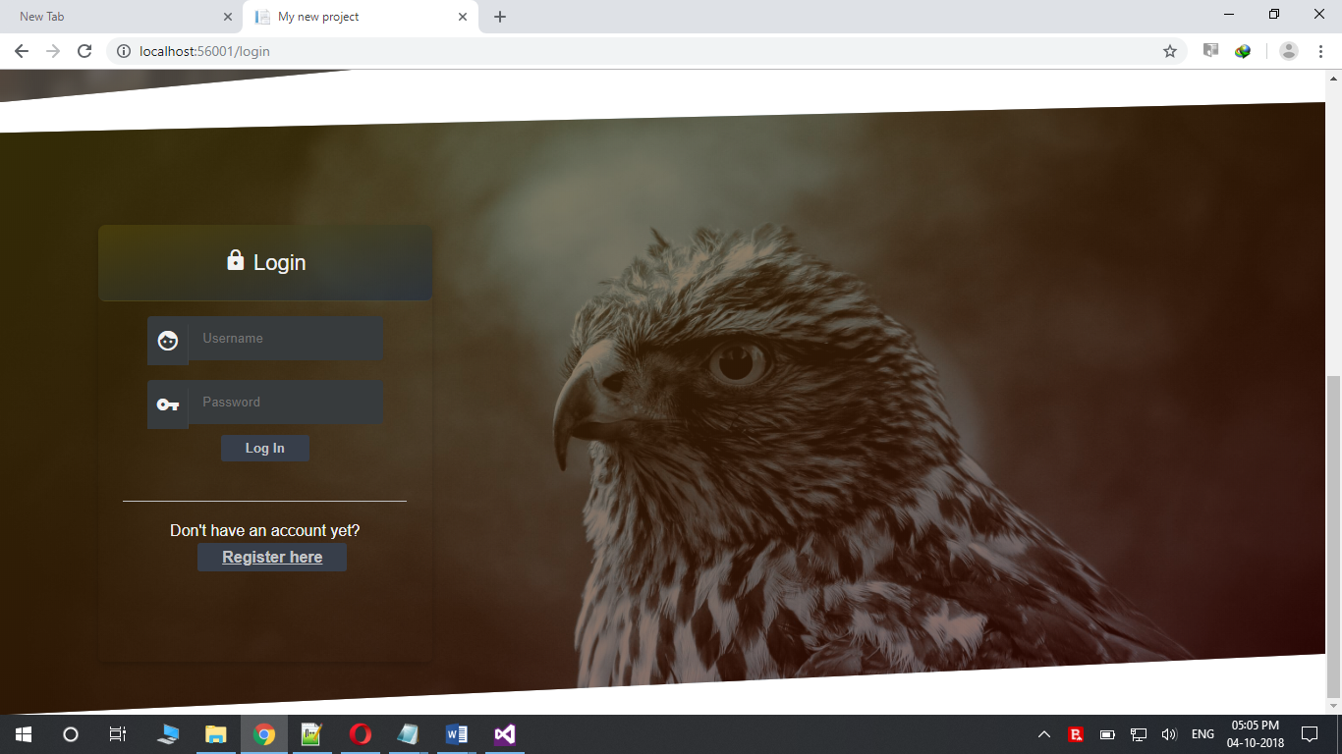

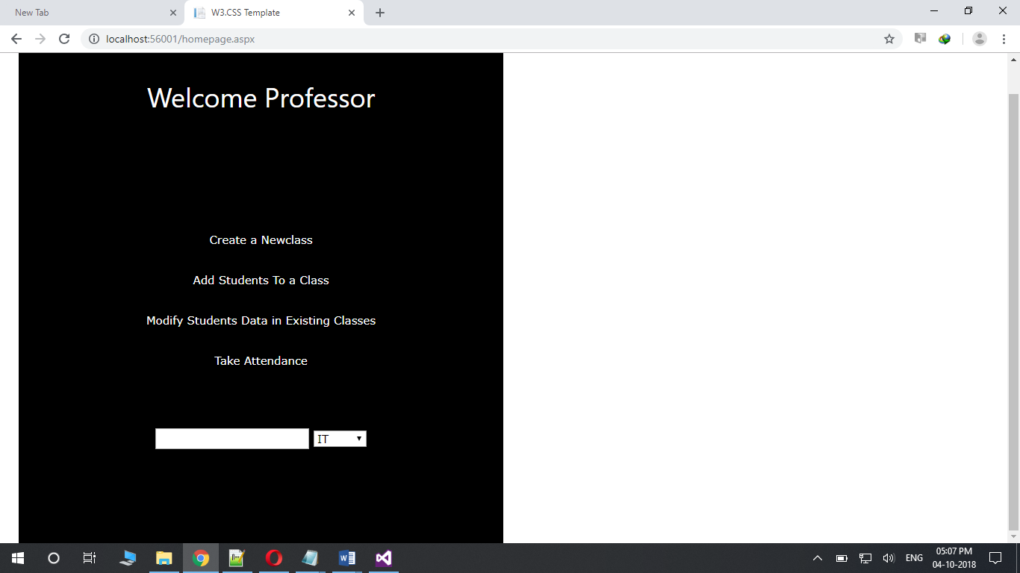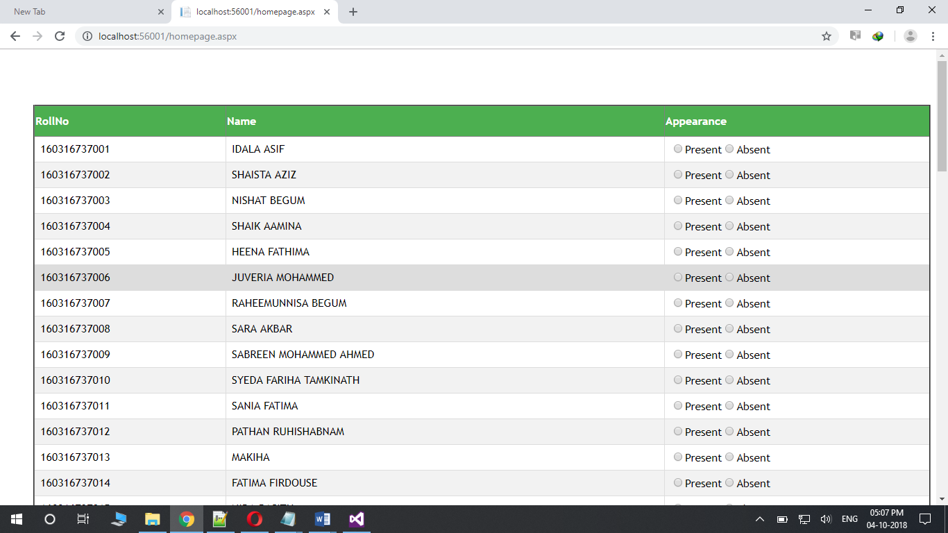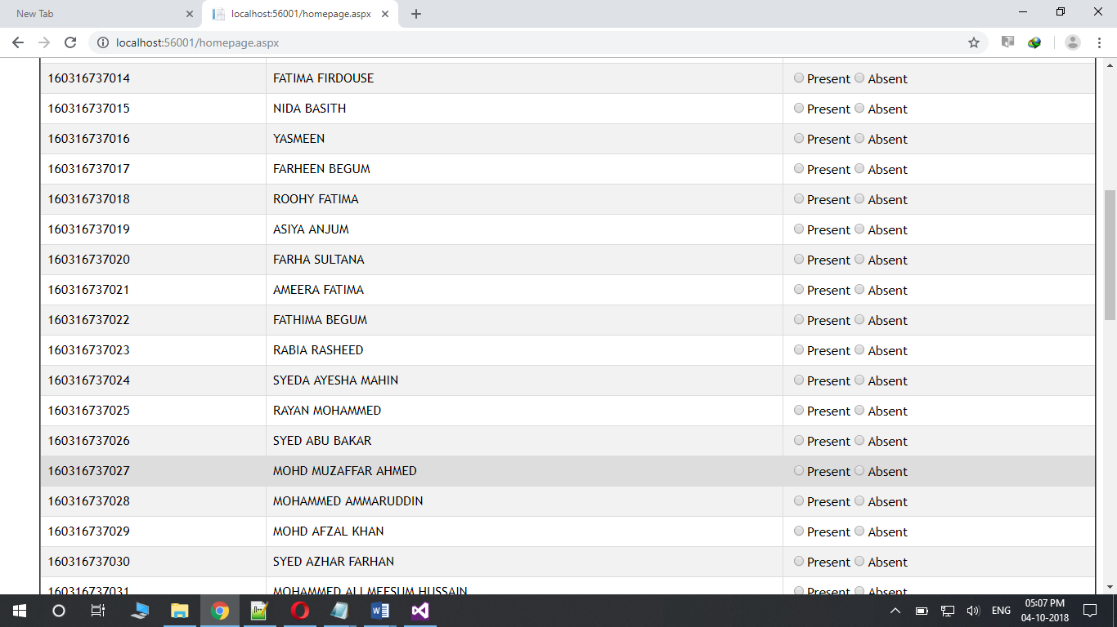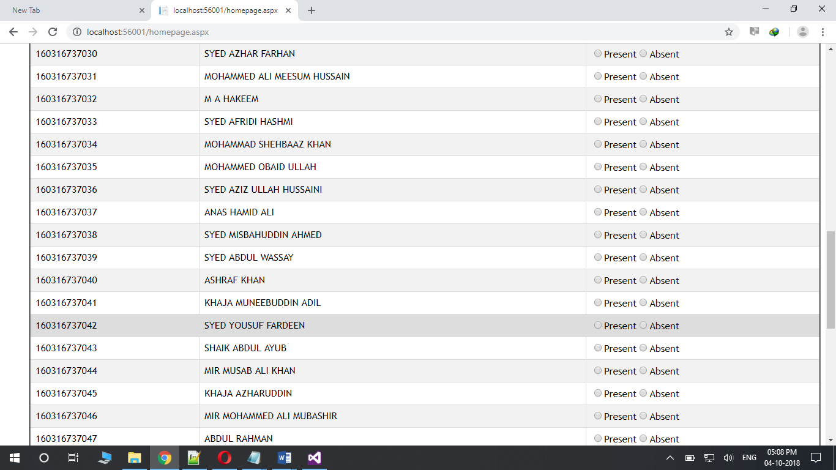

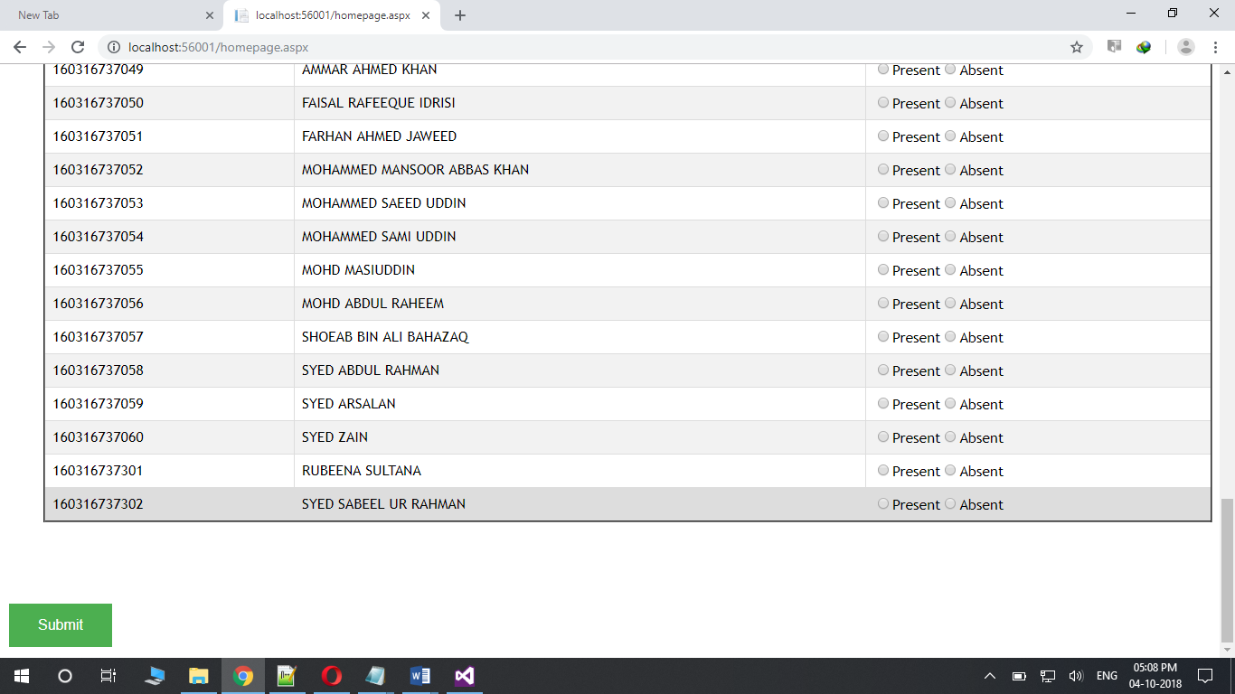

**CHAPTER -VI**

**6. CONCLUSION AND FUTURE ENHANCEMENT**

Finally after designing and coding the project we came to conclusion that this project helps an individual to maintain the Attendance records with the following features

**ACCURACY**

Humans are prone to error, even if we provide them with supporting computational devices Attendance Administrator ensures accurate time records and minimize the inevitable and costly errors with manual data entry, this accurate data thereby helps to provide accurate performance and payroll data.

**PRODUCTIVITY/EFFICIENCY**

Monitoring and managing attendance manually can be a time-consuming, laborious, and expensive affair .It takes time to process paper sheets and time cards, create schedules, authorize leave and overtime, and create payroll manually, Free up precious administration time with an automated system that does it all for you, from keeping track of employee hours to automatically importing information into your payroll system. The time and effort saved combined with data accuracy helps in optimizing the use of resources which lead to increased productivity and improves profits.

**SECURITY**

With the feature of administrative login there is no chance for any other person excluding the administrator itself to access and store the data securely. .

**FUTURE ENHANCEMENT**

* The only missing part of this website is that it’s based only for one user ,in future we would like to introduce the feature in the existing one that allow many users to use at once.
* We can also add more information of students apart from attendance like their internal assessment marks and much more.
* We could also include the features like biometric method with its own hardware that would allow the users to imply their appearance which not only increases the efficiency and lessens the efforts of the administrator
* The retina scanning could also be included for more security which would ensure no amount of manipulation.

**CHAPTER – VII**

**REFERENCES**

1. [**https://www.w3schools.com**](https://www.w3schools.com)
2. [**https://stackoverflow.com/**](https://stackoverflow.com/)
3. “Asp.net MVC Framework unleashed”, by Stephen Walther
4. “C# in Depth Third Edition”, by John Skeet.
5. “Learn C# in fun way”, Course by Udemy.
6. “Structured Query Language “, Course by Plural Sight.
7. “Head First Sql”, By Lynn Beighley.