WINDOWS POWERSHELL ENCODED COMMAND INVESTIGATION
Project 4 — Controlled SOC Laboratory Investigation
Assessment: BENIGN / CONTROLLED LAB ACTIVITY — LOW SUSPICION

1. Executive Summary
This investigation examined a controlled Windows PowerShell process launched with -EncodedCommand. The objective was to determine what executed, identify the user and process context, correlate Sysmon and PowerShell telemetry, check for attributable network activity, and assess whether the execution showed evidence of persistence or other suspicious follow-on behavior.
The activity was assessed as Benign / Controlled Lab Activity — Low Suspicion. Encoded PowerShell and ExecutionPolicy Bypass are legitimate SOC detection signals and warranted investigation, but the surrounding telemetry was consistent with the intentionally controlled test.

2. Objectives
- Identify the encoded PowerShell process and process ID.
- Correlate the process to the user, parent process, executable path and integrity level.
- Use Sysmon Event ID 1 for process-creation evidence.
- Use PowerShell Operational Event ID 4104 for ScriptBlock visibility.
- Check TCP and UDP activity for the investigated PID.
- Confirm whether the process remained active.
- Distinguish execution evidence from evidence of malicious impact.

3. Environment
Endpoint | SOC-LAB-WIN11 (Windows 11 VM)
User | SOCAnalyst\SOCAnalyst2
PowerShell | Windows PowerShell 5.1
Sysmon | Installed and operational
Primary logs | Microsoft-Windows-Sysmon/Operational; Microsoft-Windows-PowerShell/Operational

4. Timeline
Time | Evidence | Finding
14:46:34 | Sysmon Event ID 1 | PID 4720 created powershell.exe.
14:46:34 | PowerShell Event ID 4104 | Controlled ScriptBlock was logged.
14:46:34 | Command line | -NoProfile -ExecutionPolicy Bypass -EncodedCommand observed.
15:09 | TCP check | No TCP endpoints attributable to PID 4720.
15:10 | UDP check | No UDP endpoints attributable to PID 4720.
15:11 | Process-state check | PID 4720 no longer present.
15:12–15:18 | 4104 confirmation | Exact controlled ScriptBlock confirmed in PowerShell logging.

5. Process Creation Evidence
Sysmon Event ID 1 identified C:\Windows\System32\WindowsPowerShell\v1.0\powershell.exe as PID 4720 under SOCAnalyst\SOCAnalyst2. The event recorded High integrity and parent PID 7252, which was another PowerShell process.
The command line contained -NoProfile -ExecutionPolicy Bypass -EncodedCommand. Those flags are important detection signals in a real SOC, but their presence alone is insufficient to classify the activity as malicious.

6. PowerShell ScriptBlock Evidence
PowerShell Operational Event ID 4104 captured the controlled ScriptBlock:
Write-Output 'SOC-LAB-PROJECT4-ENCODED-TEST'; Get-Date; Get-Process | Select-Object -First 3 Name,Id
The marker string was written using Write-Output. A subsequent file check found no marker file, which is expected because Write-Output writes to the PowerShell output stream rather than creating a file.
Analytical caution: Event 4104 proves that the ScriptBlock content was logged; it does not independently prove that every output operation produced visible console output.

7. Network Investigation

7.1 TCP
A process-specific Get-NetTCPConnection query for PID 4720 returned no results. This is a point-in-time observation showing no active TCP endpoints attributable to the process during the check.

7.2 UDP
A process-specific Get-NetUDPEndpoint query for PID 4720 returned no results. This is likewise a point-in-time observation and does not prove that the process could never have communicated over UDP.

8. Process Lifetime
The final Get-Process query returned no process object for PID 4720. The encoded PowerShell process was therefore no longer running during the final state check, consistent with a short-lived execution.

9. Detection & Telemetry Assessment
- Sysmon Event ID 1 provided process creation, user, parent process, integrity and command-line context.
- PowerShell Event ID 4104 provided ScriptBlock visibility into the controlled encoded content.
- Native TCP and UDP queries provided process-scoped network checks.
- Negative network results should be described as point-in-time observations, not absolute historical proof.
- PID, timestamp, user, parent process and executable path should be correlated together.

10. Analyst Assessment
Verdict: BENIGN / CONTROLLED LAB ACTIVITY — LOW SUSPICION.
The execution contained characteristics that would reasonably trigger SOC investigation: PowerShell, ExecutionPolicy Bypass and EncodedCommand. However, the controlled payload was intentionally benign and correlated evidence showed a known Windows PowerShell executable path, controlled lab user, captured ScriptBlock content, no attributable TCP endpoints, no attributable UDP endpoints, no continuing process at final check, and no identified persistence, credential access, privilege escalation or suspicious child process.

11. MITRE ATT&CK Mapping
Technique | Relevance
T1059.001 — Command and Scripting Interpreter: PowerShell | PowerShell was the execution mechanism observed in the lab.
T1027 — Obfuscated/Compressed Files and Information | Encoded command content is relevant as a detection concept; this is not an assertion of adversary activity.

12. SOC Lessons
- Encoded PowerShell is a lead, not a verdict.
- Correlate process creation with ScriptBlock logging.
- Use PID + timestamp + user + parent process together.
- Check both process and network telemetry before assessing impact.
- Document negative evidence carefully as point-in-time observations.
- Separate what telemetry proves from what it merely suggests.

13. Evidence Screenshots
Initial lab evidence / controlled test preparation.
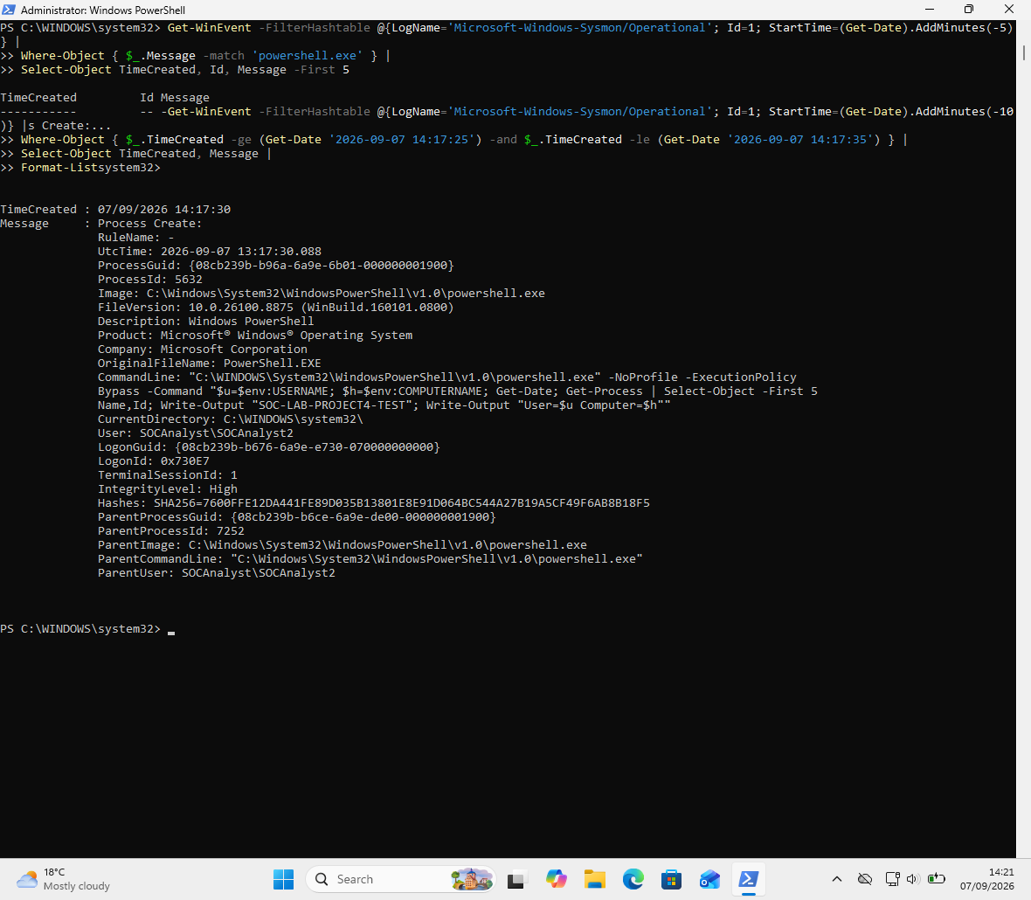
01-lab-baseline.png
Encoded PowerShell execution and controlled marker output.
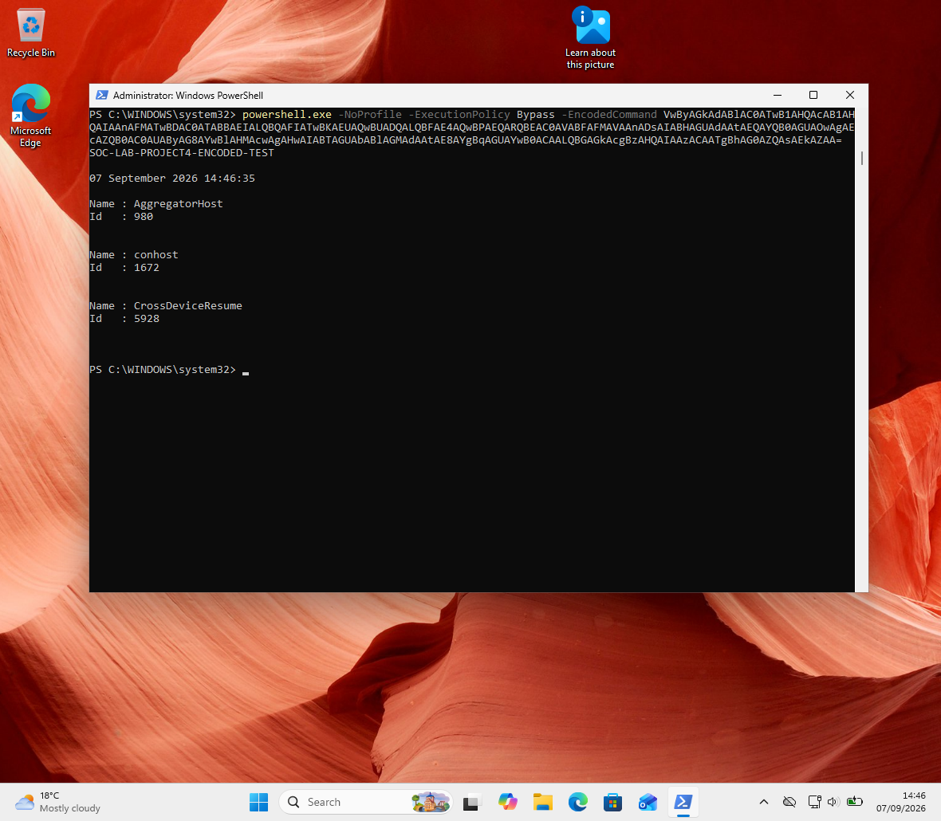
02-encoded-powershell-execution.png
Sysmon process-creation evidence and process correlation.
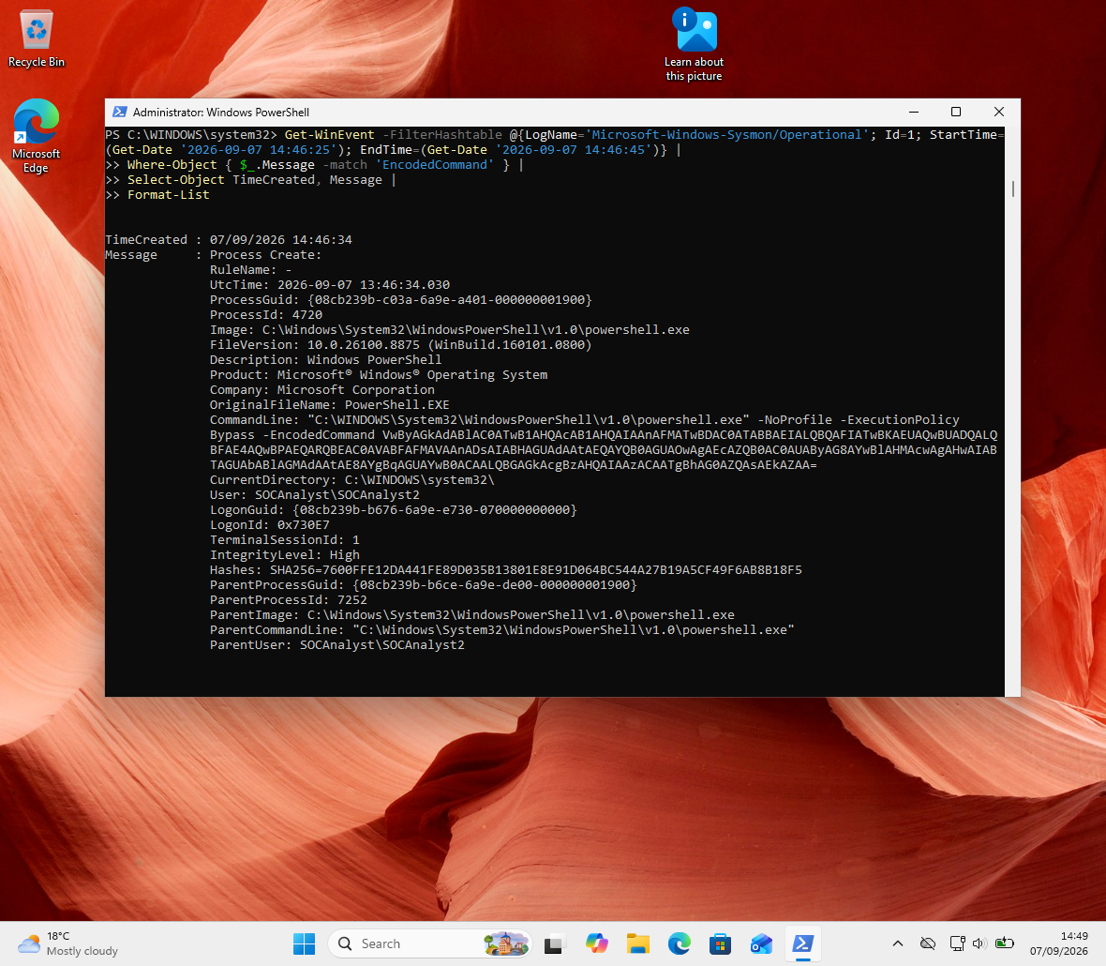
03-sysmon-process-correlation.png
PowerShell Operational logging / ScriptBlock evidence.
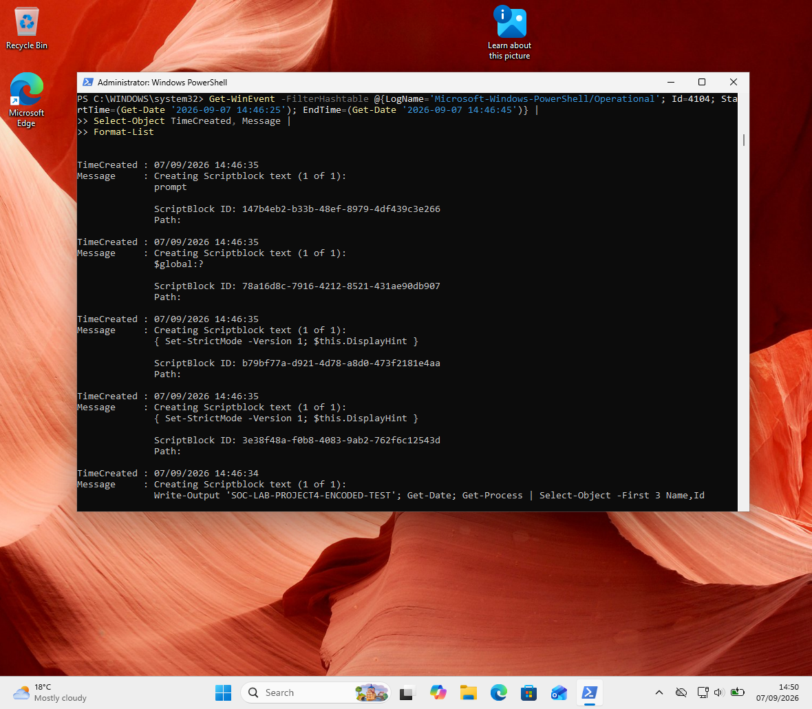
04-powershell-logging-correlation.png
Additional process context from the controlled execution.
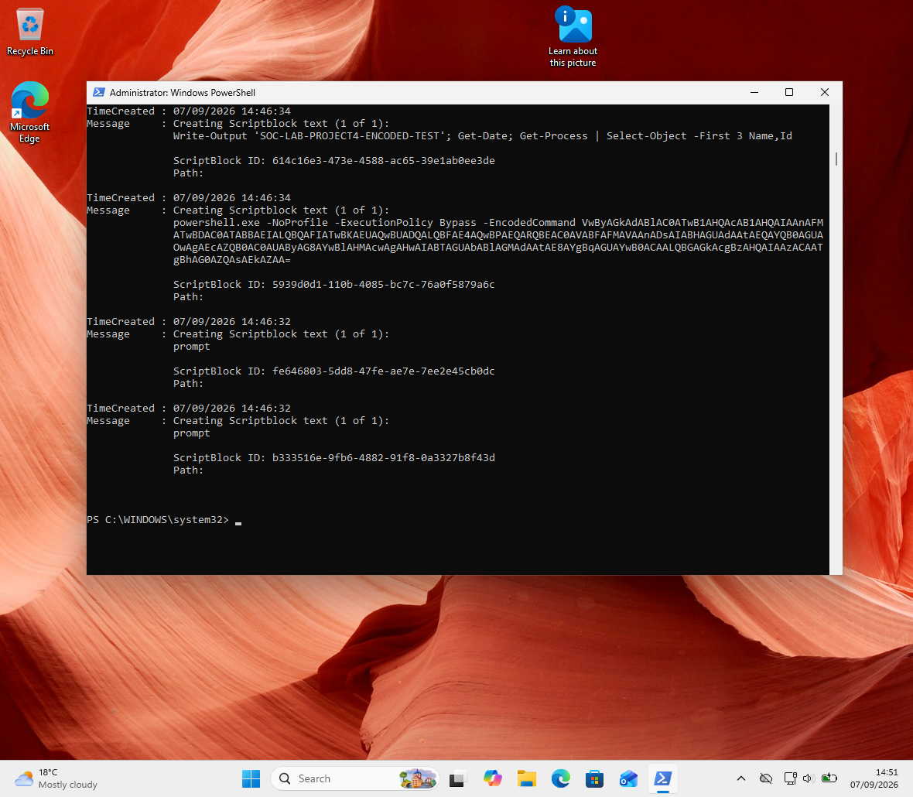
05-process-tree-and-context.png
No active TCP endpoints attributable to PID 4720.
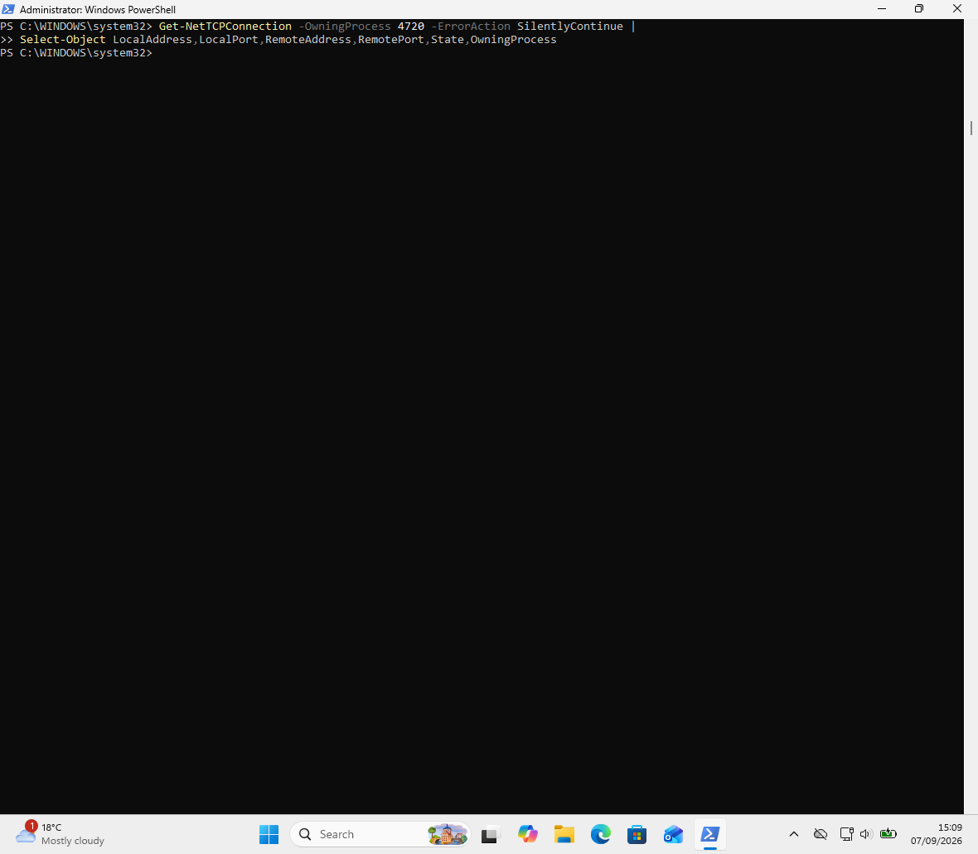
06-tcp-check.png
No active UDP endpoints attributable to PID 4720.
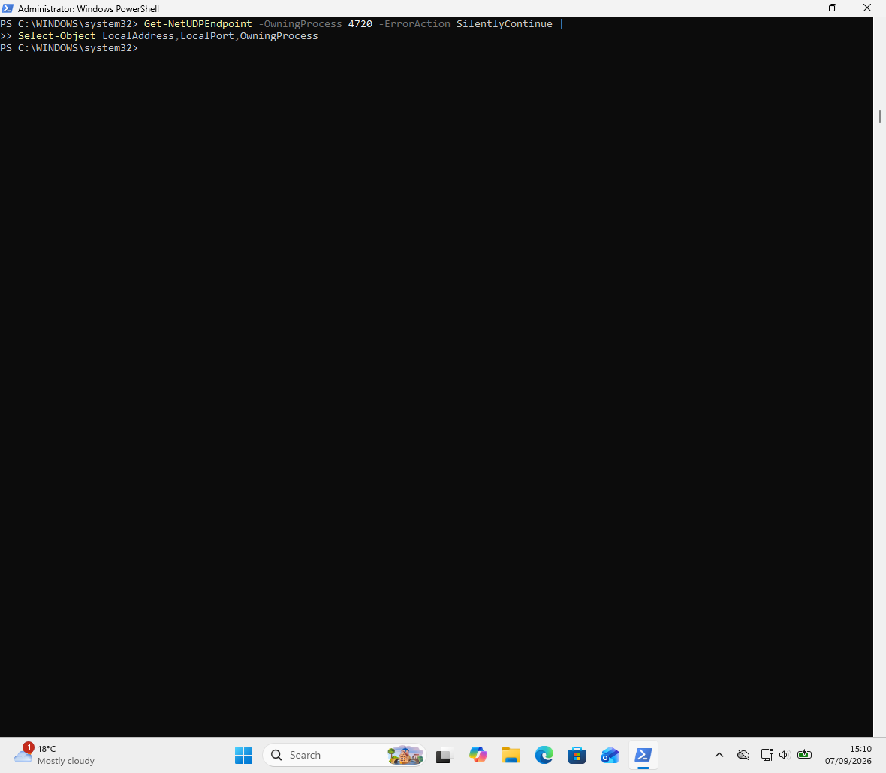
07-udp-check.png
PID 4720 no longer present at final process-state check.
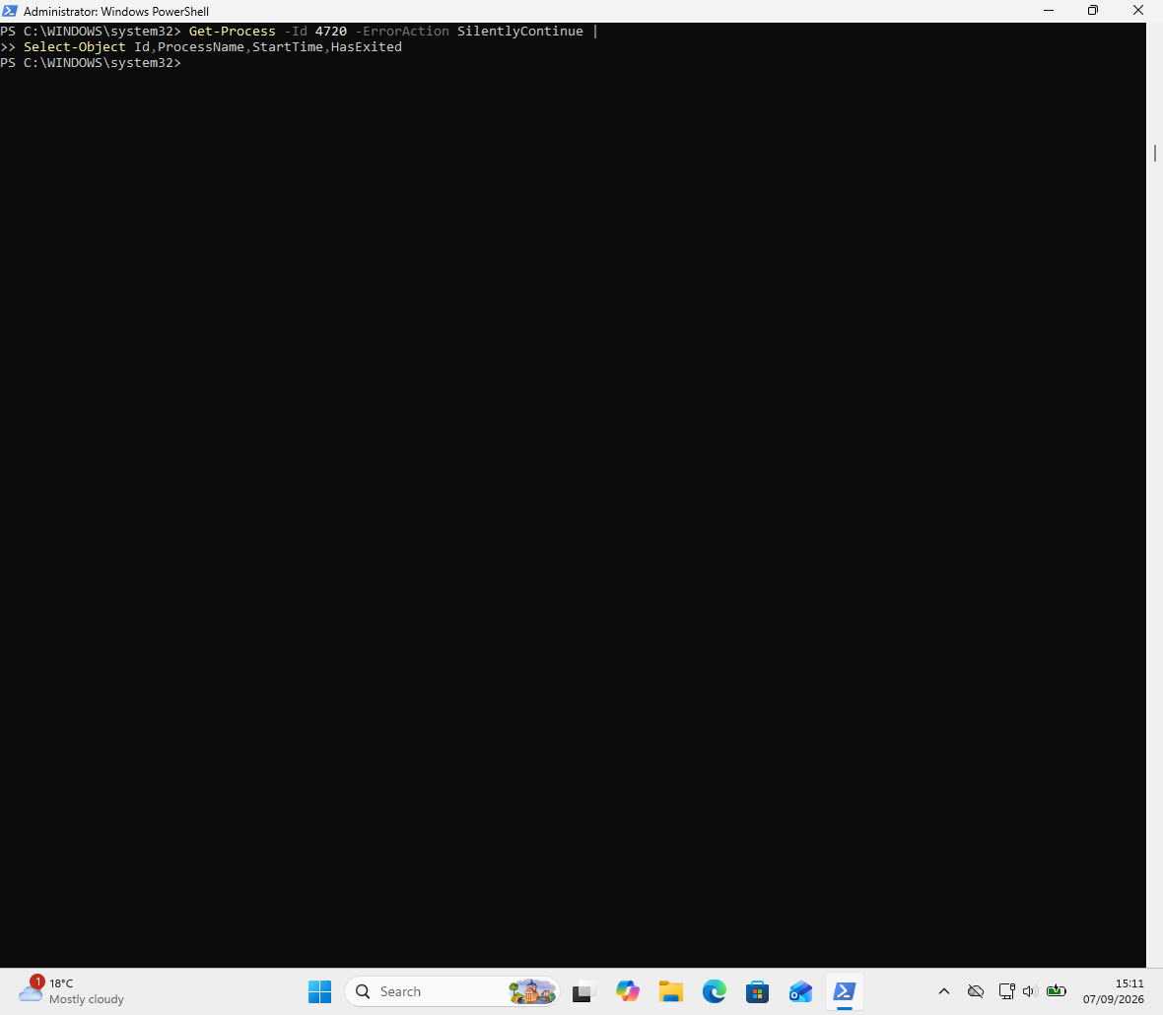
08-process-state.png
PowerShell Event ID 4104 showing the controlled encoded ScriptBlock.
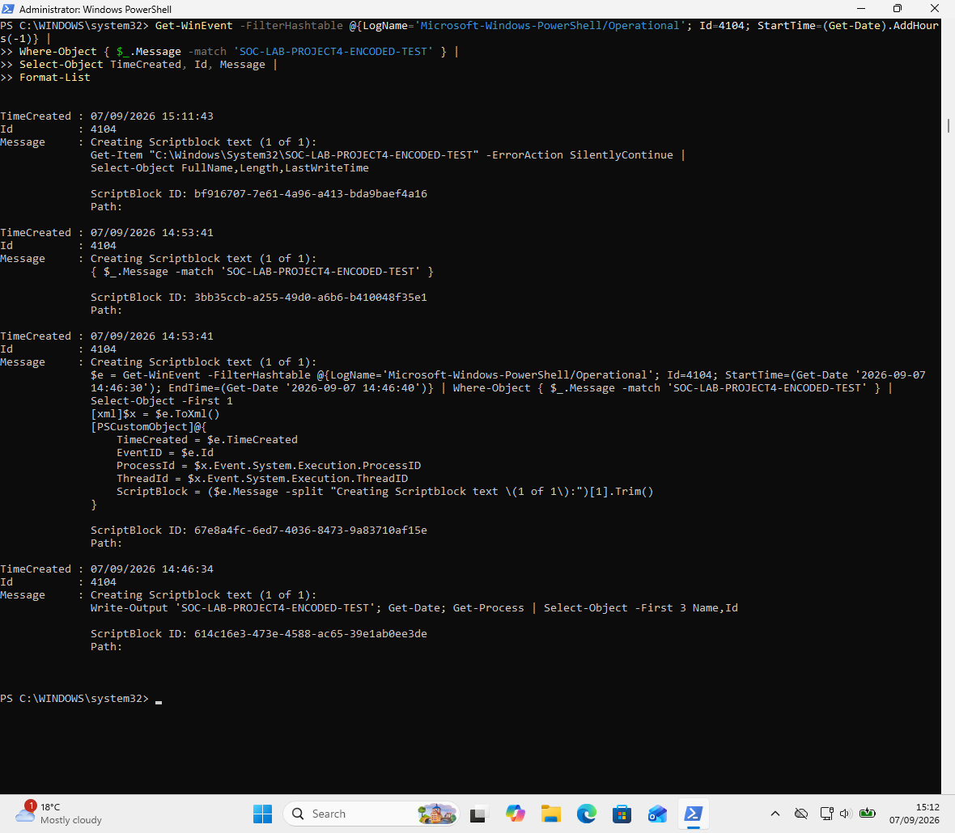
09-4104-encoded-scriptblock.png
Final time-scoped confirmation of the exact controlled ScriptBlock.
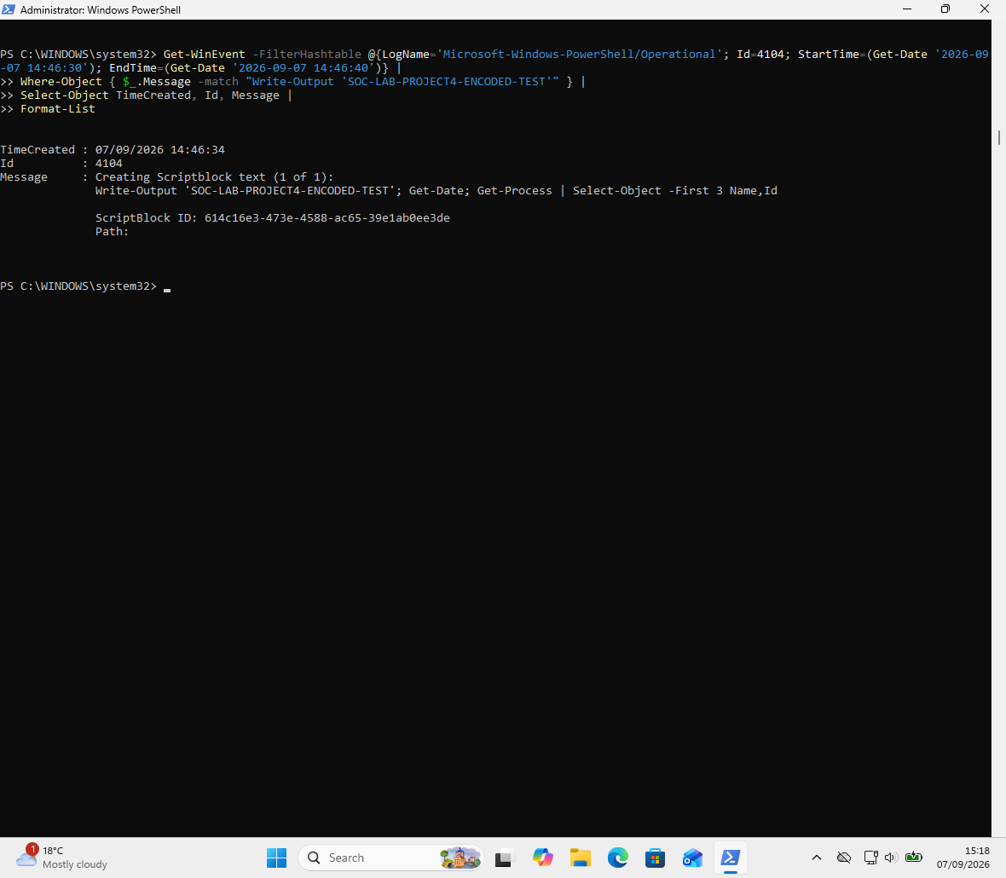
10-final-4104-confirmation.png

14. Conclusion
This investigation demonstrates a realistic SOC workflow for triaging an encoded PowerShell alert: identify the process, inspect the ScriptBlock through logging, correlate execution context, check for follow-on processes and network activity, and reach a proportionate conclusion based on the total evidence.
Final assessment: Benign / Controlled Lab Activity — Low Suspicion.

