CloudExify — Project 4

Vulnerability Assessment & Remediation — Daily Progress Log
Internship: CloudExify Summer Internship 2026 | Domain: Cybersecurity | Month 2

Day 1 — Planning
Date: _______________
Planned focus: Repo setup, objective, scope (in/out), timeline

What I did
Created the GitHub repository CloudExify-Project-4, consistent with the naming convention used for Project 1–3. Defined the objective, in-scope and out-of-scope boundaries, and referenced the 15-day timeline for the assessment.

Objective
To identify vulnerabilities in the target environment, assess their severity and potential business impact using CVSS scoring, and provide actionable remediation recommendations to reduce risk before exploitation.

Scope — In Scope
• Target: localhost XAMPP stack (Apache, MySQL, PHP)
• Target application: DVWA (Damn Vulnerable Web Application) running on the local XAMPP install
• Tester: self-authorized (own local environment, no third-party authorization required)
• Tools: Nessus Essentials (automated scan) and manual validation techniques carried over from Project 3

Scope — Out of Scope
Any hosts, devices, or services outside the local XAMPP/DVWA environment — including other devices on the home network, router/network infrastructure, and any production or third-party systems. Only localhost (127.0.0.1) and the DVWA application are authorized targets.

Timeline
Following the 15-day plan: Day 1 Planning, Day 2 Reconnaissance, Day 3 Nessus Install & Config, Day 4 Network Scan, Day 5 Web App Scan, Day 6 Enumeration, Day 7 Triage, Days 8–9 Manual Validation, Day 10 CVSS Scoring, Day 11 Remediation Research, Day 12 Executive Summary, Day 13 Technical Findings, Day 14 Roadmap & Appendices, Day 15 Assemble & Submit.

Screenshots
[Paste screenshot 1 here]

[Paste screenshot 2 here]

Notes / Issues encountered
Open question pending PM response: whether penetration_test_report.pdf is a separate deliverable from web_app_pentest_report.pdf, and whether Project 3's report should be renamed to match the guide's naming. Proceeding with local XAMPP/DVWA as the target and Nessus Essentials as the tool, per the guide's own stated defaults.

Day 2 — Reconnaissance
Date: _______________
Planned focus: Identify open ports/services, note software versions (Apache, MySQL, PHP)

What I did
I checked which ports (especially 80 and 3306 with IPv4 and IPv6) are listening and checked the versions of PHP, Apache, and MariaDB (MySQL)

Screenshots
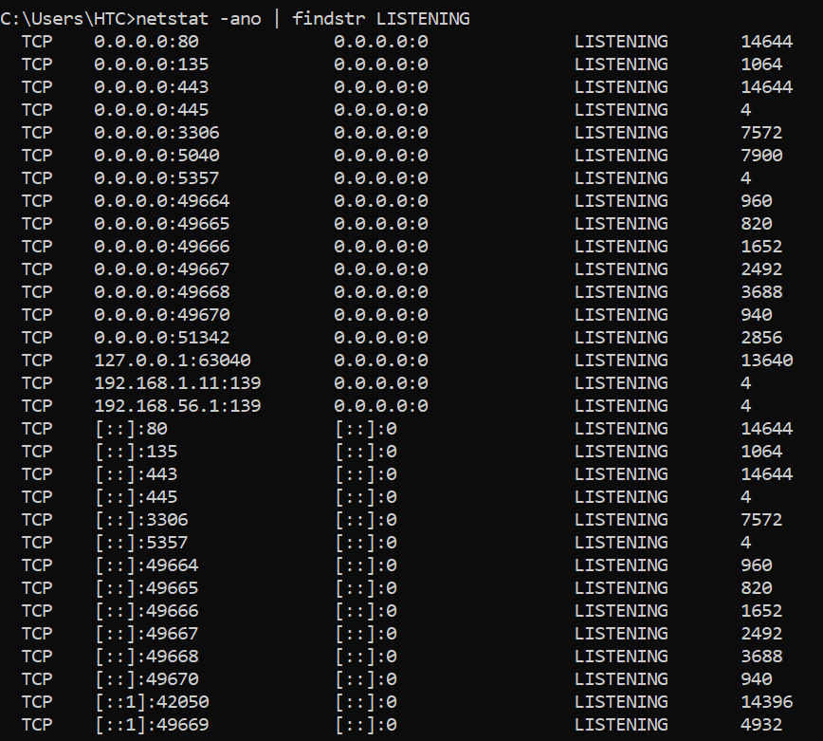

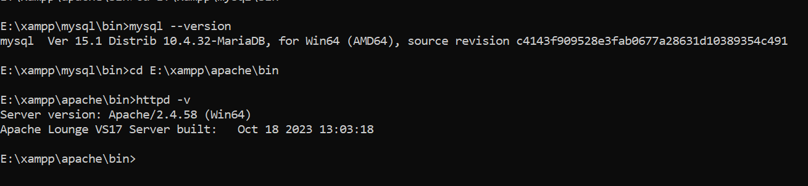

Day 3 — Nessus Install & Configuration
Date: _______________
Planned focus: Install Nessus Essentials, activate license, explore scan templates

What I did
• Downloaded and installed Nessus Essentials
• Registered with your activation code
• Created your local Nessus login (raheen)
• Confirmed the 30-day/5-IP license
• Confirmed the interface is up, waiting for plugin compilation to finish

Prediction (before testing/reviewing results)

Nessus Essentials caps scanning at 16 IP addresses total. Since this assessment only targets localhost (1 IP), the limit does not restrict scope. Scan speed is unaffected by this limit — it only restricts how many IPs can be scanned under the free license.

Result / Findings
After project completion, check folder permissions on the Nessus install directory (E:\Program Files\Tenable\Nessus\) via Properties → Security tab, to confirm non-admin write access isn't unnecessarily broad. Installer flagged this during setup — worth verifying and documenting as a hardening observation.

Screenshots
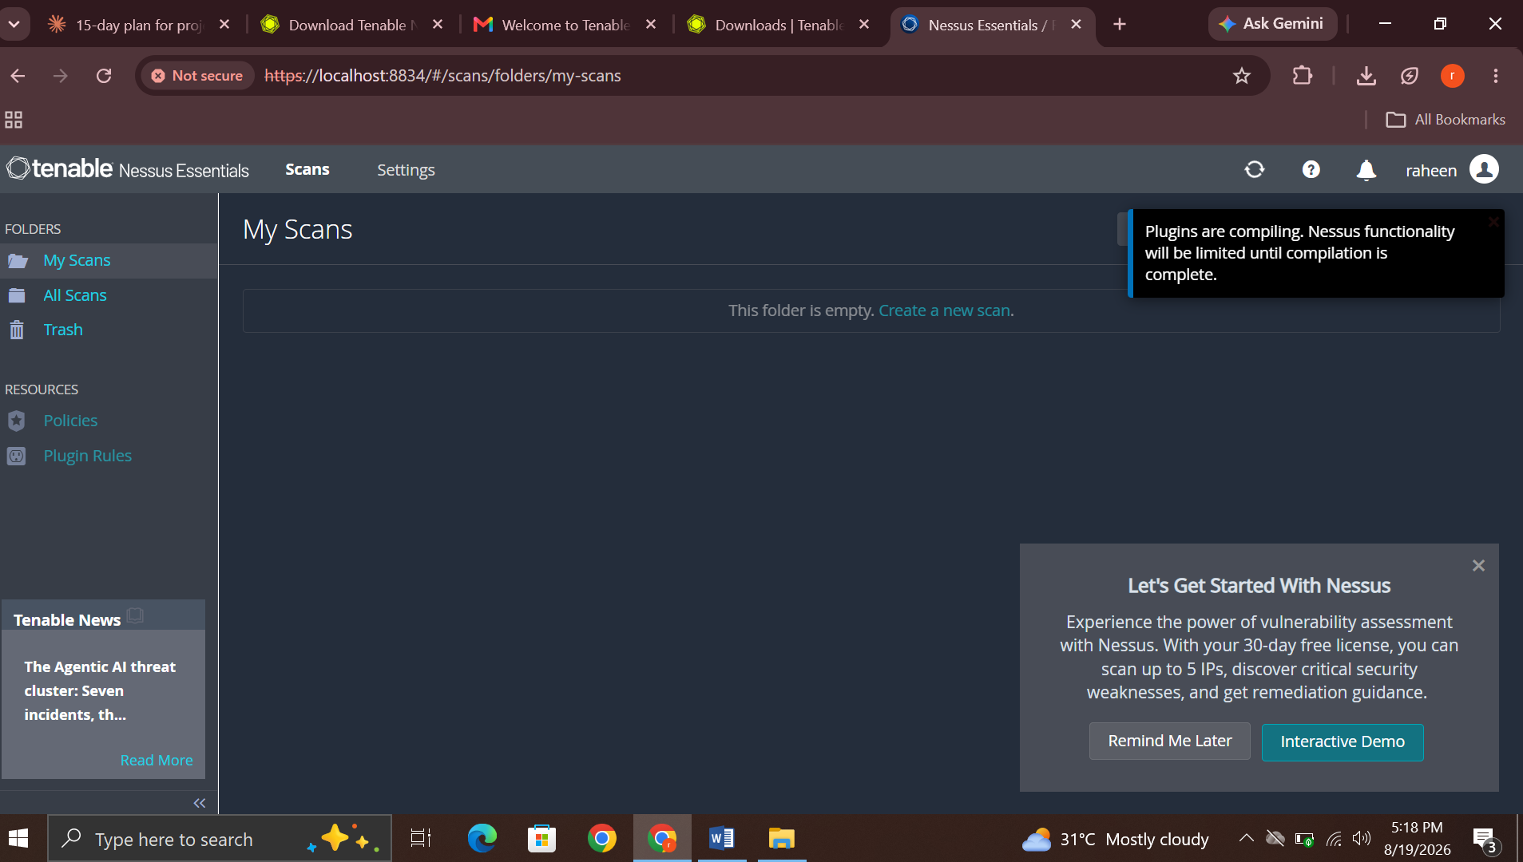

Day 4 — First Scan — Network
Date: _______________
Planned focus: Run Basic Network Scan against localhost, review results

Result / Findings

Screenshot 1 — Scan Summary (Hosts tab)
Keep — this is your primary evidence screenshot for Day 4.
Shows the scan completed, 1 host scanned (127.0.0.1), severity breakdown bar (7 Critical / 10 High / 16 Medium / 129 Low+Info), and Scan Details panel (policy, dates, elapsed time).

Screenshot 2 — Vulnerabilities list (partial, by Family)
Keep — but note it's a partial/cut-off view.
Shows vulnerabilities grouped by "Family" (CGI abuses, Web Servers, General, etc.) with severity and count columns.
(Worth a follow-up: scroll down and get a screenshot of the rest of this list too — this one's cut off, so you're missing whatever's below "INFO / General.")

Screenshot 3 — Remediations tab
Keep — this is arguably your most important screenshot from today.
This is the clearest, most report-ready summary: three specific outdated components (Apache, PHP, OpenSSL) each mapped to exact vulnerability counts and a specific upgrade target version.

Screenshot 4 — Notes tab (Network Interface warning)
Keep — important for your report's limitations section, not just a random note.
Documents a real tool limitation (packet forgery not supported on your network interface), which affects scan completeness/reliability.

Screenshot 5 — History tab
Skip, or keep only if you want completeness.
This is redundant — same scan details (policy, dates, elapsed time) already captured in Screenshot 1. Doesn't add new information.

Screenshots

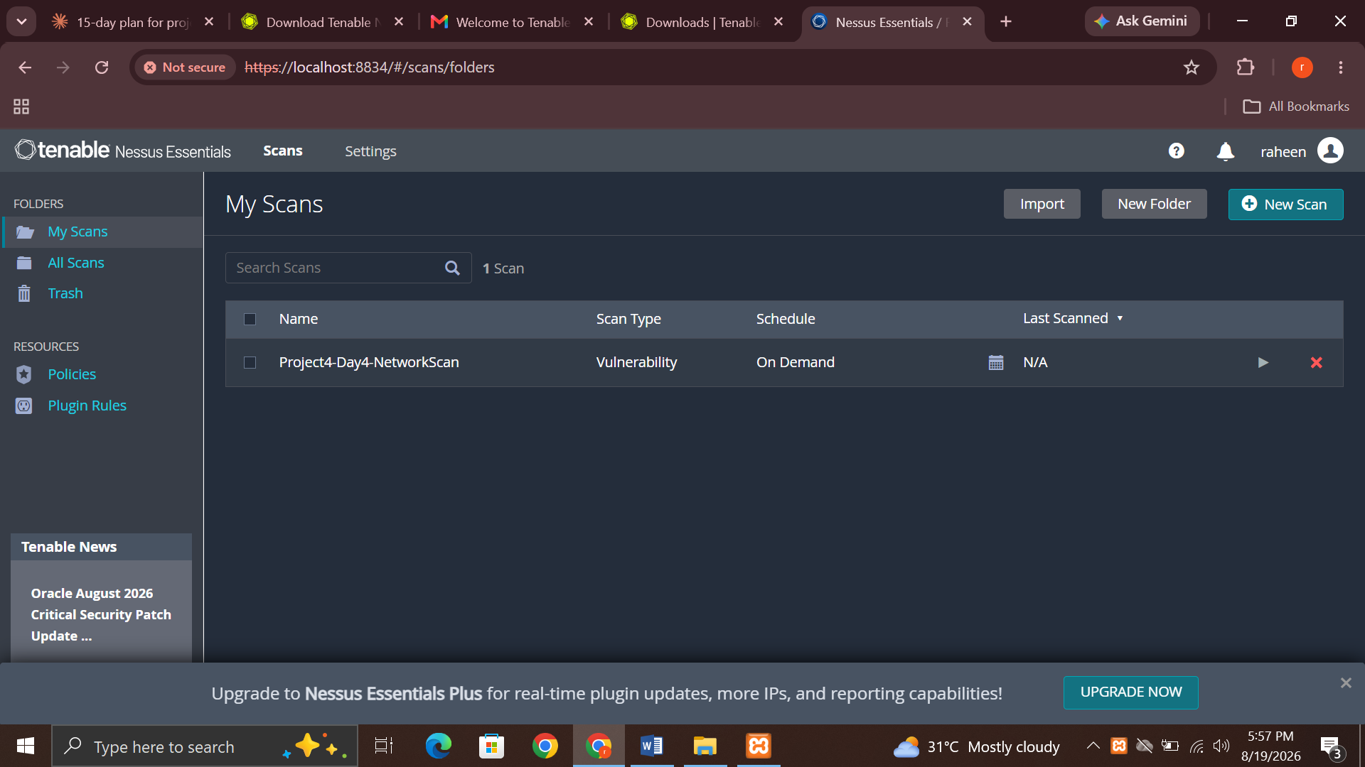

Caption: “Create a Basic Scan Network”

#1

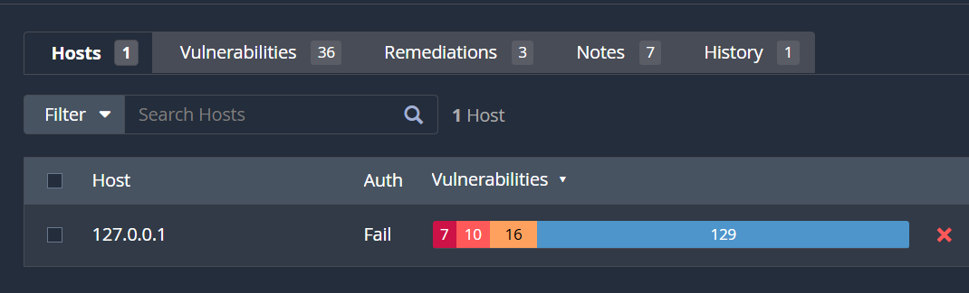

Caption: "Nessus Basic Network Scan completed against 127.0.0.1. Scan ran for 18 minutes and identified 162 total findings across severity levels: 7 Critical, 10 High, 16 Medium, remainder Low/Informational."

#2

Critical/High findings (CVSS 9.8 and 7.5) are all categorized under 'Web Servers,' consistent with the outdated Apache version identified in the Remediations tab. No Critical/High findings were attributed to the database service in this scan.
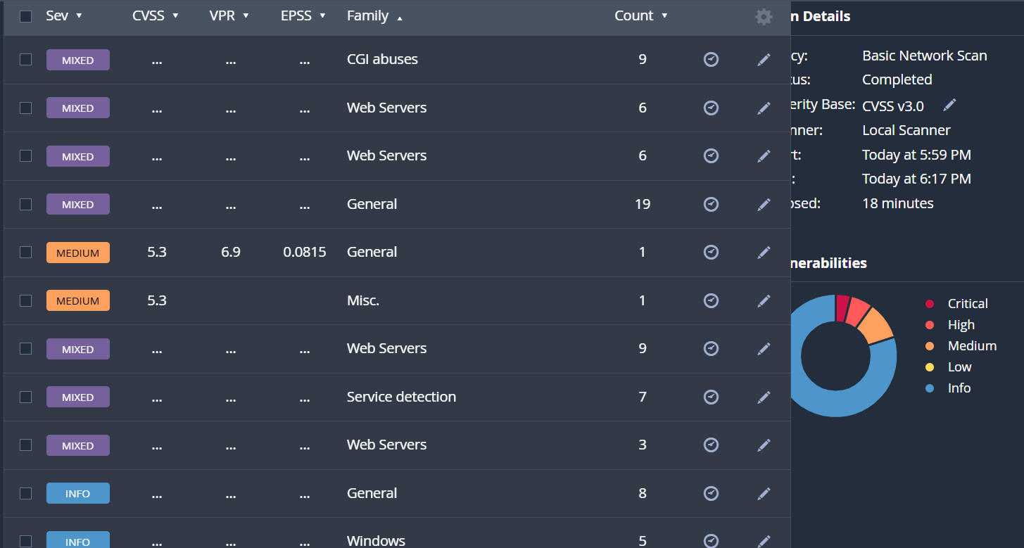

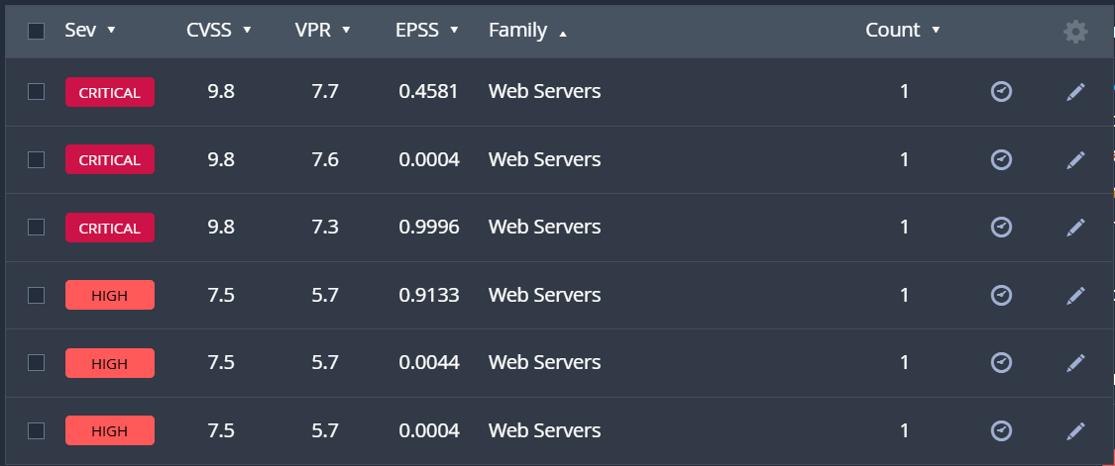

Nessus detected that the installed Apache version (2.4.58) is below the patched version (2.4.67), exposing the host to four bundled CVEs:
- CVE-2026-28780 — Heap-based buffer overflow in mod_proxy_ajp, triggered by a malicious AJP server response
- CVE-2026-23918 — Double-free vulnerability with possible Remote Code Execution (RCE) over HTTP/2
- CVE-2026-24072 — Local privilege escalation via .htaccess, allowing unauthorized file reads with httpd user privileges
- CVE-2026-29168 — Resource exhaustion (DoS) via mod_md OCSP response handling
Risk context: Nessus's VPR data flags Exploit Code Maturity as "PoC" (public proof-of-concept exists) and Product Coverage as "Very High," indicating this is a realistic, high-impact risk rather than a theoretical one.
Remediation: Upgrade Apache to version 2.4.67 or later, which resolves all four CVEs in a single update.

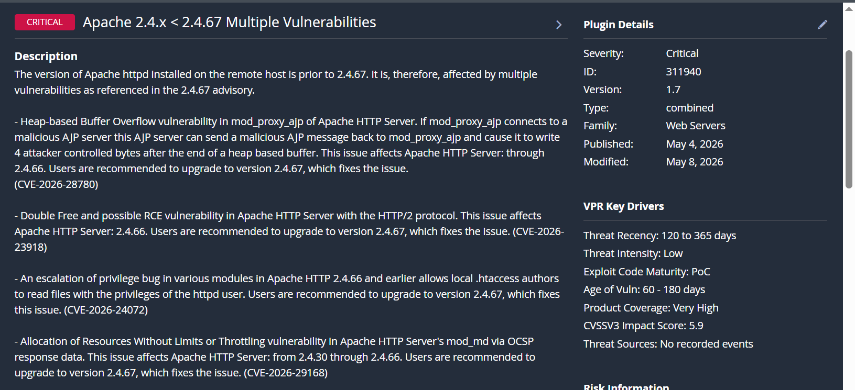

Caption: "Vulnerabilities grouped by category/family, showing severity distribution across CGI abuses, Web Servers, and General findings."

#3

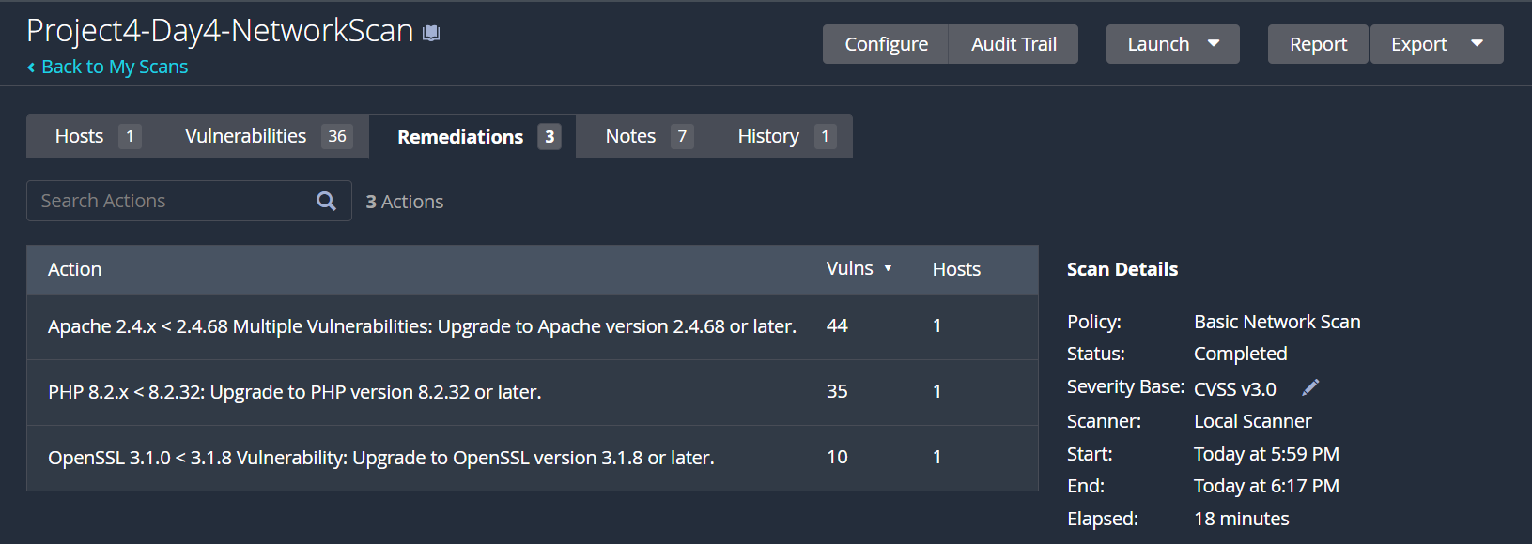

Caption: "Nessus-recommended remediation actions: upgrade Apache to 2.4.68+ (44 vulnerabilities), PHP to 8.2.32+ (35 vulnerabilities), and OpenSSL to 3.1.8+ (10 vulnerabilities)."

#4

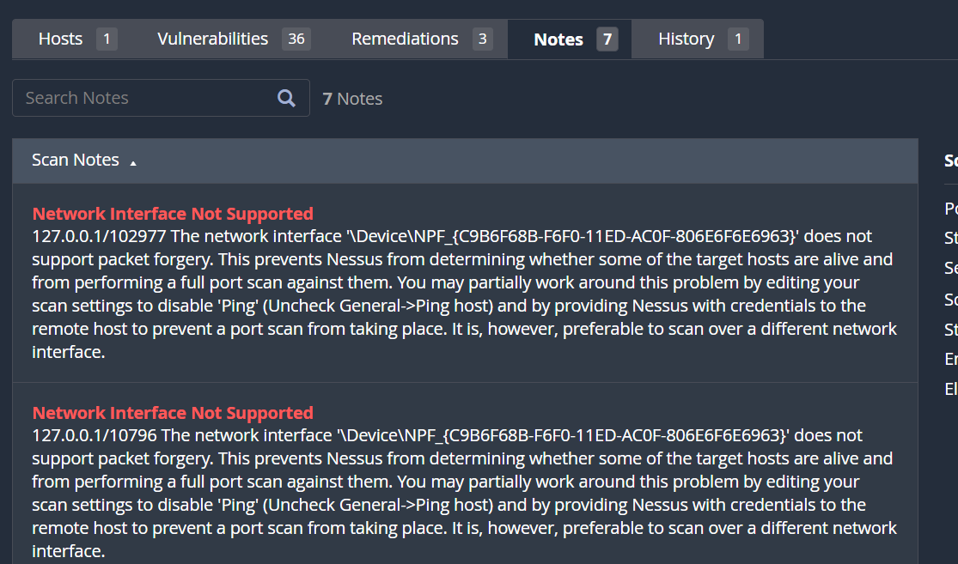

Caption: "Scan note indicating the network interface does not support packet forgery, which may have limited full port-scan coverage. Logged as a scope/methodology limitation."

#5

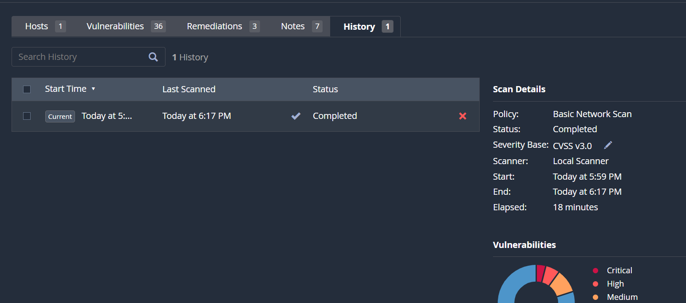

Day 5 — Second Scan — Web App
Date: _______________
Planned focus: Run Nessus Web Application Tests against DVWA, compare with Project 3 findings

Result / Findings

Result:

23 vulnerabilities found (7 Critical, 9 High, 10 Medium, 88 Low/Info) — but all Critical/High findings were version-based infrastructure issues (outdated Apache, PHP), identical to Day 4's findings. No DVWA-specific application vulnerabilities (SQLi, XSS, CSRF, Command Injection) were independently flagged by the automated scan.

Corrected finding: Both Day 4 (network scan) and Day 5 (web app scan) surfaced the same infrastructure-level vulnerabilities (outdated Apache, PHP, OpenSSL) rather than distinct DVWA application-layer vulnerabilities. Nessus's automated web app scan did not independently detect the SQL Injection, XSS, CSRF, or Command Injection vulnerabilities that were manually confirmed in Project 3. This suggests Nessus, in this configuration, is stronger at version-based infrastructure vulnerability detection than at detecting DVWA's intentionally-vulnerable application logic — supporting the earlier point that CSRF and logic-based flaws often require manual/contextual testing that automated scanners can miss.

Screenshots
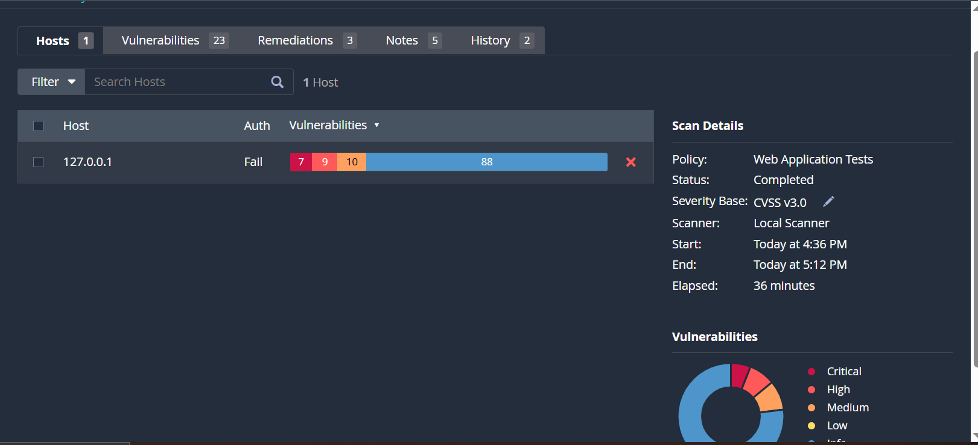

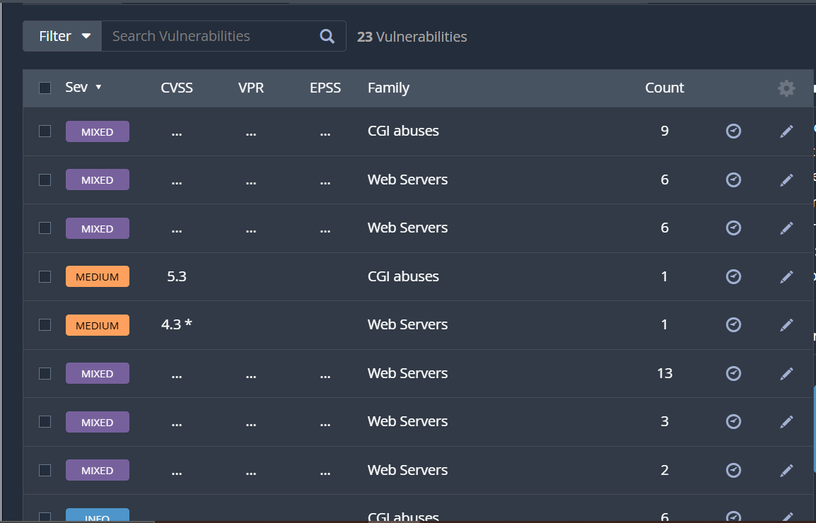
Web Server Details:

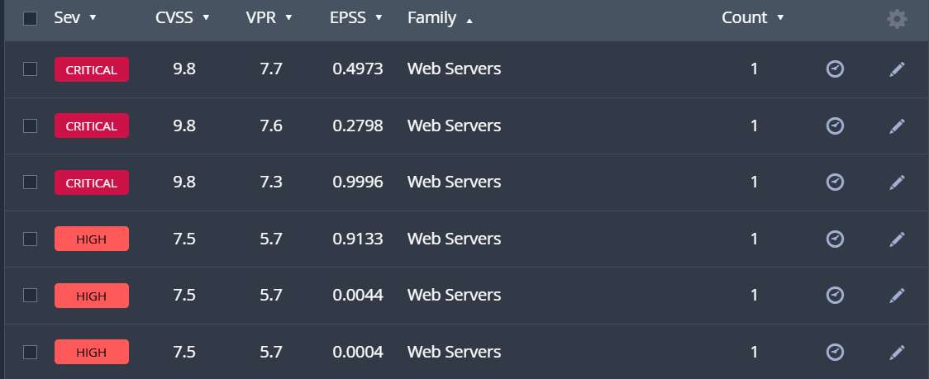

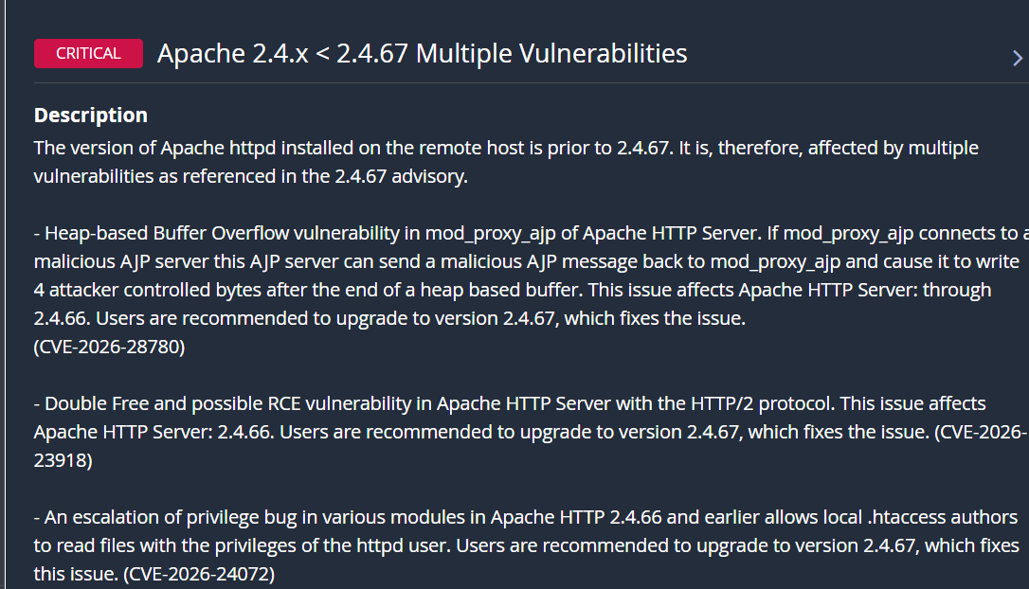

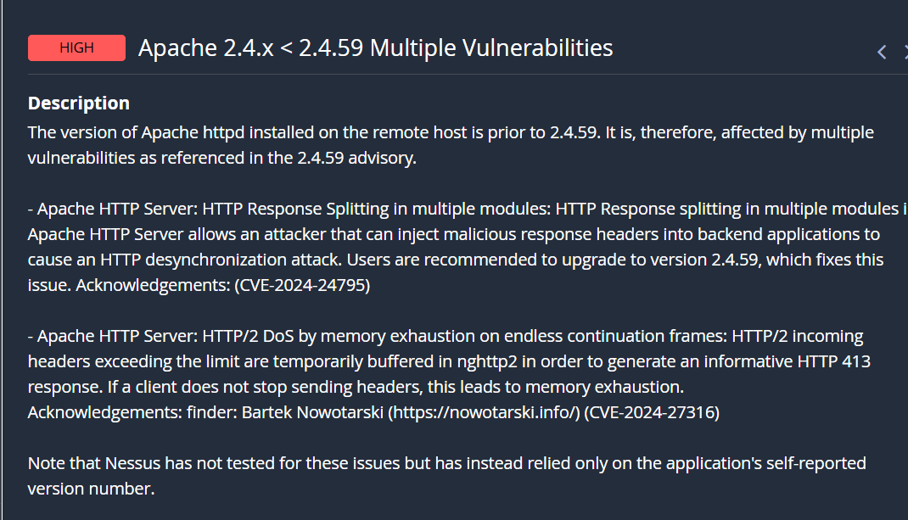

CGI abuses Detail (Count 9):

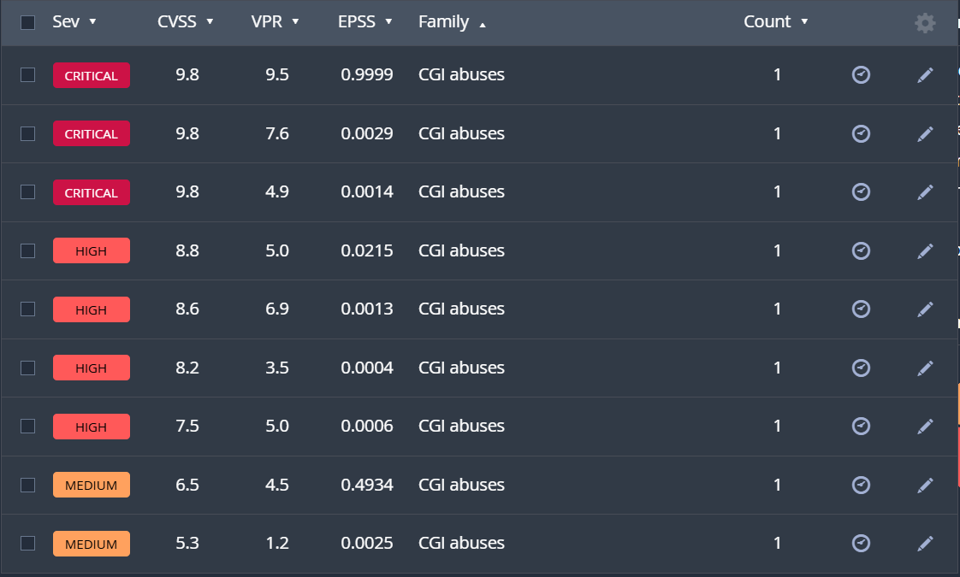

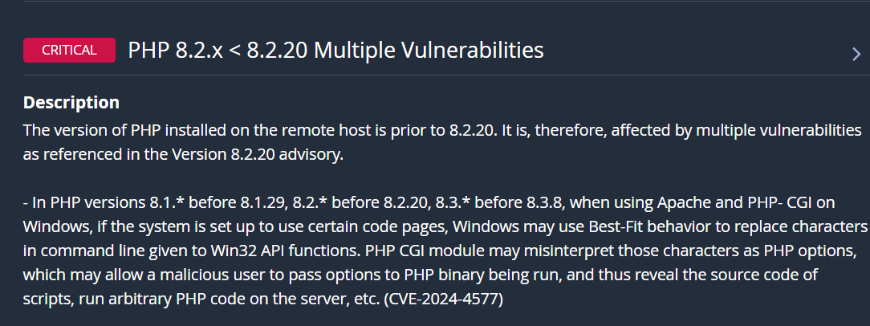

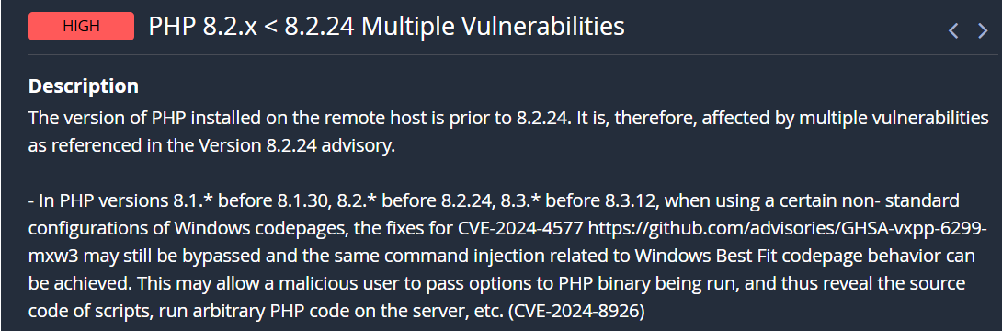

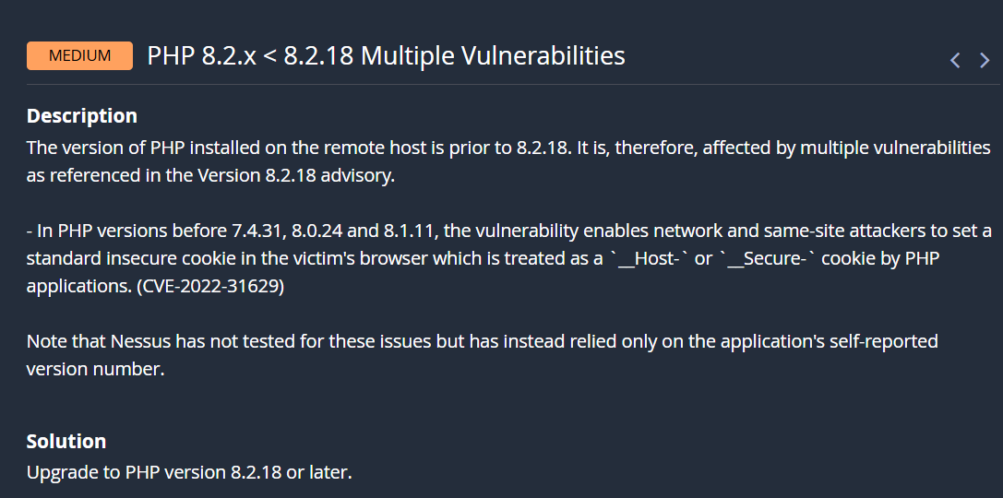

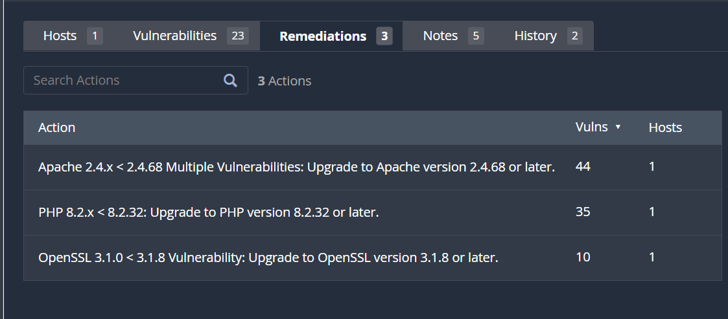

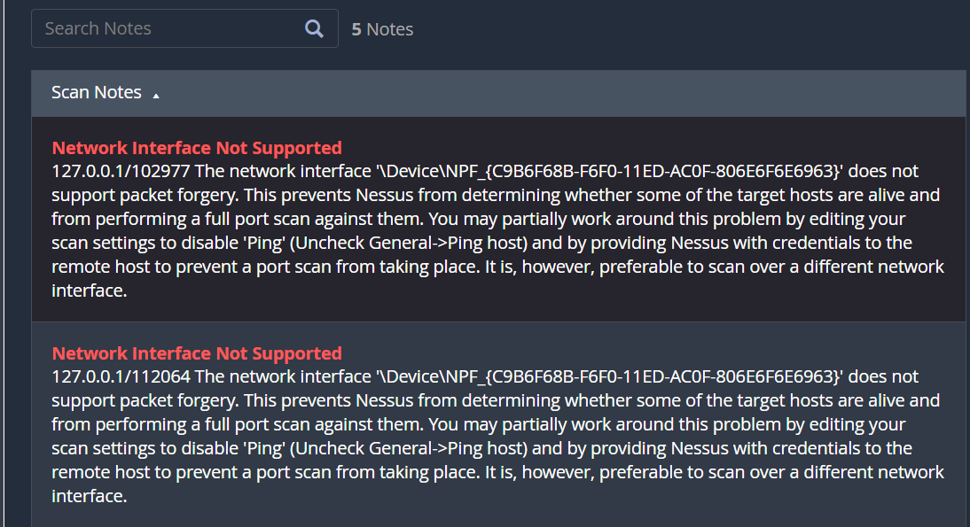

Day 6 — Enumeration
Date: _______________
Planned focus: Deep-dive flagged services, version detail, cross-reference with installed stack

What I did
Consolidated and cross-referenced the software versions verified manually on Day 2 (Apache, PHP, MariaDB) against the Nessus-flagged vulnerability thresholds from Days 4 and 5. Also checked the OpenSSL version bundled with XAMPP, which had not been directly verified before, and confirmed it against Nessus's flagged range.

Prediction (before testing/reviewing results)
Expected OpenSSL to be somewhat outdated, similar to Apache and PHP, since all three ship together as part of the same XAMPP bundle.

Result / Findings
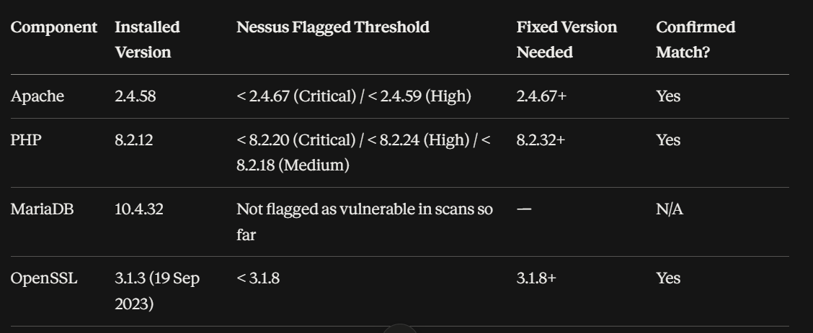

Key CVEs confirmed applicable:
- Apache: CVE-2026-28780, CVE-2026-23918, CVE-2026-24072, CVE-2026-29168, CVE-2024-24795, CVE-2024-27316
- PHP: CVE-2024-4577, CVE-2024-8926, CVE-2022-31629

Screenshots
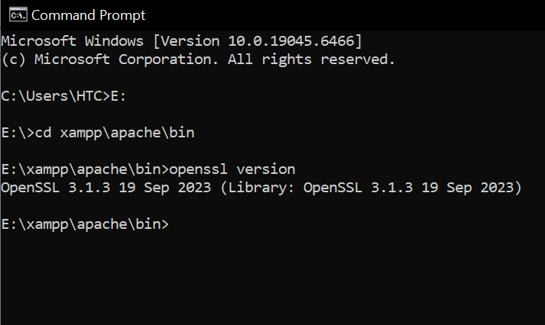

Notes / Issues encountered
Nessus explicitly noted it did not actively test the Apache and some PHP findings — these were inferred from the self-reported version string rather than active exploitation testing. This is a methodology limitation to flag in the final report and to consider when assigning CVSS confidence during scoring (Day 10).
No SQL Injection, XSS, CSRF, or Command Injection findings were independently surfaced by Nessus for the DVWA application itself, confirming that manual validation (Days 8–9) should focus on the existing Project 3 findings rather than new Nessus-flagged application vulnerabilities.

Day 7 — Vulnerability Triage
Date: _______________
Planned focus: Filter false positives, shortlist top findings for manual validation

What I did
Reviewed all findings from Days 4–6 (Nessus network scan, web app scan, and enumeration) alongside the Project 3 manual pentest report. Categorized findings into priority tiers based on confidence level (automated + manual confirmation vs. manual-only) to decide what needs re-validation in Days 8–9

Prediction (before testing/reviewing results)
Expected the Apache/PHP/OpenSSL findings and the Project 3 DVWA findings (SQLi, XSS, CSRF, etc.) to both need equal validation effort.

Result / Findings
Tier 1 — Confirmed by both Nessus and manual version checks (highest confidence, simple remediation):
- Apache 2.4.58 (outdated)
- PHP 8.2.12 (outdated)
- OpenSSL 3.1.3 (outdated)
Tier 2 — Confirmed manually only in Project 3, not caught by Nessus (requires re-validation on Days 8–9):
- SQL Injection (Low and Medium security bypass)
- Reflected XSS
- Stored XSS
- CSRF (password change exploit)
- Unrestricted File Upload → Remote Code Execution
- Command Injection
- Brute Force (no account lockout)
Tier 3 — Methodology limitation, not a new finding:
- Automated scanning (both Burp Scanner in Project 3 and Nessus in Project 4) has limited ability to detect DVWA's intentional application-layer vulnerabilities; manual testing remains essential for these categories.

Notes / Issues encountered
Priority for Days 8–9 manual re-validation: File Upload (RCE) and Command Injection first, given highest real-world impact (full server compromise); followed by SQL Injection and CSRF. Stored/Reflected XSS and Brute Force are lower priority to re-confirm, as they are simpler and well-documented from Project 3.

Day 8 — Manual Validation (Part 1)
Date: _______________
Planned focus: Reproduce/confirm exploitability for top 3–4 shortlisted findings

What I did
Re-tested two of the vulnerabilities found earlier in Project 3 to check if they still work the same way on the current setup.
First, I tried the File Upload vulnerability. I made a simple PHP file that just prints a message, uploaded it through DVWA's File Upload page, and then opened the uploaded file's link directly in the browser. The message printed on the page instead of just downloading the file, which means the server ran the PHP code — confirming the server can be tricked into running any code an attacker uploads.
Then I tried Command Injection. I first entered a normal IP address to see the regular ping result, then added an extra command to the same input. The ping still worked normally, but my extra command also ran and showed my computer's name on the screen — proving the input box doesn't block extra commands from running.
Both tests gave the same results as Project 3, confirming these vulnerabilities are still present.

Result / Findings
Re-validated File Upload vulnerability from Project 3. Uploaded validate_day8.php containing a simple PHP echo statement via DVWA's File Upload module at Low security. Accessed the uploaded file directly at http://localhost/DVWA/hackable/uploads/validate_day8.php — the server executed the PHP code rather than serving it as plain text/download, confirming Remote Code Execution is still exploitable. Result matches Project 3 findings exactly

Re-validated Command Injection vulnerability from Project 3. Submitted baseline payload 127.0.0.1 — confirmed normal ping output (4 packets, 0% loss). Submitted 127.0.0.1 && hostname — ping executed normally, and the injected command additionally returned the machine hostname (DESKTOP-NS3Q0FG), confirming arbitrary OS command execution. Result matches Project 3 findings (which used whoami/dir), confirming the vulnerability is still exploitable using a different injected command.

Screenshots
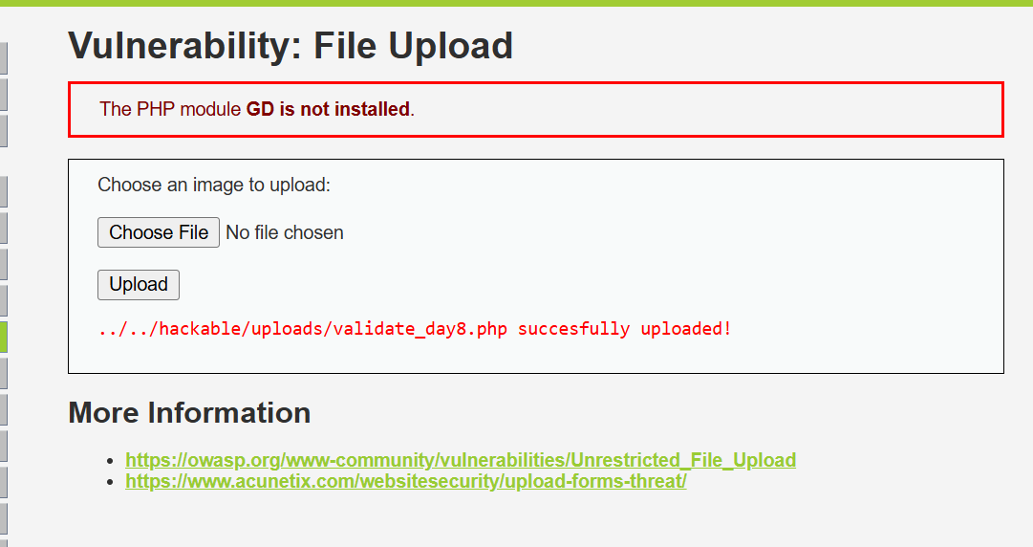

.php file uploaded

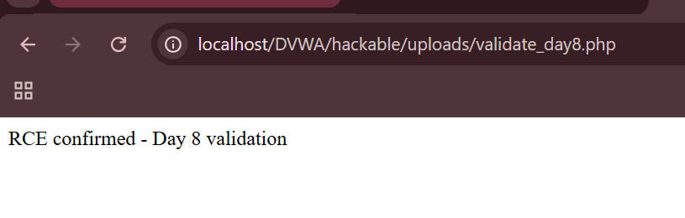

Link shows the plaintext instead of downloading the file

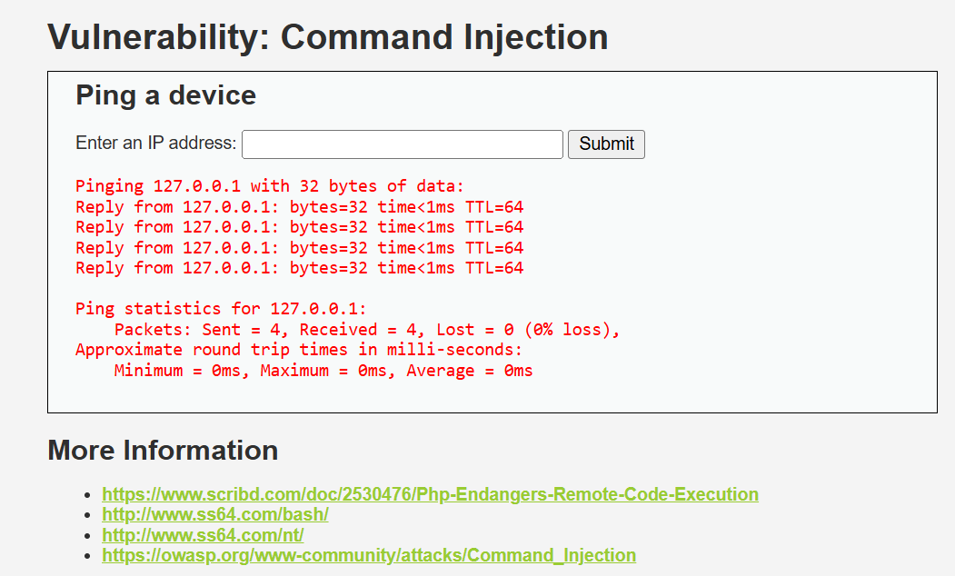

Baseline with 127.0.0.1

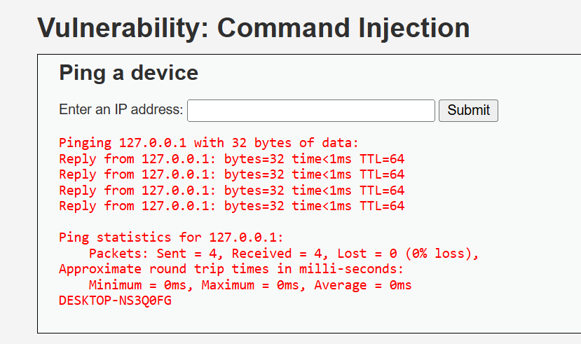

With extended payload 127.0.0.1 && hostname

Day 9 — Manual Validation (Part 2)
Date: _______________
Planned focus: Finish validating remaining shortlisted findings

What I did
Continued re-testing vulnerabilities from Project 3 to confirm they still work the same way.
First, I tested SQL Injection. I entered a normal ID number to see the regular single-result output, then entered a payload designed to trick the login logic into thinking the condition was always true. Instead of showing one user, the page showed all five users in the database, proving the input isn't properly checked before being used in the database query.
Then I tested CSRF. I created a hidden HTML file that automatically sent a password-change request in the background when opened, without asking for permission. I saved this file inside the website's own folder so it would be treated as coming from the same site (to get around a cookie protection that blocked it last time). When I opened the file, it silently changed the account password. I confirmed the attack worked by logging in with the new password successfully.
Both results matched what was found in Project 3, confirming these vulnerabilities are still present. Afterward, I changed the password back to the original one to keep the test environment in its normal state.

Result / Findings
Re-validated SQL Injection vulnerability from Project 3. Submitted baseline payload 1, then tested ' OR '1'='1 — the payload bypassed the intended single-user query logic and returned all 5 users in the database instead of one. Confirms the vulnerability still reproduces identically to Project 3 (which used ' OR 'x'='x), using a non-identical but logically equivalent payload

Re-validated CSRF vulnerability from Project 3. Created csrf_validate_day9.html containing a hidden <img> tag pointing to DVWA's password-change endpoint with a new password (validated123). Hosted the file same-origin in XAMPP's htdocs folder (accessed via http://localhost/csrf_validate_day9.html) to bypass the SameSite=Strict cookie restriction identified in Project 3. Opening the file silently changed the account password without user consent. Confirmed by successfully logging in with the new password. Result matches Project 3 findings, confirming CSRF remains exploitable at Low security

Screenshots
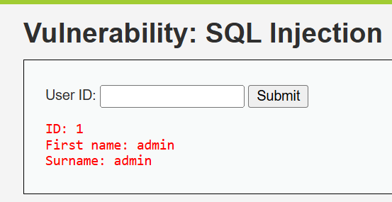

Baseline test with 1

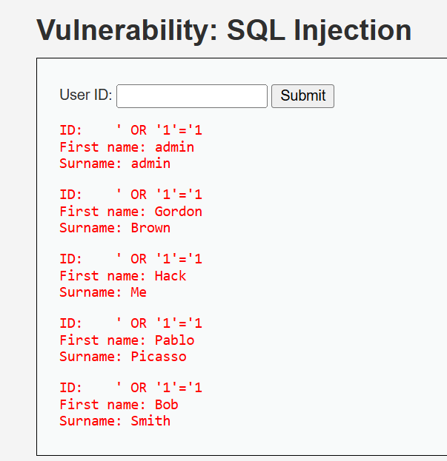

Injection Payload: ‘ OR ‘1’=’1

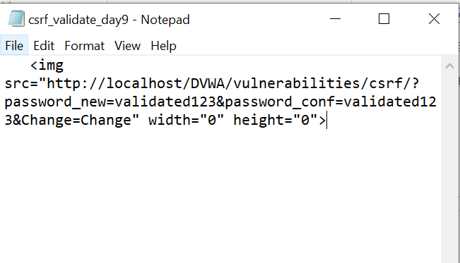

An HTML file was created to test csrf attack with an invisible image

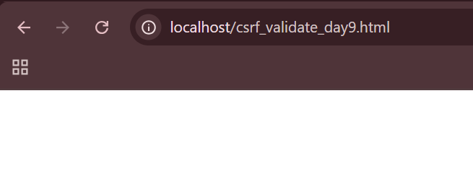
Created an HTML file and opened it with the link
http://localhost/csrf_validate_day9.html

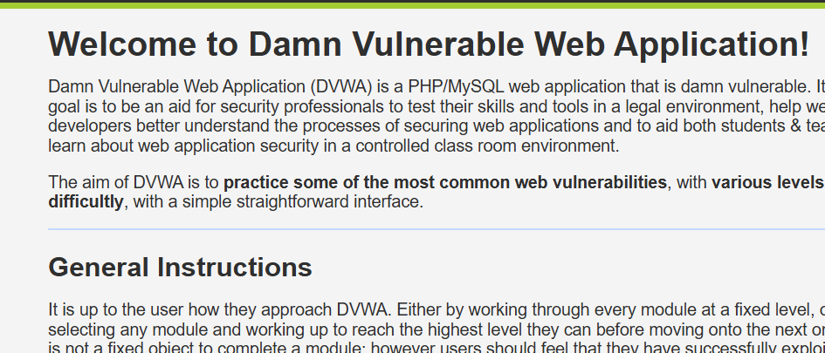

Successfully logged in with the new password “validated123” changed through a CSRF attack

Day 10 — CVSS Scoring
Date: _______________
Planned focus: Score each confirmed vulnerability with justification

What I did
Assigned CVSS v3.1 base scores to all vulnerabilities confirmed through manual validation (Days 8–9), which had no automated score from Nessus. Calculated each score by working through the 8 standard CVSS metrics (Attack Vector, Attack Complexity, Privileges Required, User Interaction, Scope, Confidentiality, Integrity, Availability) based on what was actually demonstrated during testing, rather than theoretical worst-case impact.

Prediction (before testing/reviewing results)
Expected CSRF to score highest (Critical), reasoning that account takeover is a severe outcome.

Result / Findings
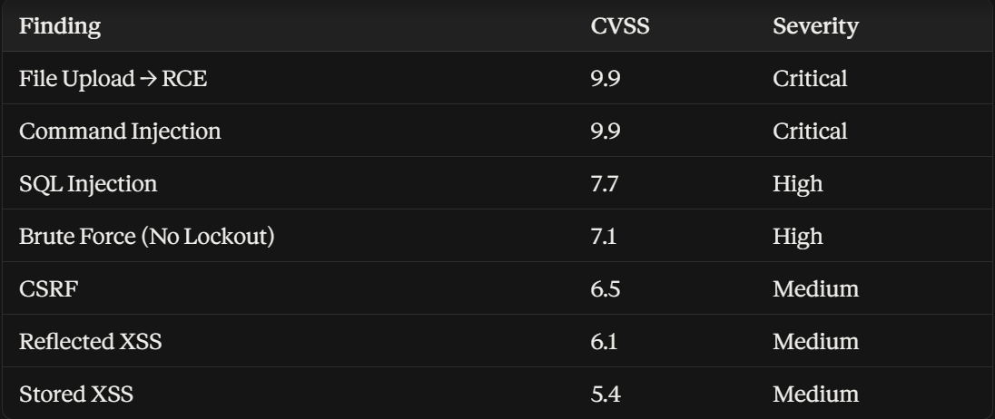

Infrastructure-level findings — Apache, PHP, OpenSSL — already carry Nessus-assigned CVSS scores from Days 4–6, e.g., Apache 9.8 (Critical).

Notes / Issues encountered
Initial prediction that CSRF would score highest was corrected: CSRF requires user interaction (a logged-in victim must open a malicious link) and only impacts integrity (no data read, no service disruption), which lowers its score under CVSS despite being a serious vulnerability. File Upload/RCE and Command Injection scored highest since both allow direct, unauthenticated-from-victim, no-interaction-needed system-level control with full confidentiality, integrity, and availability impact.

Day 11 — Remediation Research
Date: _______________
Planned focus: Write remediation steps, effort estimate, timeline per finding

Result / Findings

File Upload → RCE (CVSS 9.9 — Critical)
REMEDIATION:
- Validate file type server-side using file content/MIME type inspection, not just the file extension (extensions can be faked)
- Whitelist allowed extensions (e.g., only .jpg, .png) instead of blacklisting dangerous ones
- Store uploaded files outside the web-accessible directory, or rename them to prevent direct execution
- Disable script execution permissions in the upload directory (e.g., via .htaccess or web server config)
TIMELINE: Immediate (0–24 hours) — matches Critical severity
EFFORT: 4–6 hours for developers

Command Injection (CVSS 9.9 — Critical)
REMEDIATION:
- Avoid passing user input directly to system shell commands
- Use built-in language functions/APIs instead of shell commands where possible (e.g., use a networking library instead of shelling out to ping)
- If shell commands are unavoidable, strictly whitelist allowed characters and reject any input containing &&, |, ;, or similar shell metacharacters
TIMELINE: Immediate (0–24 hours)
EFFORT: 4–8 hours for developers

SQL Injection (CVSS 7.7 — High)
REMEDIATION:
- Use parameterized queries / prepared statements instead of directly concatenating user input into SQL
- Apply the principle of least privilege to the database account used by the app
- Add input validation as a secondary defense layer
TIMELINE: 1–7 days
EFFORT: 4–8 hours for developers

Brute Force / No Account Lockout (CVSS 7.1 — High)
REMEDIATION:
- Implement account lockout after a set number of failed login attempts (e.g., 5 attempts, 15-minute lockout)
- Add CAPTCHA after repeated failures
- Implement rate limiting on the login endpoint
TIMELINE: 1–7 days
EFFORT: 3–5 hours for developers

CSRF (CVSS 6.5 — Medium)
REMEDIATION:
- Implement server-side CSRF tokens on all state-changing requests (password change, settings updates, etc.)
- Validate the token matches the user's session before processing the request
- Continue enforcing SameSite=Strict cookies as a supporting defense layer, not a sole fix
TIMELINE: 1–30 days
EFFORT: 3–5 hours for developers

Reflected XSS (CVSS 6.1 — Medium)
REMEDIATION:
- Escape all user-supplied output using htmlspecialchars() or equivalent before rendering in HTML
- Implement a Content Security Policy (CSP) header as a defense-in-depth measure
TIMELINE: 1–30 days
EFFORT: 2–4 hours for developers

Stored XSS (CVSS 5.4 — Medium)
REMEDIATION:
- Sanitize and escape user input both on storage and on output/display
- Same CSP header recommendation as Reflected XSS
TIMELINE: 1–30 days
EFFORT: 3–5 hours for developers

Apache 2.4.58 (CVSS 9.8 — Critical)
REMEDIATION: Upgrade Apache to version 2.4.67 or later (per Nessus recommendation, Day 4/5 Remediations tab). This single upgrade resolves all four associated CVEs (CVE-2026-28780, CVE-2026-23918, CVE-2026-24072, CVE-2026-29168).
TIMELINE: Immediate (0–24 hours)
EFFORT: 1–2 hours (version upgrade + testing)

PHP 8.2.12 (CVSS varies — Critical/High/Medium by threshold)
REMEDIATION: Upgrade PHP to version 8.2.32 or later (per Nessus recommendation). Resolves CVE-2024-4577, CVE-2024-8926, and CVE-2022-31629.
TIMELINE: Immediate to 7 days, depending on highest applicable severity (Critical threshold found)
EFFORT: 1–2 hours (version upgrade + compatibility testing)

OpenSSL 3.1.3 (Nessus-flagged range < 3.1.8)
REMEDIATION: Upgrade OpenSSL to version 3.1.8 or later, bundled with a newer XAMPP release or manually replaced.
TIMELINE: 1–30 days (low current exposure since HTTPS not actively used, per Day 6 notes)
EFFORT: 1 hour (version upgrade)

Day 12 — Executive Summary + Findings Summary
Date: _______________
Planned focus: Draft management-facing sections
What I did
Drafted the two management-facing sections of the final report: the Executive Summary and the Findings Summary. Both are written in plain, non-technical language, avoiding CVE numbers, CVSS metric breakdowns, and payload details — those belong in the Day 13 technical section instead.
Executive Summary
CloudExify conducted a Vulnerability Assessment of the target web application and its underlying infrastructure, combining automated scanning (Nessus) with manual security testing to identify and confirm exploitable weaknesses.
The assessment identified 10 confirmed vulnerabilities, including 4 rated Critical and 3 rated High severity. Most critically, two vulnerabilities (Unrestricted File Upload and Command Injection) allow an attacker to execute arbitrary commands on the server itself — effectively granting full control of the system without needing any special access. Additional high-risk findings include SQL Injection, which exposes the entire user database, and an account lockout weakness that allows unlimited password-guessing attempts.
Given the severity of these findings, immediate remediation is recommended for the Critical and High-severity issues (within 24 hours to 7 days), while Medium-severity findings (such as cross-site scripting and CSRF) should be addressed within 30 days. All identified vulnerabilities have clear, low-cost technical fixes — primarily software updates and standard secure-coding practices — making remediation straightforward once prioritized.
Findings Summary
# | Finding | Severity | Business Impact (plain language)
1 | Unrestricted File Upload | Critical | An attacker can run any code on the server, gaining full control of the system
2 | Command Injection | Critical | An attacker can execute operating system commands directly on the server
3 | Outdated Apache Web Server | Critical | Multiple known security flaws could allow server compromise or crashes
4 | Outdated PHP | Critical/High | Known flaws could allow attackers to run code or access sensitive files
5 | SQL Injection | High | An attacker can extract the entire user database, exposing all customer/user data
6 | No Account Lockout (Brute Force) | High | An attacker can repeatedly guess passwords without restriction until successful
7 | Cross-Site Request Forgery (CSRF) | Medium | An attacker can trick a logged-in user into unknowingly changing account settings
8 | Reflected Cross-Site Scripting (XSS) | Medium | An attacker can run malicious scripts in a victim's browser via a crafted link
9 | Stored Cross-Site Scripting (XSS) | Medium | Malicious scripts persist on the site and run automatically for every visitor
10 | Outdated OpenSSL | Low–Medium | Encryption library has known flaws; low current risk since HTTPS isn't active
Overall Risk Level: High — 4 Critical and 3 High-severity findings require prompt attention; remaining findings are lower risk but should still be remediated within standard timelines.
Notes / Issues encountered None — both sections were drafted directly from confirmed findings and CVSS scores established in Days 4–10.

Day 13 — Detailed Technical Findings
Date: _______________
Planned focus: Write developer-facing section: CVSS justification, PoC, root cause

Result / Findings

VULNERABILITY: Unrestricted File Upload → Remote Code Execution
Severity: Critical (CVSS 9.9)
Status: Confirmed

DESCRIPTION:
DVWA's File Upload module does not validate the type or content of uploaded files at Low security. Any file, including executable server-side scripts, can be uploaded and is stored in a web-accessible directory, allowing direct execution via URL.

PROOF OF CONCEPT:
Uploaded a PHP file (validate_day8.php) containing:
<?php echo "RCE confirmed - Day 8 validation"; ?>
via DVWA's File Upload form. Upload succeeded with confirmation: "../../hackable/uploads/validate_day8.php successfully uploaded!"

RESULT:
Navigating directly to http://localhost/DVWA/hackable/uploads/validate_day8.php executed the PHP code on the server, rendering "RCE confirmed - Day 8 validation" as live output rather than serving it as plain text or a downloadable file.

ROOT CAUSE:
The application performs no server-side validation of file extension or file content (e.g., MIME type checking) before storing uploads, and stores files in a directory where the web server will execute scripts.

CVSS Vector: AV:N/AC:L/PR:L/UI:N/S:U/C:H/I:H/A:H

---

VULNERABILITY: OS Command Injection
Severity: Critical (CVSS 9.9)
Status: Confirmed

DESCRIPTION:
DVWA's Command Injection module (Ping a Device) passes user input directly to the underlying OS shell without sanitization, allowing arbitrary command chaining.

PROOF OF CONCEPT:
Baseline: 127.0.0.1 -> normal ping output.
Payload: 127.0.0.1 && hostname

RESULT:
Ping executed normally (4 packets, 0% loss), and the injected hostname command additionally returned the server's machine name (DESKTOP-NS3Q0FG), confirming arbitrary OS command execution alongside the intended function.

ROOT CAUSE:
User input is concatenated directly into a shell command without input sanitization or use of safe API alternatives, allowing shell metacharacters (&&) to chain additional commands.

CVSS Vector: AV:N/AC:L/PR:L/UI:N/S:U/C:H/I:H/A:H

---

VULNERABILITY: SQL Injection
Severity: High (CVSS 7.7)
Status: Confirmed

DESCRIPTION:
DVWA's SQL Injection module concatenates user input directly into a SQL query without parameterization, at both Low and Medium security levels (Medium filters quotes but not numeric-based bypasses).

PROOF OF CONCEPT:
Low: ' OR '1'='1
Medium: 1 OR 2=2 (bypasses quote-escaping filter)

RESULT:
Both payloads returned all 5 user records (admin, Gordon Brown, Hack Me, Pablo Picasso, Bob Smith) instead of a single queried user, confirming the query's WHERE clause logic was bypassed.

ROOT CAUSE:
The application builds SQL queries via direct string concatenation of user input rather than parameterized queries/prepared statements. Medium security's quote-escaping is insufficient since numeric-based payloads require no quotes.

CVSS Vector: AV:N/AC:L/PR:L/UI:N/S:U/C:H/I:N/A:N

---

VULNERABILITY: No Account Lockout (Brute Force)
Severity: High (CVSS 7.1)
Status: Confirmed

DESCRIPTION:
DVWA's login mechanism does not enforce any limit on failed login attempts, allowing unlimited automated password guessing.

PROOF OF CONCEPT:
Used Burp Suite Intruder to submit multiple password attempts against the login form.

RESULT:
Failed attempts returned a consistent response length (4863-4864 bytes), while the correct password returned a distinctly different length (4907 bytes), allowing the correct password to be identified without manual verification of each attempt.

ROOT CAUSE:
No rate limiting, CAPTCHA, or account lockout mechanism is implemented after repeated failed login attempts.

CVSS Vector: AV:N/AC:H/PR:N/UI:N/S:U/C:H/I:H/A:N

---

VULNERABILITY: Cross-Site Request Forgery (CSRF)
Severity: Medium (CVSS 6.5)
Status: Confirmed

DESCRIPTION:
DVWA's password change function does not implement a CSRF token at Low security, allowing state-changing requests to be forged from an external source.

PROOF OF CONCEPT:
Hosted csrf_validate_day9.html (containing a hidden <img> tag pointing to the password-change endpoint) same-origin within XAMPP's htdocs folder to bypass the SameSite=Strict cookie restriction.

RESULT:
Opening the file while logged into DVWA silently changed the account password to validated123 without user consent, confirmed by successful login with the new password.

ROOT CAUSE:
No server-side CSRF token validation is performed on the password-change request; reliance on SameSite=Strict alone is insufficient when the malicious page is hosted same-origin.

CVSS Vector: AV:N/AC:L/PR:N/UI:R/S:U/C:N/I:H/A:N

---

VULNERABILITY: Reflected Cross-Site Scripting (XSS)
Severity: Medium (CVSS 6.1)
Status: Confirmed

DESCRIPTION:
DVWA's Reflected XSS module renders user input directly into the page response without escaping.

PROOF OF CONCEPT:
Payload: <script>alert('Test123')</script>

RESULT:
The script executed immediately, displaying a browser popup ("localhost says Test123"), confirming the input was rendered as executable code rather than plain text.

ROOT CAUSE:
User input is reflected into the HTML response without output encoding/escaping (e.g., htmlspecialchars()).

CVSS Vector: AV:N/AC:L/PR:N/UI:R/S:U/C:L/I:L/A:N

---

VULNERABILITY: Stored Cross-Site Scripting (XSS)
Severity: Medium (CVSS 5.4)
Status: Confirmed

DESCRIPTION:
DVWA's Stored XSS module (guestbook/comment feature) persists unescaped user input in the database, executing for every visitor who views the page.

PROOF OF CONCEPT:
Payload: <img src=x onerror=alert('Stored99')>

RESULT:
The payload persisted and re-executed automatically on every page load until manually removed, unlike Reflected XSS which fires only once.

ROOT CAUSE:
Input is stored without sanitization and rendered without output escaping on display.

CVSS Vector: AV:N/AC:L/PR:L/UI:R/S:U/C:L/I:L/A:N

---

VULNERABILITY: Outdated Apache Web Server
Severity: Critical (CVSS 9.8)
Status: Confirmed (version-based detection)

DESCRIPTION:
Installed Apache version (2.4.58) is below the patched version (2.4.67), exposing the host to multiple CVEs.

PROOF OF CONCEPT:
Verified via httpd -v -> "Apache/2.4.58 (Win64)". Cross-referenced against Nessus scan results (Days 4-5).

RESULT:
Confirmed applicable CVEs: CVE-2026-28780 (heap buffer overflow), CVE-2026-23918 (double-free/possible RCE via HTTP/2), CVE-2026-24072 (privilege escalation via .htaccess), CVE-2026-29168 (DoS via mod_md).

ROOT CAUSE:
Software has not been updated since installation; no patch management process in place. Note: Nessus flagged this via self-reported version string, not active exploitation testing.

---

VULNERABILITY: Outdated PHP
Severity: Critical/High/Medium (version-threshold dependent)
Status: Confirmed (version-based detection)

DESCRIPTION:
Installed PHP version (8.2.12) is below multiple patched thresholds (8.2.20, 8.2.24, 8.2.32).

PROOF OF CONCEPT:
Verified via phpinfo() -> PHP 8.2.12. Cross-referenced against Nessus scan results.

RESULT:
Confirmed applicable CVEs: CVE-2024-4577 and CVE-2024-8926 (command injection via Windows Best-Fit codepage handling), CVE-2022-31629 (insecure cookie handling).

ROOT CAUSE:
Software has not been updated since installation. Note: Nessus flagged some findings via self-reported version string only.

---

VULNERABILITY: Outdated OpenSSL
Severity: Low-Medium (Nessus-flagged range < 3.1.8)
Status: Confirmed (version-based detection)

DESCRIPTION:
Installed OpenSSL version (3.1.3, bundled with XAMPP/Apache) falls below the patched threshold (3.1.8).

PROOF OF CONCEPT:
Verified via openssl version -> "OpenSSL 3.1.3 19 Sep 2023".

RESULT:
Version confirmed within Nessus's flagged vulnerable range.

ROOT CAUSE:
Bundled library not updated since XAMPP installation. Current real-world exposure is low since HTTPS is not actively used in this environment.

Day 14 — Remediation Roadmap + Testing Methodology + Appendices
Date: _______________
Planned focus: Consolidate roadmap, tools/scope/dates, screenshots, glossary

What I did
Consolidated all remediation timelines from Day 11 into a prioritized roadmap grouped by urgency. Documented the full testing methodology (tools, scope, dates, limitations) used across the assessment. Compiled appendix references and a glossary of technical terms for non-technical readers.

Prediction (before consolidating)
Expected this to be mostly a formatting/organizing task, since all underlying information was already gathered across Days 1-13.

Result / Findings

1. Remediation Roadmap

Critical (0-24 hours):
• Unrestricted File Upload -> RCE
• OS Command Injection
• Outdated Apache Web Server

High (1-7 days):
• SQL Injection
• No Account Lockout (Brute Force)
• Outdated PHP (Critical/High threshold findings)

Medium (1-30 days):
• Cross-Site Request Forgery (CSRF)
• Reflected XSS
• Stored XSS
• Outdated OpenSSL

Low (Continuous improvement):
• Nessus install directory permission hardening (non-admin write access flag from Day 3)

2. Testing Methodology

Tools used:
• Nessus Essentials 10.12.3 (automated vulnerability scanning - network + web application)
• Manual browser-based testing (Chrome) for DVWA application-layer validation
• Command Prompt (netstat, httpd -v, mysql --version, openssl version) for infrastructure enumeration
• Burp Suite Community Edition (carried over from Project 3, used for CSRF/brute force evidence)

Scope:
• Target: localhost (127.0.0.1), XAMPP stack (Apache 2.4.58, PHP 8.2.12, MariaDB 10.4.32, OpenSSL 3.1.3), DVWA application
• Out of scope: any host/device beyond localhost, home network infrastructure, third-party systems

Testing dates:
[Insert actual Day 1-14 dates from the log]

Limitations:
• Nessus's network interface did not support packet forgery, potentially limiting full port-scan coverage (Day 4)
• Nessus's Apache/PHP findings were based on self-reported version strings, not active exploitation testing (Day 5)
• Burp Suite Community Edition lacks the automated Scanner feature (Professional-only); all DVWA application vulnerabilities were identified through manual testing (Project 3)
• Nessus did not independently detect DVWA's intentional application-layer vulnerabilities (SQLi, XSS, CSRF, Command Injection, File Upload) - these required manual validation

3. Appendices

A. Detailed scan results:
Nessus scan exports/screenshots - Day 4 (Network Scan), Day 5 (Web Application Scan)

B. Screenshots of vulnerabilities:
Days 8-9 manual validation screenshots (File Upload/RCE, Command Injection, SQL Injection, CSRF)

C. Configuration recommendations:
See Day 11 Remediation Research (full remediation steps per finding)

D. Glossary of technical terms:
• CVSS - Common Vulnerability Scoring System; standardized 0-10 severity rating
• RCE - Remote Code Execution; attacker runs arbitrary code on a target system
• CSRF - Cross-Site Request Forgery; forces a logged-in victim to perform unintended actions
• XSS - Cross-Site Scripting; injection of malicious scripts into web pages viewed by others
• SQL Injection - manipulating a database query via unsanitized user input
• CVE - Common Vulnerabilities and Exposures; publicly catalogued vulnerability identifier
• EPSS - Exploit Prediction Scoring System; probability a vulnerability will be exploited in the wild

Notes / Issues encountered
This day was primarily consolidation of existing information rather than new testing; no new issues encountered.

Day 15 — Assemble & Submit
Date: _______________
Planned focus: Combine final report, confirm all deliverables, push, proofread

