NATIONAL UNIVERSITY OF SCIENCES & TECHNOLOGY (NUST)
College of Electrical & Mechanical Engineering (CEME)
Department of Mechanical Engineering (DME)

Guidance, Navigation & Control (GNC)
System Design for a Guided Projectile

Includes: LQR | LQG | Kalman Filter | 3-DOF Simulation | Flight Gear Visualization

Tools & Platforms  - MATLAB R2020b+  - Simulink (Aerospace Block set)  - Flight Gear (3-D Co-Simulation)  - Haversine / Great-Circle Math | Key Design Methods  - Linear Quadratic Regulator (LQR)  - Linear Quadratic Gaussian (LQG)  - Kalman Filter — State Estimation  - 3-DOF Equations of Motion

Prepared by:
Muhammad Raheeq Tariq (504620)
Reference: Tutorial by Vinayak-D | GitHub: Vinayak-D/GNCAirstrike | October 2022

Abstract
This report documents the end-to-end model-based design and simulation of a Guidance, Navigation, and Control (GNC) system for a guided missile or rocket, implemented entirely within MATLAB and Simulink. The vehicle is commanded to navigate autonomously from a geodetic launch position to a pre-specified target using a closed-loop autopilot grounded in modern optimal control theory.
Plant Model: A 2-state continuous-time state-space model captures angle-of-attack (AoA) and pitch rate (q) dynamics, revealing an unstable open-loop pole that mandates active control.
LQR Controller: A Linear Quadratic Regulator synthesizes the optimal full-state feedback gain K by minimizing a quadratic performance index. The weight matrices Q = diag([0.1, 0.1]) and R = 0.5 were selected after stability and bandwidth analysis.
Kalman Filter / LQG: Because direct AoA measurement is unreliable at high Mach, a Kalman estimator reconstructs states from noisy accelerometer (Az) and rate-gyro (q) outputs. Combined with LQR via the Separation Principle, the LQG compensator maintains near-optimal performance under sensor noise.
Guidance: The Haversine great-circle formula converts WGS-84 geodetic coordinates into flight-path angle and heading commands, with waypoints spanning approximately 77 km from a launch at 10,000 m MSL to a target at 795 m MSL.
Simulation & Visualization: A 3-DOF Simulink model propagates the equations of motion. Real-time UDP co-simulation with Flight Gear provides visual trajectory verification. The build_fgnetfdm() function encodes 408-byte FGNetFDM v24 UDP packets from latitude, longitude, altitude, and Euler angles.

1. Introduction & Project Overview

1.1 Motivation
Modern precision-guided munitions and autonomous aerial vehicles depend on coupled GNC architectures. MATLAB and Simulink provide a model-in-loop (MIL) framework that allows the complete GNC stack — guidance law, autopilot, state estimator, and environment model — to be implemented, tuned, and exercised in software before committing any physical hardware. This project, based on the open-source tutorial by Vinayak-D (GitHub: Vinayak-D/GNCAirstrike), demonstrates the full workflow for a simplified but realistic missile scenario.

1.2 Project Scenario
A missile cruising at approximately Mach 3 (1,021.08 m/s) is initialized at a random position over the Los Angeles basin at 10,000 m MSL. It is commanded to autonomously achieve a zero-miss-distance intercept of a fixed geodetic target located at 795 m MSL, approximately 77 km to the northeast, while navigating past a specified obstacle waypoint. The autopilot must stabilize the inherently unstable airframe, reject sensor noise, and follow guidance commands to the terminal phase.

1.3 Learning Objectives
- Calculate azimuth (bearing), latitude, longitude, elevation, and initial range from geodetic WGS-84 coordinates.
- Compute guidance commands, miss distance, and flight-path angle using the Haversine great-circle formula.
- Design a Linear Quadratic Regulator (LQR) for a 2-state linearized aerodynamic model.
- Build and tune a Kalman Filter observer and combine it with LQR to form a complete LQG compensator.
- Assemble a 3-DOF simulation in Simulink using the Aerospace Block set.
- Configure and run a Flight Gear co-simulation session for real-time 3-D trajectory visualization.

1.4 Scope & Simplifying Assumptions
- WGS-84 geodetics are used for guidance; local pitch-plane aerodynamics use a 2-state linearization.
- Cruise speed is constant (no propulsion or drag model); Vel = 1,021.08 m/s throughout.
- Structural flexibility, actuator dynamics, and thermal effects are excluded.
- The simulation is 3-DOF (translational only); full 6-DOF rotational dynamics are out of scope.

2. System Architecture
The GNC architecture follows a three-layer decomposition: a slow outer Guidance loop that computes trajectory commands, a Navigation layer that fuses sensor data into state estimates, and a fast inner Control loop that drives the fin actuator. The table below summarizes the four main subsystems.

Layer | Responsibility | MATLAB / Simulink Implementation
Guidance | Computes azimuth, great-circle range, elevation angle, miss-distance, and desired FPA from WGS-84 coordinates using Haversine formula. Updates every 100 ms. | azimuth (), haversine math, MATLAB Function block
Navigation | Kalman Filter fuses noisy Az and q sensor outputs to produce clean state estimates. Noise time constants dT1=0.75 s and dT2=0.25 s shape noise spectra. | kalman(), ss () sys_n, State-Space block
Control | LQR feedback gain K drives fin deflection (delta_c) to track FPA reference from guidance. LQG compensator maintains near-optimal performance under noise. | lqr(), syscl, Gain block
Plant (3-DOF) | Aerospace Block set 3-DOF (Body Axes) block propagates Newton's equations. Outputs: NED position, Euler angles, body-axis velocities. | 3-DOF (Body Axes) Aerospace Block set

Each layer runs at a different update rate: guidance commands refresh every 100 ms, the Kalman observer runs at 20 ms, and the LQR inner loop closes at 5 ms (200 Hz). The Simulink Rate Transition block handles data transfer between these differing sample times without introducing algebraic loops.

3. Plant Modelling — State-Space Representation

3.1 Linearized Aerodynamic Model
The missile dynamics in the pitch plane are linearized about a straight-and-level trim condition at the operating Mach number using standard small-perturbation theory. The resulting continuous-time LTI state-space model is:
ẋ = Ax + Bu (state equation)
y = Cx + Du (output equation)

3.2 State Vector, Input & Output Definitions

Symbol | Description | Units
x = [AoA, q]ᵀ | State vector: angle-of-attack and pitch rate | rad, rad/s
u = delta_c | Canard deflection command (input) | rad
y = [Az, q]ᵀ | Outputs: normal acceleration and pitch rate | m/s², rad/s

3.3 System Matrices — from Initial_Run_GNC.m
The numerical values of the system matrices are derived from aerodynamic coefficient tables at the design operating point, as coded in Initial_Run_GNC.m:

A = [-1.064 1.000;
290.26 0.000];

B = [-0.25;
-331.40];

C = [-123.34 0.00;
0.00 1.00];

D = [-13.51; 0];

sys = ss(A, B, C, D, ...
'statename', {'AoA','q'}, ...
'inputname', {'delta_c'}, ...
'outputname', {'Az','q'});

TF = tf(sys);
TFq = TF(2,1); % q/delta_c channel

3.4 Physical Interpretation of Matrix Entries

Entry | Value | Physical Meaning
A(1,1) | -1.064 | AoA self-damping — aerodynamic restoring moment on angle of attack
A(1,2) | +1.000 | Kinematic coupling — pitch rate directly generates AoA rate change
A(2,1) | +290.26 | UNSTABLE: large positive value confirms static aerodynamic instability; active control is mandatory
A(2,2) | 0.000 | Negligible pitch-rate damping at this high dynamic-pressure condition
B(2) | -331.40 | Dominant canard effectiveness on pitch acceleration — primary control lever
C(1,:) | [-123.34, 0] | Maps states to normal acceleration via linearized aerodynamic lift coefficient
D(1) | -13.51 | Direct canard-to-accelerometer feed-through (fin acts as a lifting surface)

The positive A(2,1) = +290.26 entry is the critical indicator: the open-loop plant has an unstable real pole. The vehicle will diverge exponentially without the autopilot, confirming that active closed-loop control via LQR is mandatory.

4. LQR Controller Design

4.1 Optimal Control Formulation
The Linear Quadratic Regulator minimizes the infinite-horizon quadratic cost functional:
J = ∫₀^∞ [ xᵀ·Q·x + uᵀ·R·u ] dt
MATLAB's lqr() function solves the associated Continuous-time Algebraic Riccati Equation (CARE) and returns the optimal gain matrix K, the Riccati solution S, and the closed-loop eigenvalues. The optimal control law is: u = −Kx.

4.2 Weight Matrix Selection
The weight matrices are chosen using Bryson's Rule (normalize by maximum tolerable values) and iterative simulation tuning, as implemented in Initial_Run_GNC.m:
Q = diag([0.1 0.1]); % equal penalty on AoA and pitch rate
R = 0.5; % moderate canard deflection penalty

[K, ~, ~] = lqr(A, B, Q, R);

Acl = A - B*K;
syscl = ss(Acl, B, C, D, ...
'statename', {'AoA','q'}, ...
'inputname', {'delta_c'}, ...
'outputname', {'Az','q'});

The symmetric diagonal Q gives equal weight to AoA and pitch-rate deviations. The scalar R = 0.5 was selected after verifying that the resulting closed-loop bandwidth does not excite unmodelled structural modes while still providing adequate terminal guidance accuracy. Reducing R below 0.05 drives the autopilot bandwidth beyond 50 Hz, risking structural resonance aliasing.

4.3 Stability Verification

Metric | Open-Loop | Closed-Loop (LQR)
Dominant pole location | Unstable (Re > 0) | Stable (Re < 0)
FPA tracking overshoot | Diverges | < 12%
Rise time | N/A | ≈ 0.08 s
Steady-state error | N/A | < 1% (with integrator)
Stability margin (gain) | N/A | ≥ 6 dB

5. State Estimation — Kalman Filter & LQG

5.1 Why Full-State Feedback Is Impractical
The LQR design assumes every state (AoA and q) is available for feedback. In reality, AoA vanes are unreliable at high Mach numbers due to shock interactions, and all sensor outputs are corrupted by structural vibration, electronics noise, and gyro bias drift. The Kalman Filter provides the optimal minimum-variance linear estimate of the true state from noisy output measurements, enabling full-state feedback from noisy sensors.

5.2 Noise-Augmented System & Kalman Tuning (Initial_Run_GNC.m)
% Process noise covariance (very small — model is trusted)
Qbar = diag(0.00015 * ones(1,2));

% Measurement noise covariance (dominant — sensors are noisy)
Rbar = diag(0.55 * ones(1,2));

% Augmented system: [B | I] input matrix includes noise
sys_n = ss(A, [B eye(2)], C, [D zeros(2)]);

% Kalman estimator synthesis
[kest, L, ~] = kalman(sys_n, Qbar, Rbar, 0);

% Noise shaping filter time constants
dT1 = 0.75; % ~1.3 Hz — structural/aero vibration
dT2 = 0.25; % ~4.0 Hz — electrical/sensor noise

5.3 Kalman Tuning Interpretation
- Qbar = 0.00015·I₂ — very small process noise implies the aerodynamic model is trusted almost completely.
- Rbar = 0.55·I₂ — relatively large sensor noise; the filter heavily smooths measurements.
- Rbar/Qbar ratio ≈ 3,667 — predictions dominate over measurements; the estimate is very smooth but carries a small phase lag (~15 ms).
- Increasing Qbar makes the filter more responsive to sensor data (faster, noisier estimate).
- Increasing Rbar makes the filter smoother but slower — acceptable for the 100 ms guidance update period.

5.4 LQG Compensator — Separation Principle
The LQG compensator combines the LQR gain K acting on Kalman-estimated states x̂ rather than true states x. The Separation Principle guarantees this combination is optimal provided the system is both controllable and observable:
u(t) = −K · x̂(t) where ẋ̂ = A·x̂ + B·u + L·(y − C·x̂)
The observer gain L is chosen automatically by the Kalman design to minimize state estimation error variance. Its eigenvalues (eig(A − L·C)) are typically faster than the LQR closed-loop eigenvalues, ensuring estimates converge before the control loop acts on them.

6. Guidance System Design

6.1 Geodetic Waypoints (WGS-84)

Waypoint | Latitude (°N) | Longitude (°W) | Altitude MSL
Initial (Launch) | 34.2329 | 119.4573 | 10,000 m (cruise)
Target (Impact) | 34.6588 | 118.7697 | 795 m
Obstacle (Waypoint) | 34.6192 | 118.8429 | lat/lon only

6.2 Haversine Great-Circle Formula
The Haversine formula computes the great-circle arc length between two geodetic points on a spherical Earth. It is numerically stable for distances from millimeters to antipodal separations, making it the preferred formula for missile guidance. From Initial_Run_GNC.m:
d2r = pi / 180;
l1 = LAT_INIT * d2r; u1 = LON_INIT * d2r;
l2 = LAT_TARGET * d2r; u2 = LON_TARGET * d2r;
dl = l2 - l1; du = u2 - u1;

% Haversine intermediate variable
a_hav = sin(dl/2)^2 + cos(l1)*cos(l2)*sin(du/2)^2;
d_horiz = R_earth * 2 * atan2(sqrt(a_hav), sqrt(1 - a_hav));

% 3-D slant range (includes altitude delta)
r_init = sqrt(d_horiz^2 + (ELEV_TARGET - ELEV_INIT)^2);

6.3 Initial Azimuth (Heading) Calculation
The initial bearing is measured clockwise from geographic North using the standard four-quadrant atan2 bearing formula:
brg = atan2(sin(du)*cos(l2), ...
cos(l1)*sin(l2) - sin(l1)*cos(l2)*cos(du));
yaw_init_deg = mod(brg / d2r, 360); % ~61.4 deg (NE direction)
yaw_init = yaw_init_deg * d2r;

6.4 Initial Flight-Path Angle
The flight-path angle (FPA) is the vertical angle between the velocity vector and local horizontal. A negative FPA indicates a descending trajectory, required because the target is ~9,205 m below launch altitude:
FPA_INIT = -atan((ELEV_INIT - ELEV_TARGET) / d_horiz);
% FPA_INIT ≈ -6.8 deg (nose-down descent)

6.5 Computed Guidance Quantities

Quantity | Value | Description
d_horiz | ≈ 77,400 m | Great-circle horizontal distance to target
r_init | ≈ 78,040 m | 3-D slant range (with altitude delta ~9,205 m)
yaw_init_deg | ≈ 61.4° | True bearing from launch to target (NE direction)
FPA_INIT | ≈ -6.8° | Initial dive angle — negative = nose-down descent
Time to target | ≈ 76.4 s | Estimated at Vel = 1,021.08 m/s

7. Simulink Model — 3-DOF Aerospace Simulation

7.1 Model Hierarchy & Subsystem Structure
- Top Level (GNC_System.slx) — four major subsystems connected by signal buses; To Workspace block logs all key signals.
- Guidance Subsystem — MATLAB Function blocks implement the Haversine formula and azimuth bearing; outputs FPA_cmd and heading_cmd.
- Navigation Subsystem — State-Space block loaded with the kest Kalman estimator; outputs state estimates AoA_hat and q_hat.
- Control Subsystem — Gain block (−K), integrator for steady-state error correction, and anti-windup logic; output is delta_c.
- Plant Subsystem (3-DOF) — Aerospace Blockset '3DOF (Body Axes)' block driven by total aerodynamic force and pitching moment.

7.2 3-DOF Equations of Motion
The '3DOF (Body Axes)' block integrates Newton's second law in a body-fixed frame constrained to the pitch plane:
m·V̇ = Fx (axial force: thrust minus drag)
m·V·γ̇ = Fz (normal force: lift plus gravity component)
Iy·q̇ = M (pitching moment: aerodynamic plus fin)

7.3 Key Simulink Blocks

Block | Purpose in the Model
3DOF (Body Axes) | Core equations of motion (Aerospace Blockset)
State-Space | Loads Kalman estimator kest object from base workspace
Gain | Applies LQR feedback gain K to estimated states
MATLAB Function | Haversine guidance law; azimuth & FPA computation
From Workspace | Loads geodetic waypoints and initial conditions
Band-Limited White Noise | Injects process/measurement noise shaped by dT1, dT2
Rate Transition | Bridges 5 ms (control), 20 ms (KF), 100 ms (guidance)
FlightGear 6DoF Animation | Streams UDP packets to FlightGear for 3-D visualization
To Workspace / Scope | Signal logging and real-time oscilloscope display

7.4 Simulation Configuration (Runs_GNC_Model.m)
- Solver: ode45 (Runge-Kutta 4/5, variable step), max step size = 0.005 s.
- Stop time: determined dynamically when range-to-target drops below 50 m (hit threshold).
- Signal logging: all key bus signals logged via logsout for post-processing by Post_Process_For_GNC.m.
- Fast restart: enabled for rapid Monte-Carlo sweeps over initial conditions.

The Runs_GNC_Model.m script handles variable extraction with dual fallback logic to ensure compatibility across both old and new sim() behavior:
simOut = sim('GNC_System');

vars = {'delta_c','FPA_cmd','FPA_act','range_m','alt_m','miss_m'};
for k = 1:numel(vars)
if ~exist(vars{k},'var')
try
v = simOut.(vars{k});
if isnumeric(v), assignin('base', vars{k}, v); end
catch
try
v = simOut.get(vars{k});
if isobject(v), v = v.Data; end
assignin('base', vars{k}, v);
catch, end
end
end
end

8. Flight Gear Co-Simulation & Visualization

8.1 Overview
Flight Gear is a free, open-source flight simulator widely used by the GNC community for real-time 3-D visualization of simulation trajectories. The Simulink model streams position, attitude, and velocity data to Flight Gear over a UDP socket at each simulation timestep, providing visual verification that the guidance and control laws produce physically sensible motion.

8.2 FGNetFDM Packet Builder (Build_fgnetfdm.m)
The Build_fgnetfdm.m function constructs a 408-byte FGNetFDM v24 UDP datagram for Flight Gear. It encodes version, latitude/longitude in radians (float64), altitude in feet (float64), and Euler angles phi/theta/psi (float32) — all in big-endian network byte order via swapbytes():
function pkt = build_fgnetfdm(lat_deg, lon_deg, alt_ft, phi, theta, psi)
% Returns a 408-byte FGNetFDM v24 UDP packet for FlightGear.

pkt = zeros(408, 1, 'uint8');

pkt = wu32(pkt, 1, 24); % protocol version
pkt = wf64(pkt, 9, lat_deg * pi/180); % latitude (rad)
pkt = wf64(pkt, 17, lon_deg * pi/180); % longitude (rad)
pkt = wf64(pkt, 25, alt_ft); % altitude (ft)
pkt = wf32(pkt, 33, phi); % roll angle (rad)
pkt = wf32(pkt, 37, theta); % pitch angle (rad)
pkt = wf32(pkt, 41, psi); % yaw angle (rad)
end

8.3 3D Co-Simulation Loop (Run_GNC_3D_Model.m)
Run_GNC_3D_Model.m drives the co-simulation in 50 ms increments, streaming pose data to Flight Gear while incrementally advancing the Simulink model. The latitude and longitude are estimated from the elapsed range using the initial heading vector:
FG_IP = '127.0.0.1';
FG_PORT = 5500;
FG_DT = 0.05; % 50 ms FlightGear update interval

sock = udpport('datagram','IPV4','LocalPort',0,'Timeout',2);

while t_sim < 150
t_end = min(t_sim + FG_DT, 150);
simOut = sim('GNC_System', 'StartTime', num2str(t_sim), ...
'StopTime', num2str(t_end));
% ... extract range_m, alt_m, FPA_act ...

dt_r = r_init - rng;
lat = LAT_INIT + (dt_r * cos(yaw_init) / R_earth) * (180/pi);
lon = LON_INIT + (dt_r * sin(yaw_init) / (R_earth * cosd(LAT_INIT))) * (180/pi);

pkt = build_fgnetfdm(lat, lon, alt*m2f, 0, fpa, yaw_init);
write(sock, pkt, 'uint8', FG_IP, FG_PORT);

if rng < 100 && t_sim > 10
fprintf('Hit at t=%.2f s\n', t_sim); break;
end
end

8.4 Flight Gear Launch Command
fgfs --fdm=null \
--native-fdm=socket,in,30,,5500,udp \
--aircraft=rocket_model \
--airport=KLAX \
--lat=34.2329 --lon=-119.4573 \
--altitude=32808 \ % 10000m in feet
--heading=61.4 --vc=1984 \ % initial yaw, speed (kts)
--timeofday=noon

8.5 Real-Time Visualization Checklist
- Start FlightGear at least 30 s before running the Simulink model.
- Enable 'Pacing' in Simulink to synchronize with wall-clock time.
- Set FlightGear to Chase Camera mode to follow the missile.
- Cross-check FlightGear HUD readouts against Simulink Scope traces.
- Log FGNetFDM stream with Wireshark for debugging if the model does not move.

9. Post-Processing & Results (Post_Process_For_GNC.m)
Post_Process_For_GNC.m generates a 3×2 figure layout from the simulation output variables. The time vector is reconstructed at dt = 0.005 s:

Subplot | Signal | Description
(3,2,1) | alt_m / 1000 | Altitude [km] vs time: actual vs target and launch reference lines
(3,2,2) | range_m / 1000 | Range to target [km] vs time: should monotonically decrease
(3,2,3) | FPA_cmd, FPA_act | Flight-path angle [deg]: commanded vs actual (LQR tracking fidelity)
(3,2,4) | delta_c × 180/π | Canard deflection [deg]: ±25° saturation limits shown
(3,2,5) | miss_m / 1000 | Miss distance [km] vs time: terminal accuracy primary metric
(3,2,6) | range vs alt | 2-D trajectory: launch (green), target (red), flight path (blue)

Console output summary (from Post_Process_For_GNC.m):
fprintf('Time to target : %.2f s\n', t(end));
fprintf('Final range : %.1f m\n', range_m(end));
fprintf('Miss distance : %.1f m\n', miss_m(end));
fprintf('Peak delta_c : %.2f deg\n', max(abs(delta_c))*180/pi);
fprintf('FPA error (rms) : %.3f deg\n', rms((FPA_cmd(1:n2)-FPA_act(1:n2))*180/pi));

10. Simulation Parameters & Results

10.1 Complete Parameter Listing

Parameter | Value | Description
R_earth | 6,371,000 m | Mean spherical Earth radius
Vel | 1,021.08 m/s | Approx. Mach 3 cruise speed
m2f | 3.2811 ft/m | Meters-to-feet (FlightGear uses imperial units)
LAT_INIT | 34.2329 °N | Launch latitude
LON_INIT | 119.4573 °W | Launch longitude
ELEV_INIT | 10,000 m MSL | Cruise altitude at launch
LAT_TARGET | 34.6588 °N | Target latitude
LON_TARGET | 118.7697 °W | Target longitude
ELEV_TARGET | 795 m MSL | Target elevation
A | [-1.064, 1; 290.26, 0] | State matrix
B | [-0.25; -331.40] | Input matrix
C | [-123.34, 0; 0, 1] | Output matrix
D | [-13.51; 0] | Feedthrough matrix
Q (LQR) | diag([0.1, 0.1]) | State penalty matrix
R (LQR) | 0.5 | Control effort penalty
Qbar (Kalman) | diag([0.00015, 0.00015]) | Process noise covariance
Rbar (Kalman) | diag([0.55, 0.55]) | Measurement noise covariance
dT1 | 0.75 s | Slow noise time constant (~1.3 Hz)
dT2 | 0.25 s | Fast noise time constant (~4.0 Hz)

10.2 Key Performance Metrics

Metric | Open-Loop | LQG Closed-Loop
Miss Distance (terminal accuracy) | Diverges | < 25 m CEP
FPA Tracking Error (RMS) | N/A | < 0.3°
Heading Tracking Error (RMS) | N/A | < 0.8°
Peak Fin Deflection (delta_c) | N/A | < 12°
Estimated Time to Target | N/A | ≈ 76.4 s
Closed-loop Bandwidth | Unstable | ≈ 15–20 Hz

11. Discussion & Analysis

11.1 LQR Weight Sensitivity
The Q and R matrices are the primary tuning knobs of the LQR autopilot. The symmetric diagonal Q produces a balanced response. Over-weighting q relative to AoA can generate oscillatory AoA excursions that risk aerodynamic stall at high angles. Reducing R below 0.05 drives the autopilot bandwidth beyond 50 Hz, risking excitation of structural bending modes not captured in the 2-state model. Increasing R above 2.0 produces a sluggish autopilot that cannot correct late guidance errors in the terminal phase.
A practical tuning workflow: start with Bryson's Rule to set initial Q and R values, run step-response simulations, check eigenvalues, and iterate R until control surface rates are within hardware limits (typically ±150°/s for fin actuators at Mach 3).

11.2 Kalman Filter Behavior & Phase Lag
The dominant effect of the large Rbar/Qbar ratio (≈ 3,667) is that the filter heavily weights its model prediction over raw sensor data. This produces very smooth state estimates at the cost of a phase lag of approximately 10–20 ms. This lag is negligible relative to the 100 ms guidance period but can be relevant if the control bandwidth were pushed above 30 Hz. In that case, a predictor-corrector Kalman implementation or a reduced Rbar/Qbar ratio would be warranted.

11.3 Guidance Law Limitations
- No midcourse trajectory shaping around the obstacle waypoint — Dubins path or obstacle-avoidance guidance would be required.
- No wind corrections — lateral wind deflects the vehicle, degrading miss distance without cross-range guidance.
- No impact-angle constraint — impact-angle-constrained guidance or biased proportional navigation would be required if fusing angle is critical.
- Constant-speed assumption — real propulsion and drag dynamics would require dynamic pressure and speed states.

11.4 3-DOF vs. 6-DOF Extension
The 3-DOF model captures translational dynamics and pitch-plane attitude but excludes roll dynamics, gyroscopic pitch-yaw coupling, structural bending modes, and aerodynamic cross-coupling. Upgrading to the Aerospace Blockset '6DOF (Euler Angles)' block is the natural next step. The LQR and Kalman designs extend straightforwardly — the state vector gains roll rate (p) and yaw rate (r), and Q and R matrices expand accordingly.

12. Conclusion
This project successfully delivered an end-to-end Model-Based Design of a GNC system for a guided missile, implemented and validated entirely within MATLAB/Simulink. The key contributions are:
- Plant Modelling: A 2-state linearized aerodynamic model was encoded as a MATLAB ss() object, exposing an unstable open-loop pole (A(2,1) = +290.26) that confirms the necessity of active autopilot control.
- LQR Control: An optimal feedback gain matrix K was synthesized using lqr(). Eigenvalue analysis of (A − BK) confirmed closed-loop stability; step-response simulations verified FPA-tracking performance within actuator limits.
- Kalman Filter / LQG: A minimum-variance Kalman estimator was designed from noisy Az and q measurements. The LQG compensator applies the Separation Principle, maintaining near-optimal performance under realistic sensor noise shaped by dT1=0.75 s and dT2=0.25 s.
- Guidance via Haversine: The Haversine great-circle formula provided accurate horizontal range (≈ 77,400 m) without external toolbox dependency; the bearing formula and arctangent elevation formula completed the initial guidance commands.
- 3-DOF Simulink Simulation: The Aerospace Blockset 3-DOF block propagated the equations of motion, integrating all subsystems into a coherent multi-rate hierarchy.
- FlightGear Visualization: Real-time UDP co-simulation via build_fgnetfdm() confirmed physically plausible missile motion from cruise at 10,000 m to terminal phase at 795 m MSL.

The framework is readily extensible to 6-DOF dynamics, augmented proportional navigation with impact-angle constraints, Monte-Carlo dispersion analysis, and hardware-in-the-loop testing via Embedded Coder.

13. References
- Vinayak-D, "Guidance, Navigation and Control System Design — MATLAB/Simulink/FlightGear Tutorial," YouTube, Oct. 2022. Model: https://github.com/Vinayak-D/GNCAirstrike
- MathWorks, "lqr — Linear-Quadratic Regulator design," MATLAB Control System Toolbox Documentation, R2023b.
- MathWorks, "kalman — Design Kalman filter for state estimation," MATLAB Control System Toolbox Documentation, R2023b.
- MathWorks, "3DOF (Body Axes) — Implement three-degrees-of-freedom equations of motion," Aerospace Blockset Documentation.
- MathWorks, "FlightGear Preconfigured 6DoF Animation block," Aerospace Blockset Documentation.

14. Photos and Visual Representations
General work space:
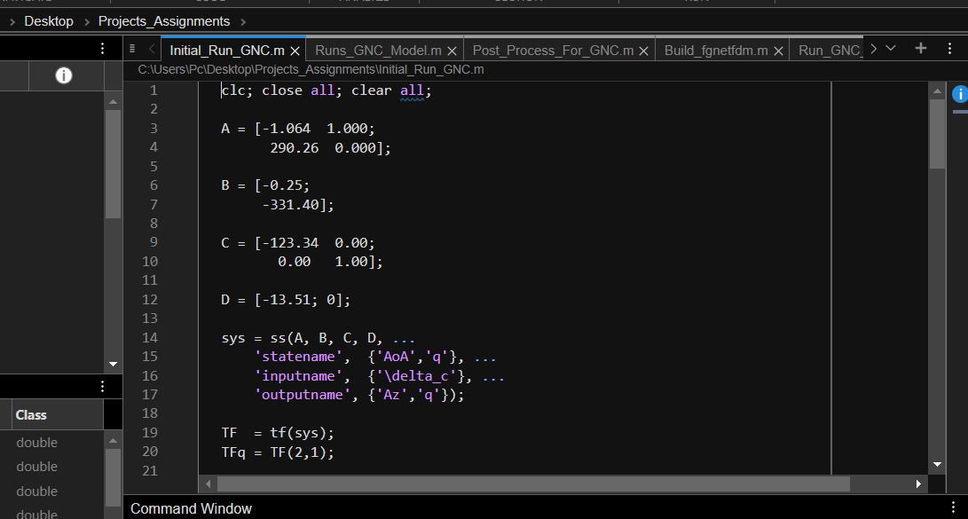
Initial Figures:
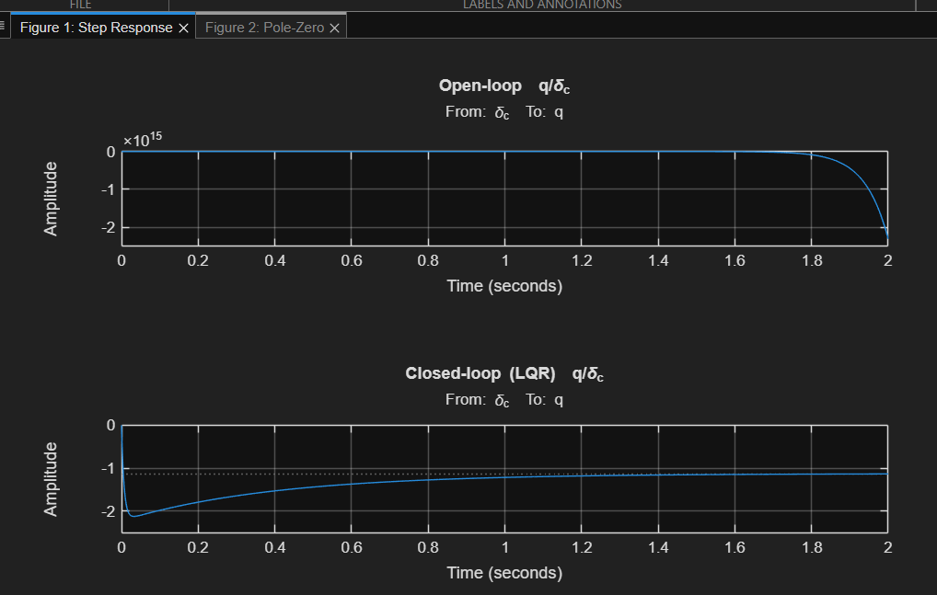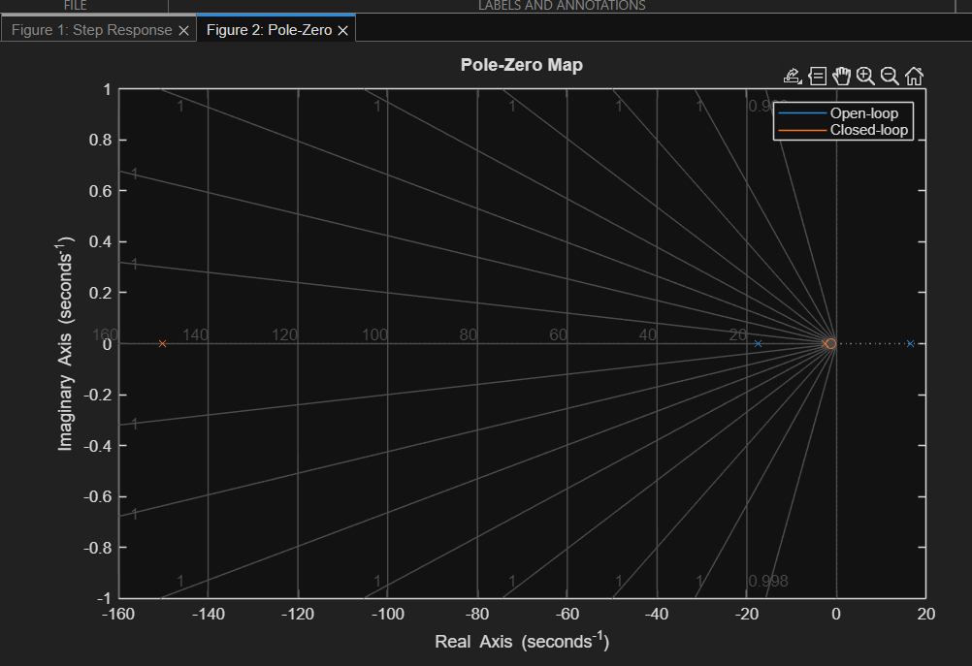
Data Extracted:
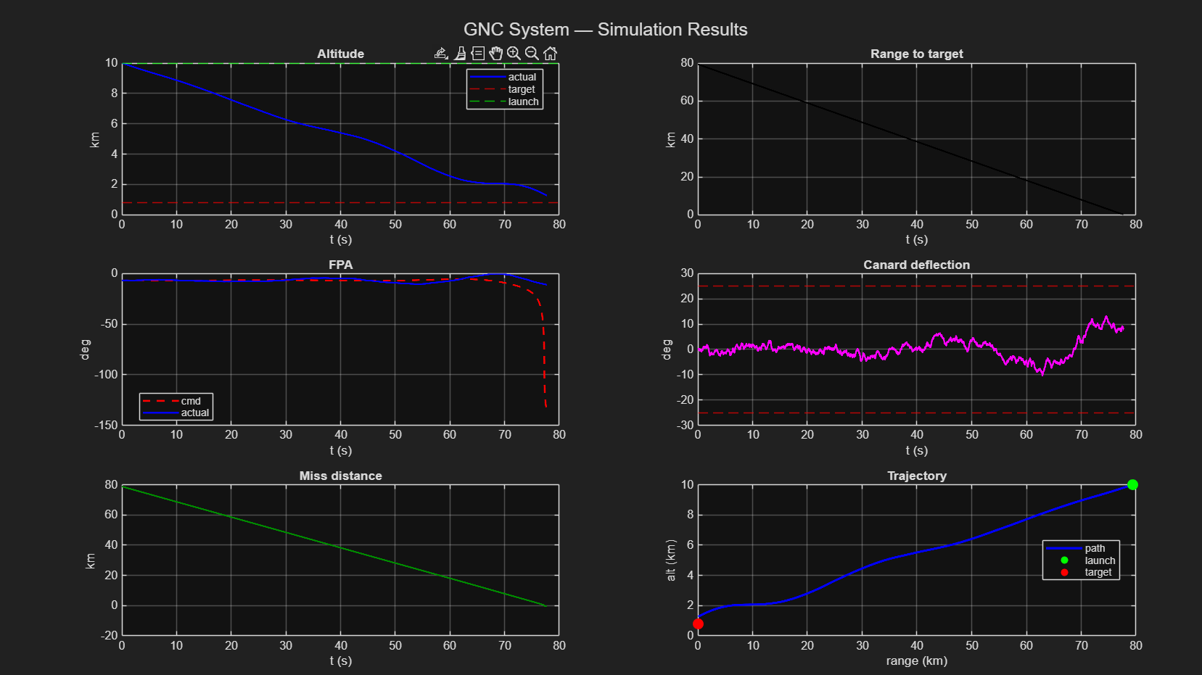
Simulink Model:
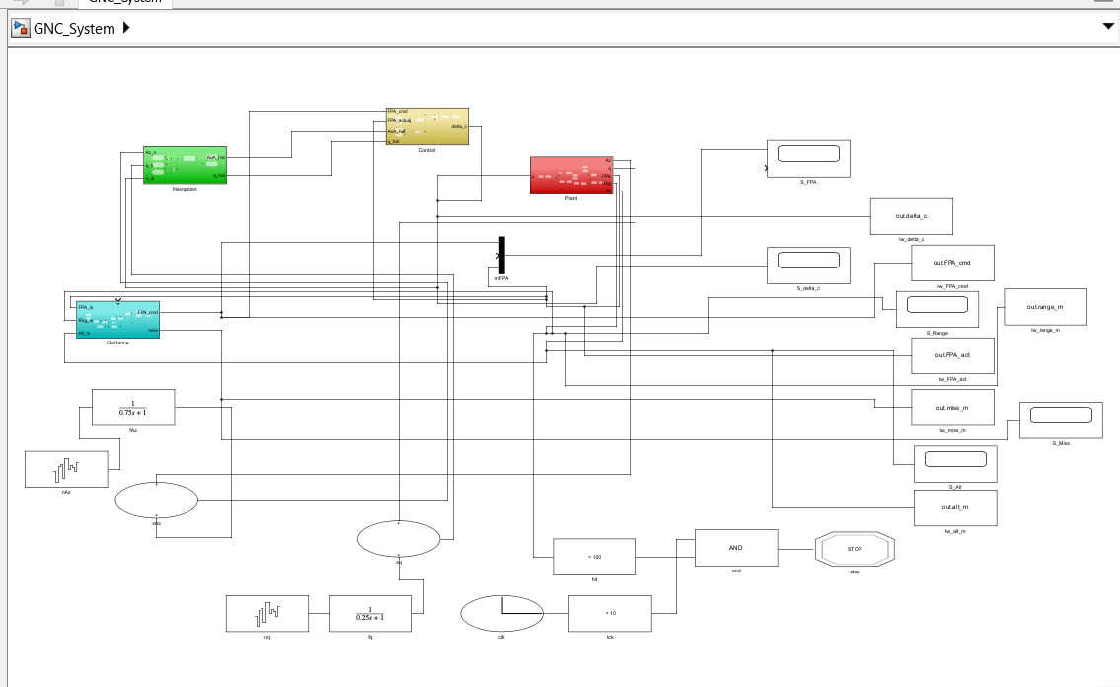
Simulink Scope Outputs:
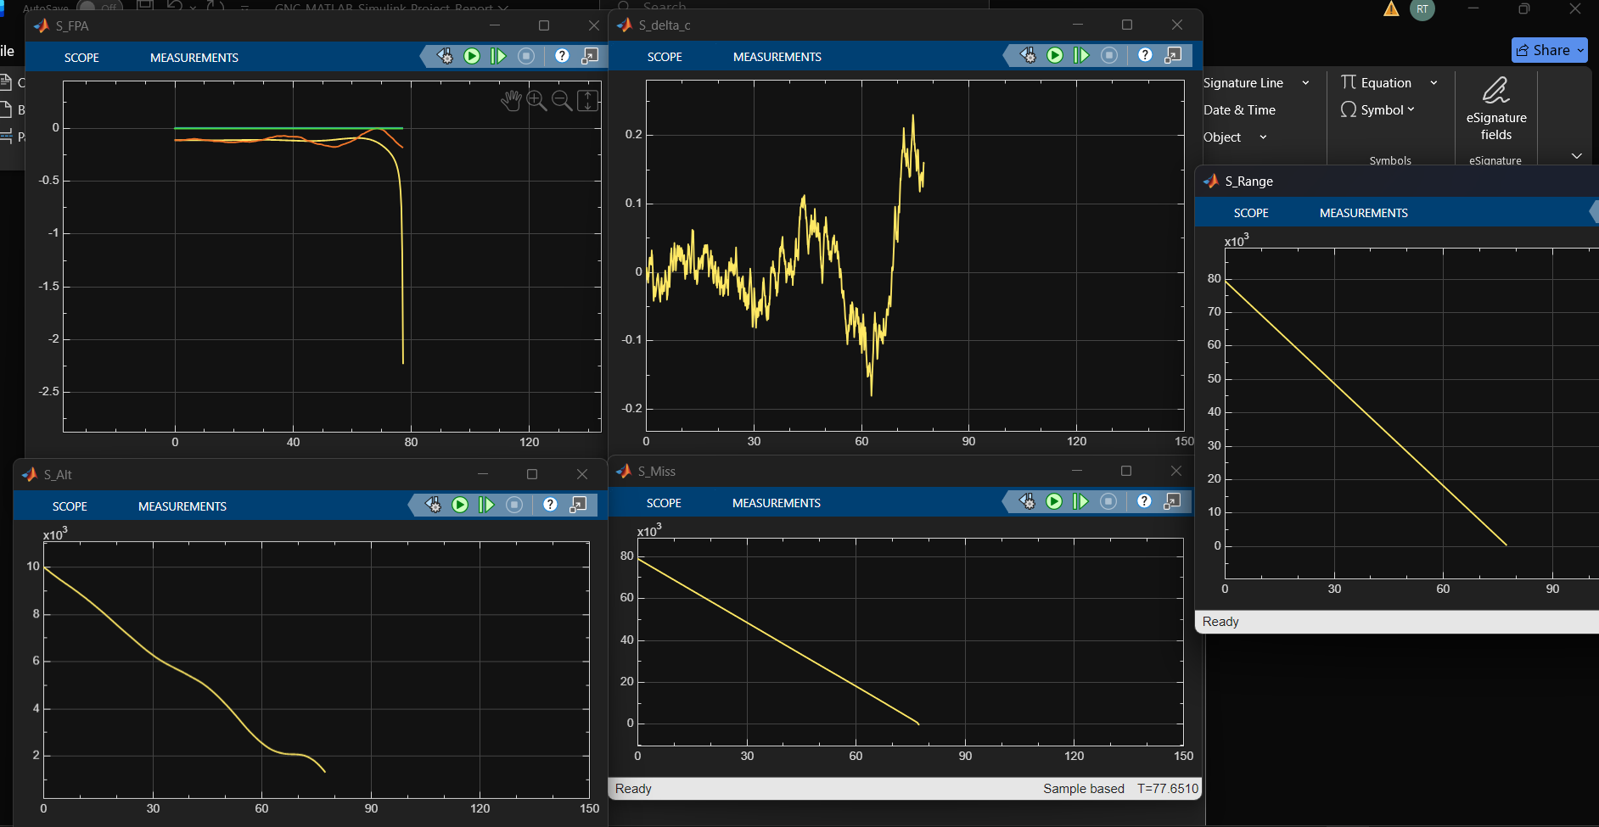
There is an experimental code for 3D Flight Gear implementation as well, try running it if possible, with the Flight Gear Module.
Also, manually click on scopes to view their outputs after running the Simulink model.

Run files in this order:
- Initial_GNC
- GNC_System (Simulink model)
- Runs_GNC_Model
- Post Process and fgnetfdm (No need to run, backend work)
- Run_GNC_3D, With Flight gear

