CA1:- python programming for story generator
INT 213
Name | Roll no | Registration no
Kiran kanth | 68 | 11910334
Raja sampath | 07 | 11907505
Praveen kumar | 10 | 11907482

Introduction:
To create a project on “Story Generator (program has already got some templates, it takes few words from user and generates a story)”

Explanation:
- In this I had used the “random module” to generate a story
- Random: It returns a random element from a list
- Syntax for random module: random. choice(sequence)
Choice () = choice method returns a randomly selected element from the specified sequence.
The sequence can be a string, a range, a list, a tuple or any kind of sequence Example:
import random
X = “PYTHON”
Print(random.choice(x))
Output: may be any letter from the string (P or Y or T or H or O or N)
Note: (“import” in python is similar to #include header_file in C/C++. Python modules can get access to code from another module by importing the file/function using import. The import statement is the most common way of invoking the import machinery, but it is not the only way.)
Same as by the example the program has already some templates and the program will ask user to enter some words and user will enter some words then the program will print the templates along with the sentence that which the user have been enter. Then the story has been generating
Step1: user will enter
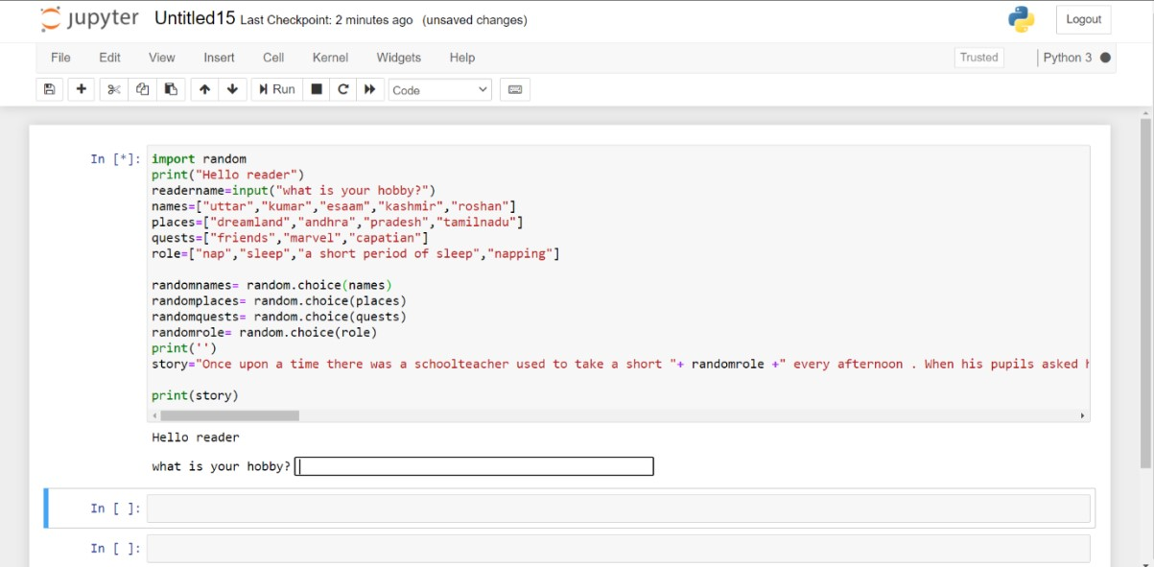
Step2: output
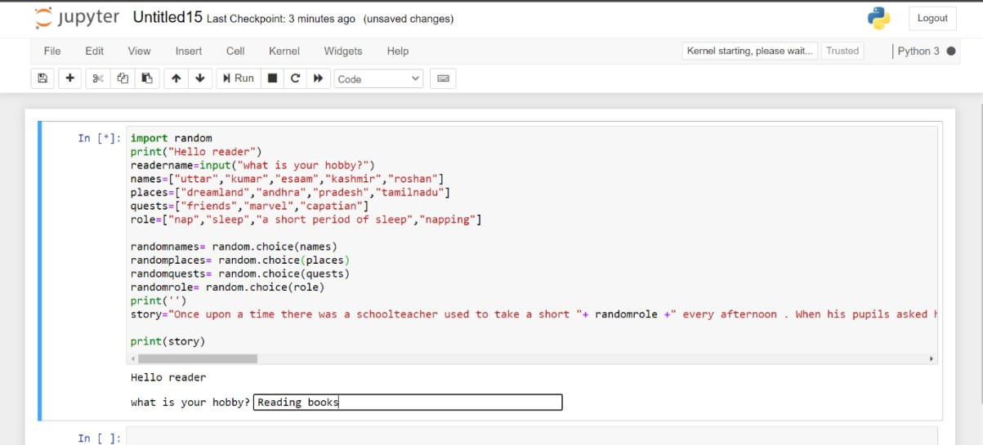

Step3: print the story along with the user input
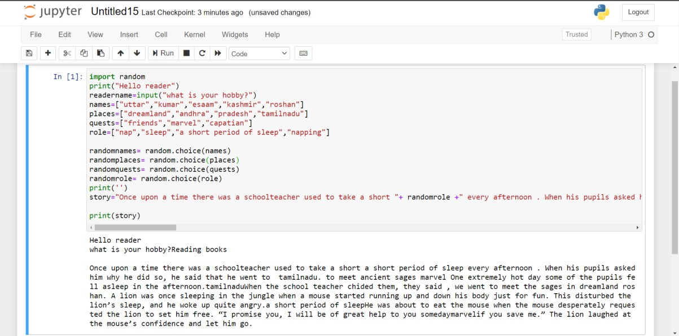
This is final output for this Source code: import random print("Hello reader")
readername=input("what is your hobby?") names=["uttar","kumar","esaam","kashmir","roshan"] places=["dreamland","andhra","pradesh","tamilnadu"] quests=["friends","marvel","capatian"]
role=["nap","sleep","a short period of sleep","napping"]

randomnames= random.choice(names) randomplaces= random.choice(places) randomquests= random.choice(quests) randomrole= random.choice(role)
print('')
story="Once upon a time there was a schoolteacher used to take a short "+ randomrole +" every afternoon . When his pupils asked him why he did so, he said that he went to "+ randomplaces +"."+" to meet ancient sages "+ randomquests +" One extremely hot day some of the pupils fell asleep in the
afternoon."+randomplaces+"When the school teacher chided them, they said , we went to meet the sages in dreamland "+ randomnames+ "."+ " A lion was once sleeping in the jungle when a mouse started running up and down his body just for fun. This disturbed the lion’s sleep, and he woke up quite angry."+ randomrole + "He was about to eat the mouse when the mouse desperately requested the lion to set him free. “I promise you, I will be of great help to you someday"+randomquests+"if you save me.” The lion laughed at the mouse’s confidence and let him go." print(story)
Note :- if we want to extend the story then we need to introduce or add the new characters into the story. But here I gone with limited characters to avoid the complexity. But I included the all.
Which are needed to a perfect story generation.
Reference :- 1) A book named python programming.
2) www.phyton.in
Conclusion :- After doing this story generator python code and Report we concluded that
This one is not that much complicated. Because we were done this in Simplified Manner. So, everyone can easily understand this code.
A Bit complicated sourcecode were used.

