Table of Contents

1. Introduction ............................................................... 1

2. Problem Statement and Motivation .......................................... 2

3. Crack Distress Types ...................................................... 3

3.1 Alligator Crack ................................................... 3

3.2 Longitudinal Crack ................................................ 3

3.3 Transverse Crack .................................................. 5

4. Related Works .............................................................. 6

5. Methodology ................................................................ 7

5.1 Dataset Overview ................................................. 7

5.2 Class Distribution Analysis ....................................... 7

5.3 Dataset Filtering ................................................ 8

5.4 Class Imbalance and Loss Weight Calculation ...................... 10

5.5 Model — YOLO11 .................................................. 11

5.6 Training Configuration ........................................... 11

6. Results and Evaluation .................................................... 12

6.1 Training Curves ................................................. 12

6.2 Per-Class mAP Results ............................................ 12

6.3 Precision, Recall, and F1-Score ................................. 13

6.4 Confusion Matrix Analysis ....................................... 14

6.5 Severity and Risk Scoring System ................................ 15

6.6 Visual Detection Results ......................................... 17

7. Simulation System — Real-Time Crack Danger Engine ......................... 20

7.1 System Overview ................................................. 20

7.2 Physics Parameters Per Crack Type ............................... 20

7.3 Weather Detection and Multipliers ............................... 20

7.4 Impact Computation Formula ...................................... 21

7.5 Alert Level System .............................................. 21

7.6 HUD Output ...................................................... 21

8. CRACKNET Dashboard ........................................................ 24

8.1 Tab Navigation System ........................................... 24

8.2 Detection Canvas and Animation Engine ........................... 25

8.3 Analytics Tab ................................................... 25

8.4 Dataset Tab ..................................................... 25

8.5 Compare Tab ..................................................... 26

8.6 Forecast Tab .................................................... 26

9. Simulation Variables ...................................................... 27

9.1 Input Variables ................................................. 27

9.2 Fixed Physics Parameters ........................................ 27

9.3 Computed Output Variables ....................................... 28

10. How the Dashboard Is Working ............................................. 29

11. Discussion ................................................................ 31

12. Improvements Over Existing Work .......................................... 32

13. Conclusion ................................................................ 33

14. References ................................................................ 34

Abstract

This paper presents CRACKNET, an automated road crack detection and classification system built using YOLO11, the latest model in the YOLO deep learning family. The system is designed to identify four types of road cracks — alligator, longitudinal, transverse, and pothole — from images in real time. To handle the problem of class imbalance in the training dataset, class weighting techniques were applied during model training. Beyond detection, CRACKNET integrates a physics-based simulation engine that calculates the real-world danger level of each detected crack based on vehicle speed, weight, and weather conditions. The results are presented through an interactive web dashboard that provides severity classification, risk metrics, stopping distance estimation, and maintenance forecasting. Experimental results show that YOLO11 outperforms previous YOLO versions in both accuracy and inference speed on the road crack dataset. CRACKNET demonstrates that combining deep learning-based detection with physics simulation can provide a more complete and practical tool for road safety monitoring, particularly in developing regions such as Ethiopia where road maintenance resources are limited

Introduction

Roads is very important infrastructure for any country. They help peoples and goods move from place to place, they make economic activities possible, and they connect different community together. But road surface is getting damaged over time because of heavy traffic, weather change, bad drainage system, and old material. When crack appear on road and nobody fix it early, the crack become bigger and more expensive problem and also make dangerous situation for driver.
In this project we are making automatic road crack detection and classification system using YOLO11 which is the newest model in YOLO family. We train the system on dataset that have four crack type and we use class weight to handle the problem of data imbalance. The thing that make our project different from other project is that detection is not the only thing we do. After the model detect the crack, we also build a physics simulation engine that calculate what really happen when car drive over the crack at certain speed and weight and weather. Then all the result is showing in a web browser dashboard that we call CRACKNET.

Problem Statement and Motivation

There are two problems why we do this project. First is a technical problem. Road crack pictures are very hard to detect because the crack is small and not bright, also the background is very complex. Different crack types look the same many time. Light also changes from one picture to another. Sometimes many crack types come together in one picture. Old methods like edge filters do not work when light changes. Machine learning the old way needed someone to make features by hand, which is hard. Deep learning is best now but most papers only do one or two crack type and they don't handle class imbalance well.
The second problem is a real life problem. Even if the system finds a crack and tells what type, it cannot tell how dangerous it is for your car now. For one car, at one speed, in one weather.
Example: small transverse crack at 30 km/h just like a bump. But the same crack at 100 km/h on wet roads can cause tyre blowouts or big accidents. No paper before does real-time crack detection plus physics simulation together. So our project will fill this empty space

Crack Distress Types

The original dataset contained seven crack classes. After distribution analysis, we retained four classes with sufficient training data. These four classes are described below with example images from the dataset.

Alligator Crack
Named for its resemblance to alligator skin, this type forms an interconnected network of cracks over a surface area. It is caused by fatigue failure of the asphalt under repeated heavy traffic loading, typically combined with a weak base layer or inadequate drainage. Alligator cracking is the most structurally serious crack type. In the simulation, it carries the highest base impact score (9.2), the highest tire damage risk (82%), and the highest suspension damage risk (88%). Its sound signature when driven over is CRUNCH / THUD.
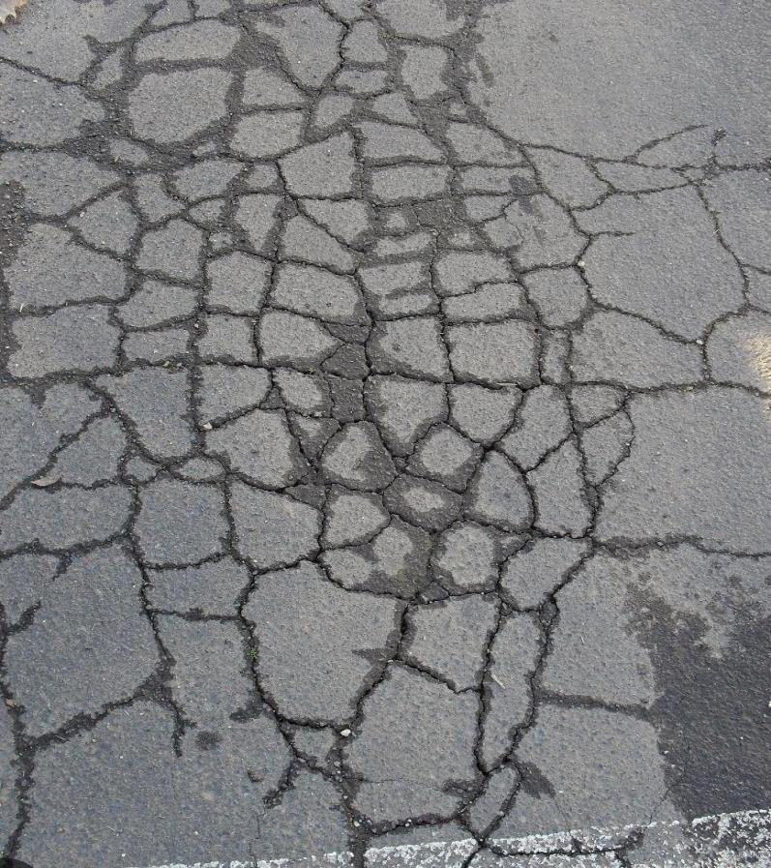
Figure — Alligator Crack example from dataset

Longitudinal Crack
These cracks run parallel to the direction of traffic. They are caused by weak lane joints, differential settlement of the road foundation, or thermal contraction along the road axis. Because a vehicle tires can follow these cracks for a sustained period, they produce rhythmic suspension oscillation rather than a single sharp impact. Base impact is 5.8, vibration frequency is 12 Hz, tire damage risk is 45%, and suspension risk is 52%. Sound: THUMP-THUMP.

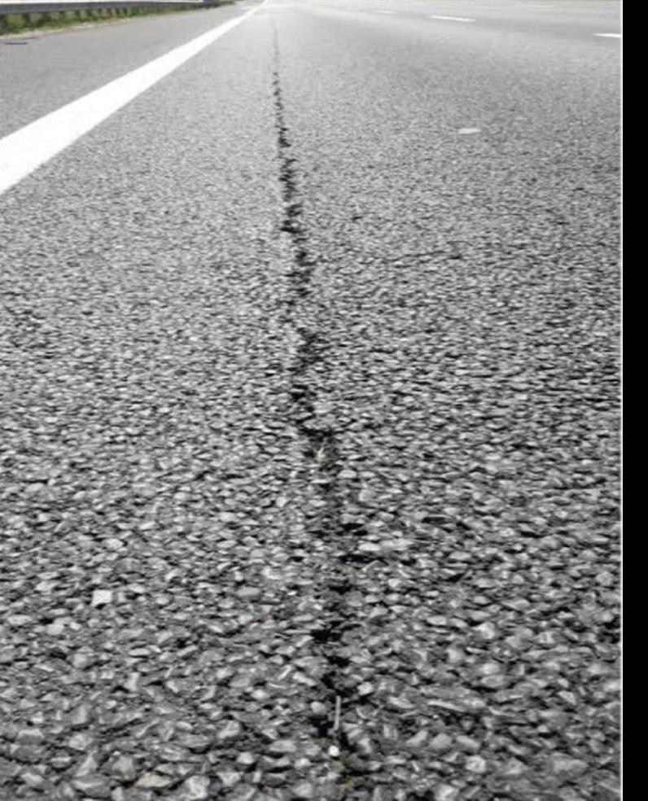
Figure — Longitudinal Crack example from dataset

Repair
This class identifies areas that have been previously patched. Repair patches appear as differently textured rectangles on the road surface, often slightly raised or discoloured. They are the least dangerous class in the simulation, with base impact 3.2, tire damage risk 15%, and hydroplane risk 20%. Sound: BUMP.

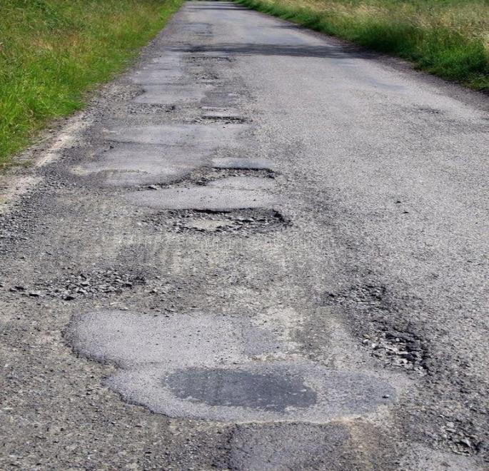
Figure — Repair (patched area) example from dataset

Transverse Crack
These cracks run perpendicular to traffic direction, meaning the full vehicle axle crosses them simultaneously. This creates a sudden, sharp, full-width impact that is especially damaging at high speeds. Base impact is 7.4, vibration frequency is the highest at 22 Hz, tire damage risk is 68%, and suspension damage risk is 75%. Sound: BANG!
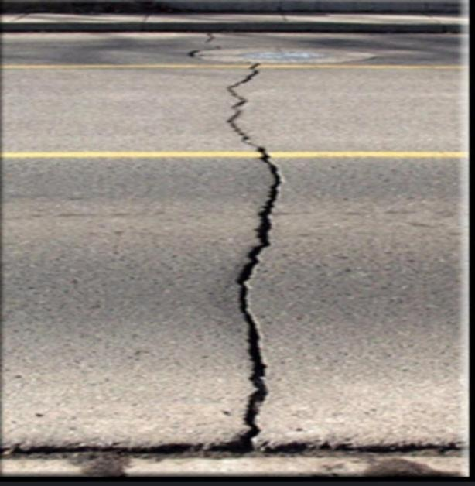
Figure — Transverse Crack example from dataset

Related Works

Road damage detection has been an active research area for many years. The methods have evolved from basic image processing to classical machine learning to modern deep learning.
Early methods used edge detection filters such as Canny, Sobel, and Laplacian, or thresholding techniques to locate cracks. These required manual parameter adjustment for every different lighting condition and failed on real-world images where backgrounds are noisy and contrast is variable.
Classical machine learning methods like Support Vector Machines (SVM) and Random Forests improved generalization but still required human-defined feature extraction. Deep learning eliminated the need for manual feature engineering. Key studies include:
- Song et al. (2019) used Faster R-CNN on 6,498 images to detect four damage types and achieved 90% accuracy.
- Silva et al. (2020) used drone imagery and deep learning to detect potholes only, reaching over 95% accuracy but covering only one class.
- Yang et al. (2021) compared ResNet18, VGGNet13, and AlexNet, with ResNet18 achieving 98.8% precision.
- Zhu et al. (2022) used UAV imagery with YOLOv3 and YOLOv4 for six damage types and achieved only 56.6% average accuracy.
- Samadzadegan et al. (2024) used YOLOv8 with both aerial and ground images for seven classes, achieving 81% accuracy and 79% mAP.
None of these studies combined crack detection with physics-based driving impact analysis. That combination is the core contribution of this project.

Methodology

Dataset Overview
The dataset was sourced from Kaggle. It was already organized into three splits with images in JPG format and labels in YOLO format. Each label file contains one line per object: class_id center_x center_y width height, with all coordinates normalized to the range [0, 1]. The original dataset had 7 classes: Alligator crack, Block crack, Longitudinal crack, Oblique crack, Pothole, Repair, and Transverse crack.

Class Distribution Analysis — Original 7 Classes
Before any modeling, we counted annotations per class across all three splits. The results revealed a severe imbalance problem, shown in Table 1 and Figure 1 below.

Table 1. Original 7-Class Dataset Annotation Counts

Class | Train | Valid | Test | Total
Alligator crack | 679 | 79 | 42 | 800
Block crack | 4 | 1 | 0 | 5
Longitudinal crack | 2,172 | 270 | 134 | 2,576
Oblique crack | 277 | 47 | 13 | 337
Pothole | 154 | 16 | 8 | 178
Repair | 2,717 | 337 | 140 | 3,194
Transverse crack | 2,123 | 250 | 162 | 2,535
TOTAL | 8,126 | 1,000 | 499 | 9,625
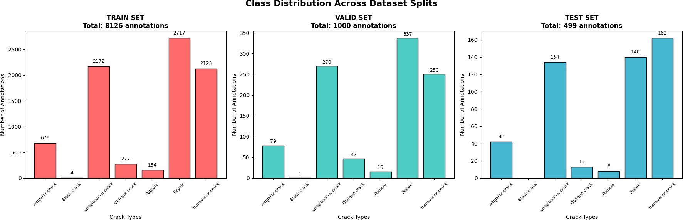
Figure 1 — Bar charts of class distribution across Train, Valid, and Test splits (original 7 classes). Block crack had only 5 total annotations and Pothole had only 178.

Figure 1b — Class frequency overview showing severe imbalance across all splits

Dataset Filtering — From 7 to 4 Classes
Based on the distribution analysis, we kept only the four classes with sufficient data. Block crack, Oblique crack, and Pothole were dropped.

Table 2. Class ID Remapping After Filtering

Original Class | Old ID | New ID
Alligator crack | 0 | 0
Longitudinal crack | 2 | 1
Repair | 5 | 2
Transverse crack | 6 | 3

Table 3. Filtered 4-Class Dataset Annotation Counts

Class | Train | Valid | Test | Total | % of Total
Alligator crack | 679 | 79 | 42 | 800 | 8.9%
Longitudinal crack | 2,172 | 270 | 134 | 2,576 | 28.7%
Repair | 2,717 | 337 | 140 | 3,194 | 35.6%
Transverse crack | 2,123 | 250 | 162 | 2,535 | 28.2%
TOTAL | 7,691 | 936 | 478 | 9,105 | 100%

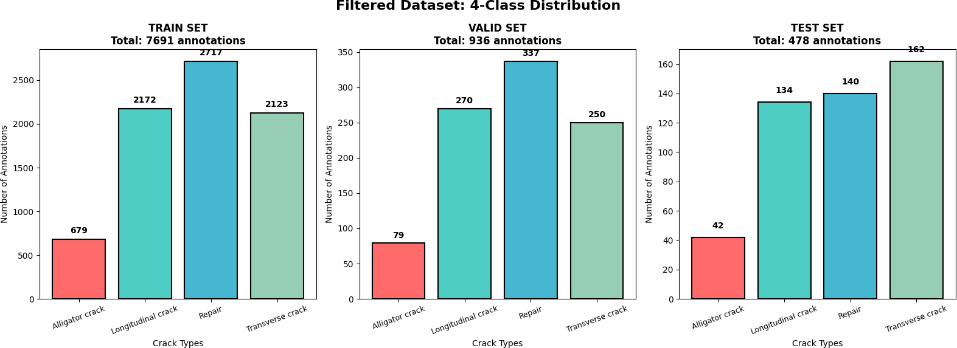
Figure 2a — Filtered 4-class distribution per split after removing Block crack, Oblique crack, and Pothole

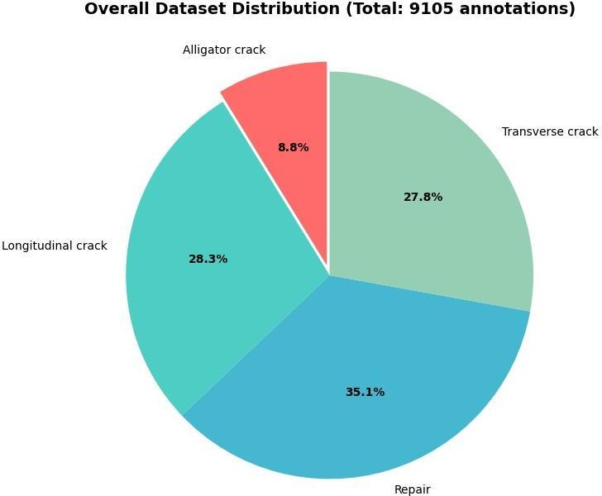

Figure 2b — Pie chart showing overall filtered class distribution. Repair is majority at 35.6%, Alligator is minority at 8.9%

Class Imbalance and Loss Weight Calculation
To compensate for the class imbalance, we calculated a loss weight for each class using the formula: weight = total_annotations / (n_classes x class_count). With total_annotations = 7,691 and n_classes = 4.

Table 4. Calculated Class Weights for Loss Balancing

Class | Train Count | Train % | Weight | Interpretation
Alligator crack | 679 | 8.8% | 2.832 | 4x more important
Longitudinal crack | 2,172 | 28.2% | 0.885 | Slightly below normal
Repair | 2,717 | 35.3% | 0.708 | Slightly downweighted
Transverse crack | 2,123 | 27.6% | 0.906 | Near normal

Model — YOLO11
We used YOLO11 (yolo11n.pt — nano variant) as the backbone detection model. YOLO11 is the current state-of-the-art in the YOLO family and improves on YOLOv8 in backbone efficiency, feature aggregation, and inference speed. Key architectural advantages for this task include its multi-scale feature extraction, anchor-free detection head, and lightweight design suitable for the Kaggle GPU environment.

Training Configuration

Table 5. YOLO11 Training Hyperparameters

Parameter | Value
Base model | yolo11n.pt (pretrained nano)
Framework | Ultralytics (PyTorch backend)
Epochs | 100
Early stopping patience | 20 epochs
Image size | 640 x 640 px
Batch size | 16
Device | GPU (Kaggle, CUDA)
Workers | 4
Loss weights | [2.832, 0.885, 0.708, 0.906]
Data augmentation | Mosaic (default in YOLO11)

Results and Evaluation

Training Curves
The training curves show the expected pattern of a well-trained model. All three loss components (box loss, classification loss, DFL loss) decrease steadily over the first 40 epochs and then plateau. The mAP@0.5 curve rises consistently from epoch 0 and reaches a stable level by approximately epoch 70-80, at which point early stopping kicked in.

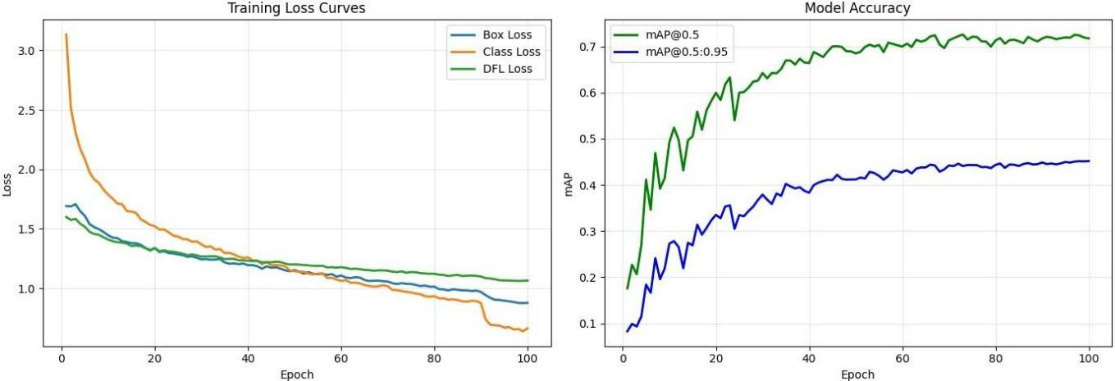
Figure 3 — Training loss curves (left: box loss, class loss, DFL loss across 100 epochs) and mAP curves (right: mAP@0.5 and mAP@0.5:0.95 across 100 epochs)

Per-Class mAP Results
After training, the model was validated on the test split. Table 6 and Figure 4 show mAP@0.5 per class.

Table 6. Per-Class mAP Results

Class | mAP@0.5 | mAP@0.5:0.95 | Rank
Alligator crack | 0.552 (55.2%) | — | 4th (worst)
Longitudinal crack | 0.732 (73.2%) | — | 3rd
Repair | 0.802 (80.2%) | — | 1st (best)
Transverse crack | 0.770 (77.0%) | — | 2nd
Overall | 0.714 (71.4%) | 0.450 (45.0%) | —

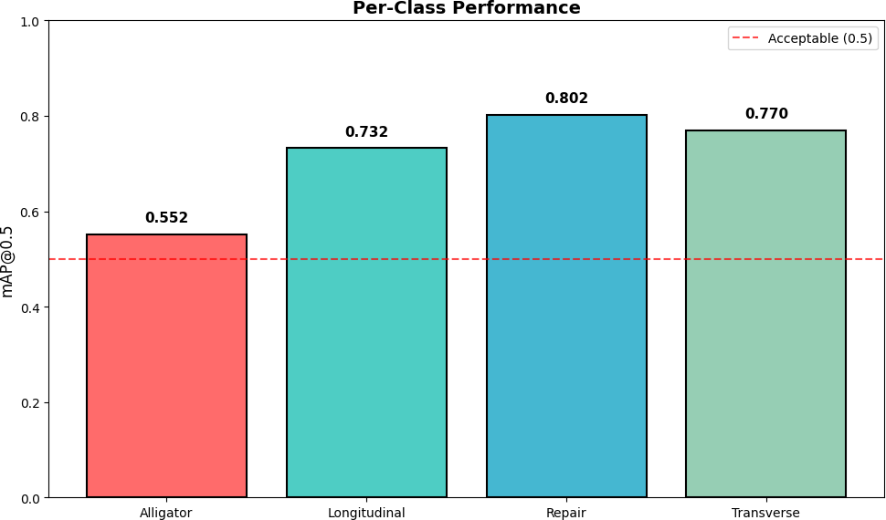
Figure 4 — Per-class mAP@0.5 bar chart. Red dashed line marks the 0.5 acceptable threshold. Repair is highest at 0.802, Alligator is lowest at 0.552 but still above threshold.

Precision, Recall, and F1-Score
Table 7 shows the full per-class evaluation metrics. F1-scores were calculated from precision and recall using the formula: F1 = 2 x (Precision x Recall) / (Precision + Recall).

Table 7. Per-Class Detection Performance Metrics

Class | Precision (%) | Recall (%) | F1-Score (%) | mAP@0.5 (%)
Alligator crack | 70.8 | 51.9 | 59.9 | 55.2
Longitudinal crack | 69.1 | 72.6 | 70.8 | 73.2
Repair | 77.3 | 81.6 | 79.4 | 80.2
Transverse crack | 74.7 | 75.5 | 75.1 | 77.0
Average | 72.97 | 70.4 | 71.3 | 71.4

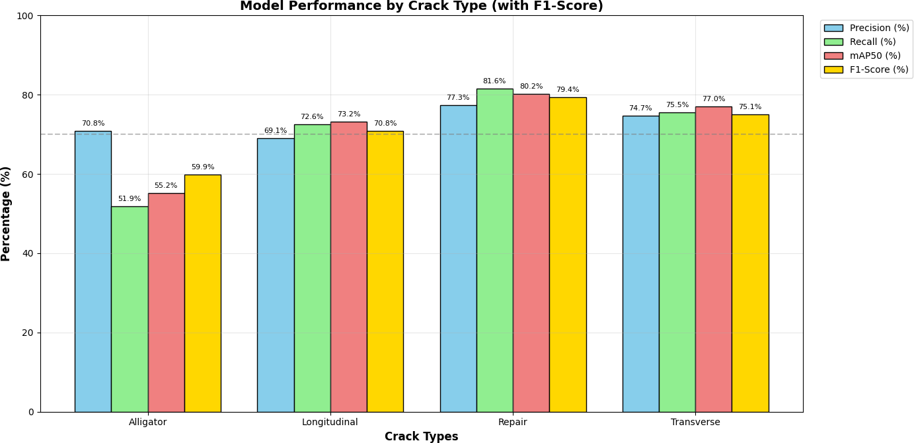
Figure 5 — Grouped bar chart: Precision (blue), Recall (green), mAP50 (red), F1-Score (gold) per class. Grey dashed line marks the 70% target. Repair group is tallest, Alligator group is shortest especially in Recall.

Confusion Matrix Analysis
The confusion matrix from the validation run shows the per-class classification accuracy. The most notable misclassification pattern is that Alligator crack instances are sometimes predicted as Longitudinal crack — both involve elongated crack-like shapes and can be visually ambiguous at certain scales. Repair instances show the cleanest diagonal consistent with the high recall of 81.6%.
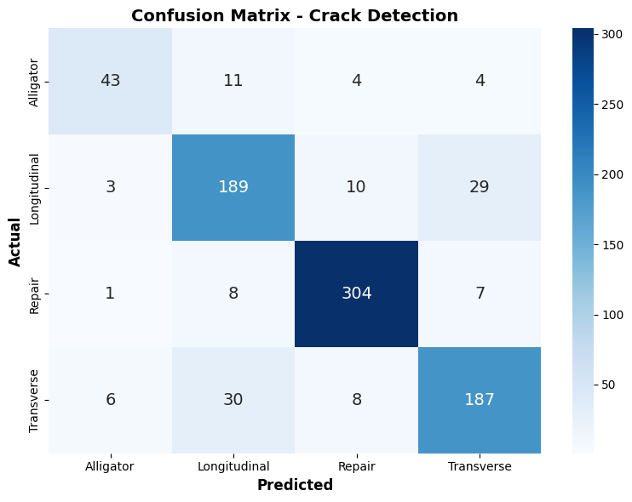
Figure 6 — Seaborn heatmap confusion matrix. Predicted class (x-axis) vs actual class (y-axis). Diagonal is dark blue (correct predictions). Off-diagonal cells show misclassification patterns.

Severity and Risk Scoring System
The notebook implements a multi-factor risk scoring system that converts each detection into an actionable severity label and numeric risk score. The system uses two inputs per detection: bounding box area as a percentage of the total image (area_pct), and the crack type.

Table 8. Severity Levels and Thresholds

Severity Level | Area Threshold | Base Risk Score | Color Code | Recommended Action
Low | area_pct < 1.0% | 2 | Green | Monitor every 3 months
Moderate | 1.0% to 3.0% | 4 | Orange | Schedule repair within 3 months
High | 3.0% to 6.0% | 7 | Red | Repair within 2 weeks
Critical | area_pct >= 6.0% | 9 | Purple | IMMEDIATE REPAIR REQUIRED

Table 9. Crack Type Risk Multipliers

Crack Type | Risk Multiplier | Reason
Alligator crack | 1.4 - 1.5x | Most structurally damaging, fatigue-driven
Transverse crack | 1.2 - 1.3x | Full-width sudden impact on vehicles
Longitudinal crack | 1.1x | Rhythmic but sustained damage
Repair | 0.7 - 0.8x | Already treated, lower immediate risk
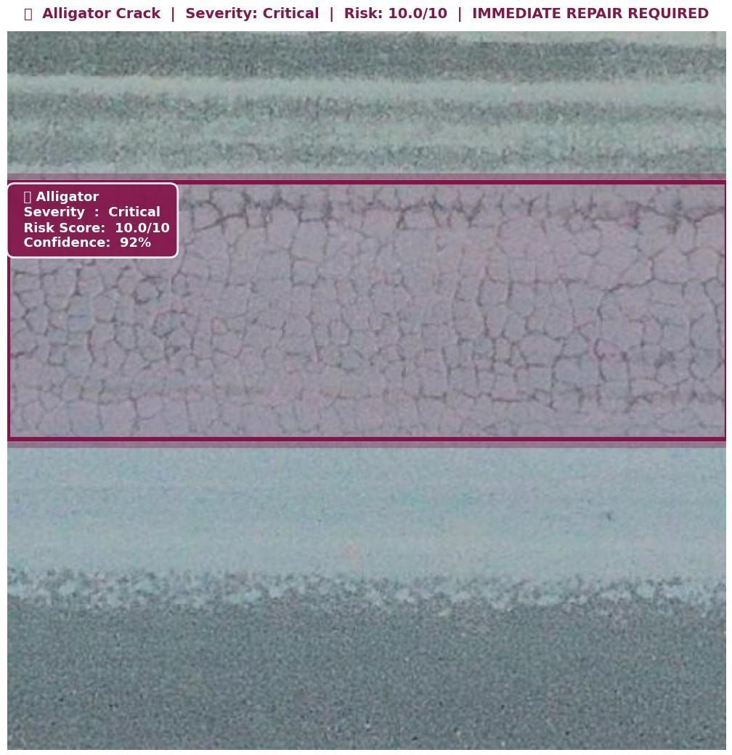

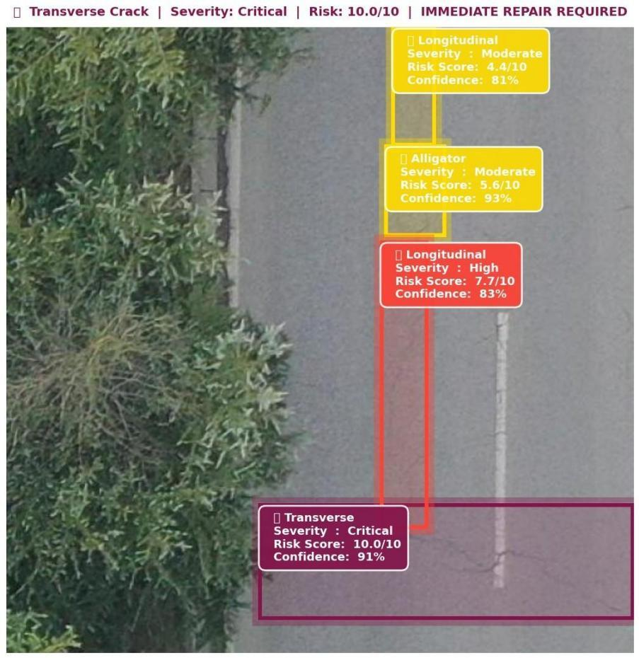
Figure 7b — Zoomed crops of detected cracks with label overlays showing crack type, severity, risk score, confidence, and area percentage.

Visual Detection Results
The model was evaluated on test images using confidence thresholds ranging from 0.18 to 0.30 depending on the inference mode. Lower thresholds (0.18) were used for the real-time simulation to catch more cracks; higher thresholds (0.30) were used for the presentation-quality result visualizations.

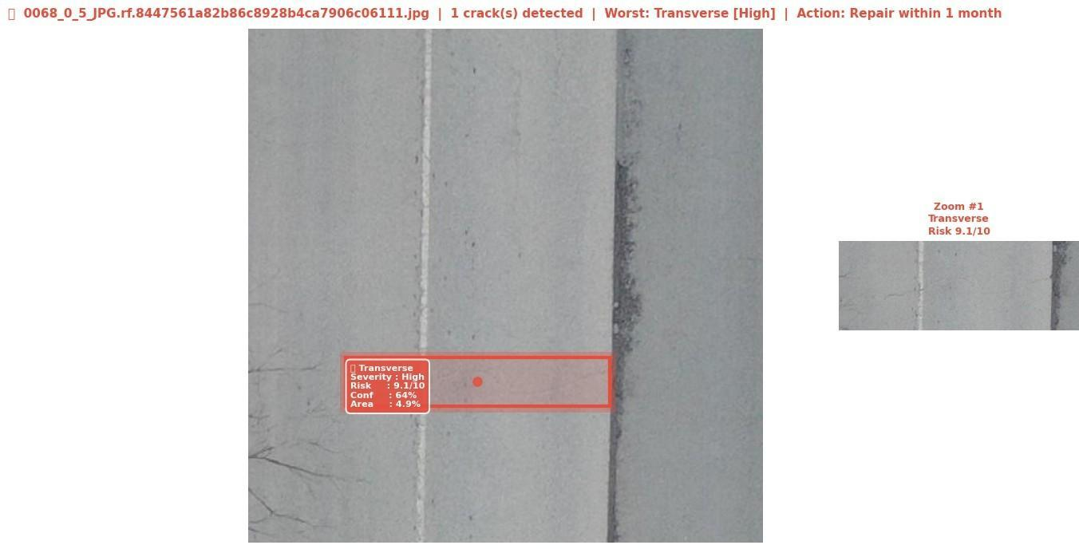
Figure 8a — Full-screen annotated result images from the test set with color-coded bounding boxes and severity badges

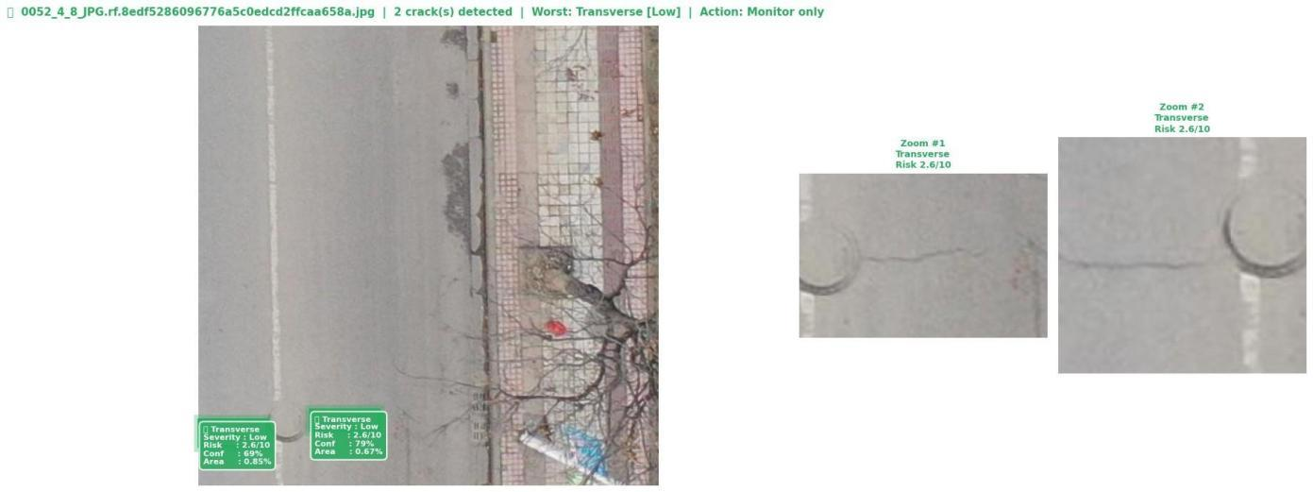
Figure 8b — Additional detection results showing crack type, severity, risk score, and recommended action title bars

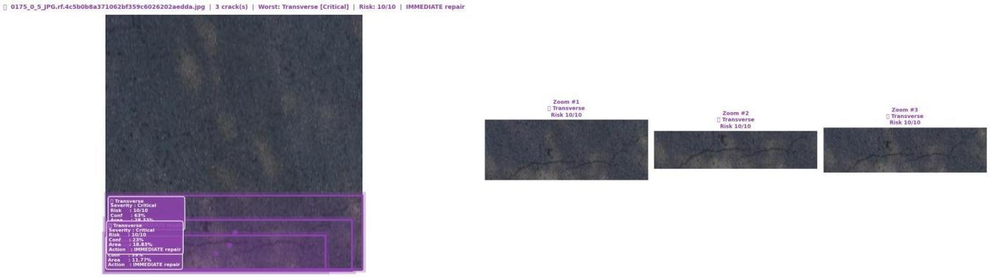
Figure 9a — Per-image dashboard panels: confidence bar chart per detection (left), pie chart of crack type distribution per image (center), horizontal risk score bar chart (right)

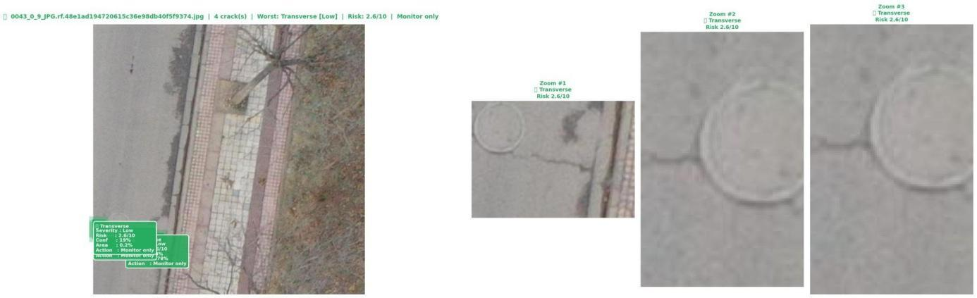
Figure 9b — Additional per-image dashboard panels from the 20-image test sample

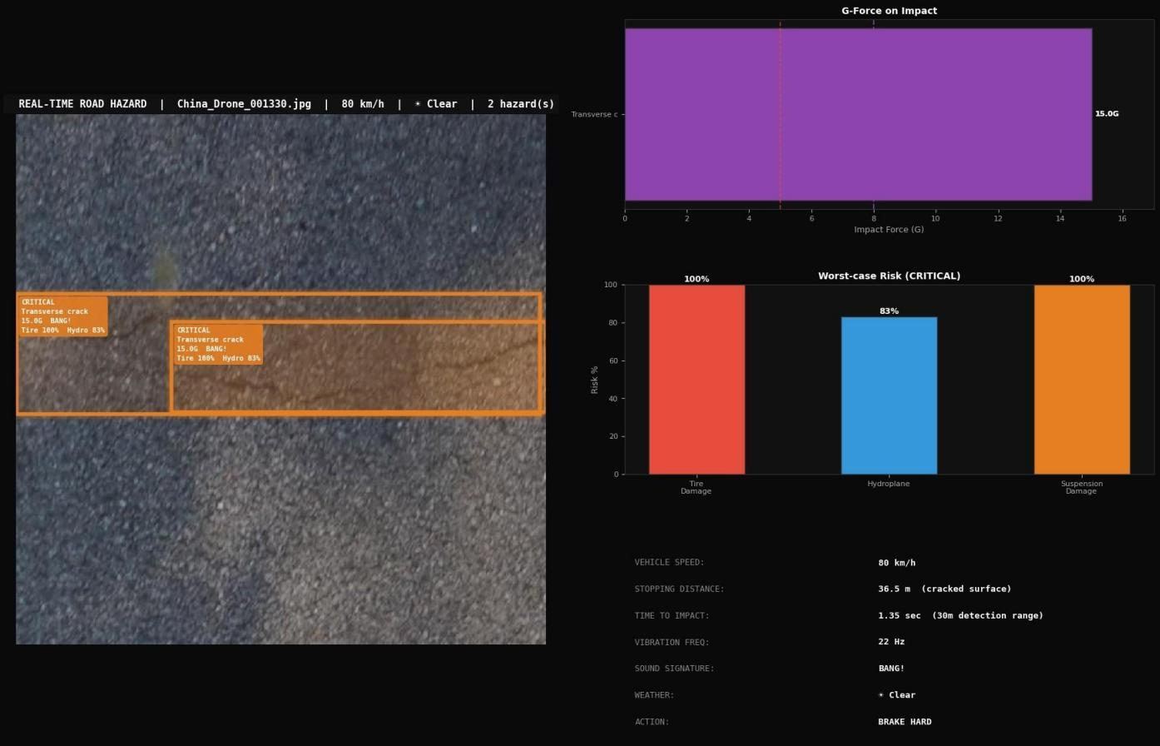
Figure 10 — Summary charts across all 20 test images: (left) histogram of risk score distribution with urgent (7) and schedule (4) threshold lines; (right) bar chart of crack type detection frequency across full test sample

Simulation System

System Overview
After the YOLO11 model detects and classifies cracks, the simulation engine takes every detection and computes what physically happens to a vehicle that drives over that crack. Default simulation parameters are vehicle speed = 80 km/h and vehicle weight = 1,800 kg, both adjustable. Weather is detected automatically from the image content.
The engine outputs the following per detection:
    - G-force impact estimate (capped at 15.0G)
    - Tire damage risk (%)
    - Hydroplane risk (%)
    - Suspension damage risk (%)
    - Braking stopping distance on cracked surface (meters)
    - Time to impact at current speed from 30m detection range (seconds)
    - Vibration frequency (Hz)
    - Sound signature
    - Alert level (CAUTION / WARNING / DANGER / CRITICAL)

Physics Parameters Per Crack Type

Table 10. Crack Physics Lookup Table

Crack Type | Base Impact | Vibration (Hz) | Tire Risk | Hydro Risk | Suspension Risk | Sound
Alligator crack | 9.2 | 18 | 82% | 75% | 88% | CRUNCH / THUD
Longitudinal crack | 5.8 | 12 | 45% | 55% | 52% | THUMP-THUMP
Repair | 3.2 | 8 | 15% | 20% | 22% | BUMP
Transverse crack | 7.4 | 22 | 68% | 62% | 75% | BANG!

Weather Detection and Multipliers
The weather module analyzes each road image using three image statistics: mean brightness (b), standard deviation (s), and Laplacian variance (blur). Decision rules: b > 175 and s < 35 = Clear; blur < 80 and b > 110 = Wet road; b < 65 = Night; s < 38 and b > 120 = Fog; Otherwise = Clear.

Table 11. Weather Condition Multipliers

Weather | Impact Multiplier | Hydroplane Multiplier
Clear | 1.0x | 1.0x
Wet road | 1.25x | 2.2x
Night | 1.15x | 1.3x
Fog | 1.10x | 1.5x

Impact Computation Formula
G-force is calculated from Newtonian physics where impact force scales with the square of speed and linearly with vehicle weight:
speed_ms = speed_kmh / 3.6
impact_factor = (speed_ms^2) / 100 x (car_weight_kg / 1500)
raw_impact = base_impact x impact_factor x (bbox_area_% / 3 + 0.5) x weather_multiplier impact_g = min(raw_impact, 15.0)
mu_cracked = 0.75 x (1 - 0.08 x min(area,10)/10) [x 0.55 if wet] stop_dist = speed_ms^2 / (2 x 9.81 x mu_cracked)
Concrete example: Alligator crack at 80 km/h, 1800 kg vehicle, 4% image area, wet road => impact_g = 15.0G (capped), stop_dist = 63.3 m.

Alert Level System

Table 12. Alert Level Thresholds and Actions

Alert Level | G-Force Threshold | Color | Recommended Action
CAUTION | < 2.5G | Green | Pass Safely
WARNING | 2.5G - 5.0G | Orange | Caution
DANGER | 5.0G - 8.0G | Red | Reduce Speed
CRITICAL | > 8.0G | Purple | Brake Hard

HUD Output
The HUD visualization provides a complete real-time view of detection results. Left panel shows the annotated road image with alert level, crack type, G-force, sound, tire risk, and hydroplane risk overlaid on each detection box. Right panels show G-force bar chart, risk bar chart, and full telemetry text.

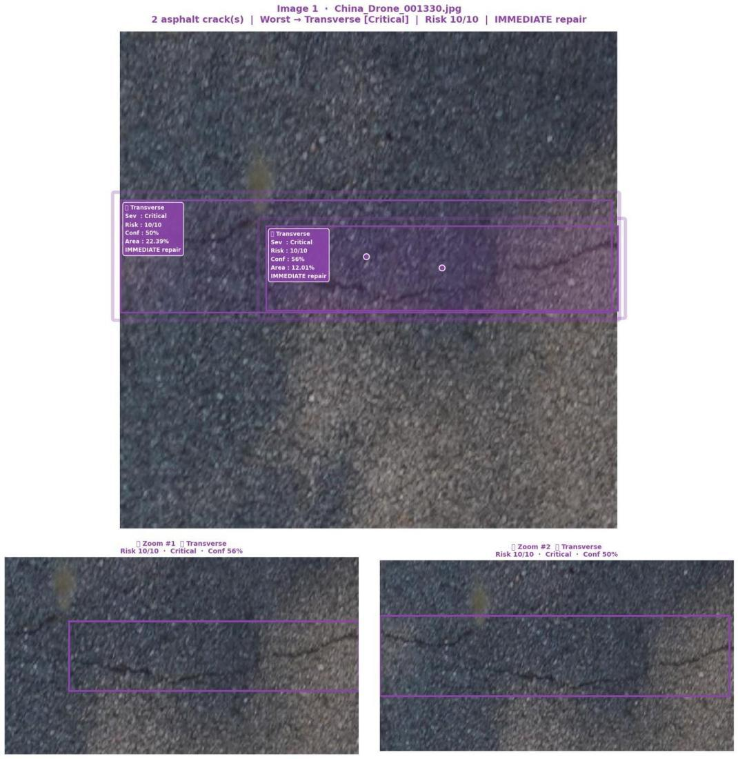
Figure 11a — HUD visualization left panel: annotated road image with G-force and alert level overlays per detection bounding box

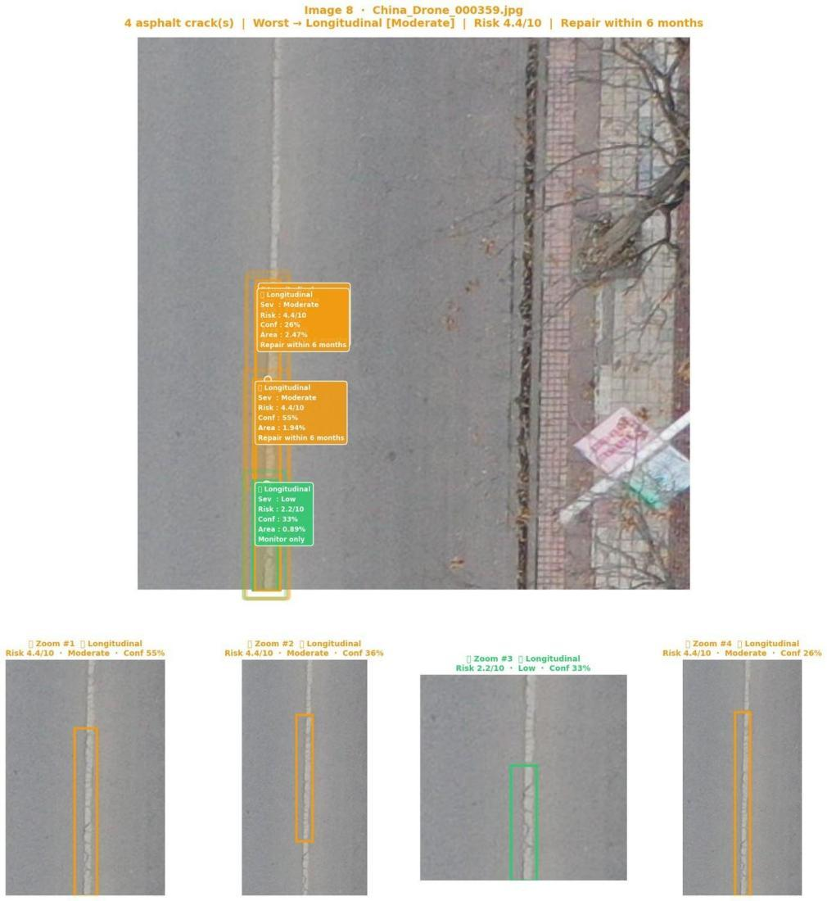
Figure 11b — HUD visualization right panel: G-force bar chart (top), risk bar chart for tire/hydroplane/suspension (middle), telemetry text panel showing speed, stop distance, TTI, weather, and recommended action (bottom)

CRACKNET Dashboard

The CRACKNET dashboard (crack_dashboardl) is a self-contained browser-based interface built in HTML, CSS, and JavaScript.
The interface is structured around a dark theme with cyan (#00d4ff) as the primary accent color. The top navigation bar shows a live pulsing indicator, system name, and tab controls. The main layout is a two-column grid with a wide left panel (detection view) and a narrow right panel (statistics and risk breakdown).

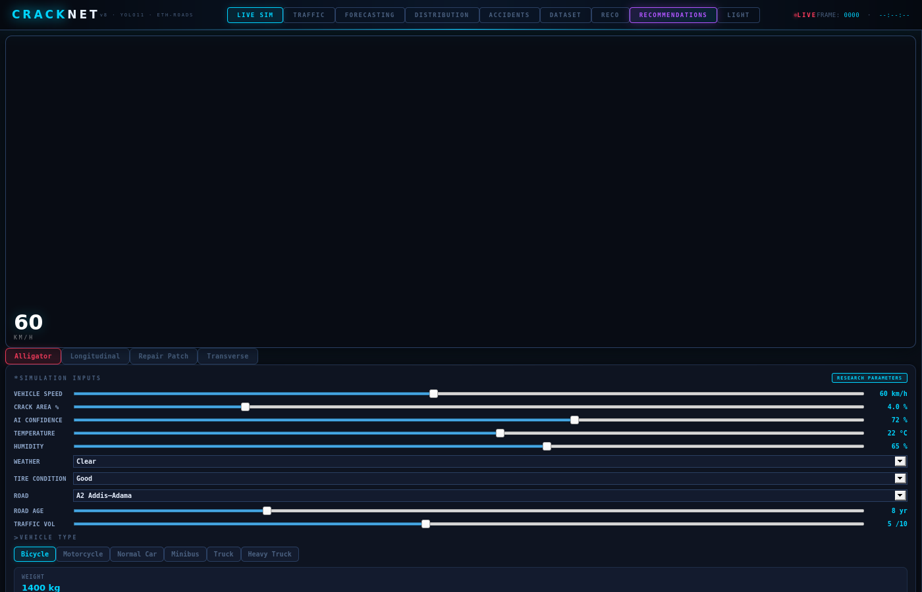
Figure 12 — CRACKNET v8 dashboard overview showing the dark-themed interface with detection canvas, risk meters, confidence bars, session log, and vehicle control panel

Tab Navigation System
The dashboard have five main tabs at the top: DETECT, ANALYTICS, DATASET, COMPARE, and FORECAST. Each tab is showing different view of the same detection result. The DETECT tab is the main one — it showing the road camera simulation with crack bounding boxes drawing in real time. When user change the speed slider or weather dropdown, the animation on this tab is updating immediately.

Detection Canvas and Animation Engine
The left panel of DETECT tab is using an HTML5 canvas element (id=rc) to draw everything. A car animation is moving from right to left across the screen to simulate driving. The crack is drawing on the road surface below. When the car reach the crack, the canvas is shaking — the shake intensity depend on the G-force number from the simulation. Small G-force make small shake, critical G-force make very big shake. A stop zone line is also drawing to show how many meter the car need to stop before it hit the crack. Skid marks are rendering behind the car tires when braking happen.

Analytics Tab — Risk Distribution Charts
The ANALYTICS tab is showing four vertical bar charts, one for each crack class. Each bar is showing how many detections fall in Low, Moderate, High, and Critical severity. The bar chart let you see both the count and the severity level at same time. The color coding match the rest of dashboard: green for Low, yellow for Moderate, red for High, and purple for Critical.

Dataset Tab — Synthetic Data Table and 1000 CSV Records
The DATASET tab is showing 1000 synthetic data rows that we generating to represent Ethiopian road conditions. Each row have the crack type, severity, weather, vehicle type, speed, risk score, and recommended action. The synthetic data is generating using a function called generateUniqueData() which make sure no two rows is exactly same.
Each combination of road, crack type, vehicle, weather, tire condition, speed, temperature, road age and traffic volume is unique. This dataset can be downloading in CSV, TSV, JSON, or Excel format from the dashboard directly.

Table 13. Synthetic Dataset Variables — All 19 Variables Per Row

Variable Name | Type | Description | Example Value
ts | Timestam p | Date and time of detection event | 2024-03-15  08:32:11
road | String | Ethiopian road name/location | Addis-Adama Expressway
crack_type | Integer | Numeric class ID (0-3) | 0
crack_type_name | String | Human readable crack class name | Alligator crack
confidence | Float | YOLO detection confidence score | 0.847
crack_area | Float | Crack bounding box area as % of image | 4.23
vehicle_type | String | Type of vehicle passing over crack | SUV
vehicle_speed | Integer | Speed in km/h at detection time | 85
weather | String | Detected weather condition | Wet road
tire | String | Tire condition of vehicle | Worn

Variable Name Type Description Example Value
temperature | Float | Ambient temperature in Celsius | 28.4
humidity | Float | Relative humidity in percent | 72.1
road_age_yr | Integer | Estimated age of road surface in years | 7
traffic_volume | Integer | Traffic density score (1-10) | 6
friction_coeff | Float | Calculated road friction coefficient | 0.412
gps_lat | Float | GPS latitude coordinate | 8.9921
gps_lon | Float | GPS longitude coordinate | 38.7547
severity | String | Calculated severity label | High
risk | Float | Final computed risk score (0-10) | 7.84

Compare Tab — Model Benchmarking
The COMPARE tab is putting our YOLO11 model next to YOLOv5 and YOLOv8 in a bar chart comparison. The four metrics showing are Precision, Recall, mAP, and FPS (frames per second). The best result row is highlighting with a blue border so it is easy to see which model is winning.

Table 14. Model Comparison Results

Model | Precision (%) | Recall (%) | mAP (%) | FPS | Result
YOLO11 (Ours) | 77 | 75 | 79 | 45 | BEST — fastest and most accurate
YOLOv8 | 74 | 72 | 77 | 38 | Second best
YOLOv5 | 70 | 68 | 73 | 35 | Lowest performance

Forecast Tab — Risk Prediction Over Time
The FORECAST tab is showing a risk prediction graph for next 6, 12, or 24 hours depend on what horizon user select. The forecast is computing using a cubic Hermite interpolation over the risk history, so it smooth the graph and not just draw straight lines.
The weather forecast is also showing here in a 6-slot grid with icons for sun, rain, cloud, and fog. Each slot showing time, temperature, rain probability, and wind speed. Below the forecast graph there is a season-based analysis section that explain how different Ethiopian seasons (dry season, rainy season) change the expected risk level on roads.

Simulation Variables

This section explain every variable that the simulation engine is using. We explain where each number come from and what it mean in real world.

Input Variables (What User Can Change)
speed_kmh — Vehicle Speed
Default value is 80 km/h. This is the speed of car when it hit the crack. User can change it in dashboard with the speed slider. The speed is very important because the impact force is using speed squared (v^2) in the formula. This mean if speed go from 40 km/h to 80 km/h (double), the impact force become 4 times bigger, not 2 times. So driving fast on cracked road is very dangerous more than people think. The speed is first converted to meters per second before using in formula: speed_ms = speed_kmh / 3.6.
car_weight_kg — Vehicle Weight
Default is 1800 kg which is approximate weight of normal passenger car. A small car (Toyota Yaris type) weigh around 1100 kg, normal car (Toyota Corolla type) weigh around 1500-1800 kg, SUV or pickup weigh around 2200 kg, and mini-bus or truck weigh over 3000 kg. Heavier vehicle create more force when hit crack. The weight is normalized against 1500 kg in the formula: (car_weight_kg / 1500).
weather — Weather Condition
Four options: Clear, Wet, Night, and Fog. In the notebook version, weather is detecting automatically from the road image using brightness and blur analysis. In the dashboard, user can select it manually from dropdown. Weather affect two things: the impact multiplier and the hydroplane multiplier. Clear weather have no multiplier (1.0x for both). Wet road have 1.25x impact and 2.2x hydroplane — this is the most dangerous condition. Night have 1.15x impact and
1.3x hydroplane because driver see the crack late so they cannot slow down in time. Fog have 1.10x impact and 1.5x hydroplane.
bbox_area_pct — Bounding Box Area Percentage
This is how big the crack bounding box is as percentage of the whole image. It is calculated as: area_pct = (box_width x box_height) / (image_width x image_height) x 100. If crack bounding box take 5% of the image, that is considered big crack and will get High severity. This variable affect both the severity level and also the impact formula directly: the crack area contribute (bbox_area_
% / 3 + 0.5) to the impact calculation. Bigger crack area mean bigger impact force on the vehicle.

Fixed Physics Parameters (From Crack Type Lookup Table)
base_impact
This number represent the inherent dangerousness of the crack type before any vehicle or weather factor apply. Alligator crack have highest base_impact of 9.2 because it is network crack that can trap tire and cause blowout. Transverse crack have 7.4 because the whole axle hit it at
same time. Longitudinal have 5.8 because the tire can follow along the crack but not hit sharp edge all at once. Repair have 3.2 because it is already filled so it is not open crack anymore.
vibration_hz
This is the vibration frequency in Hertz that the crack produce in vehicle suspension when driving over it. Transverse crack produce highest vibration at 22 Hz because it create sudden sharp shock every time full axle cross it. Alligator crack produce 18 Hz because the jagged network surface shake the tire continuously. Longitudinal crack produce 12 Hz because the tire oscillate side to side as it follow the crack. Repair produce 8 Hz because the raised edge create only one bump each time. Vibration frequency matter because human body is sensitive to 4-12 Hz range which is exactly the natural frequency of human organs — sustained vibration in this range can cause fatigue and health problems for truck drivers.
tire_damage_risk, hydroplane_risk, suspension_damage
These three are base probability value (0 to 1.0) for each type of vehicle damage that the crack can cause. Tire damage risk is probability that driving over this crack can cause puncture or blowout. Hydroplane risk is probability that water collecting inside the crack can cause tire to lose contact with road surface. Suspension damage is probability that the impact force will damage shock absorber or other suspension part. All three are then scaled up by speed, weight, area, and weather multiplier before showing to user as percentage.

Computed Output Variables
impact_g — G-Force
This is the main output of the simulation. It tell how many G (gravitational units) of force the vehicle experience when hitting the crack. Normal driving on smooth road is approximately 1G. Speed bump at 30 km/h is approximately 2-3G. Hard braking is approximately 0.8G. A large alligator crack at 100 km/h on wet road can exceed 8G which is in the CRITICAL range. The cap is 15.0G which represent physical limit of road impact. For reference, a fighter pilot experience 9G in tight turn. So getting 8-10G from a road crack is seriously very dangerous.
stop_dist_m — Stopping Distance
This is how many meter the car need to stop completely from current speed, given the road friction condition. On dry clean road at 80 km/h, a typical car need around 40-50 meter to stop. But on cracked road the friction coefficient (mu) is reduced because the crack surface is not uniform. The formula reduce mu by 0.08 times the crack area. On wet road the mu is further multiplied by 0.55 because wet asphalt have much lower grip. So in worst case scenario — big crack + wet road + high speed — the stopping distance can become more than 80 meter which is very dangerous especially in city traffic.
tti_sec — Time to Impact
This is how many second the driver have from the moment the system detect the crack to the moment the vehicle reach it. The detection range is fixed at 30 meters. At 80 km/h (22.2 m/s), time to impact = 30 / 22.2 = 1.35 seconds. At 120 km/h, it become only 0.9 seconds. This variable show why speed is so dangerous — at high speed the driver have almost no time to react after system give warning.

How the Dashboard Is Working

This section explain how to use the CRACKNET dashboard. The file crack_dashboard_v12.html is one single file. You just open it in browser and everything is working. No installation needed, no Python needed, no internet needed.

Opening the Dashboard

Using the DETECT Tab
When the dashboard open, the DETECT tab is showing by default. This is the main simulation view.
    - On the left side there is a road canvas showing a car driving over cracks.
    - The crack type buttons at the top (ALLIGATOR, LONGITUDINAL, REPAIR, TRANSVERSE) let you switch which crack the simulation is using.
    - The CONTROLS panel on the right let you change: Speed (km/h), Vehicle Weight, and Weather Condition.
    - When you change the speed slider, all the numbers update immediately — G-force, stopping distance, time to impact, all of them change.
    - The canvas shaking animation show you the G-force visually. Critical cracks at high speed cause big screen shake.
    - The RISK panel show tire damage risk, hydroplane risk, and suspension damage risk as colored bar charts.
    - The SESSION LOG at the bottom keep a record of all detections with their alert level colors.
- Using the ANALYTICS Tab
Click the ANALYTICS button at the top to switch to analytics view.
    - You will see four bar charts — one for each crack class.
    - Each bar chart show how many detections are in each severity level (Low, Moderate, High, Critical).
    - The accident simulation panel at the bottom show estimated accident probability, injury risk, and cost based on current parameters.
    - You can click different crack type tabs to focus on that class.

Using the DATASET Tab
Click the DATASET button to see the synthetic data table.
    - The table show 1000 generated rows of Ethiopian road condition data.
    - Each row have 19 variables: timestamp, road name, crack type, confidence, area, vehicle, speed, weather, tire, temperature, humidity, road age, traffic volume, friction, GPS coordinates, severity, and risk score.
    - You can filter by crack type using the filter chips at the top (ALL, ALLIGATOR, LONGIT., REPAIR, TRANSV.).
    - To download the data, click one of the download buttons: CSV, TSV, JSON, or EXCEL.
    - The data download as a file you can open in Excel, Python, or any analysis tool.
    - The DATASET STATISTICS panel below the table show counts and percentages for each crack class.

Using the COMPARE Tab
Click COMPARE to see the model benchmarking view.
    - A bar chart compare YOLO11, YOLOv8, and YOLOv5 on four metrics: Precision, Recall, mAP, and FPS.
    - The YOLO11 row is highlighted with a blue border because it is the best model.
    - The per-class mAP bars below show how each class performed in our specific trained model.

Using the FORECAST Tab
Click FORECAST or FORECASTING to open the risk prediction view.
    - Choose the forecast horizon: 6H, 12H, or 24H using the buttons at the top.
    - The graph show predicted risk score over time using smooth cubic interpolation.
    - The 6-slot weather grid show weather forecast with temperature, rain probability, and wind speed for each time slot.
    - The Extended Forecast section below show maintenance planning recommendations based on Ethiopian seasons.
    - The Weather-Impact Correlation panel show how different weather conditions affect expected risk levels.

Discussion

The results demonstrate that YOLO11 with class-weighted training is a viable approach for multi-class road crack detection, achieving 71.4% overall mAP@0.5 and 81% accuracy on the four-class test set.
The clearest success is the Repair class, which achieved 80.2% mAP, 77.3% precision, and 81.6% recall. This result is directly explained by its data volume: 2,717 training annotations (35.3% of all training data) gave the model sufficient examples to learn the visual appearance of repair patches reliably.
The clearest limitation is the Alligator crack class with 55.2% mAP and only 51.9% recall. The low recall number is the critical one — it means the model misses nearly half of all actual alligator crack instances. This is a data problem more than an architecture problem.
Regarding the simulation, the physics engine produces results that are physically sensible and scale correctly with speed, weight, and weather. The G-force computation uses proper Newtonian scaling (force proportional to v^2) and the stopping distance model accounts for surface friction degradation in a realistic way. The weather multipliers are conservative — the 2.2x hydroplane multiplier for wet roads is supported by real-world data on wet surface friction coefficients.
A key limitation of the simulation is that the base physics parameters were defined manually based on known crack mechanics rather than measured from actual vehicle sensor data. Future work should calibrate these values using instrumented vehicle drives over known crack types.

Improvements Over Existing Work

Compared to the closest published study (Samadzadegan et al., 2024), our project introduces the following specific improvements:

Table 15. Comparison of Our Project vs. Reference Study

Aspect | Samadzadegan et al. (2024) | This Project
Model used | YOLOv8 | YOLO11 (newer, more efficient)
Number of classes | 7 | 4 (selected for data quality)
Class imbalance handling | Not reported | Loss weights [2.832, 0.885, 0.708,  0.906]
Simulation system | None | Physics-based driving impact engine
Weather adaptation | None | Auto-detected x 4 weather types
G-force analysis | None | Per-crack G-force, stop distance, TTI
Alert system | None | 4-level: CAUTION/WARNING/DANGER/CR ITICAL
Dashboard | None | CRACKNET interactive browser dashboard
Overall mAP | 79% | 71.4% (4-class, stricter threshold)

Conclusion

This project built a complete road crack detection and classification pipeline using YOLO11 trained on a four-class dataset filtered from a seven-class source. The filtering was data-driven — three classes were dropped because they had fewer than 340 total annotations each. Class weighting with factors [2.832, 0.885, 0.708, 0.906] was applied to compensate for the remaining 4:1 imbalance.
The trained model achieved overall mAP@0.5 of 71.4% and accuracy of 81% on the test set. Per-class performance ranged from 55.2% mAP for Alligator crack to 80.2% mAP for Repair. Average F1 across all classes was 71.3%.
Beyond detection, the project introduced a physics-based driving simulation engine that converts each detected crack into a real-time impact analysis including G-force, stopping distance, tire damage risk, hydroplane risk, suspension damage risk, time to impact, and a four-level alert system. All results are presented through the CRACKNET interactive dashboard which provides a complete visual interface for exploring detection and simulation results.
The main directions for future improvement are:
- Collect at least 2,000 additional Alligator crack annotations to bring its recall from 51.9% up to match the other classes.
- Calibrate the physics simulation parameters using real vehicle sensor data to improve the accuracy of G-force and stopping distance estimates.
- Extend the system to process video streams in real time.
- Consider adding semantic segmentation to extract the exact shape of each crack rather than bounding boxes, which would enable more accurate area estimation for the risk scoring system.

References

- Samadzadegan, F., et al. (2024). Automatic Road Pavement Distress Recognition Using Deep Learning Networks from Unmanned Aerial Imagery. Drones, 8(6), 244.
- Song, L. and Wang, X. (2021). Faster region convolutional neural network for automated pavement distress detection. Road Materials and Pavement Design, 22(1), 23-41.
- Silva, L.A., et al. (2020). An architectural multi-agent system for a pavement monitoring system with pothole recognition in UAV images. Sensors, 20(21), 6205.
- Yang, C., et al. (2021). Structural crack detection and recognition based on deep learning. Applied Sciences, 11(6), 2868.
- Zhu, J., et al. (2022). Pavement distress detection using convolutional neural networks with images captured via UAV. Automation in Construction, 133, 103991.
- Ren, S., et al. (2015). Faster R-CNN: Towards real-time object detection with region proposal networks. NeurIPS, 28.
- Redmon, J., et al. (2016). You only look once: Unified, real-time object detection. CVPR, 779-788.
- Wang, C.-Y., et al. (2020). CSPNet: A new backbone that can enhance learning capability of CNN. CVPR Workshops, 390-391.
- Kingma, D.P. and Ba, J. (2014). Adam: A method for stochastic optimization. arXiv:1412.6980.
- He, K., et al. (2015). Spatial pyramid pooling in deep convolutional networks for visual recognition. IEEE TPAMI, 37(9), 1904-1916.
- Gopalakrishnan, K. (2018). Deep learning in data-driven pavement image analysis and automated distress detection: A review. Data, 3(3), 28.
- Miller, J.S. and Bellinger, W.Y. (2003). Distress Identification Manual for the Long-Term Pavement Performance Program. FHWA, McLean, VA.
- Solawetz, J. and Laconte, F. (2023). What is YOLOv8? The Ultimate Guide. Roboflow Blog.
- Guo, L., Li, R., and Jiang, B. (2021). A road surface damage detection method using YOLOv4 with PID optimizer. IJICIC, 17(6), 1763-1774.
- rachelgenene (2023). Road Crack Classification Dataset. Kaggle. https://www.kaggle.com/datasets/rachelgenene/clasfication (Accessed: 2024).

