Shri Ramdeobaba College of Engineering and Management, Nagpur Department of Information Technology

Session :2021-22 Assignment -1

Name: Rahi Chauhan

Roll No: 35

Sem : II Subject: Programming for Problem Solving (CST151)

1]

Human brain speed is measured in bits per second (bps). X person has a threshold limit

of Y bits per second above which his calculations are prone to errors. If X is currently

working at P bits per second, is he prone to errors? If X is prone to errors print YES, otherwise print NO. Write a algorithm and C program for the same.

ALGORITHM

INPUT: p

Initialize: y

Logic: check p>y

Print Yes

Else

Print No

C PROGRAM:

#include <stdio.h>

void main() {

char X;

int Y=3400000; //3400000 bps

int P;

printf("Enter the current brain speed of X \n");

scanf("%d",&P);

if(P>Y){

printf("prone to errors (YES)");

}else{

printf("Not prone to errors (NO)");

}

}

OUTPUT:

Enter the current brain speed of X

4500000

prone to errors (YES)

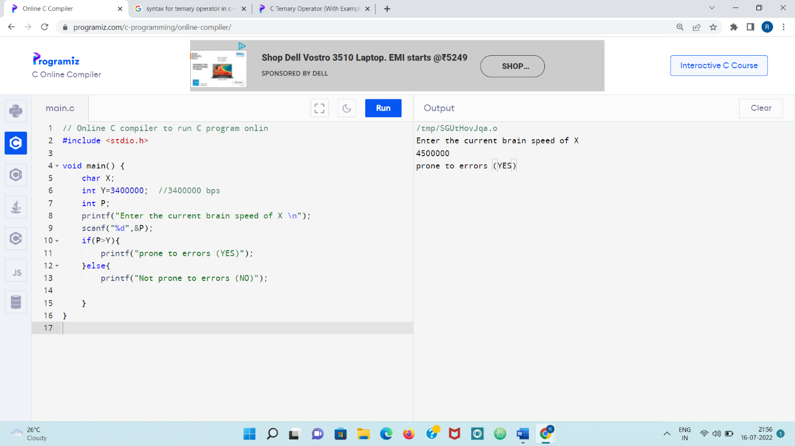

2]

Arun has planned that he will drink exactly XX liters of tea daily. He has an empty jar having a capacity of YY liters. Arun can visit the tea shop to refill the jar. In each refill, the jar is completely filled to the brim and Arun is charged ZZ rupees. Arun wonders what is the minimum amount of money he has to pay for drinking exactly XX liters of tea daily.

Write a C program for the same.

C PROGRAM:

#include <stdio.h>

int main()

{

int X,Y,Z;

float amt;

printf("Enter the number of litres of tea daily consumed:");

scanf("%d",&X);

printf("Enter the litres a empty jar can hold:");

scanf("%d",&Y);

printf("Enter the rupees to refill the empty jar to brim:");

scanf("%d",&Z);

if(X>Y)

{

amt=((X-Y)\*Z)/Y+Z;

printf("Minimum amount of money he needed to pay is %f",amt);

}

else

{

amt=((Y-X)\*Z)/Y;

printf("Minimum amount of money he needed to pay is %f",amt);

}

return 0;

}

OUTPUT:

Enter the number of litres of tea daily consumed:20

Enter the litres a empty jar can hold:40

Enter the rupees to refill the empty jar to brim:30

Minimum amount of money he needed to pay is 15.000000

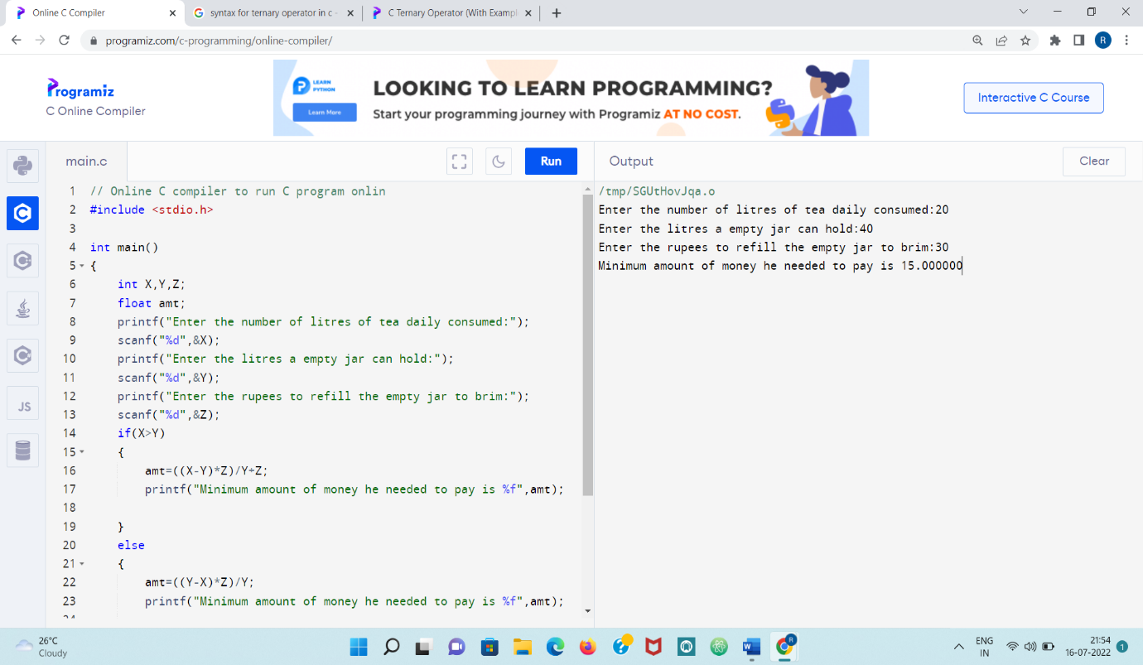

3]

The XYZ Scholarship Contest has just finished, and you finish with a rank of R. You know that Rank 1 to Rank 50 will get 100% scholarship on the XYZ exam fee and Rank 51 to Rank 100 will get 50% percentage scholarship on the XYZ exam fee. The rest do not getany scholarship. What percentage of scholarship will you get? Write a C program for the same.

C PROGRAM:

#include <stdio.h>

int main()

{

int rank;

printf("Enter the rank of a student");

scanf("%d",&rank);

if((rank>=1)&&(rank<=50))

{

printf("Scholarship rewarded on exam fee is 100%");

}

else if((rank>=51)&&(rank<=100))

{

printf("Scholarship rewarded on exam fee is 50%");

}

else

{

printf("No Scholarship to be rewarded");

}

return 0;

}

OUTPUT:

Enter the rank of a student200

No Scholarship to be rewarded

Enter the rank of a student35

Scholarship rewarded on exam fee is 100

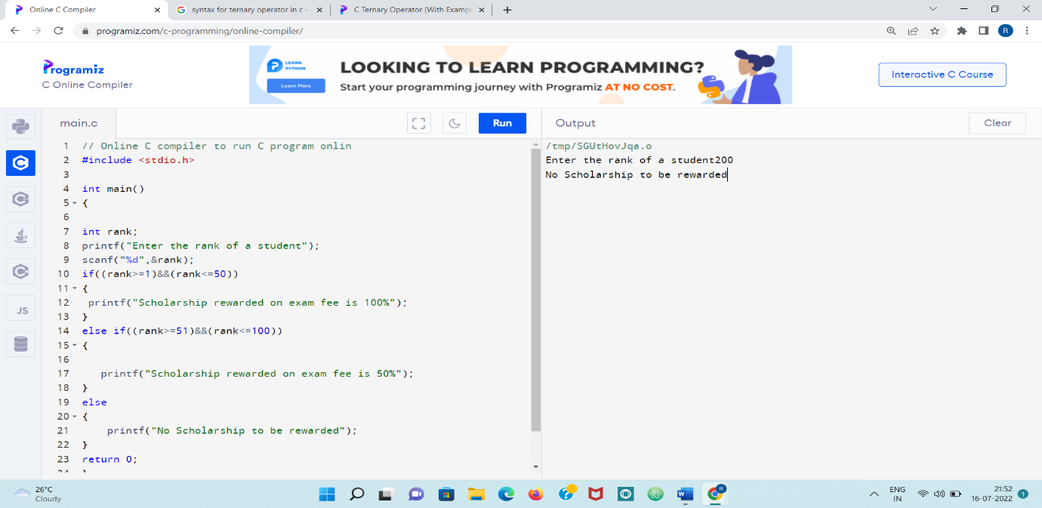

4]

Convert hexadecimal number 6E to its decimal number and viceversa. Write a program to find largest of three numbers using ternary operator.

ANSWER:

Converting hexadecimal to decimal:

For 6E:

As E in decimal is 14

Therefore

Taking the base 16 i.e. 5\*16^1 + 14\*16^0 =110

Decimal form of 6E is 110.

Now converting decimal to hexadecimal form:

110/16 = 6.875 = 6 Remainder is 14

6/16 = 0.375 =0 Remainder is 6

Therefore Hexadecimal form is 6E.

To find greatest of the three via ternary operators

C PROGRAM:

#include <stdio.h>

int main()

{

int a,b,c;

printf("Enter the values of a,b,c");

scanf("%d%d%d",&a,&b,&c);

((a>b)?((a>c)? (printf("%d is greatest",a)): (printf("%d is greatest",c))):((b>c)? (printf("%d is greatest",b)):(printf("%d is greatest",c))));

return 0;

}

OUTPUT:

Enter the values of a,b,c233 567 789

789 is greatest

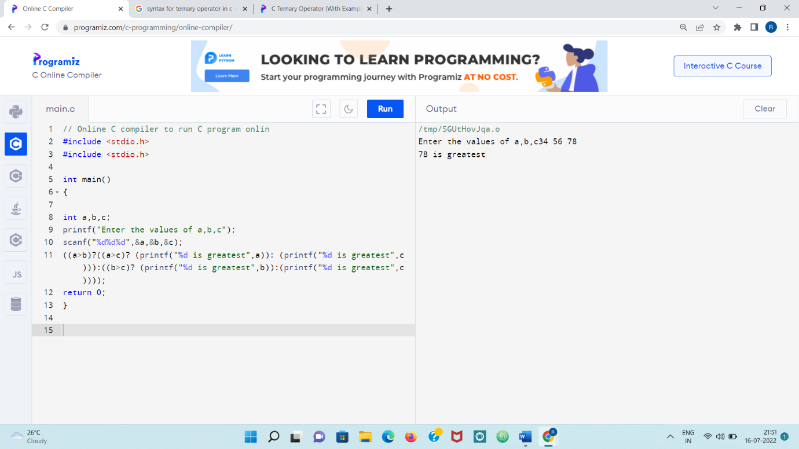

5]

Write a C program to find the eligibility of admissions for professional course based on the following criteria. Marks in Math>=65 and Marks in PHY >=55 and Marks in Chem>=55 and Total in all three subject >=190 or Total in Maths and Physics >=140

C PROGRAM:

#include <stdio.h>

void main() {

int marks,maths,phy,chem,total,r;

printf("Enter the marks for phy,chem and maths \n");

scanf("%d%d%d",&phy,&chem,&maths);

total=maths+chem+phy;

marks=phy+maths;

r=(maths>=65)&&(phy>=55)&&(chem>=55)&&(total>=190)||(marks>=140);

if(r==1)

{

printf("Eligible for admission");

}

else

{

printf("Not eligible for admission");

}

}

OUTPUT:

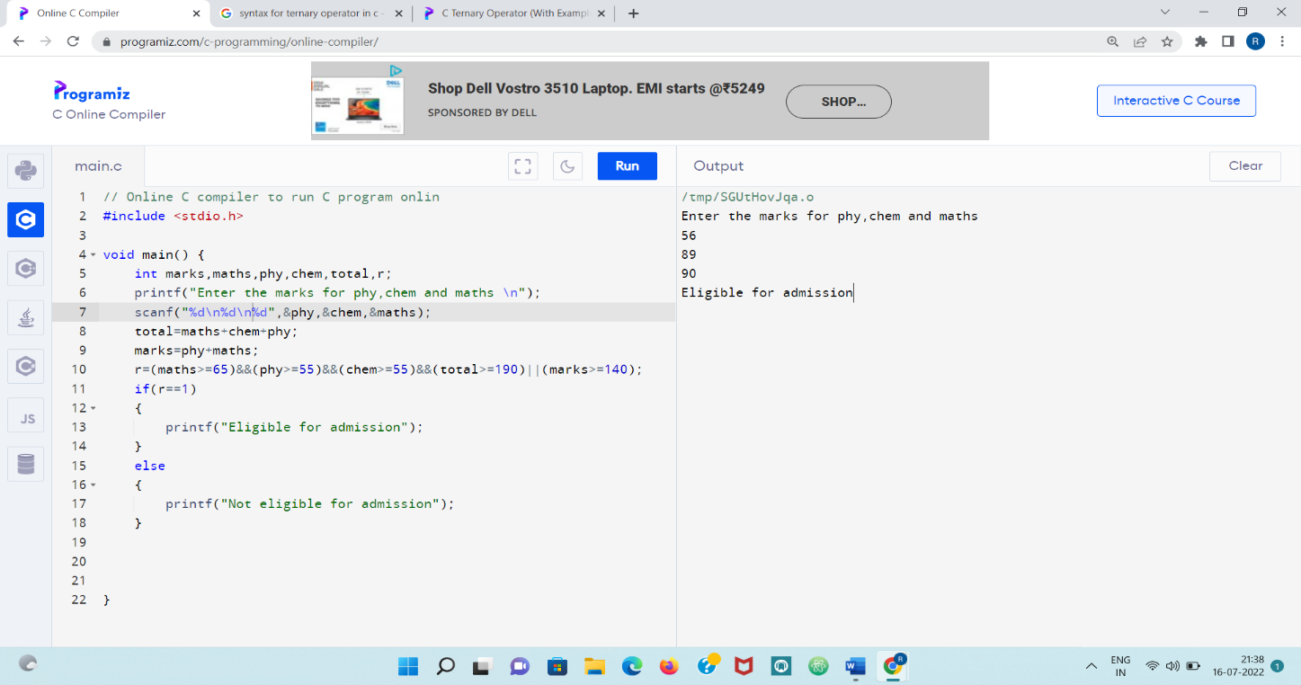

6]

Use Switch case to calculate and Print the electricity bill of a given customer. The customer id, Customer name and Unit consumed by the user should be taken from the keyboard and display the amount to pay to the customer. The charges are as follows

C PROGRAM:

#include <stdio.h>

int main()

{

int unit,choice=0,id;

float bill,per;

char name[40];

printf("Enter Unit and name and id:");

scanf("%d%s%d",&unit,name,&id);

if(unit<=199){

choice=1;

}else if(unit>=200 && unit<=400){

choice =2;

}else if(unit>=200 && unit<=600){

choice=3;

}else if(unit<=600){

choice=4;

}

switch (choice) {

case 1:

bill=1.20\*unit;

break;

case 2:

bill=1.50\*unit;

break;

case 3:

bill=1.80\*unit;

break;

case 4:

bill=2.00\*unit;

break;

}

if(bill>400){

per=bill\*0.15;

bill+=per;

}

if(bill<100){

printf("Very less amount!!! ");

}else{

printf("Your bill:%f",bill);

}

return 0;

}

OUTPUT:

Enter Unit and name and id:200 rahi ch@123

Your bill:300.000000

