Employee Task Tracker
Software Documentation
A PHP / MySQL Web-Based Task Management System
Version 1.0
Document prepared: June 30, 2026

Table of Contents

1. Introduction

1.1 Purpose of This Document
This document provides complete technical and functional documentation for the Employee Task Tracker application. It is intended for developers, system administrators, QA testers, and stakeholders who need to install, operate, maintain, or extend the system. It covers the project's architecture, database design, feature set, security model, setup procedure, and known limitations.

1.2 Project Overview
Employee Task Tracker is a lightweight, self-contained web application for assigning, tracking, and reporting on work tasks within a small team or organization. It is built using procedural PHP with direct PDO/MySQL access (no external framework) and is designed to run on a standard XAMPP/Apache/MySQL stack on localhost or a comparable LAMP/WAMP server.
The system supports three user roles (Administrator, Manager, and Employee), each with different levels of access. Administrators and Managers can create projects, create and assign tasks, manage user accounts, and review system-wide audit logs and reports. Employees can view and update only the tasks assigned to them, log comments, and record time spent.

1.3 Key Capabilities
- User authentication with session-based login and role-based access control (Admin / Manager / Employee).
- Full task lifecycle management: create, view, edit, delete, assign, and re-assign tasks.
- Task status tracking (New, In Progress, Blocked, Completed) and priority levels (Low, Medium, High).
- Project records that group related tasks (creation, editing, deletion).
- Threaded comments on individual tasks for team collaboration.
- Time tracking: employees can log hours worked against a task, automatically rolled up into the task's actual hours.
- In-app notifications for task assignment, reassignment, deletion, and due-date reminders.
- User profile management, including profile picture upload.
- Administrative user management (create, edit, change role, reset password).
- Audit logging of authentication and administrative actions (who did what, when, and from which IP).
- A reporting dashboard with completion rate, overdue tasks, and priority breakdown statistics, rendered with Chart.js.

1.4 Intended Audience
This document is written for:
- Developers who will maintain, debug, or extend the codebase.
- System administrators responsible for deployment and database setup.
- QA engineers validating functionality before release.
- Project stakeholders who need a high-level understanding of system capabilities and limitations.

2. System Architecture

2.1 Architectural Style
The application follows a traditional server-rendered, multi-page architecture. Each .php file in the project root represents a distinct page/route and is responsible for three concerns combined in a single file: handling the incoming HTTP request (including any POST form submission), performing the relevant database operations, and rendering the resulting HTML. There is no separate templating engine, routing layer, or REST API; navigation between pages happens through standard HTML links and form submissions, and PHP's header('Location: ...') is used for redirects.
Shared logic (database connection, authentication helpers, and data-access functions) is centralized in app/init.php, which every page includes via require_once. A reusable sidebar navigation component is included from includes/sidebar.php on every authenticated page.

2.2 High-Level Request Flow
- The browser requests a .php page (e.g. index.php).
- session_start() begins or resumes the PHP session, and app/init.php is loaded for shared functions.
- requireLogin() checks for $_SESSION['user']; unauthenticated users are redirected to login.php.
- If the request is a POST, the page processes form input, validates it, and calls a data-access function in app/init.php (e.g. createTask(), updateTask()).
- Data-access functions execute parameterized SQL against MySQL via PDO and return a structured result.
- On success the page either redirects (Post/Redirect/Get pattern) or re-renders itself with a flash message; on failure an inline error message is displayed.
- The page renders HTML directly inline with PHP, pulling in includes/sidebar.php for navigation and assets/styles.css / assets/app.js for presentation and light client-side interaction.

2.3 Component Diagram (Logical)
Browser
|
v
Apache + PHP (mod_php)
|-- login.php / logout.php ............ Authentication
|-- index.php .......................... Dashboard / task list
|-- task_create.php / task_edit.php
| / task_view.php / task_delete.php .. Task CRUD
|-- project_create.php / project_edit.php
| / project_delete.php
| / project_task_management.php ...... Project CRUD & overview
|-- manage_users.php / create_user.php
| / user_profile.php ................. User administration & profile
|-- notifications.php .................. In-app notifications
|-- reports.php ......................... Analytics dashboard (Chart.js)
|-- audit_logs.php ...................... Security / activity log viewer
|-- includes/sidebar.php ................ Shared navigation partial
|-- app/init.php ........................ DB connection + shared functions
v
MySQL (employee_task_tracker database)

2.4 Session & State Management
Authentication state is stored entirely in PHP's native session ($_SESSION['user']), which holds the logged-in user's row from the users table (password hash removed before storage). There is no token-based or stateless API layer; every authenticated page calls requireLogin(), which also sends no-cache headers so that the browser back button cannot reveal protected pages after logout.

3. Use Case & Data Flow Diagrams

3.1 Use Case Diagram
The diagram below summarizes which actions each role (Administrator, Manager, Employee) can perform. Administrators and Managers currently have identical access in the implementation (see Section 9.2); Employees are limited to their own tasks, time logging, comments, reports, notifications, and profile management.
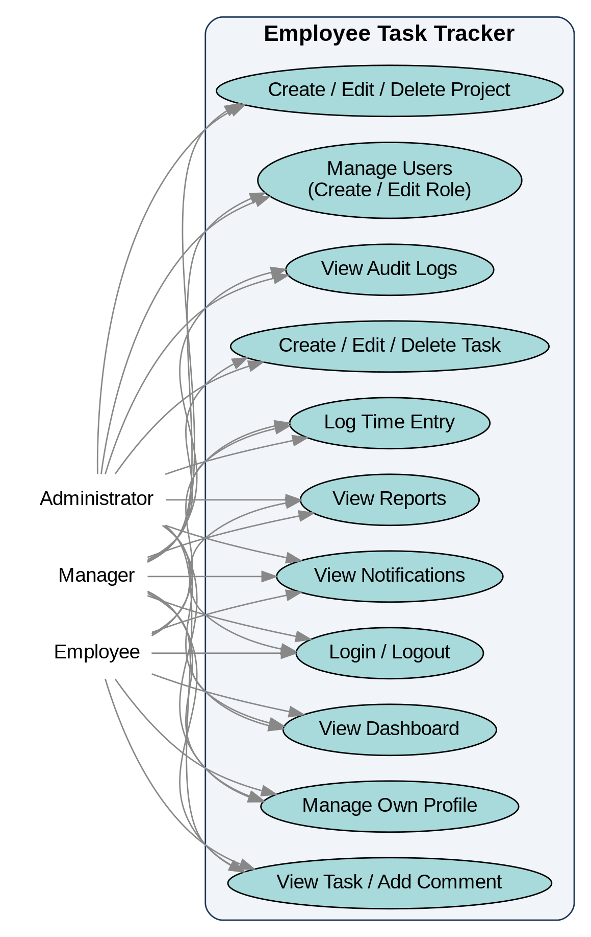

3.2 Data Flow Diagram (Level 1)
The diagram below traces how data moves between the user, the application's core processes, and the underlying MySQL data stores (D1-D6).
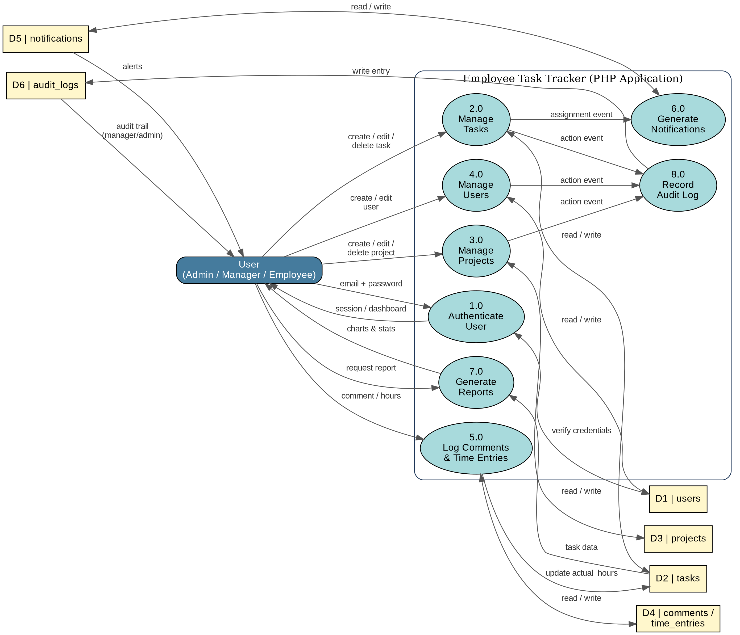

4. Technology Stack
Layer | Technology | Notes
Server-side language | PHP (procedural) | No framework; uses native PDO for database access
Database | MySQL / MariaDB | InnoDB tables with foreign-key constraints
Web/App Server | Apache (via XAMPP) | Designed for localhost / XAMPP htdocs deployment
Front-end markup | Server-rendered HTML | Generated inline inside .php files
Styling | Custom CSS (assets/styles.css) | Single shared stylesheet, no CSS framework
Client-side scripting | Vanilla JavaScript (assets/app.js) | Sidebar toggle, delete confirmation, minor UI behavior
Charts | Chart.js (CDN) | Used on reports.php for visual analytics
Password hashing | PHP password_hash() / password_verify() (bcrypt) | With a legacy fallback for MD5-style stored hashes

4.1 Standalone HTML Reference Files
The project additionally ships a set of *_standalone.html files (login_standalone.html, index_standalone.html, task_create_standalone.html, task_view_standalone.html, task_edit_standalone.html, logout_standalone.html) plus FILE_REFERENCE.html and HTML_PHP_CONNECTION_GUIDE.md. These are static, framework-free HTML templates that mirror the PHP-rendered pages and submit to the corresponding .php endpoints. They exist purely as a reference/scaffold for front-end work or for environments where the HTML needs to be decoupled from the PHP templates; they are not required for the application to function and are not linked from the main navigation.

5. Database Design

5.1 Entity Overview
The database employee_task_tracker contains seven InnoDB tables: users, projects, tasks, comments, time_entries, notifications, and audit_logs. Referential integrity is enforced with foreign keys; several relationships cascade on delete (e.g. deleting a user deletes the projects they created), while others set the reference to NULL (e.g. deleting an assigned user un-assigns their tasks rather than deleting them).

5.2 Entity-Relationship Summary
users (1) ----------< projects (many) [projects.created_by -> users.id]
users (1) ----------< tasks (many, as creator) [tasks.created_by -> users.id]
users (1) ----------< tasks (many, as assignee) [tasks.assigned_to -> users.id, nullable]
projects (1) -------< tasks (many) [tasks.project_id -> projects.id, nullable]
tasks (1) ----------< comments (many) [comments.task_id -> tasks.id]
users (1) ----------< comments (many) [comments.user_id -> users.id]
tasks (1) ----------< time_entries (many) [time_entries.task_id -> tasks.id]
users (1) ----------< time_entries (many) [time_entries.user_id -> users.id]
users (1) ----------< notifications (many) [notifications.user_id -> users.id]
users (1) ----------< audit_logs (many) [audit_logs.user_id -> users.id, nullable]

5.3 Table: users
Column | Type | Constraints | Description
id | INT UNSIGNED | PK, AUTO_INCREMENT | Unique user identifier
name | VARCHAR(100) | NOT NULL | Display name
email | VARCHAR(150) | NOT NULL, UNIQUE | Login identifier
password | VARCHAR(255) | NOT NULL | Bcrypt hash (or legacy MD5/plain value)
role | ENUM(admin, manager, employee) | NOT NULL, DEFAULT employee | Authorization level
profile_picture | VARCHAR(255) | NULLABLE | Relative path to uploaded avatar
created_at / updated_at | TIMESTAMP | AUTO | Row audit timestamps

5.4 Table: projects
Column | Type | Constraints | Description
id | INT UNSIGNED | PK, AUTO_INCREMENT | Unique project identifier
name | VARCHAR(255) | NOT NULL | Project title
description | TEXT | NULLABLE | Free-text project description
status | ENUM(active, on_hold, completed) | DEFAULT active | Project lifecycle state
created_by | INT UNSIGNED | FK -> users.id, ON DELETE CASCADE | Project owner/creator
created_at / updated_at | TIMESTAMP | AUTO | Row audit timestamps

5.5 Table: tasks
Column | Type | Constraints | Description
id | INT UNSIGNED | PK, AUTO_INCREMENT | Unique task identifier
title | VARCHAR(255) | NOT NULL | Task title
description | TEXT | NULLABLE | Task description
created_by | INT UNSIGNED | FK -> users.id, ON DELETE CASCADE | User who created the task
project_id | INT UNSIGNED | FK -> projects.id, ON DELETE SET NULL | Optional parent project
assigned_to | INT UNSIGNED | FK -> users.id, ON DELETE SET NULL | Current assignee
status | ENUM(new, in_progress, blocked, completed) | DEFAULT new | Workflow state
priority | ENUM(low, medium, high) | DEFAULT medium | Urgency level
start_date / due_date | DATE | NULLABLE | Scheduling dates
estimated_hours | DECIMAL(5,2) | NULLABLE | Planned effort
actual_hours | DECIMAL(6,2) | DEFAULT 0.00 | Sum of logged time entries
created_at / updated_at | TIMESTAMP | AUTO | Row audit timestamps

5.6 Table: comments
Column | Type | Constraints | Description
id | INT UNSIGNED | PK, AUTO_INCREMENT | Unique comment identifier
task_id | INT UNSIGNED | FK -> tasks.id, ON DELETE CASCADE | Parent task
user_id | INT UNSIGNED | FK -> users.id, ON DELETE CASCADE | Comment author
body | TEXT | NOT NULL | Comment text
created_at / updated_at | TIMESTAMP | AUTO | Row audit timestamps

5.7 Table: time_entries
Column | Type | Constraints | Description
id | INT UNSIGNED | PK, AUTO_INCREMENT | Unique entry identifier
task_id | INT UNSIGNED | FK -> tasks.id, ON DELETE CASCADE | Related task
user_id | INT UNSIGNED | FK -> users.id, ON DELETE CASCADE | User who logged the time
hours | DECIMAL(5,2) | NOT NULL | Hours logged in this entry
notes | TEXT | NULLABLE | Optional notes about the work done
created_at / updated_at | TIMESTAMP | AUTO | Row audit timestamps

5.8 Table: notifications
Column | Type | Constraints | Description
id | INT UNSIGNED | PK, AUTO_INCREMENT | Unique notification identifier
user_id | INT UNSIGNED | FK -> users.id, ON DELETE CASCADE | Recipient
type | ENUM(urgent, warning, info, success) | DEFAULT info | Visual/severity category
title | VARCHAR(255) | NOT NULL | Short heading
message | TEXT | NOT NULL | Notification body
is_read | BOOLEAN | DEFAULT FALSE | Read/unread flag
created_at | TIMESTAMP | AUTO | Creation time

5.9 Table: audit_logs
Column | Type | Constraints | Description
id | INT UNSIGNED | PK, AUTO_INCREMENT | Unique log identifier
user_id | INT UNSIGNED | FK -> users.id, ON DELETE SET NULL | Actor (nullable for system events)
action | VARCHAR(100) | NOT NULL | Action key, e.g. login, create_task
details | TEXT | NULLABLE | Human-readable description / context
ip_address | VARCHAR(45) | NULLABLE | Client IP at time of action
user_agent | TEXT | NULLABLE | Client browser/user agent string
created_at | TIMESTAMP | AUTO | Event time

5.10 Seed Data
The schema script (database/employee_task_tracker.sql) seeds three default users (one per role), three sample projects, three sample tasks, sample comments, time entries, and notifications, so the application is immediately usable after import for demonstration or testing purposes.
The seeded administrator account in the shipped SQL file stores the literal string "$Admin" as its password value rather than a proper bcrypt hash, and uses the email krahid@gmail.com instead of the admin@example.com / Admin123! credentials referenced in the README. See Section 9 (Known Issues) for details and a recommended fix before any non-local use.

6. User Roles & Permissions
Access control is role-based using a single role column on the users table with three possible values. There is no granular permission system; checks are performed inline in each page (typically "if role is employee, redirect away").
Capability | Employee | Manager / Admin
View dashboard / task list | Own tasks only | All tasks
Create / edit / delete tasks | No | Yes
View / comment on a task | Yes (any task reachable by ID) | Yes
Log time against a task | Yes | Yes
Create / edit / delete projects | No | Yes
Create new user accounts | No | Yes
Manage existing users & roles | No | Yes
View audit logs | No | Yes
View reports | Yes (own tasks) | Yes (own/all tasks)
Manage own profile / avatar | Yes | Yes

6.1 Role Definitions

Administrator
Full access to every feature: user management (including role changes and password resets), project and task CRUD for all records, audit log visibility, and reporting. Intended to be held by one or a small number of trusted operators.

Manager
Functionally equivalent to Administrator in the current codebase — the only access check used throughout the application is "role !== employee", so manager and admin accounts currently receive identical permissions. This is documented further in Section 9.

Employee
Restricted to their own assigned tasks on the dashboard, and cannot create, edit, or delete tasks or projects, manage users, or view audit logs. Employees can still comment on and log time against tasks and view their own reports and notifications.
Direct-link access control gap: task_view.php does not check whether the logged-in employee is the task's assignee before displaying it — any authenticated user who knows or guesses a task ID can view that task's full details, comments, and time entries. See Section 9 for recommended remediation.

7. Features & Functional Modules

7.1 Authentication (login.php, logout.php)
Users authenticate with an email address and password on login.php. On submission, the system looks up the user by email and verifies the password using verifyStoredPassword(), which supports three formats for backward compatibility: a plain bcrypt hash (the standard case), a 32-character hex string treated as a legacy MD5 hash, or — as a fallback — a direct string comparison against the stored value. On success, the user's row (minus password) is stored in $_SESSION['user'], an audit log entry of type login is recorded, and the user is redirected to index.php. logout.php records a logout audit event, clears all session data and the session cookie, and redirects to login.php.

7.2 Dashboard (index.php)
The dashboard is the landing page after login. It shows three to four summary cards (Open Tasks, Completed, Overdue, and — for non-employee roles — a Create Task shortcut), a search box that filters tasks by title, description, or assignee name, and a table listing tasks with title, assignee, status, priority, due date, and row-level View / Edit / Delete actions. Employees only ever see tasks assigned to them; Managers and Admins see every task in the system.

7.3 Task Management (task_create.php, task_edit.php, task_view.php, task_delete.php)
Task creation and editing are restricted to Manager/Admin roles (employees are redirected to the dashboard). Both forms capture title, description, assignee, priority, status, start date, due date, and estimated hours; the edit form additionally allows updating actual hours directly. Server-side validation in createTask()/updateTask() requires a non-empty title and restricts status and priority to their defined enumerated values, falling back to safe defaults otherwise.
task_view.php is accessible to any authenticated user and shows full task details alongside two sub-features: a threaded comment list (add via addCommentToTask()) and a time-entry log (add via addTimeEntryToTask(), which both inserts a row into time_entries and increments the task's actual_hours). task_delete.php (Manager/Admin only) permanently removes a task row; related comments and time entries are removed automatically via ON DELETE CASCADE foreign keys.
Whenever a task is created with an assignee, or an existing task is reassigned or unassigned, the system calls createNotification() to insert a row into the notifications table for the affected user(s), and logAuditEvent() records the action in audit_logs.

7.4 Project Management (project_create.php, project_edit.php, project_delete.php, project_task_management.php)
Projects are simple containers with a name, description, and status (active, on_hold, completed) used to group related tasks. Creation and editing are restricted to Manager/Admin roles. project_task_management.php is intended as a combined projects-and-tasks overview page, displaying project cards alongside the current user's task list.
project_task_management.php queries a table named project_task_management, which does not exist in the shipped schema (the actual table is named projects). As written, this query throws a PDO exception that is caught and silently ignored, so the page currently renders with an empty project list. See Section 9 for the one-line fix.

7.5 User Management (manage_users.php, create_user.php)
Manager/Admin users can create new accounts (create_user.php) by supplying name, email, password, and role, with email-format and duplicate-email validation before the password is hashed with hashPassword() (bcrypt) and inserted. manage_users.php lists all users and allows updating an existing user's name, email, role, and — optionally — password (left blank to keep the existing password) in a single form.

7.6 User Profile (user_profile.php)
Every authenticated user can update their own display name and email address and upload a profile picture. Uploads are validated for file size (2 MB maximum), file extension (jpg, jpeg, png, gif, webp), and verified as genuine images via getimagesize() before being moved into images/profile_pictures/ with a filename based on the user's ID and an upload timestamp.

7.7 Notifications (notifications.php)
This page surfaces actionable alerts to the signed-in user. It both reads previously stored notifications from the notifications table (created elsewhere in the app, e.g. on task assignment) and dynamically generates several computed categories at page-load time: overdue tasks, high-priority tasks due within three days, a digest of newly created tasks, a completed-task "achievement" message, and a static system-update message. A "clear all" action is present in the UI.
notifications.php opens its own separate PDO connection (host "localhost") instead of reusing the shared db() connection in app/init.php (host "127.0.0.1"), and its "clear all" handler only clears the in-memory $notifications array for the current request rather than updating the is_read flag in the database, so cleared notifications reappear on next page load. See Section 9.

7.8 Reports (reports.php)
Provides each user with summary statistics computed from their visible task set: total tasks, completed/in-progress/blocked/new counts, completion rate percentage, overdue count, and a breakdown by priority. The page renders these figures as both numeric cards and Chart.js-powered charts (loaded from the jsDelivr CDN).

7.9 Audit Logging (audit_logs.php, logAuditEvent())
Manager/Admin users can review a chronological feed (most recent first, capped at 200 rows) of authentication and administrative events: logins, logouts, task creation/update/deletion, project changes, and user-management actions. Each entry records the acting user, an action key, a free-text details string, the client IP address, and user agent. Logging failures are caught and silently ignored so that a logging error can never block the underlying action.

7.10 Shared Navigation (includes/sidebar.php)
A single collapsible sidebar component is included on every authenticated page. It displays the current user's avatar (or initials), name, and role, and renders a role-aware navigation menu: Dashboard and Projects & Tasks are visible to everyone, while Add New User, Manage Users, Audit Logs, and New Project links are only rendered for Manager/Admin roles. The component itself also enforces that a session exists, redirecting to login.php if not.

8. Project / File Structure
employee_task_tracker/
|-- app/
| `-- init.php Database connection + shared functions
|-- includes/
| `-- sidebar.php Shared navigation component
|-- assets/
| |-- styles.css Global stylesheet
| `-- app.js Client-side behavior (sidebar, confirm-delete)
|-- database/
| `-- employee_task_tracker.sql Schema + seed data
|-- images/
| |-- logo.png
| `-- profile_pictures/ Uploaded user avatars
|-- login.php / logout.php
|-- index.php
|-- task_create.php / task_edit.php / task_view.php / task_delete.php
|-- project_create.php / project_edit.php / project_delete.php
|-- project_task_management.php
|-- manage_users.php / create_user.php / user_profile.php
|-- notifications.php
|-- reports.php
|-- audit_logs.php
|-- rehash.php One-off maintenance script (see Section 9)
|-- *_standalone.html Static reference templates (see Section 3.1)
|-- FILE_REFERENCE.html / HTML_PHP_CONNECTION_GUIDE.md / QUICK_START_CHECKLIST.md
`-- README.md

8.1 Page / Route Reference
File | Access | Purpose
login.php | Public | Authentication form and handler
logout.php | Authenticated | Destroys session, logs the event
index.php | Authenticated | Dashboard / task list with search
task_create.php | Manager/Admin | Create a new task
task_edit.php | Manager/Admin | Edit an existing task
task_view.php | Authenticated | Task detail, comments, time entries
task_delete.php | Manager/Admin | Delete a task (POST only)
project_create.php | Manager/Admin | Create a new project
project_edit.php | Manager/Admin | Edit an existing project
project_delete.php | Manager/Admin | Delete a project (GET)
project_task_management.php | Authenticated | Combined project + task overview
create_user.php | Manager/Admin | Create a new user account
manage_users.php | Manager/Admin | List and edit existing users
user_profile.php | Authenticated | Edit own profile / avatar
notifications.php | Authenticated | View notifications
reports.php | Authenticated | Personal/team statistics and charts
audit_logs.php | Manager/Admin | System activity log

9. Installation & Setup Guide

9.1 Prerequisites
- A local or remote LAMP/WAMP/XAMPP stack: Apache, PHP 8.x with the PDO MySQL extension enabled, and MySQL or MariaDB.
- A MySQL client (phpMyAdmin, MySQL Workbench, or the mysql CLI) for importing the schema.

9.2 Step-by-Step Setup
- Copy the employee_task_tracker project folder into your web server's document root (for XAMPP on Windows: C:\xampp\htdocs\employee_task_tracker).
- Start Apache and MySQL from the XAMPP control panel (or equivalent service manager).
- Open phpMyAdmin (or your MySQL client) and import database/employee_task_tracker.sql. This script creates the employee_task_tracker database, all seven tables, and seed data in one step.
- Confirm the database connection settings in app/init.php match your environment (host 127.0.0.1, database employee_task_tracker, user root, blank password by default) and adjust them if your MySQL credentials differ.
- Browse to http://localhost/employee_task_tracker/login.php.
- Sign in using a valid seeded account (see Section 8.3) and verify the dashboard loads.

9.3 Default Accounts
Before relying on any of the credentials below, review Section 9.1 — the password seeded for the admin account in the shipped SQL script is not a valid hash and that login will not work until corrected.
Email | Password (as documented) | Role | Source
admin@example.com | Admin123! | admin | README.md
krahid@gmail.com | (invalid stored hash) | admin | database/employee_task_tracker.sql
manager@example.com | (bcrypt hash, plaintext unknown) | manager | database/employee_task_tracker.sql
employee@example.com | (bcrypt hash, plaintext unknown) | employee | database/employee_task_tracker.sql
rehash.php appears to be an in-progress maintenance script intended to reset passwords for radmin@gmail.com, manager@gmail.com, and employee@gmail.com to known plaintext values (Admin123, manager01, ram24 respectively), but as shipped it does not run successfully — see Section 9.4.

9.4 Verifying the Installation
- Log in successfully and confirm the dashboard displays the seeded sample tasks.
- Create a new task as a manager/admin account and confirm it appears in the task list.
- Open a task, add a comment, and add a time entry; confirm both appear and that Actual Hours increases.
- Edit and then delete a task; confirm the dashboard updates accordingly.
- Log in as the employee account and confirm only tasks assigned to that user are visible, and that Create/Edit/Delete controls are hidden.
- Visit Audit Logs as a manager/admin and confirm the actions above were recorded.

10. Known Issues & Technical Debt
The items below were identified through direct review of the current codebase. They are documented here so they can be triaged deliberately rather than discovered in production. None of them are exotic; all are addressable with focused, low-risk fixes.

10.1 Admin seed password is not a valid hash
In database/employee_task_tracker.sql, the admin user row stores the password column as the literal string "$Admin" rather than a bcrypt hash or even a plaintext password matching the README's documented credentials. verifyStoredPassword() will not authenticate against this value with any password. Recommended fix: replace the seed row with a properly generated password_hash() value, and align the seeded email/password with what README.md documents (or update the README to match).

10.2 Manager and Administrator roles are functionally identical
Every access check in the codebase tests only role !== 'employee'; there is no check that distinguishes manager from admin. If the intent is for certain actions (e.g. user role changes, audit log access) to be admin-only, those checks need to be added explicitly. Recommended fix: introduce a small helper (e.g. isAdmin($user)) and apply it to admin-only pages such as manage_users.php and audit_logs.php.

10.3 Employees can view any task by guessing its URL
task_view.php loads a task by ID without verifying that the logged-in employee is the assignee (or that the user is a manager/admin). Any authenticated employee can view another employee's task details, comments, and time entries simply by changing the id query parameter. Recommended fix: in task_view.php, return a 403/redirect when $user['role'] === 'employee' and $task['assigned_to'] !== $user['id'].

10.4 rehash.php is broken and should not be deployed
This script calls $updates->prepare(...), but $updates is a plain associative array, not a PDO object — it should call db()->prepare(...). As written, running this script will fatal-error. It also has no authentication guard, so if fixed and left in place it would let an unauthenticated visitor reset specific accounts' passwords to hard-coded values. Recommended fix: either remove this file from any deployed environment, or correct the database handle and add an authentication/role check before use, then delete it after the one-time migration it was intended for.

10.5 project_task_management.php queries a nonexistent table
The page selects from a table literally named project_task_management, which is not defined anywhere in the schema; the intended table is projects. The query throws and is caught by a try/catch that silently swallows the error, so the page currently always shows zero projects. Recommended fix: change the query to SELECT * FROM projects ORDER BY created_at ASC.

10.6 notifications.php uses an inconsistent, duplicate database connection
Rather than reusing db() from app/init.php, this page opens a second PDO connection with host "localhost" (versus "127.0.0.1" used everywhere else), which can behave differently depending on local MySQL socket configuration. The page also contains an early, unused merge of database notifications into $notifications before that variable is immediately reset to an empty array a few lines later, meaning persisted notifications from the notifications table are never actually displayed alongside the generated ones. The "clear all" action only mutates a local PHP variable and has no effect on the database. Recommended fix: remove the duplicate PDO connection in favor of db(), remove the dead merge/reset code, and persist read/clear state via UPDATE notifications SET is_read = 1 WHERE user_id = :id.

10.7 project_delete.php contains unreachable, mismatched code
The function exits after deleting the project and redirecting, but unreachable code below the exit; statement references an undefined $pdo variable, queries a tasks row by a $_POST['task_id'] that is never submitted on this page, and calls createNotification() with five arguments when the function (as defined in app/init.php) only accepts four. Recommended fix: delete the unreachable block entirely, since the project deletion logic above it already completes the intended operation.

10.8 No CSRF protection on state-changing forms
Forms such as task delete, project delete, and user-management actions are simple POST/GET requests with no CSRF token, so a malicious page could trigger these actions on behalf of a logged-in user. Recommended fix: add a per-session CSRF token to all state-changing forms and validate it server-side.

10.9 Plaintext fallback in password verification
verifyStoredPassword() includes a direct string-equality fallback ($storedHash === $password) for any stored value that is not bcrypt or 32-character hex. This is useful for migrating legacy data but should not remain enabled long-term, since it would silently accept a match against any password stored as plaintext. Recommended fix: run a one-time migration to bcrypt every existing user row, then remove the plaintext-equality branch.

10.10 No automated test suite
The project currently has no unit or integration tests. Given the procedural structure, introducing a lightweight integration test suite (e.g. using PHPUnit against a disposable test database) for the data-access functions in app/init.php would catch regressions like those listed above before they reach production.

11. Security Considerations

11.1 Implemented Protections
- All database queries use PDO prepared statements with bound parameters, preventing classic SQL injection.
- All user-supplied output rendered into HTML is passed through htmlspecialchars(), mitigating reflected/stored XSS.
- Passwords are hashed with PHP's bcrypt implementation (password_hash / password_verify) for newly created or updated accounts.
- Session cookies are cleared and the session destroyed on logout; protected pages send no-cache headers.
- File uploads for profile pictures are restricted by extension, size, and verified with getimagesize() before being written to disk.
- Administrative and authentication actions are recorded in an audit trail with timestamp, actor, IP, and user agent.

11.2 Gaps to Address Before Production Use
- No CSRF tokens on state-changing forms (Section 9.8).
- Object-level access control gap on task_view.php (Section 9.3).
- Legacy plaintext/MD5 password fallback should be retired (Section 9.9).
- Default/seed credentials must be rotated before any non-local deployment.
- No rate limiting or account lockout on the login form, leaving it open to brute-force attempts.
- Database credentials are hard-coded in app/init.php rather than sourced from environment variables or a non-web-accessible config file.

12. Recommended Future Enhancements
- Resolve all items in Section 9, prioritizing 9.1 (broken admin login), 9.3 (access control gap), and 9.8 (CSRF).
- Introduce a distinct permission boundary between Manager and Administrator roles if differentiated access is desired.
- Move database credentials and other configuration into environment variables or a .env file excluded from version control.
- Add pagination to the dashboard task list and audit log views as data volume grows.
- Add server-side and client-side validation for date ranges (e.g. due date earlier than start date).
- Add automated tests (unit tests for app/init.php functions; integration tests for the main user flows).
- Consider migrating to a lightweight MVC structure or framework (e.g. Slim, Laravel) as the page count grows, to separate routing, data access, and presentation.
- Add email notifications as a complement to the existing in-app notification system.

13. Appendix

13.1 Task Status & Priority Values
Field | Allowed Values
tasks.status | new, in_progress, blocked, completed
tasks.priority | low, medium, high
projects.status | active, on_hold, completed
users.role | admin, manager, employee
notifications.type | urgent, warning, info, success

13.2 Glossary
Term | Definition
Task | A discrete unit of work with a title, status, priority, optional assignee, and optional schedule/effort fields.
Project | A named container used to group related tasks.
Time entry | A logged record of hours worked against a specific task by a specific user, which increments that task's actual_hours total.
Audit log | A persisted record of a security-relevant or administrative action, including actor, timestamp, IP address, and details.
Flash message | A one-time success/info message stored in the session and displayed once on the next page load (e.g. after deleting a task).

13.3 Document Revision History
Version | Date | Notes
1.0 | June 30, 2026 | Initial documentation generated from source code review of the employee_task_tracker project.

