SET THREE
SECTION A [40 MARKS]
Attempt ALL the Questions in this Section.
Question 1
a) Define the term principles of programming languages. (2 marks)
Principles of programming languages refer to the fundamental concepts and guidelines that govern the design, implementation and behavior of programming languages. These principles are used to define the syntax, semantics and behavior of programming languages.

b) State any two objectives of principles of programming languages. (2 marks)
- Facilitate Language Design: The principles provide a framework for designing new programming languages that are efficient, effective and easy to use.
- Facilitate Program Development: The principles enable writing of programs that are correct, efficient, readable and maintainable.

c) With examples of languages in each, state any three programming paradigms. (6 marks)
- Imperative Programming Paradigm:
Imperative programming focuses on describing the step-by-step procedures or algorithms that a program should follow to achieve a desired outcome.
Examples of imperative programming languages:
  - C
  - Java
  - Python
  - C++
  - FORTRAN
- Declarative Programming Paradigm:
Declarative programming focuses on describing what the program should accomplish, rather than how it should be done.
Examples of declarative programming languages:
  - SQL (Structured Query Language)
  - Prolog
  - Haskell
  - Datalog
  - HTML (Hypertext Markup Language)
- Object-Oriented Programming (OOP) Paradigm:
Object-Oriented Programming is a programming paradigm that organizes software design around objects, which are instances of classes that encapsulate data and behavior.
Examples of object-oriented programming languages:
- Java
- C++
- Python
- C#
- Ruby
- Swift

d) Explain why there is need of so many programming paradigms. (4 marks)
- Different problem domains: Various paradigms are better suited for specific problem domains. For example, object-oriented programming is ideal for simulations and modeling real-world objects, while functional programming is suitable for data processing and algorithmic tasks.
- Programming style and preference: Developers have different programming styles and preferences, and some paradigms align better with these individual preferences.
- Evolution of programming languages: As programming languages evolve, new paradigms emerge to address limitations and challenges of existing languages.
- Specialization and trade-offs: Each paradigm offers unique benefits and trade-offs. For instance, procedural programming prioritizes efficiency, while declarative programming emphasizes abstraction and high-level thinking.
e) Explain any three skills required to become a computer programmer. (6 marks)
- Programming fundamentals: A strong understanding of programming concepts, data structures, and algorithms is crucial. This includes knowledge of programming languages, syntax, and semantics, as well as the ability to write efficient, readable, and well-documented code.
- Problem-solving skills: Programmers need to be able to analyze problems, identify solutions, and implement them effectively. This requires logical thinking, creativity, and the ability to break down complex problems into manageable parts.
- Attention to detail: Programming requires precision and attention to detail, as small errors or bugs can cause significant issues. Programmers must be meticulous in writing code, testing, and debugging to ensure their programs run correctly and efficiently.

f) State the three types of computer programming languages. (3 marks)
- High-level Programming Languages
- Mid-Level Programming Languages
- Low-Level Programming Languages

g) State any three advantages of learning computer programming. (3 marks)
- Automation and Efficiency. Computer programming enables automation of tasks which leads to increased efficiency and productivity
- Innovation and Creativity. Computer programming allows developers to create innovative solutions to real world problems fostering creativity and innovation
- Problem Solving Skills. Computer programming helps develop strong problem solving skills as programmers must analyze problems, identify solutions and implement them effectively

h). State the four of computer programming languages. (4 marks)
- Python
- Java
- C++
- Java Script
i) Explain the following as characteristics of a successful computer programming language: (2 marks @)
i) Support
ii) Simplicity and Readability
iii) Reliability
i) Support: A successful language has extensive resources like documentation and community support for problem-solving and learning.
ii) Simplicity and Readability: It should be easy to read and write, with a clear syntax and logical structure, making it accessible and maintainable.
iii) Reliability: It consistently performs well, with features for error handling and robustness to manage unexpected situations effectively.

j) Programming languages support different data types. These usually include STRING and REAL. Complete the table by giving four other data types and an example data value for each. (4 marks)
Data type | Example data value
INTEGER | 42
BOOLEAN | TRUE or FALSE
FLOAT | 3.14
CHAR | ‘A’

SECTION B [60 MARKS]
Attempt ONLY THREE Questions in this Section.
Question 2
a) Define an algorithm. (2 marks)
- A step-by-step set of instructions or a logical sequence that outlines how a specific task is to be accomplished.

b) Algorithms for solving computational tasks is divided into two sections, explain them. (4 marks)
- Sequential Algorithms: These algorithms execute instructions in a sequential order, one after the other, without branching or repetition.
- Non-Sequential Algorithms: These algorithms involve decision-making and looping constructs, where the flow of execution can change based on certain conditions or may repeat until a certain condition is met.

c) Explain any three pseudo-code key words. (6 marks)
- INPUT: This keyword is used for receiving data from a user
- OUTPUT: This keyword is used for displaying results or data
- IF-ELSE: Used for conditional branching within the algorithm to make decisions based on certain conditions.

d) State and draw the corresponding flow-chart symbols of the key-word in (c) above. (3 marks)
PSEUDO-CODE KEYWORD | SYMBOL
INPUT
OUTPUT
IF-ELSE

e) Draw a flow chart solution to the problem below: (5 marks)
You are required to capture two integers from the key board and the computer should display the bigger number of the two.
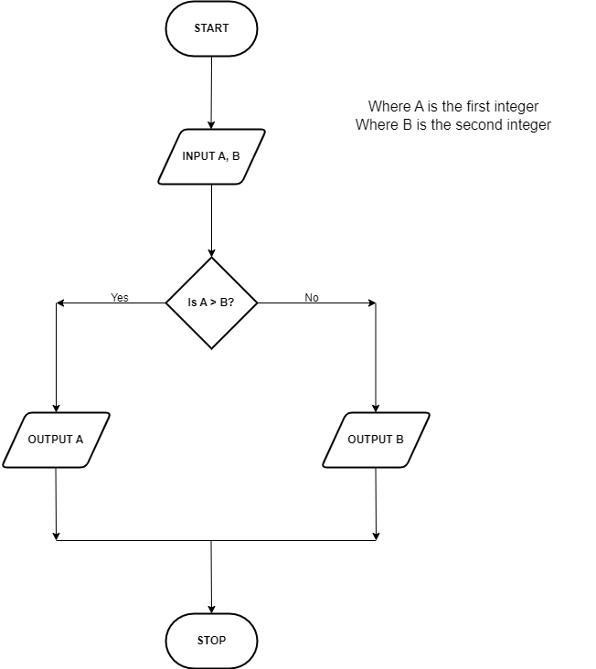

Question 3
a) Define the following terms: (2 marks @)
i) Data
ii) Data item
iii) Record
iv) File
v) Data structure
i) Data: Data refers to raw, unorganized facts or information that can be processed and used to generate meaningful information.
ii) Data item: A data item is the smallest unit of data that has meaning. It could be a single piece of information such as a number or word.
iii) Record: A record is a collection of related data items treated as a unit. For example a row in a database table
iv)File: A file is a collection of related records stored on a storage device such as a hard drive or in memory.
v) Data structure: A data structure is a way of organizing and storing data in a computer so that it can be accessed and modified efficiently.

b) State any three rules of naming data items. (3 marks)
- Use descriptive and meaningful names that convey the purpose or the content of the data item.
- Avoid using reserved words or keywords in the programming language you are using.
- Follow naming conventions specified by the programming language or organization

c) List two examples of wrong data item names (2 marks)
- Xyz (Not meaningful or descriptive)
- Class (Is a reserved word used for defining a class)

d) State any five operations on data structures. (5 marks)
- INSERT: Adds new data to the data structure
- DELETE: Removes existing data from the data structure
- SEARCH: Finds specific data within data structure
- UPDATE: Modifies existing data in the data structure
- SORT: Arranges data in a specific order within the data structure.

Question 4
a) Define the term code translation. (2 marks)
Code translation is the process of converting source code written in a high level programming language into machine language that can be executed directly by a computer’s processor.

b) Explain why translation is important. (2 marks)
- Translation is important because it allows programmers to write code in high-level languages that are easier to read and write, and then convert it into machine code that can be executed by the processor. This makes programming more efficient, enables cross-platform compatibility, and facilitates software development.

c) State any two differences between compilation and interpretation. (4 marks)
COMPILATION | INTERPRETATION
Translates the entire source code into machine code | Translates source code line by line or statement by statement
Compiled code is faster in execution as it is pre translated | Interpreted code is slower as it is translated during execution

d) Explain the six stages of compiling a program below: (2 marks @)
i) Lexical analysis.
ii) Symbol table construction.
iii) Syntax analysis.
iv) Semantic analysis.
v) Code generation.
vi) Optimization.

- Lexical Analysis: This stage involves breaking down the source code into individual tokens such as keywords, identifiers and operators
- Symbol table construction: Here a data structure called a symbol table is built, which stores information about identifiers (variables, functions, etc.) encountered in the code.
- Syntax analysis: In this stage the compiler checks the syntax of the code to ensure it follows the rules of the programming language’s grammar.
- Semantic analysis: This stage involves checking the meaning of the code beyond just its syntax, ensuring that it makes sense in the context of the programming language.
- Code generation: In this stage, the compiler translates the high level code into equivalent machine code or intermediate code suitable for execution by the processor.
- Optimization: Finally the compiler may apply various optimizations to the generated code to improve its performance such as reducing the number of instructions, eliminating redundant computations, minimizing memory usage etc.

Question 5
a) Define the following terms: (2 marks @)
i) Statement
ii) Block
iii) Expression
iv) Operator
v) Control flow

- Statement: A statement is a single programming instruction or command that performs a specific action.
- Block: A block is a collection of one or more statements which are part of another statement or function
- Expression: An expression is a combination of values, variables and operators that evaluates to a single value.
- Operator: An operator is a symbol or keyword that performs an operation on values or variables (e.g. +, -, *, /)
- Control flow: Control Flow refers to the order in which the individual statements or instructions are executed within a program.

b) With examples, explain the following operators: (2 marks @)
i) Comparison
ii) Mathematical
iii) Assignment
i) Comparison operators: These operators are used to compare two values and return a Boolean result (`true` or `false`). Examples include `==` (equal to), `!=` (not equal to), `<` (less than), `>` (greater than), `<=` (less than or equal to), and `>=` (greater than or equal to).
ii) Mathematical operators: These operators are used to perform arithmetic operations on numerical values. Examples include `+` (addition), `-` (subtraction), `*` (multiplication), `/` (division), and `%` (modulus).
iii) Assignment operators: These operators are used to assign values to variables. Examples include `=` (assignment), `+=` (addition assignment), `-=` (subtraction assignment), `*=` (multiplication assignment), `/=` (division assignment), and `%=` (modulo assignment).

c) Explain the flow control statements below: (2 marks @)
i) Selection
ii) Iteration
- Selection: Selection statements are used to execute different blocks of code based on certain conditions. The most common selection statement is the `if` statement, which executes a block of code if a specified condition is true.
- Iteration: Iteration statements, also known as loops, are used to repeatedly execute a block of code as long as a specified condition is true. Common iteration statements include `for`, `while`, and `do-while` loops.

Question 6
a) Define the following Object Oriented terms: (2 marks @)
i) Class
ii) Object
iii) Encapsulation
iv) Decomposition
v) Aggregation
i) Class: A class is a blueprint or template for creating objects. It defines the properties and behaviors that an object of that class will have.
ii) Object: An object is an instance of a class. It represents a specific entity in a program
iii) Encapsulation: Encapsulation is a mechanism in object-oriented programming that combines data and the methods that operate on that data into a single unit called a class. It allows for information hiding and protects the internal state of an object from external access.
iv) Decomposition: Decomposition is the process of breaking down complex problems or systems into smaller, more manageable parts. In object-oriented programming, decomposition involves dividing a problem into smaller classes and objects that can work together to solve the problem.
v) Aggregation: Aggregation is a relationship where one object is composed of or contains other objects which can exist independently of one another.

b) State three differences between object-oriented paradigm and imperative paradigm (6 marks)
- Approach: Object-oriented programming (OOP) focuses on creating objects and defining their interactions, while imperative programming focuses on defining a sequence of statements to be executed.
- Data and Behavior: In OOP, data and behavior are encapsulated into objects, which can have their own state and methods. In imperative programming, data and behavior are separate, and functions manipulate data.
- Code Reusability: OOP promotes code reusability through concepts like inheritance and composition, allowing objects to inherit properties and behaviors from other objects. In imperative programming, code reusability is achieved through functions or procedures that can be called multiple times.

c) With examples, explain the term modularity. (4 marks)
Modularity refers the design principle of breaking a system into smaller, self-contained modules that can be developed, modified and maintained independently.
Example: A car can be viewed as a modular system, consisting of separate modules like engine, transmission and breaks. Each module has its own specific function that can be maintained or replaced independently without affecting the entire system

END

