**Result and Discussion**

**Introduction**

Undoped zinc oxide (ZnO) and yttrium-doped zinc oxide (Y-doped ZnO) characterization results offer important new information about the structural, optical, and electrical properties of materials. To comprehend the effect of yttrium doping on the characteristics of ZnO, these characterizations are frequently carried out utilizing a variety of analytical techniques.

The impact of Y doping on the crystal structure and phase transitions of the ZnO host matrix was examined using XRD analysis. The diffractograms of the various ZnO thin films created using the sol gel process are shown in Figure 1a.

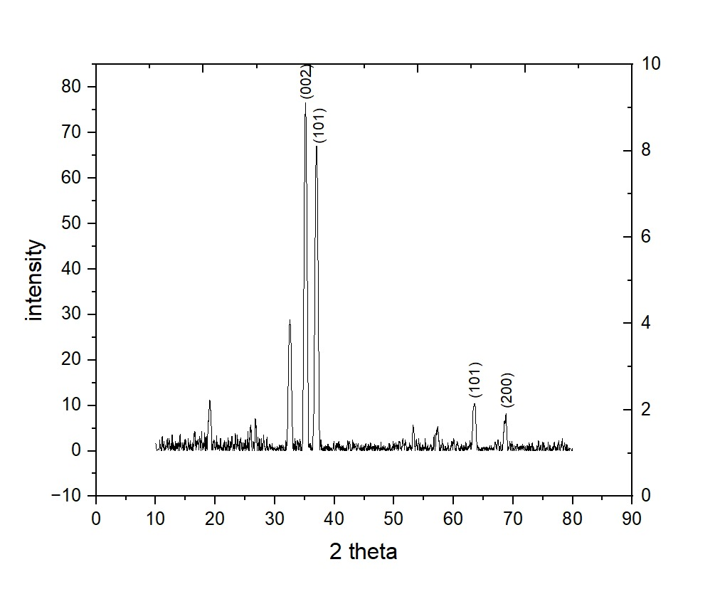

**Figure:** (a) XRD graph of pure ZnO thin film sample.

In this figure of XRD result, we can observe that, the most preferential crystal growth is along the (002) plane, which is an expected result for the ZnO wurtzite structure. In addition, (101) and (201) are also expected for this crystal structure. A little amount of impurities also seen in this peak results, so some other peaks also found here.

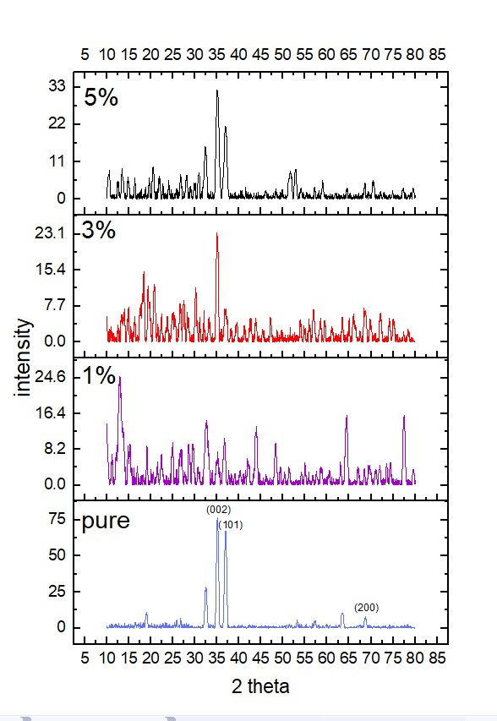

Figure 4. 1: (b) XRD graphs of all samples (pure ZnO, 1% YZO, 3% YZO, and 5% YZO) thin film samples.

Here, in the stacks, comparisons between peaks of pure, 1% YZO, 3% YZO, and 5% YZO are shown. In the 1% YZO peaks, it is observed that, there are high amount of impurities in the material, so a lot of extra peaks are showing in the XRD figure of 1% YZO thin film. But the 3% YZO, and 5% YZO thin films have better peaks rather than the 1% YZO.

Here, the intensity of the peak is low in the Yttrium doped ZnO thin films. The 1% YZO showing low peak intensity, the 3% YZO showing lower peak than the 1%, but the 5% showing more intensity than the other two YZO films. So, it is also clear that, by doping the crystallinity is decreased.

**Table:** XRD results for wurtzite ZnO for all examined samples indexed with JCPDS card number 96-101-1260.

|  |  |  |  |  |  |
| --- | --- | --- | --- | --- | --- |
| **hkl** | **2θ** | | | | |
| **ZnO Wurtzite Structure** | **Pure ZnO** | **1% YZO** | **3% YZO** | **5% YZO** |
| (002) | 34.228 |  | 34.327 | 34.411 | 34.536 |
| (100) | 31.749 | 32.138 |  | 30.248 | 31.889 |
| (101) | 36.257 | 35.903 | 36.427 |  | 36.384 |
| (102) | 47.257 |  | 48.348 |  |  |
| (110) | 56.535 |  |  | 56.841 |  |
| (200) | 63.341 | 63.846 |  |  |  |

The observed Bragg angles in our YZO films are less than those in bulk ZnO (2θBragg = 34.42°), and the 2θBragg of YZO declines with increasing Y concentration. This results from Y3+'s (0.92 Å) greater ionic radius compared to Zn2+ (0.74Å) [34]. The inclusion of bigger ionic dopants modifies the film's residual stress (σ) and lattice constant (c).

Using the Bragg equation [2], the interplanar spacing dhkl values of ZnO:Y thin films were determined:

2dhkl sinθ = nλ ----------------(1)

The lattice parameters for all the films were estimated from d values observed from d-values, according to the following equation [3]:

--------------------(2)

Using the Debye-Scherrer's formula [4], the size of the crystallites of pure and Y doped ZnO was calculated based on the broadening of the preferential orientation (002).

---------------------------(3)

Where k stands for the form factor, is the X-ray wavelength, is the Bragg's angle of the X-ray diffraction peak, and is the full width at half maximum in radians of (002) orientation. Table 2 lists the values of crystallite size for the various samples.

|  |  |  |  |  |
| --- | --- | --- | --- | --- |
| Parameters | Sample | | | |
| Pure ZnO | 1% YZO | 3% YZO | 5% YZO |
| D (nm) | 18.822 | 12.319 | 18.338 | 13.764 |
| a (Å) | 3.342 | 3.871 | 3.273 | 3.234 |
| c (Å) | 5.273 | 5.323 | 5.242 | 5.223 |
| c/a | 1.577 | 1.374 | 1.602 | 1.616 |
| d002 (Å) | 2.55 | 6.7 | 2.56 | 2.51 |
| V (Å3) | 51.033 | 69.077 | 48.632 | 47.307 |
| Density (g/cm3) | 5.295 | 3.912 | 5.556 | 5.712 |
| Dislocation density * 105 lines/m2 | 2.82 | 6.59 | 2.97 | 5.28 |
| Strain (ɛ) *10-3 | 3.874 | 4.472 | 3.931 | 4.375 |

Micro- strain ɛ for each film was also determined by using the tangent formula [5]:

-------------------(4)

In the result, from the values of this table, the microstrain is given. From the given value, it is observed that in 1% YZO microstrain increased, then reduced in 3% YZO, and again increased in the 5% YZO.

From the structural analysis, it is obtained that, Y has been successfully doped within the ZnO thin film, although there are several impurities are seen due to environmental issues.