ARP Traffic Inspector – Kernel Module

1. Prepare the Environment
Install necessary tools:
sudo apt update
sudo apt install build-essential linux-headers-$(uname -r)

2. Create the Module Files
a. Create the folder:
mkdir arp_traffic_inspector
cd arp_traffic_inspector

b. Create arp_traffic_inspector.c:

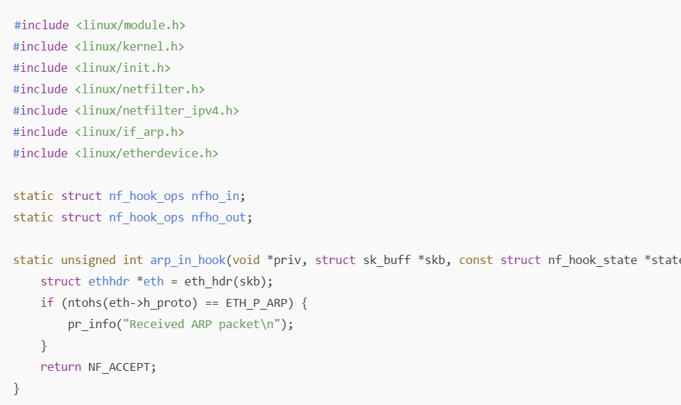

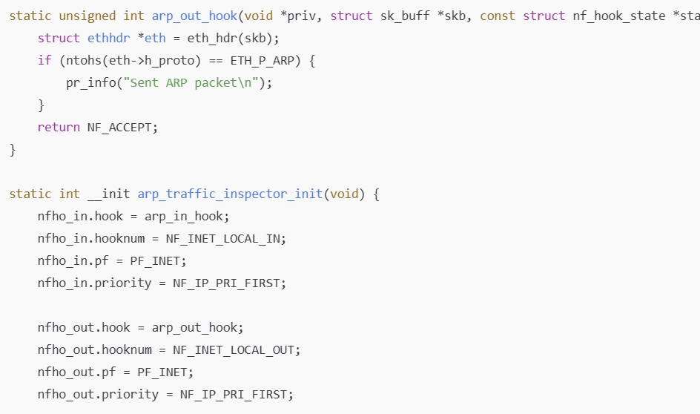

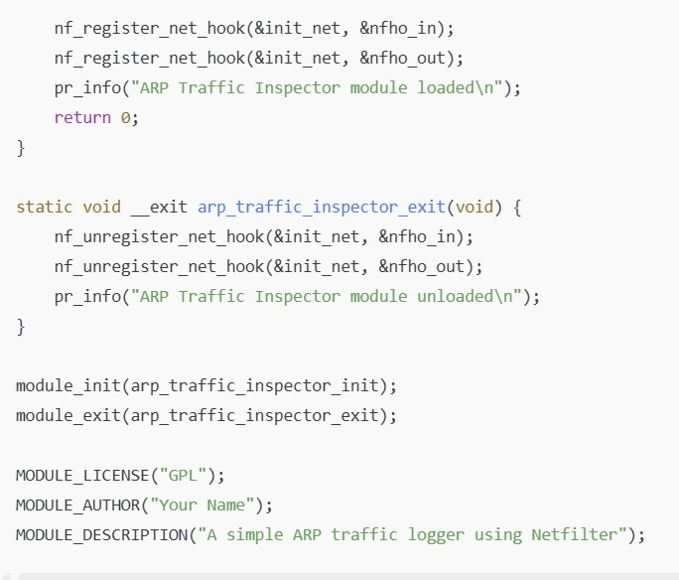

3. Create the Makefile
Create a Makefile:

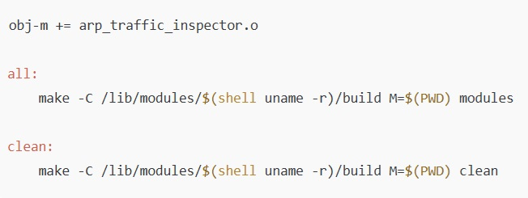

4. Compile the Module
Make

5. Insert the Module
Load the module into the kernel:

sudo insmod arp_traffic_inspector.ko
Check kernel log:
dmesg | tail

6. Generate ARP Traffic
Ping gateway
ping -c 1 192.168.1.1
Then check kernel messages:
dmesg | tail
7. Remove the Module
unload the module:
sudo rmmod arp_traffic_inspector

GitHub Instructions
- Initialize Git:
git init
- Stage and commit files:
git add .
git commit -m "Add ARP Traffic Inspector module"

- Connect to your forked GitHub repo:
git branch -M master
git remote add origin https://github.com/YOUR_USERNAME/kernel-playground.git
- Push to GitHub:
git push -u origin master
What to Expect
- ARP Traffic Inspector project will appear under projects/arp_traffic_inspector/ in your GitHub repository.
- You will see messages like "Received ARP packet" and "Sent ARP packet" in dmesg.
This project uses Netfilter to hook into incoming and outgoing packets.

To see logs
dmesg | tail -n 20

