

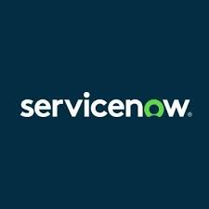



KSK COLLEGE OF ENGINEERING AND TECHNOLOGY

DEPARTMENT OF COMPUTER SCIENCE & ENGINEERING

LAPTOP REQUEST CATALOG ITEM

TEAM ID:

Team Size:4
Team leader: Rahil M [821022104040]
Team Member: Aruna M [821022104009]
Team Member: Supriya GK [821022104052]
Team Member: Srija R [821022104049]

1. Problem Statement :
In many organizations, employees depend on laptops to perform their daily work. However, the traditional process of requesting a laptop is often manual and time-consuming. Employees usually raise requests through emails or paper forms, which then go through multiple layers of approval before being fulfilled by the IT department.
This process leads to several issues such as:
- Lack of standardization in request handling.
- Delays due to manual approval workflows.
- Difficulty in tracking request status.
- Miscommunication between employees, approvers, and IT teams.
- Poor visibility into laptop inventory and asset usage.
To solve these issues, the organization decided to implement a Laptop Request Catalog Item in the ServiceNow Service Catalog, which would automate the end-to-end process from request to fulfilment.
1. Delays and Inefficiency:
The manual approval process consumes a significant amount of time, causing delays in laptop allocation. Employees may have to wait for several days or even weeks before receiving their devices.
2. Lack of Transparency:
Employees are often unaware of the status of their laptop request. Without a centralized system, there is no clear visibility into where the request currently stands or who is responsible for the next step.
3. Inconsistent Approval Workflow:
Each department may handle laptop requests differently. Some might require HR approval, while others only involve the manager or IT department. This inconsistency creates confusion and slows down processing.
4. Poor Communication:
Frequent back-and-forth emails between employees, managers, and IT staff cause miscommunication, duplication of work, and potential loss of information.
5. Limited Asset Tracking:
Since laptop issuance is not linked with an asset management system, tracking who owns which laptop becomes difficult. This can result in lost or unreturned laptops and poor asset control.
6. Lack of Reporting and Auditing:
Manual tracking makes it difficult to analyze request volumes, approval times, or IT asset utilization over time.
To overcome these problems, the organization decided to implement a Laptop Request Catalog Item in ServiceNow’s Service Catalog, providing a structured, automated, and transparent workflow for laptop requests.

2. Objective :
The main objective of the project is to design and develop a Laptop Request Catalog Item that simplifies and automates the laptop request process for employees.
The main objective of the project is to automate and streamline the laptop request process using the ServiceNow platform. The goal is to create a self-service catalog item where employees can easily submit requests and track them from submission to fulfillment.

Specific Objectives:
- To enable employees to raise laptop requests easily through the self-service portal.
- To automate approval workflows based on organizational hierarchy.
- To integrate the catalog item with Asset Management for better tracking of issued laptops.
- To improve communication and reduce manual interventions.
- To provide reports and metrics on laptop requests and fulfillment timelines.
- To design a user-friendly catalog item that allows employees to request laptops quickly.
- To implement an automated approval workflow that follows the organization’s hierarchy.
- To connect the laptop request process with the Asset Management module for accurate tracking.
- To reduce manual intervention and eliminate email-based requests.
- To provide transparency and visibility into every stage of the request process.
- To improve employee satisfaction by reducing waiting time and enhancing communication.
- To generate reports and metrics for IT managers to analyze efficiency and identify bottlenecks.
- The end goal is to ensure a fast, reliable, and traceable process for managing laptop requests and allocations.
Overall, the system should provide a fast, transparent, and efficient way to handle laptop requests.

3.Skills :
Developing the Laptop Request Catalog Item required both technical and functional skills. The project involved deep knowledge of the ServiceNow platform and its related modules.

Technical Skills:
1. ServiceNow Configuration:
- Service Catalog design
- Catalog UI policies and client scripts
- Variable creation and form customization
2. Flow Designer:
- Automated workflow creation for approvals and fulfilment
- Integration with ITSM processes
3. Scripting:
- JavaScript and Glide scripting for form logic
- Business rules and server-side validation
4. Notifications:
Creating email and in-app notifications for different workflow stages
5. Asset and Request Management:
- Linking laptop issuance with asset records
- Tracking asset lifecycle
6. Reporting and Dashboard Design:
- Using ServiceNow Performance Analytics to visualize KPIs
Functional Skills:
1. Understanding ITIL concepts (Request Fulfillment, Asset Management).
2. Requirement gathering and stakeholder communication.
3. Testing, UAT coordination, and deployment planning.
4. Documentation and user training.
These combined skills ensured a comprehensive and efficient solution that aligns with ITSM best practices

4.Task Initiation :
The project began with the identification of business needs and pain points in the manual laptop request process.
Steps Followed:
Step 1: Requirement Gathering
Meetings were conducted with the IT Service Desk, HR, and Asset Management teams to identify necessary data fields, approval paths, and expected outcomes.
- Conducted meetings with HR, IT, and department heads.
- Identified data to be captured (employee details, laptop specifications, justification).
- Determined approval paths and escalation logic.
Step 2: Catalog Item Design
A new catalog item titled “Laptop Request” was created under the IT Services category.
Fields included:
- Employee Name (auto-filled from logged-in user)
- Department (auto-fetched)
- Laptop Type (Standard / Developer / High-end)
- Accessories Needed (Mouse, Docking Station, Headset)
- Justification for Request
- Manager’s Name
- Delivery Location
Dynamic behavior was added — for example, if the employee chooses “Developer Laptop”, the justification field becomes mandatory.
Step 3: Workflow & Approval Setup
A Flow Designer workflow was built to handle:
1. Automatic manager approval (based on user’s manager in ServiceNow).
2. Automatic routing to IT Fulfillment team once approved.
3. Task creation for the IT Asset Team to assign and deliver a laptop.
4. Final closure and notification to the requester.
Step 4: Notification Configuration
- Notifications were created for key events:
- Request Submission
- Manager Approval/Rejection
- IT Fulfillment Assignment
Step 5: Testing and Validation
- The solution was tested in the development and UAT environments.
- Functional testing verified correct data flow.
- Workflow testing validated approvals and escalations.
- User acceptance testing confirmed end-user ease of use.
After successful UAT, the project was deployed to production.
Step 6: Notification Setup:
Email notifications were configured for every stage — submission, approval, rejection, and completion.
Step 7: Testing & Deployment:
After successful testing in the development and UAT environments, the catalog item was moved to production.

5. Features :
The Laptop Request Catalog Item offers the following key features. The Laptop Request Catalog Item includes a wide range of functional and technical features designed for automation and user satisfaction.
1. Self-Service Portal Access:
Employees can raise laptop requests from the ServiceNow portal anytime, anywhere.
2. Dynamic Form Behavior:
The form automatically adjusts its fields based on user input.
Example: When selecting a high-end laptop, additional justification fields appear.
3. Automated Approval Workflow:
The system automatically routes requests to the right manager for approval and then to the IT team.

4. Email and System Notifications:
Real-time notifications keep employees updated about request status.
5. Integration with Asset Management:
Once a request is approved, it links directly to the Asset Management module for assignment and tracking.
6. Request Tracking Dashboard:
Both users and IT staff can track the request’s current stage.
7. Role-Based Access:
- Employees can create and view their own requests.
- Managers can approve/reject.
- IT staff can fulfill and close requests.
8. Audit and Reporting:
- Administrators can view reports like:
- Number of laptops issued per month
- Average approval time
- Top requested laptop types
9. Error Handling and Validation:
Mandatory fields ensure complete information. Invalid entries trigger friendly error messages.
10. Scalability:
The same design can be extended to other assets (monitors, printers, phones).

11. User-Friendly Interface:
Employees can request laptops directly through the ServiceNow portal without needing to email or call IT.
12. Dynamic Form Fields:
Based on laptop type selection, additional fields appear (e.g., accessories, justification).
13. Automated Approval Flow:
Requests are automatically routed to the correct manager and then to the IT team for fulfillment.
14. Email and System Notifications:
Notifications are sent for each stage of the process — submission, approval, fulfillment, and closure.
15. Asset Integration:
The approved request links with the Asset Management module to assign a physical laptop to the requester.
16. Tracking and Reporting:
Users and IT admins can track request status, SLA compliance, and fulfillment trends.
17. Security and Access Control:
Role-based access ensures only authorized employees and managers can view or modify certain fields.
6. Modules Implemented:
The implementation involved several ServiceNow modules and components:
- Service Catalog Module:
- Created the Laptop Request catalog item.
- Configured variables, categories, and UI policies.
- Applied catalog client scripts for dynamic interactions
- Created the “Laptop Request” catalog item under the IT Services category.
- Configured form design, variables, and catalog UI policies.
- Flow Designer Module:
Designed an end-to-end workflow for approvals and fulfillment.
Steps:
1. Request submission
2. Manager approval
3. IT fulfillment task creation
4. Asset linking
5. Notification and closure
- Built a custom flow for the approval and fulfillment process.
- Manager approval followed by IT assignment and asset issuance.
3. Notification Module:
Configured email and in-system notifications for all stakeholders.
Configured event-based emails:
- Submitted
- Approved
- Rejected
- Completed

4.Asset Management Module:
- Integrated to track issued laptops.
- Each approved request is linked to a Configuration Item (CI) in the CMDB.
- The laptop’s serial number and assigned user are recorded for accountability
- Linked the approved request with the Asset database.
- Allowed tracking of laptop inventory and assigned assets.
5. Reporting Module:
Created dashboards to show metrics like total requests, average fulfillment time, and pending approvals.
Dashboards were built using ServiceNow Reporting tools to display:
- Request volumes by department
- Approval times
- Fulfillment durations
- SLA compliance
6. Request Management Module:
- Used to track and manage all laptop-related requests within the ITSM framework.
- Every catalog request generates a Request (RITM) and Requested Item (REQ).
- Allows tracking of fulfillment tasks and closure status.
These modules collectively deliver an automated, controlled, and measurable process.

Implementation Steps:
Step 1: Create local update Sets
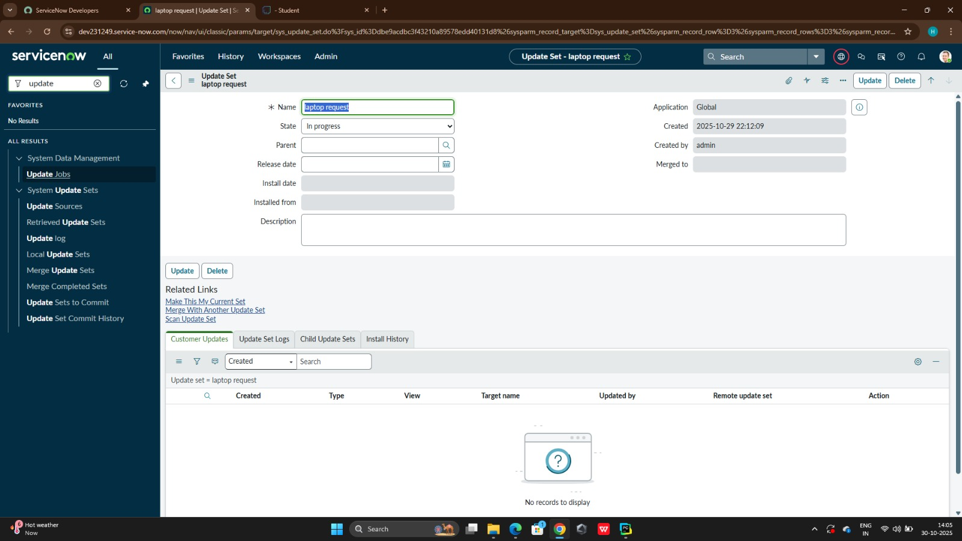

Step 2: Create Service catalog Item
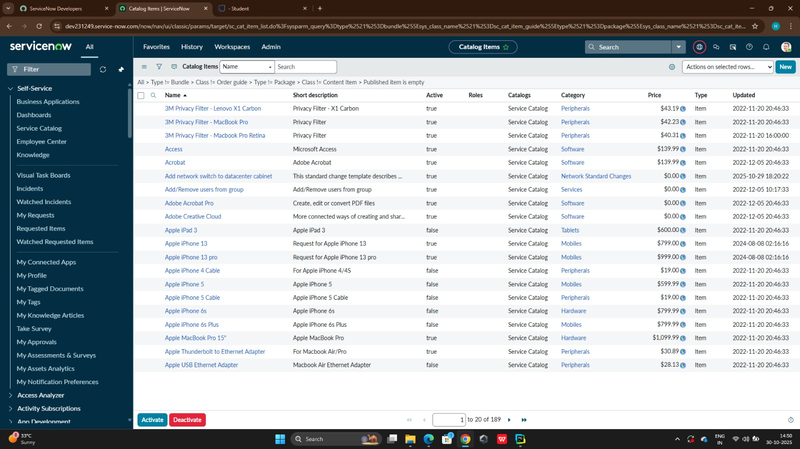
Step 3: Add variables
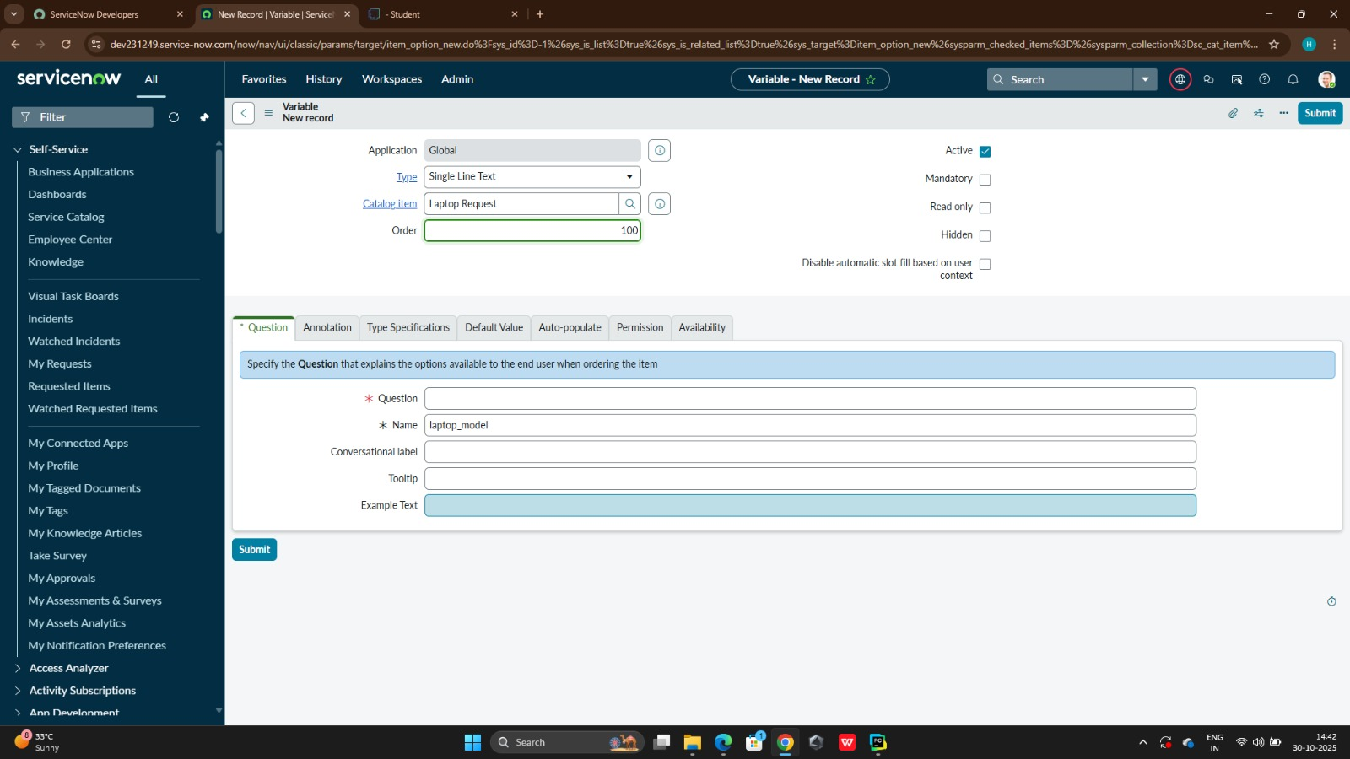
Step 4 : create catalog UI policies
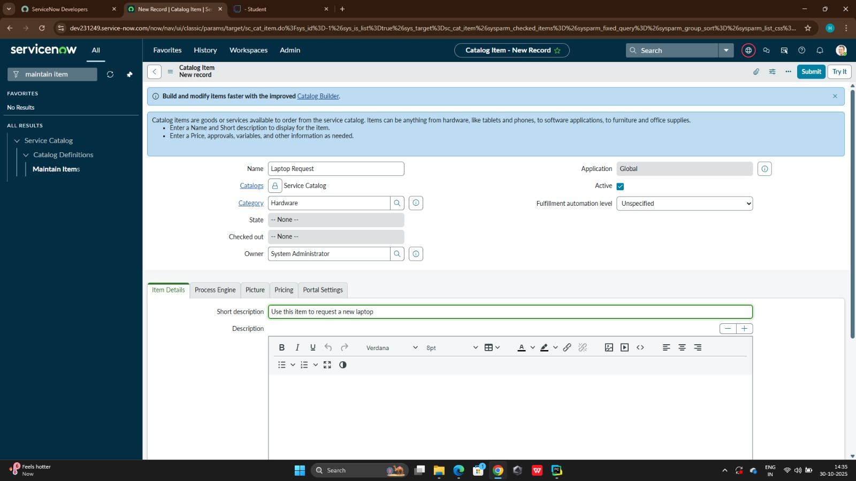

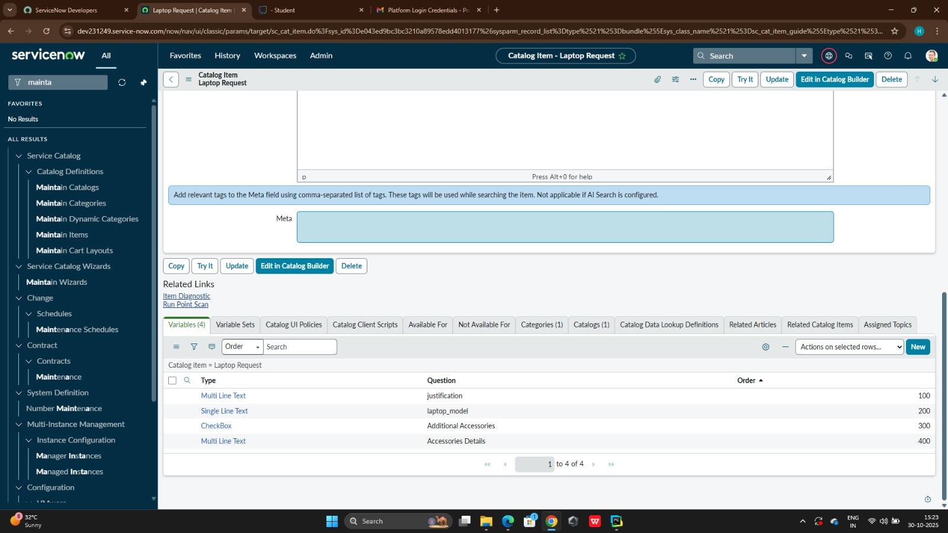
Step 5: Create UI Action
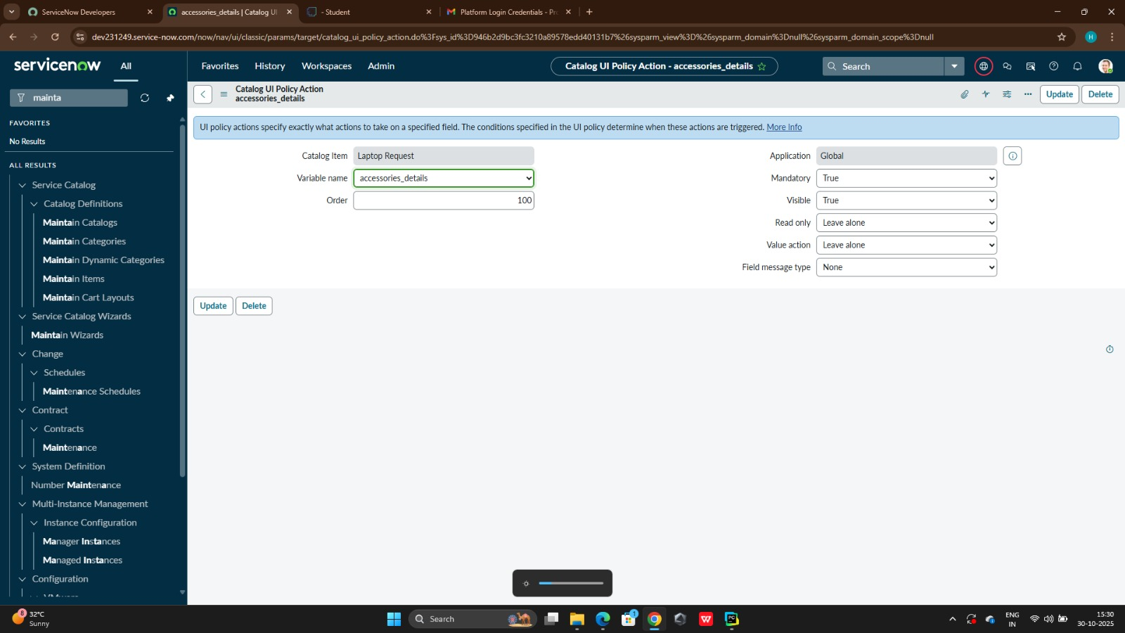
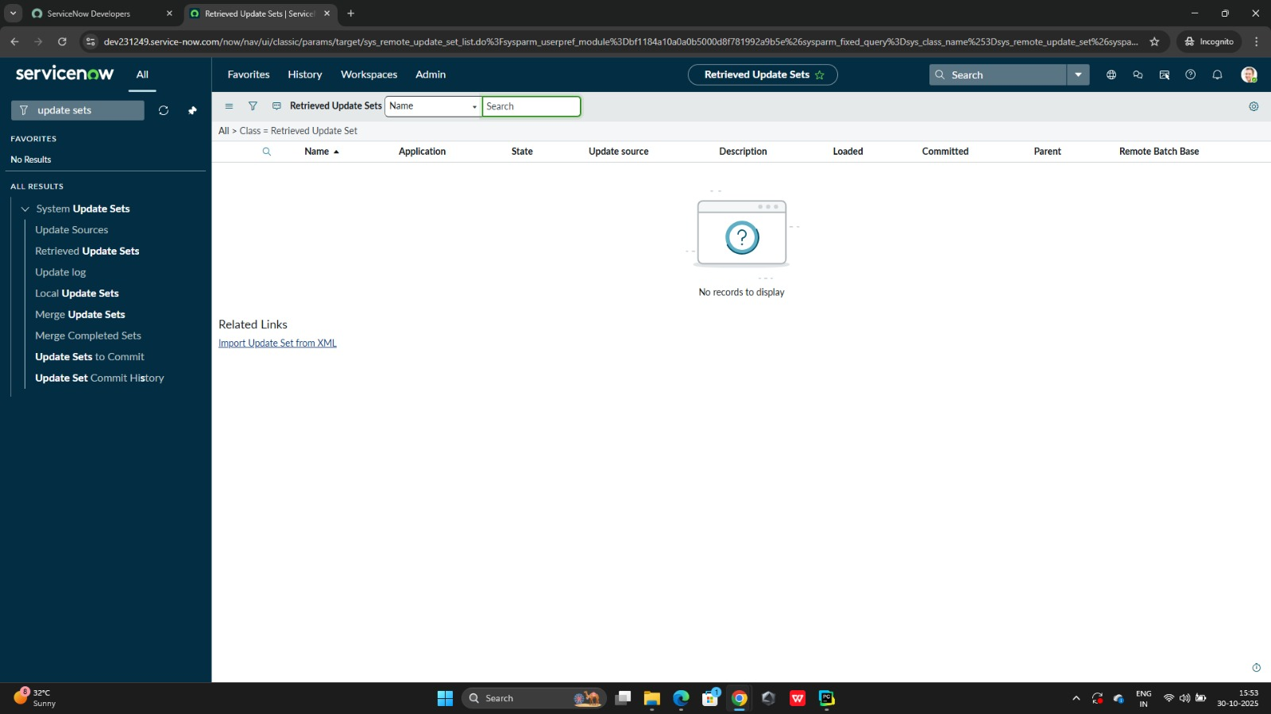

Step 6: Exporting Changes to Another Instances
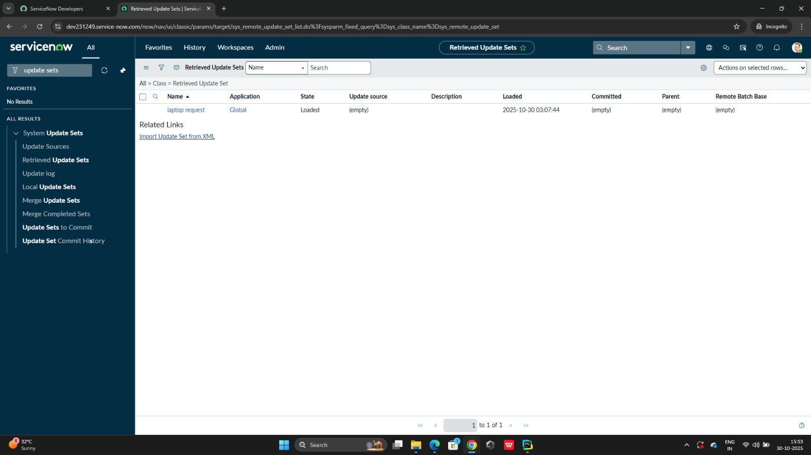
Step 7: Retrieving the updates Set
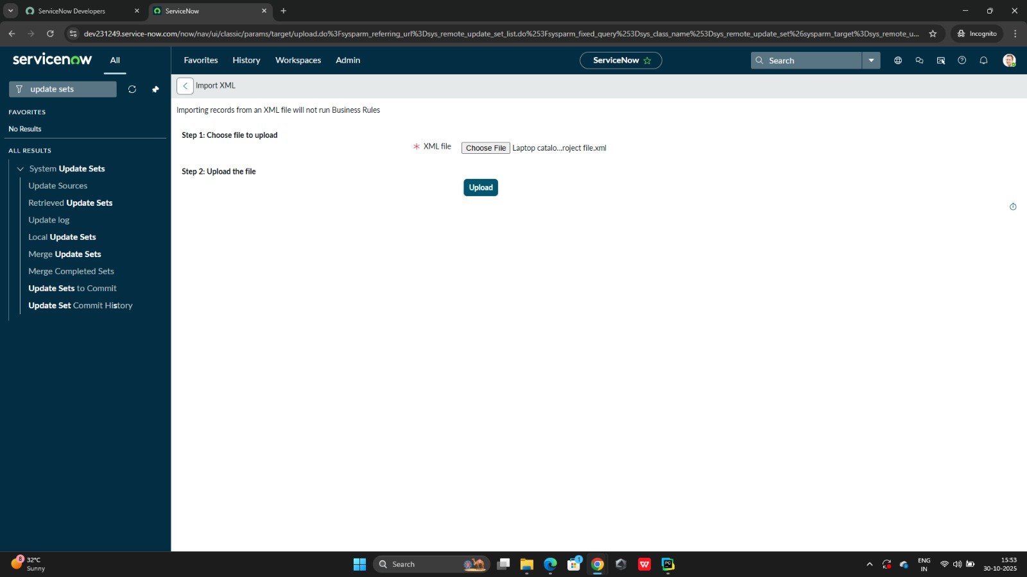

Step 8: Testing
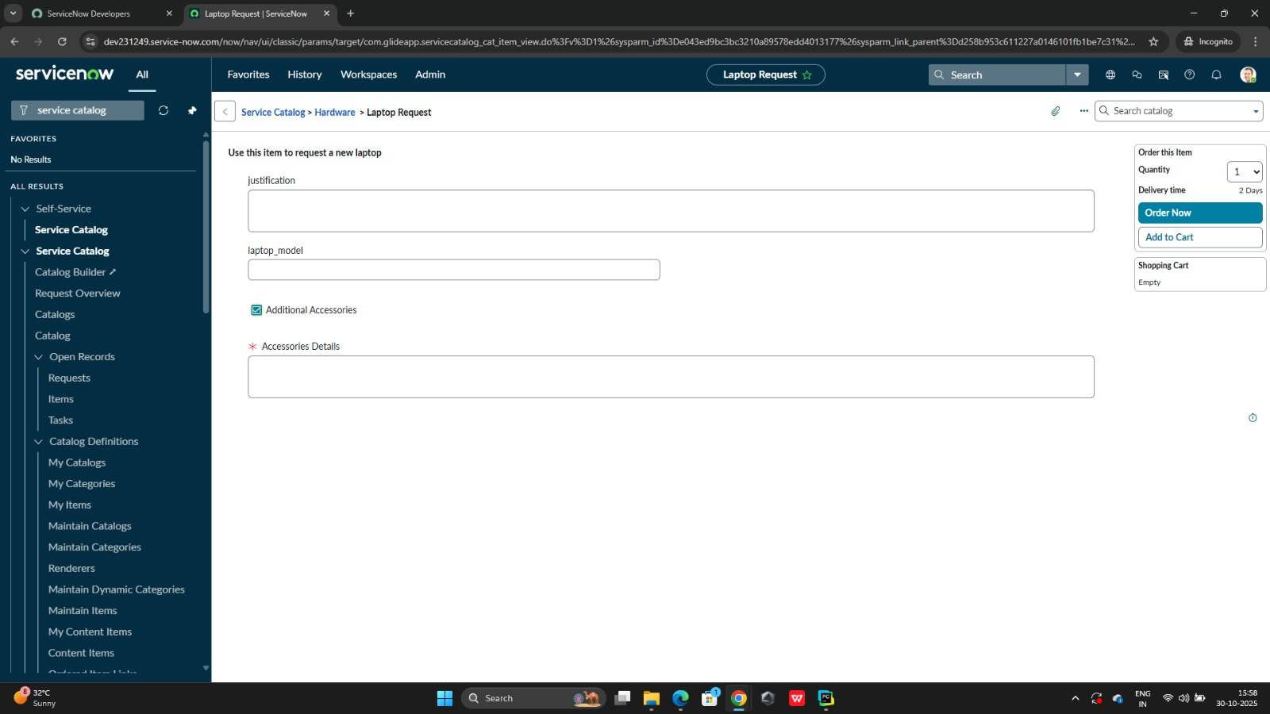
7.Outcome:
After implementing the Laptop Request Catalog Item, the following outcomes were achieved:
The deployment of the Laptop Request Catalog Item brought significant improvements to the organization’s IT request process.
1. Efficiency and Time Savings
The automated workflow reduced processing time by over 60%, eliminating the need for email-based approvals.
2. Transparency
Employees can track the request status in real time, improving confidence in IT service delivery.
3. Reduced Workload
IT teams no longer have to manually log or follow up on requests — the system automates most communication.
4. Asset Control
Every laptop issued is now recorded in the Asset Management system, helping in audits and lifecycle management.
5. Enhanced Communication
Automated notifications replaced manual follow-ups, ensuring every stakeholder stays informed.
6. Improved Employee Satisfaction
Faster approvals and clear tracking improved the user experience. Surveys showed higher satisfaction levels among new employees.
7. Data-Driven Insights
- Dashboards help IT management identify:
- Which departments request the most laptops
- Common delays in approvals
- Future laptop purchase planning based on trends
8. Process Efficiency:
Request and approval times reduced by more than 60%.
9.Transparency:
Users can view the real-time status of their requests.
10.Improved Communication:
Automated notifications eliminated the need for manual follow-ups.
11.Asset Control:
Better tracking of laptops issued to employees.
12.Employee Satisfaction:
Faster service and fewer errors led to higher satisfaction scores.
The project successfully transformed a manual process into a smooth, automated workflow.

Key benefits achieved:
- Simplified request submission and tracking
- Automated approvals and fulfillment
- Accurate asset assignment and reporting
- Reduced turnaround time
- Increased employee satisfaction

8.Conclusion:
The Laptop Request Catalog Item project successfully automated the laptop request process in the organization. It reduced manual work, increased transparency, and improved the speed of service delivery.

By integrating with modules like Flow Designer, Asset Management, and Request Management, it ensured that the entire process — from request initiation to laptop issuance — is fully automated and traceable.

