***ST. ANTHONY’S SR. SEC. SCHOOL UDAIPUR***

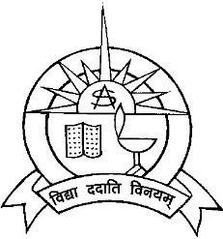

***~English Project~***

***SESSION : 2024-25***

***A project report on***

***””EXTRACURRICULAR ACTIVITY””***

***Submitted by- Rishika Alawat Class-XII (PCM)***

***Roll no:***

***Under the guidance of Mrs. Alpa Shamra***

***ACKNOWLEDGEMENT***

I would like to express my sincere gratitude to all those who supported me throughout the preparation of this project.

First and foremost, I would like to thank my physics teacher, Mrs. Alpa Sharma for their invaluable guidance and encouragement. Their insights and feedback helped me deepen my understanding of the subject and improve the quality of my work.

I would also like to extend my thanks to my classmates and friends for their collaborative spirit and assistance during the project. Their support made the learning experience enjoyable and memorable.

Lastly, I appreciate my family for their constant encouragement and belief in my abilities, which motivated me to complete this project successfully.

Thank you all for your contributions!

Rishika Alawat

XII--PCM

***CERTIFICATE***

This is to certify that Rishika Alawat of class XII -(pcm) has successfully completed the Physics project titled

“Extracurricular activity” as part of the Class 12 curriculum during the academic year 2024-25. The project was undertaken under the guidance of Mrs.Alpa Shamra .

The project demonstrates a thorough understanding of the principles of physics and reflects commendable effort and creativity.

Date:

Signature:

