Software Requirements and Design Document

For

Group <17>

Version 2.0

Authors:
Tyler K.
Angus L.
Cassadi Q.
Rachel A.
Rahil J.

Overview (5 points)

Our application is a Magic: The Gathering card tracker which will allow users to be notified when their tracked cards reach a price that goes below a certain threshold. Users will be able to sign up, and login using a username, email and password and then search for cards to track using various search information. They will interact using a smooth and fast web interface.

Functional Requirements (10 points)

- After entering account information in the login process shouldn’t take more than 3 seconds.
- After entering account information in the creation account process shouldn’t take more than 5 seconds.
- The query to search for a certain card shouldn’t take longer than 7 seconds.
- The time it takes to add or remove a card from the user’s list should feel instant, but the actual update on the server does not have to be.
- Changing user information should take no longer than 3 seconds.

Non-functional Requirements (10 points)

- Users should be able to login to the application or create an account using an email.
- Users should be required to verify their email and the verification process must be secure from cross-site script injection and also use no cookies.
- There should be a navigation bar at the top of the screen to make navigation simple and easy to understand.
- Logged in users should not be able to go to login and signup page while non-signed in users should not be able to go to login pages like dashboard and account.
- The website routes should be strict depending on if the user is logged in (logged in users should not be able to go to the login or signup pages and vice versa).
- Card price data should periodically be refreshed to allow users to receive alerts without requiring manual querying.
- Users should be able to easily remove cards from their list.
- Users’ passwords should be hashed and require a certain minimum character count.
- Users should be able to change their email and password.
- Users should be able to delete their account.
- Users should be able to track a card with optional thresholds that will email the user if those thresholds are reached.

Use Case Diagram (10 points)

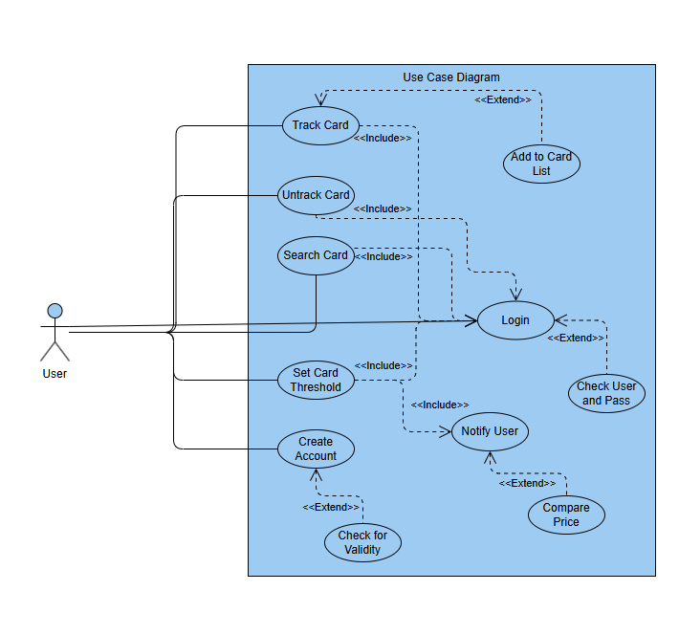

Class Diagram and/or Sequence Diagrams (15 points)

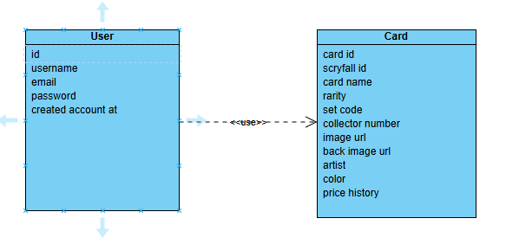

Operating Environment (5 points)

The software is a web application that will be usable by any web browser. The front end is developed for a computer monitor interface and is not meant for devices like phones or tables. For development all developers use Windows and require python and NPM for the basic pieces. Some of the automation scripts that we wrote to develop the project are still built strictly as .ps1 files for Windows, but running and downloading dependencies is now designated to python scripts allowing developers to develop on other machine types.

Assumptions and Dependencies (5 points)

The product will only work assuming the required external APIs for card prices stay available. Currently we are using the Scryfall price monitoring API. We decided to use Neon for hosting the database and we are developing the app using ReactJS front-end and a Python Flask back end. Because Neon is a dependency we are assuming there would be no issues or outages on their part.

