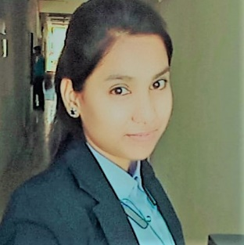

**RAHILA**

Phone: +91 8418081396

Email ID: [khanrahila799@gmail.com](mailto:khanrahila799@gmail.com)

Address: 125, udanpura, kalpi, Jalaun, Uttar Pradesh-285204

CAREER OBJECTIVES

Challenging career in IT industry, in an organization, which offers abundant opportunity to innovate, grow and develop.

WORK EXPERIENCE

* Fresher

ACADEMIC QUALIFICATION

|  |  |  |  |
| --- | --- | --- | --- |
| **S No.** | **EXAMINATION** | **BOARD** | **YEAR** |
| 1. | ADIT | MSDE | Pursuing |
| 2. | ITI | NSVT | 2021 |
| 3. | 12th | UP | 2020 |
| 4. | 10th | UP | 2018 |

ADDITIONAL SKILLS

* Able to work with Linux, open office, MS office
* Networking.
* HTML, CSS.
* DIT+ (Diploma in information technology).
* Cyber security from cisco.

EXTRA CURRICULUM ACTIVITY

* 2nd prize on Fashion designing competition.
* 2nd prize on Essay written competition.

STREHGTH & HOBBIES

|  |
| --- |
| * Heard & smart working * Honest & punctual skill * Good Communication skill |

|  |
| --- |
|  |

PERSONAL DETAILS

|  |
| --- |
|  |

Father’s name : Mohd Jaki Siddiqi

Mother’s name : Azara khatoon

Date of birth : 10/02/2003

Gender : Female

Marital status : married

I hereby declare that the information provided is true to the best of my knowledge.

**Date**:

**Current place**: (Noida Uttar Pradesh) Rahila