

**American International University-Bangladesh**

**Use Case Diagram and Mock Design**

**Software Engineering**

**Prepared By**

**Name ID**

Atiq, Rahin : 17-35697-3

Akter, Rozina : 18-38557-2

Ema, Sadia : 18-38378-2

**SECTION:**  G

**Guided By**

DR. MD. RAZIB HAYAT KHAN  
Assistant Professor  
Department of Computer Science

**UML USE CASE DIAGRAM**

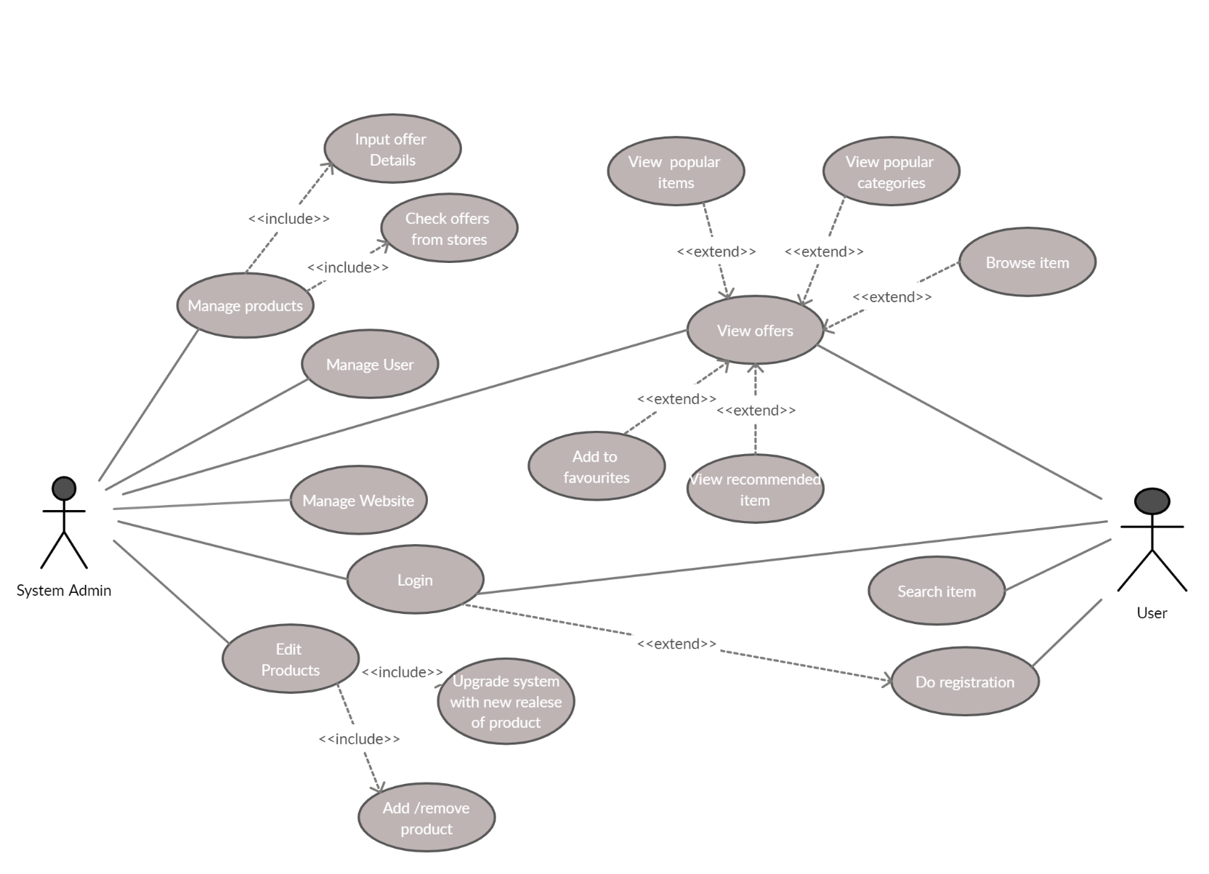

**MOCK DESIGN :**

