Rahisul Haque

CS 81

Assignment 1

1. Ans:

Computer scientist Brendan Eich wrote first JavaSript as a prototype in 1995 while he is working in Netscape Communication as a complementary of java (sidekick of actual Java). With in years this language gained popularity to make responsive and dynamic websites.

JavaScript is one of the world  most popular scripting language. Comparing other language, it is very easy to learn.   
It is dynamic in nature that means it is an interpreting language. It is also a high level language (human readable).

Brendan Eich, the creators of javascript took the name 'java' because in that time "Java programming language" was really popular.

JavaScript became really powerful with the introduction of 'NodeJS'. Rayan Dahl, a Google engineers made Node V8 engine  which runs JavaScript as language and bring this language to backend as full-scale server side programming language. So, lot of servers are running in  nodejs ie in JavaScript. Nodejs brought npm which is a rich package manager with a large number of modules.

In recent years AngularJS, Express gave another dimension to NodeJS as well as JavaScript   
In a nutshell, JavaScript is taking over the internet.

2.Ans.

ECMAScript is a trademarked of scripting–language specification standardized by ECMA (European Computer Manufacturers Association) . ECMA Script standards are based on several originating technologies, the most well known is JavaScript.

Web Scripting language is developed by different organization in different time. For example, JScript has been developed by Microsoft while JavaScript has been developed by Sun MicroSystem. There are many more. Though they have different names and they differs little bit from each other, their  main purpose and structure/ grammar is almost same. To avoid clashes of these languages, to take a load from the browsers and synchronize the internet browsing, ECMAScript  came up with a specific standard for all scripting languages for the browser.

Therefore, if javascript is written in the ECMA standard then it is obvious that the script will run in all  popular browser.

3. Ans:

true && true is true ;

 true || false is true;

false && true is  false;

 false  || !(false) is true;

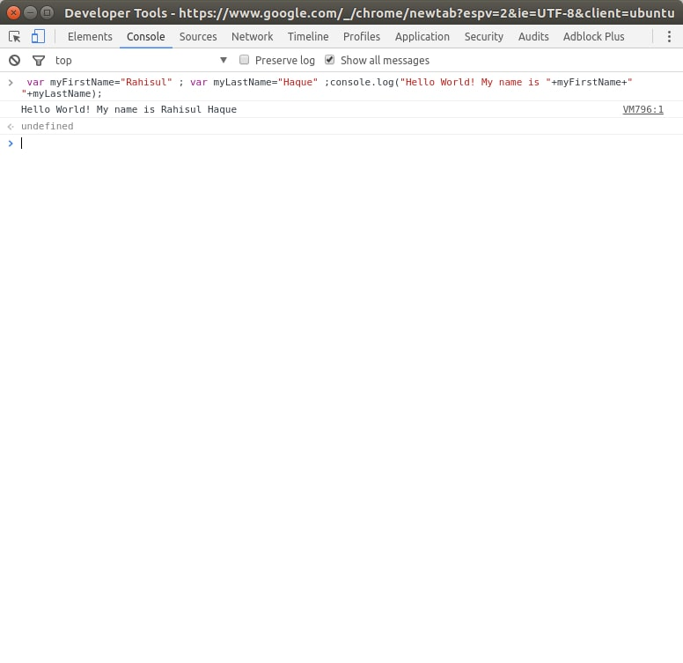4.ans

5.Ans.

There are 6 different data type in JavaScript.

They are i. String, ii. number, iii.  boolean,  iv.Symbol , v. Object and  vi. Null and undefined.

One of the most interesting thing in JavaScript“var” can hold all these different kind of value.

Number is a built in type value in JavaScript. It includes integer and float.

String is a very useful value type in JavaScript. It is always wrapped by double quotation or single quotation.

Undefined is a type of JavaScript value which means the value can not be defined by JavaScript.