OUTPUT:

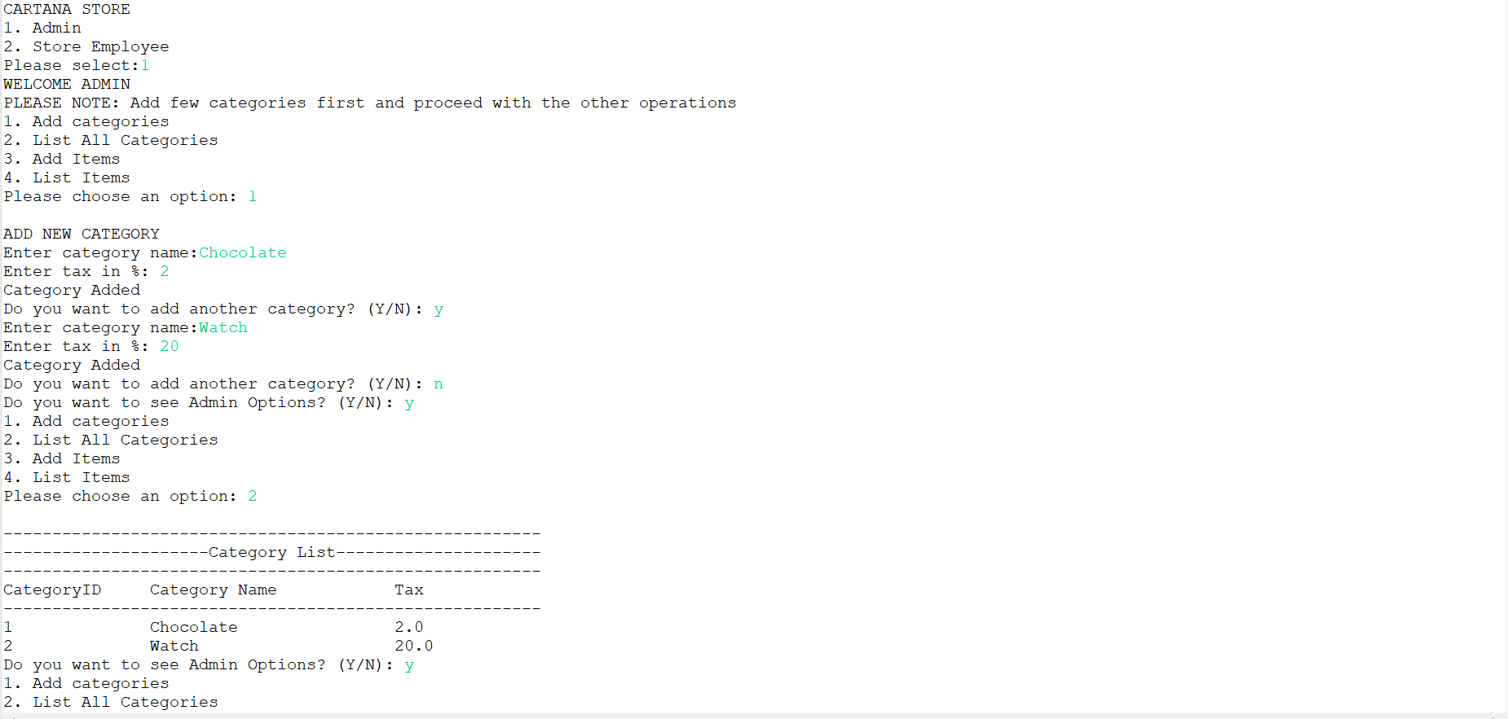

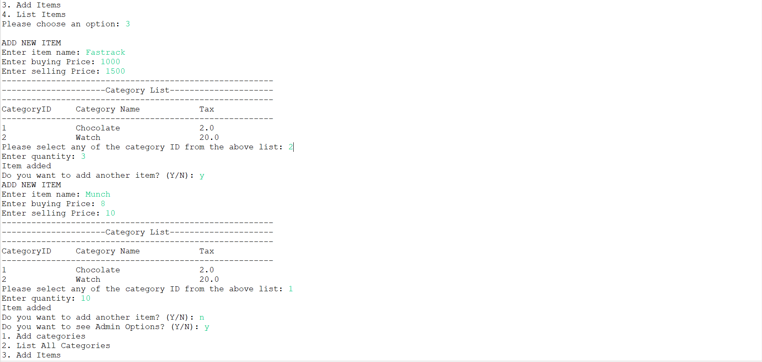

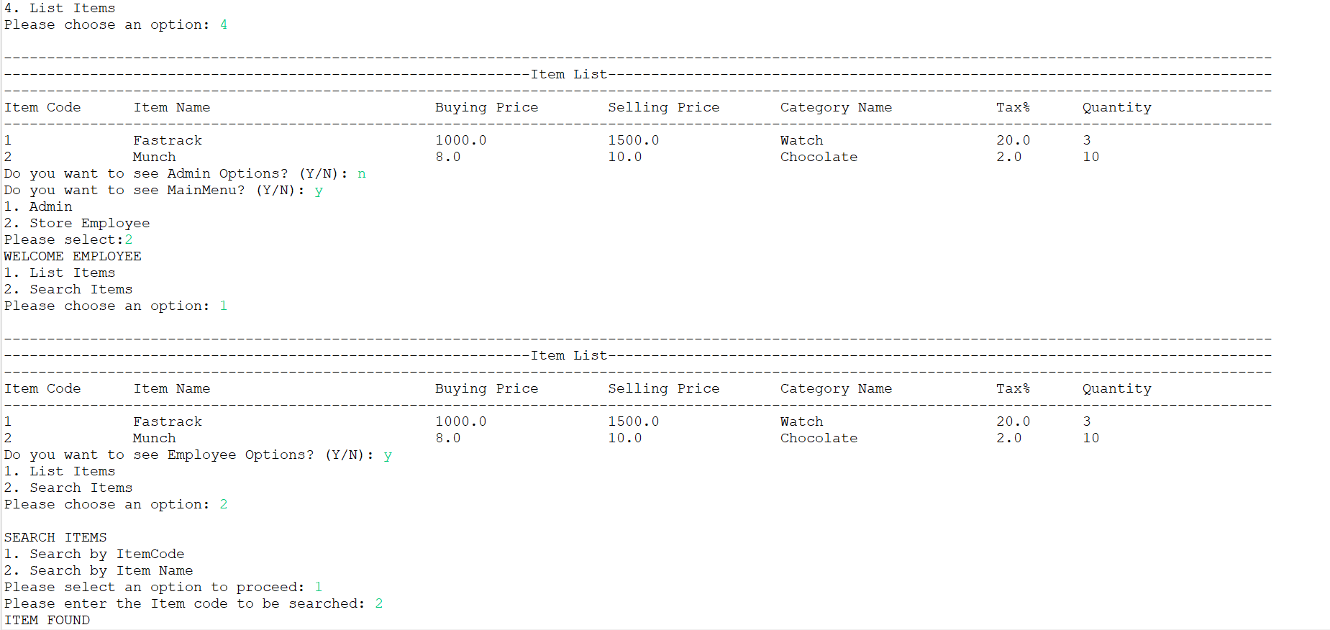

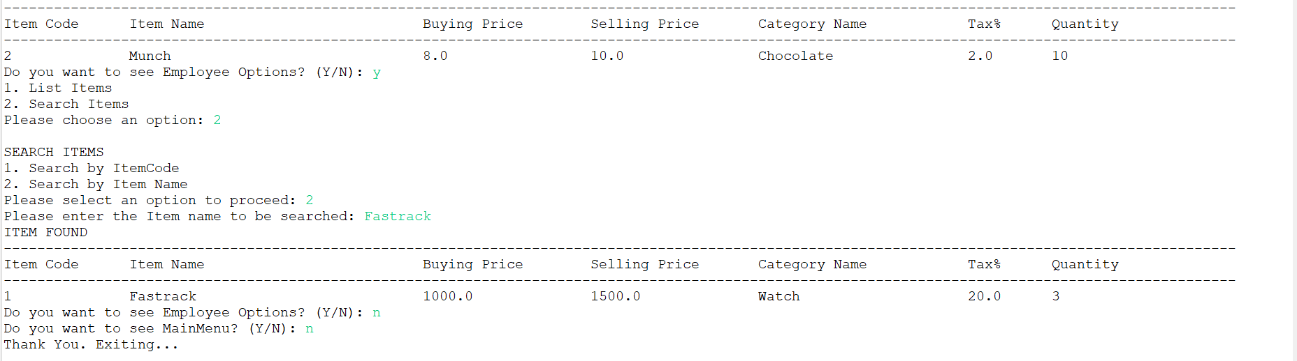

OUTPUT:

CARTANA STORE

1. Admin

2. Store Employee

Please select:1

WELCOME ADMIN

PLEASE NOTE: Add few categories first and proceed with the other operations

1. Add categories

2. List All Categories

3. Add Items

4. List Items

Please choose an option: 1

ADD NEW CATEGORY

Enter category name:Chocolate

Enter tax in %: 2

Category Added

Do you want to add another category? (Y/N): y

Enter category name:Watch

Enter tax in %: 20

Category Added

Do you want to add another category? (Y/N): n

Do you want to see Admin Options? (Y/N): y

1. Add categories

2. List All Categories

3. Add Items

4. List Items

Please choose an option: 2

-------------------------------------------------------

---------------------Category List---------------------

-------------------------------------------------------

CategoryID Category Name Tax

-------------------------------------------------------

1 Chocolate 2.0

2 Watch 20.0

Do you want to see Admin Options? (Y/N): y

1. Add categories

2. List All Categories

3. Add Items

4. List Items

Please choose an option: 3

ADD NEW ITEM

Enter item name: Fastrack

Enter buying Price: 1000

Enter selling Price: 1500

-------------------------------------------------------

---------------------Category List---------------------

-------------------------------------------------------

CategoryID Category Name Tax

-------------------------------------------------------

1 Chocolate 2.0

2 Watch 20.0

Please select any of the category ID from the above list: 2

Enter quantity: 3

Item added

Do you want to add another item? (Y/N): y

ADD NEW ITEM

Enter item name: Munch

Enter buying Price: 8

Enter selling Price: 10

-------------------------------------------------------

---------------------Category List---------------------

-------------------------------------------------------

CategoryID Category Name Tax

-------------------------------------------------------

1 Chocolate 2.0

2 Watch 20.0

Please select any of the category ID from the above list: 1

Enter quantity: 10

Item added

Do you want to add another item? (Y/N): n

Do you want to see Admin Options? (Y/N): y

1. Add categories

2. List All Categories

3. Add Items

4. List Items

Please choose an option: 4

---------------------------------------------------------------------------------------------------------------------------------------------------

-------------------------------------------------------------Item List-----------------------------------------------------------------------------

---------------------------------------------------------------------------------------------------------------------------------------------------

Item Code Item Name Buying Price Selling Price Category Name Tax% Quantity

---------------------------------------------------------------------------------------------------------------------------------------------------

1 Fastrack 1000.0 1500.0 Watch 20.0 3

2 Munch 8.0 10.0 Chocolate 2.0 10

Do you want to see Admin Options? (Y/N): n

Do you want to see MainMenu? (Y/N): y

1. Admin

2. Store Employee

Please select:2

WELCOME EMPLOYEE

1. List Items

2. Search Items

Please choose an option: 1

---------------------------------------------------------------------------------------------------------------------------------------------------

-------------------------------------------------------------Item List-----------------------------------------------------------------------------

---------------------------------------------------------------------------------------------------------------------------------------------------

Item Code Item Name Buying Price Selling Price Category Name Tax% Quantity

---------------------------------------------------------------------------------------------------------------------------------------------------

1 Fastrack 1000.0 1500.0 Watch 20.0 3

2 Munch 8.0 10.0 Chocolate 2.0 10

Do you want to see Employee Options? (Y/N): y

1. List Items

2. Search Items

Please choose an option: 2

SEARCH ITEMS

1. Search by ItemCode

2. Search by Item Name

Please select an option to proceed: 1

Please enter the Item code to be searched: 2

ITEM FOUND

---------------------------------------------------------------------------------------------------------------------------------------------------

Item Code Item Name Buying Price Selling Price Category Name Tax% Quantity

---------------------------------------------------------------------------------------------------------------------------------------------------

2 Munch 8.0 10.0 Chocolate 2.0 10

Do you want to see Employee Options? (Y/N): y

1. List Items

2. Search Items

Please choose an option: 2

SEARCH ITEMS

1. Search by ItemCode

2. Search by Item Name

Please select an option to proceed: 2

Please enter the Item name to be searched: Fastrack

ITEM FOUND

---------------------------------------------------------------------------------------------------------------------------------------------------

Item Code Item Name Buying Price Selling Price Category Name Tax% Quantity

---------------------------------------------------------------------------------------------------------------------------------------------------

1 Fastrack 1000.0 1500.0 Watch 20.0 3

Do you want to see Employee Options? (Y/N): n

Do you want to see MainMenu? (Y/N): n

Thank You. Exiting...