MODULE – B

Asset Definition: provide AssetType and AssetDefinition tables with records

1. ADDING NEW ASSET TYPE

ENDPOINT: POST-> <http://localhost:9090/api/assetTypes>

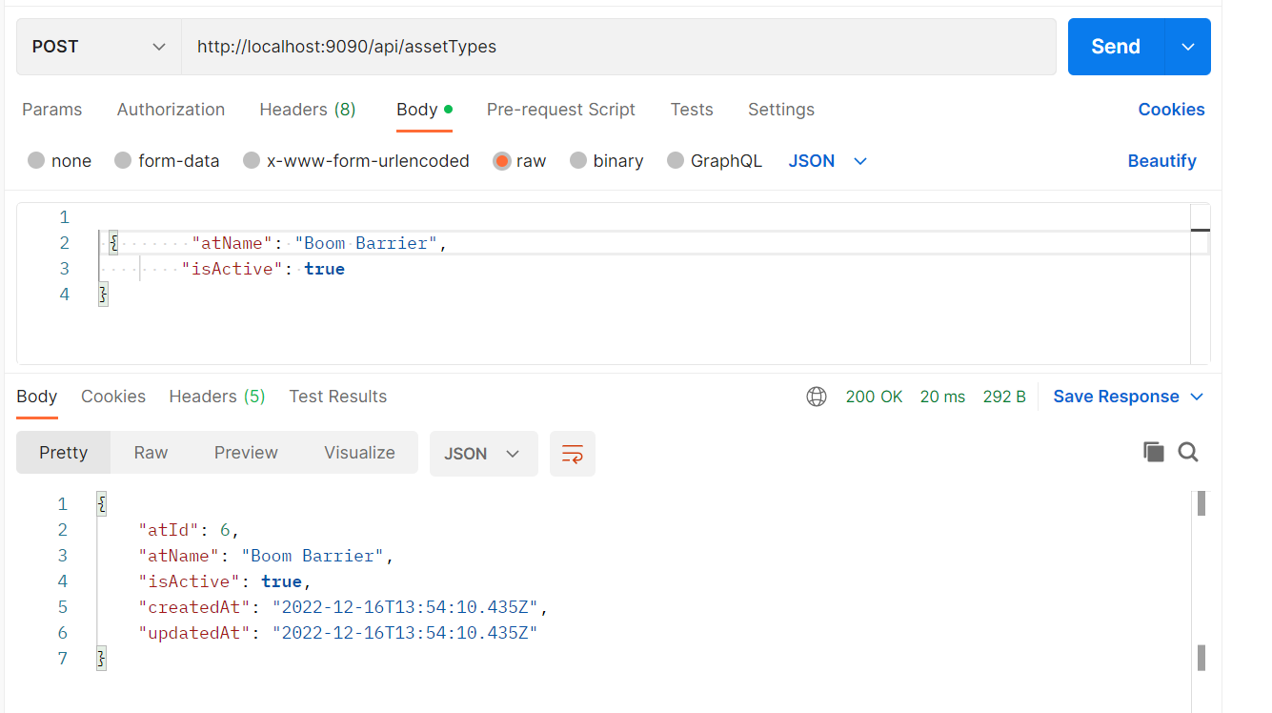

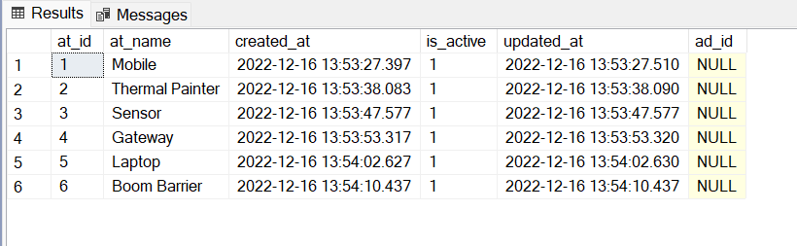

1. LISTING ALL ASSET TYPES

ENDPOINT: POST-> <http://localhost:9090/api/assetTypes>

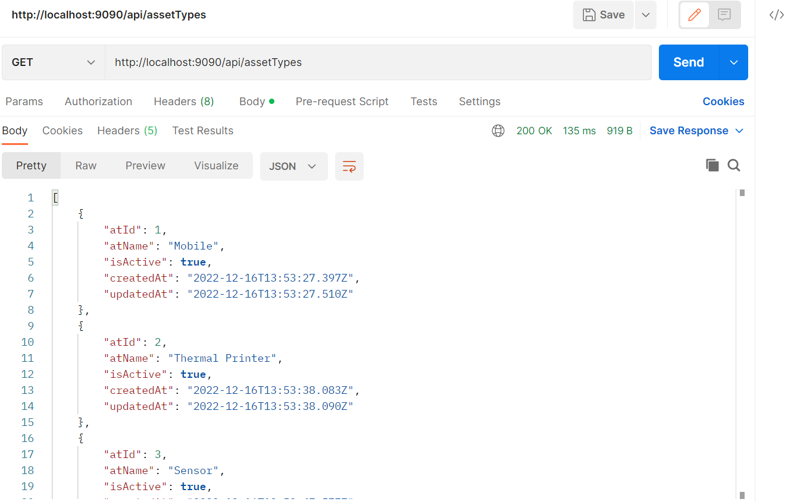

1. UPDATING AN ASSET TYPE BY ASSET TYPE ID

ENDPOINT: PUT-> <http://localhost:9090/api/assetTypes/2>

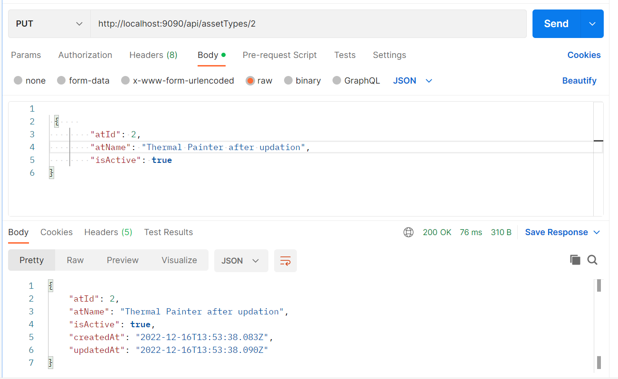

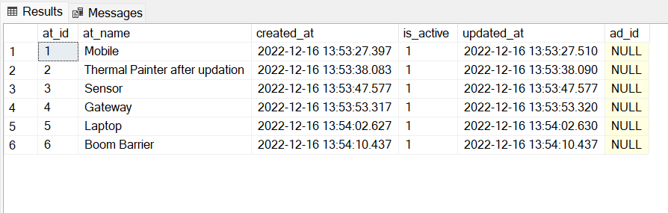

1. SEARCHING ASSET TYPE BY NAME

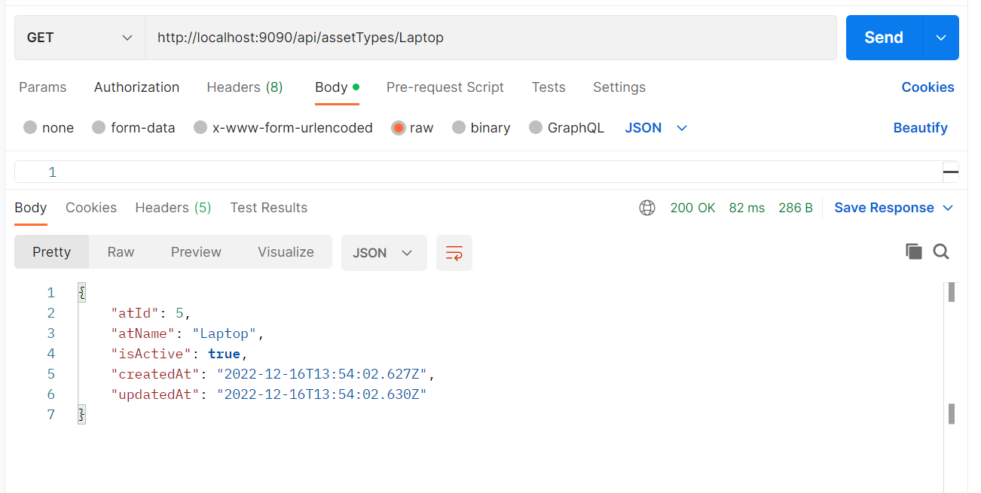

1. DELETING ASSET TYPE BY ID

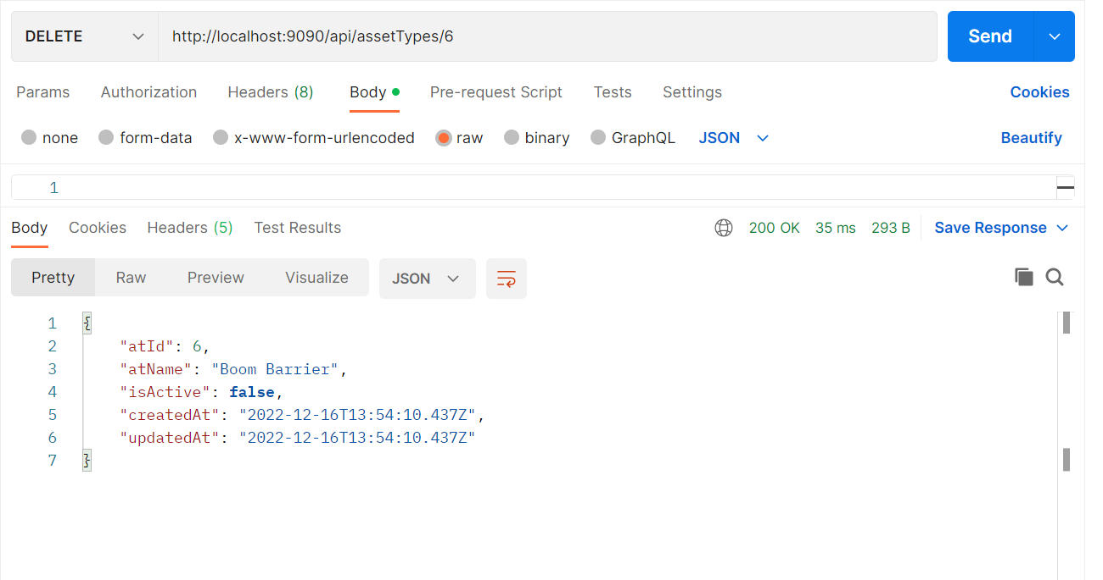

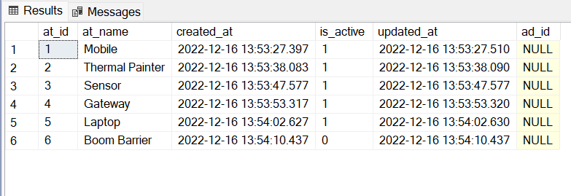

ASSET DEFINITION

1. ADDING NEW ASSET

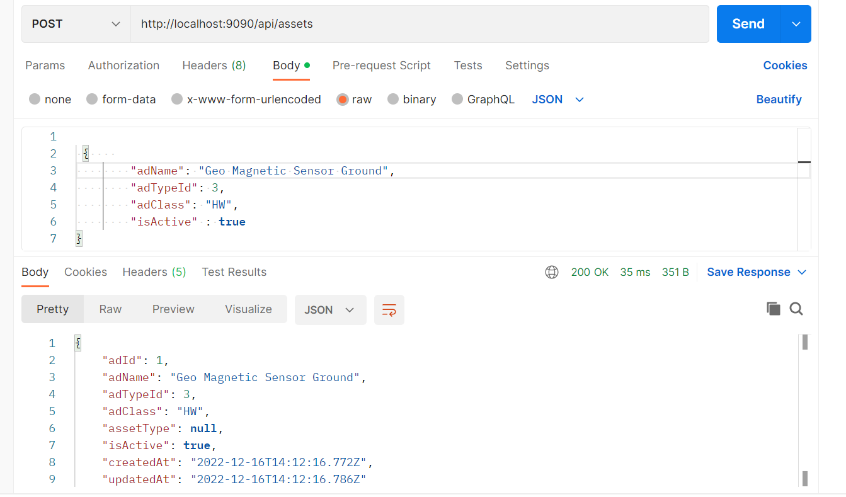

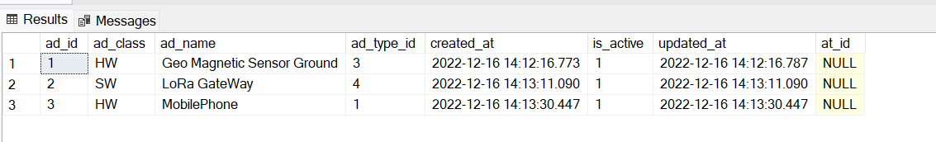

1. Updating an asset by ID

Changed AdClass to SW for AssetId = 2

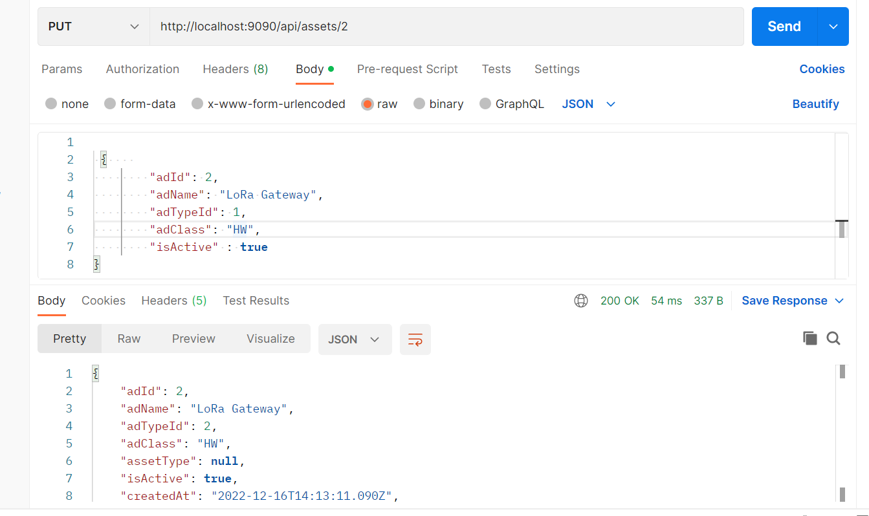

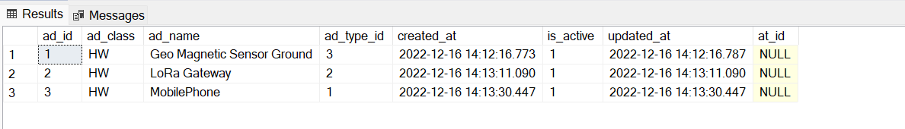

1. Listing all Assets

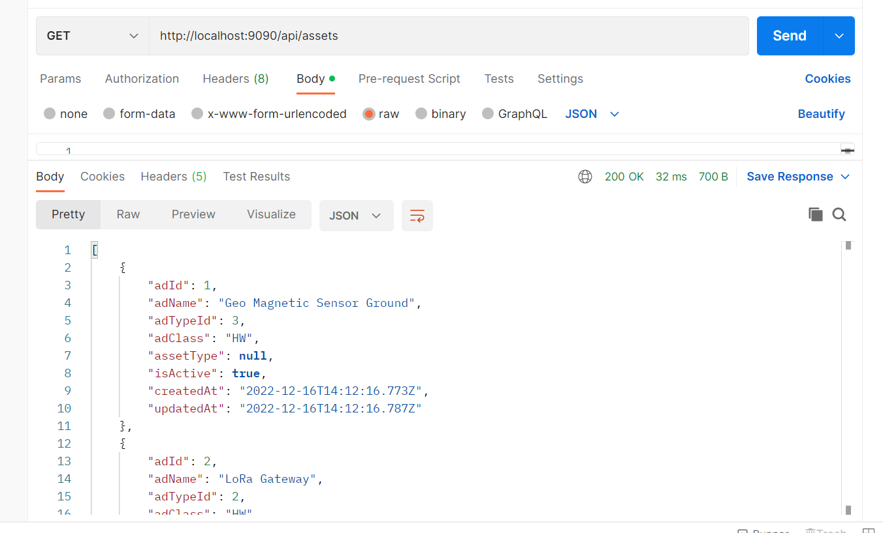

1. Searching an asset by name

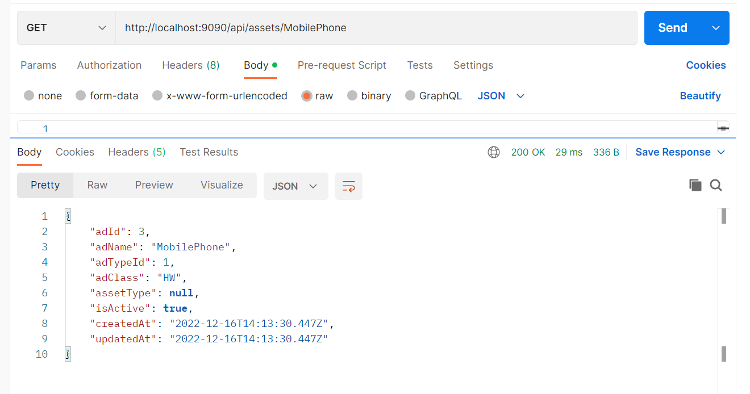

1. Deleting an asset

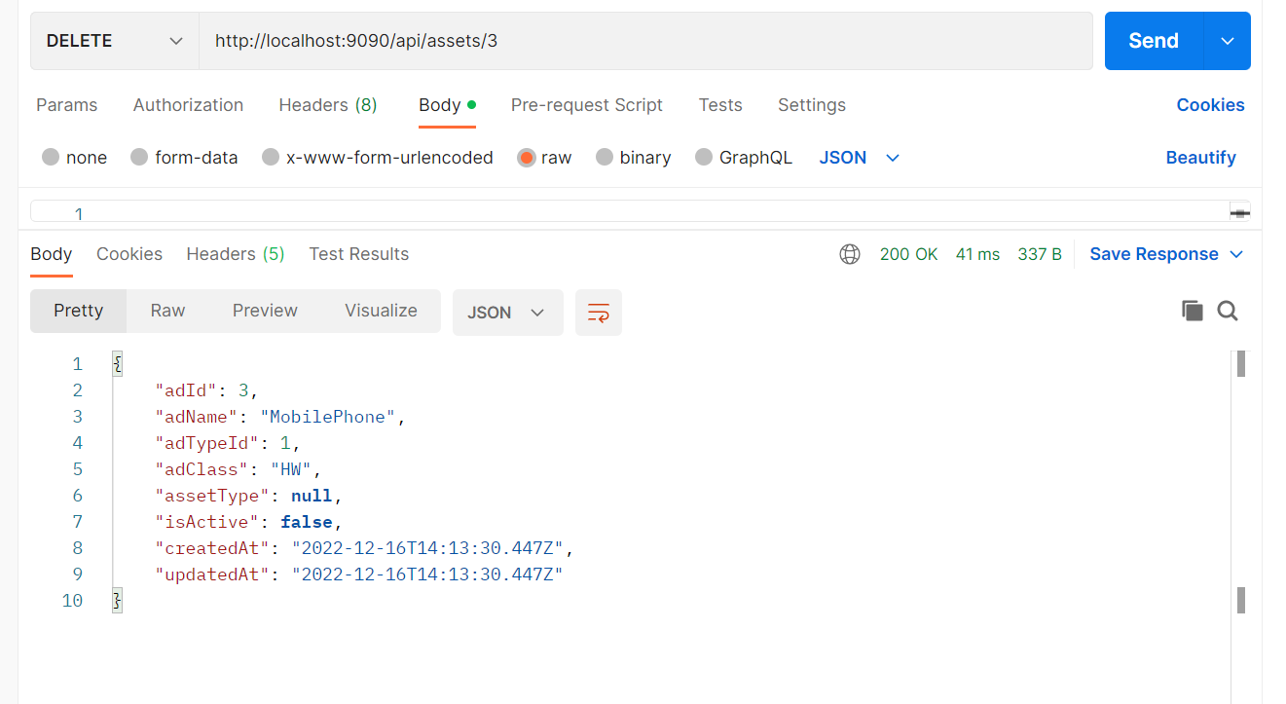

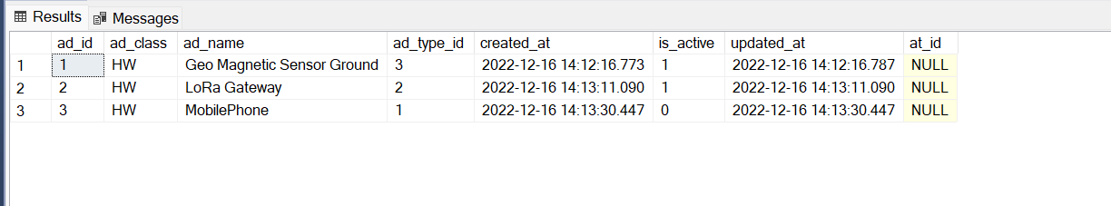

**MODULE – C**

**Vendor Creation: provide Vendor table with records**

1. Adding a new vendor

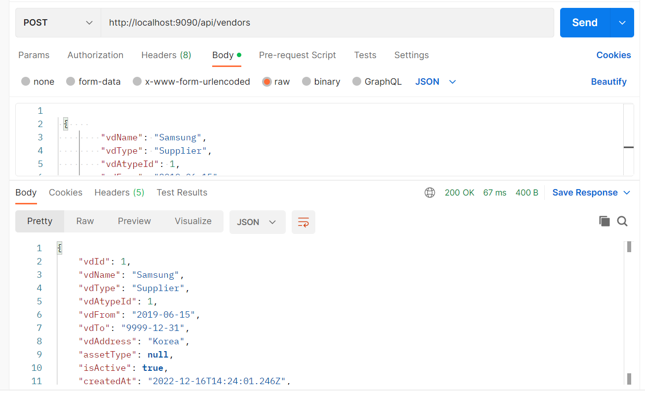

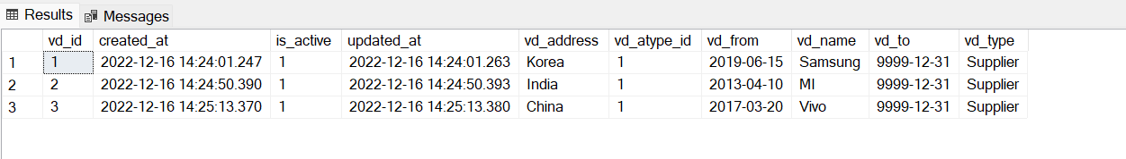

1. Updating a vendor by id

Changed Vendor address of vendor ID 3 from China to India

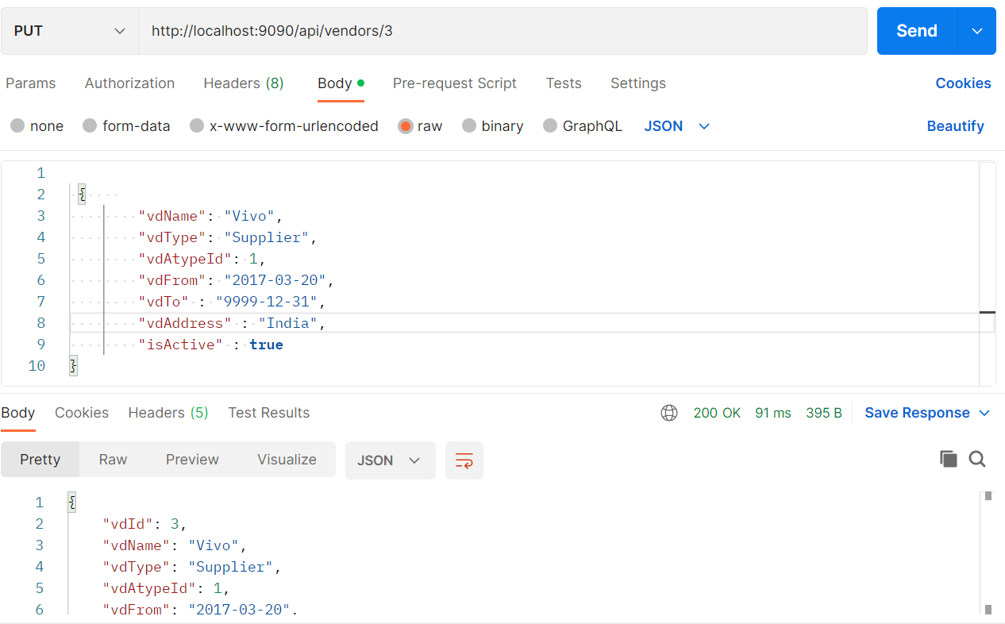

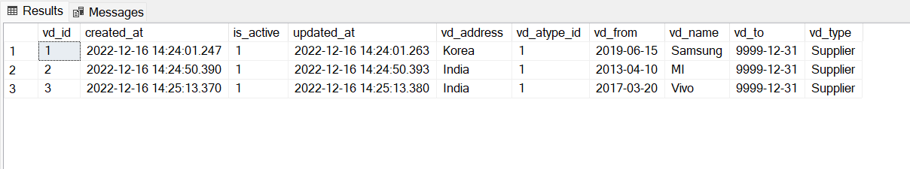

1. List all vendors

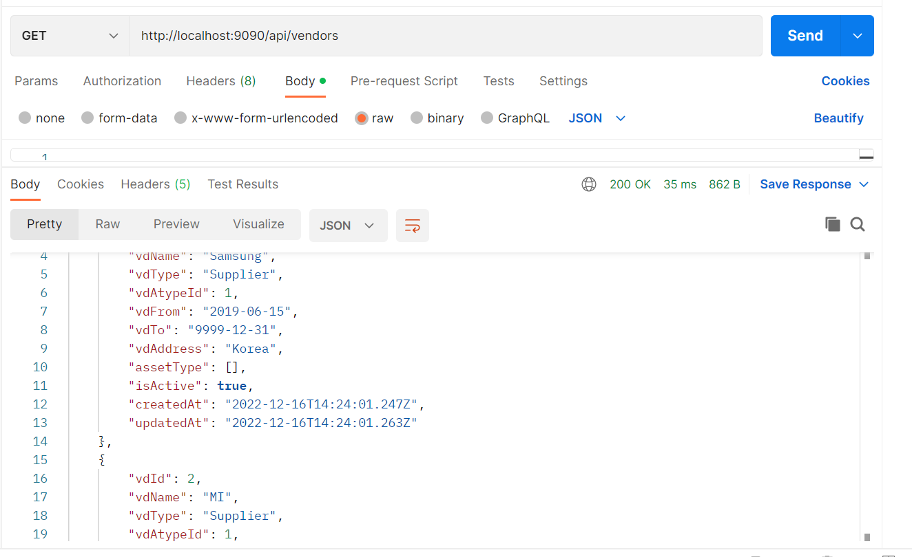

1. Search vendor by name

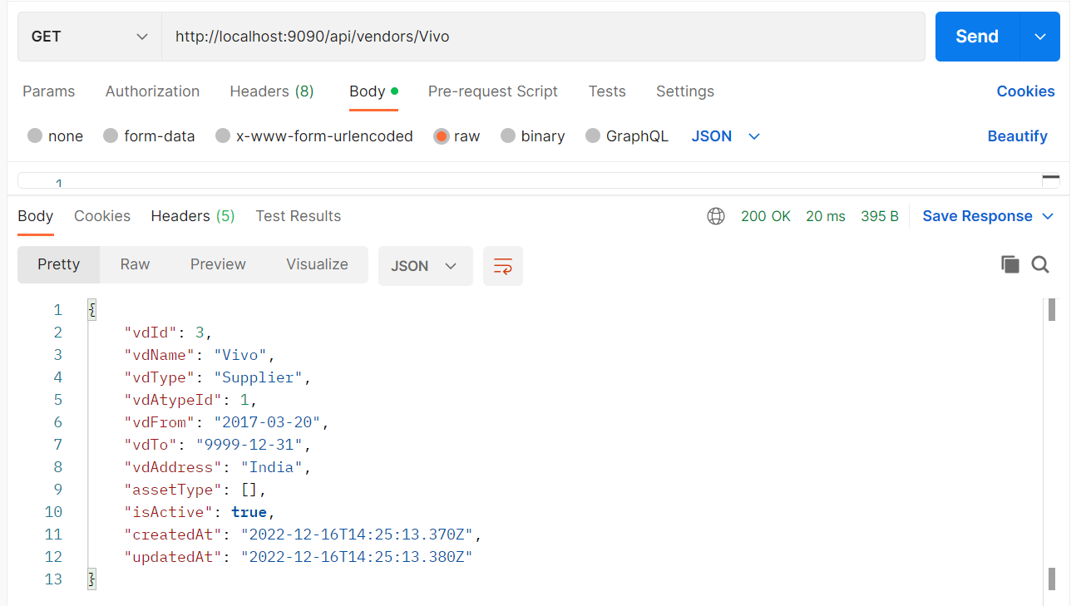

1. Delete a vendor

