Eggplosion

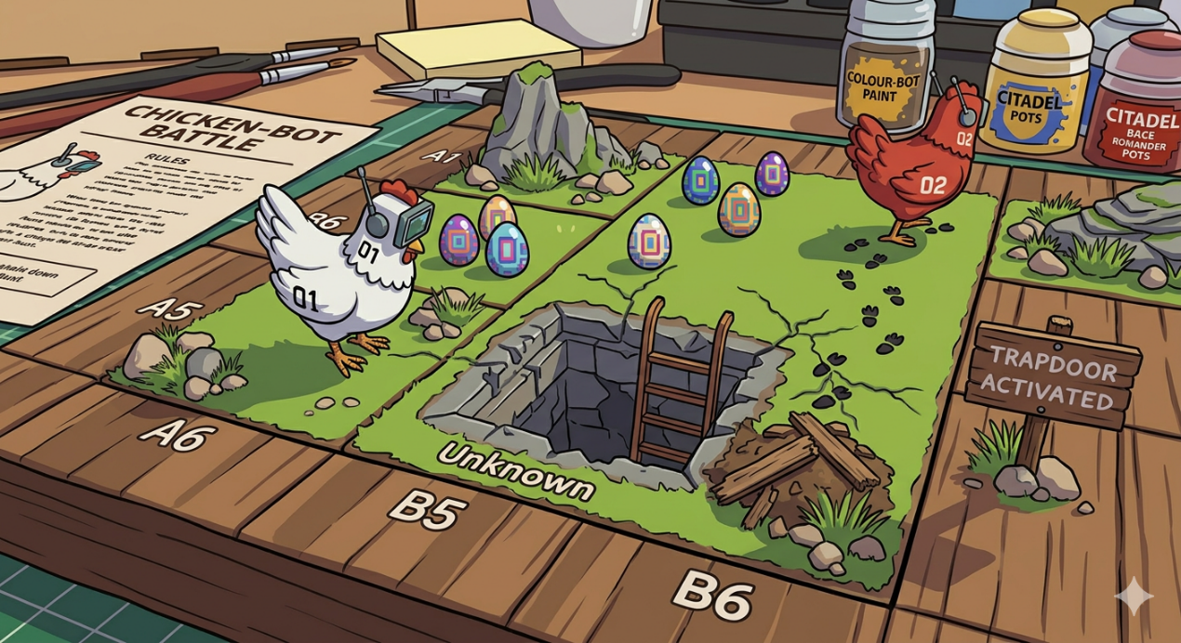

Members:
Rahma Hosam Salem, Rehma Reda ElSayad, Sara Ahmed Nabih. Section: 4
Why this idea?
This project was chosen because it combines strategic gameplay with artificial intelligence decision-making in a controlled environment. Board-game–like environments are widely used in artificial intelligence research because they provide a clear structure where agents must evaluate possible actions and select optimal strategies.
Idea Importance and Goal:
The importance of this project lies in demonstrating how artificial intelligence agents can operate in environments that involve both strategy and uncertainty. The main goal of this project is to design a grid-based chicken game environment and implement an AI agent capable of selecting optimal moves using the Minimax algorithm with Alpha–Beta pruning, and allow a human player to compete against the AI agent in real time.
Eggplosion Game Description:
This is a two-player (Human vs. Agent), turn-based strategy game on a grid board.
Each player controls one chicken that moves around the board and lay eggs on tiles to score points and can place turds (obstacles) a limited number of turds can be placed by each chicken to obstruct or block the opponent.
However, the board contains hidden trapdoors. If a chicken steps on a trapdoor, it becomes revealed, and the player receives a penalty.
The objective is to win by laying more eggs than the opponent before the move limit is reached.

PEAS

Performance: Maximize number of eggs, Minimize opponent eggs, Avoid trapdoors.
Environment: Grid map, Trapdoors, Eggs, Turds, Opponent Chicken.
Acuators: Keyboard (Move up, down, left, right) and mouse clicks (Lay eggs, Place turds)
Sensors: Information AI receives: Board state, Revealed tiles, Egg & Turd Locations, Chicken Positions.

ODESA

Minimax with Alpha-Beta Pruning (Adversial Search): The AI uses the Evaluation Function. It calculates the value of the board state for every possible move. It will prioritize tiles that are safe (already stepped on) or tiles that are valuable (clusters of empty squares).
Alpha-Beta Pruning is vital for maximizing the score. Because it’s AI vs. Human, the AI assumes the Human will play perfectly. It will search deep enough to see if the Human is trying to Trap the AI in a corner with Turds. If the AI sees a future where it gets trapped (score = 0), it will choose a different path now.

Algorithms

Observability: Partially Observable (because of hidden trapdoors).
Deterministic or Stochastic: Stochastic (because of hidden trapdoors).
Episodic or Sequential: Sequential.
Static or Dynamic: Static.
Agents: Multi-agent, Competitive (Human vs. AI).

