Eggplosion

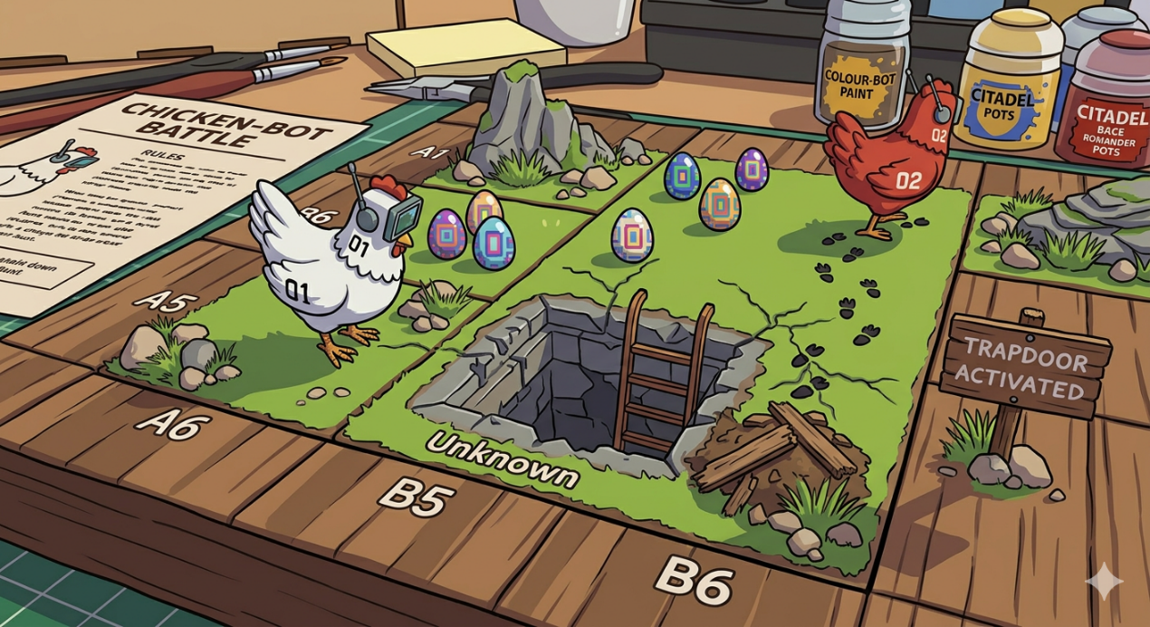

Initial Setup:
Before the game begins:
- Board and Game Screen are created
- Trapdoors placed
- Players placed at starting tiles
- Each player receives:
  - moves_left
  - turds_remaining
  - eggs_placed
- No eggs exist initially
Board Description:
- Checkerboard of green_grass.png and light_grass.png
- Trapdoors are placed randomly and are not reveled until a chicken step on it.
- Two Chicken: white_chicken.png, and black_chicken.png
- As the game progresses, chickens place eggs (according to some conditions) such that once an egg (either dark_egg.png or white_egg.png) is placed it remains shown and fixed on the board over the grass, same logic applies when a chicken steps on a hidden trapdoor and when a chicken places a turd.

Game Screen:
- The game screen is mainly two parts: the bigger part on the left is the game board where chickens play, the smaller part on the right is the match stats such that it has two parts, one for the white chicken, the other for the black chicken, each part contains the number of eggs_placed, moves_left, turds_remaining. The bottom of the right side that contains the match stats shows which chicken turn is.
Turn Order:
- Players alternate turns: White → Black → White → Black ….
- White chicken (human player) always starts.
Turn Structure:
- Each turn consists of:
- Movement (mandatory)
- Tile resolution
- Optional action
Movement (Mandatory):
- A player moves exactly one tile in UP, DOWN, LEFT, RIGHT. (Diagonal movement is not allowed, player moves only to adjacent tiles).
- When a chicken moves on a tile, tile is revealed.
- When a player moves to a tile, does an optional action, the moves_left counter decrements by 1, and the turn goes to the other chicken
Illegal Moves:
- A move is illegal if the tile:
- is outside the board
- contains the opponent chicken
- contains a turd
- contains a revealed trapdoor
- Unknown tiles can be entered.
Tile Resolution:
- If tile is:
- Safe: → Continue
- Trapdoor: → Apply penalty (lose 2 moves_left), End turn immediately, No egg allowed, trapdoor revealed, chicken returns to previous tile.
- Trapdoor tiles become permanently blocked.

Player Actions:
After movement, the player may perform one action: Lay egg, Place turd, or Do nothing.
Egg Placement:
- A player may place an egg only on the tile they currently occupy, after moving onto it and confirming it is safe.
- Conditions: tile is SAFE, no egg on tile, (and no trapdoor, opponent chicken, or turd, which are already illegal moves from the first place).
- When a player places an egg, the eggs_placed counter for that player increments by 1.
Turd Placement:
- Players have limited turds.
- A turd can be placed only on the tile the chicken currently occupies, and only after a successful move onto a SAFE tile.
- Conditions to place a turd:
- Tile is SAFE (already revealed by stepping on it this turn)
- Tile has no egg
- Tile has no turd
- Player has turds_remaining > 0
- After placing a turd, turds_remaining decrements by 1.
- When a chicken places a turd on its current tile, and later moves to another tile, the turd becomes a permanent obstacle.
Game End:
- Game ends if: Both players have moves_left = 0, or no legal moves remain.
Winning Condition:
- Winner is the player with the higher score.
- Score = number of eggs collected.
- If equal: Draw

