**Homework 2**

1)

2)

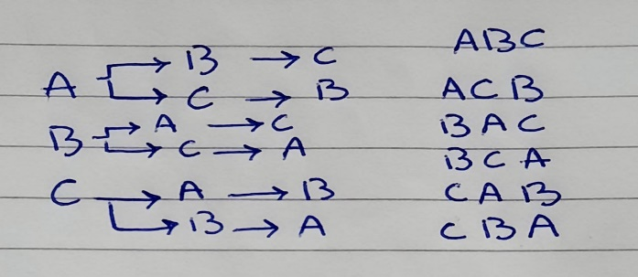

3)

   (i) 2/12 + 2/12 = 4/12 = 1/3

   (ii)  1/12 + 2/12 = 3/12 = 1/4

4)

   (i) 3/15

   (ii) P(A1 | A2) = (3/15 . 1/3) / 1/3 = 1/5

   (iii) 1/15 + 2/15 + 3/15 = 6/15 = 2/5

5)

|  |  |  |  |
| --- | --- | --- | --- |
| Total | Boys | Girls |  |
| 15 | 5 | 10 | From Mansoura |
| 15 | 5 | 10 | Not from Mansoura |
| 30 | 10 | 20 | Total |

P(A ∪ B) = ⅓ + ½ = 5/6

6)

(i) p(A') = 1 - (⅜) = ⅝

   (ii)  p(B') = 1 - (½) = ½

(iii) p(A' ∩ B') = (⅝) . (½) = 5/16

   (iv)  p(A' ∪ B') = (⅝) + (½) - (⅝ . ½) = 13/16

   (v)  p(A ∩ B') = (⅜) . (½) = 3/16

   (vi)  p(A' ∩ B) = (⅝) . (½) = 5/16

7)  p(A) = 0

8)  k² - 8 = 1    ∴ k= 3

9) p(A' ∩ B') = p(A ∪ B)' = 1 – (0.35 + 0.45) = 0.2