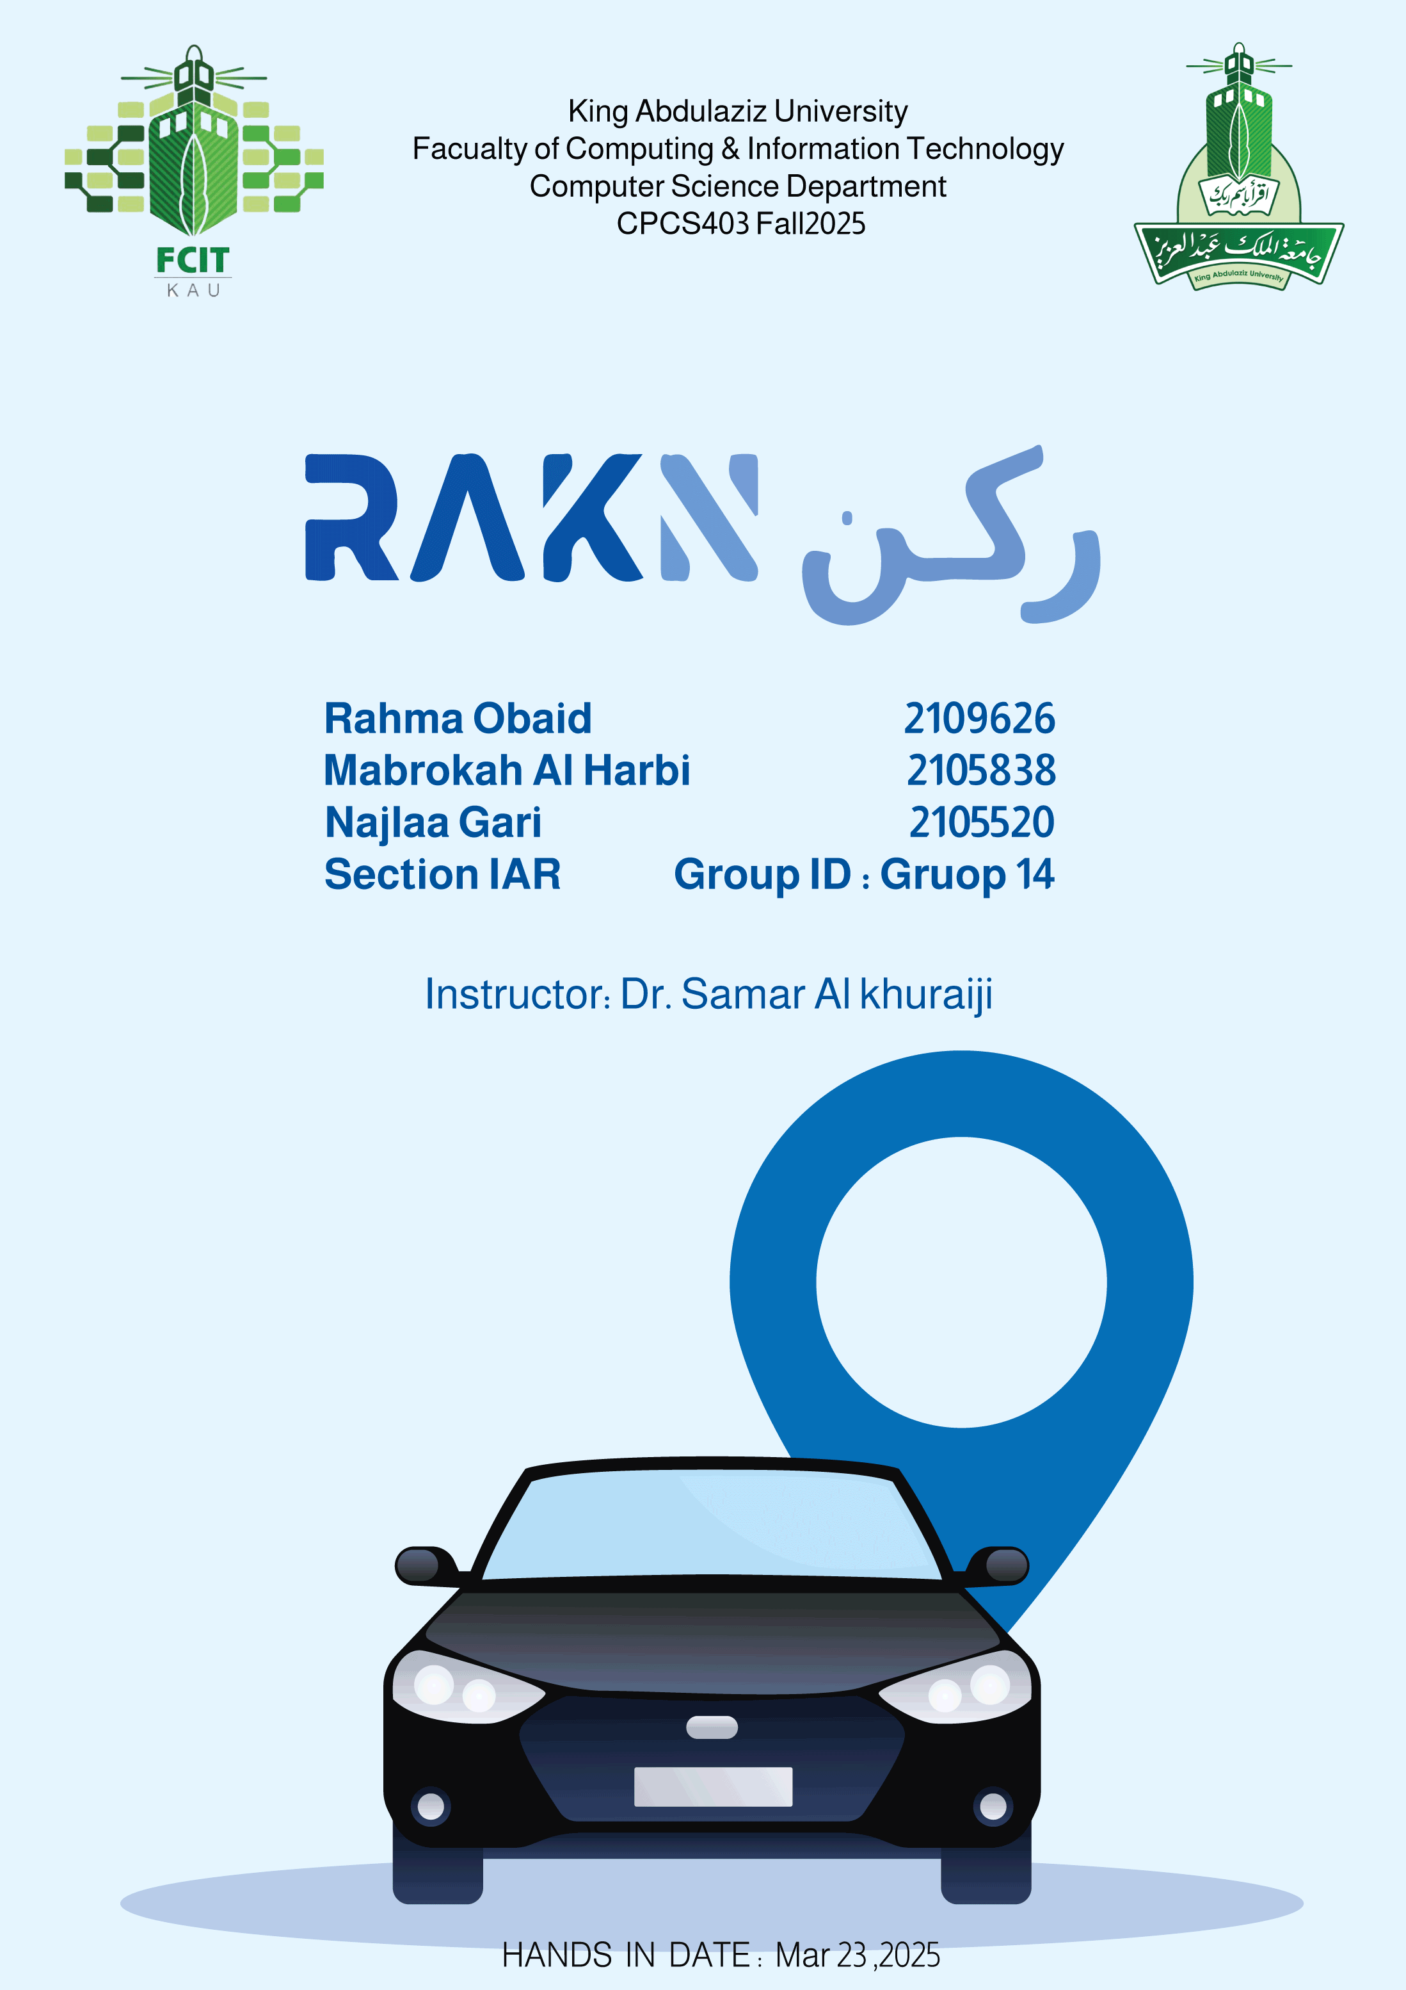

2

**Table of Contents**

**1.** **Project Idea** 3

**2.** **Recommended Solution** 3

**3.** **Key Benefits of the RAKN System** 5

**4.** **Storyboard** 6

**5.** **Site map** 7

**6.** **Our website** 7

3

# **Project Idea**

As urban areas grow increasingly congested, the demand for parking spaces. This escalating challenge leads to significant time loss for users searching for parking, heightened frustration, and unsafe parking practices, which can contribute to accidents and traffic congestion. The lack of efficient parking management not only affects the experience of drivers but also disrupts the operational flow of these institutions, compromising service delivery and safety.

Current manual systems that require security personnel to issue tickets for parking violations pose significant challenges. Security guards are typically responsible for a wide range of tasks, such as monitoring the premises, ensuring the safety of individuals, and handling emergencies. The added responsibility of managing parking violations, which requires time and attention, can be overwhelming and detracts from their primary duties. As a result, these systems are often inefficient, leading to delayed enforcement and reduced overall effectiveness in maintaining proper parking regulations.  
  
To address these issues, there is a pressing need for a comprehensive parking management solution that integrates artificial intelligence and automation to streamline the parking process, improve safety, and enhance the overall experience for all users.

# **Recommended Solution**

 RAKN system is an innovative parking management solution designed to address unauthorized entry and incorrect parking, both of which cause inefficiencies and inconvenience for drivers. To implement the system, facilities must provide employee photographs for facial recognition, mobile numbers for communication, and job numbers to link employees with their vehicles. Unauthorized entry is managed through a camera at the parking gate that uses AI to recognize car plates and verify the driver's face against a stored database. If the driver's face is not recognized, the gate remains closed; otherwise, the car plate is linked to the job number, and the gate is opened. To detect incorrect parking, drone cameras patrol the parking lot at regular intervals, capturing video footage that is analyzed using AI. In the case of a violation, the system captures an image, identifies the car plate, and sends an alarm to the user to park correctly via SMS message that includes a link to our chat bot for further details. In case the car remains in the wrong parking position, the system

4

records the violation against the owner and sends a notification. After working hours, drones also monitor vehicles parked beyond allowed times, sending notifications to security personnel for further action. This comprehensive solution enhances parking management by combining AI-powered facial and license plate recognition with automated drone surveillance to ensure security, efficiency, and an improved user experience.

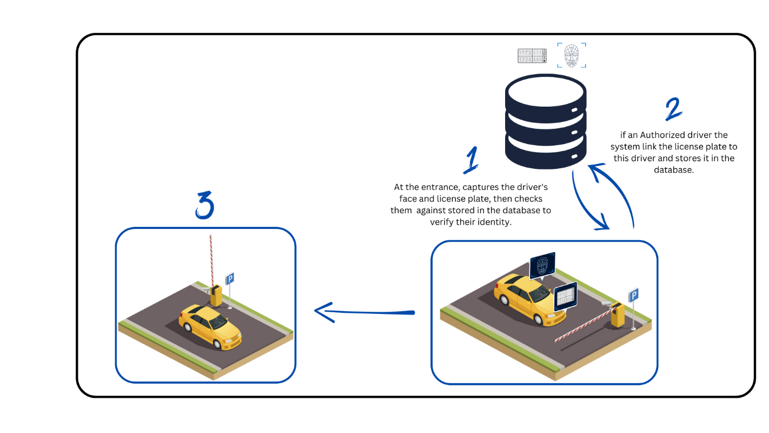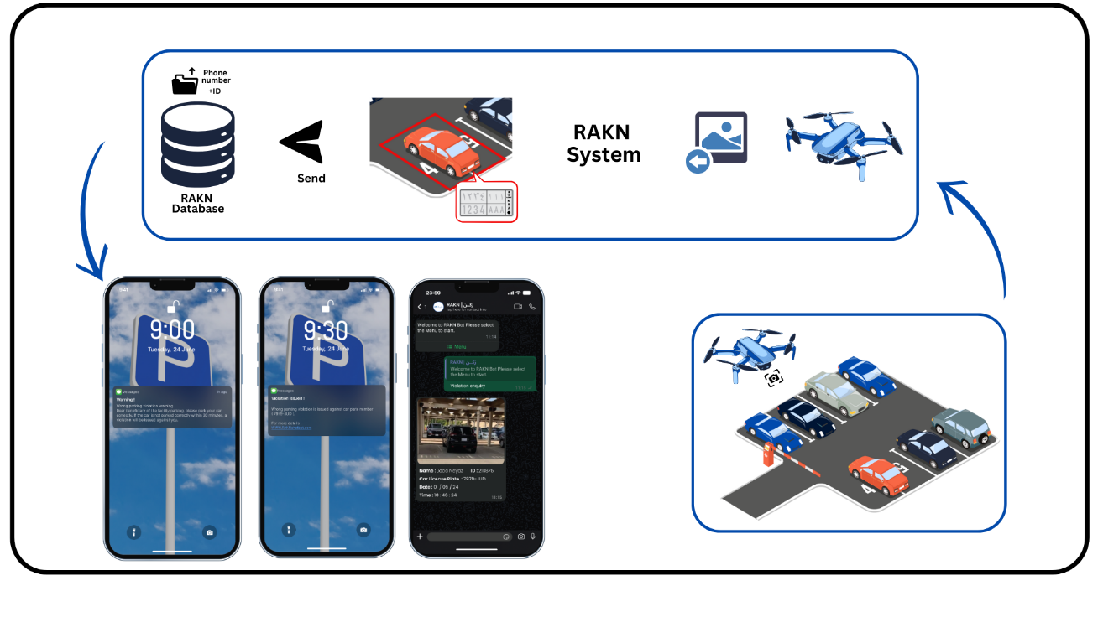

Figure 1: Solution Part1

Figure 2 : Solution Part2

5

1. **Key Benefits of the RAKN System**

**Efficient Violation Management:** The RAKN System streamlines the process of recording, tracking, and managing vehicle violations by security personnel. This ensures accurate documentation and faster resolution of incidents.

**Real-Time Monitoring:** Our system provides real-time updates, allowing security teams to track violations as they occur. This enhances accountability and enables prompt action when necessary.

**User-Friendly Interface:** Designed with simplicity and efficiency in mind, the RAKN System features an intuitive interface that makes it easy for security personnel to log violations and for administrators to review and process reports.

**Data Security & Accuracy:** The system ensures that all violation records are securely stored and protected, minimizing the risk of errors or tampering while maintaining data integrity.

By offering a reliable and user-friendly platform, the RAKN System enhances the efficiency of security operations, promotes transparency, and contributes to a safer and more organized environment.

6

# **Storyboard**

7

1. 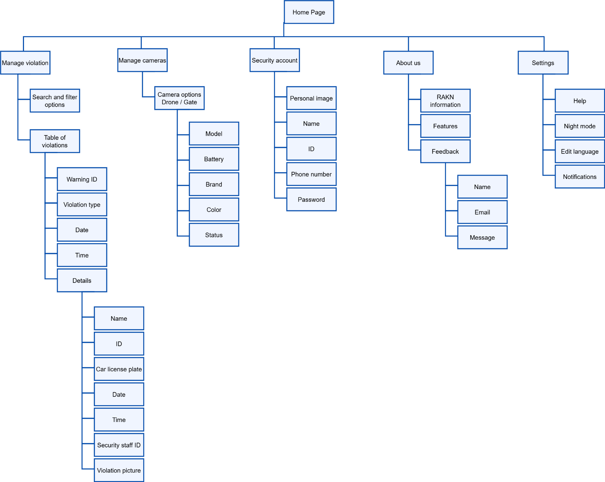**Site map**
2. **Our website**

The domain of our website: <https://rakn.atwebpages.com/>. Initially, we created a potential version of the pages. At this stage of programming, we have completed six pages (first page, sign-up page, Login page, Home page, Violation page, Manage camera page ) , and are still working to finalize the remaining pages, which will be completed and submitted in the last version.