PEAS &ODESDA for Pac-Man
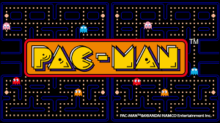

PEAS(AGENT)
Performance: Score and lives.
Environment: Maze containing white dots, Four ghosts and Power pills.
Actuators: Arrow keys.
Sensors: Game screen.

ODESA (Environment)
Observability: Fully observable.
Deterministic: Deterministic.
Episode: Sequential.
Static: Static.
Discrete: Discrete.
Agent: Single agent.

Type of Agent program:
Goal-based reflex Agent
