GRADUATION PROJECT PROPOSAL · FULL WORKFLOW
Basmati · بصمتي
Daily carbon footprint for people and a government facility: a phone app and an IoT energy monitor, piloted on the Computer Science department floor
Team | [9 team members]
Supervisor | [Supervisor name]
Pilot site | Computer Science department floor, [Faculty / University] (a government facility)
Duration | 20 weeks, starting early November 2026
Estimated budget | 8,140 EGP
Contents | Idea, architecture, workflow, data flow, equations, AI models, datasets, performance metrics, related work 2020–2026 with links, plan and budget
Date | October 2026

1. Summary
Basmati (بصمتي, “my footprint”) is an Android app and a small IoT system that calculate a daily carbon footprint, in kilograms of CO₂-equivalent, with almost no typing. The project is built for a government facility. The pilot is one floor: the Computer Science department.
It produces two numbers every day:
- A personal footprint for each member of the department who uses the app: their commute, their meals, and their share of the floor’s electricity for the hours they spent there, compared with a daily budget of 6.8 kg.
- A floor footprint for the facility: the floor’s measured electricity, its CO₂e, the energy used after working hours, and a forecast, shown on a display at the floor entrance and on a dashboard for the department head.
The project uses three AI models on real Egyptian data: transport mode detection, meal recognition from a photo, and a forecast of the floor’s electricity. A fourth model detects after-hours waste. Two ESP32 monitors with current clamps measure the floor’s electrical board. Every model is compared with a simple baseline, and every target is measured on people and days that were not used for training.

2. Problem and motivation
- No idea of size or source. Neither people nor facility managers know how much CO₂e they produce, or which habit or room produces most of it.
- One bill, too late. A government building receives one monthly bill for the whole building. It does not show the floor, the hour or the person, and it arrives after the energy is used. Egyptian university buildings usually lack even monthly data per building [15].
- Where the energy goes. In Cairo’s public administrative buildings about 40% of electricity goes to cooling and 60% to lighting and equipment [16]. In an Egyptian faculty building, PCs, laboratories, lighting and air conditioning dominate [15]. ACs and lab PCs left on after hours are invisible.
- Not built for Egypt. Personal carbon calculators are yearly questionnaires with foreign factors (no microbus, no koshary, no Egyptian grid), and they give inconsistent results [4].
Goal: measure the CS floor and each member’s day automatically, with Egyptian factors and real data, and show where the waste is.

3. Background: carbon footprint and the daily budget
A carbon footprint is the total greenhouse gas caused by a person, product or building over a period, measured in kg of CO₂-equivalent (CO₂e). Every activity converts to CO₂e through an emission factor: kg CO₂e per kWh of electricity, per km travelled or per kg of food.
Figure | Value | Source
Egypt, per person per year (2023) | 3.4 t CO₂e | EDGAR 2024 report [2]
World average, per person per year (2023) | 6.6 t CO₂e | EDGAR 2024 report [2]
1.5 °C lifestyle target per person by 2030 | 2.5 t CO₂e | Hot or Cool Institute [1]
Daily budget per person | 2,500 ÷ 365 ≈ 6.8 kg | Our calculation

Personal colors. A day is green up to 4.8 kg (70% of the budget), yellow up to 6.8 kg, and red above 6.8 kg.
Floor colors. The floor is compared with its own baseline (the same weekday in the first three weeks, before any feedback): green when it uses at most 90% of the baseline, yellow up to 100%, red above.
Country figures are territorial emissions; the target is a lifestyle (consumption) figure, so the comparison is indicative.

4. Proposed system

4.1 Components
Component | What it does
Android app (Kotlin, Jetpack Compose) | Detects trips and transport mode; recognizes meals from a photo; counts hours on the floor with a geofence check-in; shows the daily total, color and tips; has a volunteer labeling mode
Floor monitors (2 × ESP32) | Monitor A: a CT clamp on each of the three main phases of the floor’s electrical board. Monitor B: clamps on three circuits (lab ACs, lab PCs, lighting). Send readings every 10 s over MQTT
Server (FastAPI) | Receives trips, meals and readings; runs the daily footprint engine, the floor forecast and the waste detector; stores data in PostgreSQL with TimescaleDB
Entrance display | An LED ring at the floor entrance shows the floor’s day in green, yellow or red
Facility dashboard | Daily kWh, CO₂e, after-hours waste, forecast and a weekly report for the department head; waste alerts to the floor technician

4.2 Pilot site and approvals
The pilot is the Computer Science department floor. Before installation the team needs an official approval from the faculty administration, access to the floor’s electrical board, the department timetable and the building’s past electricity bills. In week 2 the team surveys the floor: rooms, laboratories, number of PCs and ACs, and the circuits on the board, following the datasheet idea of Safwat et al. [15].
Safety. CT clamps close around the cables without cutting them, and the monitors run on 5 V adapters, so no mains voltage enters their circuits. The faculty electrician installs them with the board switched off. The first test is done in the lab on a known load, such as a 2,000 W kettle.

4.3 Scope
In scope | Out of scope
Commute, meals and the floor’s electricity for department members; optional home part from the monthly bill | Purchases, flights (manual entry only), other floors and buildings
Measuring, forecasting and alerting on the floor’s electricity | Switching devices on or off (we measure and alert; we do not control)
Android app, server, two monitors, dashboard | iOS version

5. System architecture
The phones and the floor monitors send small records to one server, which adds up the day. The models run on the phone, so photos and locations never leave it: the server receives only final numbers such as distance, mode, dish, portion and hours on the floor.
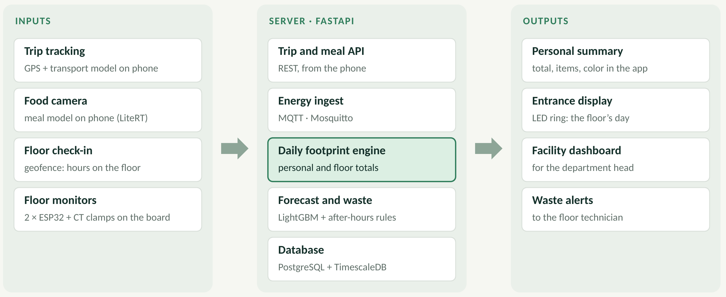
Figure 1. System architecture: inputs, server and outputs.
Layer | Technology
Mobile | Kotlin, Jetpack Compose, CameraX, LiteRT (TensorFlow Lite), Room, Activity Recognition API, geofencing
Hardware | ESP32, SCT-013 current clamps (100 A on main phases, 30 A on circuits), ADS1115 16-bit ADC, WS2812B LED ring
Messaging | MQTT with the Mosquitto broker; REST/JSON from the phone
Server | Python, FastAPI, PostgreSQL + TimescaleDB, LightGBM, scikit-learn
Dashboard | Web dashboard (Grafana or a simple web page) on a faculty server or a free cloud tier

6. Workflow
The app senses, the user confirms only when needed, and the server adds up. Every answer from a user becomes new training data.
Figure 2. The six steps of the workflow.
- Sense: the phone records GPS and motion sensors, takes the meal photo and checks in at the department; the monitors sample current.
- Classify: on-phone models give the transport mode and the top 3 dishes; the server turns current into kWh.
- Confirm: the user answers with one tap only when the model is unsure (confidence below 70%) and picks the portion size.
- Compute: the daily footprint engine applies the emission factors to each record (Section 8).
- Notify: at 11 pm the app shows the personal total and color; the entrance display and dashboard show the floor’s day; after-hours waste raises an alert.
- Improve: confirmed modes, corrected dishes and confirmed waste alerts are added to the training data for the next model version.
When | What happens
A trip ends | Mode classified on the phone; one-tap question if confidence is below 70%
A meal photo is taken | Top 3 dishes shown; the user picks the dish and the size
Arriving at the department | Geofence check-in counts the hours on the floor (no location is kept)
Every 10 seconds | Floor monitors send current per phase and per circuit
After working hours | Load above the base level outside the timetable raises a waste alert
11 pm | Personal total and color in the app; the floor’s total and color on the entrance display
Every week | A personal tip aimed at the biggest item; a floor report to the department head

7. Data flow
Three pipelines feed the daily footprint engine. Each sends small records, not raw media.
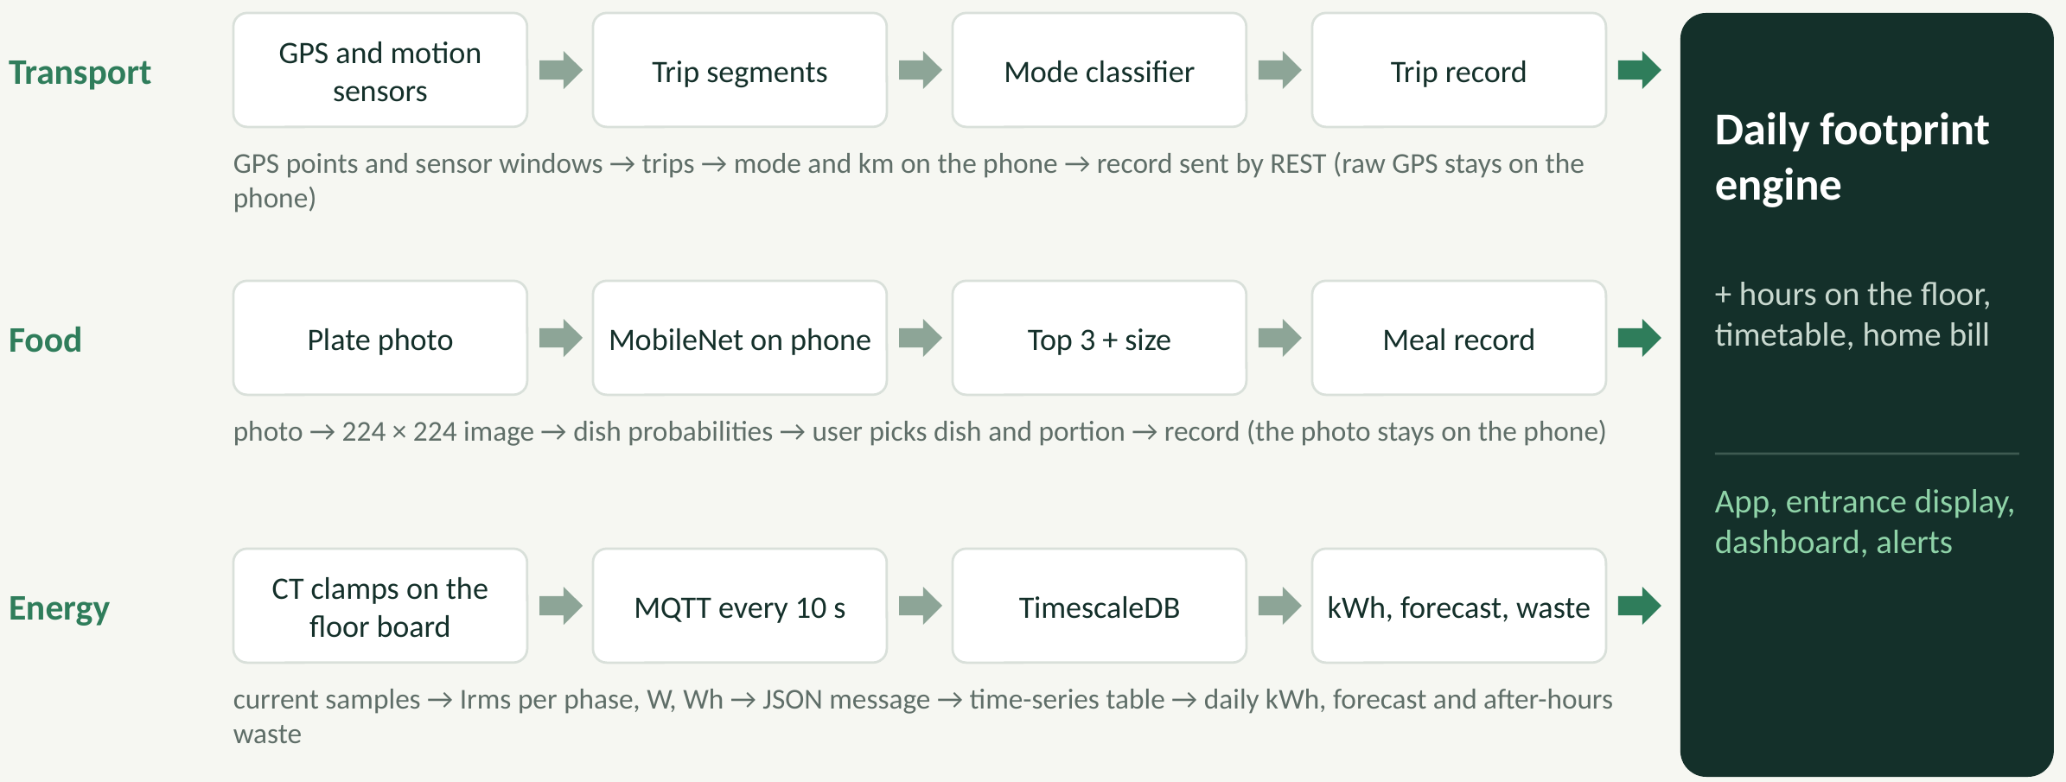
Figure 3. Data flow: transport, food and energy pipelines.
- Transport: GPS points and sensor windows → trip segments → mode classifier and distance on the phone → one trip record sent by REST. Raw GPS stays on the phone and is deleted after the trip is summarized.
- Food: plate photo → 224 × 224 image → dish probabilities from MobileNet on the phone → the user picks the dish and portion → one meal record. The photo stays on the phone.
- Energy: current samples → Irms per phase, power (W) and energy (Wh) on the ESP32 → JSON message over MQTT every 10 s → time-series table → daily kWh, forecast and after-hours waste on the server.
- Other inputs: hours on the floor (one number per user per day), the department timetable (once per term) and, optionally, the home electricity bill and gas cylinders (once per month).

7.1 Records
Record | Key fields | Rate | Stored in
Meter reading | device, circuit, time, Irms, W, Wh | every 10 s | TimescaleDB
Trip record | user, start, end, km, mode, confidence, passengers | per trip | PostgreSQL
Meal log | user, dish, portion, time | per meal | PostgreSQL
Floor presence | user, date, hours on the floor | daily | PostgreSQL
Timetable | room, day, hour, expected people | per term | PostgreSQL
Waste event | circuit, start, end, kWh, confirmed | when found | PostgreSQL
Daily footprint | user or floor, date, items, total, color | daily | PostgreSQL

Privacy by design. Photos and locations never leave the phone, presence is stored as hours only, volunteers are IDs instead of names, raw GPS is deleted once the trip is summarized, and every volunteer signs a consent form and can withdraw. Emission factors live in one settings file on the server, so a factor can be updated without changing code.

8. Equations

8.1 The core rule

Every footprint is an activity amount A_{i} (kWh, km, kg) multiplied by its emission factor EF_{i} in kg CO₂e per unit.
Activity | Unit | kg CO₂e / unit | Source
Egypt grid electricity (2024) | kWh | 0.45 | Low-Carbon Power (447 g/kWh)
Petrol car, divided by passengers | km | 0.17 | UK DESNZ (approximate)
Microbus or bus | passenger-km | 0.10 | Our estimate
Metro | passenger-km | 0.06 | Our estimate
Walking or cycling | km | 0 | —
LPG cylinder (12.5 kg) | cylinder | 37.5 | LPG combustion (approximate)
Beef (dairy herd to beef herd) | kg | 33 to 99.5 | Poore and Nemecek (2018)
Chicken | kg | 9.9 | Poore and Nemecek (2018)
Rice | kg | 4.5 | Poore and Nemecek (2018)
Lentils and beans | kg | 1.8 | Poore and Nemecek (2018)

8.2 A person’s day

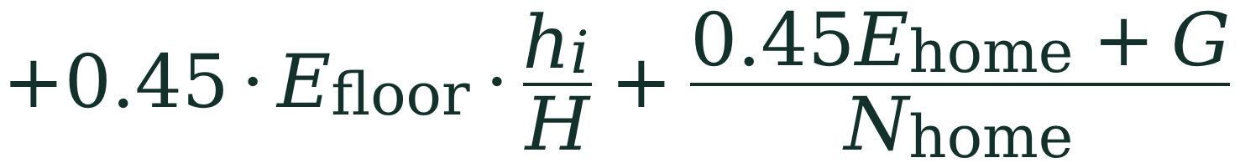
Symbol | Meaning
d | trip distance in km
f_{mode} | mode factor (car factor divided by passengers)
f_{dish} | meal footprint from its ingredients (Section 8.3)
s | portion size: small 0.7, medium 1, large 1.4
E_{floor} | floor kWh per day, measured by the monitors
h_{i} and H | your hours on the floor, and all person-hours on the floor that day (from the timetable)
E_{home} | home kWh per day from the monthly bill (optional)
G and N_{home} | home gas (cylinders per month × 37.5 ÷ 30) and household members

Worked example. A student’s day:
Item | Calculation | kg CO₂e
Transport | 20 km by microbus × 0.10 | 2.0
Food | beans, two eggs, rice and 150 g of chicken | 2.6
Floor share | 0.45 × 330 kWh × 6 h ÷ 1,480 person-hours | 0.6
Home | (0.45 × 250 kWh ÷ 30 + 37.5 ÷ 30) ÷ 4 members | 1.2
Total | 6.4 kg = 94% of 6.8 kg: above the 4.8 kg green line, so the day is yellow | 6.4

Swapping the chicken for 150 g of beef raises the day to about 9.9 kg, which is red.

8.3 Meals

w_{j} is the raw weight of ingredient j in kg, EF_{j} its factor from Poore and Nemecek (2018), and s the portion size chosen by the user.
Dish (medium plate) | Ingredients, raw weight | kg CO₂e
Koshary | rice 100 g, lentils 50, pasta 50, tomato 50, onion 30 | 0.73
Chicken with rice | chicken 150 g, rice 100 | 1.93
Beef with rice | beef 150 g, rice 100 | 5.4 to 15.4

The team builds this table for 20 dishes, including the faculty cafeteria menu, using three recipe sources per dish plus a plate weighed on a kitchen scale. Beef uses the dairy-herd factor (33) as a conservative value.

8.4 The floor
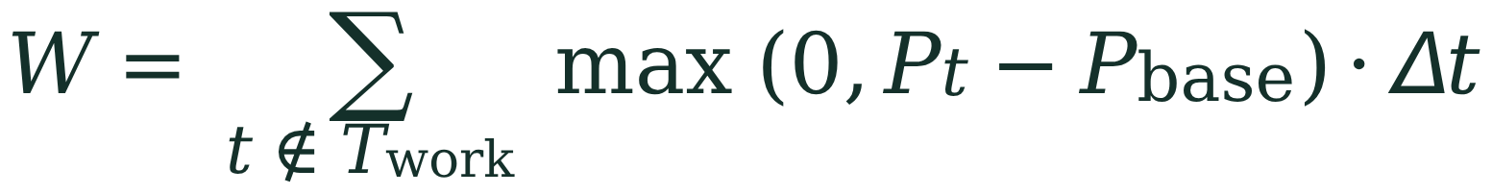
Symbol | Meaning
C_{floor} | the floor’s footprint in kg CO₂e per day
I | intensity: kg CO₂e per person-hour on the floor
r | ratio to the baseline; green r ≤ 0.9, yellow r ≤ 1.0, red r > 1.0
E_{base} | average kWh for the same weekday in the first 3 weeks (before feedback)
W | after-hours waste in kWh
T_{work} and P_{base} | timetable hours, and the night base load (servers, fridges)

Example. A working day of 330 kWh gives 0.45 × 330 ≈ 149 kg CO₂e. With 1,480 person-hours the intensity is about 0.10 kg per person-hour. If lab ACs run for three hours after the last lecture and add 40 kWh above the base load, W = 40 kWh, about 18 kg CO₂e of waste.

8.5 The energy monitor
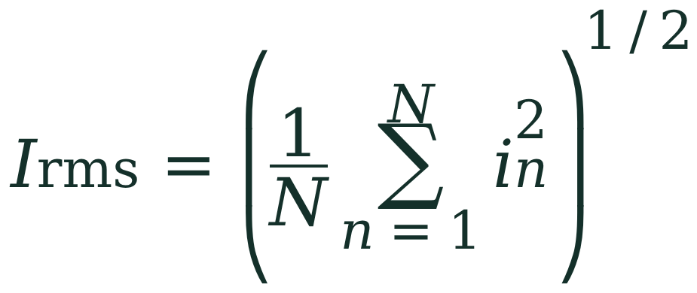
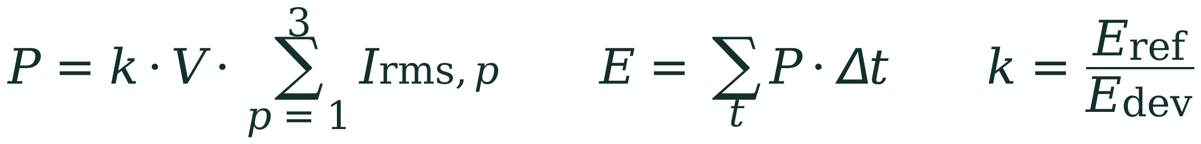
- Monitor A has a clamp on each of the three main phases; monitor B has clamps on lab ACs, lab PCs and lighting.
- The ADS1115 samples the clamps (up to 860 samples per second in total); the ESP32 computes Irms for each channel.
- Power uses V = 220 V and a calibration factor k, updated weekly from a reference reading: the floor sub-meter if there is one, otherwise a handheld power meter from the electrical lab.
- Target: weekly error below 10% against the reference.

9. AI models
Model | Input | Method | Runs on | Baseline
Transport mode (core) | Speed, stops, acceleration, sensor vibration, GPS loss | Activity Recognition API, then Random Forest or LightGBM; exported to Kotlin with m2cgen | Phone | Activity Recognition API alone
Meal recognition (core) | Plate photo | Transfer learning on MobileNetV3 or EfficientNet-Lite0; LiteRT int8 | Phone | Most common dish
Floor forecast (core) | Hourly kWh, hour, weekday, temperature, timetable | LightGBM; LSTM if there is enough data | Server | Same hour last week
After-hours waste (core) | Load per circuit, timetable, forecast | Rules first, then Isolation Forest on forecast errors | Server | Fixed threshold
Appliance breakdown (optional) | Floor main power | NILM, e.g. sequence-to-point; checked against monitor B | Server | —

Rule: every model must beat its baseline, measured first, on people and days not used in training. Metro trips are found by a rule: GPS is lost underground and the trip starts and ends inside a geofence around a station.
First 15 dishes: ful, ta’meya, eggs, cheese, koshary, lentils, chicken with rice, beef with rice, kofta, mahshi, molokhia, béchamel pasta, chicken shawarma, fish and salad, plus the cafeteria menu.

10. Datasets

10.1 Public datasets
Dataset | Year | Contents | Our use
ImageNet | 2012 | About 1.28M training images, 1,000 classes | Pretrained MobileNetV3 weights
Food-101 | 2014 | 101,000 images of 101 dishes | Food pretraining and benchmark
SHL | 2018 | Phone sensor data, 8 transport and locomotion modes | Pretrain the transport classifier
GeoLife | 2012 | GPS trajectories from 182 users, part with mode labels | Benchmark trip features
Building Data Genome 2 | 2020 | Hourly meter data of 1,636 non-residential buildings over 2 years | Pretrain and benchmark the floor forecast
UK-DALE | 2015 | Whole-house and appliance demand, 5 UK homes | NILM benchmark (optional)
Poore and Nemecek | 2018 | Global food life-cycle emission factors | Dish footprints
OpenStreetMap | — | Locations of Cairo metro stations | Metro geofences
Open-Meteo | — | Hourly temperature at the faculty | Forecast input

Public datasets do not contain microbuses, Egyptian dishes or Egyptian public buildings, so they are used for pretraining and benchmarking only. The final evaluation is always on the data we collect.

10.2 Data collected by the team
Data | Amount | How | Weeks
Floor electricity | 6 channels every 10 s; about 2,350 hourly readings each | Monitors on the floor board; weekly reference reading | 6–20
Timetable and presence | Room schedule; hours on the floor per volunteer | Department administration; app check-in | 2–20
Building bills | 12–24 months of the building’s electricity bills | Official request to the faculty administration | 2–4
Food photos | 200+ per dish: 3,000 photos from 30 people | Volunteers photograph meals and pick the dish name | 4–10
Dish recipes | 20 dishes with ingredients in grams | 3 recipe sources each, plus a weighed plate | 2–5
Labeled trips | 20 volunteers × 2 weeks ≈ 560 trips; 80+ per mode | Volunteer mode records GPS and sensors; user picks the mode | 5–9
Waste events | About 30 labeled after-hours events | Staged with the technician (e.g. one AC left on for an hour), plus confirmed alerts | 8–18

- Split: 70 / 15 / 15 by person (trips, photos) and by week (electricity), never by photo, trip or hour, so test results reflect new people and new days.
- Ethics: consent forms, IDs instead of names, raw GPS deleted after feature extraction, right to withdraw, and official approval for the floor monitors.

11. Performance metrics

11.1 Definitions
Classification (transport mode per trip; waste events found or missed). TP, FP and FN are true positives, false positives and false negatives. For transport they are computed per mode and averaged (macro F1); for waste a detection is correct if it overlaps a labeled event.
Regression (floor forecast, monitor error, trip distance). MAPE is used for the daily floor forecast; MAE and RMSE for distance and monitor error.
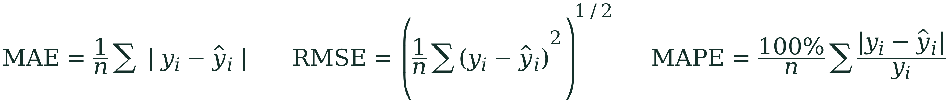
Top-k accuracy (meal recognition): the share of photos whose true dish is among the model’s k best guesses. We report Top-1 and Top-3, because the app shows three guesses.


11.2 Targets
Part | Metric | Target
Transport mode | Accuracy per trip (and macro F1) | At least 85%
Trip distance | Error vs. true distance | Below 10%
Meal recognition | Top-1 / Top-3 accuracy | At least 80% / 95%
Meal speed | Time on a mid-range phone | Under 1 second
Floor monitor | Weekly error vs. reference reading | Below 10%
Floor forecast | Daily MAPE | Below 15%, and beats last week
Waste detection | Recall / precision on labeled events | At least 90% / 80%
Battery | App use per day | Below 5%
Real data | Volunteers and site | 20 volunteers, 1 floor, 14 weeks

11.3 Evaluation protocol
- Measure every baseline first, then each model, on the same held-out people and weeks.
- First evaluation at the first full version (week 10); final evaluation in week 18.
- Report real numbers even when they fall short of a target, with the confusion matrix and the error analysis.
- Battery: run the app for a full day on three phone brands and read Android battery statistics.

11.4 Curves we will report
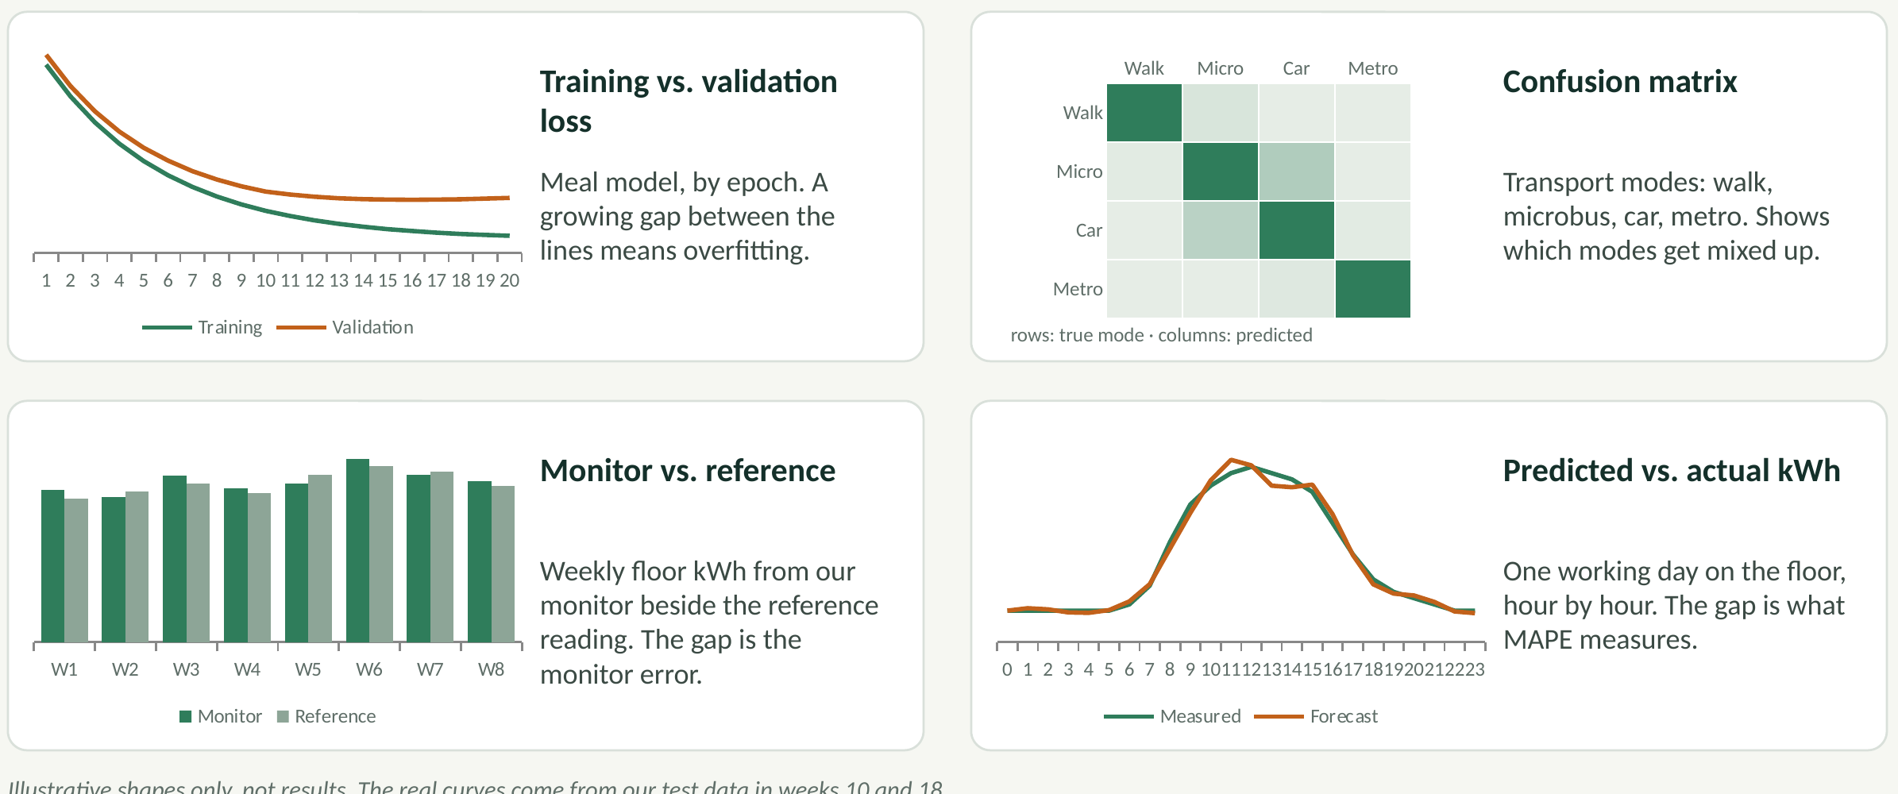
Figure 4. The four plots for the results chapter. Illustrative shapes only, not results.
- Training vs. validation loss of the meal model (overfitting check).
- Confusion matrix of transport modes (walk, microbus, car, metro).
- Weekly floor kWh: monitor vs. reference reading (monitor error).
- Predicted vs. actual hourly floor kWh on a working day (forecast error, MAPE).

12. Related work 2020–2026
We reviewed 21 papers and reports from 2020 to 2026, in four groups. The numbers match the reference list; Appendix A gives a link for each one.
# | Paper | Year | Group
1 | Akenji et al. | 2021 | Footprint targets and calculators
2 | Crippa et al. (EDGAR) | 2024 | Footprint targets and calculators
3 | Ajufo and Bekaroo | 2021 | Footprint targets and calculators
4 | Bekaroo et al. | 2021 | Footprint targets and calculators
5 | Zhang et al. | 2026 | Footprint targets and calculators
6 | Valls-Val and Bovea | 2021 | Universities and public buildings
7 | Helmers, Chang and Dauwels | 2021 | Universities and public buildings
8 | Sadeghian, Håkansson and Zhao | 2021 | Transport mode detection
9 | Wang et al. (SHL) | 2021 | Transport mode detection
10 | Wang and Jiang | 2022 | Transport mode detection
11 | Tahir and Loo | 2021 | Food recognition
12 | Dalakleidi et al. | 2022 | Food recognition
13 | Ismail and Sahari | 2024 | Energy monitoring
14 | García-Monge et al. | 2023 | Universities and public buildings
15 | Safwat et al. | 2024 | Universities and public buildings
16 | Hamada, Hong and Raslan | 2025 | Universities and public buildings
17 | Miller et al. | 2020 | Forecasting and waste detection
18 | Anand et al. | 2021 | Forecasting and waste detection
19 | Himeur et al. | 2021 | Forecasting and waste detection
20 | Angelis et al. | 2022 | Forecasting and waste detection
21 | Azad, Rajabi and Estebsari | 2023 | Forecasting and waste detection

12.1 Personal footprint apps and targets
[1] Akenji et al. (2021)
Akenji, L., Bengtsson, M., Toivio, V., Lettenmeier, M., et al. (2021). 1.5-Degree Lifestyles: Towards a fair consumption space for all. Hot or Cool Institute, Berlin.
Summary: Sets per-person targets for lifestyle carbon footprints compatible with 1.5 °C: about 2.5 t CO₂e by 2030, falling to 0.7 t by 2050, and compares the lifestyle footprints of ten countries.
What we take: The 2.5 t target gives our personal daily budget: 2,500 ÷ 365 ≈ 6.8 kg CO₂e.
Link: https://hotorcool.org/1-5-degree-lifestyles-report · Free download from the institute
[2] Crippa et al. (EDGAR) (2024)
Crippa, M., Guizzardi, D., Pagani, F., et al. (2024). GHG emissions of all world countries: 2024 report. Publications Office of the European Union, Luxembourg. JRC138862. doi:10.2760/4002897
Summary: Greenhouse gas emissions of every country from 1970 to 2023, by sector, from the EDGAR database of the European Commission’s Joint Research Centre and the IEA.
What we take: Source of the per-person figures for Egypt (3.4 t) and the world (6.6 t) in 2023.
Link: https://data.europa.eu/doi/10.2760/4002897 · Free (EU Publications Office / edgar.jrc.ec.europa.eu)
[3] Ajufo and Bekaroo (2021)
Ajufo, C., & Bekaroo, G. (2021). An automated personal carbon footprint calculator for estimating carbon emissions from transportation use. In Proceedings of the International Conference on Artificial Intelligence and its Applications (icARTi ’21). ACM. doi:10.1145/3487923.3487935
Summary: TCTracker, a mobile app that estimates a person’s transport emissions automatically from GPS with AI-based mode detection; evaluated with 40 users using the Technology Acceptance Model.
What we take: Closest earlier app to ours; shows automatic tracking is accepted by users. We add food, a building share and Egyptian factors.
Link: https://doi.org/10.1145/3487923.3487935 · ACM Digital Library (check the university library)
[4] Bekaroo et al. (2021)
Bekaroo, G., Roopowa, D., Zakari, A., & Niemeier, D. (2021). Calculating carbon emissions from personal travelling: insights from a top-down analysis of key calculators. Environmental Science and Pollution Research, 28(7), 8853–8872. doi:10.1007/s11356-020-11179-z
Summary: Analyses ten transport carbon calculators: they differ in granularity, have limited transparency, sometimes give very different results for the same trip, and do not fully engage users.
What we take: Motivates an automatic, transparent calculator with documented factors.
Link: https://doi.org/10.1007/s11356-020-11179-z · Free author copy: repository.mdx.ac.uk/item/8929y
[5] Zhang et al. (2026)
Zhang, Y., Echchabi, O., Feng, T., Zhang, W., Liao, H.-K., & Chang, C. (2026). Detecting transportation mode using dense smartphone GPS trajectories and Transformer models. International Journal of Geographical Information Science. arXiv:2603.00340
Summary: SpeedTransformer, a Transformer model that detects transport mode from dense phone GPS speed data; tested in the CarbonClever app with 348 users to estimate personal transport footprints.
What we take: The most recent system like ours; confirms that automatic mode detection works for personal footprints at the scale of hundreds of users.
Link: https://arxiv.org/abs/2603.00340 · Free on arXiv

12.2 Universities and public buildings
[6] Valls-Val and Bovea (2021)
Valls-Val, K., & Bovea, M. D. (2021). Carbon footprint in higher education institutions: a literature review and prospects for future research. Clean Technologies and Environmental Policy, 23, 2523–2542. doi:10.1007/s10098-021-02180-2
Summary: Systematic review of how universities assess their carbon footprint (studies up to March 2021): scopes, methods and emission sources, with directions for future research.
What we take: Frames our floor as a university facility and shows that assessments are usually yearly and inconsistent.
Link: https://doi.org/10.1007/s10098-021-02180-2 · Repository copy: repositori.uji.es (handle 10234/195375)
[7] Helmers, Chang and Dauwels (2021)
Helmers, E., Chang, C. C., & Dauwels, J. (2021). Carbon footprinting of universities worldwide: Part I—objective comparison by standardized metrics. Environmental Sciences Europe, 33, 30. doi:10.1186/s12302-021-00454-6
Summary: Collects carbon footprint data from 20 universities worldwide; reported footprints are hard to compare because methods, measures and targets differ; proposes standardized metrics.
What we take: Supports reporting per person and per person-hour (our intensity I), not only totals.
Link: https://doi.org/10.1186/s12302-021-00454-6 · Open access
[14] García-Monge et al. (2023)
García-Monge, M., Zalba, B., Casas, R., Cano, E., Guillén-Lambea, S., López-Mesa, B., & Martínez, I. (2023). Is IoT monitoring key to improve building energy efficiency? Case study of a smart campus in Spain. Energy and Buildings, 285, 112882. doi:10.1016/j.enbuild.2023.112882
Summary: Continuous IoT monitoring on a university campus in Zaragoza, used to support energy decisions; the authors report that the approach can save 40–70% of HVAC energy, and stress CO₂ monitoring in rooms with changing occupancy.
What we take: Direct evidence that measuring a campus building continuously pays off, especially for air conditioning.
Link: https://doi.org/10.1016/j.enbuild.2023.112882 · Repository copy: zaguan.unizar.es/record/130169
[15] Safwat et al. (2024)
Safwat, H., Abdel-Rehim, A. A., El-Mahallawi, I., Hussein, A. A., Amer, A. M., Elshazly, E., & Elshamy, A. I. (2024). Guidelines for data collection on energy performance of higher-education buildings in Egypt: a case study. HBRC Journal, 20(1), 615–642. doi:10.1080/16874048.2024.2345553
Summary: Egyptian university buildings usually lack monthly electricity and gas records per building, so the authors build equipment and HVAC datasheets to estimate consumption; in their case study, PCs, laboratories, lighting and air conditioning drive electricity use.
What we take: Egyptian evidence that the data our monitors produce does not exist today; we reuse their survey idea in week 2.
Link: https://doi.org/10.1080/16874048.2024.2345553 · Open access (also openresearch.lsbu.ac.uk/item/97z76)
[16] Hamada, Hong and Raslan (2025)
Hamada, A. A., Hong, S.-M., & Raslan, R. (2025). Evaluating the operational performance in Cairo’s public administrative buildings: stock characterisation and typical energy use. Energy and Buildings, 346, 116065. doi:10.1016/j.enbuild.2025.116065
Summary: First characterisation of Cairo’s public administrative buildings from metered data: about 40% of electricity goes to cooling and 60% to lighting and equipment; a winter month uses about 5% of the annual energy and a summer peak month about 13%.
What we take: Shows where a government building’s energy goes and why temperature is a forecast input.
Link: https://discovery.ucl.ac.uk/id/eprint/10211499 · Open access copy at UCL Discovery

12.3 Transport mode detection and food recognition
[8] Sadeghian, Håkansson and Zhao (2021)
Sadeghian, P., Håkansson, J., & Zhao, X. (2021). Review and evaluation of methods in transport mode detection based on GPS tracking data. Journal of Traffic and Transportation Engineering (English Edition), 8(4), 467–482.
Summary: Reviews and compares transport mode detection methods on GPS data. Most are supervised and need manually labeled trips, which is slow and error-prone; deep learning is promising for large unlabeled data.
What we take: Labeled local trips are the bottleneck, hence our volunteer labeling mode and one-tap confirmation.
Link: https://doaj.org/article/cedcdc9d16f541aaa07a5c67ef7f5d2b · Open access
[9] Wang et al. (SHL) (2021)
Wang, L., Gjoreski, H., Ciliberto, M., Lago, P., Murao, K., Okita, T., & Roggen, D. (2021). Three-year review of the 2018–2020 SHL challenge on transportation and locomotion mode recognition from mobile sensors. Frontiers in Computer Science, 3, 713719. doi:10.3389/fcomp.2021.713719
Summary: Reviews three years of the SHL challenge (8 modes from phone motion sensors, 48 submissions). Most modes are recognized well, but separating rail from road transport remains hard.
What we take: Our metro rule (GPS loss underground plus station geofences) targets exactly the rail-versus-road confusion.
Link: https://doi.org/10.3389/fcomp.2021.713719 · Open access
[10] Wang and Jiang (2022)
Wang, P., & Jiang, Y. (2022). Transportation mode detection using temporal convolutional networks based on sensors integrated into smartphones. Sensors, 22(17), 6712. doi:10.3390/s22176712
Summary: T2Trans, a temporal convolutional network on lightweight phone sensors; macro F1 of 86.42% on SHL and 88.37% on the HTC dataset for 8 modes.
What we take: A realistic reference for our 85% transport target.
Link: https://doi.org/10.3390/s22176712 · Open access
[11] Tahir and Loo (2021)
Tahir, G. A., & Loo, C. K. (2021). A comprehensive survey of image-based food recognition and volume estimation methods for dietary assessment. Healthcare, 9(12), 1676. doi:10.3390/healthcare9121676
Summary: Surveys food recognition and volume estimation methods and the mobile apps that use them; about two thirds of the studies use deep visual features, and all use CNN variants for ingredient recognition.
What we take: Supports transfer learning on a lightweight CNN, and a user-chosen portion size instead of volume estimation.
Link: https://doi.org/10.3390/healthcare9121676 · Open access (also arXiv:2106.11776)
[12] Dalakleidi et al. (2022)
Dalakleidi, K. V., Papadelli, M., Kapolos, I., & Papadimitriou, K. (2022). Applying image-based food-recognition systems on dietary assessment: a systematic review. Advances in Nutrition, 13(6), 2590–2619. doi:10.1093/advances/nmac078
Summary: Systematic review of image-based food recognition systems used for dietary assessment; 78 studies reviewed in full text.
What we take: Shows how such systems are evaluated in practice; we report Top-1 and Top-3 accuracy on new people.
Link: https://www.ncbi.nlm.nih.gov/pmc/articles/PMC9776640/ · Open access (PubMed Central)

12.4 Energy monitoring, forecasting and waste detection
[13] Ismail and Sahari (2024)
Ismail, M. L., & Sahari, N. (2024). Real time energy monitoring & current spikes detection system for enhanced energy conservation in residential area. Progress in Engineering Application and Technology, 5(1), 79–87. doi:10.30880/peat.2024.05.01.008
Summary: ESP32 with a ZMPT101B voltage sensor and an SCT-013-030 current clamp, sending data to ThingSpeak and a mobile app; tracks voltage, current, energy and bill, and flags current spikes. Worst-case error about 12.4%.
What we take: Same board and clamp family as our monitor; its error is why we calibrate weekly against a reference.
Link: https://penerbit.uthm.edu.my/periodicals/index.php/peat/article/view/14767 · Open access
[17] Miller et al. (2020)
Miller, C., et al. (2020). The ASHRAE Great Energy Predictor III competition: overview and results. Science and Technology for the Built Environment, 26(10). doi:10.1080/23744731.2020.1795514
Summary: Overview of a large competition on forecasting hourly energy meters of non-residential buildings; the winning solutions relied on gradient boosting with careful preprocessing.
What we take: Why the floor forecast starts with LightGBM; its dataset (Building Data Genome 2) is our public benchmark.
Link: https://arxiv.org/abs/2007.06933 · Free on arXiv
[18] Anand et al. (2021)
Anand, P., Deb, C., Yang, K., Yang, J., Cheong, D., & Sekhar, C. (2021). Occupancy-based energy consumption modelling using machine learning algorithms for institutional buildings. Energy and Buildings, 111478. doi:10.1016/j.enbuild.2021.111478
Summary: Models energy from occupancy for eight space types in three institutional buildings; the occupancy–energy link differs by space and time; a deep network is slightly more accurate, gradient boosting much faster.
What we take: Justifies the timetable (occupancy) as a forecast input and gradient boosting as the first model.
Link: https://doi.org/10.1016/j.enbuild.2021.111478 · Repository record: research-collection.ethz.ch (handle 20.500.11850/508529)
[19] Himeur et al. (2021)
Himeur, Y., Ghanem, K., Alsalemi, A., Bensaali, F., & Amira, A. (2021). Artificial intelligence based anomaly detection of energy consumption in buildings: a review, current trends and new perspectives. Applied Energy, 287, 116601. doi:10.1016/j.apenergy.2021.116601
Summary: Review and taxonomy of AI methods for detecting abnormal energy use in buildings, by algorithm, features, detection level, computing platform and application.
What we take: Guides our waste detector: simple rules first, then an unsupervised model on forecast errors.
Link: https://arxiv.org/abs/2010.04560 · Free preprint on arXiv
[20] Angelis et al. (2022)
Angelis, G.-F., Timplalexis, C., Krinidis, S., Ioannidis, D., & Tzovaras, D. (2022). NILM applications: literature review of learning approaches, recent developments and challenges. Energy and Buildings.
Summary: Critical review of non-intrusive load monitoring: experimental frameworks, datasets, hand-made versus learned features, and the move to deep learning, with limitations and future directions.
What we take: Background for the optional appliance breakdown, which we can check against monitor B.
Link: https://www.researchgate.net/publication/358612135 · Author copy on ResearchGate (journal details to confirm)
[21] Azad, Rajabi and Estebsari (2023)
Azad, Rajabi, & Estebsari (2023). Non-intrusive load monitoring (NILM) using deep neural networks: a review. arXiv:2306.05017
Summary: Review of deep neural network approaches to non-intrusive load monitoring and the public datasets used to train them.
What we take: Model and dataset choices for the optional NILM step.
Link: https://arxiv.org/abs/2306.05017 · Free on arXiv

12.5 Research gap and our contribution
Personal calculators stop at the person, and building studies stop at the bill: nothing links a person’s day to the public building they work in.
- Automatic and daily: commute, meals and a share of the floor’s electricity combined into one number, with almost no typing [3, 4, 5].
- Local factors and data: microbus, metro, Egyptian dishes and the Egyptian grid, with data we collect ourselves [8–12].
- Measured public building: the floor’s real electricity, each person’s share and after-hours waste for the facility manager, where Egyptian buildings lack data today [14–16, 19].

13. Plan

13.1 Timeline
Weeks | Work | Milestone
1–2 | Interfaces (MQTT, API, model inputs); floor survey; official approval request; order parts | Week 2: interfaces agreed
3–5 | App screens, database, trip tracking prototype; dish list and recipes; monitor tested on a kettle in the lab | —
6 | Monitors installed on the floor board by the faculty electrician; volunteer mode live with 20 people | Week 6: monitors and volunteers
7–10 | Data collection; first models; daily engine end to end; first curves | Week 10: first full version
11–12 | Mid-year exams: light work; monitors keep recording | —
13–16 | Improve models; on-phone inference; forecast, waste detection and dashboard | Week 16: feature freeze
17–18 | Final evaluation on held-out people and weeks; battery tests | —
19–20 | Report, demo and defense | Week 20: final delivery

13.2 Team
Team | People | Owns
Mobile app | 3 | Trip tracking; food camera and on-phone models; screens, check-in and volunteer mode
AI | 2 | Meal model and dish database; transport model; waste detection
Backend | 2 | API, database, daily calculation, MQTT, forecast, dashboard
Hardware | 2 | Circuits and enclosures; installation with the faculty electrician; calibration; entrance display

Extra roles inside the teams: a team lead, a volunteer coordinator and a report editor.

13.3 Budget (estimates)
Item | Details | EGP
Floor monitors | 3 ESP32 boards, 7 CT clamps (six plus a spare), 3 ADS1115, DIN-rail enclosures, burden resistors, 5 V adapters | 5,500
Entrance display | LED ring in a small enclosure | 600
Printing | Report and poster | 1,000
Kitchen scale | Weighing dish ingredients | 300
Contingency | 10% | 740
Server | Faculty server or a free cloud tier | 0
Total |  | 8,140

Prices are estimates at the time of writing. The reference power meter is borrowed from the electrical lab.

13.4 Risks
Risk | Mitigation
Installation approval is delayed | Request it in week 1; meanwhile test on a lab circuit and pretrain the forecast on Building Data Genome 2
Main-phase current is above the clamp range, or the board is hard to reach | 100 A clamps on main phases; electrician survey in week 2; measure sub-circuits if needed
Few volunteers or low engagement | Recruit from department courses; one tap per trip; weekly feedback
Meal model weak on Egyptian dishes | 200+ photos per dish; Top-3 with user confirmation
Monitor error | Weekly calibration factor k against a reference reading
Privacy concerns | On-phone processing, IDs, consent, hours-only presence, raw GPS deleted

14. Next steps

Decisions we need from the supervisor
- Approval of the idea and the pilot on the CS floor
- An official letter to the faculty administration for installation
- Access to the timetable and the building’s past electricity bills
- Consent form for 20 volunteers
- Final team names and roles

Our next two weeks
- Interfaces: MQTT, API and model inputs
- Floor survey: rooms, labs, ACs, PCs and the electrical board
- Order parts; test one clamp on a kettle in the lab
- Dish list with the cafeteria menu; consent form

References
[1] Akenji, L., Bengtsson, M., Toivio, V., Lettenmeier, M., et al. (2021). 1.5-Degree Lifestyles: Towards a fair consumption space for all. Hot or Cool Institute, Berlin. https://hotorcool.org/1-5-degree-lifestyles-report
[2] Crippa, M., Guizzardi, D., Pagani, F., et al. (2024). GHG emissions of all world countries: 2024 report. Publications Office of the European Union, Luxembourg. JRC138862. doi:10.2760/4002897 https://data.europa.eu/doi/10.2760/4002897
[3] Ajufo, C., & Bekaroo, G. (2021). An automated personal carbon footprint calculator for estimating carbon emissions from transportation use. In Proceedings of the International Conference on Artificial Intelligence and its Applications (icARTi ’21). ACM. doi:10.1145/3487923.3487935 https://doi.org/10.1145/3487923.3487935
[4] Bekaroo, G., Roopowa, D., Zakari, A., & Niemeier, D. (2021). Calculating carbon emissions from personal travelling: insights from a top-down analysis of key calculators. Environmental Science and Pollution Research, 28(7), 8853–8872. doi:10.1007/s11356-020-11179-z https://doi.org/10.1007/s11356-020-11179-z
[5] Zhang, Y., Echchabi, O., Feng, T., Zhang, W., Liao, H.-K., & Chang, C. (2026). Detecting transportation mode using dense smartphone GPS trajectories and Transformer models. International Journal of Geographical Information Science. arXiv:2603.00340 https://arxiv.org/abs/2603.00340
[6] Valls-Val, K., & Bovea, M. D. (2021). Carbon footprint in higher education institutions: a literature review and prospects for future research. Clean Technologies and Environmental Policy, 23, 2523–2542. doi:10.1007/s10098-021-02180-2 https://doi.org/10.1007/s10098-021-02180-2
[7] Helmers, E., Chang, C. C., & Dauwels, J. (2021). Carbon footprinting of universities worldwide: Part I—objective comparison by standardized metrics. Environmental Sciences Europe, 33, 30. doi:10.1186/s12302-021-00454-6 https://doi.org/10.1186/s12302-021-00454-6
[8] Sadeghian, P., Håkansson, J., & Zhao, X. (2021). Review and evaluation of methods in transport mode detection based on GPS tracking data. Journal of Traffic and Transportation Engineering (English Edition), 8(4), 467–482. https://doaj.org/article/cedcdc9d16f541aaa07a5c67ef7f5d2b
[9] Wang, L., Gjoreski, H., Ciliberto, M., Lago, P., Murao, K., Okita, T., & Roggen, D. (2021). Three-year review of the 2018–2020 SHL challenge on transportation and locomotion mode recognition from mobile sensors. Frontiers in Computer Science, 3, 713719. doi:10.3389/fcomp.2021.713719 https://doi.org/10.3389/fcomp.2021.713719
[10] Wang, P., & Jiang, Y. (2022). Transportation mode detection using temporal convolutional networks based on sensors integrated into smartphones. Sensors, 22(17), 6712. doi:10.3390/s22176712 https://doi.org/10.3390/s22176712
[11] Tahir, G. A., & Loo, C. K. (2021). A comprehensive survey of image-based food recognition and volume estimation methods for dietary assessment. Healthcare, 9(12), 1676. doi:10.3390/healthcare9121676 https://doi.org/10.3390/healthcare9121676
[12] Dalakleidi, K. V., Papadelli, M., Kapolos, I., & Papadimitriou, K. (2022). Applying image-based food-recognition systems on dietary assessment: a systematic review. Advances in Nutrition, 13(6), 2590–2619. doi:10.1093/advances/nmac078 https://www.ncbi.nlm.nih.gov/pmc/articles/PMC9776640/
[13] Ismail, M. L., & Sahari, N. (2024). Real time energy monitoring & current spikes detection system for enhanced energy conservation in residential area. Progress in Engineering Application and Technology, 5(1), 79–87. doi:10.30880/peat.2024.05.01.008 https://penerbit.uthm.edu.my/periodicals/index.php/peat/article/view/14767
[14] García-Monge, M., Zalba, B., Casas, R., Cano, E., Guillén-Lambea, S., López-Mesa, B., & Martínez, I. (2023). Is IoT monitoring key to improve building energy efficiency? Case study of a smart campus in Spain. Energy and Buildings, 285, 112882. doi:10.1016/j.enbuild.2023.112882 https://doi.org/10.1016/j.enbuild.2023.112882
[15] Safwat, H., Abdel-Rehim, A. A., El-Mahallawi, I., Hussein, A. A., Amer, A. M., Elshazly, E., & Elshamy, A. I. (2024). Guidelines for data collection on energy performance of higher-education buildings in Egypt: a case study. HBRC Journal, 20(1), 615–642. doi:10.1080/16874048.2024.2345553 https://doi.org/10.1080/16874048.2024.2345553
[16] Hamada, A. A., Hong, S.-M., & Raslan, R. (2025). Evaluating the operational performance in Cairo’s public administrative buildings: stock characterisation and typical energy use. Energy and Buildings, 346, 116065. doi:10.1016/j.enbuild.2025.116065 https://discovery.ucl.ac.uk/id/eprint/10211499
[17] Miller, C., et al. (2020). The ASHRAE Great Energy Predictor III competition: overview and results. Science and Technology for the Built Environment, 26(10). doi:10.1080/23744731.2020.1795514 https://arxiv.org/abs/2007.06933
[18] Anand, P., Deb, C., Yang, K., Yang, J., Cheong, D., & Sekhar, C. (2021). Occupancy-based energy consumption modelling using machine learning algorithms for institutional buildings. Energy and Buildings, 111478. doi:10.1016/j.enbuild.2021.111478 https://doi.org/10.1016/j.enbuild.2021.111478
[19] Himeur, Y., Ghanem, K., Alsalemi, A., Bensaali, F., & Amira, A. (2021). Artificial intelligence based anomaly detection of energy consumption in buildings: a review, current trends and new perspectives. Applied Energy, 287, 116601. doi:10.1016/j.apenergy.2021.116601 https://arxiv.org/abs/2010.04560
[20] Angelis, G.-F., Timplalexis, C., Krinidis, S., Ioannidis, D., & Tzovaras, D. (2022). NILM applications: literature review of learning approaches, recent developments and challenges. Energy and Buildings. https://www.researchgate.net/publication/358612135
[21] Azad, Rajabi, & Estebsari (2023). Non-intrusive load monitoring (NILM) using deep neural networks: a review. arXiv:2306.05017 https://arxiv.org/abs/2306.05017

Data and emission factors
- Miller, C., et al. (2020). The Building Data Genome Project 2, energy meter data from the ASHRAE Great Energy Predictor III competition. Scientific Data, 7, 368.
- Kelly, J., & Knottenbelt, W. (2015). The UK-DALE dataset. Scientific Data, 2, 150007.
- Bossard, L., Guillaumin, M., & Van Gool, L. (2014). Food-101: mining discriminative components with random forests. ECCV.
- Poore, J., & Nemecek, T. (2018). Reducing food’s environmental impacts through producers and consumers. Science, 360, 987–992.
- Low-Carbon Power (2024). Egypt electricity carbon intensity. UK DESNZ (2024). Greenhouse gas reporting: conversion factors.

Appendix A. Where to download each paper
Most papers are open access. For the others, a free author copy or preprint is listed; otherwise use the university library login.
# | Paper | Link | Access
1 | Akenji et al. (2021) | hotorcool.org/1-5-degree-lifestyles-report | Free download from the institute
2 | Crippa et al. (EDGAR) (2024) | data.europa.eu/doi/10.2760/4002897 | Free (EU Publications Office / edgar.jrc.ec.europa.eu)
3 | Ajufo and Bekaroo (2021) | doi.org/10.1145/3487923.3487935 | ACM Digital Library (check the university library)
4 | Bekaroo et al. (2021) | doi.org/10.1007/s11356-020-11179-z | Free author copy: repository.mdx.ac.uk/item/8929y
5 | Zhang et al. (2026) | arxiv.org/abs/2603.00340 | Free on arXiv
6 | Valls-Val and Bovea (2021) | doi.org/10.1007/s10098-021-02180-2 | Repository copy: repositori.uji.es (handle 10234/195375)
7 | Helmers, Chang and Dauwels (2021) | doi.org/10.1186/s12302-021-00454-6 | Open access
8 | Sadeghian, Håkansson and Zhao (2021) | doaj.org/article/cedcdc9d16f541aaa07a5c67ef7f5d2b | Open access
9 | Wang et al. (SHL) (2021) | doi.org/10.3389/fcomp.2021.713719 | Open access
10 | Wang and Jiang (2022) | doi.org/10.3390/s22176712 | Open access
11 | Tahir and Loo (2021) | doi.org/10.3390/healthcare9121676 | Open access (also arXiv:2106.11776)
12 | Dalakleidi et al. (2022) | www.ncbi.nlm.nih.gov/pmc/articles/PMC9776640/ | Open access (PubMed Central)
13 | Ismail and Sahari (2024) | penerbit.uthm.edu.my/periodicals/index.php/peat/article/view/14767 | Open access
14 | García-Monge et al. (2023) | doi.org/10.1016/j.enbuild.2023.112882 | Repository copy: zaguan.unizar.es/record/130169
15 | Safwat et al. (2024) | doi.org/10.1080/16874048.2024.2345553 | Open access (also openresearch.lsbu.ac.uk/item/97z76)
16 | Hamada, Hong and Raslan (2025) | discovery.ucl.ac.uk/id/eprint/10211499 | Open access copy at UCL Discovery
17 | Miller et al. (2020) | arxiv.org/abs/2007.06933 | Free on arXiv
18 | Anand et al. (2021) | doi.org/10.1016/j.enbuild.2021.111478 | Repository record: research-collection.ethz.ch (handle 20.500.11850/508529)
19 | Himeur et al. (2021) | arxiv.org/abs/2010.04560 | Free preprint on arXiv
20 | Angelis et al. (2022) | www.researchgate.net/publication/358612135 | Author copy on ResearchGate (journal details to confirm)
21 | Azad, Rajabi and Estebsari (2023) | arxiv.org/abs/2306.05017 | Free on arXiv

