STATE-OF-THE-ART REPORT
Energy-Efficient Secure Clustering in Wireless Sensor Networks Using Hybrid Cryptography
From LEACH, HEED and PEGASIS to the proposed v8-Chain protocol — results, evidence and rationale
Eng. Rahma Khaled Oshba · Supervised by Dr. Hesham ElZouka, Dr. Amani Saad, Dr. Khaled Saada
Key results
Final protocol: v8-Chain — single-pass energy × connectivity CH selection, 5-round cluster reuse, proactive CH handover plus backup failover, direct-to-BS delivery for nodes near the sink, energy-gated CH election, and an energy-aware CH-to-CH relay.
BS at the field center: FND 2621 / HND 2711 / LND 2756 rounds, PDR 99.27% — the latest first-node death of every protocol reproduced, and the highest PDR of every protocol whose first node survives past round 2000 (H-LEACH Improved: FND 2347, PDR 97.33%; EECH-HEED with sensing: FND 2502, PDR 92.14%). LEACH, PEGASIS, HEED and SH-LEACH Improved deliver 0.1–0.5 pp more (99.40–99.79%), but their first node dies 1,200–2,000 rounds earlier.
Far BS (50, −100): FND 1716 / HND 1886 / LND 1956, PDR 99.07% — FND +36% and PDR +0.93 pp over the chain-based v7, with HND/LND within 1%.
Robustness: same ranking across 8 random topologies (mean center FND 2618, PDR 99.25%).

1. Introduction
A wireless sensor network (WSN) consists of many small, battery-powered nodes that sense their environment and forward readings to a base station (BS, or sink). Batteries are rarely replaceable, and radio communication — especially over long distances — dominates energy use, so the way nodes are organised and how data reaches the sink decides how long the network remains useful.
Clustering groups nodes under a rotating cluster head (CH) that aggregates its members' data and forwards one packet towards the sink. It is the dominant energy-saving architecture, but it moves the burden onto the CHs: a poorly chosen or over-used CH dies early, its cluster loses connectivity, and packets are lost.
Research question. How can CH selection, cluster maintenance and inter-cluster routing be designed together so that a WSN lives longer and delivers more of its data, without adding significant control overhead?
Contributions of this work
- A reproduction of five published protocols (LEACH, HEED, PEGASIS, SH-LEACH, H-LEACH) plus EECH-HEED, first under each paper's own settings and then in one unified ns-3 environment, so that they can be compared fairly.
- Targeted corrections of two literature hybrids whose published algorithms could not work as described (H-LEACH deadlock, SH-LEACH single doubling).
- An original hybrid protocol evolved through controlled, one-mechanism-at-a-time versions (v1 → v8-Chain), each measured with FND, HND, LND and PDR.
- A final design, v8-Chain, that protects cluster heads both before and after failure and adapts its routing to the sink position automatically.

2. Background

2.1 Clustering and routing in WSNs
In a clustered WSN, each round has a setup phase (CHs are elected and nodes join a CH) and a steady-state phase (members send data to their CH; the CH aggregates and forwards). Two families dominate the literature: cluster-based protocols such as LEACH and HEED, where every CH talks to the sink, and chain-based protocols such as PEGASIS, where data is passed along a chain of nodes and a leader transmits to the sink.

2.2 Radio energy model
All protocols in this study use the first-order radio model with two path-loss regimes. Transmitting k bits over distance d costs E_TX(k,d) = E_elec·k + E_fs·k·d² when d < d0 (free space), and E_elec·k + E_mp·k·d⁴ when d ≥ d0 (multipath); receiving costs E_RX(k) = E_elec·k, and aggregation costs E_DA per bit. The threshold d0 = √(E_fs/E_mp) ≈ 87.7 m. Because cost grows with d² and then d⁴, short hops and fewer long-range transmissions are the main levers for saving energy — the principle behind both the direct-to-BS rule and the energy-aware relay in v8-Chain.

2.3 Performance metrics
- FND / HND / LND: Round in which the first node, half of the nodes and the last node die. FND reflects load balance and coverage stability; HND and LND reflect overall lifetime.
- PDR: Packets delivered to the BS ÷ packets generated over the whole network lifetime.
- Delivered packets: Total data that actually reached the BS — used to expose "alive but silent" nodes that inflate LND.

3. Related Work and Research Gap
Protocol (year) | Core mechanism | Strength | Limitation addressed in this work
LEACH (2000) [1] | Probabilistic CH rotation with a threshold T(n); nodes join the nearest CH | Simple, distributed, balanced rotation | CH choice ignores residual energy and connectivity
HEED (2004) [2] | CH probability ∝ residual energy; iterative negotiation with communication cost | Better-informed CHs, high PDR | Iterative control overhead every round; short lifetime in our tests
PEGASIS (2002) [3] | Greedy chain of all nodes; one rotating leader per round | Very long lifetime, short hops | Single chain: delay and a single point of failure
SH-LEACH (2015) [4] | LEACH + HEED-style probability doubling | Delays first node death | Formula applies one doubling only; no failure recovery
H-LEACH (2016) [5] | Energy-gated CH eligibility (energy > average) | Energy-aware election | Literal gate never fires with equal energy (deadlock)
EECH-HEED (2025) [6] | HEED + EECH zones + adaptive threshold sensing | Longest raw lifetime (fewer transmissions) | Not a LEACH+HEED hybrid; used as context only
FTEC (2019) [10] | HEED-based clustering with a backup CH for fault tolerance | CH failure is tolerated | No cluster reuse and no energy-based relay
CH rotation review (2022) [11] | Survey of threshold-based and periodic CH rotation | Shows handover before depletion is known | Survey: no single integrated protocol
EEUC (2005) [12], EAUCA (2021) [13] | Unequal clusters and multi-hop CH-to-CH relaying toward the sink | Balances the load near the sink | No failure recovery; relay is not decided by an energy test per round
TLC-LEACH (2024) [7], DL-HEED (2025) [8], RL-ILEACH (2026) [9] | Two-level grids; graph neural network; Q-learning in CH selection | Specialised gains | No cluster reuse, failure recovery or relay combined

Research gap. Each approach improves one part of the problem. None combines (1) energy- and connectivity-aware CH selection, (2) low-overhead multi-round cluster reuse, (3) cluster-head failure recovery and (4) an inter-cluster relay that adapts to where the sink is. The proposed protocol integrates all four. Each mechanism exists individually in the literature (backup CH [10], threshold-based handover [11], multi-hop relay [12,13]); the contribution is their integration, the per-round energy test that decides every relay hop, and the controlled step-by-step evaluation under one two-slope radio model [14].

4. Methodology
The study followed seven steps: literature review → protocol reconstruction → unified simulation environment → targeted protocol modification → proposed hybrid protocol → controlled experiments → performance analysis. Every published protocol was first reproduced under its own paper's settings to validate the code, and only then moved into the unified environment below, so that differences between protocols are due to the algorithms and not to the settings.
Parameter | Value
Network size | 100 nodes
Field | 100 × 100 m
Initial energy E0 | 0.5 J / node
Packet size | 2000 bits (control 200 bits)
Data rate | 250 kbps
BS position | (50, 50) center; far scenario (50, −100)
Communication range | 25 m
Radio model | First-order, two-slope (d² / d⁴)
E_elec | 50 nJ/bit
E_fs | 10 pJ/bit/m²
E_mp | 0.0013 pJ/bit/m⁴
E_DA | 5 nJ/bit/signal
d0 = √(E_fs/E_mp) | ≈ 87.7 m
Random seed | 12345 (robustness: 8 seeds)

PHY/MAC sanity check. Before relying on the analytical energy model, a small IEEE 802.15.4 (LR-WPAN) scenario with real PHY/MAC layers, log-distance path loss and a per-state energy source was run in ns-3 (3 sensors + 1 sink, 1000 s): 300/300 packets delivered (PDR 100%), 120 bit/s throughput, 62.64 J consumed per node out of 100 J. All four nodes — sink included — spent the same energy because the receiver stays on (idle listening: 3.3 V × 19 mA × 999 s ≈ 62.6 J; transmitting took only ≈ 0.2 s in total). This is why clustering protocols let members sleep outside their TDMA slot, and why the 100-node study charges energy per transmitted and received bit.

5. Reproduction of Existing Protocols
Protocol | Published LND | Paper-exact LND | Unified FND | Unified HND | Unified LND | Unified PDR
LEACH | 1312 | 1327 | 1383 | 1586 | 1842 | 99.40%
HEED | graph only | 2259 | 634 | 1216 | 1883 | 99.68%
PEGASIS | 2192 | 2186 | 1324 | 2352 | 3504 | 99.42%
SH-LEACH | graph only | 884 | 1440 | 1584 | 1604 | 99.17%
SH-LEACH (improved) |  |  | 1247 | 1600 | 1649 | 99.79%
H-LEACH | ≈4312 | 1210 | 2177 | 2255 | 2305 | 97.33%
H-LEACH (improved) |  |  | 2347 | 2449 | 2499 | 97.33%
EECH-HEED | 2200 | 1129 | 1653 | 2134 | 2184 | 91.68%
EECH-HEED (improved) |  |  | 2502 | 3758 | 3808 | 92.14%

What the reproduction showed. PEGASIS matched its paper within 0.3% on LND and within 3.1% on FND and HND; LEACH matched the paper's LND within 1.1%. HEED was run with 500 nodes as in the paper, which reports graphs only. While checking the codes against the papers, a reporting bug was found and fixed: a run that hit the round limit used to report its last death as LND; all protocols now run until the last node really dies. H-LEACH, as literally written, never elects a CH: with equal initial energy no node is strictly above the average, so a fallback was required just to run it; relaxing the gate to 0.8× the average let the energy-weighted rule actually decide, improving FND/HND/LND by 7.8–8.6% at no PDR cost. SH-LEACH applied a single probability doubling instead of HEED's iterative doubling; correcting it improved HND, LND and PDR but lowered FND (fewer, larger clusters). HEED kept a high PDR (99.68%) but the earliest first-node death (FND 634), because its iterative CH negotiation is paid every round. EECH-HEED reaches the longest raw lifetime only because its adaptive sensing transmits less often, so it is kept as context.
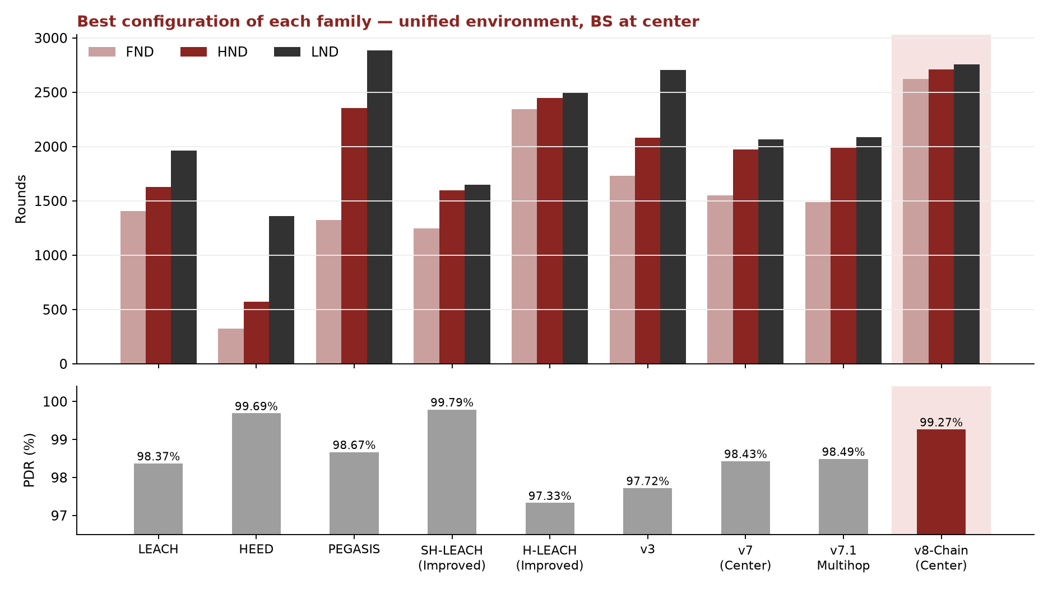
Figure 1 — Best configuration of each family in the unified environment (BS at center).

6. Evolution of the Proposed Protocol
The protocol was developed in versions that each change one mechanism, so the effect of every change can be measured on its own.
Version | Change introduced | Int. | FND | HND | LND | PDR
v1 | HEED-style CH selection + LEACH clustering, no reuse | 5 | 330 | 557 | 1318 | 99.74%
v2 | + rotation-fairness penalty | 5 | 345 | 534 | 1393 | 99.79%
v3 | Single-pass energy × connectivity score + 5-round reuse | 5 | 1730 | 2081 | 2703 | 97.72%
v4 | Setup interval 5 → 15 rounds | 15 | 1513 | 2219 | 2521 | 94.67%
v5 | + Backup CH failover | 15 | 1513 | 2127 | 2416 | 97.05%
v5-exp (Int 5) | Interval 5 + Backup + Cluster Repair | 5 | 1730 | 2086 | 2156 | 98.27%
v5-exp (Int 10) | Interval 10 + Backup + Cluster Repair | 10 | 1621 | 2141 | 2291 | 97.94%
v6 (Center) | CH-to-CH ordered chain | 5 | 1551 | 1981 | 2106 | 97.49%
v7 (Center) | Chain + Backup + Chain Repair | 5 | 1551 | 1976 | 2066 | 98.43%
v7.1 Multihop (Int 5) | Greedy multihop tree + Backup + Routing Repair | 5 | 1491 | 1991 | 2086 | 98.49%
v7.2 Multihop (Int 10) | Same multihop, interval 10 | 10 | 1381 | 2071 | 2241 | 97.88%
v5b (Energy-Aware) | v5-exp + Energy-Aware Repair (5% of E0) — LND inflated | 5 | 1730 | 2091 | 3203 | 97.31%
v8 (Center) | v5b + I1–I5 + relative low-energy threshold | 5 | 2621 | 2711 | 2761 | 99.22%
v8-Chain (Center) | v8 + energy-aware CH relay (0 relays) | 5 | 2621 | 2711 | 2756 | 99.27%

- v1 → v3: Replacing HEED's iterative negotiation with a single-pass score (E/E0)·(1 + degree/maxDegree), recomputed only every 5 rounds, was the decisive change: LND +94% over v2 (1393 → 2703).
- v3 → v5: Stretching reuse to 15 rounds alone hurt every metric (PDR 97.72% → 94.67%), because a CH that dies mid-interval strands its cluster; a pre-designated backup CH (v5) recovered most of the PDR at zero messaging cost.
- v6 → v7.2: A CH-to-CH chain helped mainly when the sink is far; adding backup failover with chain repair (v7) raised PDR at both placements; a greedy multihop tree (v7.1) reached PDR 98.49%, and interval 10 (v7.2) traded PDR for LND.
- v5b: An "energy-aware repair" rule refused to promote or reconnect any node below 5% of E0. Late in the run every node is below that fixed 0.025 J, so nodes were left alive but silent: LND rose to 3203 while its last 1038 rounds delivered only 59 packets, and backups were rejected 20 times out of 20. A latent epoch bug also produced 998 rounds with zero CHs.
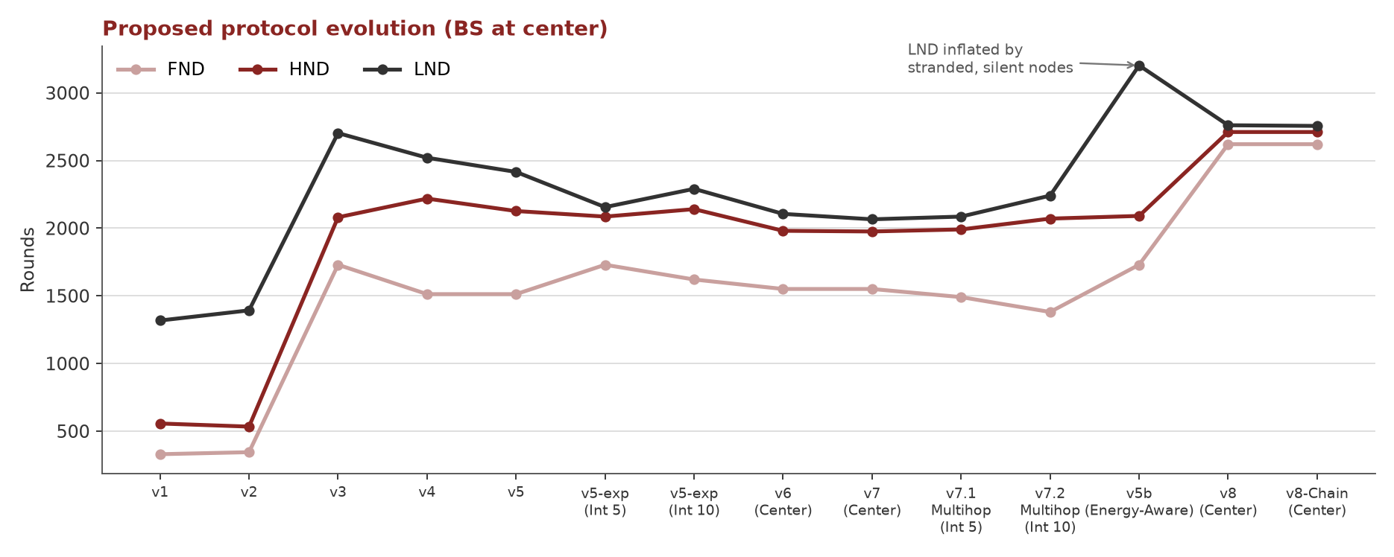
Figure 2 — FND/HND/LND of every center-BS version, in development order.

7. Final Protocol: v8-Chain
v8-Chain keeps the v3/v5 core (single-pass energy × connectivity election, 5-round reuse, backup CH with cluster repair) and adds the mechanisms below. Each can be switched off at compile time, which is how the ablation in Section 8 was produced.
Mechanism | Problem addressed | How it works
I1 Epoch-exhaustion fix | Intervals with zero CHs when every alive node has already served in the epoch | Start a new epoch early
I2 Proactive CH handover | A CH that dies mid-aggregation loses its whole cluster's packets for that round | Before the data phase, a CH that cannot afford this round's workload hands over to its strongest member (1 control packet)
I3 Orphan re-join | Members of a dead CH without a usable backup stay unclustered | Join the nearest surviving CH (known from the setup advertisements)
I4 Direct-to-BS | Nodes nearer the sink than their CH still relay through the CH | Send straight to the BS: equal or lower cost for the node, and the CH saves RX + aggregation
I5 Energy-gated election | Weak nodes can be elected CH and die first | Only nodes at or above the average residual energy may volunteer
Relative low-energy test | Fixed 5%·E0 rejected every late backup (0/20) | Compare with 5% of the live network average (18 successful promotions)
Energy-aware CH relay | Direct CH→BS links are very expensive when the sink is far (d⁴ region) | A CH forwards to a CH closer to the BS only if Tx(CH→CH) + Rx + Agg < Tx(CH→BS); the path is rebuilt every round, so a replacement CH takes its predecessor's place
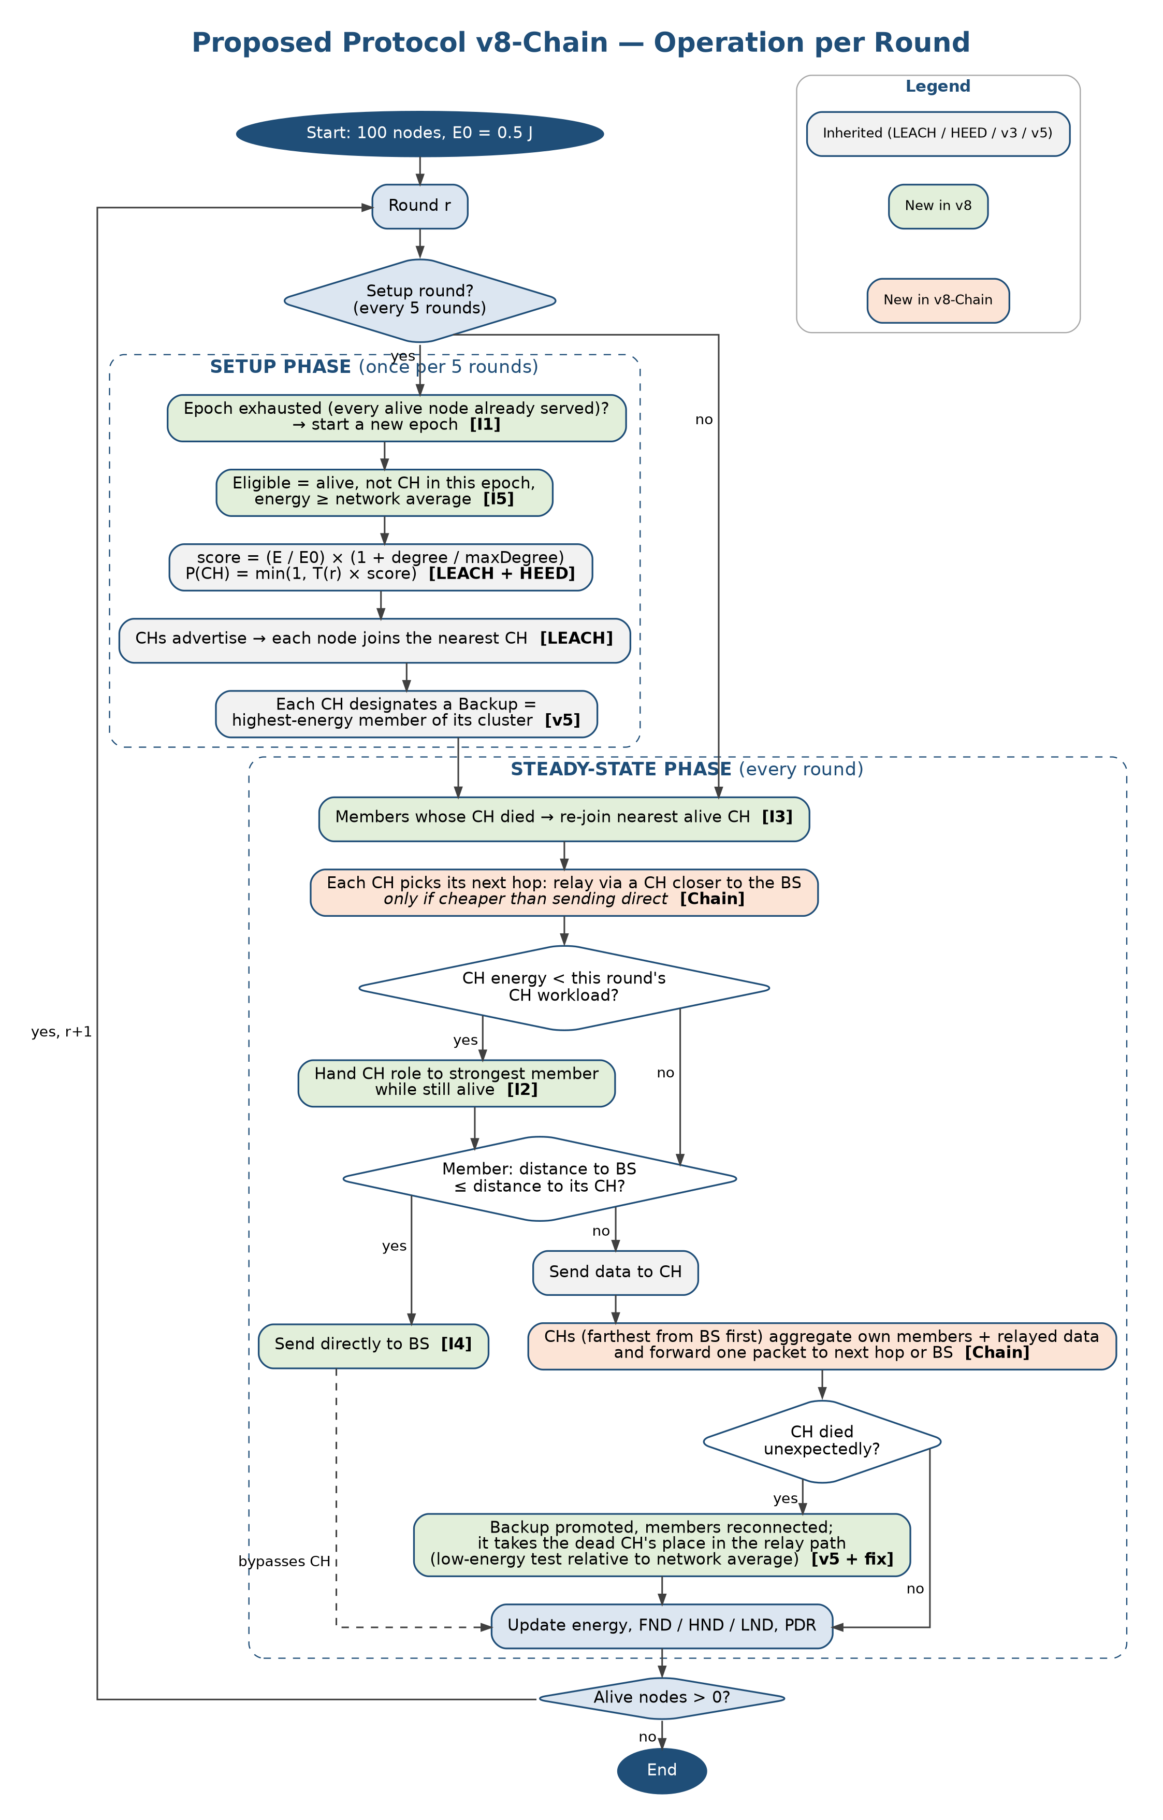
Figure 3 — Operation of v8-Chain per round (grey: inherited; green: new in v8; orange: new in v8-Chain).
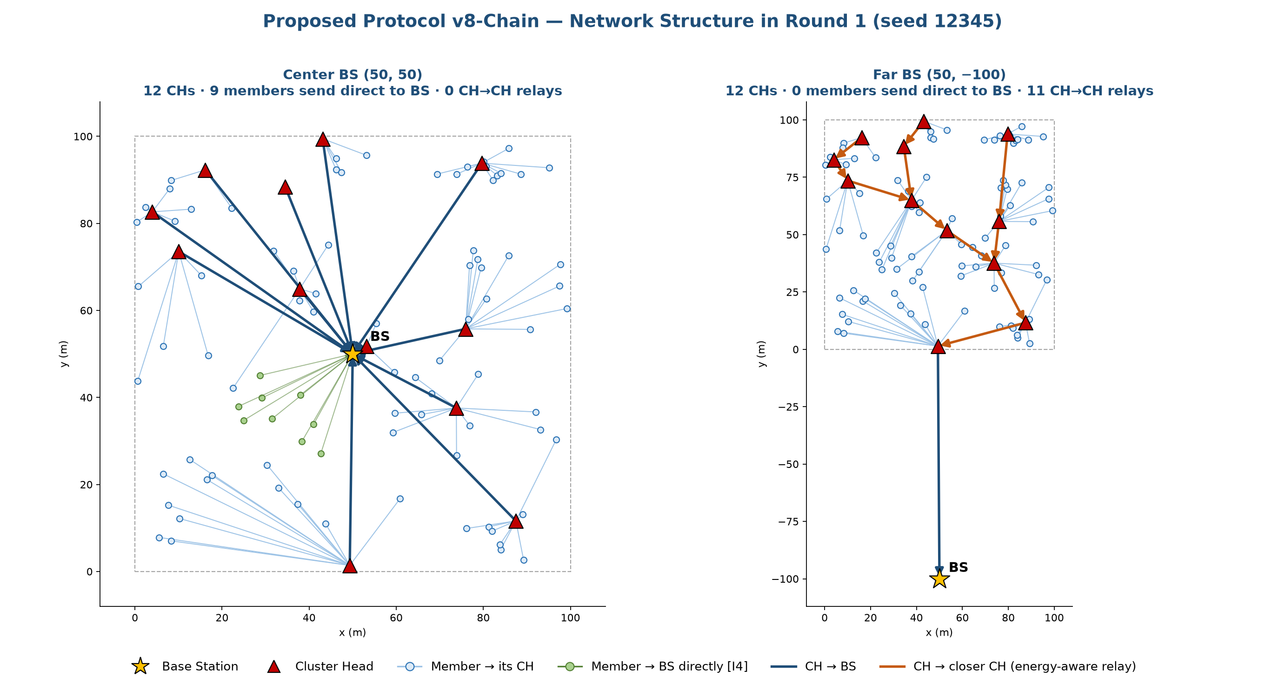
Figure 4 — Round 1 (seed 12345): with a central sink no CH relays and nearby members send directly; with a far sink the CHs form a relay chain on their own.

8. Results

8.1 Center versus far base station
Protocol | Center FND / HND / LND | Center PDR | Far FND / HND / LND | Far PDR
v6 (ordered chain) | 1551 / 1981 / 2106 | 97.49% | 1266 / 1910 / 2031 | 97.08%
v7 (chain + backup + repair) | 1551 / 1976 / 2066 | 98.43% | 1266 / 1891 / 1976 | 98.14%
v8 | 2621 / 2711 / 2761 | 99.22% | 1471 / 1646 / 1716 | 98.66%
v8-Chain | 2621 / 2711 / 2756 | 99.27% | 1716 / 1886 / 1956 | 99.07%
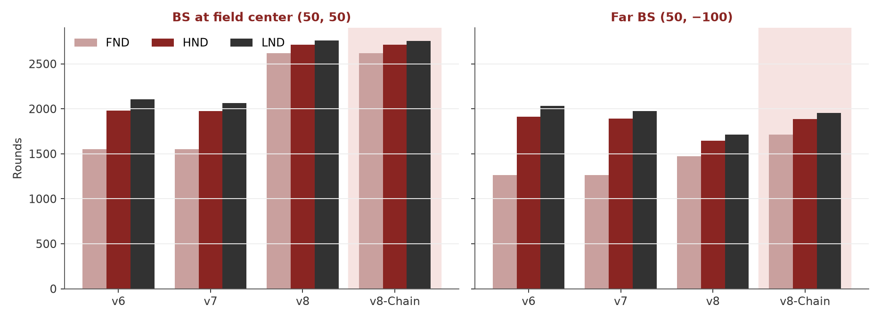
Figure 5 — The same protocols with the BS at the center and far from the field.
At the center sink, v8-Chain never finds a relay cheaper than going direct, so it behaves exactly like v8 — and a forced ordered chain would cost it about 55 rounds of FND. At the far sink, CH-to-BS links of 100–200 m fall in the d⁴ multipath region; splitting them into short CH hops is cheaper, so the relay forms by itself (4,710 relays over the run) and adds about 245 rounds to v8's FND, HND and LND. Compared with v7, v8-Chain dies first 450 rounds later with higher PDR, while HND/LND stay within 1%.

8.2 Which mechanism matters? (ablation, center BS)
Variant | Mechanism removed | FND | HND | LND | PDR | Delivered
v8 (full) | — | 2621 | 2711 | 2761 | 99.22% | 268,610
v8 − I1 | Epoch-exhaustion fix | 2621 | 2711 | 2761 | 99.22% | 268,610
v8 − I2 | Proactive CH handover | 2585 | 2726 | 2766 | 98.98% | 268,509
v8 − I3 | Orphan re-join | 2621 | 2711 | 2761 | 99.22% | 268,610
v8 − I4 | Direct-to-BS | 1821 | 2001 | 2076 | 99.32% | 198,218
v8 − I5 | Energy-gated CH election | 2171 | 2641 | 2746 | 99.05% | 258,228
Threshold fix only | All of I1–I5 | 1730 | 2086 | 2166 | 98.16% | 201,565

Direct-to-BS delivery (I4) and the energy gate (I5) carry most of the lifetime gain; proactive handover (I2) mainly adds PDR by preventing packet loss when a CH dies mid-aggregation. I1 and I3 had no measurable effect once the other mechanisms were on (they are safety nets; I1 alone removes all 998 zero-CH rounds of v5b). Over the whole lifetime v8 delivered 268,610 packets against 201,505 for v5b — 33% more data for the same 50 J.

8.3 Robustness across topologies
Across 8 random topologies (seeds 12345, 1, 7, 42, 99, 2024, 31337, 555) the mean results were: center BS — v8-Chain 2618 / 2720 / 2765 rounds, PDR 99.25% (v5b: 1688 / 2119 / 2374, 97.56%); far BS — 1743 / 1932 / 1995 rounds, PDR 99.05%. At the far BS, v8-Chain matched or exceeded v7's LND of 1976 in 6 of the 8 topologies.

9. Discussion and Recommendations
Deployment priority | Recommended configuration | Reason
Sink inside or near the field | v8-Chain (= v8 here) | Latest FND of all tested protocols; PDR 99.27%
Sink far from the field | v8-Chain | Best far-BS FND and PDR; relay forms automatically; HND/LND equal to v7
Maximum raw LND regardless of data delivered | Not recommended as a target | High LND can come from silent nodes (v5b) — check delivered packets
Simplest implementation with good PDR | v7.1 multihop or v5-exp (interval 5) | No proactive or relay logic; PDR ≈ 98.3–98.5%

- Architecture beats parameter tuning: the two largest gains came from changing how CHs are chosen (v3) and how CHs are protected and relieved (v8), not from tuning intervals or probabilities.
- Lifetime must be read together with delivery: a protocol can report a long LND while its surviving nodes send almost nothing; FND, PDR and total delivered packets expose this.
- Relaying should be a per-CH energy decision: a fixed chain helps only at a far sink and hurts at a central one; comparing the two costs every round adapts automatically.

10. Limitations and Future Work
- The study is simulation-based (100 nodes, analytical radio model in ns-3); no hardware or SDR testbed was used.
- Only two sink placements, one field size and 8 random topologies were evaluated.
- The direct-to-BS gain depends on the sink being inside or near the field.
- Failure scenarios were single CH deaths caused by energy depletion; simultaneous or malicious failures were not tested.
- Future work: validate v8-Chain on hardware; sweep sink positions, field sizes and node counts; compare the greedy relay rule with an optimal minimum-energy tree; and evaluate it together with the thesis's hybrid-cryptography layer under attack.

11. Conclusion
This work reproduced the main LEACH/HEED-family protocols in one fair environment, corrected two literature hybrids whose published algorithms could not work as written, and evolved an original hybrid protocol one mechanism at a time. The final design, v8-Chain, combines a single-pass energy × connectivity CH election with 5-round cluster reuse, protects cluster heads both before failure (proactive handover) and after it (backup failover with cluster repair), lets nodes near the sink bypass their CH, restricts the CH role to above-average-energy nodes, and relays between CHs only when that saves energy. It achieved the latest first-node death of all protocols tested at a central sink (FND 2621) with PDR 99.27%, above every protocol of comparable lifetime and, with the sink far away, improved on the chain-based v7 by 36% in FND and 0.93 pp in PDR at equal HND/LND — a single configuration that works well in both deployments.

References
[1] W. R. Heinzelman, A. Chandrakasan and H. Balakrishnan, “Energy-Efficient Communication Protocol for Wireless Microsensor Networks,” Proc. HICSS, 2000.
[2] O. Younis and S. Fahmy, “HEED: A Hybrid, Energy-Efficient, Distributed Clustering Approach for Ad Hoc Sensor Networks,” IEEE Trans. Mobile Computing, 2004.
[3] S. Lindsey and C. S. Raghavendra, “PEGASIS: Power-Efficient Gathering in Sensor Information Systems,” Proc. IEEE Aerospace Conference, 2002.
[4] Shrestha, Kim, Jung and Lee, “The Improved Energy Efficient LEACH Protocol Technology of WSNs,” IJIBC, 2015.
[5] A. Razaque, M. Mudigulam, K. Gavini, F. Amsaad, M. Abdulgader and P. Krishna, “H-LEACH: Hybrid-Low Energy Adaptive Clustering Hierarchy for Wireless Sensor Networks,” Proc. IEEE LISAT, 2016.
[6] Kaur, Kour and Singh, “EECH-HEED: An Adaptive Hybrid Clustering Protocol for Energy Efficient Soil Monitoring,” Scientific Reports, 2025.
[7] Subedi, Acharya, Lee and Lee, “Two-Level Clustering Algorithm for Cluster Head Selection in Randomly Deployed WSNs,” Telecom (MDPI), 2024.
[8] Juwaied and Jackowska-Strumillo, “DL-HEED: A Deep Learning Approach to Energy-Efficient Clustering in Heterogeneous WSNs,” Applied Sciences (MDPI), 2025.
[9] El-Sayed, Abd-Elgaber and Refaay, “An Intelligent RL Enhanced Improved LEACH Protocol for Prolonging WSN Lifetime,” Scientific Reports, 2026.
[10] J. Jassbi and S. Moridi, “Fault Tolerance and Energy Efficient Clustering Algorithm in Wireless Sensor Networks: FTEC,” Wireless Personal Communications, 2019. doi:10.1007/s11277-019-06281-6
[11] R. Pachlor, D. Shrimankar, K. K. Nagwanshi and M. Paliwal, “Cluster-Head Rotation Approaches in Sensor Networks: A Review,” arXiv:2206.08892, 2022.
[12] C. Li, M. Ye, G. Chen and J. Wu, “An Energy-Efficient Unequal Clustering Mechanism for Wireless Sensor Networks,” Proc. IEEE MASS, 2005.
[13] V. Chauhan and S. Soni, “Energy Aware Unequal Clustering Algorithm with Multi-hop Routing via Low Degree Relay Nodes for Wireless Sensor Networks,” J. Ambient Intelligence and Humanized Computing, vol. 12, pp. 2469–2482, 2021. doi:10.1007/s12652-020-02385-1
[14] W. B. Heinzelman, A. P. Chandrakasan and H. Balakrishnan, “An Application-Specific Protocol Architecture for Wireless Microsensor Networks,” IEEE Trans. Wireless Communications, 2002.
[15] ns-3 Network Simulator, release 3.41, https://www.nsnam.org

