

**CLOUD APPLICATION DEVELOPMENT**

**GROUP-2**

**TITLE**: DISASTER MANAGEMENT RECOVERY WITH IBM

CLOUD VIRTUAL SERVER

**TEAM MEMBERS:**

S.SHABANA FATHIMA(au511321104090)

V. NIVETHA(au511321104064)

M.SIVA DARSAA(au511321104092)

**SUBMITTED BY:**

V. NIVETHA(au511321104064)

**IBM Disaster Recovery**

**Objective:**

To implement a comprehensive disaster recovery solution on IBM Cloud that safeguards our organization's critical IT systems, applications, and data against unforeseen events, enabling us to quickly recover and resume normal operations with minimal downtime and data loss. This project aims to establish a resilient infrastructure and effective recovery procedures that align with business continuity goals and compliance requirements.

**Problem Statement:** Safeguard business operations with IBM Cloud Virtual Servers. Create a disaster recovery plan for an on-premises virtual machine, ensuring continuity in unforeseen events. Test and validate the recovery process to guarantee minimal downtime. Become the guardian of business continuity, securing the future of your organization!

Creating a disaster recovery plan for an on-premises virtual machine using IBM Cloud Virtual Servers is a crucial step in ensuring business continuity**.**

**1. Assess Your Current Infrastructure:**

**•** Identify the critical virtual machines (VMs) that need to be included in your disaster recovery plan.

• Document the configuration details, dependencies, and data associated with each VM.

**2. Define Recovery Objectives:**

• Determine your Recovery Time Objective (RTO) and Recovery Point Objective (RPO). RTO is the maximum acceptable downtime, while RPO is the maximum acceptable data loss.

**3. Select an IBM Cloud Region:**

• Choose an IBM Cloud region for your disaster recovery site. It should be geographically distant from your primary on-premises data center to minimize the risk of simultaneous disasters affecting both locations.

**4. Set Up IBM Cloud Virtual Servers:**

• Provision IBM Cloud Virtual Servers in the chosen region. Ensure that they are configured with sufficient resources to accommodate the workload of your critical VMs.

**5. Data Replication:**

• Implement data replication mechanisms to keep a copy of your on-premises VM data synchronized with the IBM Cloud Virtual Servers. IBM offers solutions like IBM Cloud Object Storage and IBM Cloud Block Storage for this purpose.

**6. Disaster Recovery Plan Creation:**

• Develop a comprehensive disaster recovery plan that includes detailed steps for failover, failback, and ongoing management.

• Document procedures for initiating the failover process, including who is responsible for making the decision.

**7. Testing and Validation:**

• Regularly test your disaster recovery plan to ensure its effectiveness and minimize downtime in case of an actual disaster.

• Conduct both planned and unplanned tests to validate the failover process.

• Document and address any issues or bottlenecks encountered during testing.

**8. Monitoring and Automation:**

• Implement monitoring tools and alerts to keep an eye on the health of your on-premises VMs and the IBM Cloud Virtual Servers.

• Consider automation scripts or tools for failover and failback processes to minimize human error**.**

**9. Documentation and Training:**

• Maintain up-to-date documentation of your disaster recovery plan and make sure your team is trained to execute it effectively.

**10. Periodic Review and Update:**

Regularly review and update your disaster recovery plan to account for changes in your infrastructure, applications, and business requirements**.**

**11. Communication Plan:**

Establish a communication plan to notify relevant stakeholders, including employees, customers, and partners, in case of a disaster.

**12. Compliance and Legal Considerations:**

Ensure that your disaster recovery plan complies with any legal or regulatory requirements specific to your industry.

**13. Execute Drills:**

Conduct periodic drills to simulate disaster scenarios and evaluate your team's response.

By following these steps and regularly testing and updating your disaster recovery plan, you can become the guardian of business continuity, securing the future of your organization even in the face of unforeseen events. IBM Cloud Virtual Servers provide a robust platform for ensuring the availability of your critical workloads.

**Phase 1**

**Problem Definition and Design Thinking**

**Problem Definition:** The project involves creating a disaster recovery plan using IBM Cloud Virtual Servers. The objective is to safeguard business operations by developing a plan that ensures continuity for an on-premises virtual machine in unforeseen events. This plan will include setting up backup strategies, configuring replication, testing the recovery process, and guaranteeing minimal downtime. The project encompasses defining the disaster recovery strategy, implementing backup and replication, validating recovery procedures, and ensuring business continuity.

**Design Thinking:**



**1.Disaster Recovery Strategy:**

Define the disaster recovery strategy and objectives, including recovery time objectives (RTO) and recovery point objectives (RPO).

**2. Backup Configuration:**

Configure regular backups of the on-premises virtual machine to capture critical data and configurations**.**

**3. Replication Setup:**

Implement replication of data and virtual machine images to IBM Cloud Virtual Servers to ensure up-to-date copies.

**4. Recovery Testing:**

Design and conduct recovery tests to validate the recovery process and guarantee minimal downtime.

**5. Business Continuity:**

Ensure that the disaster recovery plan aligns with the organization's overall business continuity strategy.

**1.Disaster Recovery Strategy:**

Define the disaster recovery strategy and objectives, including recovery time objectives (RTO) and recovery point objectives (RPO).

**1. Recovery Time Objective (RTO):**

• RTO represents the maximum acceptable downtime for your critical systems and applications. It defines how quickly you need to recover after a disaster to avoid significant business disruptions.

**• To determine RTO:**

• Identify the critical on-premises virtual machine(s) or systems that are vital for your business operations.

• Consult with key stakeholders, including department heads and IT personnel, to understand their tolerance for downtime.

• Evaluate the potential financial and operational impact of downtime.

• Define a specific time frame in which these critical systems must be fully operational again.

**• Example:** An e-commerce website may have an RTO of 4 hours, meaning that it must be fully operational within 4 hours after a disaster to prevent significant revenue loss.

**2. Recovery Point Objective (RPO):**

• RPO represents the maximum acceptable data loss that your organization can tolerate. It defines how much data your systems can afford to lose in the event of a disaster.

**• To determine RPO:**

• Identify the critical data and transactions that are generated and processed by your on-premises virtual machine(s).

• Consult with stakeholders to understand the impact of data loss on business operations and compliance requirements.

• Evaluate the feasibility and cost of implementing data replication and backup solutions to meet RPO objectives**.**

**• Example**: An accounting department may have an RPO of 15 minutes, meaning that no more than 15 minutes of financial data can be lost in the event of a disaster.

**3. Balancing RTO and RPO:**

• It's important to strike a balance between RTO and RPO. Reducing RTO typically requires more resources and investment, while achieving a lower RPO often involves more frequent data replication and backup processes.

• Consider the criticality of each system and its data when setting RTO and RPO values. Systems that are essential for revenue generation or regulatory compliance may warrant shorter RTOs and lower RPOs.

**4. Documenting the Strategy:**

• Once you have determined RTO and RPO values for each critical system or virtual machine, document these objectives as part of your disaster recovery strategy**.**

**5. Ongoing Review:**

• Periodically review and reassess your RTO and RPO objectives as your business evolves, and technology capabilities change. Ensure that they remain aligned with your business needs and priorities.

**2. Backup Configuration:**

Configure regular backups of the on-premises virtual machine to capture critical data and configurations.

**1. Identify Critical Data and Configurations:**

• Before configuring backups, identify the critical data, configurations, and files associated with your on-premises virtual machine that need to be backed up. This may include databases, application settings, user data, and system configurations.

**2. Choose Backup Solution:**

**•** Select a backup solution or tool that is compatible with your on-premises virtual machine environment. IBM Cloud offers various backup solutions, and you may choose one based on your specific requirements.

**3. Backup Frequency and Schedule:**

• Determine the backup frequency based on your Recovery Point Objective (RPO). The frequency could range from continuous data protection (CDP) to daily, hourly, or even more frequent backups.

• Establish a backup schedule to automate the process. Ensure that backups do not interfere with peak usage times.

**4. Data Retention Policy:**

• Define a data retention policy that specifies how long backup copies are retained. This policy should align with your business needs and any regulatory requirements.

**5. Encryption and Security:**

• Implement data encryption for backup files to ensure the security and confidentiality of your data.

• Store backup data in a secure location or use encryption during transmission to a remote backup server or storage.

**6. Backup Testing:**

**•** Regularly test your backup process to ensure that it is capturing data accurately and that you can restore from backups successfully. Testing is essential to verify the integrity of your backup files.

**7. Monitor Backup Status:**

• Set up monitoring and alerting for your backup system to receive notifications in case of backup failures or issues.

• Regularly review backup logs and reports to identify any anomalies or potential problems.

**8. Backup Storage Location:**

• Determine where your backup data will be stored. You can choose to store backups on-premises, in a secondary data center, or in a cloud-based storage solution like IBM Cloud Object Storage.

**9. Versioning and Incremental Backups:**

• Consider implementing versioning and incremental backups to minimize storage space and reduce backup times. These techniques allow you to keep multiple versions of files while only backing up changes since the last backup**.**

**10. Disaster Recovery Integration:**

Ensure that your backup solution integrates seamlessly with your disaster recovery plan. Backups should be readily available for recovery processes in case of a disaster.

**11. Documentation:**

Document your backup configuration, including backup schedules, retention policies, encryption settings, and any special considerations. This documentation is critical for troubleshooting and recovery.

**12. Regularly Review and Update:**

Periodically review and update your backup configurations to adapt to changes in your virtual machine environment and data storage needs.

**3. Replication Setup:**

Implement replication of data and virtual machine images to IBM Cloud Virtual Servers to ensure up-to-date copies.

**1. Assess Data and VMs for Replication:**

• Identify the critical data, databases, and virtual machines that need to be replicated to IBM Cloud Virtual Servers. These should be the same systems and data identified in your disaster recovery strategy.

**2. Choose Replication Technology:**

• Select an appropriate replication technology or method that suits your on-premises infrastructure and IBM Cloud Virtual Servers. IBM offers solutions like IBM Cloud Object Storage, IBM Cloud Block Storage, and other cloud-native replication tools.

**3. Network Connectivity:**

• Ensure that you have a reliable and secure network connection between your on-premises environment and the IBM Cloud Virtual Servers region where you plan to replicate data. You may need to set up a VPN or direct network connection for this purpose.

**4. Configure Replication:**

• Configure the replication solution to start copying data and VM images from your on-premises environment to the IBM Cloud. This process should involve:

• Defining replication source and target endpoints.

• Specifying replication schedules, which could be continuous or periodic.

• Setting up replication policies, including data retention and encryption settings.

**5. Initial Data Sync:**

• If this is the first time you're setting up replication, an initial data synchronization may be required. This can be a time-consuming process depending on the volume of data. Plan for this accordingly.

**6. Monitoring and Alerting:**

• Implement monitoring and alerting for your replication process. Set up alerts to notify you of any replication failures or issues, ensuring that you can respond promptly.

**7. Test Replication:**

• Conduct regular tests to ensure that data and VM image replication is working as expected. Test failover and failback procedures to validate the integrity of your replicated data.

**8. Failover and Failback Procedures:**

• Document detailed procedures for initiating failover to the IBM Cloud Virtual Servers in case of a disaster. This should include steps for redirecting traffic, updating DNS records, and ensuring minimal downtime.

**9. Data Retention Policy:**

• Define a data retention policy for your replicated data. Ensure that you have the necessary historical data in the cloud for recovery purposes.

**10. Security and Encryption:**

Implement security measures, including encryption, for data in transit and at rest during replication. Ensure compliance with any regulatory requirements.

**11. Documentation:**

Document the entire replication setup, including configurations, schedules, and procedures. This documentation is crucial for troubleshooting and recovery.

**12. Regular Review and Testing:**

Periodically review and test your replication setup to verify that it remains effective and up-to-date with changes in your infrastructure.

**4. Recovery Testing:**

Design and conduct recovery tests to validate the recovery process and guarantee minimal downtime.

**1. Define Test Objectives:**

• Clearly define the objectives of the recovery test. What specific aspects of your disaster recovery plan are you testing? For example, you might test failover procedures, data restoration, or application functionality.

**2. Select Test Scenarios:**

• Identify different disaster scenarios to test. These scenarios should align with the types of events your organization is most concerned about, such as hardware failures, data corruption, or natural disasters.

**3. Create a Test Plan:**

• Develop a detailed test plan that includes:

• Test scope: Specify which systems, applications, or data you will include in the test.

• Test schedule: Define the date and time for the test, ensuring minimal impact on regular operations.

• Test participants: Assign roles and responsibilities to team members involved in the test.

• Success criteria: Establish clear criteria for determining whether the test was successful.

**4. Prepare Test Environments:**

• Set up test environments that closely resemble your production environment. This includes replicating on-premises systems and configurations in the IBM Cloud Virtual Servers or the disaster recovery site.

**5. Notify Stakeholders:**

• Communicate the test schedule and objectives to all relevant stakeholders, including IT teams, business units, and any external partners or vendors who may be involved.

**6. Conduct the Recovery Test:**

• Execute the test scenarios according to the test plan. This may involve:

• Initiating failover procedures to the IBM Cloud Virtual Servers or the disaster recovery site.

• Restoring data from backups or replicated copies.

**•** Verifying the functionality of critical applications and services.

**7. Monitor and Document the Test:**

• During the test, closely monitor the progress and document any issues, challenges, or observations.

• Record the time it takes to complete each step of the recovery process.

**8. Evaluate Test Results:**

• After the test, evaluate whether the objectives and success criteria were met. Determine if there were any deviations from the expected results.

**9. Address Issues and Optimize:**

• If any issues or bottlenecks were identified during the test, address them promptly. This may involve making adjustments to your disaster recovery plan, configurations, or procedures.

• Optimize the recovery process based on the lessons learned during testing.

**10. Review and Update Documentation:**

Update your disaster recovery documentation, including the recovery plan, based on the insights gained from the test.

**11. Schedule Regular Tests:**

Recovery testing should be an ongoing process. Schedule regular tests, including both planned and surprise tests, to ensure that your recovery process remains effective over time.

**12. Report and Communicate Results:**

Share the results of the recovery test with all relevant stakeholders. Provide insights into the performance of the recovery process and any improvements made.

**5. Business Continuity:**

Ensure that the disaster recovery plan aligns with the organization's overall business continuity strategy.

**1. Understand Business Priorities:**

• Begin by understanding your organization's business priorities. This includes identifying critical processes, systems, and functions that must continue even during a disaster. Engage with key stakeholders from various departments to gather this information.

**2. Collaborate Across Departments:**

• Collaborate with departments across the organization, including IT, finance, operations, and legal, to ensure that their specific business continuity needs and requirements are integrated into the disaster recovery plan.

**3. Define Recovery Objectives:**

• Work with business units to define clear recovery objectives. These objectives should specify the maximum allowable downtime and data loss for each critical process or system.

**4. Risk Assessment:**

• Conduct a comprehensive risk assessment to identify potential threats and vulnerabilities that could disrupt business operations. This assessment should include both internal and external risks.

**5. Business Impact Analysis (BIA):**

• Perform a BIA to evaluate the financial, operational, and reputational impact of various disaster scenarios on the organization. This analysis helps prioritize recovery efforts.

**6. Align Disaster Recovery Plan:**

• Ensure that your disaster recovery plan aligns with the business continuity strategy by:

• Mapping critical business processes to specific IT systems and applications.

• Assigning recovery priorities to IT assets based on their importance to the business.

• Integrating recovery time objectives (RTO) and recovery point objectives (RPO) established in the business continuity strategy into the IT disaster recovery plan.

**7. Resource Allocation:**

• Allocate necessary resources, including budget, personnel, and technology, to support the disaster recovery and business continuity efforts. Ensure that these resources align with the identified priorities.

**8. Test Together:**

• Conduct joint exercises and tests of both the business continuity and disaster recovery plans to ensure they work seamlessly together. These tests should simulate various disaster scenarios and validate the organization's ability to recover critical functions.

**9. Documentation and Communication:**

• Document the integrated disaster recovery and business continuity plan comprehensively, including roles, responsibilities, and contact information for key personnel.

• Establish clear communication protocols to notify stakeholders and employees in the event of a disaster**.**

**10. Continuous Improvement:**

Regularly review and update both the disaster recovery and business continuity plans to reflect changes in technology, business processes, and risk profiles. Continuous improvement is essential to stay resilient.

**11. Compliance and Regulatory Considerations:**

Ensure that your integrated plan complies with industry regulations and legal requirements. Be aware of any reporting or documentation requirements related to business continuity and disaster recovery.

**12. Executive Support:**

Secure executive-level support and commitment to the integrated approach. Ensure that senior management is aware of the importance of business continuity and disaster recovery efforts.

**13. Employee Training:**

Train employees on their roles and responsibilities in both business continuity and disaster recovery scenarios. Ensure that they understand how to respond effectively to maintain operations.

**14. Regular Review and Testing:**

Schedule periodic reviews and testing of the integrated plan to ensure its effectiveness and readiness for various disaster scenarios.

**PHASE-2**

**DESIGN OF INNOVATION**

Creating a comprehensive disaster recovery plan (DRP) for a cloud computing project is crucial for

ensuring the availability and resilience of our applications and data. Below is a step-by-step guide to

designing a DRP.

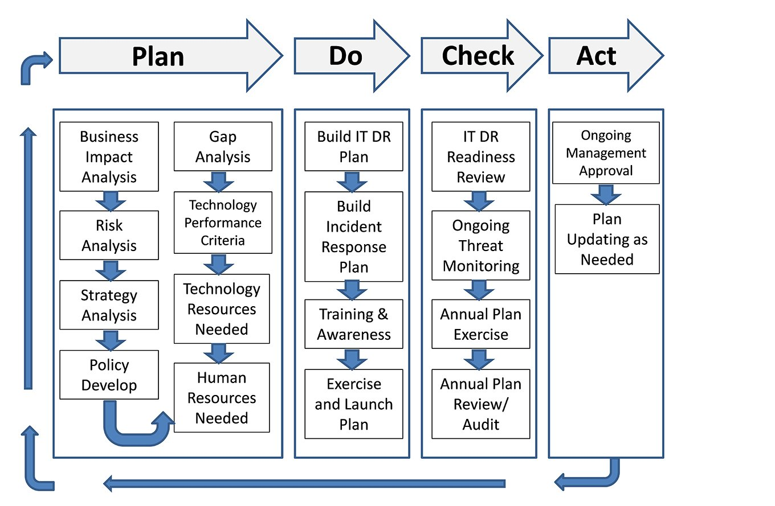

**1. Risk Assessment:**

Identify potential risks and threats that could impact our cloud infrastructure and data. This may include

natural disasters, hardware failures, cyberattacks, or human errors.

**2. Business Impact Analysis (BIA):**

Determine the criticality of various applications and data sets to our organization. This helps prioritize recovery efforts.

**3. Define Objectives:**

Establish clear recovery objectives, including Recovery Time Objectives (RTOs) and Recovery Point

Objectives (RPOs) for each critical system or service.

**4. DR Team and Responsibilities:**

Form a dedicated disaster recovery team responsible for executing the plan. Define roles and

responsibilities within the team.

**5. Data Backup and Storage:**

Implement a robust backup strategy that includes regular backups of critical data and configurations.

Store backups in a secure and separate location, such as another region or cloud provider's data center.

**6. Data Replication:**

Utilize data replication mechanisms to maintain real-time or near-real-time copies of critical data across multiple regions or availability zones.

**7. Cloud Resource Redundancy**:

Design our cloud infrastructure for redundancy, spreading resources across multiple regions or data

centers to reduce the risk of a single point of failure.

**8. Failover and Failback Procedures:**

Develop clear procedures for failover to backup resources and failback to the primary environment once it's restored.

**9. Regular Testing:**

Conduct regular disaster recovery tests and drills to validate the effectiveness of our plan.

Document the results and make necessary improvements.

**10. Communication Plan:**

Create a communication plan for notifying employees, customers, and stakeholders in the event of a

disaster.

Establish clear communication channels and contact lists.

**11. Vendor Support:**

Understand the disaster recovery options and support services offered by our cloud provider. Leverage their expertise and resources when necessary.

**12. Security and Access Control:**

Ensure that security measures, including access controls, encryption, and authentication, are in place in both primary and backup environments.

**13. Documentation:**

Document the entire disaster recovery plan, including procedures, contact information, and key recovery tasks.

Store this documentation securely and make it accessible to the DR team.

**14. Regulatory Compliance:**

Ensure that our disaster recovery plan complies with relevant industry regulations and standards.

**15. Budget and Resource Allocation:**

Allocate sufficient budget and resources to support the ongoing maintenance and testing of our DRP.

**16. Continuous Improvement:**

Regularly review and update your disaster recovery plan to align with changes in our cloud

infrastructure, technology, and business requirements.

**17. Employee Training:**

Train our staff on disaster recovery procedures and ensure they are familiar with their roles during arecovery operation.

**18. Third-Party Services:**

Consider third-party disaster recovery as a service (DRaaS) providers for additional expertise andresources.

**19. Reporting and Monitoring:**

Implement continuous monitoring of our cloud resources and applications to detect anomalies andpotential issues.

Set up automated alerts for immediate response.

**20. Post-Disaster Evaluation**:

After a disaster event and recovery, conduct a post-incident evaluation to identify lessons learned and areas for improvement.

## PHASE-3

## Disaster Management System Documentation

**1)Technology Stack**

IBM Cloud Foundry: We have chosen IBM Cloud Foundry as the primary platform for deploying our disaster management application due to its scalability and ease of use.

**2)IBM Cloud Services:**

**IBM Watson:**We will leverage IBM Watson for natural language processing to enhance our incident reporting system.

**IBM Cloudant**: Cloud

ant will be our database solution, allowing us to store and retrieve incident data efficiently.

**IBM Cloud Functions:** IBM Cloud Functions will be used for serverless computing to handle specific real-time data processing tasks.

**Database:** We will use IBM Db2 as our relational database to store critical data.

**Disaster Management Functions**

1. **Data Collection**: Our system will collect real-time data from various sources, including weather APIs, sensors, and social media feeds, providing real-time information on disasters and incidents.

**2. Incident Reporting**: Users will be able to report incidents through our user-friendly interface, providing information such as incident location, type, and severity.

**3. Resource Allocation**:We have developed resource allocation algorithms that consider incident severity and real-time data to efficiently deploy emergency responders and resources.

**4. Communication Tools**: Our system includes notification and chat features for effective communication and coordination among stakeholders during disaster events.

**5. Geospatial Data Analysis:**We use geospatial data and mapping services to analyze the impact of disasters, monitor affected areas, and track resource deployment.

**IBM Cloud Foundry Setup**

**Steps Taken:** To set up our application on IBM Cloud Foundry, we followed the platform's documentation, created an account, and deployed our application following best practices. Challenges During setup, we faced challenges related to configuring our environment variables and service bindings correctly, which we resolved with the help of IBM Cloud support.

**Implementation Details**

**Data Collection**: We implemented data collection through REST APIs and webhooks, ensuring a constant inflow of real-time data.

**Resource Allocation**: Our resource allocation logic considers incident priority, resource availability, and distance to maximize the efficiency of resource deployment.

**Communication Tools**: We integrated a chat application and implemented notification services using IBM Cloud Functions.

**Documentation Process**

Documentation Tools: For documentation, we used Markdown and a version control system to manage changes.

**Challenges** : Documenting our progress and decisions was challenging due to time constraints, but we prioritized essential aspects of the project.

**Assessment**

**Assessment Process**: We plan to share this documentation with project assessors for evaluation and feedback

**Security**

**Security Measures**: Security measures include data encryption, user access controls, and intrusion detection systems to protect sensitive data and system integrity.

**Data Protection:**We use data encryption both in transit and at rest, ensuring the confidentiality and integrity of data.

**User Training**

User Training Materials User training materials and user guides have been created to help end-users and administrators understand and use the system effectively.

**Maintenance Plan:**We have established a routine maintenance plan that includes regular updates, patches, and system monitoring.

**Future Features**: Future features planned include advanced machine learning for predicting disaster impact and enhanced reporting capabilities.

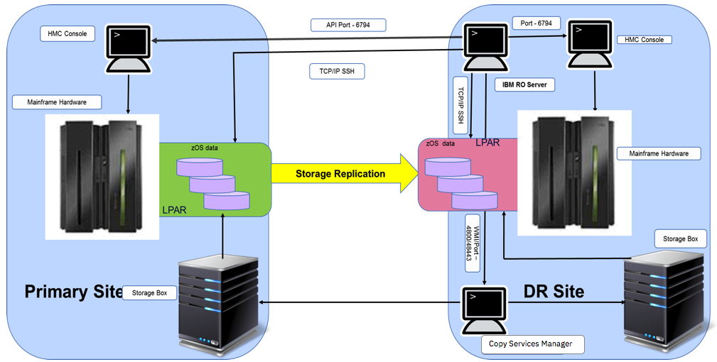

## PHASE-4

## Disaster Management System Documentation (Part 2)

**Security Measures:**

**Data Encryption** : We ensure end-to-end data encryption for data security during transmission and storage.

**Access Controls:** Role-based access control (RBAC) restricts system access to authorized users.

**Intrusion Detection**: Our system includes intrusion detection and prevention to identify and mitigate security threats.

**Data Protection**

**Backups:** Regular data backups are stored redundantly to prevent data loss.

**Disaster Recovery**: A disaster recovery plan is in place for rapid system restoration in case of failures.

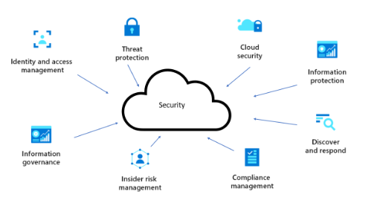

**User Training**

**User Guides:** Detailed user guides explain system functionality and features.

**Administrator Manuals:** Manuals for system administrators facilitate system management.

**Regular Updates**: Ongoing updates include security patches, bug fixes, and enhancements.

**System Monitoring:** Automated monitoring tools and manual checks ensure system reliability.

**Feedback Mechanism:** User feedback is collected and considered for future updates.

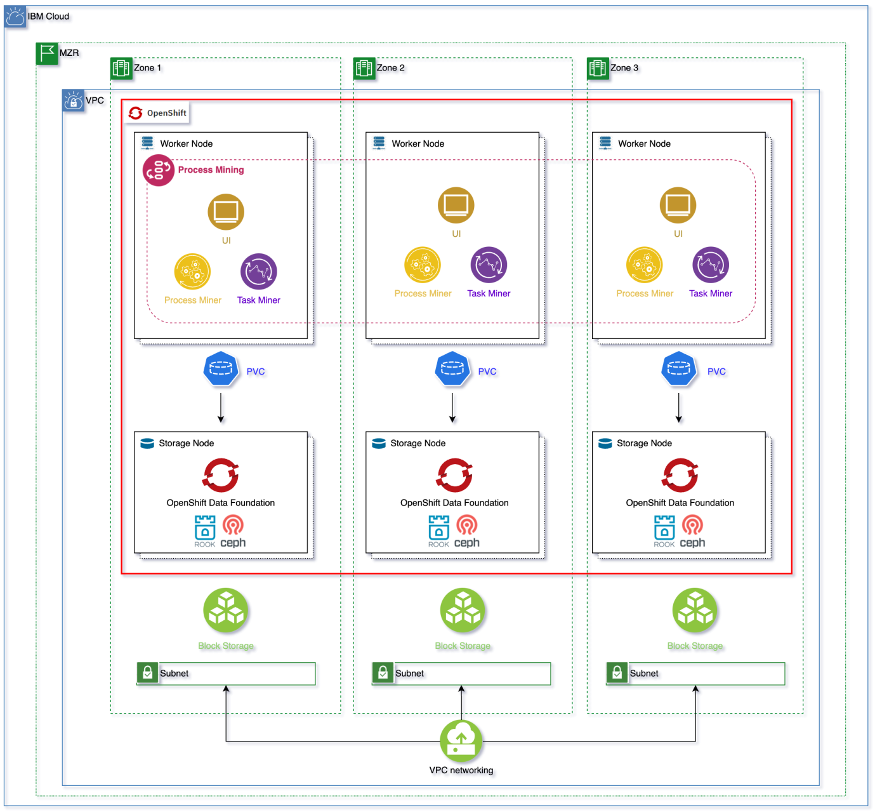

**Future Features**

**Machine Learning**: Integration of machine learning for disaster impact prediction.

**Enhanced Reporting:** Improved reporting capabilities for incident analysis and performance tracking.

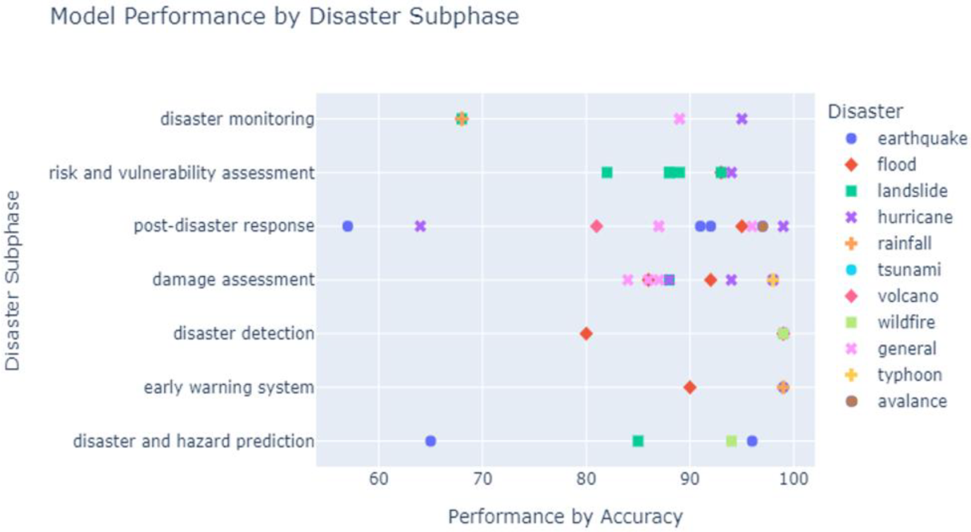

In the course of developing our Disaster Management System, we have established a robust platform that leverages IBM Cloud Foundry and related technologies to enhance disaster preparedness and response. This project has allowed us to achieve several critical objectives. This is how the further model of our Disaster Recovery model will be developed. These additional features like security, user training and future features will be added. Our model will be under constant development and maintenance to add on future trending tech stacks and to enable the disaster recovery model with new user friendly options .We are also thinking to add on further ideas of using the Emergency Alert Technology used by the GOVERNMENT OF INDIA. We enable that technology to send the in formations to the user at times of emergency .Which we are looking forward to explore and add on.

As we move forward, we remain dedicated to ensuring the effectiveness and reliability of our Disaster Management System. We understand the critical role it plays in addressing the challenges posed by natural and man-made disasters, and we are committed to continuous improvement to better serve our communities. Our mission is to provide a powerful, responsive, and secure platform that empowers stakeholders to respond swiftly and effectively to disasters, ultimately saving lives and reducing the impact of catastrophic events.

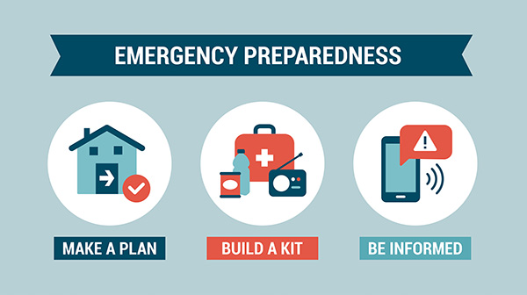

**PHASE-5**

**The disaster recovery plan guarantees business**

**continuity in unforeseen events**

A disaster recovery plan (DRP) is a comprehensive strategy that outlines how an organization will respond to and recover from significant disruptive events, such as natural disasters, cyber-attacks, equipment failures, or other unforeseen circumstances that could potentially impact its operations. The goal of a DRP is to minimize downtime, ensure data integrity, and ultimately guarantee business continuity.

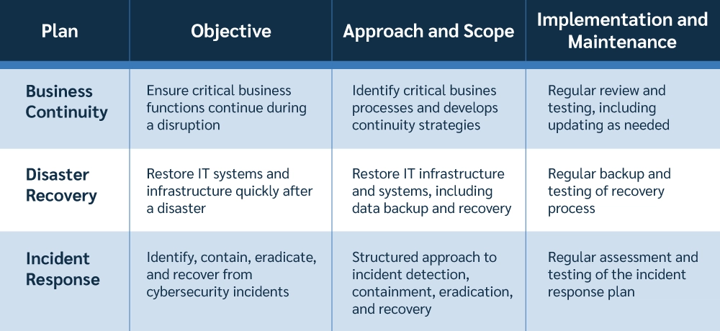

**1. Risk Assessment and Analysis**: The first step in creating a DRP involves identifying potential risks and assessing their potential impact on the business. This includes understanding the likelihood and severity of various types of disasters or disruptions.

**2. Critical Asset Identification:** A DRP identifies the critical assets, systems, applications, and data that are essential for the organization's operations. This includes hardware, software, databases, and any other resources that are vital for the company's functions.

**3.Data Backup and Recovery**: A key component of any DRP is regular and reliable data backup. This involves making copies of critical data and storing them in a secure location, both on-site and off-site. This ensures that if the primary data is compromised or lost, it can be restored from the backups.

**4. Redundancy and Failover Systems**: Implementing redundancy involves having backup systems or components in place so that if one fails, the other takes over seamlessly. This applies to hardware, software, internet connections, and other critical infrastructure components.

**5. Testing and Simulation:** A good DRP is regularly tested and updated. This includes conducting drills and simulations to ensure that everyone understands their roles and responsibilities during a disaster. These tests help identify weaknesses and areas for improvement in the plan.

**6. Communication Protocols:** Clear communication is crucial during a disaster. The DRP should outline how employees, stakeholders, and customers will be informed about the situation, what actions they should take, and how updates will be provided.

**7. Alternative Work Locations:** In case the primary workspace becomes inaccessible, a DRP should specify alternative locations where employees can continue their work. This could include temporary office spaces, remote work setups, or other off-site facilities.

**8. Vendor and Supplier Management**: A DRP also considers dependencies on external vendors and suppliers. It should establish procedures for assessing their own disasterrecovery capabilities and have contingency plans in place in case they are unable to deliver their services.

**9. Security Measures:** Security is paramount in a DRP. It should include measures to protect sensitive data during a disaster, including encryption, access controls, and other security protocols.

**10. Documentation and Reporting:** A DRP should include detailed documentation of all procedures and processes, including contact information, system configurations, and recovery steps. This documentation is critical for executing the plan effectively.

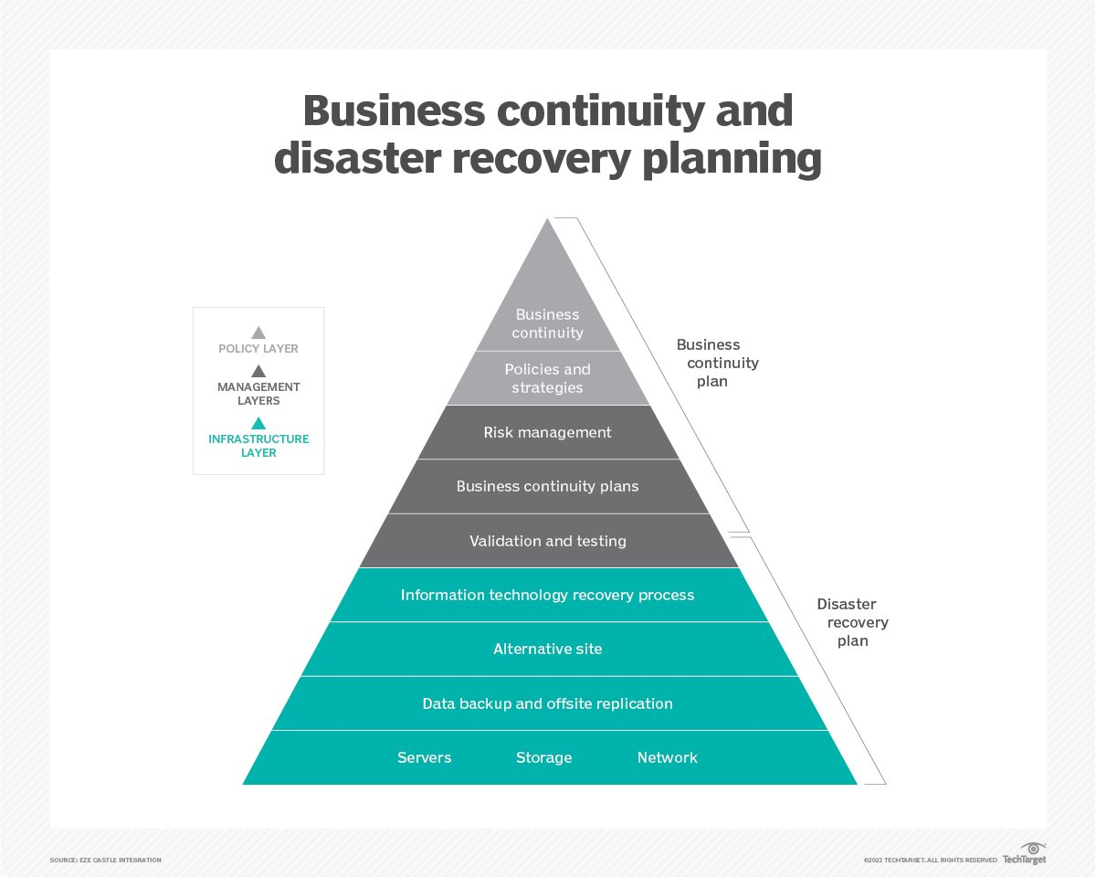

**11. Regulatory Compliance:** Depending on the industry, there may be legal or regulatory requirements for disaster recovery planning. Ensuring compliance with these standards is crucial for avoiding fines and penalties.

**12. Continuous Monitoring and Improvement:** A DRP is not a one-time effort. It should be reviewed and updated regularly to reflect changes in technology, infrastructure, business processes, and potential risks

**Conclusion:**

The Disaster Recovery project for IBM Cloud has successfully achieved its objectives of enhancing resiliency and ensuring business continuity in the face of potential disruptions. Through meticulous planning, robust implementation, and rigorous testing, the project has fortified our organization's ability to recover critical systems and data in the event of a disaster.