**Survey Force User Guide**

1. Before using Survey Force, make sure the steps in the ‘Survey Force Installation Guide’ were completed.
2. Create a Survey. This can be done from the Surveys tab or the ‘Create New’ section on the sidebar.

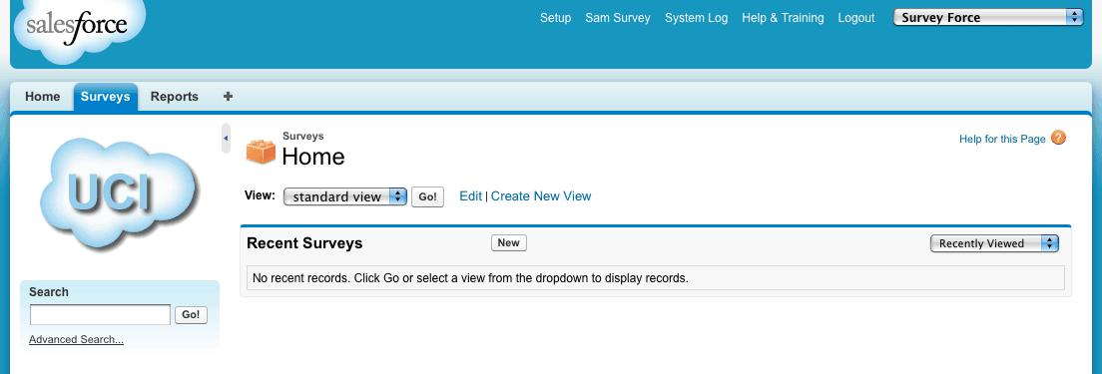

1. Fill out the desired fields and click ‘Save.’ Below is a description of each field:
   1. Survey Name: the name of the Survey
   2. Select Site: this will be populated with your active sites

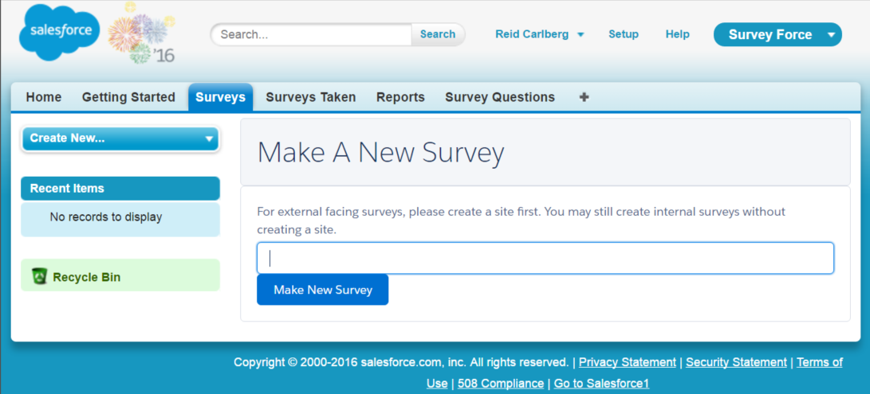

1. You are now ready to create Survey questions. Click on the ‘Add Question’ button to launch the wizard.

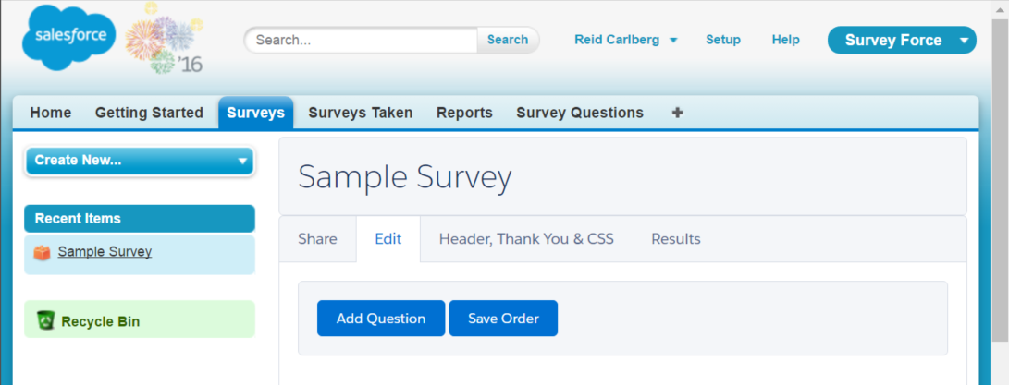

1. Select the question type. There are four (4) options:
   1. Single Select – Vertical
      1. Allows for one response; formatted vertically
   2. Single Select – Horizontal
      1. Allows for one response; formatted horizontally
   3. Multi-Select – Vertical
      1. Allows for multiple responses; formatted vertically
   4. Free Text
      1. Allows survey taker to leave a free text response

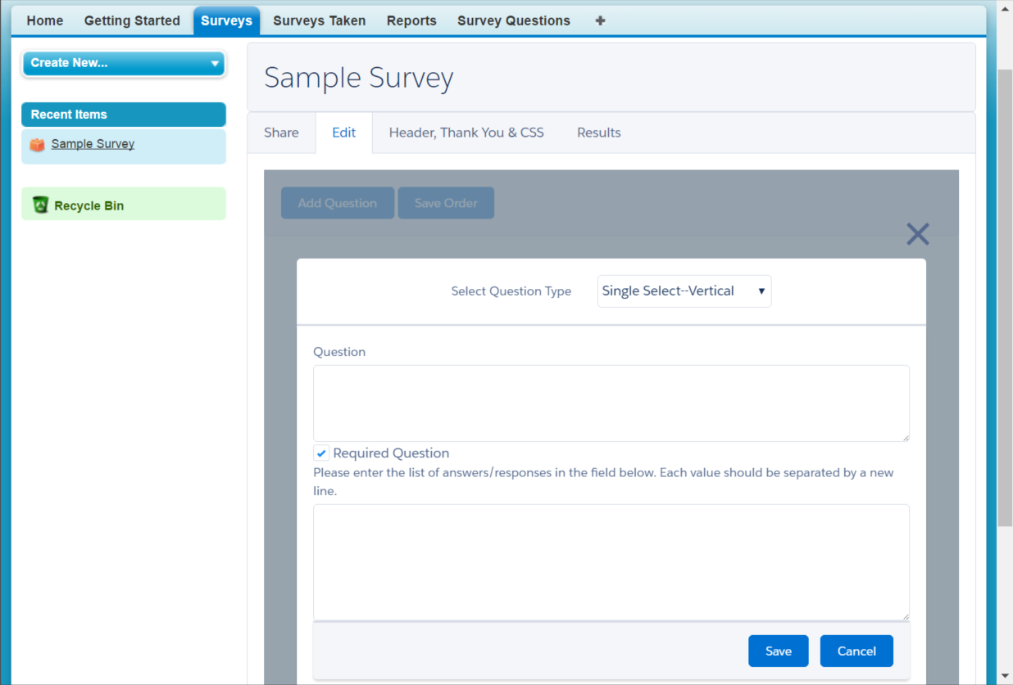

1. Paste or type a question into the ‘Question’ field. Then, check off whether the question is required. Finally enter the possible survey responses (removed for free text questions). Each survey answer/response should be separated by a new line. Hit the ‘Save’ button.

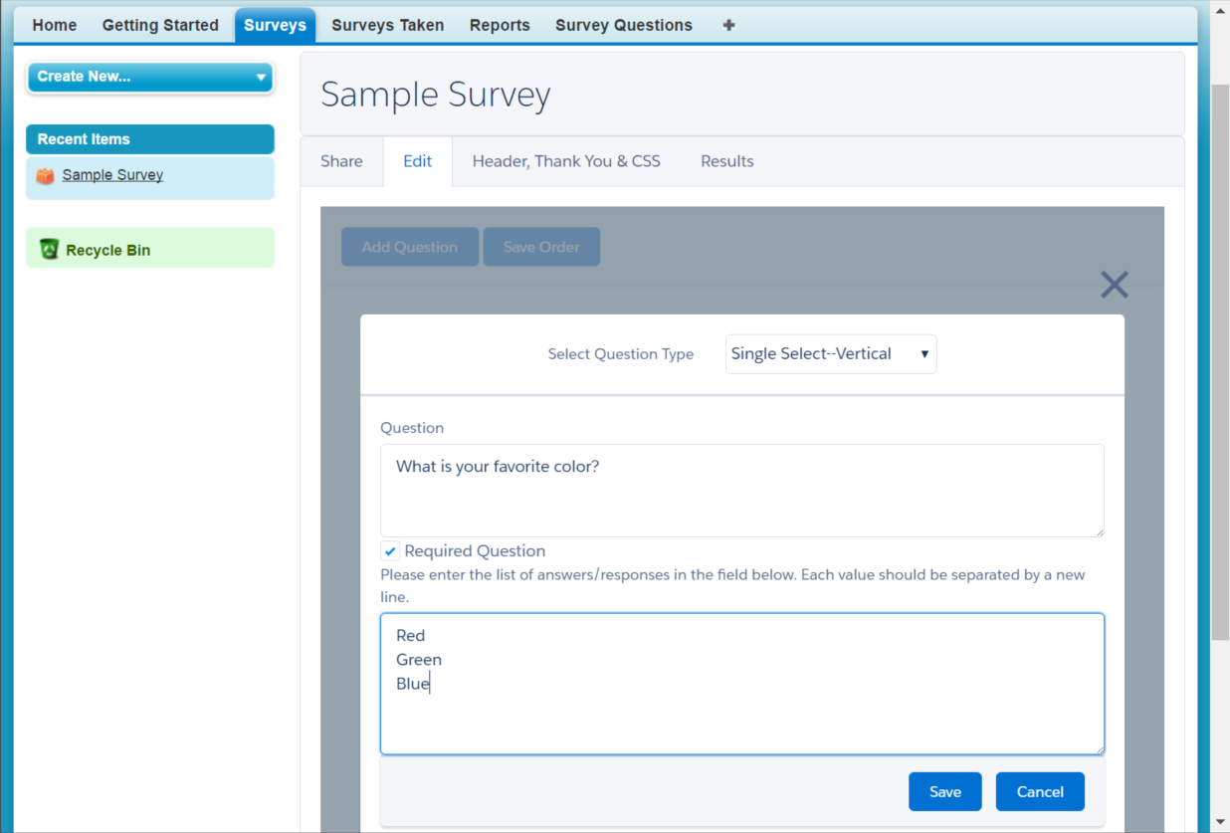

1. Repeat the process for each question by clicking the ‘Add Question’ button.

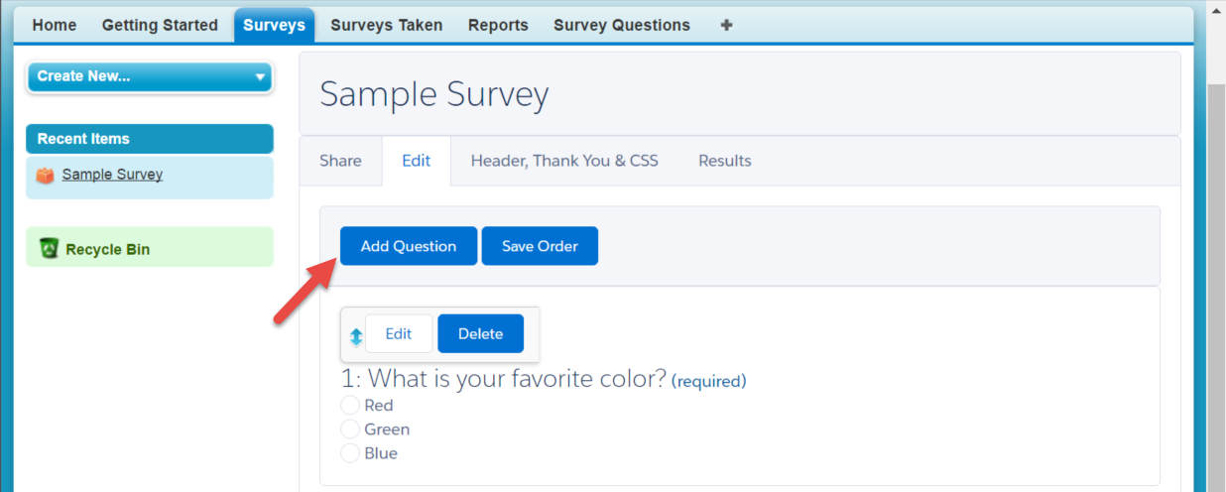

1. Edit individual questions by clicking on the ‘Edit’ button next to the question. You can also delete the question by clicking the ‘Delete’ button.

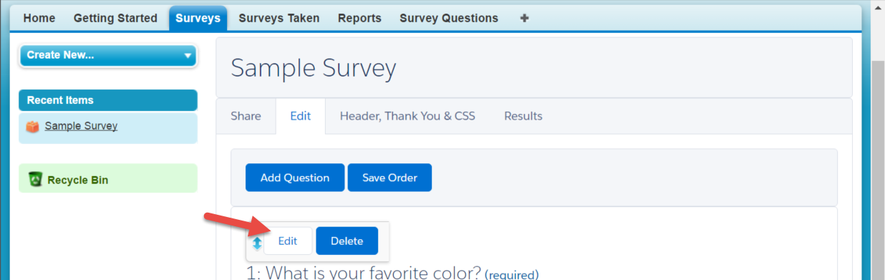

1. Reorder questions via drag-and-drop and click the ‘Save Order’ button once the questions are in the order you prefer.

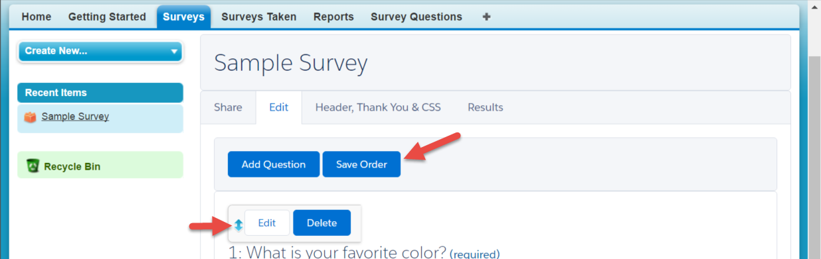

1. You can get sharing link by going to “Share” tab and selecting various “Sharing Options”

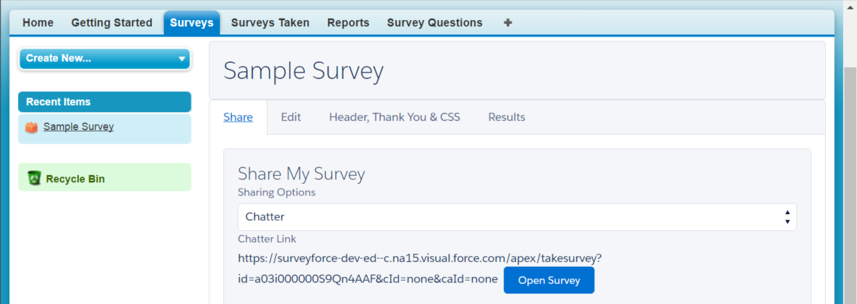

1. Survey Options, in “Header, Thank You & CSS” allow you further customize survey
   1. Survey Name: Shows up at the top of the survey
   2. Hide Survey Name: Hides the survey name
   3. Survey Header: This text shows up above the Survey Name
   4. Thank You Text: Shows up after survey is completed
   5. Survey Container CSS: Allows to add CSS to survey container to easily format any survey; if needed.

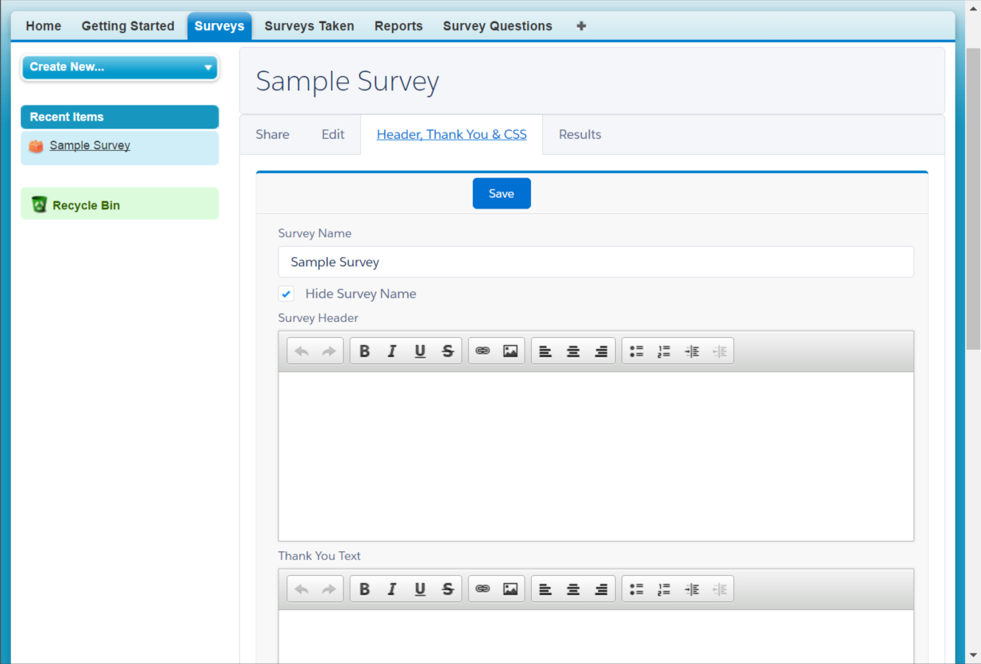

1. Report tab takes users to Survey reports filtered by current survey

