**Calculator**

**Using Logic Gates**

**By:**

Bsee-21005 (Furqan Bari)

Bsee-210036 (Sami Ullah Laang)

Bsee-210063 (Muhammad Noman)

Bsee-210080 (Abdul Rahman)

**Problem Statement:**

* Inputs:
  + Clock Pulse CP
  + Command Available CA
  + Command C0...C2
  + Input Data A0...A3
* Output:
  + Output Available OA
  + Output Data D0...D3

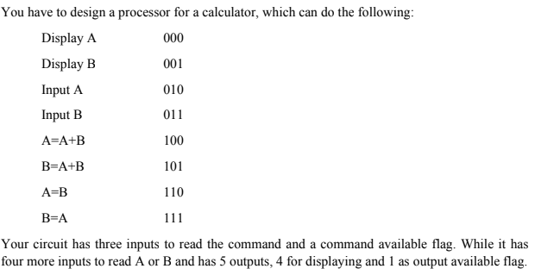

**Introduction:**

It is a Logic Gate IC’s based calculator, which perform different functions using 3 bit input command and 4 bit algebraic input’s.

Our first approach is making a RAF Block approach Diagram.

**Block Diagram:**

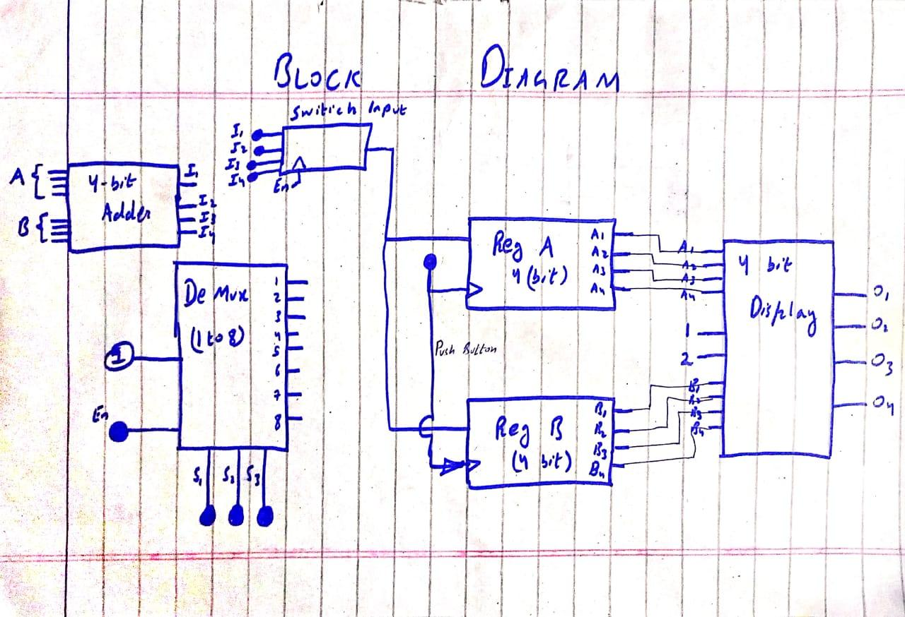

**Truth Table:**

It gives the closed output future idea of the components output:

* De-mux(1-to-8) (74LS138N)

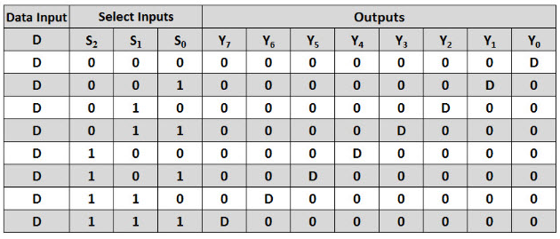

* 7483 ( 4-BIT ADDER )

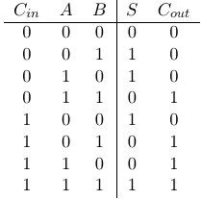

* 74LS194 ( UNIVERSAL REGISTER )

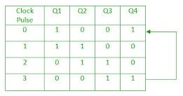

**Schematic Diagram:**

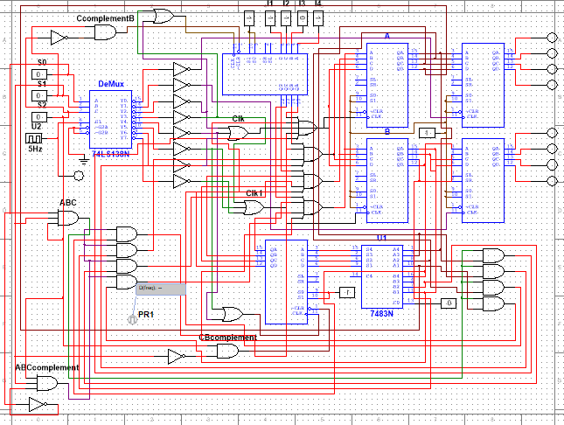

**Multisim Results:**

* Display A

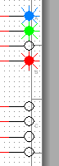 

* Display B

 

* Input A

  

* Input B

  

* A = A+B

 

* B = A+B

 

* A = B

 

* B = A

 

**Conclusion:**

Hence, this project perform its all task correctly and all connections and gates and IC’s we use are completely working and performing according to their datasheet truth table.