

American International University-Bangladesh (AIUB)
Department of Computer Science Faculty of Science & Technology (FST)
PROGRESS REPORT OF PROJECT
A Computer Graphics Project Progress Report Submitted
By
Semester-->Summer-25-26 |  | Section: W
SL | Student Name | Student ID
1 | Md. Ashikur Rahman Mirza | 24-56849-1
2 | Mahabub Alom Apon | 24-56851-1
3 | Md. Mostafizur Rahman | 24-56803-1
4 | Shahed Bhuiyan Rony | 24-56776-1
5 | Shajiya Afrin | 24-56826-1

PROGRESS REPORT
Project Title: | Two Worlds: An Interactive 2D Smart City and Traditional Village Simulation Using OpenGL (GLUT) | Report Date: | [DD/MM/YYYY]
Reporting Period: | Initial Development – Current Animation Stage | Section: | W
1. INTRODUCTION
Two Worlds is an interactive 2D Computer Graphics project developed using C++ and OpenGL (GLUT). The project presents two contrasting environments within a single scene: a modern smart city and a traditional village. The city side contains modern buildings and infrastructure, while the village side represents traditional rural life. A river and connecting bridge visually integrate the two environments.
The major static components of both environments have been implemented. The project has also entered the animation and interaction stage. Moving clouds and keyboard-controlled Day, Evening, Night, and Rain modes have been developed. Night mode includes a moon and stars, while Rain mode includes dark storm clouds and animated background and foreground rainfall. Object-based animations including windmill blade rotation and continuous cow movement have also been implemented. In addition, multiple cars and a bus move continuously from the city side through the bridge toward the village side.
2. OBJECTIVES
The main objectives of this project are:
- To design and develop an interactive 2D environment combining a modern smart city and a traditional village using OpenGL (GLUT).
- To represent city and village environments using basic computer graphics primitives, transformations, and reusable drawing functions.
- To implement dynamic object animations such as moving clouds, rotating windmill blades, moving cows, cars, and a bus using GLUT timer functions.
- To provide keyboard-controlled Day, Evening, Night, and Rain environmental modes for interactive scene visualization.
3. FUNCTIONS
Function / Module | Description | Progress Status
Base Environment & Scene Layout | Developed the complete 2D scene structure including sky, ground, smart-city region, traditional village region, main river, curved river section, road layout, sidewalks, and the overall City–Village transition. | Completed
City Objects & Infrastructure | Implemented the AIUB Building, distant city skyline, High-Rise Building, Food Court, Hospital, City Park, Bus Stop, highway, Zebra Crossing, Traffic Signal, Street Lights, and City–Village Bridge. | Completed
Village Environment & Objects | Implemented village hills, background trees, pine trees, Mud House, Tin House, Windmill, large village trees, cows, Paddy Field, Bamboo Fence, Hay Stack, and village-side road environment. | Completed
Environmental Animation & Scene Control | Implemented continuously moving clouds and keyboard-controlled Day, Evening, Night, and Rain modes. Night mode displays the moon and stars, while Rain mode uses dark storm clouds with animated background and foreground rainfall. | Completed
Object & Vehicle Animation | Implemented rotating windmill blades, continuous forward movement of village cows, multiple moving city cars, and a moving bus. Vehicles travel from the city side through the bridge toward the village side and reset after leaving the visible scene. | Ongoing

4. FEATURES
Feature | Description | Completion (%)
Smart City Environment | Developed the complete smart-city area with AIUB Building, distant skyline, High-Rise Building, Food Court, Hospital, City Park, Bus Stop, highway, sidewalks, Zebra Crossing, Traffic Signal, Street Lights, and other supporting city elements. | 100%
Traditional Village Environment | Developed the traditional village area with hills, background trees, pine trees, Mud House, Tin House, Windmill, large village trees, cows, Paddy Field, Bamboo Fence, Hay Stack, and village road environment. | 100%
City–Village Connection & Scene Integration | Integrated the two contrasting environments using the river, curved river section, connecting bridge, city highway, and village-side road to create one continuous Two Worlds scene. | 100%
Environmental Modes & Animation | Implemented moving clouds and keyboard-controlled Day, Evening, Night, and Rain modes. Night mode includes the moon and stars, while Rain mode includes a dark rainy environment, dark storm clouds, and animated background and foreground rainfall. | 100%
Moving Objects & Dynamic Animation | Implemented rotating windmill blades, continuous forward-moving cows, multiple moving cars, and a moving bus. Cars and the bus travel from the city through the bridge toward the village and reappear after leaving the scene. Additional object animations are still under development. | 60%

5. WORK DISTRIBUTION OF MEMBERS
SL | Student Name | Student ID | Assigned Work | Progress / Status
1 | Md. Ashikur Rahman Mirza | 24-56849-1 | Base Environment, AIUB Building, City Foundation, Highway, Sidewalks, Road Markings, River and Scene Integration, Expanded World Layout, Village Hills and Background Environment, Moving Cloud Animation, Day/Evening/Night/Rain Modes, Moon, Stars, Dark Storm Clouds, and Layered Rain Animation. | Completed – Static foundation and assigned environmental animation completed.
2 | Mahabub Alom Apon | 24-56851-1 | High-Rise Building, Food Court, City Park, Bus Stop, City Cars, City Bus, Multiple Vehicle Placement, and Continuous Car and Bus Movement Animation. | Completed – Assigned static city objects and vehicle animation completed.
3 | Md. Mostafizur Rahman | 24-56803-1 | Hospital, City–Village Bridge, Traffic Signal, Zebra Crossing, and Street Lights. | Ongoing – Assigned static objects completed; Traffic Signal and Street Light animation/control pending.
4 | Shahed Bhuiyan Rony | 24-56776-1 | Mud House, Tin House, Windmill, Large Village Trees, Village Cows, Windmill Blade Rotation, and Continuous Forward Cow Movement Animation. | Completed – Assigned static village objects and object animations completed.
5 | Shajiya Afrin | 24-56826-1 | Paddy Field, Bamboo Fence, and Hay Stack. | Ongoing – Assigned static village objects completed; animation/interaction work pending.

Overall Project Completion: _____85_______ %

- PROJECT PROGRESS IMAGE
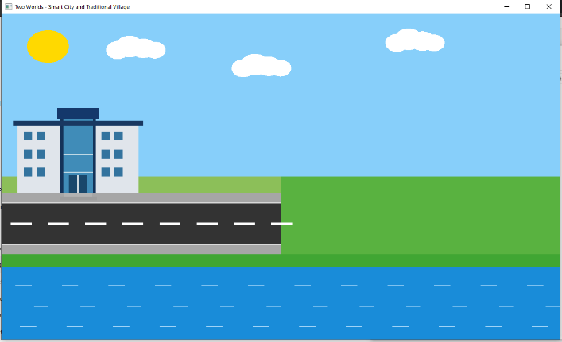
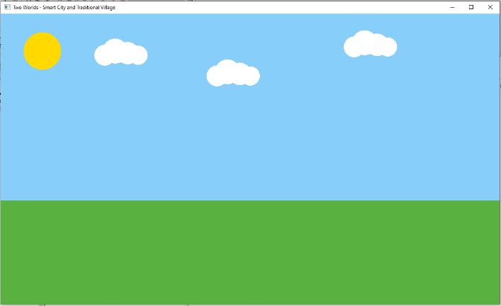
Fig. 1. Project progress at Checkpoint 02 showing the base environment, AIUB Academic Building, city highway, sidewalks, river bank, and river.

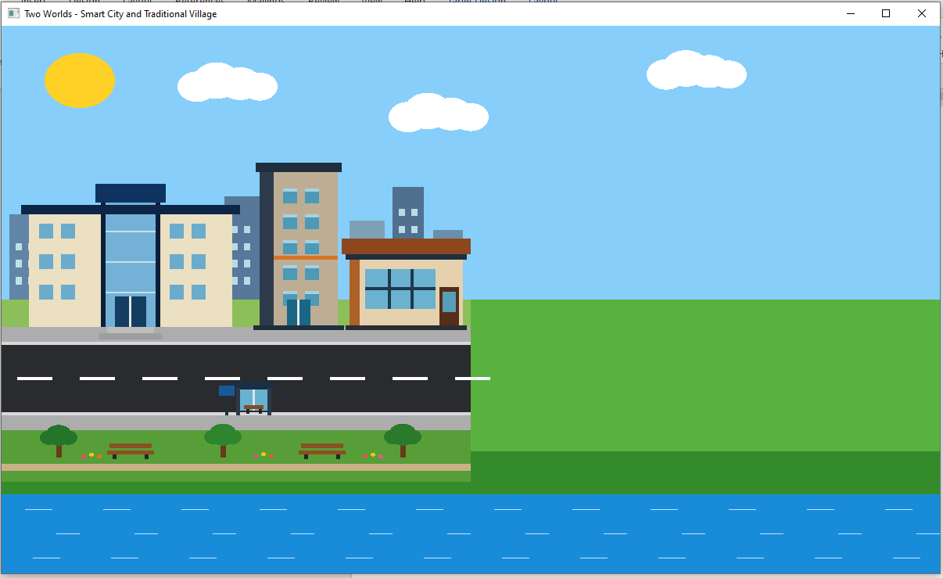
Fig. 2. Checkpoint 03 showing the completed Apon city development including the modern high-rise building, Food Court, Bus Stop, riverfront city park, and improved distant city skyline
.
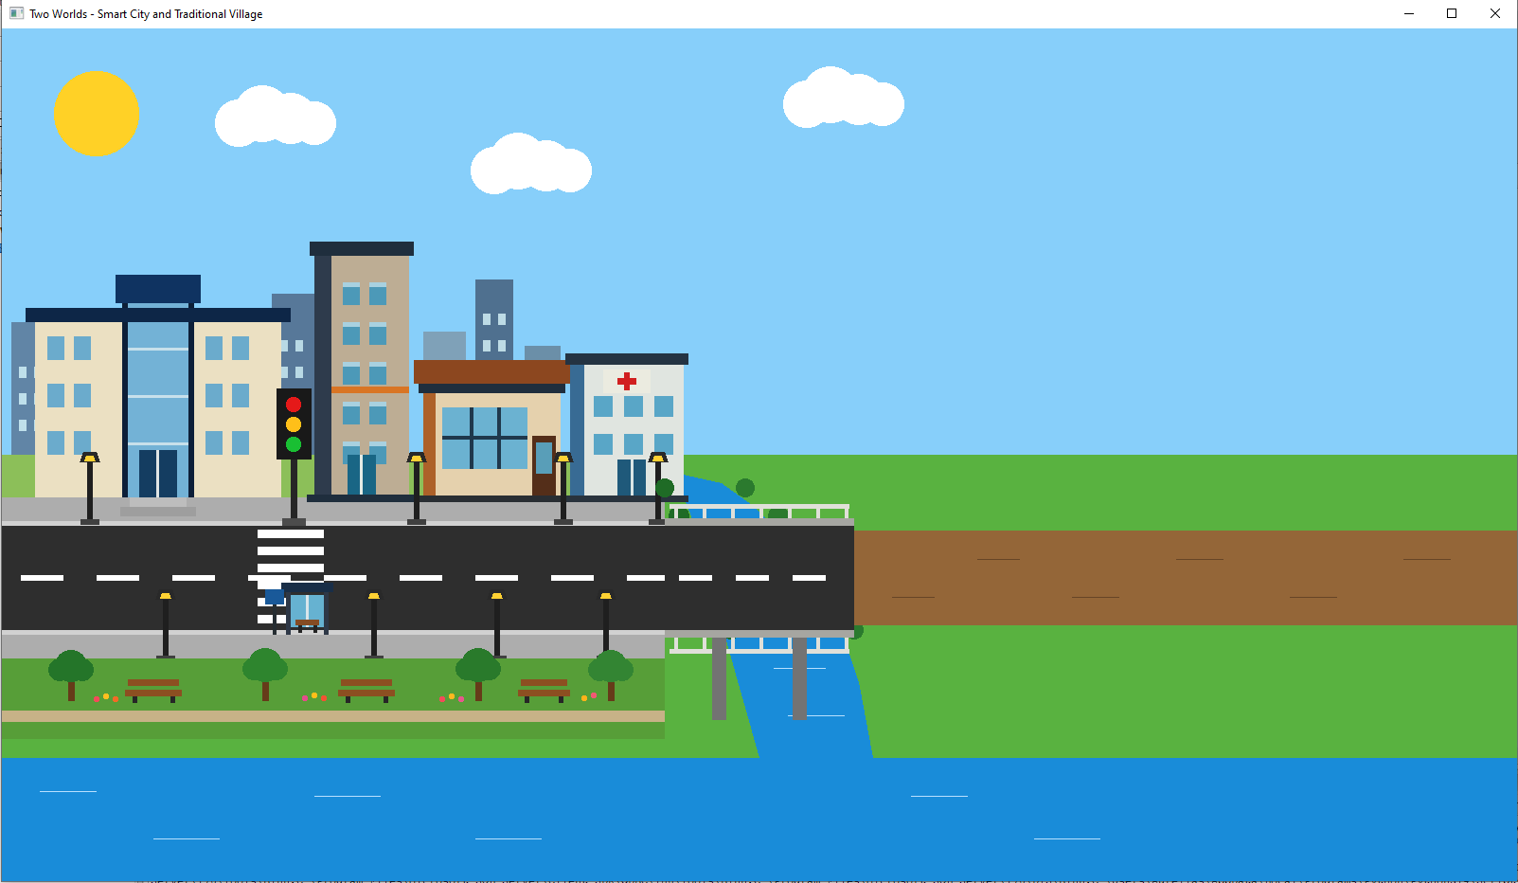
Fig. 3. Checkpoint 04 showing the developed smart city infrastructure with the hospital, City–Village bridge, traffic signal, zebra crossing, street lights, expanded riverfront park, and connected river system.
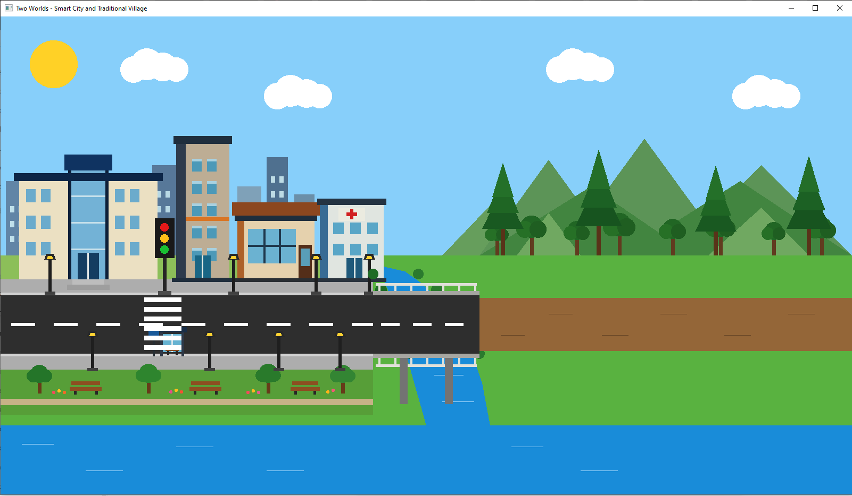
Fig. 4. Checkpoint 05 showing the expanded Two Worlds scene with completed smart city infrastructure, City Village river and bridge connection, and the newly developed traditional village background containing layered hills, varied distant trees, and tall pine/jhau-type trees.
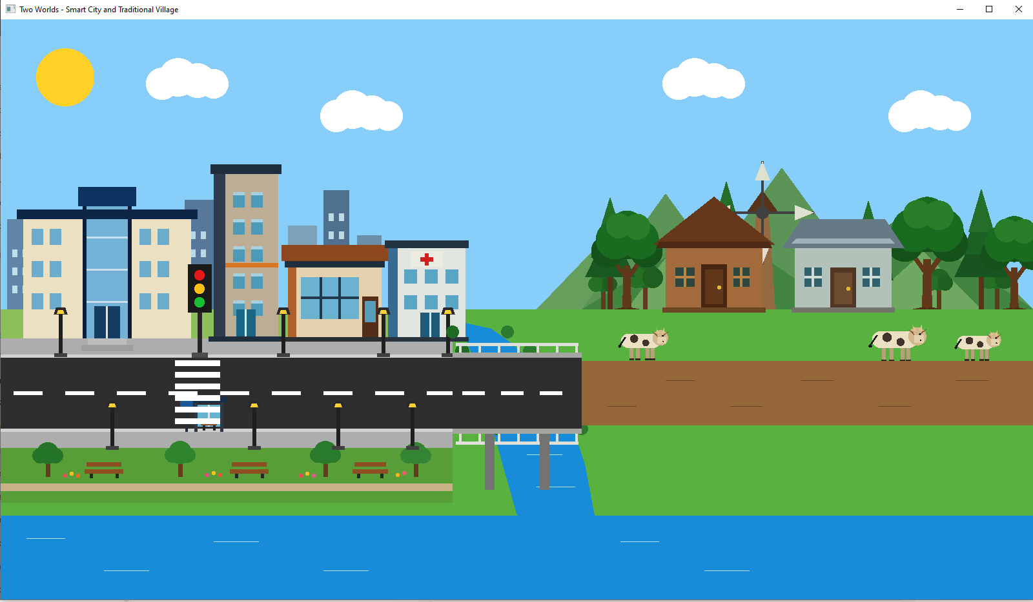
Fig. 5. Checkpoint 06 showing the completed traditional village structures and rural elements including the Mud House, Tin House, Windmill, detailed village trees and multiple cows.
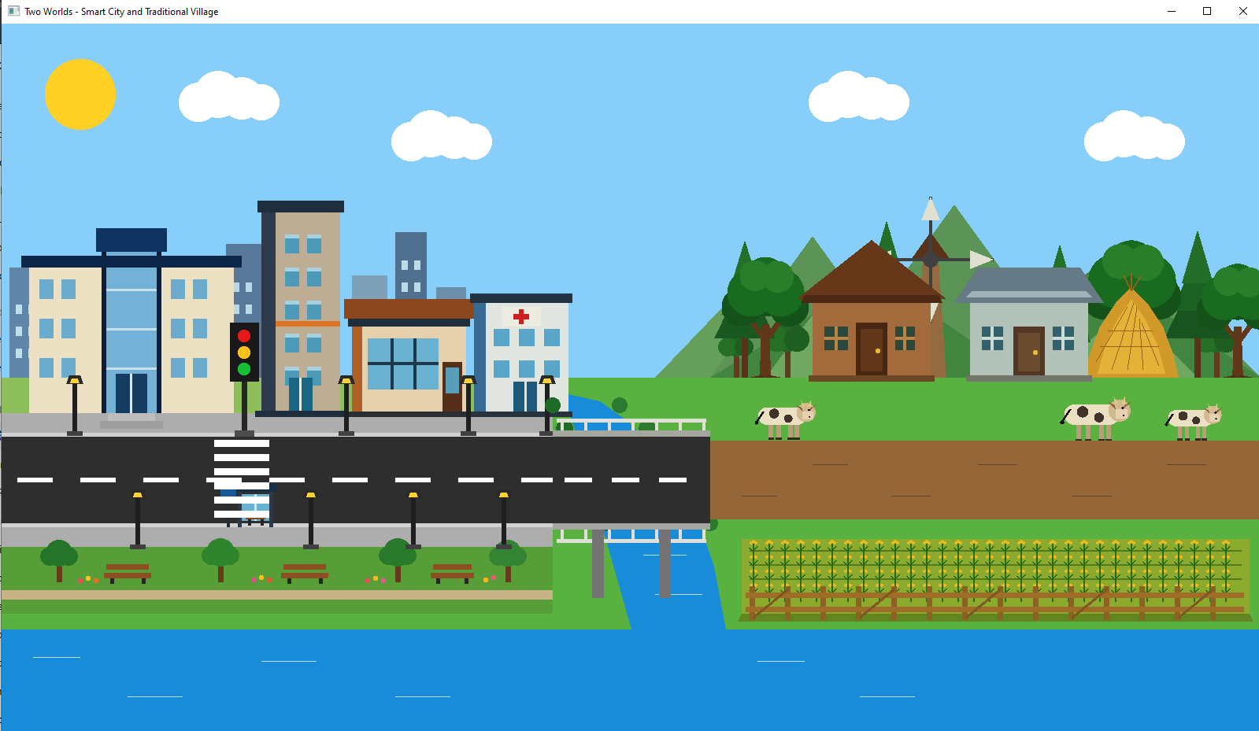
Fig. 6. Project progress at Checkpoint 07 showing the developed smart city, river and bridge transition, village background, traditional houses, windmill, village trees and cows, paddy field, bamboo fence, and hay stack.

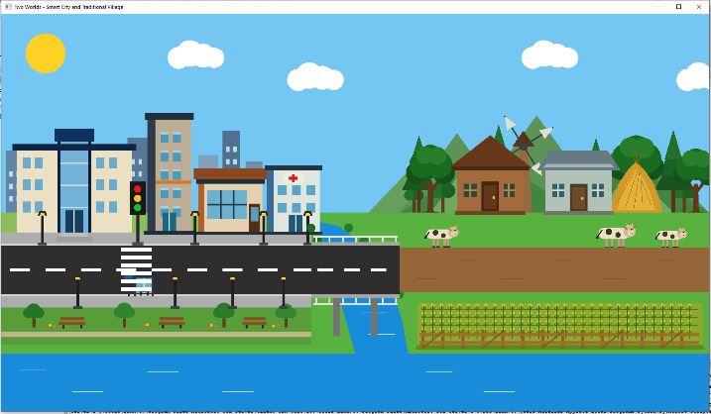 | 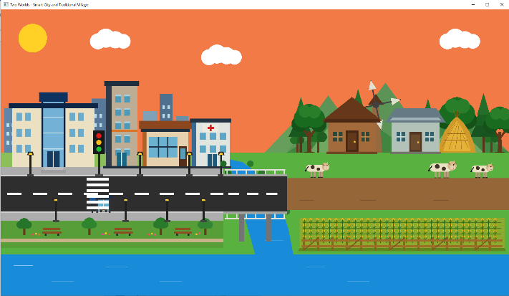
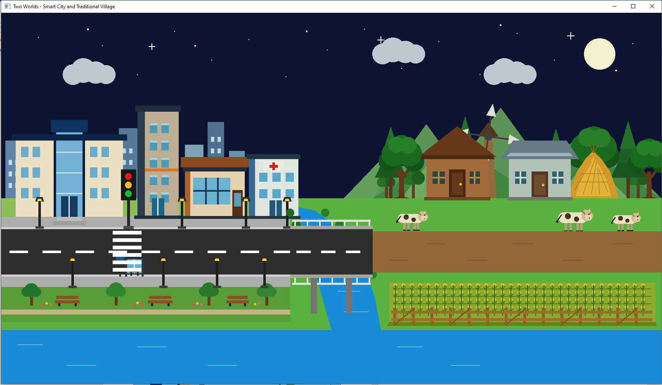 | 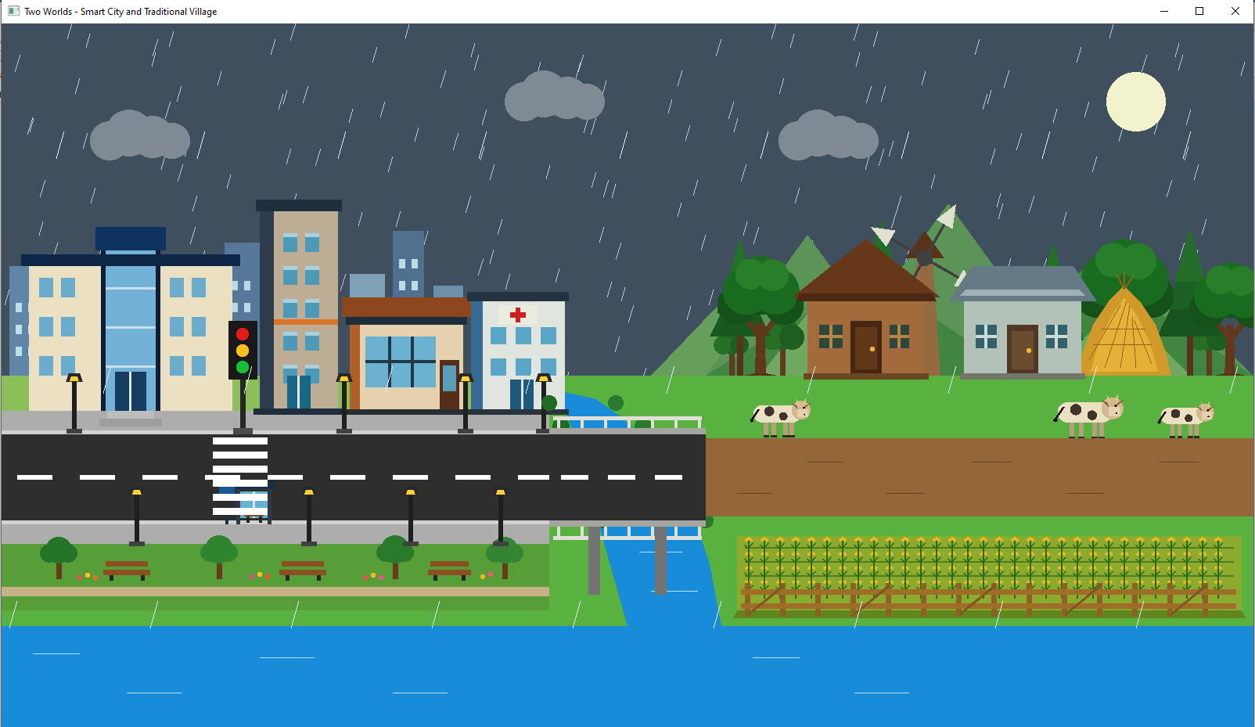
Fig. 7. Implemented interactive environmental modes showing Day, Evening, Night, and Rain scenes. The environment includes moving clouds, moon and stars in Night mode, and dark storm clouds with layered animated rainfall in Rain mode.
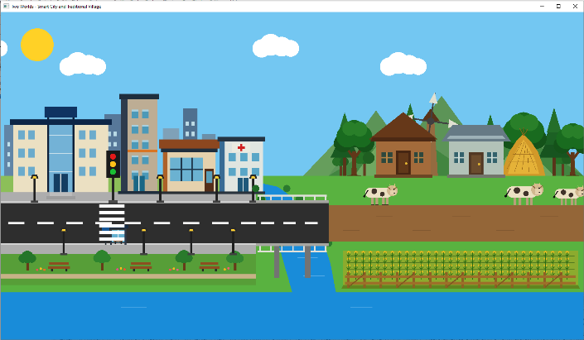 | 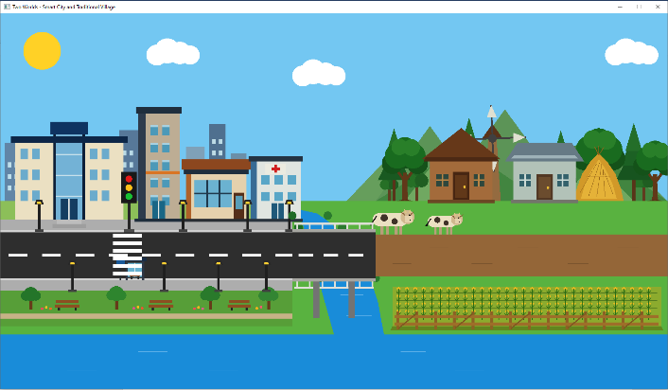
Fig. 8. Village-side object animation checkpoint showing the implemented windmill blade rotation and continuous forward movement of village cows.
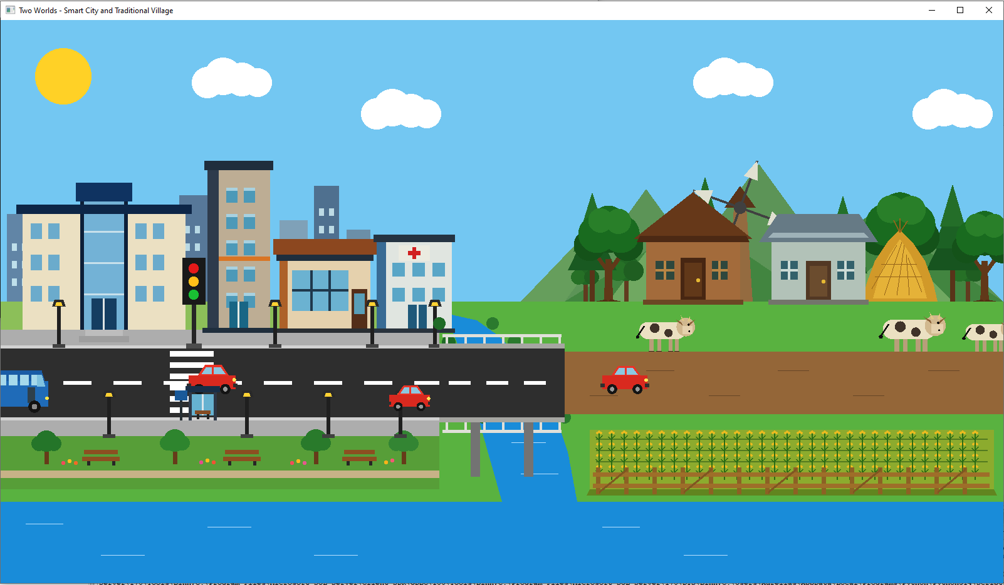 | 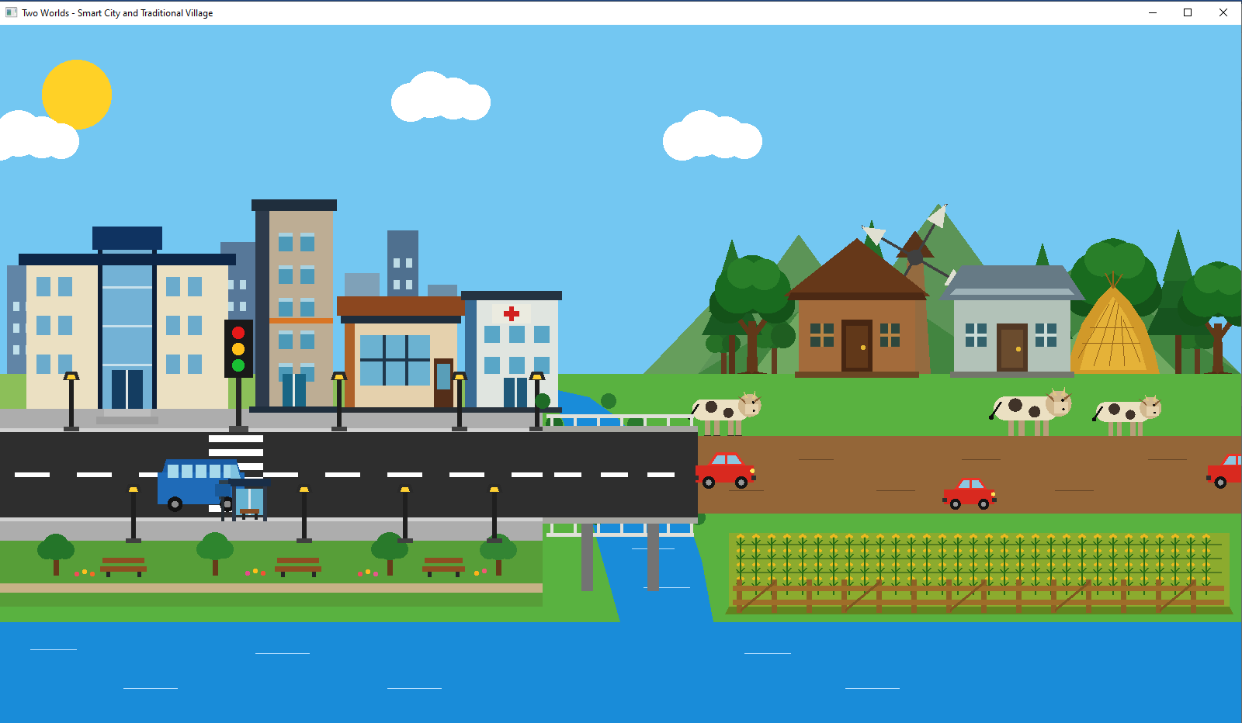
Fig. 9. Moving vehicle animation showing multiple cars and a bus travelling from the city side through the bridge toward the village environment.

