
American International University-Bangladesh (AIUB)
Department of Computer Science
Faculty of Science & Technology (FST)
PROJECT REPORT
Two Worlds: An Interactive 2D Smart City and Traditional Village Simulation Using OpenGL (GLUT)

A Computer Graphics Project Submitted
By Md. Ashikur Rahman Mirza
Semester: Summer-25-26 | Section: W | Group:08

SL | Student Name | Student ID
1 | Md. Ashikur Rahman Mirza | 24-56849-1
2 | Mahabub Alom Apon | 24-56851-1
3 | Md. Mostafizur Rahman | 24-56803-1
4 | Shahed Bhuiyan Rony | 24-56776-1
5 | Shajiya Afrin | 24-56826-1
Department of Computer Science, AIUB

TABLE OF CONTENTS
1. Introduction
2. Project Objectives
3. Project Overview and Features
4. Project Graph / Scene Design
5. List of Objects and Object IDs
6. Functions Used to Represent Objects
7. Animation and Interaction Functions
8. Work Distribution / Contribution
9. Conclusion

1. Introduction
The Two Worlds project is a 2D interactive computer graphics project created with OpenGL and GLUT using C++. In this project, we tried to present two different places in the same scene: a modern smart city and a traditional village.
The city part shows modern life through buildings, roads, vehicles, traffic signals, street lights, a hospital, a bus stop, and a city park. The village part shows rural life with village houses, trees, paddy fields, cows, a windmill, a tea stall, farming areas, and other natural elements. The two sides are connected by a bridge and road, so the city and village appear together as one environment.
We also added several animations to make the scene active. Cars, buses, boats, birds, an airplane, pedestrians, cows, and clouds can move. The windmill rotates, and water ripple animation is also included. Using keyboard controls, the scene can be changed between Day, Evening, Night, and Rain modes. These features make the environment more interactive and realistic.
The main purpose of this project is to use the basic concepts of computer graphics in one application. These include drawing 2D objects, working with colors and shapes, positioning objects, applying transformations, creating animations, and using keyboard interaction.

2. Project Objectives
The main objectives of the Two Worlds project are:
- To create a complete 2D environment where a modern smart city and a traditional village can be shown together in one scene.
- To draw different objects for the city and village using basic OpenGL primitives such as points, lines, polygons, circles, and quadrilaterals.
- To use different computer graphics concepts, including translation, rotation, scaling, coloring, and object positioning.
- To include animations for vehicles, clouds, birds, boats, cows, pedestrians, windmill rotation, paddy field movement, and river water movement.
- To add interactive Day, Evening, Night, and Rain modes that can be changed by the user through keyboard controls.
- To show the difference between modern city life and traditional village life while connecting the two environments through roads, a bridge, and the river area.
- To build a complete interactive graphics project with C++, OpenGL, and GLUT and gain practical knowledge of 2D computer graphics.

3. Project Overview and Features
SL | Feature | Brief Description
1 | Smart City Environment | Shows modern city life with buildings, a hospital, roads, traffic system, vehicles, bus stop, city park, and other urban elements.
2 | Traditional Village Environment | Shows rural life with traditional houses, paddy field, windmill, cows, farming areas, trees, tea stall, bullock cart, and other village elements.
3 | Animation and Movement | Contains different moving objects and effects such as cars, bus, clouds, cows, boats, birds, airplane, pedestrians, paddy field movement, windmill rotation, and river ripples.
4 | Day, Evening, Night and Rain Modes | Includes four environmental modes that change the look and atmosphere of the whole scene.
5 | Interactive and Connected Environment | The bridge, road, and river area connect the city and village, while keyboard controls and animated objects make the environment interactive.

4. Project Graph / Scene Design
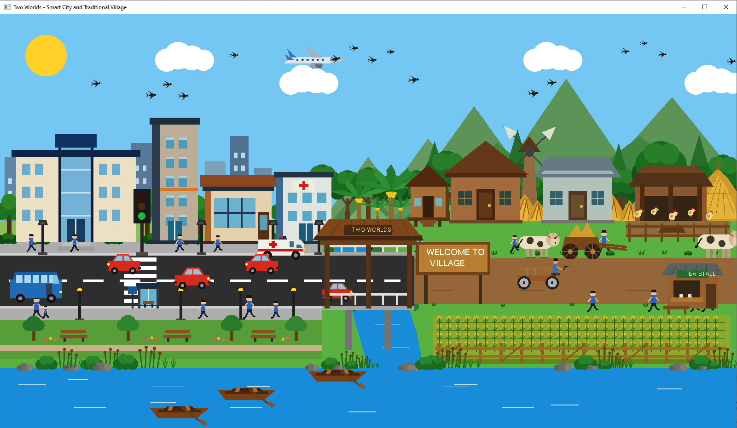  (D/d) Day Mode | 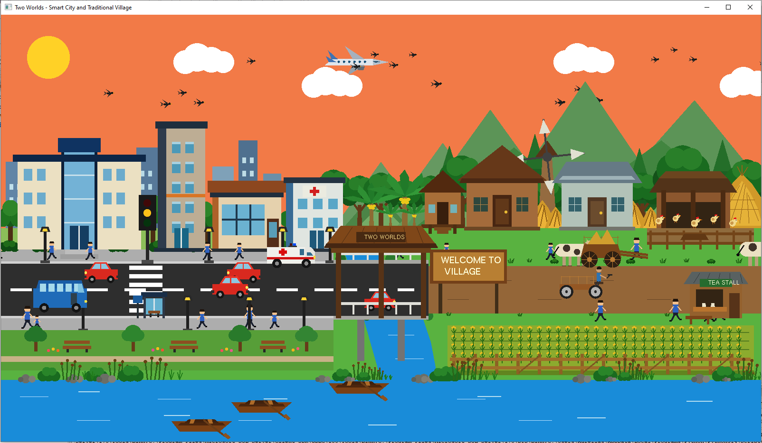  (E/e) Evening Mode
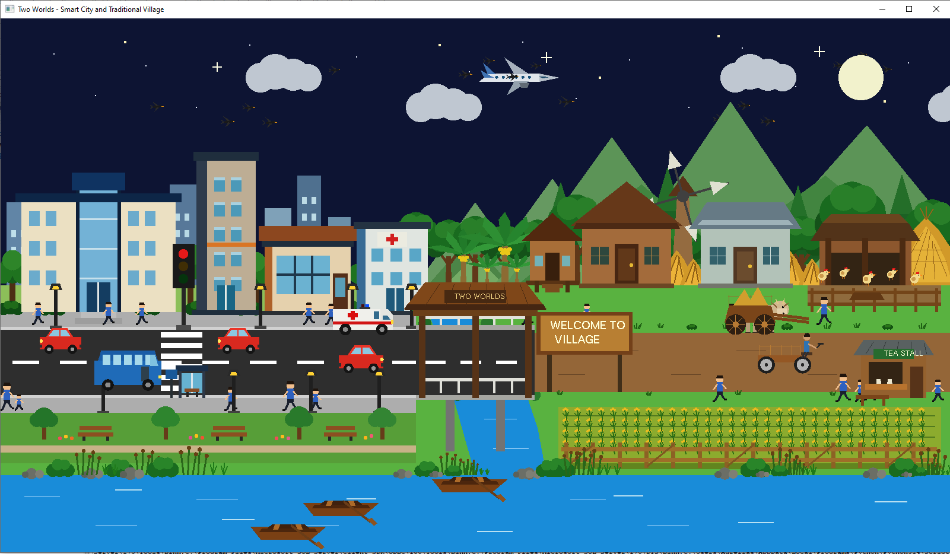  (N/n) Night Mode | 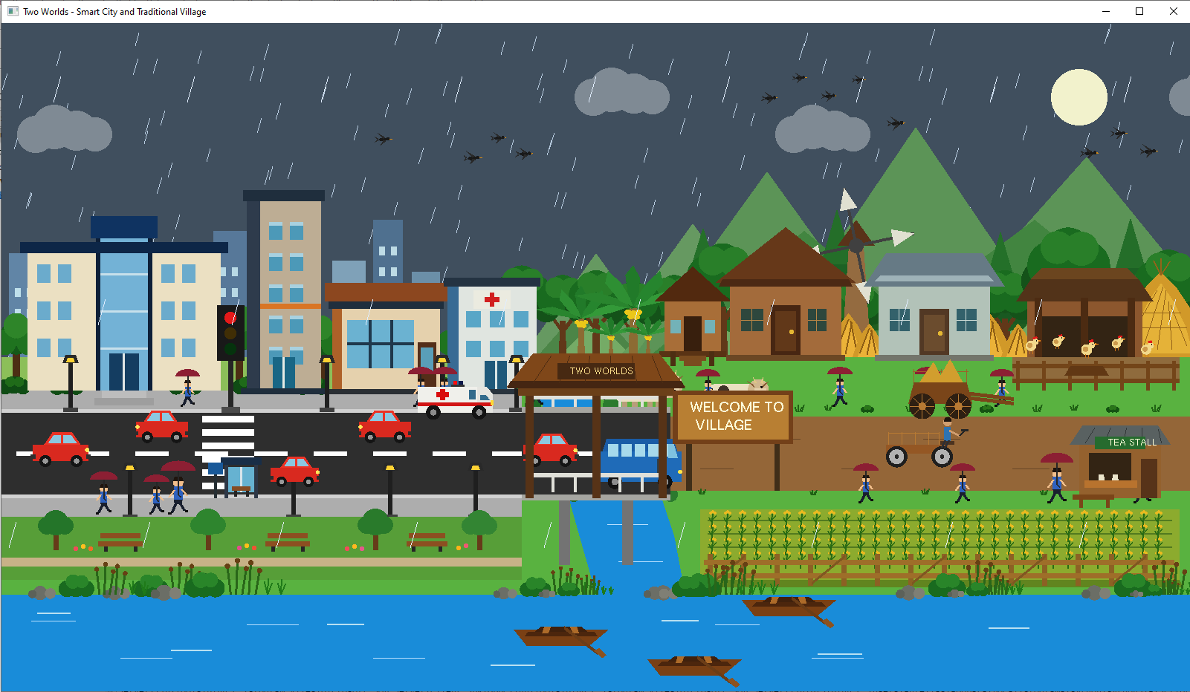  (R/r) Rainy Mode
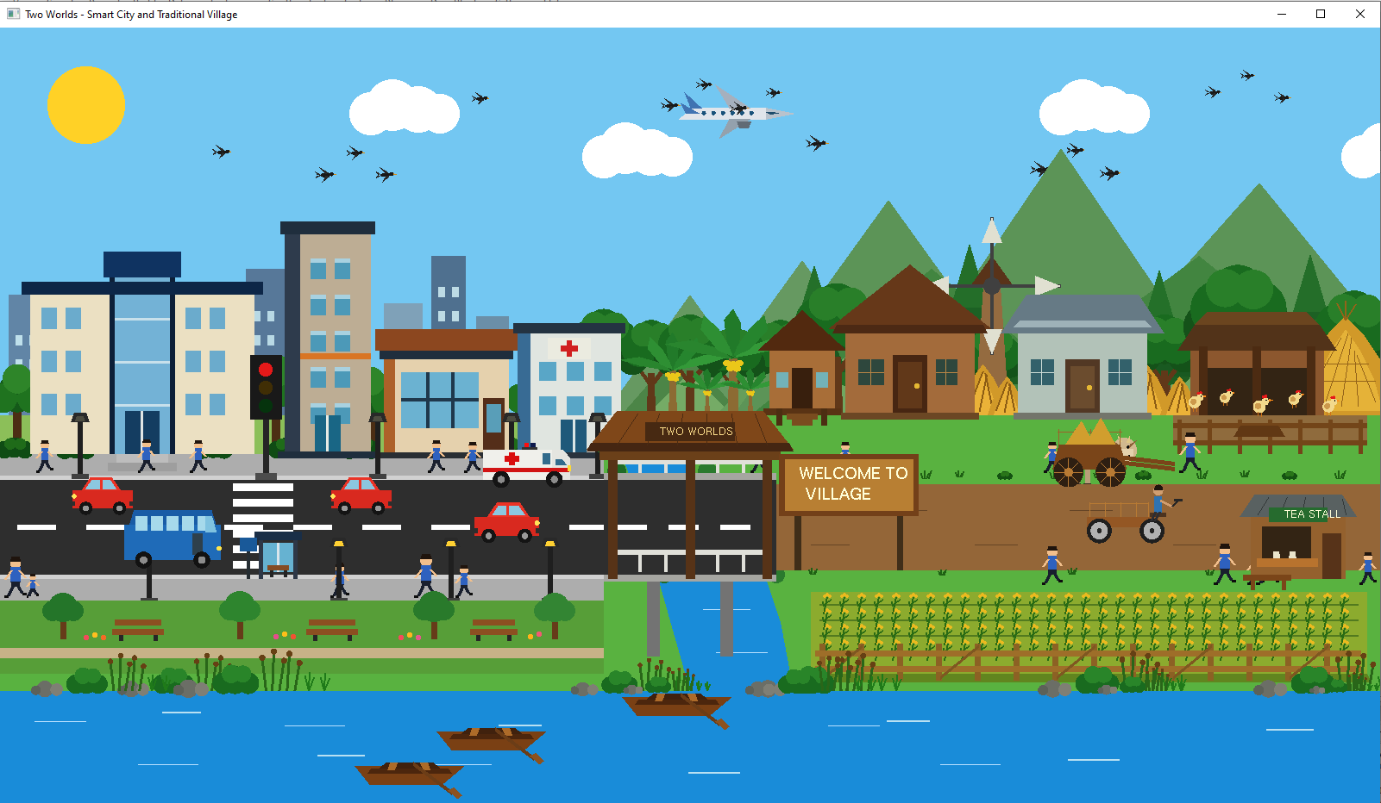
Figure 1: Complete Scene of Two Worlds Project in Different Environmental Modes:
(a) Day Mode, (b) Evening Mode, (c) Night Mode, and (d) Rain Mode.

Figure 1 presents the complete scene of the Two Worlds project in four environmental modes: Day, Evening, Night, and Rain. Each mode shows the scene under a different environmental condition. The modern smart city is shown on the left side, while the traditional village is on the right. Both sides are connected visually by the bridge, road, and river area.

4.1 Coordinate / Transformation Notes
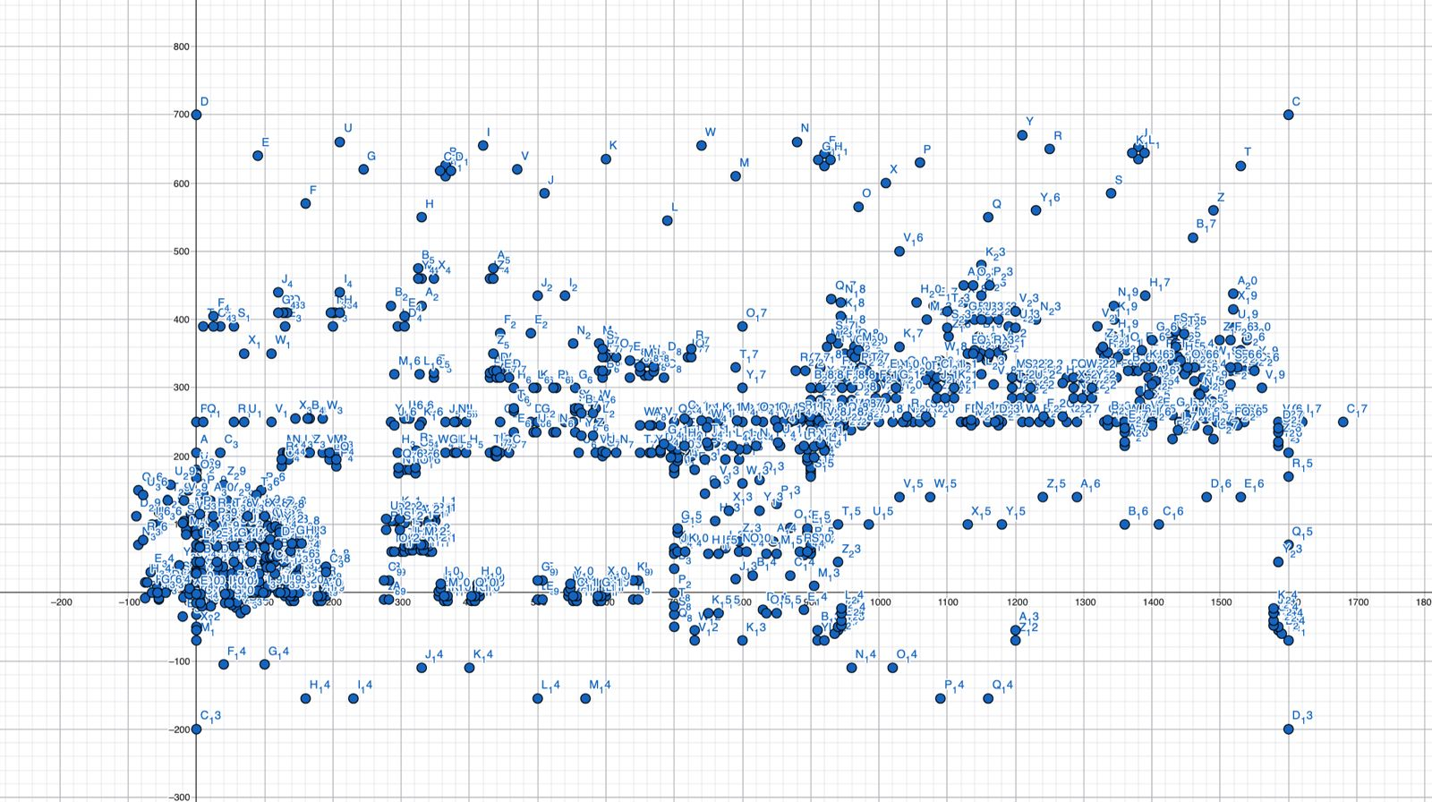
The project follows a 2D coordinate system using gluOrtho2D(0, 1600, -200, 700), and the application window is 1600 × 900 pixels. Most of the city objects are placed on the left side, while the village objects are on the right. The bridge and road connect these two parts, and the river goes across the lower area of the scene.
We used different transformations for movement and animation. Translation is used to move cars, buses, boats, birds, cows, pedestrians, and the airplane. Rotation is used for the blades of the windmill. Scaling helps us draw similar objects in different sizes and positions. GLUT timer functions continuously update the objects that have animation.

5. List of Objects and Object IDs
SL# | Object ID | Object Name | Description / Role
1 | OBJ_BASE_01 | Sky | Shows the background sky of the whole scene.
2 | OBJ_BASE_02 | Ground | Shows the main ground area of the environment.
3 | OBJ_BASE_03 | Sun | Shows the sun in the day environment.
4 | OBJ_BASE_04 | Cloud | Shows the clouds moving across the sky.
5 | OBJ_CITY_01 | City Base | Shows the main base area of the smart city.
6 | OBJ_CITY_02 | City Highway | Shows the main road where city vehicles move.
7 | OBJ_CITY_03 | Road Markings | Shows the lane markings on the city road.
8 | OBJ_CITY_04 | City Sidewalk | Shows the pedestrian sidewalk beside the city road.
9 | OBJ_CITY_05 | AIUB Academic Building | Shows an academic building in the city area.
10 | OBJ_CITY_06 | Modern High-Rise Building | Shows modern high-rise buildings in the city.
11 | OBJ_CITY_07 | Modern Food Court | Shows a modern food court in the city area.
12 | OBJ_CITY_08 | Riverfront City Park | Shows the recreational park located beside the river.
13 | OBJ_CITY_09 | Bus Stop | Shows the waiting area for public transport in the city.
14 | OBJ_CITY_10 | City Hospital | Shows the hospital building in the city area.
15 | OBJ_CITY_11 | Traffic Signal | Shows and controls the traffic lights on the city road.
16 | OBJ_CITY_12 | Zebra Crossing | Shows the crossing area for pedestrians.
17 | OBJ_CITY_13 | Street Lights | Provides lighting along the city road.
18 | OBJ_CITY_14 | City Background Trees and Bushes | Adds trees and bushes to the city background.
19 | OBJ_CITY_15 | City Car | Shows an animated car moving along the city road.
20 | OBJ_CITY_16 | City Bus | Shows an animated public bus moving in the city.
21 | OBJ_CITY_17 | City Sky Airplane | Shows an airplane moving across the sky.
22 | OBJ_CITY_18 | Hospital Ambulance | Shows an ambulance near the city hospital.
23 | OBJ_ENV_05 | River Bank | Shows the boundary area along the river.
24 | OBJ_ENV_06 | Connected Curved River | Shows the main river that connects the environments.
25 | OBJ_ENV_07 | City-Village Bridge | Connects the smart city with the traditional village.
26 | OBJ_VILLAGE_01 | Traditional Mud House | Shows a traditional mud house in the village.
27 | OBJ_VILLAGE_02 | Traditional Tin House | Shows a common tin house found in village areas.
28 | OBJ_VILLAGE_03 | Traditional Windmill | Shows a windmill with rotating blades in the village.
29 | OBJ_VILLAGE_04 | Large Village Trees | Adds large trees to the village environment.
30 | OBJ_VILLAGE_05 | Village Cows | Shows cows as part of rural village life.
31 | OBJ_VILLAGE_06 | Paddy Field | Shows the paddy field and farming area of the village.
32 | OBJ_VILLAGE_07 | Bamboo Fence | Shows traditional bamboo fencing in the village area.
33 | OBJ_VILLAGE_08 | Hay Stack | Shows stored hay in the rural environment.
34 | OBJ_VILLAGE_09 | Wooden Village House | Adds another traditional wooden house to the village.
35 | OBJ_VILLAGE_10 | Additional Village Trees | Adds more trees to the village environment.
36 | OBJ_VILLAGE_12 | Banana Tree | Shows banana plants commonly found in rural areas.
37 | OBJ_VILLAGE_13 | Small Vegetable Garden | Shows a small area used for vegetable farming.
38 | OBJ_VILLAGE_14 | Traditional Bullock Cart | Shows a traditional form of rural transportation.
39 | OBJ_VILLAGE_15 | Traditional Village Tea Stall | Shows a common tea stall in the village.
40 | OBJ_VILLAGE_16 | Natural Village Roadside Greenery | Adds grass and natural greenery along the village road.
41 | OBJ_VILLAGE_17 | Village Van with Driver | Shows a moving local van with a driver in the village.
42 | OBJ_RIVER_01 | Wooden River Boat | Shows a traditional wooden boat moving on the river.
43 | OBJ_RIVER_02 | River Bank Decoration | Adds natural elements around the river bank.
44 | OBJ_RIVER_03 | Moving River Ripples | Shows the animated movement of water in the river.
45 | OBJ_ENV_01 | Flying Birds | Shows birds flying across the scene.
46 | OBJ_ENV_08 | Village Welcome Billboard | Shows the entrance to the traditional village area.
47 | OBJ_ENV_09 | Covered Wooden Transition Bridge | Adds a covered wooden structure to the transition area.
48 | OBJ_ENV_10 | Bridge Lower White Railing | Shows the lower white safety railing of the bridge.
49 | OBJ_ENV_11 | Walking Pedestrian with Rain Umbrella | Shows pedestrians walking in the scene and using umbrellas during rain.
50 | OBJ_ENV_02 | Village Background Hills | Shows natural hills in the village background.
51 | OBJ_ENV_03 | River Side Hills | Shows natural hills beside the river between the city and village.
52 | OBJ_ENV_04 | Village Background Trees | Adds natural trees to the village background.
53 | OBJ_VILLAGE_11 | Village Pine Trees | Shows pine trees in the background of the traditional village.
54 | OBJ_VILLAGE_18 | Animal Farm | Shows a small animal farm and farm shed in the village.
55 | OBJ_VILLAGE_19 | Farm Chickens | Shows chickens in the animal farm and adds rural life to the village scene.

6. Functions Used to Represent Objects
SL# | Object ID | Object Name | Function Name | Purpose
1 | OBJ_BASE_01 | Sky | drawSky() | Draws the sky in the background.
2 | OBJ_BASE_02 | Ground | drawGround() | Draws the main ground of the scene.
3 | OBJ_BASE_03 | Sun | drawSun() | Draws the sun in the sky.
4 | OBJ_BASE_04 | Cloud | drawCloud() | Draws the clouds in the sky.
5 | OBJ_CITY_01 | City Base | drawCityBase() | Draws the main base of the city.
6 | OBJ_CITY_02 | City Highway | drawCityHighway() | Draws the main highway in the city.
7 | OBJ_CITY_03 | Road Markings | drawRoadMarkings() | Draws the markings on the city road.
8 | OBJ_CITY_04 | City Sidewalk | drawCitySidewalk() | Draws the sidewalks beside the city road.
9 | OBJ_CITY_05 | AIUB Academic Building | drawAIUBBuilding() | Draws the AIUB academic building.
10 | OBJ_CITY_06 | Modern High-Rise Building | drawHighRiseBuilding() | Draws the modern high-rise building.
11 | OBJ_CITY_07 | Modern Food Court | drawFoodCourt() | Draws the food court in the city.
12 | OBJ_CITY_08 | Riverfront City Park | drawCityPark() | Draws the city park beside the river.
13 | OBJ_CITY_09 | Bus Stop | drawBusStop() | Draws the bus stop in the city.
14 | OBJ_CITY_10 | City Hospital | drawHospital() | Draws the hospital building.
15 | OBJ_CITY_11 | Traffic Signal | drawTrafficSignal() | Draws the traffic signal on the city road.
16 | OBJ_CITY_12 | Zebra Crossing | drawZebraCrossing() | Draws the zebra crossing for pedestrians.
17 | OBJ_CITY_13 | Street Lights | drawStreetLights() | Draws the street lights beside the road.
18 | OBJ_CITY_14 | City Background Trees and Bushes | drawCityBackgroundTree() / drawCityBackgroundBush() | Draws trees and bushes in the city background.
19 | OBJ_CITY_15 | City Car | drawCityCar() | Draws the moving car in the city.
20 | OBJ_CITY_16 | City Bus | drawCityBus() | Draws the moving bus in the city.
21 | OBJ_CITY_17 | City Sky Airplane | drawAirplane() | Draws the airplane moving in the city sky.
22 | OBJ_CITY_18 | Hospital Ambulance | drawAmbulance() | Draws the ambulance near the hospital.
23 | OBJ_ENV_05 | River Bank | drawRiverBank() | Draws the area along the river bank.
24 | OBJ_ENV_06 | Connected Curved River | drawRiver() | Draws the main river in the scene.
25 | OBJ_ENV_07 | City-Village Bridge | drawBridge() | Draws the bridge that connects the city and village.
26 | OBJ_VILLAGE_01 | Traditional Mud House | drawMudHouse() | Draws the traditional mud house in the village.
27 | OBJ_VILLAGE_02 | Traditional Tin House | drawTinHouse() | Draws the traditional tin house in the village.
28 | OBJ_VILLAGE_03 | Traditional Windmill | drawWindmill() | Draws the windmill in the village.
29 | OBJ_VILLAGE_04 | Large Village Trees | drawLargeVillageTrees() | Draws large trees in the village area.
30 | OBJ_VILLAGE_05 | Village Cows | drawVillageCows() | Draws the cows in the village.
31 | OBJ_VILLAGE_06 | Paddy Field | drawPaddyField() | Draws the paddy field in the village.
32 | OBJ_VILLAGE_07 | Bamboo Fence | drawBambooFence() | Draws the bamboo fence in the village.
33 | OBJ_VILLAGE_08 | Hay Stack | drawHayStack() | Draws the hay stack in the village.
34 | OBJ_VILLAGE_09 | Wooden Village House | drawWoodenVillageHouse() | Draws the wooden house in the village.
35 | OBJ_VILLAGE_10 | Additional Village Trees | drawAdditionalVillageTrees() | Draws additional trees in the village.
36 | OBJ_VILLAGE_12 | Banana Tree | drawBananaTree() | Draws banana trees in the village area.
37 | OBJ_VILLAGE_13 | Small Vegetable Garden | drawVegetableGarden() | Draws a small vegetable garden in the village.
38 | OBJ_VILLAGE_14 | Traditional Bullock Cart | drawBullockCart() | Draws the traditional bullock cart.
39 | OBJ_VILLAGE_15 | Traditional Village Tea Stall | drawVillageTeaStall() | Draws the traditional tea stall in the village.
40 | OBJ_VILLAGE_16 | Natural Village Roadside Greenery | drawVillageGrass() / drawVillageLowShrub() | Draws grass and shrubs beside the village road.
41 | OBJ_VILLAGE_17 | Village Van with Driver | drawVillageVanDriver() | Draws the village van with its driver.
42 | OBJ_RIVER_01 | Wooden River Boat | drawWoodenBoat() | Draws the wooden boat on the river.
43 | OBJ_RIVER_02 | River Bank Decoration | drawRiverBankDecoration() | Draws natural decorations beside the river.
44 | OBJ_RIVER_03 | Moving River Ripples | drawRiverRipples() | Draws the moving ripple effects on the river.
45 | OBJ_ENV_01 | Flying Birds | drawBirds() | Draws the birds flying across the scene.
46 | OBJ_ENV_08 | Village Welcome Billboard | drawVillageWelcomeBoard() | Draws the welcome board at the village entrance.
47 | OBJ_ENV_09 | Covered Wooden Transition Bridge | drawBridgeCanopy() | Draws the covered wooden structure over the transition bridge.
48 | OBJ_ENV_10 | Bridge Lower White Railing | drawBridgeLowerRailing() | Draws the lower white railing of the bridge.
49 | OBJ_ENV_11 | Walking Pedestrian with Rain Umbrella | drawWalkingPerson() | Draws pedestrians walking through the road environment.
50 | OBJ_ENV_02 | Village Background Hills | drawVillageHills() | Draws natural hills in the village background.
51 | OBJ_ENV_03 | River Side Hills | drawRiverSideHills() | Draws hills beside the river between the city and village.
52 | OBJ_ENV_04 | Village Background Trees | drawVillageBackgroundTrees() | Draws trees in the background of the village.
53 | OBJ_VILLAGE_11 | Village Pine Trees | drawVillagePineTrees() | Draws pine trees in the village background.
54 | OBJ_VILLAGE_18 | Animal Farm | drawAnimalFarm() | Draws the animal farm and farm shed in the village.
55 | OBJ_VILLAGE_19 | Farm Chickens | drawFarmChickens() | Draws chickens inside the village animal farm.

7. Animation and Interaction Functions
SL# | Function ID | Function Name | Object / Scene | Trigger | Brief Description
1 | FUNC_ANIM_01 | Cloud Movement Animation | Clouds | GLUT Timer | Moves the clouds continuously across the sky.
2 | FUNC_ANIM_02 | Rain Animation | Rain Scene | GLUT Timer | Changes the rain positions continuously to show rainfall.
3 | FUNC_ANIM_03 | Windmill Rotation | Windmill | GLUT Timer | Rotates the windmill blades continuously.
4 | FUNC_ANIM_04 | Cow Forward Movement | Village Cows | GLUT Timer | Moves the cows forward through the village area.
5 | FUNC_ANIM_05 | City Car Movement | City Car | GLUT Timer | Moves the city car along the road and restarts it after it leaves the area.
6 | FUNC_ANIM_06 | City Bus Movement | City Bus | GLUT Timer | Moves the city bus continuously through the scene.
7 | FUNC_ANIM_07 | Traffic Signal Animation | Traffic Signal | GLUT Timer | Changes the traffic signal between different light states.
8 | FUNC_ANIM_08 | Paddy Field Sway Animation | Paddy Field | GLUT Timer | Moves the paddy field back and forth to create a swaying effect.
9 | FUNC_ANIM_09 | River Boat Movement | Wooden River Boat | GLUT Timer | Moves the boats continuously along the river.
10 | FUNC_ANIM_10 | Flying Birds Movement | Flying Birds | GLUT Timer | Moves the birds continuously across the sky.
11 | FUNC_ANIM_11 | Airplane Movement | City Sky Airplane | GLUT Timer | Moves the airplane across the sky and restarts it after it crosses the scene.
12 | FUNC_ANIM_12 | Ambulance Emergency Light | Hospital Ambulance | GLUT Timer | Turns the ambulance emergency light on and off repeatedly.
13 | FUNC_ANIM_13 | City Car to Village Van Transition | Transition Vehicle | GLUT Timer | Controls the vehicle movement during the city to village transition.
14 | FUNC_ANIM_14 | Reverse City Car Movement | Reverse City Car | GLUT Timer | Moves a city car in the opposite direction on the road.
15 | FUNC_ANIM_15 | Bidirectional Pedestrian Movement | Pedestrians | GLUT Timer | Moves pedestrians from left to right and right to left.
16 | FUNC_ANIM_16 | River Ripple Movement | River Ripples | GLUT Timer | Moves the river ripples to show flowing water.
17 | FUNC_INT_01 | Day Evening Night Control | Complete Scene | Keyboard D / E / N / R | Changes the whole scene between Day, Evening, Night, and Rain modes.
18 | FUNC_TRANS_01 | Two Worlds Vehicle Transformation | City-Village Transition | Scene Movement | Draws the vehicle transformation between the city and village environments.

8. Work Distribution / Contribution
SL | Member Name | Student ID | Implemented Functions / Objects | Animation / Interaction Work | Contribution (%)
1 | Md. Ashikur Rahman Mirza | 24-56849-1 | Sky, Ground, Sun, Cloud, City Base, City Highway, Road Markings, City Sidewalk, AIUB Academic Building, River Bank, Connected River, Wooden Village House, Village Background Hills, River Side Hills, Village Background Trees, Village Pine Trees, Animal Farm, Farm Chickens, Village Welcome Billboard, River Bank Decoration | Cloud Movement, Rain Animation, Day/Evening/Night/Rain Keyboard Control | 20%
2 | Mahabub Alom Apon | 24-56851-1 | Modern High-Rise Building, Modern Food Court, Riverfront City Park, Bus Stop, City Car, City Bus, Banana Tree, Hospital Ambulance | City Car Movement, City Bus Movement, Flying Birds Movement, City-Car-to-Village-Van Transition, Reverse City Car Movement, Vehicle Transformation | 20%
3 | Md. Mostafizur Rahman | 24-56803-1 | City Hospital, City-Village Bridge, Traffic Signal, Zebra Crossing, Street Lights, Additional Village Trees, Wooden River Boat, City Sky Airplane, Covered Wooden Transition Bridge, Bridge Lower White Railing, Walking Pedestrian | Traffic Signal Animation, Ambulance Emergency Light, Bidirectional Pedestrian Movement | 20%
4 | Shahed Bhuiyan Rony | 24-56776-1 | Traditional Mud House, Traditional Tin House, Traditional Windmill, Large Village Trees, Village Cows, Small Vegetable Garden, Traditional Village Tea Stall, Natural Village Roadside Greenery | Windmill Rotation, Cow Forward Movement, Airplane Movement | 20%
5 | Shajiya Afrin | 24-56826-1 | Paddy Field, Bamboo Fence, Hay Stack, Flying Birds, Traditional Bullock Cart, Village Van with Driver, City Background Trees and Bushes, Moving River Ripples | Paddy Field Sway Animation, River Boat Movement, River Ripple Movement | 20%

9. Conclusion
The Two Worlds project presents an interactive 2D environment where a modern smart city and a traditional village are shown together in one scene. We developed the project using C++, OpenGL, and GLUT. During the development, we used different computer graphics concepts such as drawing 2D objects, using colors, positioning objects, translation, rotation, scaling, animation, and keyboard interaction.
The final scene includes different objects from both city and village life. These include buildings, roads, vehicles, a hospital, traffic signals, a bridge, traditional houses, trees, paddy fields, cows, a windmill, farming areas, boats, and other environmental objects. We also added animations for cars, buses, cows, birds, boats, pedestrians, an airplane, the windmill, paddy fields, and river ripples. The user can also change the environment using the Day, Evening, Night, and Rain modes.
One limitation is that the project is a 2D simulation, so the objects and their movements cannot look as realistic as they would in a 3D environment. In the future, more user interactions, smoother animations, extra environmental effects, sound effects, and more detailed objects can be added. The project can also be developed as a 3D version to show city and village life in a more realistic way.

(D/d) Day Mode
(E/e) Evening Mode

(N/n) Night Mode
(R/r) Rainy Mode

Figure 2: Final Output of the Two Worlds Interactive 2D Smart City and Traditional Village Simulation

