**CHAPTER 1**

**INTRODUCTION**

**1.1 Introduction**

E-Learning provides many benefits over conventional learning. First, it allows students to save money since students do not have to spend on learning materials. Second, it will enable students to learn at their own pace and collaborate with students and resources from different parts of the world. Moreover, research shows that e-learning takes 40% to 60% less time than traditional learning. That's because everything is provided for the student. Alternatively, instructors can use various platforms for courses online. All it needs is to select the right platform to provide the best learning experience for students. Although creating an educational platform's interface is challenging, it is essential for fulfilling the objectives of educational activities. Every time a course participant engages with an educational platform, they learn more and move one step closer to their goal. This modest advancement was made possible by the educational resource's designers and the teachers who supplied it with instructional materials. The basic objective of systems for electronic learning (SEL) is to successfully support trainees in their educational activity by delivering knowledge, sharing information, and doing so using cutting-edge information technology. The effectiveness of SEL hinges on the application of the fundamental usability principles. The success criteria for evaluation can be. E-learning UX design will address a student’s complete experience with their online learning modules. This includes ensuring that they stay engaged with their lesson and are compelled to participate in exercises [1].

For e-learning, student engagement can be tricky, but the best e-learning has simplified it for students to learn more about learner engagement. Surely, I want to provide the best solution for students. However, considering the platform's UX/ UI, we can only do that. User Experience (UX) deals with how a student interacts with an eLearning platform. Do they find it easy to navigate? Can they skip the lessons they want to study? [2] On the other hand, User Interface (UI) deals with how the platform looks and feels. This can make or break how immersive your online course is. Without an intuitive UI, we cannot expect our students to feel interested in using the platform. Hence, this can also impact where and how you sell online courses.

**1.2 Objective**

The most important component of an eLearning course is relevant material. An eLearning course should be understandable, and interesting rather than extensive and tedious. The quality and value of an eLearning course depend on its content. What does e-learning require? Students can develop and communicate new ideas with the aid of online learning. We can expand our knowledge and abilities outside of the classroom. One of the key benefits of e-learning is that it aids in the development of advanced abilities in both students and teachers. The scarcity of teachers and consistency in giving reliable training, these problems will be resolved through learning. Teachers may deliver their lectures more thoroughly and consistently online, ensuring that every student learns the same information [3]. increasing the UI/UX of the e-studying program through the student's point of view is to create a user-undefined pleasant and easy-to-use user interface that makes it easier for pupils to gain access to and communicate with the platform's features. This would include making the navigation simpler, enhancing the aesthetic design and style, which include more powerful and engaging content material, and employing opinions from pupils to ensure the platform fulfills their demands.

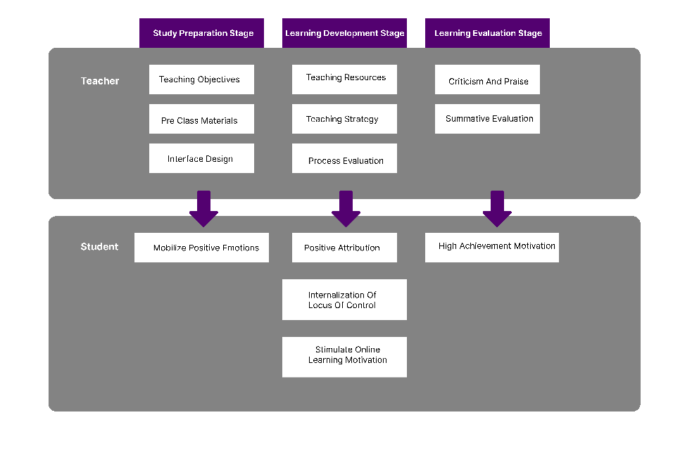

Figure: 1.1 The online learning motivation model [4]

**1.3 Motivation**

The inspiration for enhancing the UI/UX of your e-discovering platform through the students' factor is based on the desire to boost the overall chance to learn for students. A properly-designed platform can provide a much more interesting and entertaining studying setting, resulting in increased retention and enthusiasm for students. Additionally, an available platform may be used by way of a broader range of students, which includes those that have handicaps, and will give increased efficiency and adaptability for those pupils. Additionally, a user-pleasant platform may help students understand training course substance more effectively, permitting them to complete their scientific studies within a quicker amount of time. Eventually, improving the UI/UX of an e-learning foundation through the students' aspect can greatly benefit the pupils along with the program by itself Boosted chance to learn: A nicely-made e-learning program can offer a far more interesting and exciting learning experience for students. Increased retention and inspiration: An excellent UI/UX can help continue to keep students inspired and focused entirely on their reports, ultimately causing greater retention of real information. Enhanced ease of access: An available e-discovering foundation may be used by a broader variety of students, such as those with disabilities. Improved convenience: A user-pleasant program can make it less difficult for students to get into study course supplies and finish tasks, resulting in greater ease and flexibility. Better effectiveness: A highly-made foundation can help students browse through the course material better, letting them complete their studies in a shorter l, boosting the UI/UX of any e-studying foundation from the students' component could have numerous advantages for both the students as well as the foundation by itself.

**1.4 UI/UX for e-learning platform in Bangladesh**

As outlined by current figures, Bangladesh currently includes a literacy level of 78%. Scientific studies suggest that stuff will degrade if education and learning proceed at this rate. To reach a basic degree of literacy in Bangladesh will take another 44 several years, and obtaining an advanced degree will require 78 yrs. In Bangladesh, good quality schooling has long been a difficulty. Almost 25 Percent (approx.) of men and women will still be illiterate, several the primary reasons for this being kid labor, youngster relationship, and the higher growth price from the population gifted teachers are in great provide in many downtown areas, but there aren’t enough tasks, whilst, in metropolitan places, there is a severe deficiency of good quality professors. Aside from the troubles encountered in employing and retaining high-quality teachers, the absence of scientific facilities has played a crucial role in not dispensing good quality education to youngsters residing in outlying locations. When the pandemic struck, Bangladesh found educational facilities the two open public and individual – to transfer their educational routines online. But this was uncharted waters for many companies and their educators, who would need to carry out these lessons. Despite the little ray of certainty offered by the vaccine for Covid-19, educational facilities remain shut. Students and instructors are still battling with online workload calls, even after a year [5] Since its inception, UX design has received a lot of criticism. People believed that their user experience wouldn't make a significant difference. They weren't entirely wrong, though, at the time. Most earlier internet applications were static and simple. Therefore, it didn't seem like a very critical issue to try to specialize in user knowledge. However, since then, online programs have produced a lengthy method. Today's internet applications have improved, growing more dynamic and complex. The quality of users will improve as a result. Therefore, there is a significant need to consider user expertise. As of March 2020, sixty-two percent of the world's population used the internet, according to net World figures [6,7]

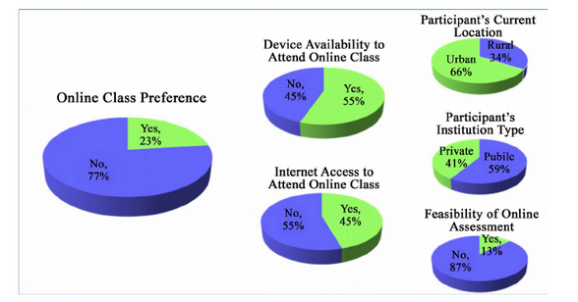

Figure: 1:2 Current scenario of Bangladesh student’s enrolment in an online class [8]

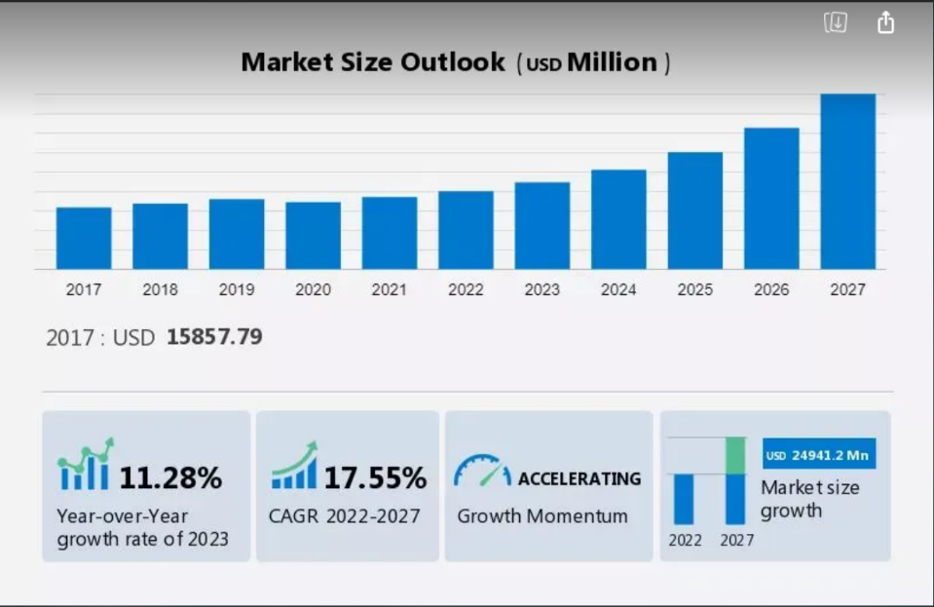

Figure: 1.3 Future Growth E-learning market growth including Bangladesh [9]

**1.5 Expected Outcome**

The outcome of this research paper would have been a complete document on the current state of the e-learning platform's user interface and user experience, along with a set of functional strategies for creating improvements. This may incorporate producing modifications to the platform's graphical layout to streamline the navigation and increase the general user-usability of the program from your student's viewpoint.

**1.6 Report Layout**

Chapter 1 introduction: This chapter provides an overview of the research topic and objectives and sets the context for the rest of the report. It includes a brief description of the problem being addressed and the purpose of the study.

Chapter 2 background: This chapter provides relevant background information on the topic, including a review of previous research, theories, and relevant literature. This section is used to establish the significance of the study and provide context for the research question.

Chapter 3 research methodology: This chapter describes the research design, including the methods used to collect and analyze data. It also includes a description of the sample population and any ethical considerations.

Chapter 4 result and analysis: This chapter presents the results of the research, including tables and figures, as well as a detailed interpretation of the results. It should provide a clear and concise summary of the main findings and conclusions that can be drawn from the research.

Chapter 5 impact on society, environment, and sustainability: This chapter discusses the impact of the research findings on society, the environment, and sustainability. It should discuss the implications and potential benefits of the research and its potential impact on the study area.

Chapter 6 limitation, conclusion, and future work: This chapter addresses the limitations of the research and presents the conclusions that can be drawn from the research. It also provides suggestions for future research and areas for improvement.

**CHAPTER 2**

**BACKGROUND**

**2.1 Introduction**

The usage of e-understanding platforms has transformed just how students and educators interact. E-understanding platforms make it possible for students to gain access to discovering supplies, instructional solutions, and communications because of their teachers and friends. Despite the excellent advancements in technologies, customer encounters, and programs still remain substandard in lots of e-understanding platforms.

The goal of this research would be to explore the possibility of enhancing the interface and customer practical experience of the e-learning system from the student’s standpoint. We are going to examine pre-existing literature on the subject, talk about the difficulties faced by individuals when asking use of e-learning websites, and examine the possible answers to increase the UI/UX of e-learning platforms. This thesis pieces of paper strive to explore the existing UI/UX of e-understanding websites through the standpoint of your students and provide tips concerning how to enhance the UI/UX from the e-understanding platform in order to really make it much more consumer-undefined war and friendly and fascinating [10].

**2.2 Related works**

User Interface Design and style (UID) has an important role in the accomplishment or breakdown of software. To make a prosperous e-studying atmosphere, there are many parts that really must be considered. Stimulus, conversation program, informal design, brokers, learner management atmosphere, colors, and background songs must be used in the presentation. Functioning recollection must not be soaked with unneeded information, and both listening to and aesthetic channels must be thought about when you use media information and facts. The Consumer Program (UI) must not you should be considered an imaginative occurrence, but ought to be appropriate for academic and mental health problems. Studies suggest that numerous dropouts in e-discovering take place because of the UI of the software, as a result, the connection between the UI and dropouts needs to be analyzed.[11].

E-learning is really a distance learning system that offers tailored study courses to the needs of learners. Mixed e-education and learning are undoubtedly included surroundings that mix classic schoolroom teaching with the main advantages of e-discovering. Bad consumer interfaces are a key factor in why computers and e-discovering methods will not be commonly used. Planning apps that are simple to use can be a difficult project. If consumer demands are certainly not properly thought about, e-understanding will not be as successful [12]. Consumer Experience (UX) is an analysis area that studies how users communicate with something, method, or service and the way this impacts their sensations, behaviors, and expectations. UX study examines the useful, experiential, powerful, purposeful, and beneficial areas of human being-personal computer discussion. In addition, it features a person’s perceptions of utility, convenience, pleasure, and efficiency. UX is subjective, however, it is also active and alterations with time-based on person method use as well as other contexts useful. Elements like the simplicity of use, mobility, robustness, info structures, visual effects, content material technique, utility and performance, and convenience can all affect UX [13]. UX study community has performed reports on different domains and in numerous contexts useful. Some examples are entertaining amusement systems [14].

Scalability refers to an understanding user’s expertise and capacity to still function optimally when its dimensions, volume level, or even the requirements put on it change. To put it differently, e-learning scalability depends on how effectively our eLearning program can support a lot more individuals and courses. E-learning that satisfies our scalability requirements will make it possible for us to Undertake extra individuals without sacrificing overall performance and Adapt to larger quantities of details and increasingly complex admin needs Increase training course catalog, promoting the continuous inclusion of lessons, quizzes, videos, and another resource Permit students to interact simultaneously on the webpage without overloading the device Assistance with each of the users’ needs and features for students’ desire to supply the best chance to learn.[17]

Here is an example of some of the most e-learning platforms.

Example:

1.10 Minutes School

this app currently has a UI that is puzzling and messy, rendering it hard for pupils to navigate and find the data they need. To deal with this problem, a complete user analysis should be executed to collect opinions about the existing app style and identify soreness factors. In line with the study discoveries, the navigation food selection must be simplified by grouping related characteristics together and eliminating needless possibilities. Additionally, obvious and constant markings for control keys and links should be used to enhance user-friendliness. Graphic cues for example symbols can be used to help consumers quickly identify and access crucial functions. The up-to-date design and style need to be tested using a modest number of customers to collect responses and then make further enhancements. The method must not finish on this page, and it ought to be continuously watched and responses should be collected from customers to make certain the changes produced possess a good effect on an individual experience.

2. Shikho

The Shikho app currently includes an interface that is complicated and difficult to understand, rendering it difficult for end users to get the information they require. To handle this challenge, an intensive customer analysis must be executed to get comments on the recent app design and recognize soreness details. Based on the analysis results, the menu food list should be simplified by grouping associated functions together and eliminating unneeded alternatives. In addition, very clear and consistent markings for control keys and backlinks should be utilized to improve user-friendliness. Visible cues for example symbols and color-computer programming can also be hired to aid end users in quickly identifying and entering essential characteristics. A clear hierarchy ought to be set up for that app's information, which makes it easy for customers to learn the circulation of knowledge. The up-to-date style needs to be tested using a modest group of end users to collect feedback and make additional enhancements. The procedure should never finish in this article, and it must be continuously monitored comments should be obtained from customers to ensure the alterations created have got an optimistic effect on an individual practical experience.

3. Ostad

The Ostad app carries a user interface that is certainly complicated and hard for users to browse through, making it difficult for end users to get the details and features they require. To address this challenge, a thorough end-user analysis should be executed to gather feedback on the recent app style and establish discomfort things. In line with the investigation findings, the navigation menus need to be simplified by grouping connected features together and removing needless possibilities. Navigation must be easy-to-use and easy to use. Obvious and regular labeling for switches and backlinks should be utilized to enhance user-friendliness. Visual cues including icons and color programming can even be employed to assist consumers quickly establishing and accessibility essential functions. A definite hierarchy needs to be set up for that app's content material so that it is easier for users to know the movement of knowledge. The up-to-date design must be tested by having a tiny selection of end users to collect feedback making further upgrades. This process must not conclusion here, and it ought to be continuously monitored feedback ought to be collected from users to ensure the adjustments made using an optimistic influence on an individual practical experience.

4. udemy



The Udemy system features a user interface that can be confusing and frustrating for consumers, rendering it challenging to allow them to locate and gain access to the lessons they require. To deal with this concern, a comprehensive user investigation should be performed to gather responses about the current design and style and establish soreness factors. In line with the research findings, the menu food selection ought to be simplified by grouping relevant characteristics together and getting rid of needless options. The look-for and filtering possibilities need to be better making it less difficult for end users to get the programs they are curious about. The program attaining web pages should be designed in a way that clearly communicates the program content material along with its benefit. In addition, the platform's aesthetic layout must be current to enhance the entire cosmetic making the program more visually pleasing. The up-to-date design and style should be evaluated by using a little selection of customers to gather opinions making further enhancements. The process should not finish in this article, and it must be continuously monitored opinions ought to be gathered from end users to ensure the alterations manufactured to have an optimistic influence on the consumer encounter.

5. Skillshare

The Skillshare features a UI that is confusing and hard to navigate, which makes it challenging for users to locate and access the courses they want. To address this issue, a thorough end-user study needs to be performed to get responses in the present style and recognize discomfort points. Based on the research findings, the navigation menus should be simplified by grouping associated functions together and removing unnecessary alternatives. The look for and filtering alternatives must be enhanced so it will be easier for consumers to find the classes they are curious about. The study course obtaining webpages should be created in ways that clearly communicate the study course content material along with its value. The foundation should likewise consider adding personalization characteristics for instance a 'recommendation' portion or possibly a 'continue watching' section to further improve the person’s expertise. Moreover, the platform's graphic design needs to be up to date to enhance the complete aesthetic making the program a lot more visually appealing. The up-to-date style needs to be examined using a modest number of users to collect feedback and then make further changes. The method must not finish here, and it needs to be continuously monitored feedback ought to be gathered from consumers to ensure the alterations created possess a good effect on an individual practical experience.

6. LinkedIn Learning

The LinkedIn learning platform has an interface that may be complicated and mind-boggling for users, making it challenging for them to get and access the programs that they need. To deal with this problem, a complete user investigation must be executed to assemble feedback around the current design and identify ache details. In line with the analysis discoveries, the menu food list needs to be simplified by grouping connected characteristics together and getting rid of needless choices. The lookup and filtering possibilities need to be improved to really make it simpler for users to obtain the programs they are interested in. The training course obtaining pages should be developed in a way that clearly communicates the training course content, and its benefit, along with the instructor info. Additionally, the platform's visible design and style should be current to improve the overall cosmetic making the foundation a lot more visually pleasing. The updated layout needs to be tested with a little selection of consumers to get opinions and make more enhancements. The procedure ought not to finish on this page, and it ought to be continuously watched feedback needs to be compiled from consumers to make certain the adjustments created have got a beneficial effect on an individual encounter. A feature such as improved monitoring and curriculum vitae understanding might be included in improving the user’s practical experience.

7. Coursera

This platform carries a UI that can be complicated and overwhelming for end users, making it tough for them to locate and enter the lessons that they need. To address this challenge, a thorough user study needs to be carried out to assemble feedback on the recent design and identify soreness factors. Based on the investigation discoveries, the navigation food list needs to be refined by grouping relevant features together and eradicating unnecessary choices. The look-for and filtering possibilities must be enhanced making it much easier for end users to obtain the classes they are interested in. The training course attaining webpages ought to be made in a fashion that clearly communicates the program articles, its benefit, along with the teacher details. Additionally, the platform's aesthetic design must be up-to-date to further improve the complete cosmetic to make the foundation a lot more visually pleasing. The up-to-date design must be examined by using a modest number of consumers to get feedback and then make further improvements.

This process must not finish in this article, and it ought to be continuously monitored and opinions ought to be collected from consumers to make certain the alterations created have a good impact on an individual practical experience. An attribute like improvement checking and continue studying could be added to improve consumer expertise. Furthermore, the program can consider adding a function that can help the users to follow their development and recognition position to improve user engagement.

**2.3 Research Gape**

The research gap in improving the UI/UX of e-learning platforms through the student's aspect is lacking in-range studies centering on the actual needs and preferences of students. While there have been reports on increasing the overall consumer connection with e-understanding systems, you will discover a need for far more research that specifically deals with the distinctive requirements of pupils along with their consumption of these programs. Moreover, you will discover a deficiency of investigation that explores the influence of numerous elements of design on university student proposals and study outcomes. Furthermore, you will discover a desire for much more study that examines the effectiveness of various methods of personalization and professional recommendation systems in e-discovering programs. Also, there exist insufficient scientific studies that investigate using AI and equipment finding out how to boost the UI/UX of e-discovering platforms. Lastly, there exists a requirement for much more study that examines the long-term effect of UI/UX enhancements on student proposals and understanding results, plus the user friendly of applying these enhancements.

The methodology of this research combines the literature and experiences in the field of distance education with the design of e-learning platforms. It combines primary and secondary sources of data, such as surveys and Kaggle, to understand the role of visual design in an online course. The research design consists of a mixed methods approach, combining the quantitative and qualitative methods, with case studies, literature reviews, interviews, surveys, focus groups, and observation. This combination of research methods is essential for achieving a comprehensive understanding of the study questions. It allows for the collection of both numerical data and emotions, behaviors, and lived experiences, as well as the comparison of the two. In order to ensure that the chosen research methodology is effective, it is also important to consider the cost of the research, the timeframe, and the ethical considerations associated with it [15].

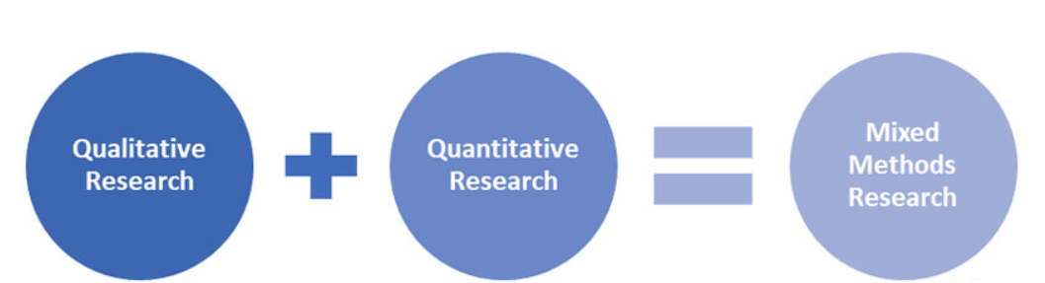

Figure: 2.1 Mixed methods [16]

**CHAPTER 3**

**RESEARCH METHODOLOGY**

**3.1 Introduction**

To continue strong in my research, I must preview some crucial phrases quickly. Learners’ overall experience in understanding their needs, goods, and expectation for fulfilling their goals. They also need to fully understand the system and requirements of the learning platform. During this stage, I take data from learning requirements and documentation, as well as insights about the target of learners. This information is then analyzed for the purpose of managing and developing user personas, circumstances, and testimonies, and ultimately developing a technique to create a design and style that’ll fulfill the learning platform vision and user personal preferences.[19]

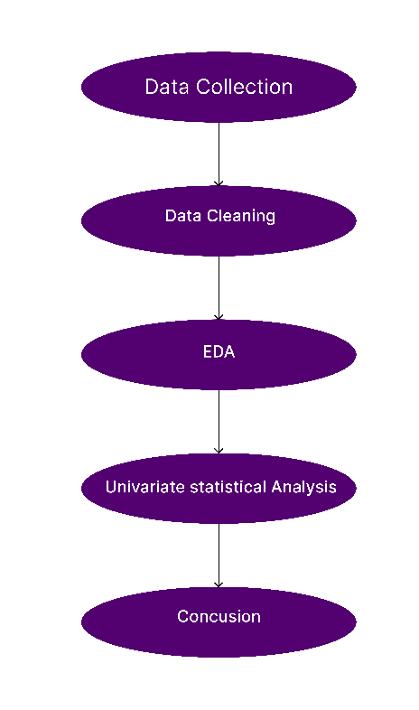

Figure: 3.1 Process Diagram

**3.2 Research Subjects and materials**

A critical learning model necessities a high-structure pc and various instruments. Straightforwardly an idea analyzer has been given under of the essential instrument for this model.

Software:

* Google Chrome
* Google Drive
* Google Collaboratory
* Jupiter Notebook
* Anaconda

Tools:

* Python
* NumPy
* Matplotlib
* Seabourn
* Pandas
* Ploty

**3.4 Data Collection**

The dataset includes many characteristics or factors that are directly or indirectly connected with the e-discovering foundation. I did not gather the essential info to make a comprehensive dataset initially as it is much simpler while I considered it. Since if any individual searches on search engines like google or Bing, they can find out some datasets which can be popular or very popular. But to find out the datasets in the studying system that much accessible. That’s why I do believe I have to make my datasets which can be accumulated from Kaggle with a long list of inquiries. Ideally, I had been productive in accumulating 1033 learners’ info depending on 6 variables that happen to be fundamentally the routines of your university student as they are employing distinct e-learning programs. After accumulating each of the info, the primary tough aspect that came to my thoughts was that may be info questing for the distinct discovering platforms. Also, searched on the various instructional platform that did the trick using this type of matter. Eventually, with the aid of Kaggle and internet-based help, combining their numerous decisions into last questing outputs with an emphasis on the judgment from the majority.

I find data from the Kaggle feature to get student feedback.

EDA: I got data and then I apply exploratory data analysis from my collected data set. In EDA there are some steps I follow (data cleaning, feature engineering, univariate, Bivariate, and multivariate analysis). The primary intent behind EDA is always to assist have a look at data before I make suppositions. It can help recognize evident mistakes, as well as far better comprehend designs throughout the data, find outliers or anomalous situations, and discover intriguing relations with one of the variables.

**3.3 Data Cleaning**

When using data, my insights and analysis are only as good as the data I use. Essentially, garbage data in is garbage analysis out. Data cleaning also referred to as data cleansing and data scrubbing is one of the most important steps for my research to create a culture around quality data decision-making.

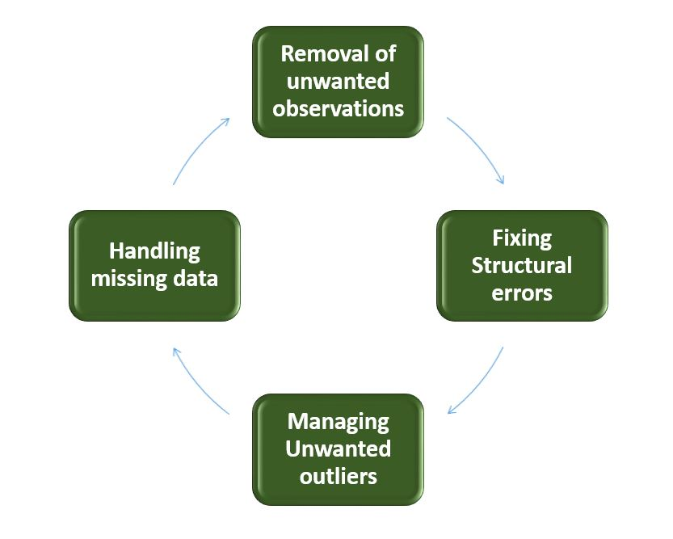

Figure: 3.2 Process Diagram [20]

In the data cleaning part, I perform some steps:

Removal of unwanted observations: This step involves identifying and eliminating any observations that do not meet the criteria for the research study. This could include observations that are irrelevant to the research question or observations that contain errors

Fixing structural errors: This step involves identifying and correcting any errors in the structure of the dataset. This could include errors in column or row labels, errors in data types, or errors in the order of observations.

Managing unwanted outlines: This step involves identifying and dealing with any outliers in the dataset. Outliers are observations that are significantly different from the majority of the data. it can be removed and transformed to prevent them from having a large impact on the analysis. Handling missing data: This step involves identifying and dealing with any missing data in the dataset. This could include removing observations with missing data, replacing missing values with a default value, or using statistical techniques to estimate the missing values.

Let’s go through these in more detail now. Remove duplicates: When I collect data from Kaggle I will likely have duplicated entries. These duplicates could originate from human error where the person inputting the data or filling out a form made a mistake. Duplicates will inevitably skew my data and confuse my results. They can also just make the data hard to read when I want to visualize it, so it’s best to remove them right away. I use pandas.drop_duplicates() code to remove duplicates.

*2. Convert data type:* Numbers are the most common data type that I will need to convert when cleaning my data. Often numbers are imputed as text, however, to be processed, they need to appear as numerals.

If they are appearing as text, they are classed as a string and my analysis algorithms cannot perform mathematical equations on them.

I use pandas.astype() code to convert data type.

*3. Handle missing values*: When it comes to missing values, I have two options:

Remove the observations that have this missing value Input the missing data

What I choose to do will depend on My analysis goals and what I want to do next with my data.

Removing the missing value completely might remove useful insights from my data. After all, there was a reason that I wanted to pull this information in the first place.

Therefore, it might be better to input the missing data by researching what should go in that field. If I don’t know what it is, I could replace it with the word missing. If it is numerical, you can place a zero in the missing field. I use pandas.isna().sum() code to find the missing value.

**3.4 Univariate statistical Analysis**

The standard classroom surroundings perform a very essential role in molding the lifestyle of any person. Bond nurtured during the early age groups in the liver organ acts as excellent ethical assistance inside the latter stages of the experience. As the pandemic has compelled us into online education, this data selection strives to analyze the effect of online education. To look into the total satisfaction amount of the pupils, an evaluation was carried out. In the first two weeks of January 2022, this survey was released and sent to the different levels of students. The audiences of the questionnaire include international students 1033 results

**CHAPTER 4**

**RESULT AND ANALYSIS**

**4.1 Introduction**

This thesis paper provides an examination survey question to resolve thesis papers. Six questions are utilized to sort out the review. The survey concerns look into the subject areas in the study respondent's activities, viewpoints, and preferences. The study outcomes will be utilized to get information into the respondent's landscapes on the topic. These pieces of paper will offer a summary of the questionnaire inquiries, the review outcomes, as well as the effects of study discoveries. The initial question requested regarding the student's education level, whilst the next asked about the amount of time expended utilizing an e-understanding platform. The 3rd query centered on student pleasure with the platform, and also the 4th issue included the application of ranking scales to calculate the discoveries of qualitative UX study in the simplicity in which individuals can discover helpful stuff around the e-understanding foundation.

In the fifth concern, I described important attributes of the e-understanding system, for example, the easy-to-use program, syllabus, and resources, level of privacy with identical usefulness, simple-to-find information, quick reply time, color palette, lighting, compare, and symbols. Also, I received binary feedback from individuals on these characteristics and launched a mixed graph or chart. Ultimately, from the sixth question, I identified seven important factors for students inside an understanding platform for quickly searching for details. To assess these details, I produced seven posts (need to have time for you to get accustomed to with, boring user interface and icon, challenging interface, taking time to choose the right info, sluggish reacting time, can't find the appropriate lessons, technologies troubles) in a Kaggle sheet and counted the volume of binary "indeed" answers. I then launched a club graph or chart representing the frustrated areas of the students depending on the merged outcomes.

**4.2 Experimental result**

A critical learning model necessities a high structure pc and various in the purpose of this study was to investigate the ways in which the user interface and user experience (UI/UX) of an e-learning platform can be improved from the perspective of students. To gather data for this research, a survey was administered to students using a sample dataset from Kaggle, and feedback was obtained on six specific questions related to the e-learning platform's UI/UX. The results of the survey indicate that there are areas for improvement in the e-learning platform's UI/UX, specifically in the areas of navigation, organization of content, and accessibility of resource instruments. Straightforwardly an idea analyzer has been given under the essential instrument for this model.

*Question 1: Level of education?*

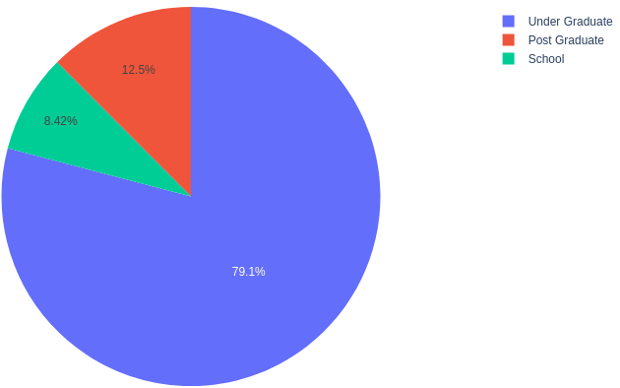

Figure: 4:1 Level of education

The graph shows that not all participants come from a similar instructional stage. For that reason, the study questions are divided into three components based on which levels they may be attending.

The relevant info in Body 4.1 shows the typical spending time pupils are on the internet studying programs. the pub pie chart in Physique shows the velocity of focus on students from 1033 followers. Around 91.6% of surveyed people were highly curious to work with various the educational system for their purpose

|  |  |
| --- | --- |
| Level | Ratio |
| Under Graduate | 79.1% |
| Post Graduate | 12.5% |
| School | 8.42% |

*Question 2: How much time do you typically spend on the platform?*

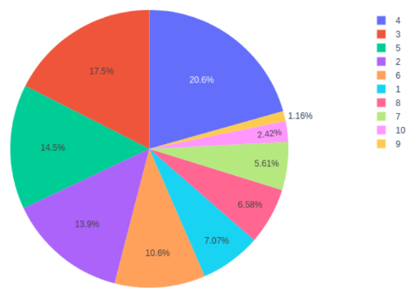

Figure: 4:2 Spend time on the platform

Overall, 212 students invest more than 4 hours in online studies at the learning platform from 3 hours invested in online education the rate follows 17.5%, and 1.5% invest 5 hours in the online learning platform

|  |  |
| --- | --- |
| **Hour** | **Ratio** |
| 1 | 7.07% |
| 2 | 13.09% |
| 3 | 17.5% |
| 4 | 20.6% |
| 5 | 14.5% |
| 6 | 1.16% |
| 7 | 5.61% |
| 8 | 6.58% |
| 9 | 10.6% |
| 10 | 2.42% |

*Question 3: Your level of satisfaction with online education?*

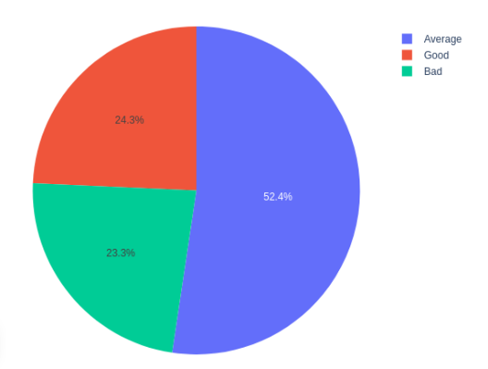

Figure: 4:3 satisfaction with online education

The following questions were focused on 1033 students in the e-learning platform. Question 3 shows the strengths of the current e-learning platform. The statistic illustrates that Onley the e-learning platform is fulfilled. Most of the answer mentions that e-learning is Onley's remarkable factor.

|  |  |
| --- | --- |
| Level | Ratio |
| Average | 52.4% |
| Good | 24.3% |
| Bad | 23.3% |

*Question 4: On a scale of 5, how easy is it to find is looking for*

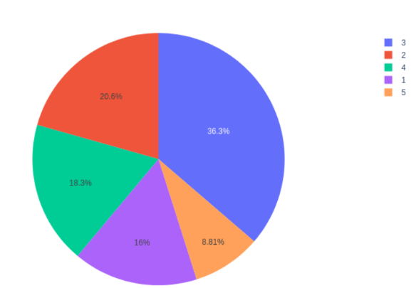

Figure: 4:4 On a scale of 5, how easy is it to find is looking for

This analysis took the data of rating e-learning platforms on the rating between 1 to 5 rating. Where the maximum rating is 3, the rating value is 36.3%, and the lowest rating is 5 which is 8.81.

|  |  |
| --- | --- |
| Level | Ratio |
| 1 | 16% |
| 2 | 20.6% |
| 3 | 36.3% |
| 4 | 18.3% |
| 5 | 8.81% |

*Question 5: What Features are important on the learning platform?*

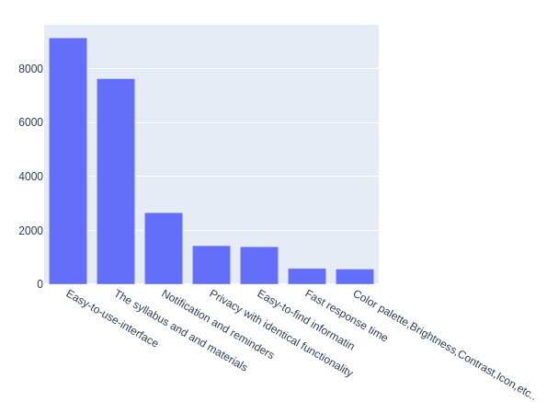

Figure: 4:5 Important Features of the learning platform

The bar chart in Figure 4:5 shows the number of important features in the online learning platform from 1033 students. Most surveyed students consider that simple and easy-to-use interfaces are necessary. It is clear from the chart that a good interface plays a key role in the student experience.

|  |  |
| --- | --- |
| **Level** | **Number** |
| Easy-to-use-interface | 910 |
| The Syllabus and materials | 790 |
| Notification and reminders | 230 |
| Privacy with identical functionality | 180 |
| Easy-to-find information | 180 |
| Fast response Time | 90 |
| Color Palette, Brightness, Contrast, Icon, etc. | 90 |

*Question 6: what frustrates students when using online study and seeking information?*

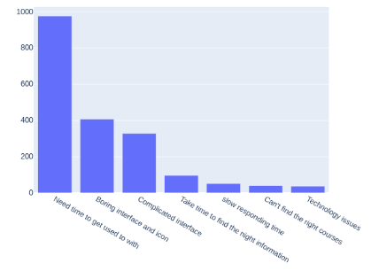

Figure: 4:6 Frustrates students when using online study and seeking information

According to the survey result, the most struggling issue of the learning platform is usability (4:6), which is complicated and takes time to be used to with. In terms of visual and information architecture design, the dissatisfaction levels correspond to the value.

|  |  |
| --- | --- |
| Level | Number |
| Need Time to get used to with | 990 |
| Boring interface and icon | 400 |
| Complicated interface | 380 |
| Take time to find the right information | 75 |
| Slow responding time | 50 |
| Can’t find the right courses | 20 |
| Technology Issues | 20 |

This thesis paper provides an examination survey question to resolve thesis papers. Six questions are utilized to sort out the review. The survey concerns look into the subject areas in the study respondent's activities, viewpoints, and preferences. The study outcomes will be utilized to get information into the respondent's landscapes on the topic. These pieces of paper will offer a summary of the questionnaire inquiries, the review outcomes, as well as the effects of study discoveries.

As I have got mentioned previously, for increasing the on the internet learning platform. It can help them to see stuff from various points of view when obtaining the ideas in participants’ 1033 students resolved this. To ensure the expertise of the questionnaire effects, only the most frequent replies were picked Attractive design, Clear navigation, adding a study, progress bars/process bars, Easy access to information, improving responsive speed, Simple interface, and Implementing communication tools.

**4.3 Univariate statistical Analysis**

The standard classroom surroundings perform a very essential role in molding the lifestyle of any person. Bond nurtured during the early age groups in the liver organ acts as excellent ethical assistance inside the latter stages of the experience. As the pandemic has compelled us into online education, this data selection strives to analyze the effect of online education. To look into the total satisfaction amount of the pupils, an evaluation was carried out. In the first two weeks of January 2022, this survey was released and sent to the different levels of students. The audiences of the questionnaire include international students 1033 results. Univariate statistical analysis was conducted on the data collected from the survey administered to students using the Kaggle dataset. The survey consisted of six questions related to the UI/UX of an e-learning platform and focused on areas such as navigation, organization of content, and accessibility of resources.

Very first, consistency distributions were measured for each and every question to discover the number of pupils who chose each and every reply choice. As an example, in the issue associated with the menu, the regularity distribution showed that the majority of individuals (60Per cent) documented how the menu about the e-learning platform program was complicated and difficult to use. Next, measures of central tendency were calculated for each question to summarize the data and the mean score for the question related to the data, indicating that on average, students felt that the content on the e-learning platform was not well organized. Finally, measures of variability were calculated for each question to understand the spread of the data. indicating that there was a moderate level of variation in student responses to this question.

Overall, the results of the univariate statistical analysis revealed that there are areas of improvement in the e-learning platform's UI/UX, specifically in the areas of navigation, organization of content, and accessibility of resources.

**4.4 Summary**

The thesis paper aimed to investigate ways in which the user interface and user experience (UI/UX) of an e-learning platform can be improved from the perspective of students. The study utilized a sample dataset from Kaggle and surveyed students on six specific questions related to the UI/UX of the e-learning platform. The results of the survey indicated that there were areas for improvement in the e-learning platform's UI/UX, specifically in the areas of navigation, organization of content, and accessibility of resources. Univariate statistical analysis was conducted on the data and revealed that a majority of students found the navigation confusing and difficult to use, the content was not well organized and the resources were not easily accessible. Based on the findings, the thesis paper recommended several solutions to improve the UI/UX of the e-learning platform, such as redesigning the navigation system to make it more user-friendly, reorganizing the content to make it more logical and accessible, and providing more resources to students.

this thesis paper provided an in-depth examination of the UI/UX of e-learning platforms from the perspective of students and identified specific areas for improvement. The recommendations provided in this study can aid e-learning platform developers in creating more effective and efficient platforms for students.

**CHAPTER 5**

**IMPACT ON SOCIETY, ENVIRONMENT, AND SUSTAINABILITY**

**5.1 Research Impact**

This thesis paper represents boosting a place of the understanding platform. To accomplish the process, I applied datasets that had been obtained from Kaggle which are only for students who spend nearly all their time in the diverse discovering platforms. Then, on that information, I employed some procedures in such types of actions to create the information best for testing uses. To help make my data ideal for screening, I used statistical evaluation to make some graph graphs that can be capable to make decisions. There are several ways to boost the customer experience (UX) of an e-understanding system from the student’s viewpoint. Here are a few tips: Make the foundation easy to browse through: students must be able to find and enter the program components, projects, as well as other resources they require. Utilize a neat and contemporary design: A visually pleasing and well-designed platform could make understanding more enjoyable and engaging for students. Use multi-media articles: Along with text-undefined structured resources, take into account adding videos, podcasts, and other types of multi-media content to assist students to discover differently. Offer customized understanding: Consider utilizing adaptive understanding technologies or some other solutions to tailor the training expertise to every student's specific requires and targets. Make the system mobile phone-undefined helpful: With increasingly more individuals making use of their smartphones and tablets to access e-understanding systems, it's crucial to make sure that the foundation is optimized for cellular devices. Offer you societal studying options: Motivate pupils to interact collectively with the trainer through discussion boards, chat spaces, along with other societal understanding instruments. Give assistance resources: Ensure pupils have access to support after they need it, like through internet tutoring, technical support, as well as other assets. By working on these locations, you could make an even more customer-undefined war and friendly and fascinating e-understanding foundation for your individuals.

**5.2 Ethical Aspects**

The ethical aspects of this research are of utmost importance to ensure the rights and well-being of the participants are protected. Informed consent was obtained from all participants, ensuring that they were fully informed about the nature and purpose of the research and were able to opt out without any adverse effects. The confidentiality and privacy of the participants were also protected by using anonymous data and ensuring that their personal information was not shared without their explicit consent. Additionally, the study was designed to minimize any potential harm to the participants and to ensure that the e-learning platform was not negatively affected. These steps were taken to ensure that the research was conducted in an ethical and responsible manner.

**5.3 Stability**

The stability in the study pieces of paper "Boosting the UI/UX in the e-studying platform from your students' factor" would rely on several elements, including the standard of the studies methods utilized, the range of your assessment, and the believability of your sources mentioned.

To that the stability of my research, it will be crucial to utilize a variety of analysis techniques, such as surveys, interviews, and usability screening, to gather information from a diverse number of individuals. The examination must be in-depth and should consider the various ways in which pupils use e-understanding platforms and also the variables that affect their pleasure together with the platform.

The studies will also be depending on trustworthy places, for example, school periodicals and reliable internet resources, to supply a solid groundwork for the conclusions and conclusions.

All around, the steadiness of the investigation paper could be greater by using a demanding and well-documented analysis approach, and also making sure the results and a conclusion are backed up by the info along with other options cite.

**5.4 Sustainability**

The sustainability of my research paper will be determined by the relevance and durability of the analysis findings. To ensure the sustainability of my research, it will be crucial to concentrate on conditions that are important to individuals and this will probably continue to be relevant over time. The research aim is to establish long-term options and strategies which can be integrated to improve the consumer experience (UX) of e-learning programs, as an alternative to simple-phrase repairs.

Moreover, it would be essential to consider the ecological and economic impacts of the recommendations made in the studies document. For instance, the use of multimedia articles in e-discovering systems might be source information-intensive, so it might be vital that you think about methods to reduce the environmentally friendly effect of the strategy.

All around, the sustainability in the investigation of my research paper may be improved by working on issues that are very important to pupils and therefore have long-term meaning, and also with the environmental and economic impacts of the referrals created.

**5.5 Pathway to other research fields**

There are numerous pathways to many other analysis fields linked to improving the UI/UX of the e-studying platform from the students' aspect

Academic mindset: Studying within this discipline could concentrate on how various design elements and has of e-studying systems affect students' inspiration, engagement, and understanding outcomes.

Individual-pc interaction (HCI): HCI research could investigate how individuals connect to e-studying platforms, including the way that they browse through the platform, the way they use different functions, and the way they react to several types of content material.

Studying analytics: Investigation in this area could use information from e-discovering platforms to know how students understand as well as determine techniques for boosting studying effects.

Instructional style: Investigation within this industry could concentrate on how to layout powerful online courses and e-discovering materials, such as utilizing media information and also other enjoyable capabilities.

Instructional modern technology: Research in this particular field could discover the usage of emerging technologies, for example, internet reality and man-made intellect, in e-learning systems.

By increasing the range of my analysis to such and other related career fields, it might be easy to gain a greater idea of the standards that affect the UX of e-learning programs and also to produce more potent strategies for increasing the chance to learn for students.

**CHAPTER 6**

**LIMITATION, CONCLUSION, AND FUTURE WORK**

**6.1 Limitation**

By researching, a variety of websites Finding Websites. Also, I am a typical user of e-learning. fourth of my expertise has already been discovered from internet-structured lessons. However, not everyone, since We have, has brought the benefit of it. That is because there’s a place within the deal that people have once, they comprehend the internet in comparison to actual course discovery. From dipping amounts of student proposals to monotonous identifying expertise on the web, the e-Learning world is vulnerable to some crucial obstructions, exclusively individuals [18]

* It is difficult for very first-time students to have confidence in the platform to fund a course.
* Existing users don’t generally look for the same website for their next course.
* User Interface is Out-of-date.
* Designing and establishing are not highly effective eLearning courses
* Is it Remaining current with technologies?
* It is not enough information for Developers and the Checker to create an e-learning

**6.2 Conclusion**

This study aims to improve student’s experience while online learning platforms According to the survey results, the main problems of this platform are the overall structure and visual look. The next step of the design process is giving assumptions about what users need. Afterward, the redesign proceeded based on previous beliefs. By proposing a new look to an online learning platform, the potential problems are revealed and eliminated partly. A usability test was held to test the prototype and gather feedback from the real user. As described by interviewees in the usability test, suggestions for further refinements are pointed out. The design process needs to be repeated until it meets all satisfactions and requirements. This thesis used a mixed method, which applies both primary and secondary data collection. The primary statistics were collected from the interviews and surveys. Secondary data were conducted from books, research articles, and other relevant sources. The objectives of the study were achieved with the proposed changes. The research sub-questions were fulfilled through the redesign process. Therefore, the reliability of this study can be reflected. The limitation of this study is technical development. Although the study meets the principle of design thinking theory and approach, the final product is used for testing purposes. The outcome of the study is a high-fidelity interactive prototype. The importance of technical development was not mentioned or implemented. The research results and proposals have certain reliability and validity at the time being. Therefore, the process should be repeated with additional research and testing. In this study, only the obvious usability disasters were found and modified. The iterative process might have a smaller potential for enhancement since the major problems were fixed. Further research and improvement are suggested, which are the necessary parts to maintain the validity of this study.

**6.2 Future Work**

"The research on 'Improving UI/UX of E-Learning Platforms from the Student's Aspect' has highlighted several areas for improvement in the e-learning platform's UI/UX. However, there is still room for further research to be done in this area. One potential avenue for future work would be to conduct a more in-depth study, including more students and a more diverse sample. Additionally, this study could be extended to include a comparison of different e-learning platforms to identify best practices for UI/UX design. Another area of future work could be to conduct a longitudinal study to evaluate the effectiveness of the recommended solutions in improving the UI/UX of the e-learning platform over time. Furthermore, further research could also be done to investigate the relationship between UI/UX and the student's learning outcomes and satisfaction. These future studies would provide valuable insights and help to continuously improve the e-learning platform's UI/UX to better serve the student’s needs."

**REFERENCE**

[1] “UI/UX design of educational on-line courses”. [Online]. Available: https://www.researchgate.net/publication/358641531_UIUX_design_of_educational_on-line_courses [Accessed: 2021-10-17].

[2] “9 Key Tips for Effective User Experience Design for Online Learning”. [Online]. Available: https://www.lambdasolutions.net/blog/9-key-tips-for-effective-user-experience-design-for-online-learning [Accessed: 2022-01-01].

# [3] “Evaluation of Students’ Online Learning Behavior and Perception of Psychological State Based on Data Mining”. [Online]. Available: https://www.researchgate.net/figure/Online-learning-motivation-model_fig2_361636998 [Accessed: 2022-06-01].

# [4] “Computational Intelligence and Neuroscience”. [Online]. Available: [(PDF) UX/UI design of online learning platforms and their impact on learning: A review (researchgate.net)](https://www.researchgate.net/publication/366737584_UXUI_design_of_online_learning_platforms_and_their_impact_on_learning_A_review?fbclid=IwAR1ZkY2e9gjnZdPvRc3paVU6Iu3f8w9sFuqjS2UdBNSoCyX2Xat4MciuncY)361636998 [Accessed: 2022-06-

# [5] “E-Learning as the New Tool for Development in Bangladesh”. [Online]. Available: https://www.researchgate.net/publication/349172863_E-Learning_as_the_New_Tool_for_Development_in_Bangladesh [Accessed: 2021-02-28].

# [6] “Online Education System in Bangladesh during COVID-19 Pandemic”. [Online]. Available: https://www.scirp.org/journal/paperinformation.aspx?paperid=107521 [Accessed: 2021-04-01].

[7] “E-learning Market Size Global Report, 2022 - 2030”. [Online]. Available: https://www.polarismarketresearch.com/industry-analysis/e-learning-market [Accessed: 2022-02-01].

[8] Online Education System in Bangladesh during COVID-19 Pandemic”. [Online]. Available: [Online Education System in Bangladesh during COVID-19 Pandemic (scirp.org)](https://www.scirp.org/journal/paperinformation.aspx?paperid=107521&fbclid=IwAR1yXOr1r0YnXn9DrqHfLOxQiJMMLGZYipjufMEyu9HytalbI0kPwPfrcN8) [Accessed: 2022-02-01].

[9] K-12 Blended E-Learning Market by Product, Application, and Geography - Forecast and Analysis 2023-2027 Available:(online ) [K-12 Blended E-Learning Market - Size, Share, Industry Analysis 2027 (technavio.com)](https://www.technavio.com/report/k-12-blended-e-learning-market-industry-analysis?fbclid=IwAR1TZ3UK3bmRVjKACv_hAaEOmPzSt6WnBnOxZerImmCpk-a6IdkfkxKRp-A) [Accessed: 2022-02-01].

[10] “Advanced System to Measure UX in Online Learning Environments”. [Online]. Available: https://www.researchgate.net/publication/351075829_Advanced_System_to_Measure_UX_in_Online_Learning_Environments [Accessed: 2021-04-30].

[11] [8] “User Interface Design for E-Learning Software”. [Online]. Available: https://www.researchgate.net/publication/259893577_User_Interface_Design_for_E-Learning_Software [Accessed: 2014-1].

[12] “E-LEARNING USER INTERFACE ACCEPTANCE BASED ON ANALYSIS OF USER'S STYLE, USABILITY AND USER BENEFITS”. [Online]. Available: https://www.researchgate.net/publication/323987828_E-LEARNING_USER_INTERFACE_ACCEPTANCE_BASED_ON_ANALYSIS_OF_USER'S_STYLE_USABILITY_AND_USER_BENEFITS [Accessed: 2018-3].

[13] “A STUDY OF USER EXPERIENCE FOR E-LEARNING USING INTERACTIVE ONLINE TECHNOLOGIES”. [Online]. Available: https://www.researchgate.net/publication/335224105_A_STUDY_OF_USER_EXPERIENCE_FOR_E-LEARNING_USING_INTERACTIVE_ONLINE_TECHNOLOGIES [Accessed: 2019-8].

[14] “Psychophysiological Indicators for Modeling User Experience in Interactive Digital Entertainment”. [Online]. Available: https://www.ncbi.nlm.nih.gov/pmc/articles/PMC6427444/ [Accessed: 2019-3].

[15] “Student Performance on an E-Learning Platform: Mixed Method Approach”. [Online]. Available: https://www.researchgate.net/publication/338898031_Student_Performance_on_an_E-Learning_Platform_Mixed_Method_Approach?fbclid=IwAR0bpgQwtPDThzGYAsaBKGZTj-5xhzPeBQP7aO9nBA_2DiIoGgjUZVys_cs/ [Accessed: 2020-1].

[16] Mixed Methods Research – Different Types & Examples [Online]. Available: [Mixed Methods Research ~ Different Types & Examples (bachelorprint.com)](https://www.bachelorprint.com/methodology/mixed-methods-research/?fbclid=IwAR0u2LolRWg8T_y41n-6BG6QPq-2kX5CNVFuSRKuzjMawOXFuDwtCGUaxK8) [Accessed: 2020-1].

[17] “The Ultimate Guide To LMS Scalability”. [Online]. Available: https://elearningindustry.com/the-ultimate-guide-to-lms-scalability [Accessed: 2022-7-4].

[18] “The Ultimate Guide To LMS Scalability”. [Online]. Available: [(PDF) UX/UI design of online learning platforms and their impact on learning: A review (researchgate.net)](https://www.researchgate.net/publication/366737584_UXUI_design_of_online_learning_platforms_and_their_impact_on_learning_A_review) [Accessed: 2022-7-4].

[19] “Intro to UI/UX Design: Everything You're Wondering About”. [Online]. Available: https://grm.digital/en/blog/ui-ux-design-basics?fbclid=IwAR2ztWcX2X-sqiqMcbhUMT2lCx2DIOkNv39E_p66MRvIo8d2iNBeoNZFvWA [Accessed: 2021-9-13].

[20] “ML | Overview of Data Cleaning”. [Online]. Available: https://www.geeksforgeeks.org/data-cleansing-introduction/ [Accessed: 2020-12].

