Improved integer

|  |  |  |  |  |  |  |  |
| --- | --- | --- | --- | --- | --- | --- | --- |
| M | N | K | Omega | EF | Execution time | Hybrid | Execution time |
| 5 | 2 | 5 | 2 | 262.8 | 0.4 | 262.8 | 3.9 |
| 10 | 2 | 10 | 5 | 290.3 | 0.6 | 290.3 | 600.5 |
| 3 | 2 | 3 | 4 | 103.8 | 4.6 | 103.8 | 8.1 |
| 50 | 5 | 20 | 50 | 813.7 | 479.9 | 824.2 | 1009.9 |
| 50 | 5 | 1000 | 5 | 1908.6 | 71.6 | 3322.5 | 119.8 |

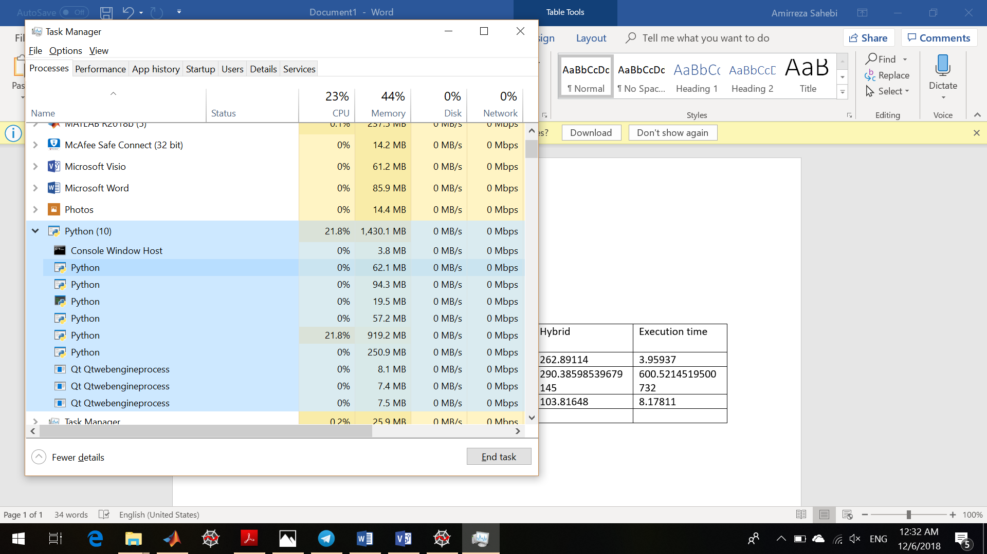



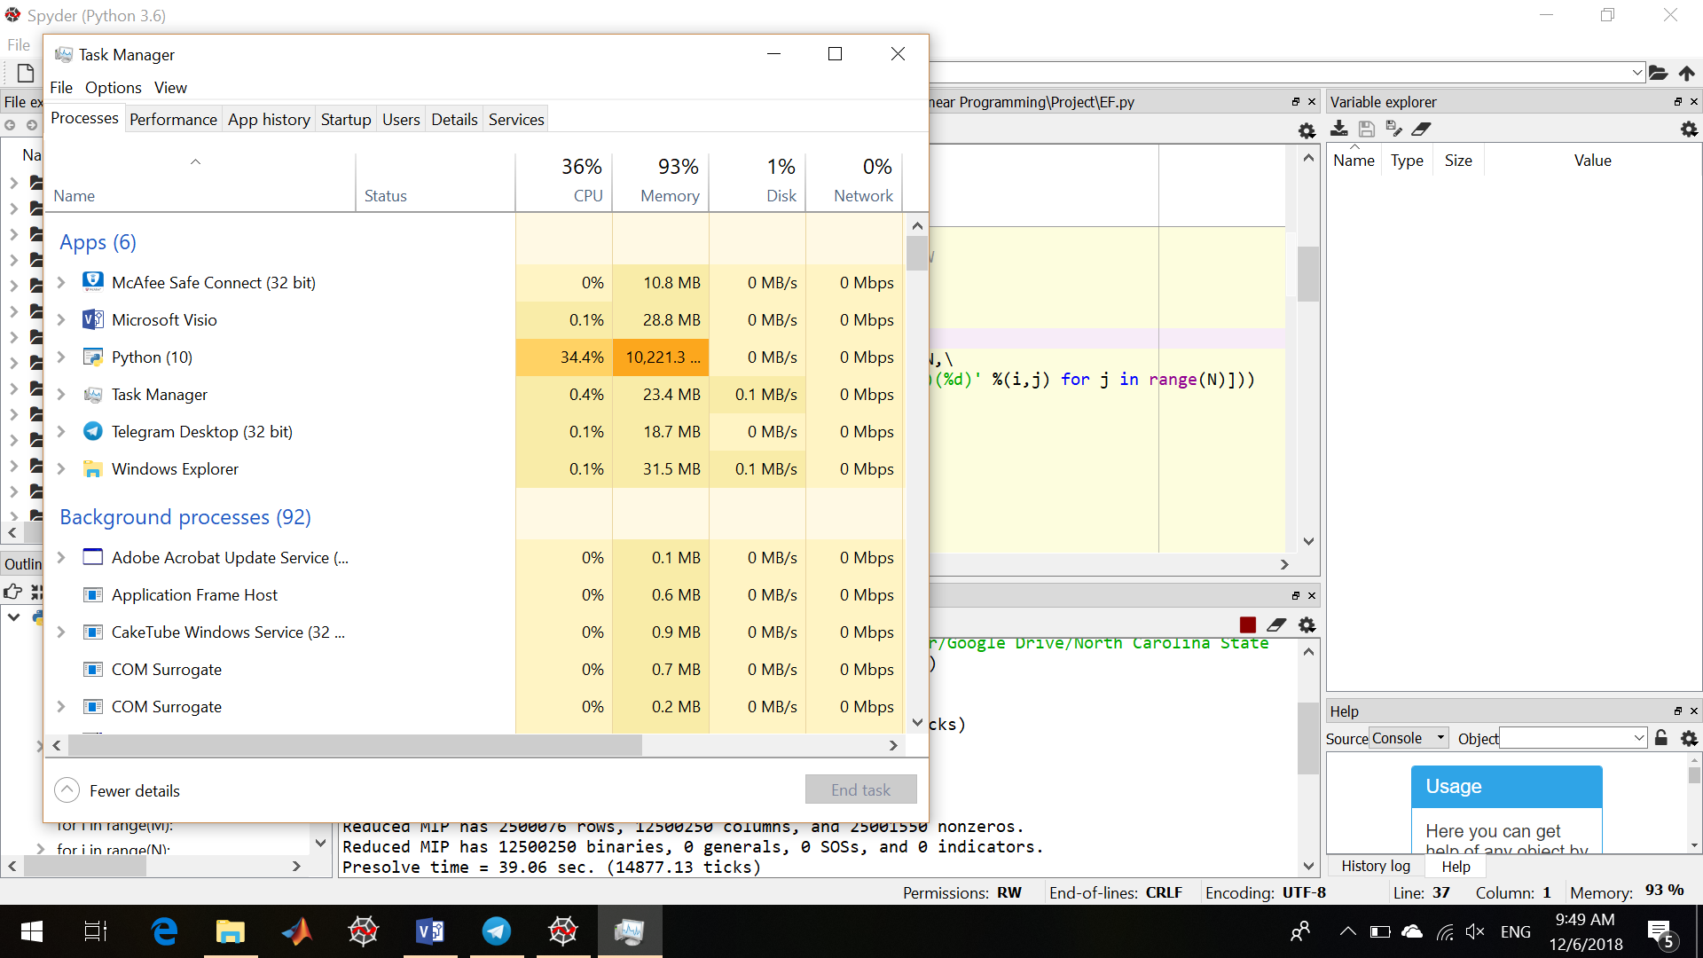



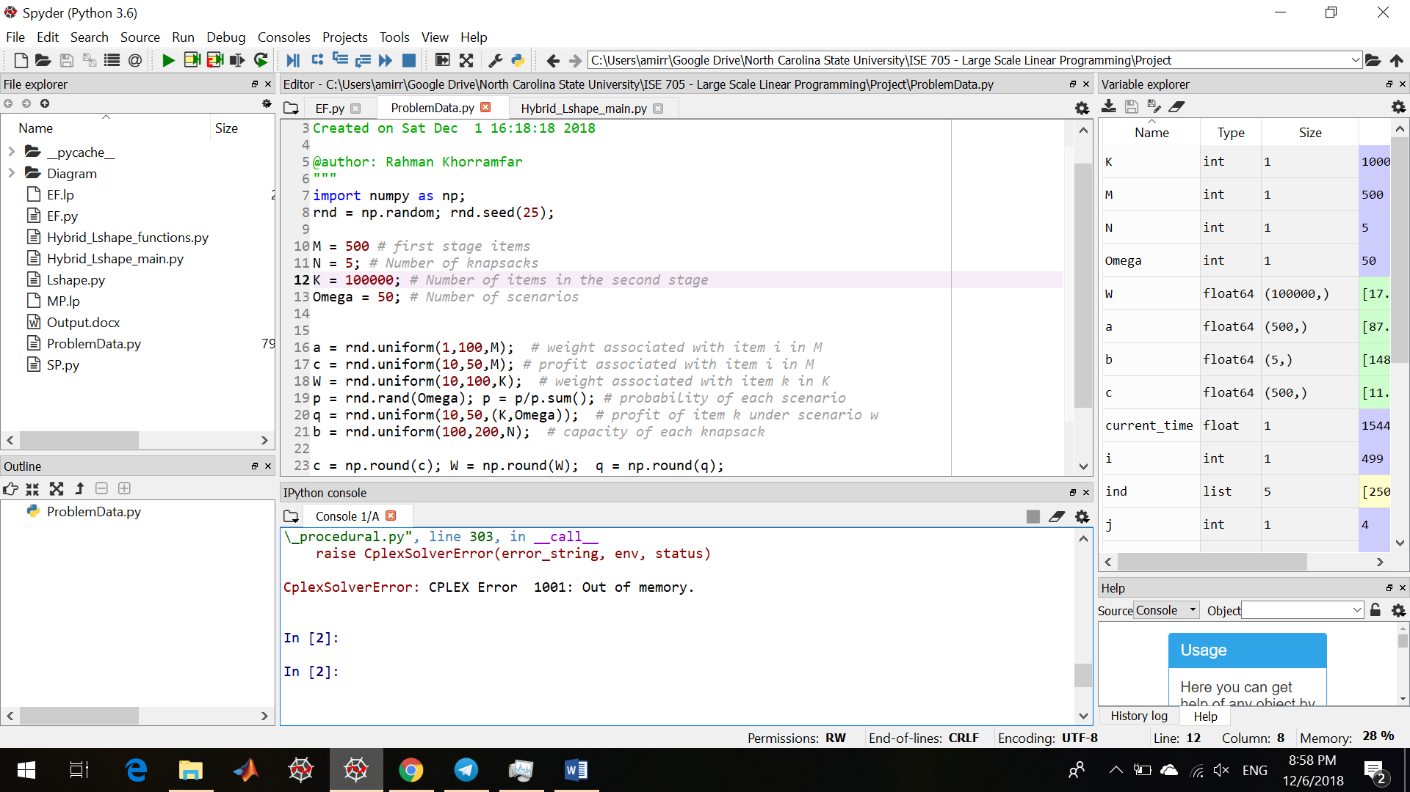

Not improved

|  |  |  |  |  |  |  |  |
| --- | --- | --- | --- | --- | --- | --- | --- |
| M | N | K | Omega | EF | Execution time | Hybrid | Execution  time |
| 5 | 5 | 100 | 10 | 977.6 | 0.6 | 977.6 | 2.2 |
| 5 | 5 | 100 | 50 | 1069.4 | 1.5 | 1069.4 | 7 |
| 5 | 5 | 500 | 50 | 1838.8 | 4.3 | 1838.8 | 13.6 |
| 5 | 5 | 500 | 100 | 1797.4 | 11.6 | 1797.4 | 26.4 |
| 50 | 5 | 500 | 100 | 1880.9 | 18.6 | 1880.9 | 86.5 |
| 50 | 5 | 1000 | 100 | 2394.4 | 34.8 | 2395.3 | 97.3 |
| 100 | 20 | 1000 | 100 | 5961.2 | 251.2 | - | - |
| 50 | 20 | 5000 | 100 | 8125.2 | 3099.8 | 10705.8 | 431.4 |

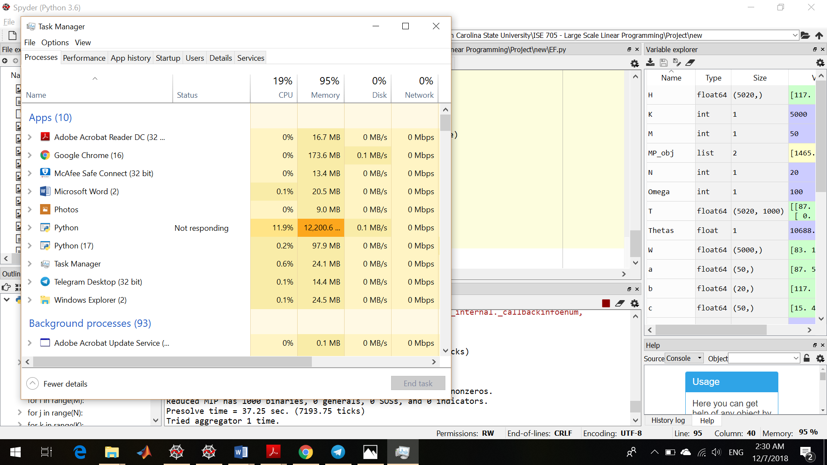

Objective Function: 952.1670492827449

Elapsed Time: 2.0780029296875

Objective Function:

Elapsed Time: 2.2848567962646484

