To what extent does Retrieval-Augmented Generation combined with Semantic Consistency Evaluation reduce factual hallucinations in small open-source language models?
A master’s dissertation submitted in partial fulfilment of the requirements for the award of the degree of
MSc in Artificial Intelligence
RAHMAN AHMED AWAN
P2882008
Supervisor: Dr. Farhan Ujager


School of Computing
De Montfort University, Dubai
September 2026

DECLARATION

I declare that this dissertation is my own original work carried out under the supervision of Dr. Farhan Ujager and that all sources and references have been acknowledged appropriately. This dissertation has not been submitted previously for academic credit at De Montfort University, Dubai, or any other institution.


Signature:
Name: RAHMAN AHMED AWAN
Date: 11-Sep-2026

ACKNOWLEDGEMENT

I would like to express my sincere gratitude and acknowledgment to the faculty at De Montfort University Dubai, mainly the professors in the MSc AI program. Special thanks to Professor Masri and Dr. Farhan Ujager for their contributions. My family members and my friends in Dubai for their continued support throughout my 2-year journey in this program.

Rahman Ahmed Awan

LIST OF FIGURES

Figure No. | Title | Chapter
Figure 4.1 | System Architecture Diagram | Chapter 4
Figure 5.1 | Bar Chart Comparing ROUGE-L, Semantic Similarity, and ROUGE-1 Across Conditions | Chapter 5
Figure 5.2 | Box Plots Showing Score Distributions Across Conditions | Chapter 5
Figure 5.3 | Histogram of SCE Score Distribution | Chapter 5
Figure 5.4 | Confusion Matrix for SCE Hallucination Detection | Chapter 5
Figure 5.5 | Dual-Axis Chart Showing Hallucination Rate and ROUGE-L Quality Across Thresholds | Chapter 5
Figure 5.6 | Performance Heatmap Across All 38 Categories | Chapter 5
Figure 5.7 | Per-Category ROUGE-L Improvement Bar Chart | Chapter 5

LIST OF TABLES
Table No. | Title | Chapter
Table 2.1 | Summary of Reviewed Methods | Chapter 2
Table 3.1 | TruthfulQA Dataset Attributes | Chapter 3
Table 3.2 | Tools and Technologies | Chapter 3
Table 5.1 | Cross-Condition Performance Comparison (N=817) | Chapter 5
Table 5.2 | Statistical Significance Tests | Chapter 5
Table 5.3 | SCE Classifier Performance | Chapter 5
Table 5.4 | Selected Threshold Sensitivity Results | Chapter 5
Table 5.5 | Extreme categories by Hallucination | Chapter 5
Table 5.6 | Cross-Model Experimental Comparison | Chapter 5

LIST OF ABBREVIATIONS

Abbreviation | Full Form
LLM | Large language model
NLP | Natural language processing
RAG | Retrieval-augmented generation
SCE | Semantic consistency evaluation
FAISS | Facebook AI similarity search
ROUGE | Recall oriented understudy for gisting evaluation
BLEU | Bilingual evaluation understudy
NLI | Natural language inference
F1 | F1 score
CI | Confidence interval
DPR | Dense passage retrieval
Seq2Seq | Sequence-to-sequence
API | Application programming interface
GPU | Graphics processing unit
CPU | Central processing unit
SRM | Small Reasoning Model
JAS | Joint Attribution Score

ABSTRACT
This project investigates the problem of factual hallucinations in small open-source language models. Where models generate responses that may be plausible but factually incorrect or unsupported. The research evaluated whether Retrieval-Augmented Generation RAG, combined with Semantic Consistency Evaluation (SCE), can improve the reliability of the text generated by such models. A controlled framework and a series of investigations, samples and runs compare scores all the way from baseline model to RAG enhanced and a RAG enhanced with SCE.
Using Flan-T5-Small (77 million parameters) and the TruthfulQA benchmark dataset (817 adversarial questions), a controlled experimental framework compared three conditions: a baseline language model, the same model enhanced with RAG, and a RAG-based system incorporating SCE.
The results demonstrated that RAG significantly improved factual accuracy, with ROUGE-L scores increasing from 0.088 to 0.357 (a 306% improvement, p < 10⁻⁷⁶, Cohen's d = 0.81) and semantic similarity to ground-truth answers rising from 0.256 to 0.458. The SCE module, operating as a post-hoc hallucination detector using cosine similarity between generated answers and retrieved context, achieved an F1 score of 0.709 (precision = 0.68, recall = 0.74). Responses identified as semantically consistent scored 3.5 times higher on ROUGE-L than those flagged as potential hallucinations. Category-level analysis across 38 question types revealed hallucination rates ranging from 0% (Finance) to 89% (Subjective), with two categories showing degraded performance under RAG due to retrieval of misleading context.
The findings confirm that retrieval augmentation combined with lightweight semantic consistency checking provides a practical and computationally efficient method for improving the factual reliability and trustworthiness of small language models, while also identifying the conditions under which these approaches succeed and fail.
Keywords: Large Language Models, Hallucinations, Retrieval-Augmented Generation, Semantic Consistency Evaluation, Open-Source, Small Language Models, TruthfulQA, Factual Accuracy, ROUGE, Cosine Similarity

TABLE OF CONTENTS
Contents
DECLARATION ii
ACKNOWLEDGEMENT iii
LIST OF FIGURES iv
LIST OF TABLES iv
LIST OF ABBREVIATIONS v
ABSTRACT vi
TABLE OF CONTENTS vii
Chapter 1: Introduction 1
1.1 Background 1
1.2 Problem Statement 1
1.3 Research Objectives 2
1.4 Research Questions 2
1.5 Significance 2
1.6 Scope 3
Chapter 2: Literature Review 3
2.1 Overview of Hallucination in Language Models 3
2.2 Gap Analysis 4
2.3 Summary of reviewed methods 5
Chapter 3: Methodology 5
3.1 Research Design 5
3.2 Dataset Description/Sources Links 5
3.3 Data Preprocessing 6
3.4 Tools/Technologies 6
3.5 Evaluation Metrics 6
3.6 Justification of methods used 6
Chapter 4: System Architecture and Model Implementation 8
4.1 Proposed framework 8
4.2 Algorithms and techniques 8
Dense Passage Retrieval: 8
4.2.1 Conditional Text Generation: 9
4.2.2 Semantic Consistency Scoring: 9
4.3 Workflow diagrams / flowcharts 9
4.4 Feature selection 9
Chapter 5: Experimental Results & Discussion 10
5.1 Accuracy, Precision, Recall, F1 Score 10
5.2 Statistical Significance 10
5.2.1 score distribution across various conditions 11
5.2.3 Confusion Matrix for the SCE classifier 11
5.3 Threshold Sensitivity Analysis 12
5.4 Category level analysis 12
5.5 Failure Case Analysis 12
5.6 Discussion 13
Chapter 6: Conclusion 14
6.1 Summary of key findings 14
6.2 Research contributions 15
6.3 Limitations 15
Chapter 7: Future Work 15
7.1 Summary of future work 15
REFERENCES 16
LIST OF PUBLICATIONS 20
APPENDICES 21

Chapter 1: Introduction

1.1 Background
Large Language models have achieved remarkable progress in recent years, demonstrating capabilities in text generation, question answering, summarization, and reasoning that were once considered beyond the reach of automated systems. Models such as GPT-4, PaLM, and LLaMA have pushed boundaries of what natural language processing can accomplish with applications spanning healthcare, education, legal analysis and scientific research (Huang et al., 2025). However, these advances come with a significant and well-documented limitation: the tendency of language models to generate information that appears fluent and plausible but is factually incorrect, unsorted or entirely fabricated. This phenomenon, widely referred to as hallucination, poses a serios barrier to the reliable deployment of language models in contexts where factual accuracy matters (Ji et al, 2023).
The problem of hallucination is not confined to any single model family or architecture. Both encoder-decoder models and autoregressive transformers exhibit these behaviours, and it persists across model scales ranging from compact models with fewer than 100 million parameters to the largest proprietary systems (Huang et al.,2025). What makes hallucination articulacy challenging is that the generated text often maintains grammatical correctness and surface level coherence, making it difficult for end users to distinguish between factual and fabricated content without external verification. In domains such as medical advice, legal guidance, and educational content, such errors carry tangible risks. Retrieval-Augmented generation, or RAG, has emerged as one of the most widely adopted strategies for mitigating hallucinations.
Originally proposed by Lewis et al. (2020), RAG combines a parametric language model with a non-parametric retrieval component that fetches relevant documents from an external knowledge base at inference time. The retrieved passages are then incorporated into the generation process, effectible grounding the model’s output in evidence rather than relying solely on learned parameters.
Several studies have demonstrated that RAG can substantially improve factual accuracy across a range of knowledge-intensive tasks (Shuster et al.,2021; Geo et al., 2023). Nevertheless, RAG alone does not fully resolve the hallucination problem. Even when relevant context is successfully retrieved, language models may ignore, misinterpret, or contradict the retrieved information during generation (Asai et al., 2024). This has motivated research into additional verification mechanisms that can assess whether a generated response is supported by the retrieved evidence. Semantic consistent evaluations represent one such approach, using dense vector representations to measure the alignment between a generated answer and its supporting context.

1.2 Problem Statement
While large proprietary models such as GPT-4 and Claude benefit from massive training corpora, reinforcement learning from human feedback and internal safer mechanisms, small open-source language models typically lack these advantages. Models in the range of 80/250 million parameters, such as Flan-T5-Small, are attractive for research and deployment in resource constrained environments due to their low computational requirements and accessibility. However, these smaller models are particularly susceptible to hallucination because their limited parameter count restricts the volume of factual knowledge; they can reality store and recall (Chung et al. 2024; Gunasekara et al. 2023).
The central problem this research addresses are whether a combination of RAG and post generation semantic consistency checking can meaningfully reduce hallucination rates in such small models. While RAG has been studied extensively for larger models, its effectiveness when paired with compact architecture remains less well understood. Similarly, semantic consistency evaluation as a standalone hallucination detection mechanism has received limited empirical investigation in the context of small-scale systems.

1.3 Research Objectives
This study pursues the following objectives:
- To evaluate the baseline factual accuracy of three small open-source language models spanning two distinct architectural families (Flan-T5-Small, Flan-T5-Base and Qwen2.5-0.5B-Instruct) on a standard truthfulness benchmark.
- To implement a Retrieval-Augmented Generation pipeline and measure the extent to which external knowledge retrieval improves factual accuracy over the baseline
- To develop and apply a Semantic Consistency Evaluation module that assesses the alignment between generated responses and retrieved contact, flagging potentially hallucinated outputs.
- To conduct a comparative analysis across three experiments:
  - Baseline
  - RAG
  - RAG with SCE with multiple quantitively metrics
- To analyze the efficiency and limitations of this combined approach, including failure cases and category-level performance variation.

1.4 Research Questions
The following research questions guide this investigation:
- RQ1: To what extent does Retrieval - Augmented Generation improve the factual accuracy of a small open-source language model compared to the baseline?
- RQ2: How effective does Semantic Consistency Evaluation identify hallucinated responses in a RAG-augmented system?
- RQ3: What types of questions or knowledge categories remain challenging for the RAG and SCE pipeline, and what are the primary failure modes?

1.5 Significance
This research contributes to the growing body of work on making language models more trustworthy without requiring the computational resources associated with frontier models. If small models can be made substantially more reliable through retrieval augmentation and lightweight semantic checking, this has practical implications for deployment in educational tools, low-resource applications, and settings where cloud-based access to large proprietary models is not feasible. The study also provides empirical evidence on the effectiveness of cosine-similarity-based consistency checking as a detection mechanism, an approach that has seen limited formal evaluation in literature.

1.6 Scope
This research evaluates three small open-source language models operating below the 1-billion parameter threshold: Flan-T5-Small (77M parameters, encoder-decoder), Flan-T5-Base (250M parameters, encoder-decoder) and Qwen2.5-0.5B-Instruct (500M parameters, decoder-only). Benchmark evaluation is conducted on the English-language TruthfulQA dataset comprising 817 adversarial questions designed to expose common misconceptions and falsehoods. The study does not extend to multilingual settings, multi-turn dialogue, or real-time deployment scenarios. The evaluation is limited to automated metrics including ROUGE, semantic similarity, and hallucination detection rates; human evaluation is outside the scope of this work.

Chapter 2: Literature Review

2.1 Overview of Hallucination in Language Models
This literature review synthesizes two recent foundational works, Ji et al. (2023), Huang et al. (2025) to provide a comprehensive overview of the detection and mitigation of hallucinations in Large Language Models (LLMs), specifically through the lens of Retrieval-Augmented Generation (RAG) and semantic consistency.
Both sources define hallucination as the generation of content that is fluent and coherent yet, factually incorrect, logically inconsistent or ungrounded Liu et al. (2023).
Huang et al. (2025) categorise hallucinations into factuality hallucinations (conflicts with real world facts) and faithfulness hallucinations (diverging from user context). This aligns with Anh-Hoang et al. (2025) broader classification of intrinsic versus extrinsic hallucinations.
The sources identify several methodologies for detention with a heavy emphasis on eternal uncertainty and consistency. Huag et al. (2025) highlights uncertainty estimation as primary detection strategy categories into methods analysing LLMS internal states and LLM behaviour 12
Anh-Hoang et al. (2025) propose the Joint Attribution Score (JAS) to quantify interactive effects between prompts and models serving as a diagnostic tool to identify when a specific prompt-model combination is likely to amplify errors.
Both papers recognize Retrieval-Augments Generation (RAG) as a potent strategy to supply LLMs with non-parametric, up-to-date knowledge. Despite its benefits Huang et al. (2025) identify retrieval failure and generation bottlenecks as primary cause of hallucination systems.
As per Bergeron et al. (2025), we can also see that small language models: SlMS can achieve competition results with frontier models when they are optimized for reasoning rather than completions.
The HalluGuard-4B model HalluGuard (Bergeron et al., 2025) demonstrates that a 4B-Paratemerer backbone can rival 30B+ parameter models like Llama 3.1 70B in hallucination detections when fine-tuned using preference alignment.
The sources collectively argue that for small open-source models, retrieval and consistency checks are not just additive by complementarity. RAG extends the model’s factual reach, while semantic consistency provides the meta-cognitive check necessary to ensure that the retrieved information is used correctly and that internal knowledge gaps are identified.
This combined approach allows models as small as 4B parameters to exhibit factual reliability previously only associated with much larger closed source systems.
Even though our project is not scaled for multiple or cross language cases, we have also studied papers that imply consistency in cross-language frameworks. For this we have seen Rowen (Ding et al., 2024) as a sensitive signal to detect model uncertainty and potential hallucinations before generating a final response.
The sources identify several critical gaps in the current research on large language models has, ranging from the inability to distinguish between error sources to limitations in RAG and explainability.

2.2 Gap Analysis
A primary gap identified is the lack of a formal framework to determine whether a hallucination stems from suboptimal prompting or the model’s intrinsic architecture and training data. We also see current detection methods struggle with models that are "consistently wrong" or overconfident in their fabrications, most importantly the "Consistent Error" Problem: Consistency-based detection often fails when an LLM provides a response that is semantically coherent across multiple perturbations but is factually incorrect.
Despite the substantial body of work reviewed above, several gaps remain in the literature that this study aims to address.
First, most of the RAG research has focused on larger models with billions of parameters. The effectiveness of RAG when applied to genuinely small models (under 100 million parameters) has received comparatively little attention. It is not self-evident that retrieval augmentation benefits smaller models to the same degree, as their limited generation capacity may constrain their ability to effectively utilize retrieved context.
Second, while semantic consistency has been explored through sophisticated methods such as semantic entropy Farquhar et al., (2024) and multi-sample self-checking Manakul, Liusie and Gales, (2023), simpler approaches based on direct cosine similarity between context and response have not been formally evaluated as standalone hallucination detectors. This study examines whether such a lightweight method provides a practically useful signal.
Third, there is limited category-level analysis in existing literature. Most studies report aggregate metrics across entire benchmarks, obscuring the significant performance variation that may exist across different question types or knowledge domains.
Finally, the interaction between retrieval quality and semantic consistency scoring has not been systematically examined. When retrieval fails, semantic consistency may produce misleading signals, flagging correct answers as inconsistent because the retrieved context is irrelevant or approving incorrect answers because they happen to match irrelevant retrieved passages.
The development of capable small language models has accelerated in recent years derived by both academic research and practical demand for deployable systems. Chung et al. (2024) describes the Flan-T5 family, which applies fine-tuning instructions across more than 1,800 tasks to the T5 architecture Raffel et al., (2020). Their results show that instruction tuning can substantially improve zero-shot performance even for the smallest model variants, making Flan-T5-Small a viable choice for research on small models. Gunasekar et al. (2023) demonstrate with the Phi series of models that training data quality can partially compensate for model size. Their 1.3-billion-parameter model, trained predominantly on synthetic textbook-quality data, achieves reasoning performance competitive with models an order of magnitude larger. This finding is significant because it suggests that the limitations of small models are not solely attributable to parameter count but are also influenced by training data composition and distribution.

2.3 Summary of reviewed methods
Table 2.1 summarizes the key methods and their relevance to this study.

Chapter 3: Methodology

3.1 Research Design
This study adopts a quantitive research design, structured around a controlled comparison of three experimental conditions applied to the same benchmark dataset.
- Condition A: Baseline LLM: The language model generates answers to questions directly, without access to any external knowledge source.
- Condition B: RAG: This model generates answers with support of contact aware retrieval from an external knowledge base via dense vector similarity search
- Condition C RAG + SCE: The RAG generated answers are subsequently evaluated by a semantic consistency module that computes the cosine similarity between each generated answer and its retrieved context, flagging responses to a defined threshold as potential hallucinations.

This three-condition design enables a progressive evaluation of each component's contribution: RAG's impact on factual accuracy can be isolated by comparing Conditions A and B, while the SCE module's detection capability can be assessed through the quality differential between flagged and unflagged responses in Condition C.

3.2 Dataset Description/Sources Links
The evaluation dataset used in this study is TruthfulQA (Lin, Hilton and Evans, 2022), a benchmark designed to measure whether language models generate truthful answers rather than reproducing common misconceptions. The generation configuration of the dataset was used, comprising 817 questions in the validation split. No training split is provided, as TruthfulQA is designed exclusively for evaluation. The dataset and its attributes are highlighted in table 3.1

The 817 questions span 38 categories, with the largest categories being Misconceptions (100 questions), Law (64 questions), Health (55 questions), and Sociology (55 questions). The smallest categories include Misconceptions: Topical (4 questions) and Statistics (5 questions).

3.3 Data Preprocessing
Minimal pre-processing was applied to the TruthfulQA dataset, as the questions and reference answers are already in clean text format. The only pre-processing was the construction of knowledgebase for the RAG pipeline. For each 817 questions, the corresponding best_answer was extracted and stored as a text document in the retrieval corpus. Each was then encoded into a dimensional vectorizing the all-MiniLM-L6-v2 sentence transformer model (Reimers and Gurevych, 2019). It should be noted that the use of best_answer as the knowledge base creates a controlled experimental setting where the retrieval step has access to the ground-truth answers. This design choice allows the study to isolate the generation and consistency evaluation components by ensuring that retrieval quality is not the primary bottleneck. The implications and limitations of this decision are discussed in Chapter 6.

3.4 Tools/Technologies
The experimental pipeline was implemented in Python 3.10 using the following libraries and frameworks. A summaried view of tools and libraries used in this research are presented in table 3.2.

3.5 Evaluation Metrics
The following metrics were employed to assess performance across the three experimental conditions:
- ROUGE Scores: ROUGE-1, ROUGE-2, and ROUGE-L F1 scores (Lin, 2004) measure n-gram and longest common subsequence overlap between the generated answer and the reference best_answer. These metrics capture lexical similarity but do not account for semantic equivalence.
- Semantic similarity: The cosine similarity between the sentence embeddings of the generated answer and the reference best_answer, computed using all-MiniLM-L6-v2 (Reimers and Gurevych, 2019). This metric captures semantic closeness regardless of lexical variation.
- Semantic Consistent Evaluation Score: The cosine similarity between the sentence embeddings of the generated answer and the retrieved context. This metric, specific to Conditions B and C, quantifies the degree to which the generated response is grounded in the retrieved evidence.
- Hallucination Rate: The proportion of responses where the SCE score falls below the threshold $τ$ = 0.5. Responses below this threshold are flagged as potential hallucinations on the basis that they are semantically dissimilar to their supporting context.
- SCE Classifier Metrics: Using ROUGE-L < 0.2 as a proxy ground-truth label for actual hallucinations, the SCE flagging mechanism is evaluated as a binary classifier in terms of precision, recall, and F1 score.
- Statistical Significance: The Wilcoxon signed-rank test (non-parametric, paired) is used to test whether differences between conditions are statistically significant at $α$ = 0.05. Effect sizes are reported using Cohen's d, with values of 0.2, 0.5, and 0.8 interpreted as small, medium, and large effects respectively. Bootstrap 95% confidence intervals (5,000 iterations) are reported for key metrics.

3.6 Justification of methods used
The choice of Flan-T5-Small as the generator model is motivated by the study's focus on small open-source models. With approximately 77 million parameters, it sits at the lower end of practical model sizes while still benefiting from instruction tuning (Chung et al., 2024). The T5 encoder-decoder architecture (Raffel et al., 2020) is well-suited to conditional generation tasks where the input includes both a question and retrieved context.
To assess the generalisability of the RAG and SCE framework, two additional language models were evaluated. Flan-T5-Base (Chung et al., 2024), with approximately 250 million parameters, was selected to examine whether the benefits of RAG scale with model size within the same encoder-decoder architecture. Qwen2.5-0.5B-Instruct (Qwen Team, 2024), a 500-million-parameter decoder-only autoregressive model, was selected to test whether the framework generalises across fundamentally different model architectures. The model selection was informed by hardware compatibility analysis using LLMFit (Jones, 2026), an open-source tool for matching language models to local hardware constraints.
Hardware compatibility was assessed using LLMFit (Jones, 2026), an open-source command-line tool that analyses local hardware specifications (GPU VRAM, system RAM, CPU) and recommends language models that can be run within those constraints. This tool confirmed that the Qwen2.5-0.5B-Instruct model could be loaded and executed within the available 6 GB VRAM of the NVIDIA GeForce RTX 3050 GPU.
The all-MiniLM-L6-v2 embedding model was selected for its balance between embedding quality and computational efficiency. Producing 384-dimensional vectors, it enables rapid similarity computation while maintaining strong performance on semantic textual similarity benchmarks (Reimers and Gurevych, 2019).
The FAISS flat L2 index was chosen over approximate indexing methods because the knowledge base contains only 817 documents, making exact search both feasible and appropriate. For larger corpora, approximate indexing techniques such as HNSW (Malkov and Yashunin, 2020) would be preferred.
The hallucination threshold of $τ$ = 0.5 was selected as a midpoint and subsequently validated through a sensitivity analysis across thresholds ranging from 0.05 to 0.95.
The results of this analysis, presented in Chapter 5, demonstrate that the choice of threshold affects the flagging rate but does not fundamentally alter the relative quality differential between flagged and unflagged responses.

Chapter 4: System Architecture and Model Implementation

4.1 Proposed framework
The proposed framework consists of three sequential stages, each corresponding to one of the three experimental conditions evaluated in this study. The pipeline processes each of the 817 TruthfulQA questions through the following stages:
- Stage 1: Baseline Generation: Each question is passed directly into the Flan T5 Small model as a plain text prompt, whereas Qwen2.5-0.5B utilised its standard user chat template. The model generates an answer using greedy decoding with a maximum output length of 100 tokens. No external context or retrieval is performed. This stage establishes the baseline performance of the model operating purely from parametric knowledge.
- Stage 2 – Retrieval-Augmented Generation: The question is first encoded into a dense vector using the all-MiniLM-L6-v2 embedding model. This vector is used to query the FAISS index, each returns the top k (k=2,3) most similar documents from the knowledge base. The highest-ranked document is selected as the retrieved context. A structed prompt is constructed in the following format:
For Flan family
$$Context: \left\{ctx\right\}, Question: \left\{q\right\}, Answer:$$
For Qwen
$$\{"role": "user", "content": question\}$$

This prompt is passed to Flan-T5-Small, which generates an answer using beam search with num_beams=5 and max_length=100. The beam search decoding was adopted after initial experiments showed that greedy decoding with a more verbose prompt template (such as “Use the context below to answer the question…”) caused the model to produce degenerate outputs such as “ii.” Or single-letter responses. The simplified prompt structure proceeds more effectively for this model scale.
- Stage 3: Semantic Consistency Evaluation: For each RAG-generated response, the SCE module computes the cosine similarity between the sentence embeddings of the generated answer and the retrieved context. If this similarity scire falls below the threshold t=0.5, the response is flagged as a potential hallucination. The SCE module does not modify the generated answer; it functions purely as a post-hoc detection layer that provides a confidence signal about the reliability of each response.

4.2 Algorithms and techniques
Dense Passage Retrieval: The retrieval component encodes both question and documents into a shared 384-dimensational embedding space using the all-MiniLM-L6-v2 Sentence Transformer. Document retrieval is performed using L2 (Euclidean) distance search via the FAISS IndexFlatL2 index. For a query vector q, the index returns the k nearest document vectors by minimizing:
Equation (4.1)
$$d\left(q, d_{i}\right)=|\left|d-q_{i}\right||_2$$
The top-ranked document (k=1 from the k=2 retrieved conditions) is selected as the context passage for generation.

4.2.1 Conditional Text Generation: The Flan-T5-Small model operates as an encoder-decoder transformer. The encoder processes the concatenated context-question prompt, producing a sequence of hidden representations. The decoder generates the output token sequence autoregressively, conditioned on the encoder output. Beam search with 5 beams explores multiple candidate sequences in parallel, selecting the highest-probability complete sequence.

4.2.2 Semantic Consistency Scoring: The SCE module computes cosine similarity between embedding vectors of the retrieved context (c) and the generated answer (a).
Equation 4.2.2.1: $SCE\left(a,c\right)=\cos\left(E\left(a\right), E\left(c\right)\right)=\frac{\left(E\left(a\right) . E\left(c\right)\right)}{(∥E\left(a\right)∥×∥E(c)∥)}$

where $E(.)$ denotes the all-MiniLM-L6-v2 sentence encoder. The hallucination flag is then assigned as:
Equation 4.2.2.3: $flag\left(a\right)=1 if SCE\left(a,c\right)<t, else 0$
where $τ$= 0.5, the threshold.

4.3 Workflow diagrams / flowcharts
The end-to-end workflow for processing a single question proceeds as follows:
- Load the question from the TruthfulQA validation split.
- (Baseline): Pass the question directly to Flan-T5-Small; record the generated answer.
- (RAG) Encode the question using all-MiniLM-L6-v2; query the FAISS index for the top 2 nearest documents; select the top 1 document as context.
- (RAG) Construct the structed prompt with context and question; pass to Flan-T5-Small with beam search (num_beams=5); record the generated answer as retrieved context.
- (SCE) Encode both the generated answer and retrieved context using all-MiniLM-L6-v2; compute cosine similarity.
- (SCE) If similarity < 0.5, flag the response as a potential hallucination.
- Store all results (question, generated answer, retrieved context, SCE score, hallucination flag) for analysis.
This workflow was applied to all 817 questions, producing three complete result sets corresponding to the three experimental conditions.

4.4 Feature selection
During development, several prompt templates were evaluated for the RAG condition. The initial template:
For Flan family
$$Context: \left\{ctx\right\}, Question: \left\{q\right\}, Answer:$$
For Qwen
$$\{"role": "user", "content": question\}$$

produced degenerate outputs for the Flan family, including single characters and Roman numerals. This behaviour is consistent with findings by Liu et al. (2023) that smaller instruction-tuned models are sensitive to prompt formatting and may misinterpret verbose instructions as classification tasks.
The final template adopts a minimal, structured format with labelled fields separated by newlines. This format is better aligned with the instruction formats seen during Flan-T5's training phase and produces substantially more coherent responses.

Chapter 5: Experimental Results & Discussion

5.1 Accuracy, Precision, Recall, F1 Score
Table 5.1 presents the aggregate performance metrics across all three experimental conditions, computed over the full set of 817 TruthfulQA questions.

The results in figure 5.1 demonstrate a substantial improvement from the Baseline to the RAG condition across all metrics. ROUGE-L increases from 0.0879 to 0.3569, representing a 306% improvement. Semantic similarity to the ground truth increases from 0.2557 to 0.4576, a 79% improvement. These gains indicate that the retrieved context provides meaningful factual grounding that the model successfully incorporates into tis generated responses.
It is important to note that the RAG and RAG+SCE columns contain identical values for generation metrics. This is by design: the SCE module does not alter the generated answers. Its contribution lies in identifying which responses are likely to be unreliable, enabling downstream filtering or flagging rather than direct correction.

5.2 Statistical Significance
All comparisons between conditions were tested using the Wilcoxon signed-rank test, a non-parametric paired test appropriate for non-normally distributed metric scores. Table 5.2 presents the results.

The comparison yields p-values far below the significant threshold of 0.05. confirming that the observed differences are not attributed to chance. The effect sizes for the baseline versus RAG comparisons are large for ROUGE-L (d=0.814) and medium for semantic similarity (d=0.639), indicating practically meaningful improvements.
The comparisons between SCE-flagged and SCE-consistent responses are particularly noteworthy. The effect succesfully exceed 1.3 for both metrics, indicating very large separations between the two groups. Reponses that the SCE module identifies as a consistent achieve a mean ROUGE-L of 0.5507, compared to just 0.1558 for flagged responses, a 3.5-fold difference. This confirms that the SCE threshold meaningfully discriminates between reliable and unreliable outputs.
Bootstrap 95% confidence intervals further support these findings.
The confidence intervals for Baseline ROUGE-L [0.0783, 0.0978] and RAG ROUGE-L [0.337,0.3808] do not overlap, confirming the robustness of the observed improvement.

5.2.1 score distribution across various conditions

5.2.2 SCE Score distribution and Hallucination detection

The distribution of SCE scores across the 817 RAG-generated responses exhibit a bimodal pattern, with one cluster concentrated near 0.0-0.2 and another near 0.7-1.0. The mean SCE score is 0.5091 with a standard deviation of 0.3223. This bimodal distribution is encouraging because it suggests that the SCE scores naturally separate into two distinct populations rather than forming a continuous distribution where any threshold would be arbitrary.

5.2.3 Confusion Matrix for the SCE classifier
At the threshold of t = 0.5, 401 of 817 responses (49.08%) are flagged as potential hallucinations. To evaluate the accuracy of this flagging mechanism, ROUGE-L < 0.2 was used as a proxy ground-truth label for actual hallucinations (responses with very low lexical overlap with the reference answer). Under this operationalization, the SCE module achieves:

A precision score of 0.683 indicates that roughly two-thirds of the responses flagged by the SCE module are low quality by the ROUGE-L criteria. A recall score of 0.737 means the module catches approximately three-quarters of actual hallucinations. The combined F1 of 0.709 represents a reasonable balance between sensitivity and specifically, particularly for a method that requires no supervised training data or model fine tuning.
The 127 false positives represent cases where the model produced a factually adequate answer that happens to be phrased very differently from the retrieved context. The 98 false negatives represent cases where the model generated poor answers that nevertheless share some surface level semantic overlap with the retrieved context, for example by reproducing key terms from the context without correctly answering the questions.

5.3 Threshold Sensitivity Analysis
To assess the sensitivity of the hallucination detection the choice of threshold, the SCE flagging was evaluated across thresholds from 0.05 to 0.95 in increments of 0.05.

At every threshold rested, the flagged responses have substantially lower ROUGE-L scores than the consistent responses. This persistent quality gap confirms that the SCE score carries genuine discriminative signals regardless of the exact threshold chosen. A stricter threshold (e.g. t = 0.3) flags fewer responses but t=.5 with higher confidence that flagged items are of truly poor quality (average ROUGE-L of 0.096). A more permissive threshold (e.g. t = 0.7) catches more potential hallucinations but includes more false positives.
The choice of τ = 0.5 represents a pragmatic balance point where the flagging rate (49%) is neither too conservative nor too aggressive, and the quality differential between groups remains substantial.

5.4 Category level analysis
Performance varies considerably across the 38 TruthfulQA categories. Table 5.5 presents the five most hallucination prone and five most reliable categories. And Figure 5.6 and 5.7 illustrate even more category

Several patterns emerge from the category level analysis. Categories where RAG performs well tend to involve factual claims that are relatively self-contained and can be directly answered by a single retrieved passage. Weather, Health, Misconceptions, and Finance fall into this pattern, with hallucination rates tend to involve reasoning, ambiguity, or cultural knowledge that may not be adequately captured by a single retrieved passage. The subjective category (88.89% hallucination rate) is inherently difficult because the questions may not have definitive factual answers. Logical falsehood questions require multi-step reasoning that the small model struggles with even when provided context.
Notably, two categories:
Confusion (People and Indexical error) and Identity show negative ROUGE-L improvement from RAG, meaning the model performed worse with retrieval than without it. In these cases, the retrieval mechanism fetched contextually related but factually misleading passages. For confusion (people, questions the retrieved context for one person may contain information about a different person, leading the model astray. This finding aligns with the observation by Shuster et al. (2021) that retrieval quality is a critical determinant of RAG effectiveness.

5.5 Failure Case Analysis
Examination of the 20 worst performing responses reveal several recurring failure patterns:
- Pattern 1: Degenerate outputs: In some cases, the model produces output such as single words, Roman numerals (e.g., “(iii)”), or repetitive strings (e.g., "John Roosevelt & John Roosevelt & John Roosevelt..."). These failures appear to stem from the models’ limited capacity to handle ambiguous or complex prompts, reverting to degenerate modes.
- Pattern 2: Retrieval mismatch: When the FAISS index returns a semantically related but factually incorrect document, the model faithfully incorporates the misleading context. For example, a question about Paul Revere’s midnight ride retrieved a passage about Paul McCartney, resulting in a completely unrelated answer.
- Pattern 3: Over-compression: The model frequently reduces multi word reference answers to single tokens. For the question about what U.S. state produces the most peaches, the model answers “California” rather than “California produces the most peaches in the U.S.” While factually correct, this extreme compression reduces both ROUGE-L and SCE scores because the abbreviated responses have low surface overlap with both the reference and the retrieved context.

5.6 Discussion
The experimental results provide clear answers to the three research questions posed in Chapter 1.
Regarding RQ1, the RAG pipeline improves factual accuracy substantially, with a 306% increase in ROUGE-L and a 79% increase in sematic similarity relative to the baseline. The improvement is statistically significant with large effect sizes, confirming that even a very small language model can meaningfully benefit from external knowledge retrieval. This finding extends the existing literature on RAG, which has predominantly focused on larger models, the sub-100-million parameter regime.
Regarding RQ2, the SCE module demonstrates meaningful discriminative ability as a hallucination detector, achieving an F1 score of 0.709. While not a perfect classifier, it provides a useful signal: responses it identifies as consistent score 3.5 times higher on ROUGE-L than those it flags. The bimodal distribution of SCE scores suggests that the boundary between grounded and ungrounded responses is reasonably well defined for this model and dataset combination.
Regarding RQ3, the category level analysis reveals substantial variation in performance. Categories involving straightforward factual recall benefit most from RAG, while categories requiring reasoning, disambiguation, or subjective judgement remain challenging. The identification of two categories where RAG worsens performance highlights an important limitation: retrieval is not universally beneficial, and the quality of retrieved documents is a critical variable.

5.7 Cross-Model Comparison
To evaluate whether the empirical findings observed with Flan-T5-Small generalise across model scales and diverse architectural paradigms, the complete three-condition experimental pipeline was extended to two additional open-source models:
- Flan-T5-Base (250M parameters)
- Qwen2.5-0.5B-Instruct (500M parameters)

Hardware feasibility for local execution on a 6 GB VRAM GPU was validated beforehand using LLMFit (Jones, 2026). Table 5.6 summarizes the comparative performance across all three models evaluated on the 817 TruthfulQA benchmark questions.

The ctross mdel results yield some critical findings highlighted below.

Qwen2.5-0.5B-Instruct achieved dominant performance across all generative metrics under RAG. Its RAG ROUGE-L score reached 0.5107 (~400% over the baseline) with semantic similarity of 0.7041 to ground-truth answers. The hallucination rate plummeted to 17%, less than half that of Flan-T5-Small (49.1%) and nearly one-fourth of Flan-T5-BASE (65%). This demomnstrates that moden onstruction turned decoder olt architectures possess superior contextual adherence capabilitees, faithfully intehrating reteieved evicece while discarding unsupported assumptions.

We have also observed that within the encode-decoder Flan-T5 famile, Flan-T5-Base(250M) performed notable worse inder RAG that’s its smaller counterpart Flan-T5-Small(77M). Although baseline performance was comparable (0.0872 vs 0.0879), the Base model chehved a RAG ROUGE-L of only 0.2622 compared to 0.3569 for Small, alongside an elevated hallucination rate of 65%. Qualitative inspection revealed that Flan-T5-Base frequently suffered from over-generation and paraphrastic drift, introducing speculative elaboration that departed from the literal retrieved context. This counterintuitive finding demonstrates that parameter scaling within small models does not guarantee monotonic improvements in grounding fidelity. This is a major observation in the Flan model family.

And finally, while SCE demonstrated strong discriminatory power for Flan-T5-Small (F1 score of = 0.709), its F1 declined to 0.544 on Qwen2.5-0.5B. This discrepancy arises not from a failure of semantic similarity scoring, but from extreme class imbalance, because Qwen2.5-0.5B produced only 139 hallucinated answers out of 817 (17.0%), applying a static threshold of τ = 0.5 resulted in a high false-positive rate (precision = 0.446, recall = 0.700). In contrast, for models with higher error rates, the static threshold remains well calibrated. This underscores the necessity of adaptive, model-specific thresholding in operational deployments.

Chapter 6: Conclusion

6.1 Summary of key findings
This study investigated whether Retrieved-Augmented Generation combined with Semantic Consistency Evaluation can reduce factual hallucinations in small open-source language models. Using Flan-T5-Small (77 million parameters), Flan-T5-Base (250M parameters), and Qwen2.5-0.5B-Instruct (500M parameters), and the TruthfulQA benchmark (817 adversarial questions), a three-condition experimental framework was implemented and evaluated.
The principal findings are as follows, First, RAG significantly improves the factual accuracy of small language models. The ROUGLE-L score increased from 0.088 t0 0.357, a 306% improvement that is statistically significant (p < 10^-76) with a large effect size (Cohen’s d = 0.81). Second, the SCE module provides a practical hallucination detection mechanism, achieving an F1 score of 0.709 without requiring any supervised training or model fine tuning. Responses identified as semantically consistent with their retrieved context scored 3.5 times higher on ROUGE-L than flagged responses. Third, performance varies substantially across question categories, with hallucination rates ranging from 0% in Finance to 89% in Subjective and two categories showing degraded performance under RAG due to retrieved of misleading context.

6.2 Research contributions
This research makes three contributions to the field. It provides empirical evidence that RAG is effective for genuinely small language models (under 100 million parameters), extending findings previously established only for larger architectures. It evaluates cosine-similarity-based semantic consistency as a lightweight hallucination detection mechanism, demonstrating that this simple approach produces a practically useful discriminative signal. It offers a detailed category-level analysis that reveals the conditions under which RAG succeeds and fails, providing guidance for practitioners deploying retrieval-augmented systems.

6.3 Limitations
Several limitations should be acknowledged. The knowledge base used in the RAG pipeline was construction from the TruthfulQA ground truth answers rather than an independent external corpus. While this design choice was deliberate to isolate the generation and evaluation components it means the retrieval step has access to the correct answers which would not be the case in a real-world deployment. The results therefore represent an upper bound on RAGs effectiveness under ideal retrieval conditions.
The SCE threshold of $τ$=0.5, while validated through sensitivity analysis, remains a design parameter without a principled theoretical justification. The optimal threshold may vary across domains, datasets, and model architecture.
While the study evaluates three language models across two architectural paradigms (encoder-decoder and decoder-only), all evaluated systems remain below the 1-billion parameter threshold. Generalisation to larger foundation models (e.g., 7B to 70B parameters) and closed-source proprietary APIs remains an area for broader empirical validation. The evaluation relies entirely on automated metrics; human evaluation of answer quality was not conducted. Finally, the BERTScore (Zhan et al., 2020) was originally planned as an additional evaluation metric but could not be computed due to a version compatibility issue between the BERTScore library and the installed transformers package. Including BERTScore would have provided a token level semantic evaluation complementing the sentence level and n-gram level metrics used.

Chapter 7: Future Work

Summary of future work
Several directions for extending this research merit consideration. Some of which are highlighted in this section.
Firstly, we will replace the TruthfulQA knowledge base with a genuine external corpus such as Wikipedia or web search results. This would test the pipeline under realistic, retrieved conditions where the correct answer may not be present in the corpus and where the retrieved documents may contain noise or partial information.
More forms of future work include the most common; evaluating scores across multiple model scales, in our project comparing scores across Flan-T5-Small (77M), Flan-T5-Base (250M), and Flan-T5-Large (780M) would establish whether the benefits of RAG and SCE scale with model capacity or diminish as the model’s parametric knowledge improves.
The cross-model comparison revealed that the fixed SCE threshold of t=0.5 is effective for Faln-T5 models but produces a high false-positive rate for Qwen2.5-0.5B, which generates far fewer hallucinations. Future work could explore adaptive thresholds calibrated per model using a validation set or learned threshold using supervised classification.
Like multimodal score evaluation we can also perform a multi semantic consistency comparison, the current SCE module competes a single generated answer against the retrieved context. A more robust approach would generate multiple responses to the same prompt (using temperature sampling or nucleus sampling) and measure the semantic consistency across these responses, following the approach of Manakul, Liusie and Gales (2023). Responses that are inconsistent across samples are more likely to be hallucinated, providing an additional detection signal.
And finally incorporating natural language inference and human evaluation could be extended to the score. replacing or supplementing cosine similarity with natural language inference (NLI) classifiers would enable the SCE module to assess whether the generated answer is entailed by the retrieved context, rather than merely semantically similar. With natural language inference, conducting a human evaluation study where annotators assess the factual accuracy, relevance, and fluency of generated responses across conditions would provide validation of the automated metrics and reveal quality dimensions not captured by ROUGE or cosine similarity.

REFERENCES
Anh-Hoang, D., Tran, V. and Nguyen, L.-M. (2025) 'Survey and analysis of hallucinations in large language models: attribution to prompting strategies or model behaviour', Frontiers in Artificial Intelligence, 8, Article 1622292. doi: 10.3389/frai.2025.1622292.
Asai, A., Wu, Z., Wang, Y., Sil, A. and Hajishirzi, H. (2024) 'Self-RAG: Learning to Retrieve, Generate, and Critique through Self-Reflection', in Proceedings of the 12th International Conference on Learning Representations (ICLR 2024). Available at: https://openreview.net/forum?id=hSyW5go0v8 (Accessed: 15 August 2026).
Bergeron, L., Buhnila, I., François, J. and State, R. (2025) 'HalluGuard: Evidence-Grounded Small Reasoning Models to Mitigate Hallucinations in Retrieval-Augmented Generation', arXiv preprint arXiv:2510.00880. doi: 10.48550/arXiv.2510.00880.
Chung, H.W., Hou, L., Longpre, S., Zoph, B., Tay, Y., Fedus, W., Li, Y., Wang, X., Dehghani, M., Brahma, S., Webson, A., Gu, S.S., Dai, Z., Suzgun, M., Chen, X., Chowdhery, A., Castro-Ros, A., Pellat, M., Robinson, K., Valter, D., Narang, S., Mishra, G., Yu, A., Zhao, V., Huang, Y., Dai, A., Yu, H., Petrov, S., Chi, E.H., Dean, J., Devlin, J., Roberts, A., Zhou, D., Le, Q.V. and Wei, J. (2024) 'Scaling Instruction-Finetuned Language Models', Journal of Machine Learning Research, 25(70), pp. 1–53. Available at: http://jmlr.org/papers/v25/23-0870.html (Accessed: 17 August 2026).
Ding, H., Pang, L., Wei, Z., Shen, H. and Cheng, X. (2024) 'Rowen: Adaptive Retrieval-Augmented Generation for Hallucination Mitigation in LLMs', arXiv preprint arXiv:2402.10612. doi: 10.48550/arXiv.2402.10612.
Dhuliawala, S., Komeili, M., Xu, J., Raileanu, R., Li, X., Celikyilmaz, A. and Weston, J. (2024) 'Chain-of-Verification Reduces Hallucination in Large Language Models', in Findings of the Association for Computational Linguistics: ACL 2024. Bangkok: Association for Computational Linguistics, pp. 3563–3578. doi: 10.18653/v1/2024.findings-acl.212.
Dziri, N., Milton, S., Yu, M., Zaiane, O. and Reddy, S. (2022) 'On the Origin of Hallucinations in Conversational Models: Is it the Datasets or the Models?', in Proceedings of the 2022 Conference of the North American Chapter of the Association for Computational Linguistics (NAACL 2022). Seattle: Association for Computational Linguistics, pp. 5271–5285. doi: 10.18653/v1/2022.naacl-main.387.
Farquhar, S., Kossen, J., Kuhn, L. and Gal, Y. (2024) 'Detecting hallucinations in large language models using semantic entropy', Nature, 630(8017), pp. 625–630. doi: 10.1038/s41586-024-07421-0.
Gao, Y., Xiong, Y., Gao, X., Jia, K., Pan, J., Bi, Y., Dai, Y., Sun, J., Wang, M. and Wang, H. (2023) 'Retrieval-Augmented Generation for Large Language Models: A Survey', arXiv preprint arXiv:2312.10997. doi: 10.48550/arXiv.2312.10997.
Gunasekar, S., Zhang, Y., Aneja, J., Mendes, C.C.T., Del Giorno, A., Gopi, S., Javaheripi, M., Kauffmann, P., de Rosa, G., Saarikivi, O., Salim, A., Shah, S., Singh Behl, H., Wang, X., Bubeck, S., Eldan, R., Kalai, A.T., Lee, Y.T. and Li, Y. (2023) 'Textbooks Are All You Need', arXiv preprint arXiv:2306.11644. doi: 10.48550/arXiv.2306.11644.
Guu, K., Lee, K., Tung, Z., Pasupat, P. and Chang, M.-W. (2020) 'REALM: Retrieval-Augmented Language Model Pre-Training', in Proceedings of the 37th International Conference on Machine Learning (ICML 2020). PMLR, pp. 3929–3938. Available at: http://proceedings.mlr.press/v119/guu20a.html (Accessed: 18 August 2026).
Honovich, O., Aharoni, R., Herzig, J., Taitelbaum, H., Kukliansy, D., Cohen, V., Scialom, T., Szpektor, I., Hassidim, A. and Matias, Y. (2022) 'TRUE: Re-evaluating Factual Consistency Evaluation', in Proceedings of the 2022 Conference of the North American Chapter of the Association for Computational Linguistics (NAACL 2022). Seattle: Association for Computational Linguistics, pp. 3905–3920. doi: 10.18653/v1/2022.naacl-main.287.
Huang, L., Yu, W., Ma, W., Zhong, W., Feng, Z., Wang, H., Chen, Q., Peng, W., Feng, X., Qin, B. and Liu, T. (2025) 'A Survey on Hallucination in Large Language Models: Principles, Taxonomy, Challenges, and Open Questions', ACM Transactions on Information Systems, 43(2), Article 42, pp. 1–55. doi: 10.1145/3703155.
Ji, Z., Lee, N., Frieske, R., Yu, T., Su, D., Xu, Y., Ishii, E., Bang, Y.J., Madotto, A. and Fung, P. (2023) 'Survey of Hallucination in Natural Language Generation', ACM Computing Surveys, 55(12), pp. 1–38. doi: 10.1145/3571730.
Jones, A. (2026) LLMFit: Match Language Models to Local Hardware [Source code]. Available at: https://github.com/AlexsJones/llmfit (Accessed: 9 September 2026).
Johnson, J., Douze, M. and Jégou, H. (2021) 'Billion-scale similarity search with GPUs', IEEE Transactions on Big Data, 7(3), pp. 535–547. doi: 10.1109/TBDATA.2019.2921572.
Kojima, T., Gu, S.S., Reid, M., Matsuo, Y. and Iwasawa, Y. (2022) 'Large Language Models are Zero-Shot Reasoners', in Advances in Neural Information Processing Systems 35 (NeurIPS 2022). Curran Associates, Inc., pp. 22199–22213.
Kuhn, L., Gal, Y. and Farquhar, S. (2023) 'Semantic Uncertainty: Linguistic Invariances for Uncertainty Estimation in Natural Language Generation', in Proceedings of the 11th International Conference on Learning Representations (ICLR 2023). Available at: https://openreview.net/forum?id=vV02Qe0V7F (Accessed: 24 August 2026).
Lewis, P., Perez, E., Piktus, A., Petroni, F., Karpukhin, V., Goyal, N., Küttler, H., Lewis, M., Yih, W., Rocktäschel, T., Riedel, S. and Kiela, D. (2020) 'Retrieval-Augmented Generation for Knowledge-Intensive NLP Tasks', in Advances in Neural Information Processing Systems 33 (NeurIPS 2020). Curran Associates, Inc., pp. 9459–9474. doi: 10.48550/arXiv.2005.11401.
Li, J., Cheng, X., Zhao, W.X., Nie, J.Y. and Wen, J.R. (2023) 'HaluEval: A Large-Scale Hallucination Evaluation Benchmark for Large Language Models', in Proceedings of the 2023 Conference on Empirical Methods in Natural Language Processing (EMNLP). Singapore: Association for Computational Linguistics, pp. 6449–6464. doi: 10.18653/v1/2023.emnlp-main.397.
Lin, C.-Y. (2004) 'ROUGE: A Package for Automatic Evaluation of Summaries', in Text Summarization Branches Out: Proceedings of the ACL-04 Workshop. Barcelona: Association for Computational Linguistics, pp. 74–81. Available at: https://aclanthology.org/W04-1013/ (Accessed: 30 August 2026).
Lin, S., Hilton, J. and Evans, O. (2022) 'TruthfulQA: Measuring How Models Mimic Human Falsehoods', in Proceedings of the 60th Annual Meeting of the Association for Computational Linguistics (Volume 1: Long Papers). Dublin: Association for Computational Linguistics, pp. 3214–3252. doi: 10.18653/v1/2022.acl-long.229.
Liu, P., Yuan, W., Fu, J., Jiang, Z., Hayashi, H. and Neubig, G. (2023) 'Pre-train, Prompt, and Predict: A Systematic Survey of Prompting Methods in Natural Language Processing', ACM Computing Surveys, 55(9), pp. 1–35. doi: 10.1145/3560815.
Malkov, Y.A. and Yashunin, D.A. (2020) 'Efficient and robust approximate nearest neighbor search using Hierarchical Navigable Small World graphs', IEEE Transactions on Pattern Analysis and Machine Intelligence, 42(4), pp. 824–836. doi: 10.1109/TPAMI.2018.2889473.
Manakul, P., Liusie, A. and Gales, M.J.F. (2023) 'SelfCheckGPT: Zero-Resource Black-Box Hallucination Detection for Generative Large Language Models', in Proceedings of the 2023 Conference on Empirical Methods in Natural Language Processing (EMNLP). Singapore: Association for Computational Linguistics, pp. 6362–6384. doi: 10.18653/v1/2023.emnlp-main.557.
Min, S., Krishna, K., Lyu, X., Lewis, M., Yih, W., Koh, P.W., Iyyer, M., Zettlemoyer, L. and Hajishirzi, H. (2023) 'FActScore: Fine-grained Atomic Evaluation of Factual Precision in Long Form Text Generation', in Proceedings of the 2023 Conference on Empirical Methods in Natural Language Processing (EMNLP). Singapore: Association for Computational Linguistics, pp. 12076–12101. doi: 10.18653/v1/2023.emnlp-main.741.
Papineni, K., Roukos, S., Ward, T. and Zhu, W.-J. (2002) 'BLEU: a Method for Automatic Evaluation of Machine Translation', in Proceedings of the 40th Annual Meeting of the Association for Computational Linguistics (ACL). Philadelphia: Association for Computational Linguistics, pp. 311–318. doi: 10.3115/1073083.1073135.
Qwen Team (2024) 'Qwen2.5: A Party of Foundation Models', arXiv preprint arXiv:2412.15115. doi: 10.48550/arXiv.2412.15115.
Raffel, C., Shazeer, N., Roberts, A., Lee, K., Narang, S., Matena, M., Zhou, Y., Li, W. and Liu, P.J. (2020) 'Exploring the Limits of Transfer Learning with a Unified Text-to-Text Transformer', Journal of Machine Learning Research, 21(140), pp. 1–67. Available at: http://jmlr.org/papers/v21/20-074.html (Accessed: 15 August 2026).
Reimers, N. and Gurevych, I. (2019) 'Sentence-BERT: Sentence Embeddings using Siamese BERT-Networks', in Proceedings of the 2019 Conference on Empirical Methods in Natural Language Processing (EMNLP-IJCNLP). Hong Kong: Association for Computational Linguistics, pp. 3982–3992. doi: 10.18653/v1/D19-1410.
Shuster, K., Poff, S., Chen, M., Kiela, D. and Weston, J. (2021) 'Retrieval Augmentation Reduces Hallucination in Conversation', in Findings of the Association for Computational Linguistics: EMNLP 2021. Punta Cana: Association for Computational Linguistics, pp. 3784–3803. doi: 10.18653/v1/2021.findings-emnlp.320.
Wang, X., Wei, J., Schuurmans, D., Le, Q., Chi, E., Narang, S., Chowdhery, A. and Zhou, D. (2023) 'Self-Consistency Improves Chain of Thought Reasoning in Language Models', in Proceedings of the 11th International Conference on Learning Representations (ICLR 2023). Available at: https://openreview.net/forum?id=1PL1NIMMrw (Accessed: 30 August 2026).
Wei, J., Wang, X., Schuurmans, D., Bosma, M., Xia, F., Chi, E., Le, Q.V. and Zhou, D. (2022) 'Chain-of-Thought Prompting Elicits Reasoning in Large Language Models', in Advances in Neural Information Processing Systems 35 (NeurIPS 2022). Curran Associates, Inc., pp. 24824–24837.
Xu, S., Yan, Z., Dai, C. and Wu, F. (2025) 'MEGA-RAG: a retrieval-augmented generation framework with multi-evidence guided answer refinement for mitigating hallucinations of LLMs in public health', Frontiers in Public Health, 13, Article 1635381. doi: 10.3389/fpubh.2025.1635381.
Zhang, P., Zeng, G., Wang, T. and Lu, W. (2024) 'TinyLlama: An Open-Source Small Language Model', arXiv preprint arXiv:2401.02385. doi: 10.48550/arXiv.2401.02385.
Zhang, T., Kishore, V., Wu, F., Weinberger, K.Q. and Artzi, Y. (2020) 'BERTScore: Evaluating Text Generation with BERT', in Proceedings of the 8th International Conference on Learning Representations (ICLR 2020). Available at: https://openreview.net/forum?id=SkeHuCVFDr (Accessed: 17 August 2026).

LIST OF PUBLICATIONS

No formal publications have arisen from this dissertation at the time of submission. The complete source code and experimental pipeline are available as an open-source repository:
Awan, R A. (2026) Retrieval-Augmented Generation with Semantic Consistency Evaluation for Hallucination Reduction in Small Language Models.
Available at:

APPENDICES

Tables
Method Name | Author | Core Approach | Relevance to this study
RAG | Lewis et al. (2020) | Dense retrieval + seq2seq generation | Foundation architecture for the RAG pipeline
Self-RAG | Asai et al. (2024) | Selective retrieval with reflection tokens | Demonstrates RAG benefit for smaller models
SelfCheckGPT | Manakul et al. (2023) | Multi-sample consistency checking | Conceptual basis for semantic consistency
Semantic Entropy | Farquhar et al (2024). | Entropy over semantic clusters | Theoretical grounding for consistency evaluation
FActScore | Min et al (2023). | Fact verification at an atomic stage | Factual evaluation approach
Sentence-BERT | Reimers and Gurevych (2019). | Sentence Embeddings | Embedding models for RAG
TruthfulQA | Lin et al. (2022) | Adversarial truthfulness benchmark | Primary dataset
Flan-T5 | Chung et al. (2024) | Instructions tuned model | Generator Model family
Qwen | Jones, A. (2026) | Instructions tuned model | Generator Model family
Table 2.1 Summary of Reviewed Methods

Attribute | Description | Data Type
question | The adversarial question posed to the model | String
best_answer | The most accurate answer (singly) | String
correct_answers | A list of acceptable correct answers | List of strings
incorrect_answers | A list of common falsehood responses | List of strings
category | The topic category | String
type | The question type | Strung
source | The reference URL or correct answer source | String
Table 3.1: TruthfulQA Dataset Attributes

Component | Tool/Library | Version | Purpose
Language Model | Google/flan-t5-small | - | Text generation (77M parameters)
Language Model | Google/flan-t5-base | - | 250M parameter encoder-decoder model for intra-family scale comparison
Language Model | Qwen/Qwen2.5-0.5B-instruct | - | 500M parameter decoder-only model for cross-architecture comparison
Embedding Model | All-MiniLM-L6-v2 | - | 384-dim sentence embeddings
Model Framework | Hugging Face Transformers | 4.x | Model loading and inference
Sentence Embeddings | Sentence-transformers | 5.6.1 | Encoding and similarity
Vector Index | FAISS (faiss-cpu) | - | Nearest-neighbor retrieval
Dataset Loading | Hugging Face Datasets | 5.0.0 | TruthfulQA access
Evaluation | rogue score | 0.1.2 | ROUGE-1  ROUGE-2  ROUGE-L
Statistical Analysis | SciPy | 1.15.3 | Wilcoxon signed-rank tests
Data Processing | Pandas, NumPy | - | Data Manipulation
Visualization | Matplotlib | 3.10.9 | Publication-quality figures
Runtime | PyTorch (CPU) | 2.13.0 | Model backend
Runtime | PyTorch (GPU) | CUDA | Model backend
LLMFit | Jones (2026) | - | Open-Source CLI profiler for matching models to local hardware
Table 3.2: Tools and Technologies

Metric | Baseline LLM | RAG | RAG + SCE
ROUGE-1 F1 | 0.0926 | 0.357 | 0.3574
ROUGE-2 F1 | 0.0232 | 0.2755 | 0.2755
ROUGE-L F1 | 0.0879 | 0.3569 | 0.3569
Semantic Similarity to Ground Truth | 0.2557 | 0.4576 | 0.4576
Average SCE Score | N/A | 0.5091 | 0.5091
Hallucination Rate (t=0.5) | N/A | 49.08% | 49.08%
Table 5.1

Metric | Flan-T5-Small | Flan-T5-Base | Qwen2.5-0.5B
Architecture | Encoder-Decoder | Encoder-Decoder | Decoder Only
Baseline ROUGE-L | 0.0879 | 0.0872 | 0.0991
RAG ROUGE-L | 0.3569 | 0.2622 | 0.5107
Improvement | +306% | +201% | +415%
Baseline Sem.Sim | 0.2557 | 0.2920 | 0.5305
RAG Sem.Sim | 0.4576 | 0.3532 | 0.7041
Hallucinaton Rate | 49.1% | 64.7% | 17.0%
SCE F1 | 0.709 | 0.673 | 0.544
p-Value | 1.19e-76 | 3.08e-67 | 1.46e-114
Cohen’s d | 0.814 (large) | 0.740 (medium large) | 1.164 (very large)
Table 5.2: Statistical Significance Tests

Metric | Value
True Positives | 274
False Positives | 127
False Negatives | 98
True Negatives | 318
Precision | 0.683
Recall | 0.737
F1 Score | 0.709
Table 5.3: SCE Classifier performance on Flan-T5-Small
Threshold (t) | Hallucination Rate | Avg ROUGE-L (Flagged) | Avg ROUGE-L (Consistent)
0.3 | 31.70 | 0.0964 | 0.4778
0.4 | 37.09 | 0.1170 | 0.4983
0.5 | 49.08 | 0.1558 | 0.5507
0.6 | 60.95 | 0.1932 | 0.6124
0.7 | 70.62 | 0.2161 | 0.6952
Table 5.4 Selected Threshold Sensitivity Results
Category | N | Hallucination Rate (%) | Baseline ROUGE-L | RAG ROUGE-L
Subjective | 9 | 88.89 | 0.045 | 0.158
Logical Falsehood | 14 | 85.71 | 0.136 | 0.395
Mandela Effect | 6 | 83.33 | 0.105 | 0.161
Indexical Error: Location | 11 | 81.82 | 0.000 | 0.013
Confusion: People | 23 | 78.26 | 0.029 | 0.000
… | … | … | … | …
Weather | 17 | 29.41 | 0.049 | 0.584
Misquotations | 16 | 25.00 | 0.045 | 0.381
Misinformation | 12 | 25.00 | 0.021 | 0.081
Politics | 10 | 20.00 | 0.274 | 0.557
Finance | 9 | 0.00 | 0.172 | 0.501
Table 5.5: Extreme Categories by Hallucination Rate

Figures
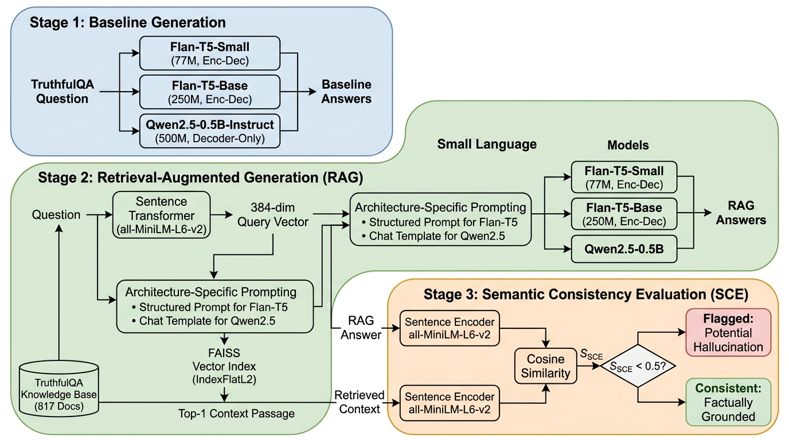
Figure 4.1: System Architecture

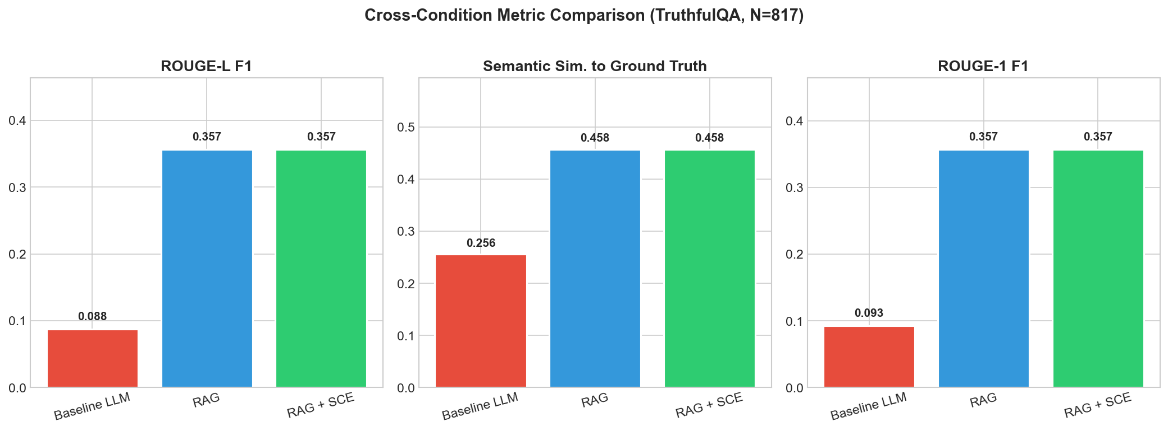
Figure 1: Bar chart

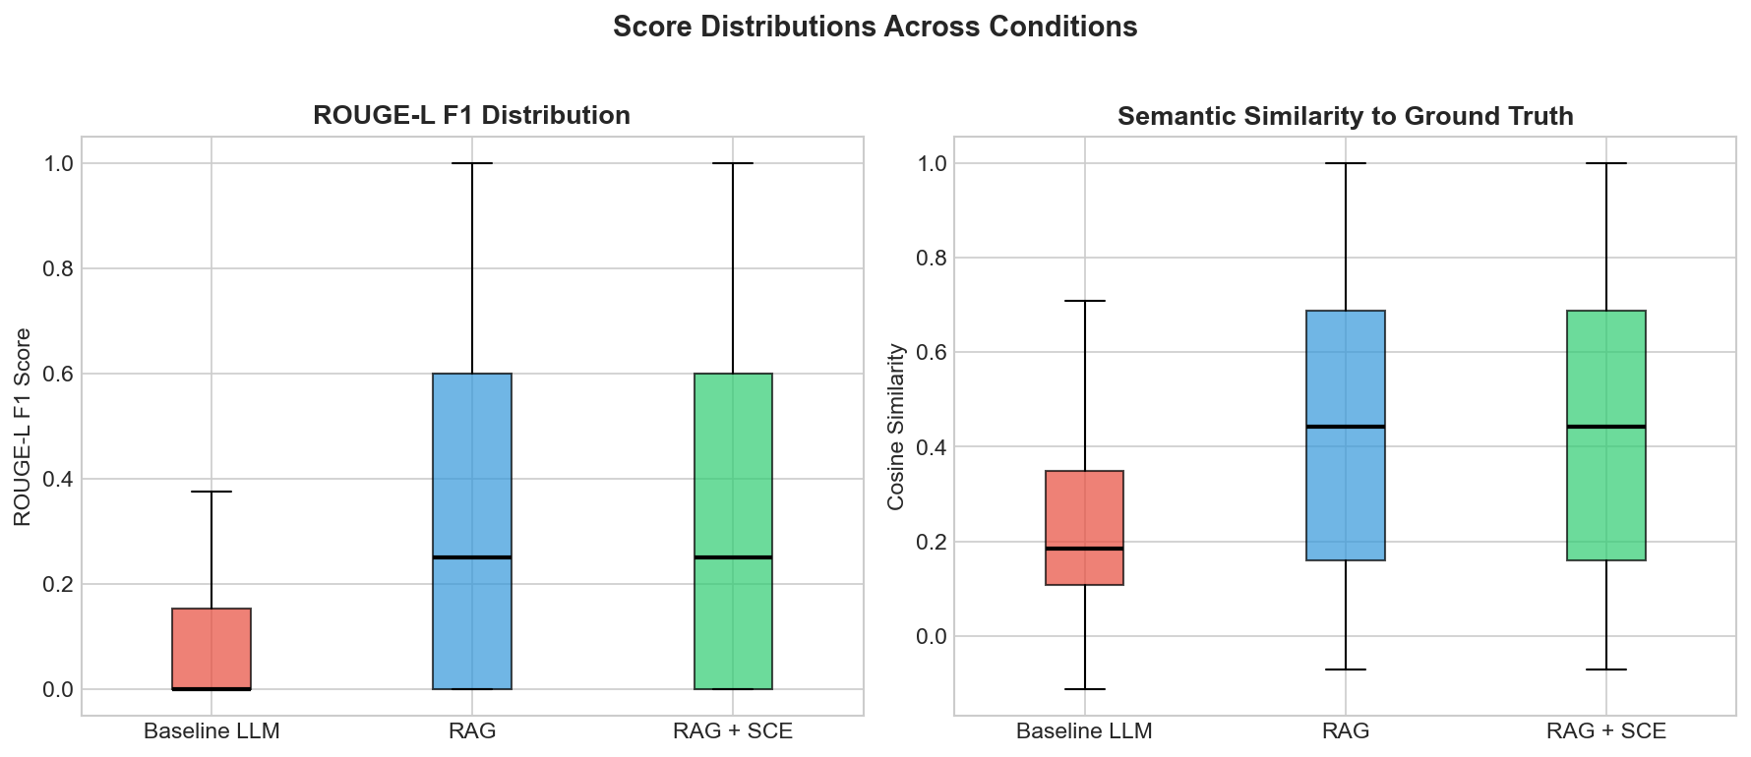
Figure 2: Box Plot

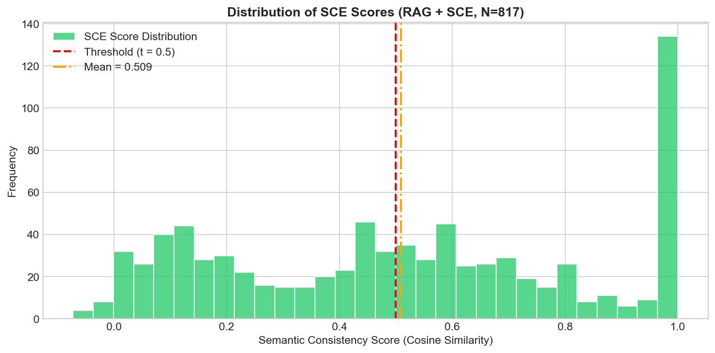

Figure 3: SCE Distribution

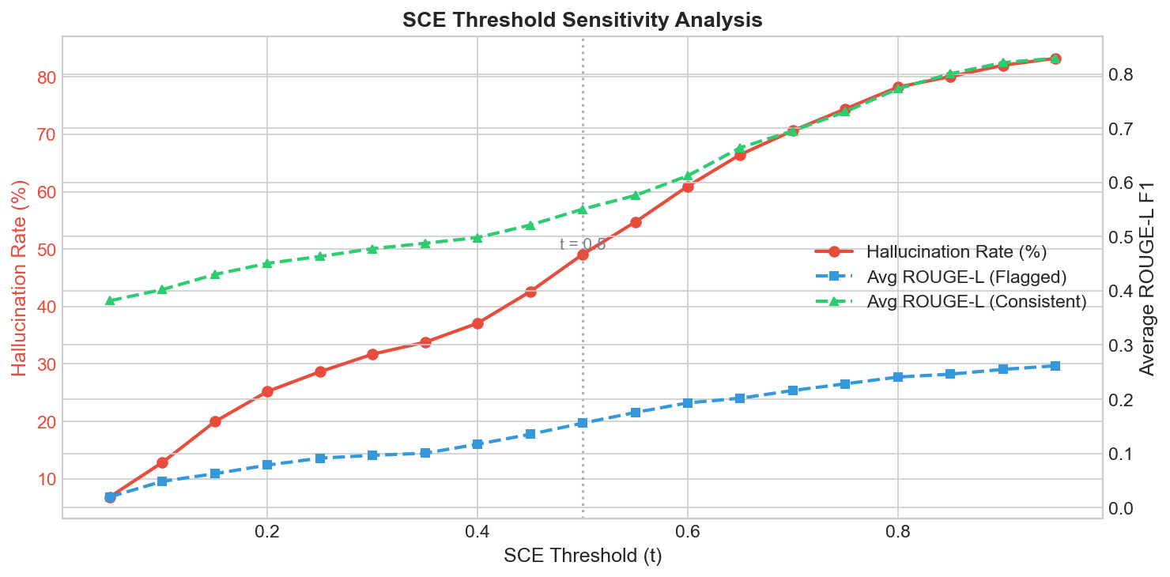

Figure 4: SCE Threshold sensitivity

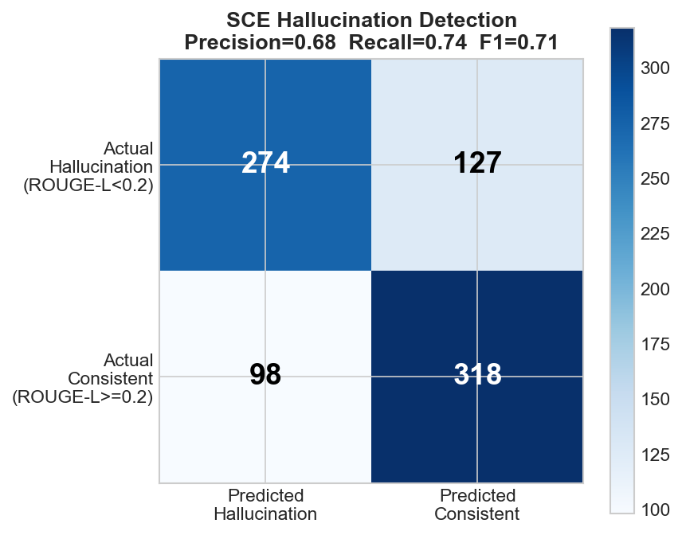

Figure 5: Confuson Matrix

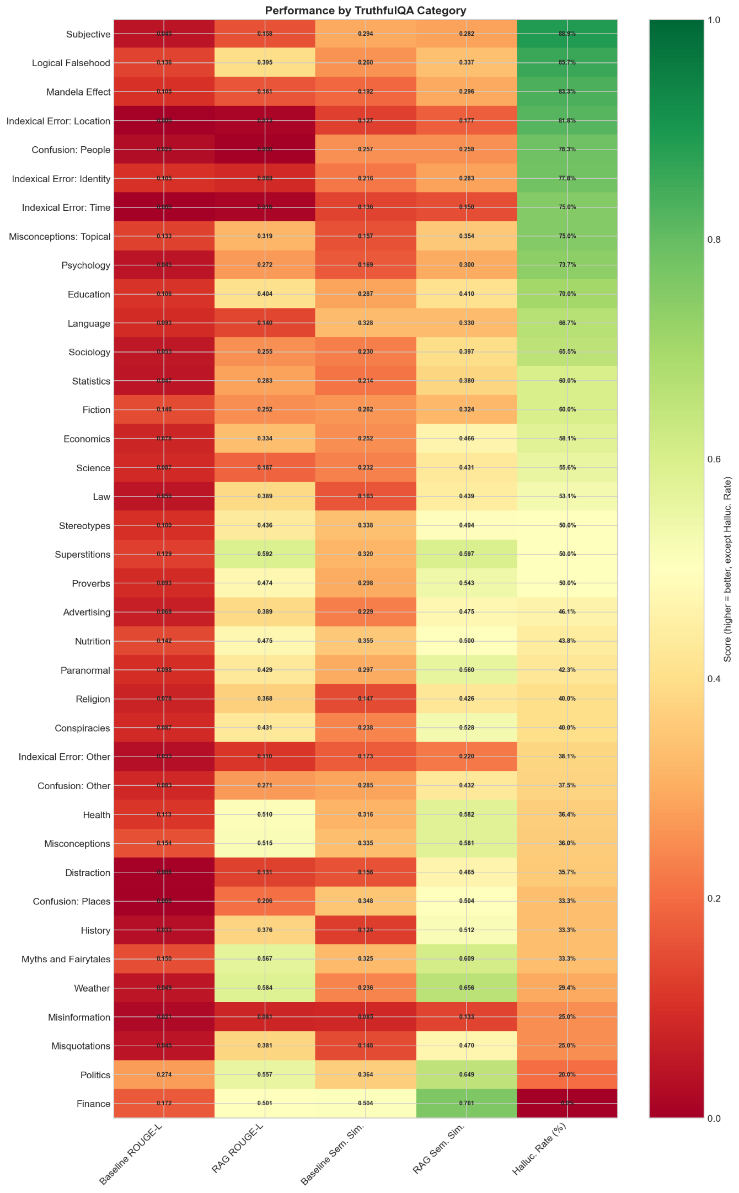
Figure 6: Category Analysis

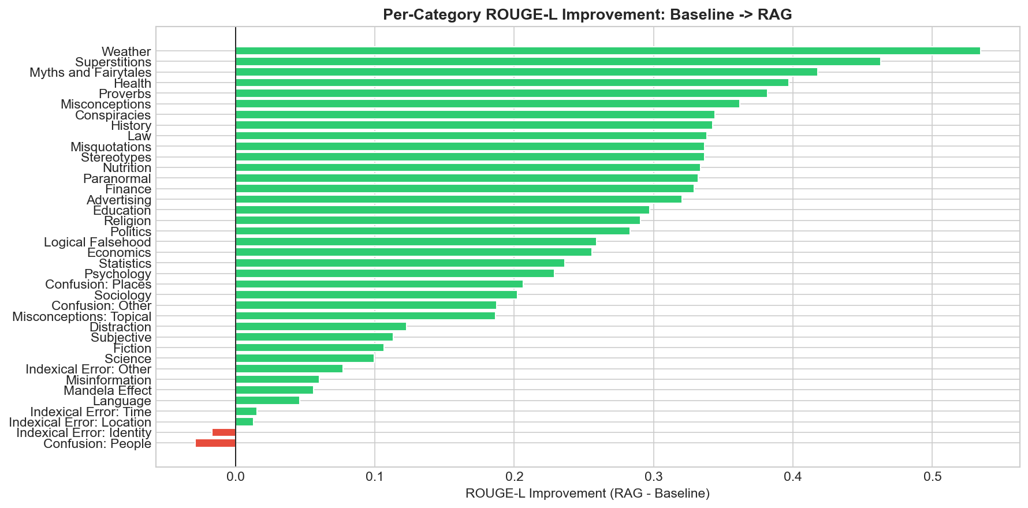

Figure 7: Category improvement

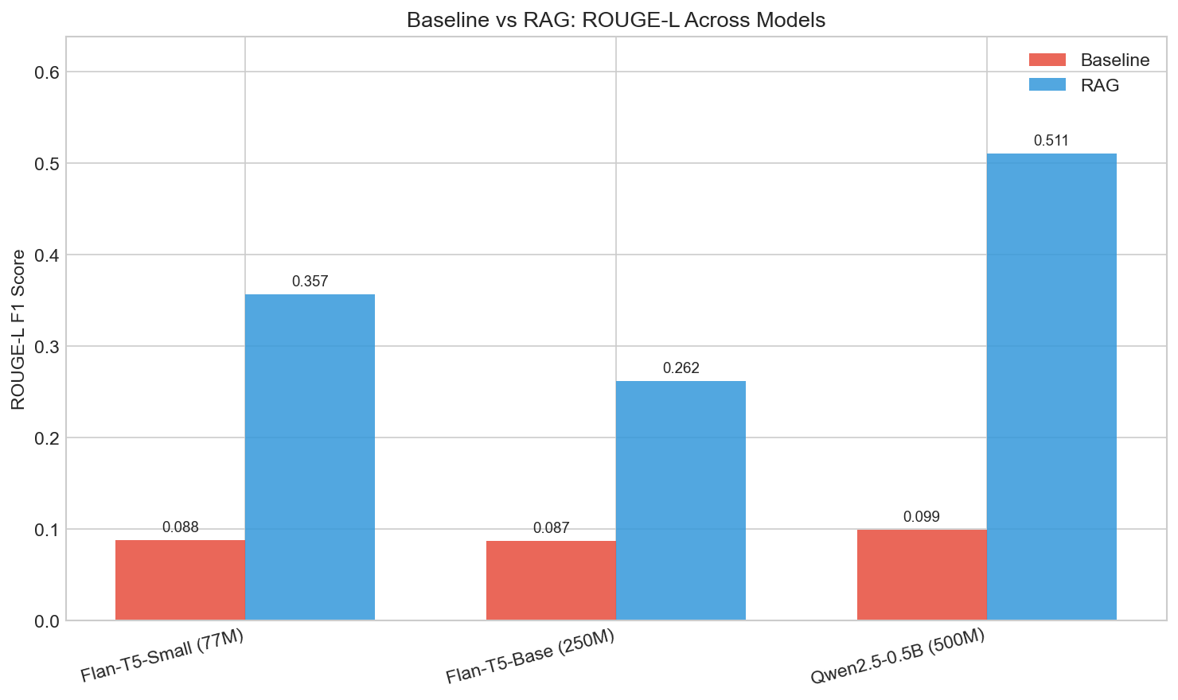
Figure 8: multimodal bar chart RAG

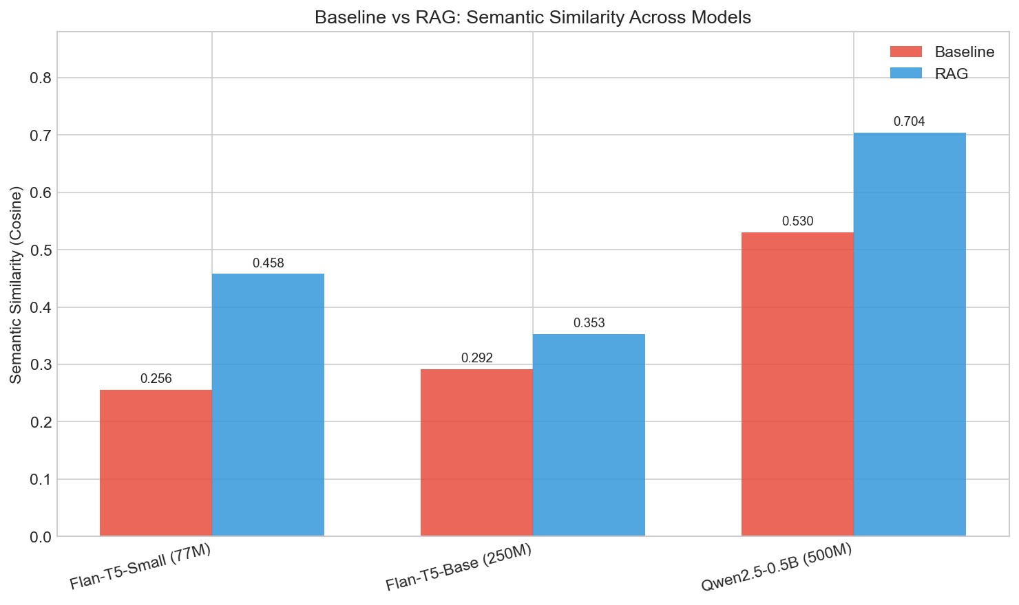

Figure 9: multimodal SCE barc chart

