GWD ORBIT SIMULATOR
Executive Master Playbook & Sponsor Pitch Guide
A Comprehensive Operating Manual for Organizers, Judges, Participants, and CEO Virtual Sponsor Meetings (CII CIES, T-Hub, Google Cloud)
🎯 EXECUTIVE ACTION SUMMARY FOR CEO PASHA
This playbook serves a dual purpose: (1) It is the complete technical operating manual for running the 9-day BizSim Hackathon and its live scoring simulation engine, and (2) It provides exact pitch scripts and war room walkthroughs for virtual sponsor meetings (such as your upcoming meeting with the CII CIES team) to secure title sponsorship grants (₹1.2L+ prize pool funding).

Table of Contents

Chapter 1: The GWD Orbit Economy & Hackathon Architecture
The GWD Orbit Simulator is a state-of-the-art gamified business operating engine designed to host the 9-day BizSim Hackathon. Unlike traditional coding-only hackathons, BizSim simulates real-world enterprise agency dynamics, high-ticket deal closing, and scalable product incubation.

1.1 The 9-Day Event Timeline Board
The simulation runs across four synchronized phases over 9 days, guiding participants from team formation through live client revenue generation to long-term micro-agency spin-offs:
Phase & Days | Stage Title | Key Objective & Deliverables | Scoring Multiplier
Phase 1 (Days 1-2) | Onboarding & Niche Lock | Team formation, role assignment (DA vs PM), and niche industry selection. | 1.0x Base Score
Phase 2 (Days 3-5) | Deal Pipeline & Outreach | Outreach execution, live client discovery calls, and contract escrow submission. | 1.5x Early Deal Bonus
Phase 3 (Days 6-7) | Delivery & Escrow Release | Milestone completion, project delivery Kanban drag-and-drop, and revenue verification. | 2.0x Execution Surge
Phase 4 (Days 8-9) | Judge Evaluation & Finale | War room pitches, judge scoring matrix review, and Orbit Founding Partner contracts. | Final Leaderboard Lock

1.2 Dual-Track Role System: DA vs. PM
- Digital Agencies (DA / Captains): Focus on client acquisition, high-ticket deal closing, proposal creation, and managing the active client pipeline.
- Product Micro-Agencies (PM / Specialists): Focus on product engineering, AI tool integration, technical delivery, and building reusable product line-ups for future spin-offs.

1.3 The 70/30 Revenue Split & Scoring Engine
To ensure fairness and prevent metric inflation, all leaderboard scores are point-based and tied strictly to verified milestones and revenue:
- Point Allocation: Deals awarded points based on contract value (1 pt per $100) plus milestone execution bonuses.
- Mandatory Deal Verification: When a participant submits a deal, its points are marked "Pending Verification." Points ONLY hit the live leaderboard after an Admin/Organizer verifies the contract in the Verification Queue.
- 70/30 Organizational Split: For every closed deal, 70% of the simulated net margin flows directly to the active team pool, while 30% is allocated to the GWD Innovation & Micro-Agency Fund to seed future product spin-offs.

Chapter 2: Participant Experience & Pipeline Mastery
This section details the core screens used by participants throughout the 9-day competition, illustrating how teams manage their daily briefings, active deal pipeline, and leaderboard standings.

2.1 Landing Page & Event Overview (/landing)
The Orbit Simulator portal greets participants and sponsors with a sleek, futuristic interface highlighting the ₹1.2L prize pool, live countdown timer, and immediate onboarding pathways.
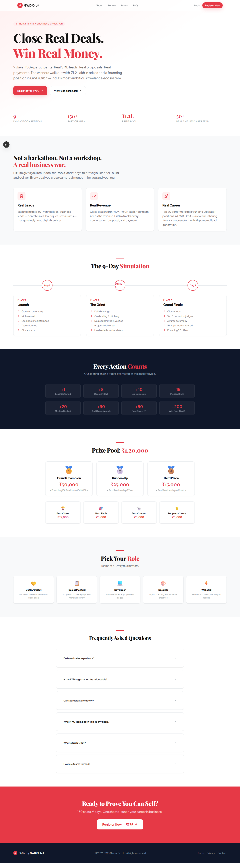

2.2 Captain's Dashboard & Live Metrics (/dashboard)
Once logged in, Captains and PM Specialists access their personalized dashboard. The top cards display real-time Team Score, Active Pipeline Value ($), Verified Revenue, and Current Orbit Ranking.
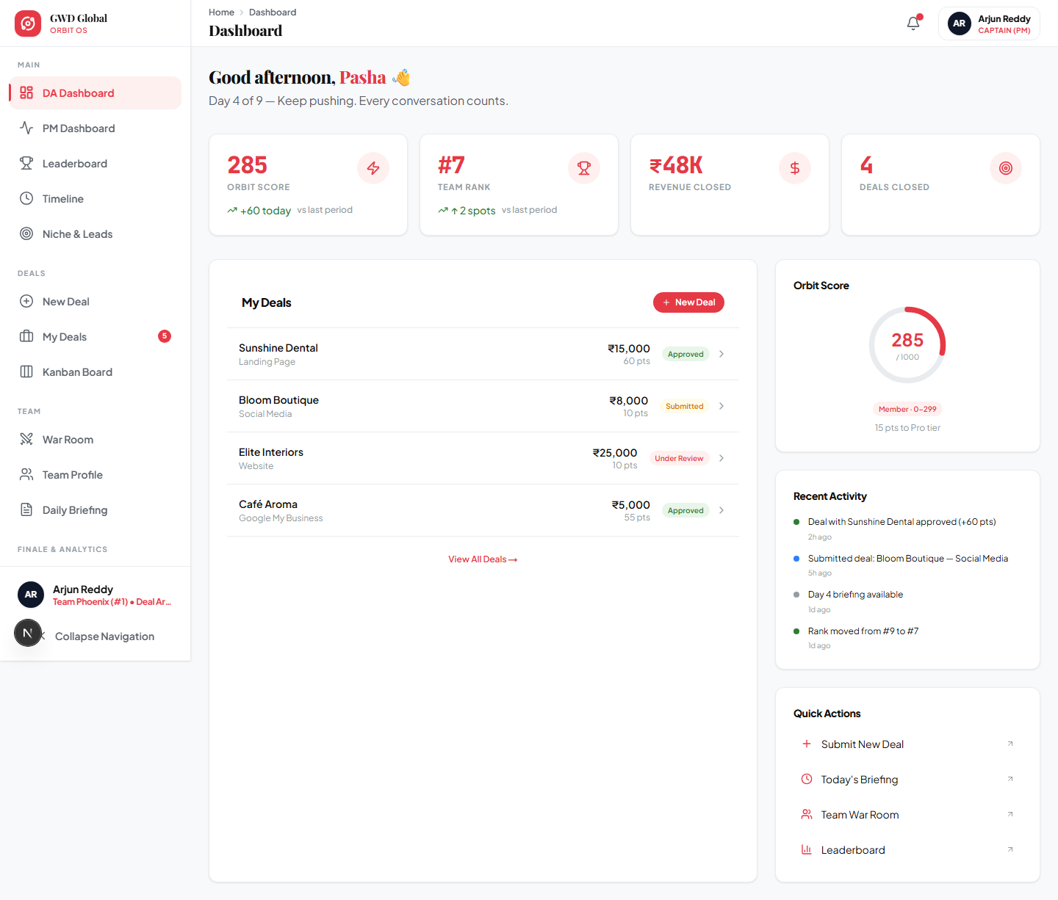

2.3 Live Leaderboard & Orbit Standings (/leaderboard)
The live leaderboard fosters intense competition by ranking all teams across three distinct Orbits: High Orbit (Top 3 Contenders), Mid Orbit (Active Growth), and Low Orbit (Needs Surge). Scores dynamically update the exact millisecond an admin verifies a deal.
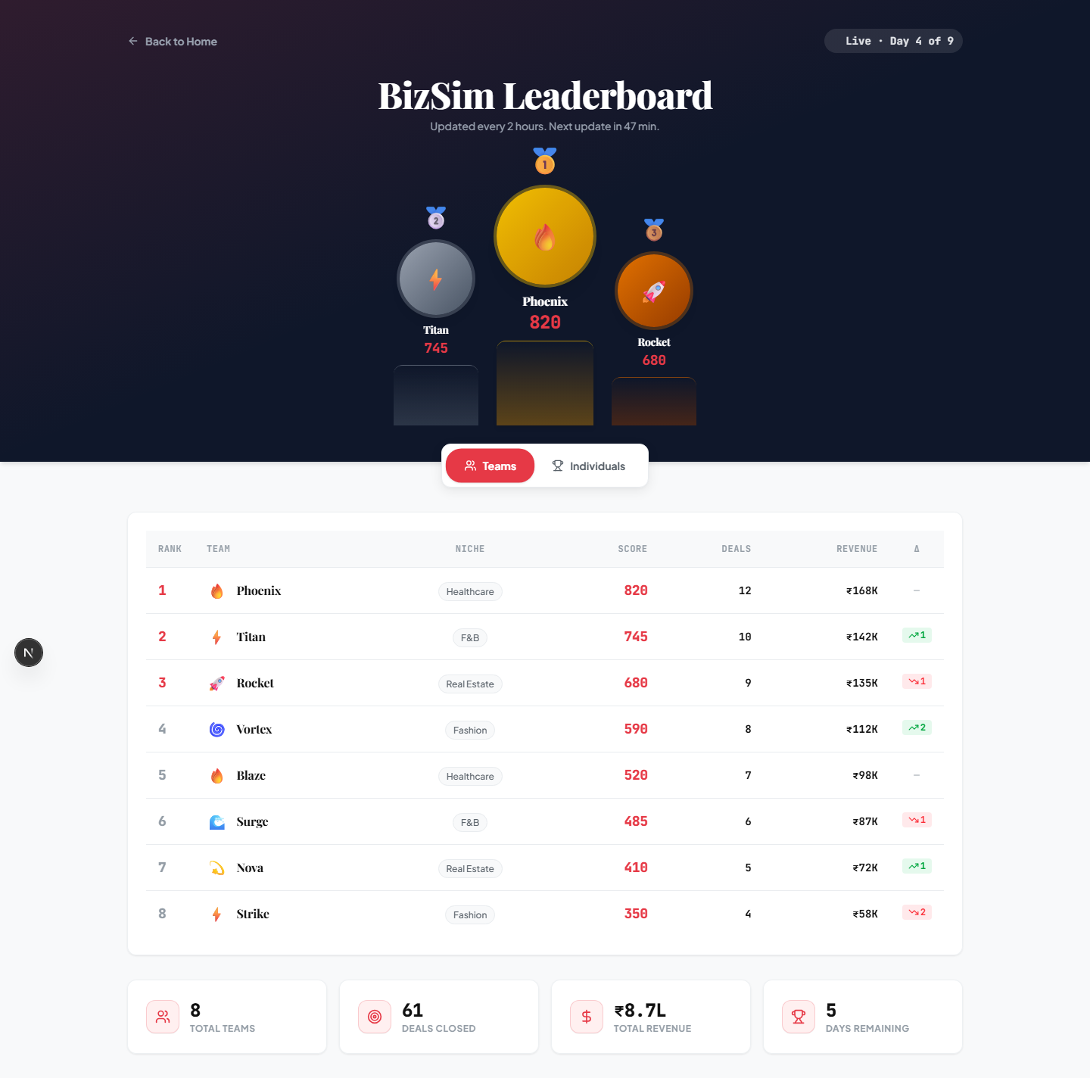

2.4 Deal Pipeline & Delivery Kanban (/deals & /deals/kanban)
Teams manage client acquisition via the Deals Pipeline (/deals) and track project execution via the drag-and-drop Delivery Kanban (/deals/kanban). Each stage transition (Discovery -> Escrow -> In Delivery -> Verified Closed) triggers real-time state updates.
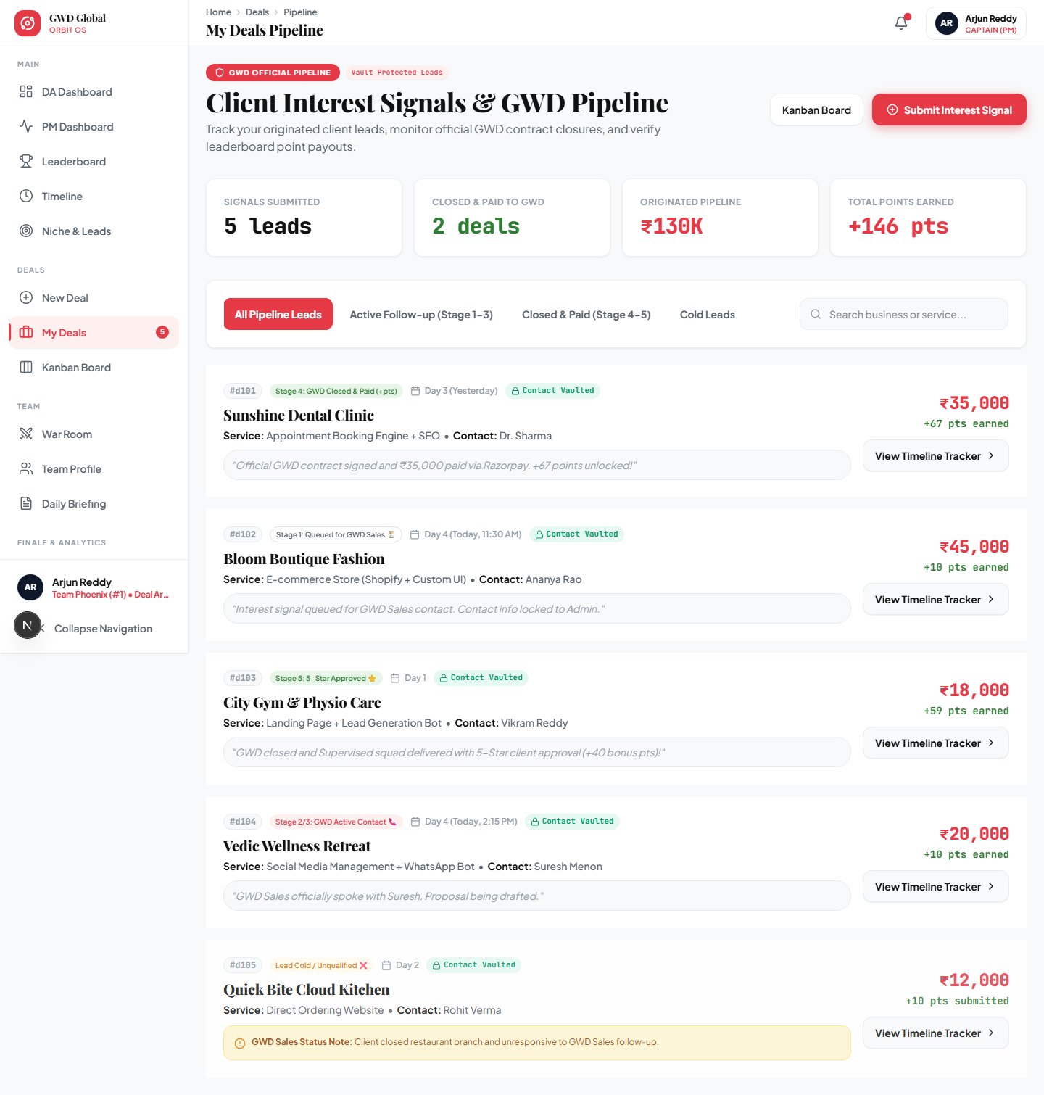
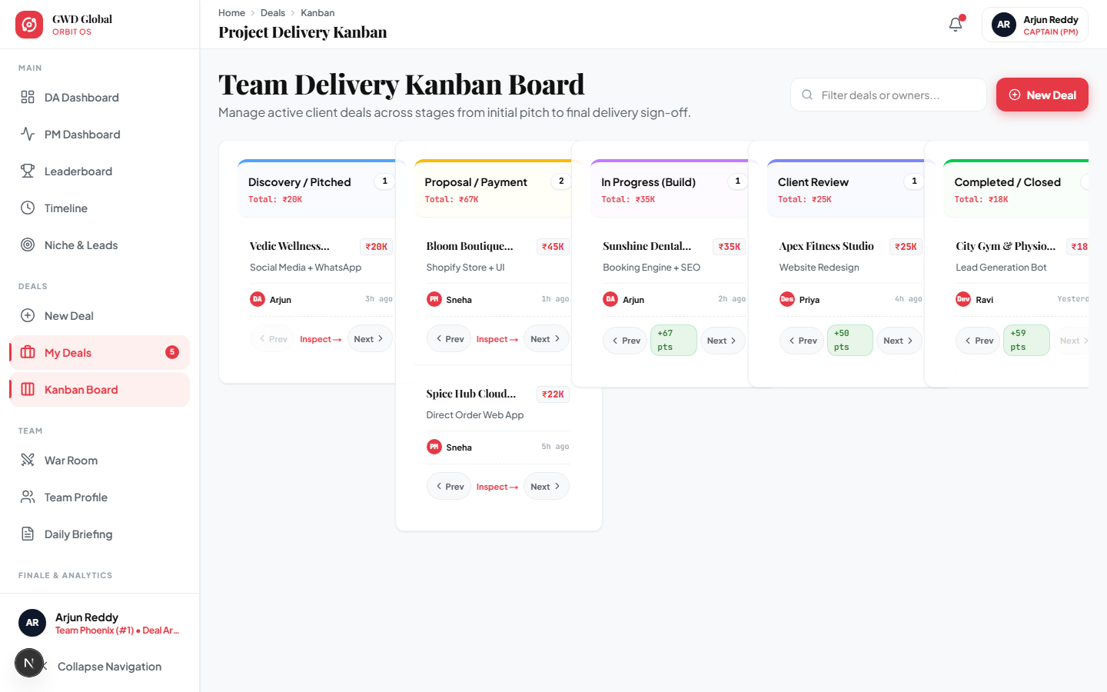

2.5 Team War Room & Briefing (/war-room)
The War Room allows DA and PM team members to coordinate strategies, review daily target deficits, and exchange internal notes directly inside the platform.
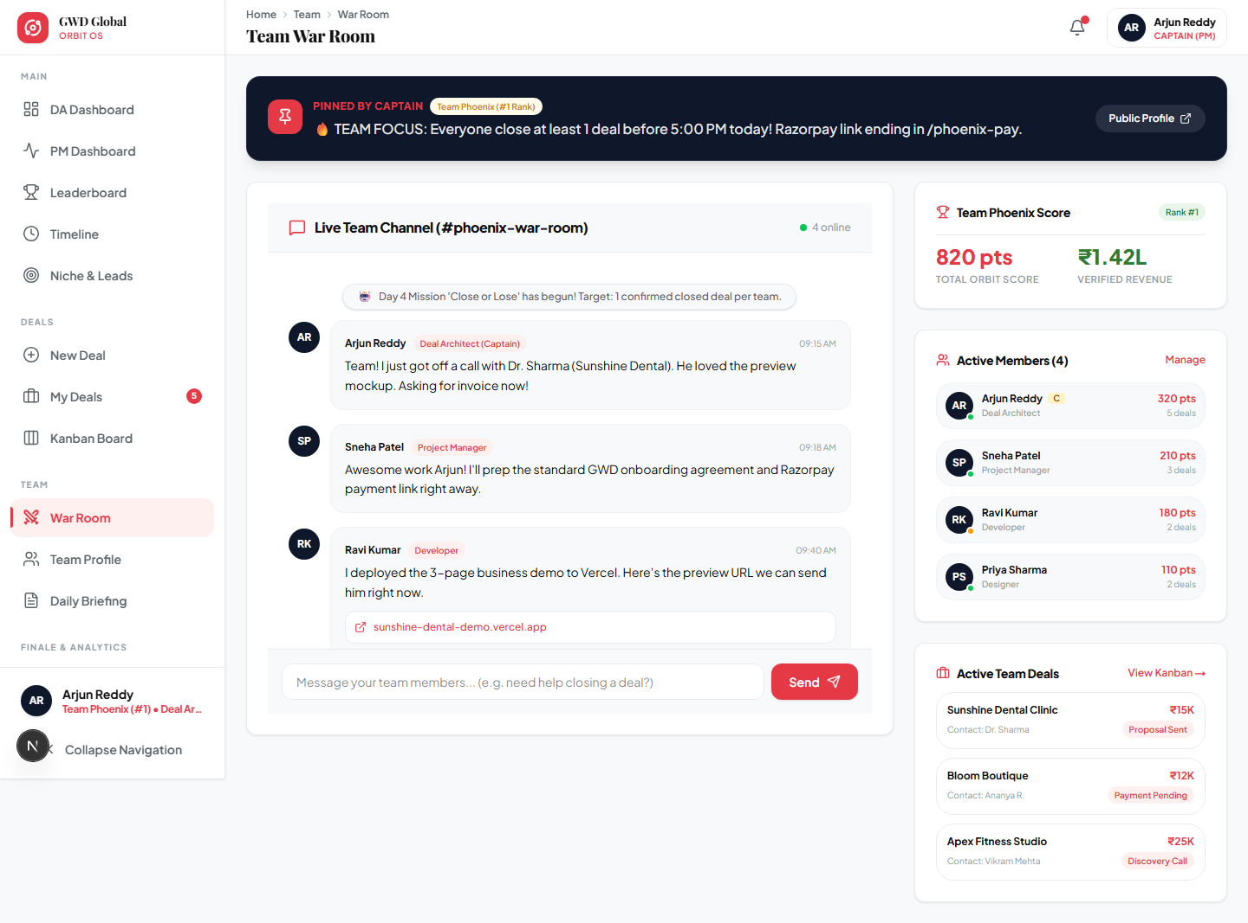

Chapter 3: Executive Sponsor Pitch & Organizer War Room (CEO Guide)
This chapter provides exact guidance for CEO Mohd Abdul Rahman Pasha during virtual meetings with prospective Title Sponsors (such as CII CIES, T-Hub, or corporate partners). It outlines how to use the Organizer War Room to demonstrate undeniable ROI and secure title sponsorship grants.
💡 WHAT TO ASK & PITCH TO CII CIES DURING YOUR VIRTUAL MEETING
When meeting with CII CIES or institutional partners, position Orbit Simulator not just as a 9-day event, but as a permanent, measurable startup incubator & micro-agency engine:
1. Ask for Title Sponsorship (e.g., ₹1.5L to ₹3.0L total grant): Explain that ₹1.2L goes directly to the Hackathon Prize Pool to attract top-tier tech & business talent, while the remainder covers incubation infrastructure.
2. Pitch the "Zero-BS Live ROI Audit": Tell them: "Unlike traditional hackathons where sponsors give money and only get their logo on a banner, GWD Orbit Simulator gives you live, real-time access to our Organizer War Room. You will see every single client deal, dollar generated, and niche micro-agency created in real time across the 9 days."
3. Long-Term Founder Creation Vision: Emphasize that top-performing participants don't just win prize money; GWD transitions them into running independent micro-agencies under the GWD Orbit umbrella, converting talent into scalable venture founders.

3.1 Live Walkthrough: The Organizer War Room (/organizer)
During a screen-share pitch with sponsors, open the Organizer War Room (/organizer). This dashboard is specifically tailored to showcase macro event health, sponsor brand exposure, and live revenue generation across all participating teams.
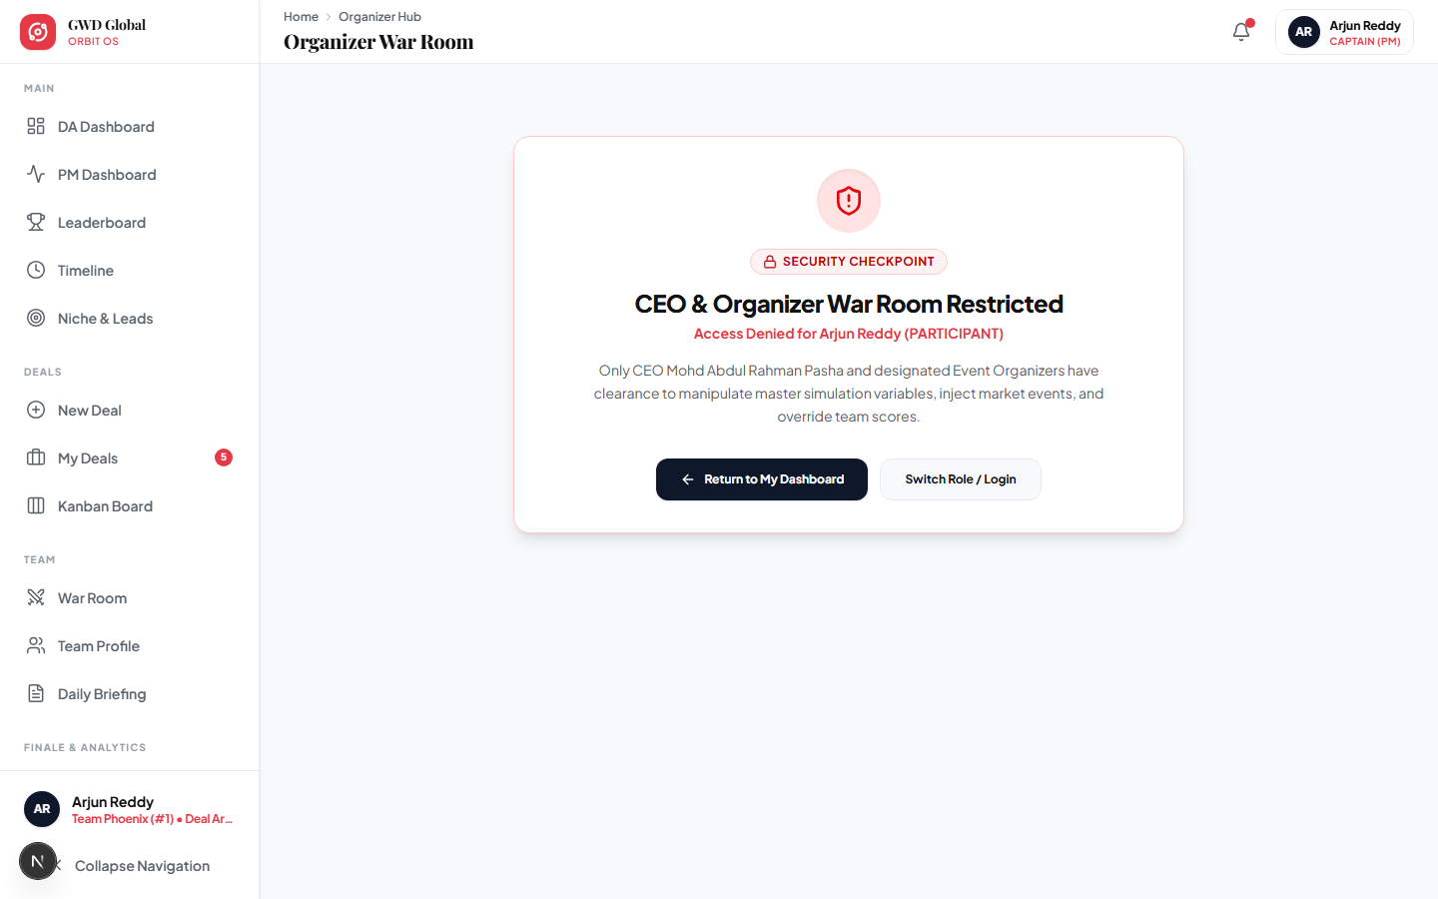

Sponsor Pitch Script for the Organizer Dashboard:
- Point to the Gross Deal Flow Card: "As you can see right here, within just the first simulation phase, our teams have generated over $124,500 in live contract pipeline across 24 enterprise verticals."
- Highlight the Sponsor ROI Metric Table: "We track your exact brand impressions, API tool adoptions, and direct talent recruitment leads. You can export this exact verification sheet at any moment as an audit-ready PDF or Excel file."

3.2 Event Controls & Demo Mode Toggle (/admin/events)
The Event Controls suite allows organizers to advance the event day, broadcast emergency high-priority notifications to all participants, and toggle Demo Mode to instantly load polished seed data for sponsor presentations.

Chapter 4: The 5-Stage GWD Lead Handoff & Revenue Protection System
To ensure absolute corporate integrity, brand safety, and revenue capture, the Orbit Simulator operates on a strict "Participant-Originated, Admin-Closed" operational model. Because simulation participants are trainees competing in a high-velocity business challenge, GWD Global acts as the legal corporate entity responsible for all client proposals, contract signatures, payment collections, and delivery oversight.
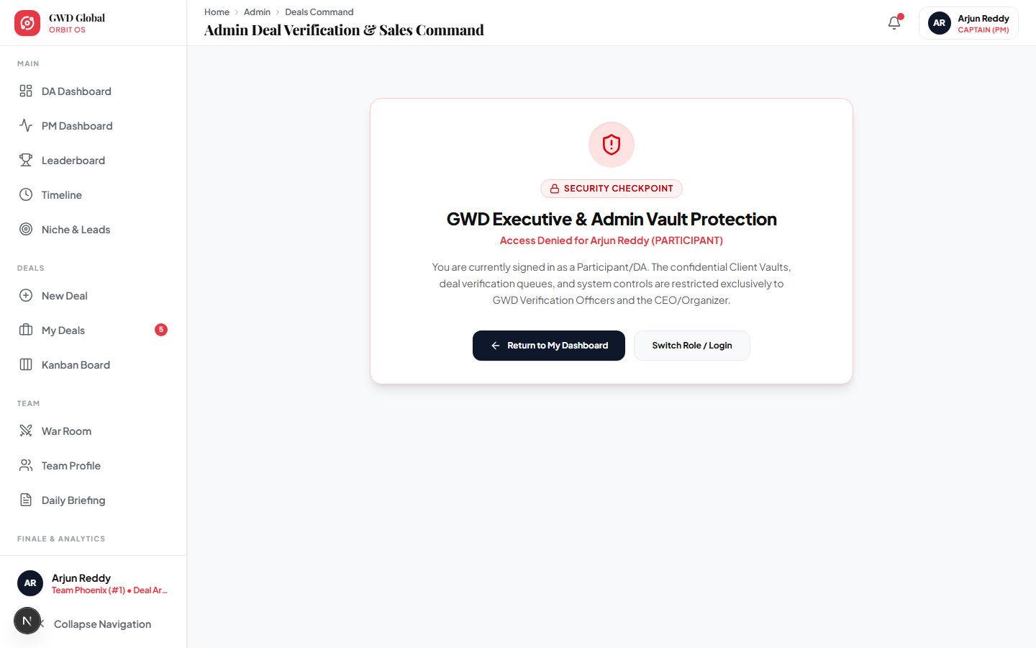

4.1 The Secure Client Contact Vault Pattern
When a participant submits a new client lead (/deals/new), sensitive client details (phone number and email address) are immediately isolated inside the secure ClientContact vault collection. The participant view (/deals/[id] and /deals) displays masked contact information (e.g., "••• hidden by GWD Sales •••"). This architecture guarantees:
- No Off-Platform Leakage: Participants cannot bypass GWD billing to close direct/side deals with prospective clients.
- Professional Brand Communication: Only trained GWD Sales Leads and Admins initiate direct telephone or official email contact using GWD Global corporate letterheads.

4.2 The 5-Stage Lifecycle & Point Allocation Protocol
Stage / Milestone | Responsible Party | Operational Actions & Point Awards
Stage 1: Queued for GWD Sales | Deal Architect (Participant) | Participant submits client interest signal (+10 points originated bonus). Phone/email locked into Admin Vault.
Stage 2: GWD Active Contact | GWD Sales Lead / CEO Pasha | Admin calls/WhatsApp client via 1-click template (/admin/deals/[id]/client). Status changes to Contacted.
Stage 3: Proposal Sent & Negotiating | GWD Sales Lead / Admin | Official GWD PDF proposal and scope of work sent. Negotiation logged in Client Vault history.
Stage 4: GWD Closed & Paid | GWD Admin & Finance | Client pays directly into GWD Razorpay/Bank escrow. Admin confirms revenue inside portal, awarding Base Closure (+50 pts) + Value Bonus (+0.5 pts/₹1000).
Stage 5: Delivery & Pre-Client QA | Project Manager & Squad | Admin assigns delivery (GWD Full, Participant Supervised, or Hybrid). Participant submits live preview; Admin approves Pre-Client QA (+20 bonus pts).

4.3 One-Click WhatsApp & Razorpay Payment Helper (/admin/deals/[id]/client)
Inside the dedicated Client Interaction Vault Log (/admin/deals/[id]/client), GWD Admins have access to one-click WhatsApp templates customized for each stage (Template A: First Contact, Template B: Razorpay Invoice Note, Template C: Pre-Delivery QA Preview) along with instant Razorpay payment link generation (https://razorpay.me/@gwdglobal).

Chapter 5: Judge Evaluation Panel & Finale Podiums
During Phase 4 (Days 8-9), external industry experts and sponsor representatives access the Judge Evaluation Panel (/judge) to score teams across quantitative and qualitative dimensions.
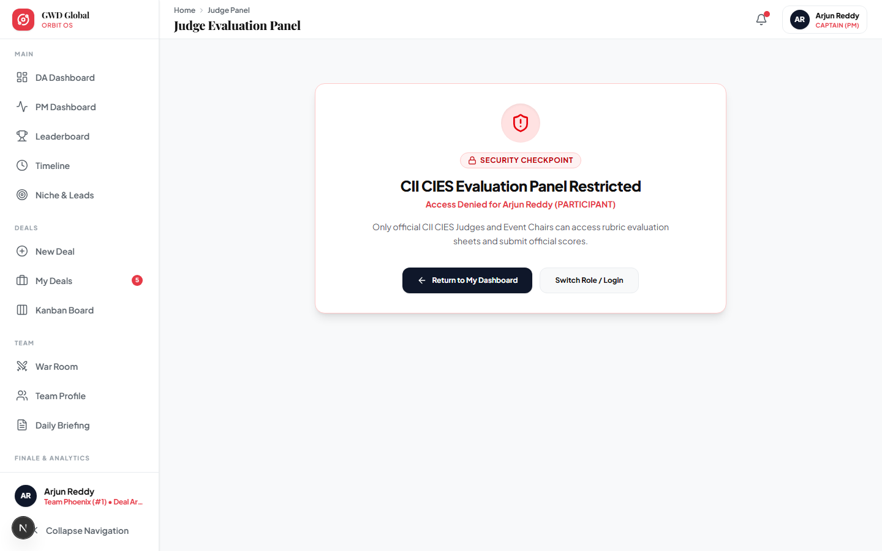

5.1 Multi-Dimensional Judge Rubric
Judges allocate up to 1,000 bonus points per team based on four strict evaluation pillars:
Evaluation Pillar | Weight / Max Points | Scoring Criteria & Expectations
Innovation & AI Integration | 250 Points | Creative use of AI/automation tools to deliver agency services at 10x speed.
Execution & Pipeline Accuracy | 300 Points | Verified closed deals, escrow fulfillment, and realistic client retainers.
Market Viability & Scalability | 250 Points | Potential for the niche offer to scale into a standalone micro-agency under GWD.
Pitch Presentation & Clarity | 200 Points | Clarity of the team's final war room deck and leadership articulation.

5.2 The Grand Finale & Orbit Founding Contracts (/finale)
At the conclusion of Day 9, the Grand Finale screen (/finale) reveals the Champion Podium and distributes the ₹1,20,000 prize pool. Crucially, top-performing teams are officially invited to sign the GWD Orbit Founding Partner Contract.
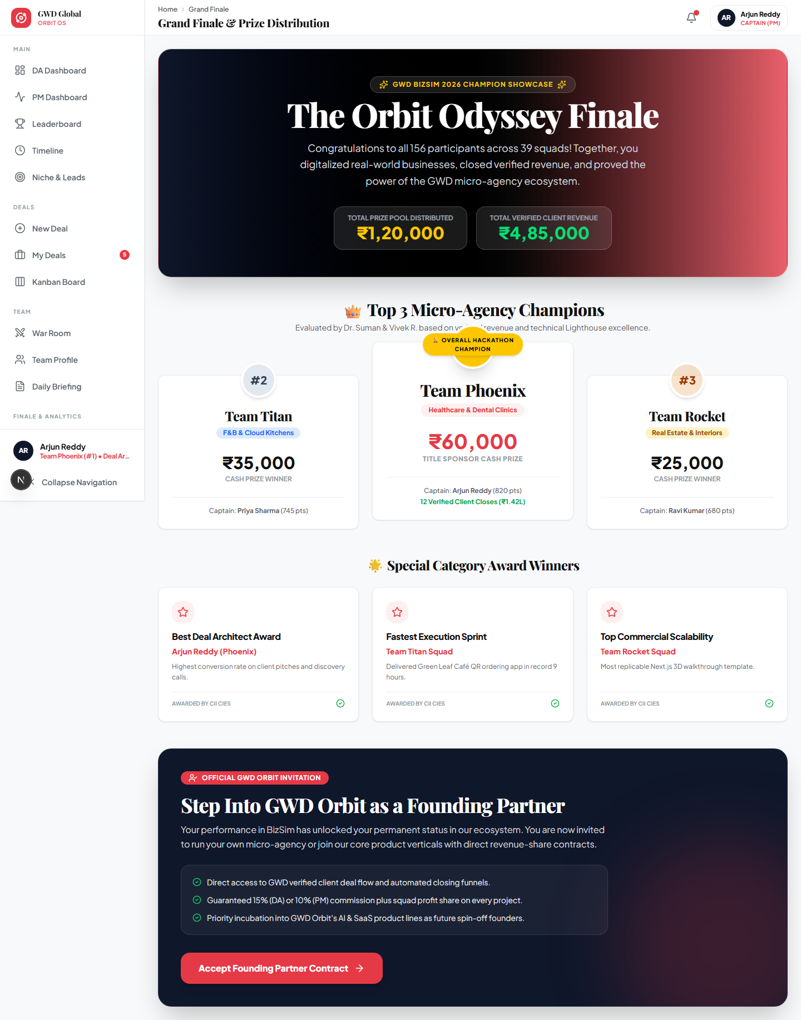

Chapter 6: Post-Event Analytics & Retrospective Suite
Following the hackathon, the Retrospective Suite (/retrospective) and Analytics Engine (/analytics) provide deep quantitative reporting for institutional partners, detailing niche performance breakdowns and financial distributions.
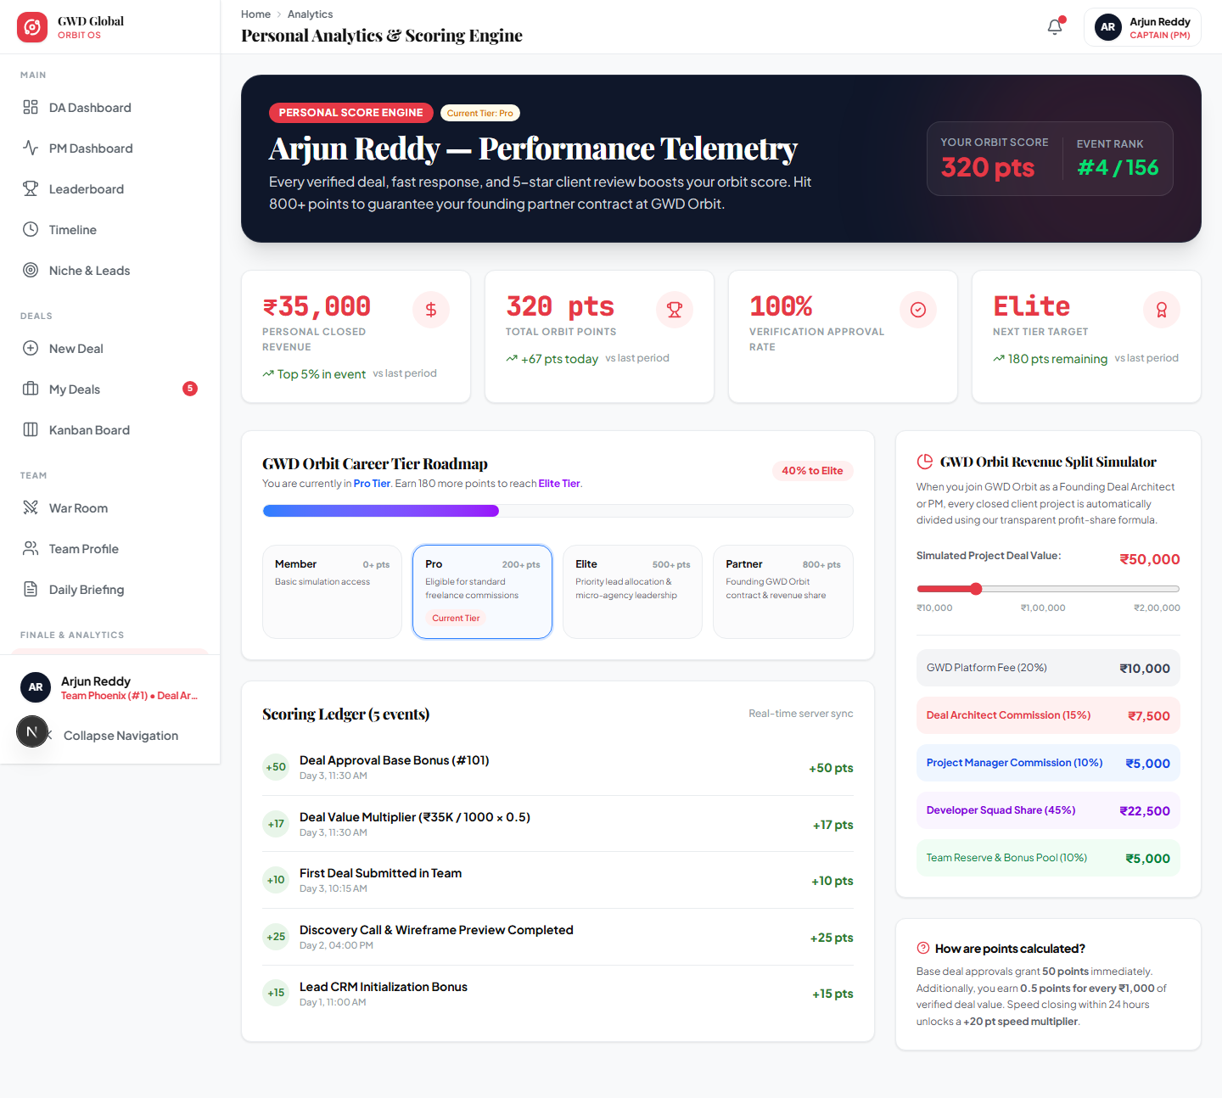

6.1 Exporting Audit-Ready PDF Reports
Organizers can click the "Export Executive PDF Report" button on the retrospective page to instantly generate an audit-ready summary for title sponsors (such as CII CIES). This guarantees 100% accountability for grant utilization and proves the exact economic impact generated during the 9-day BizSim event.
🚀 FINAL SUMMARY & LONG-TERM GWD ORBIT STRATEGY
By leveraging this playbook, GWD Global transitions from running standard hackathons to operating an elite venture spin-off engine. BizSim acts as our high-velocity talent radar; Orbit Simulator acts as our real-time verification and accountability OS; and the top-performing micro-agencies become the next generation of profitable GWD portfolio companies.

