Fault tolerance of Embedded System
Assignment 3
Assignment 3
Author: your surname, your name
Supervisor: Mehdi Saman Azari
Semester: HT25
Course code: 2DT303

Hema

Deadline:
The deadline to submit the assignment is 19 Oct 2025.

Rules:
- You have to submit a report for Assignment 3, with the LNU template.
- You have to submit a file in .pdf format.
- You must use the LNU template for your report. You are allowed to use this file or a new one. In both cases, the student has to adopt the LNU template.
- The file you submit must be renamed as follows <ASGM3 -surname_name.pdf>
- Deadline is 19 Oct 2025. Each day of delay over the submission deadline will cause a 2 points penalization.
- The evaluation for this assignment is in points. Maximum points 50pts.

Exercise 1 (50 points)

The objective of this assignment is to investigate and understand the fault tolerance capabilities of the Raspberry Pi Pico microcontroller, identify potential failure scenarios, and develop strategies to mitigate or recover from these faults.
Initial phase:
  - Conduct an initial Raspberry Pi project that includes hardware in a loop, featuring at least one sensor and one actuator. Please note that the complexity of the baseline project will influence the execution of this assignment and will also affect the final grade.
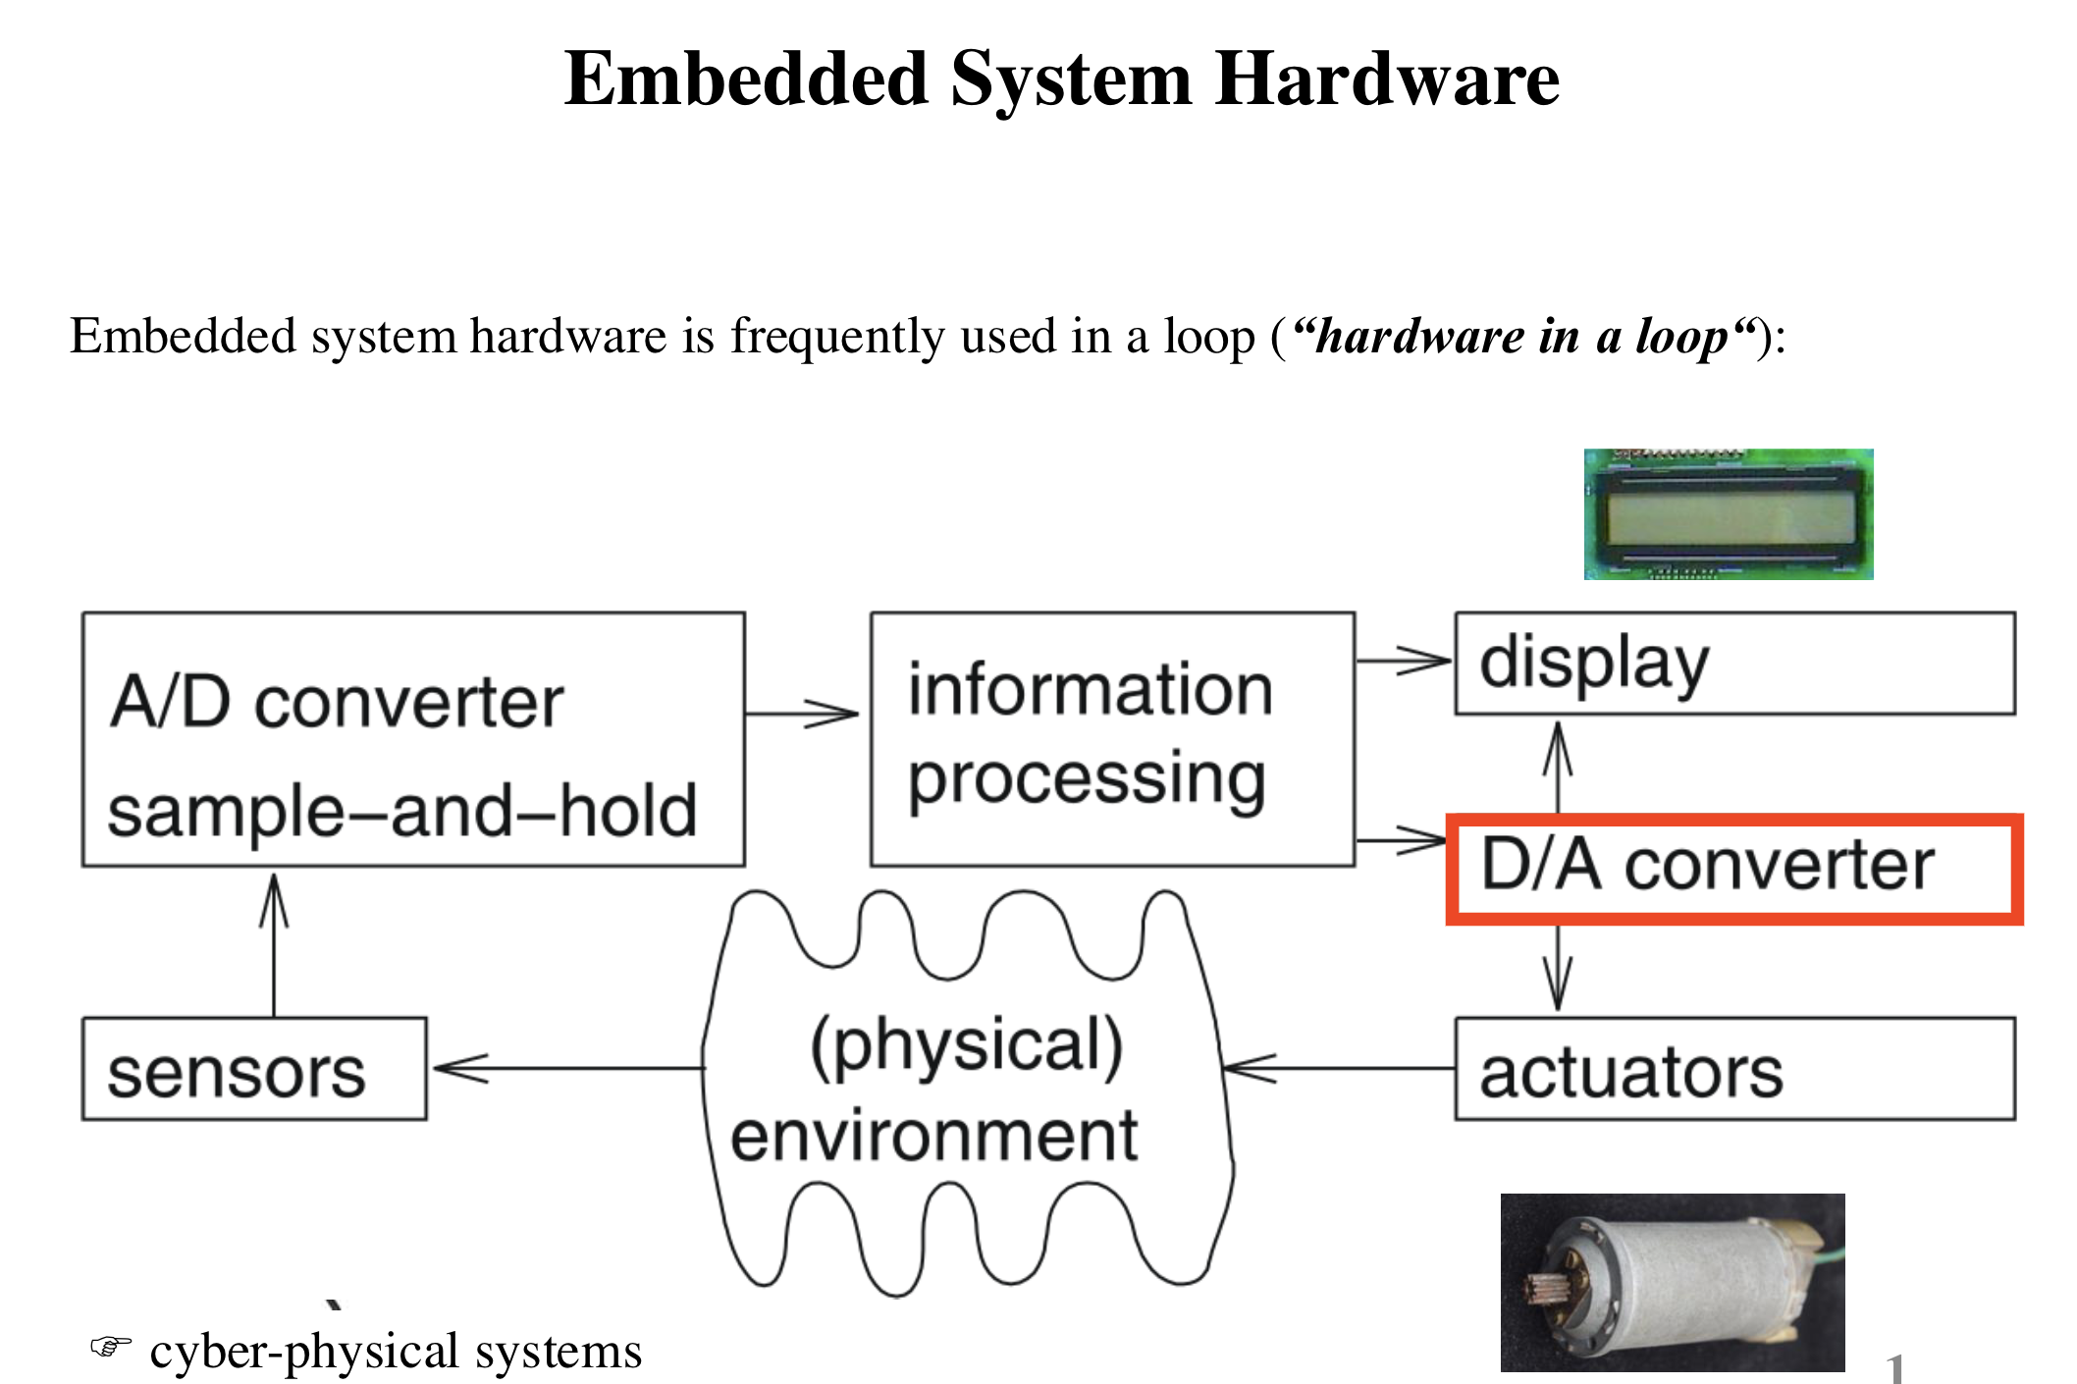

  - Ensure that the Raspberry Pi Pico functions correctly under normal operating conditions.

Project Tasks:
Task 1: Introduction to Fault Tolerance
- Provide a brief overview of fault tolerance, its importance in real-world applications.
Fault tolerance is the ability of a system to keep working correctly even when something goes wrong. In embedded systems, this means the system can detect, handle, or recover from faults without completely failing. The main goal is to make the system dependable by maintaining reliability and availability. To achieve this, designers often use techniques like redundancy, watchdog timers, and error detection to minimize the impact of faults.
- Explain the concept of fault tolerance in embedded systems, specifically in the context of Raspberry Pi Pico.
Fault tolerance is very important in real-world applications because embedded systems are often used in safety-critical areas like cars, medical equipment, and industrial automation. For example, an airbag controller must still work even if a sensor fails, and a medical device must continue to operate during small electrical disturbances.
In the case of the Raspberry Pi Pico, fault tolerance can be achieved using both hardware and software solutions. Hardware techniques include adding watchdog timers to reset the system if it freezes, using backup sensors to confirm readings, and stabilizing the power supply. On the software side, techniques like exception handling, data validation, and saving system states can help the Pico recover from unexpected errors. Since the Pico has two cores, one can be used to monitor the other, which adds an extra layer of fault detection and reliability.

- List the common types of faults that can occur in hardware in loop component, especially in embedded systems.
When working with hardware-in-the-loop (HIL) setups that combine sensors and actuators, different types of faults can occur:
- Transient faults: Short, temporary problems caused by voltage spikes or electromagnetic interference.
- Intermittent faults: Irregular issues such as loose wires or unstable connections.
- Permanent faults: Long-lasting failures like a damaged sensor or actuator.
- Software faults: Bugs in the code that cause crashes or incorrect outputs. Communication faults: Data errors or loss during I²C, SPI, or UART communication.
- Environmental faults: External factors such as temperature or humidity affecting hardware stability.

Task 2: Identifying Fault Scenarios
In Task 2, you need explore potential fault scenarios that could affect your baseline project based on Raspberry Pi Pico, aiming to gain a deeper understanding of the various risks and vulnerabilities that an embedded system may encounter. This task is designed to encourage you to think critically about the potential challenges in fault tolerance and prepare you for developing relevant strategies in the subsequent tasks.
- Brainstorm Fault Scenarios: you should brainstorm a list of fault scenarios. These scenarios should encompass a wide range of potential issues that could affect the operation of your baseline project. Examples include:
  - Power supply interruptions or voltage fluctuations.
  - Code errors, such as infinite loops or software crashes.
  - Hardware faults like a malfunctioning sensor or actuator or a broken connection.
  - Environmental factors like extreme temperatures or humidity.
  - Communication failures with other devices or network issues.

- Describe Each Scenario: For each identified fault scenario, you should provide a detailed description, explaining what the scenario entails, its potential consequences, and how it might impact the operation of the Raspberry Pi Pico.

- Prioritize Scenarios: Once you have a list of fault scenarios, you should prioritize them. So, in addition to describing and prioritizing scenarios, create a Failure Modes and Effects Analysis (FMEA) table with at least 5 identified failure modes, showing:
- Fault description
- Effect on the system
- Severity (1–10)
- Likelihood (1–10)
- Detection difficulty (1–10)
- Risk Priority Number (RPN = Severity × Likelihood × Detection

Task 3: Developing Fault Tolerance Strategies

In Task 3, you need focus on developing strategies to address the fault scenarios that identified in Task 2. you need explore various fault tolerance mechanisms that can be applied to the Raspberry Pi Pico and decide on a strategy to implement for specific fault scenario.

- Review Fault Scenarios: Begin by revisiting the list of fault scenarios identified in Task 2. Select two fault scenarios—one hardware fault and one software fault—that are relevant to your project/application.

- Research Fault Tolerance Mechanisms: For each selected scenario, develop a fault-tolerance strategy (briefly justify why you chose the scenario and why the strategy is appropriate). Some common mechanisms include:

  - Code redundancy: Implementing backup or redundant code paths.
  - Error handling: Implementing error-checking and error-handling routines in the code.
  - Backup power sources: Integrating backup power supplies (e.g., batteries or supercapacitors).
  - Watchdog timers: Using hardware or software timers to monitor system health.
  - Sensor redundancy: Employing multiple sensors for the same measurement.
- Resource Requirements: Identify any additional components or resources required for implementing the chosen strategy (e.g., extra sensors, capacitors, hardware watchdog timer, etc.). Ensure these resources are readily available.

Task 4: Practical Implementation

In Task 4, you must implement each of the two fault-tolerance strategies you selected in Task 3—one for the hardware fault and one for the software fault—on the Raspberry Pi Pico. This hands-on task gives you practical experience integrating fault-tolerance mechanisms into embedded system.

- Code Implementation: you need write or modify the code to integrate the selected fault tolerance strategy into their Raspberry Pi Pico project. This may involve incorporating redundancy, error handling, watchdog timers, or other mechanisms, as chosen in Task 3.
- Hardware Integration: If the chosen fault tolerance strategy involves additional hardware components (e.g., backup power sources, sensors), you should connect and integrate these components with the Raspberry Pi Pico.
- Testing: After implementing their chosen strategies, you should carry out tests to evaluate the effectiveness of their fault tolerance mechanisms.
- Analysis: you should document the results of the tests and analyse how well their strategy mitigated or recovered from the fault.

​# Evaluation Criteria
This assignment will be assessed based on the following criteria:
- Complexity of the baseline project.
- Creativity and effectiveness of fault tolerance strategies.
- Quality of implementation.
- Comprehensive testing and evaluation.
- Clarity and organization of the report.. You must submit a detailed academic-style report that answers each task’s questions one by one in separate, clearly labeled sections (Task 1 → Task 4). Include figures/tables where relevant, cite any sources used, and ensure the document is well organized and readable.

# Notes
- This assignment should be completed individually

