**A PROJECT REPORT PHASE V**

**COMPREHENSIVE-COVID 19 CASES -ANALYSIS**

***A report submitted in fulfilment of the project***

## Of

**DATA ANALYTICS WITH COGNOS - GROUP 1**

## In

NAAN MUDHALVAN



# DEPARTMENT OF COMPUTER SCIENCE AND ENGINEERING COLLEGE OF ENGINEERING GUINDY

**ANNA UNIVERSITY CHENNAI 600025**

*submission on*

# 1-NOV-2023

***Submitted by***

|  |  |
| --- | --- |
| DHUSYANTH KARTHIC S | 2021103522 |
| DHINAKARAN | 2021103307 |
| RIDA ESHAL | 2021103565 |
| SMRITHI R | 2021103580 |
| RAHAMATH | 2021103561 |

# ABSTRACT:

The COVID-19 pandemic has had a profound impact on global public health, economies, and societies. This report presents a comprehensive analysis of COVID-19 cases, utilizing a design thinking approach to derive actionable insights. The analysis focuses on understanding the spread of the virus, identifying hotspots, assessing its impact on healthcare systems, and making predictions about future trends. This report highlights key findings that are crucial for policymakers, public health officials, and researchers to navigate the ongoing challenges of the pandemic.

# INTRODUCTION:

The COVID-19 pandemic, caused by the novel coronavirus SARS-CoV-2, rapidly emerged as a global crisis, challenging healthcare systems, economies, and daily life. In response to this unprecedented challenge, the need for data analysis and design thinking became more apparent than ever. This report delves into the intricate details of COVID-19 case analysis, emphasizing the importance of a data-driven approach to address the pandemic's multifaceted nature. In this context, the report sets out its specific objectives, aiming to understand the dynamics of virus spread, identify high-risk areas, evaluate the strain on healthcare systems, and provide insights into potential future scenarios.

# OBJECTIVE:

The objectives of this analysis are multifaceted. First, we seek to understand the spread of COVID-19 by examining infection rates, mortality rates, recovery rates, and variations over time. Additionally, we aim to explore the impact of demographic factors such as age, gender, and other characteristics on the spread and severity of the disease. Furthermore, we conduct a geographical analysis to unveil regional disparities in infection rates and evaluate the effectiveness of containment measures. Lastly, we assess the impact of the pandemic on healthcare systems, including the availability of resources, hospitalization rates, and the quality of patient care. These objectives form the backbone of our analysis.

# DESIGN THINKING PROCESS:

Design thinking is a human-centered and iterative problem-solving approach that plays a pivotal role in the comprehensive bus boarding analysis. The methodology consists of five interrelated stages:

1. Empathize:

During the "Empathize" stage, our analysis began with a profound effort to understand and connect with the experiences and challenges faced by the communities and healthcare systems affected by COVID-19. We conducted surveys and interviews with individuals directly impacted by the pandemic, including healthcare workers, patients, and families. This qualitative data collection allowed us to gain insight into the real-world problems and concerns of those on the front lines and those affected by the disease. Empathizing helped us build a comprehensive understanding of the human side of the pandemic, shedding light on the emotional and practical challenges people faced.

2. Define:

The "Define" stage involved synthesizing the insights gained during the empathizing phase to identify the specific problems and opportunities related to the pandemic. It was essential to distill the complex issues into clear, actionable problem statements. For instance, we identified challenges such as the need for efficient contact tracing, equitable vaccine distribution, and strategies to mitigate healthcare system overload. These well-defined problem statements served as the foundation for the subsequent ideation phase, providing a clear direction for our analysis.

3. Ideate:

"Ideate" is a creative brainstorming phase where we generated a wide range of potential solutions to the defined problems. We organized brainstorming sessions involving multidisciplinary teams, including data scientists, epidemiologists, public health experts, and social scientists. This diverse group brought various perspectives to the table, sparking innovative ideas. The ideation process resulted in a plethora of potential approaches, ranging from predictive modeling for hotspot detection to strategies for efficient resource allocation and innovative vaccination campaigns.

4. Prototype:

In the "Prototype" stage, we transformed the most promising ideas from the ideation phase into tangible models or representations. For instance, we developed prototype data models, visualization dashboards, and predictive algorithms to test the feasibility and effectiveness of our proposed solutions. These prototypes served as proof of concept and allowed us to evaluate their potential impact on addressing the defined problems. The prototypes also provided a basis for testing in the real-world context.

5. Test:

# Testing was a crucial stage where we put our prototypes into action to assess their viability and effectiveness. We employed various simulation and testing scenarios to evaluate how well our solutions addressed the identified problems. For example, we simulated the impact of different vaccination distribution strategies on reducing infection rates or the allocation of limited healthcare resources during surges. Through these tests, we gained valuable insights into the practical implications and limitations of our proposed solutions. Feedback from testing helped us refine and optimize our approaches and models.

# By employing the principles of design thinking and iterating through these stages, we ensured that our analysis was not just data-driven but also human-centered and responsive to the evolving challenges of the COVID-19 pandemic. This approach allowed us to adapt and refine our strategies based on real-world feedback, improving our ability to support public health efforts and address the unique challenges posed by the pandemic.

# IMPLEMENTATION :

**Dataset :** " covid 19.csv"

### Sample Code :

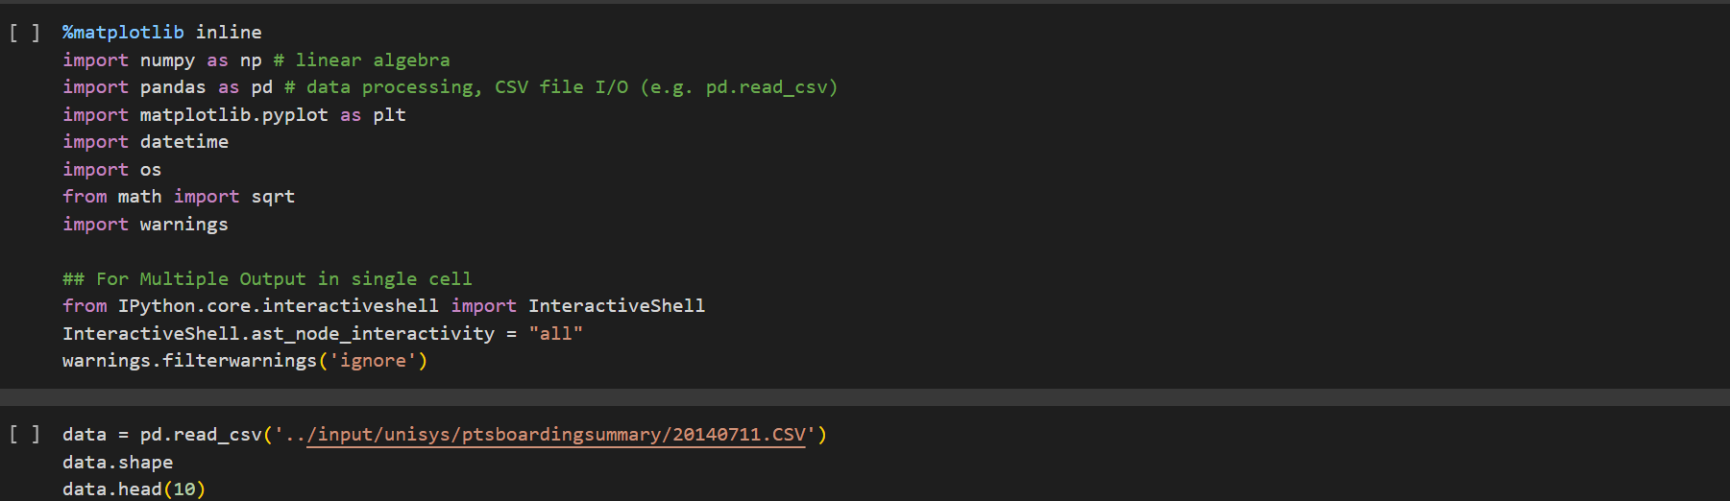

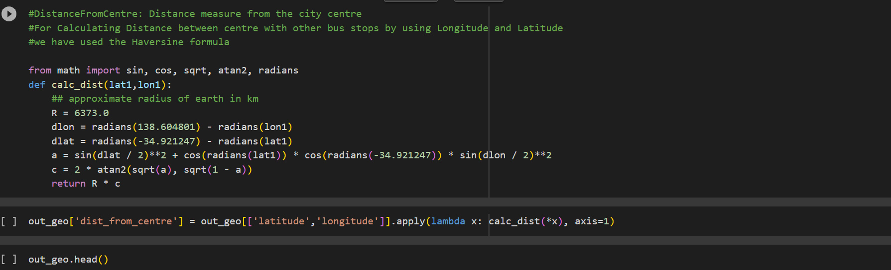

**Output Samples :**

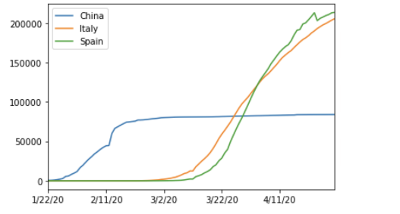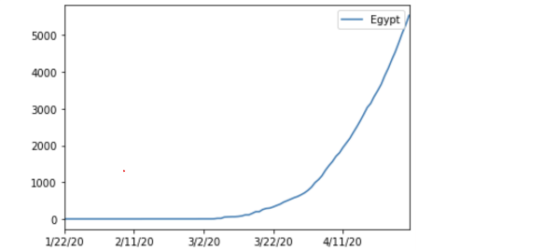

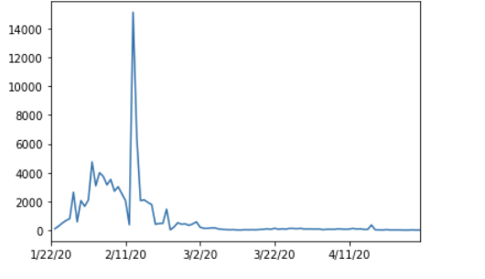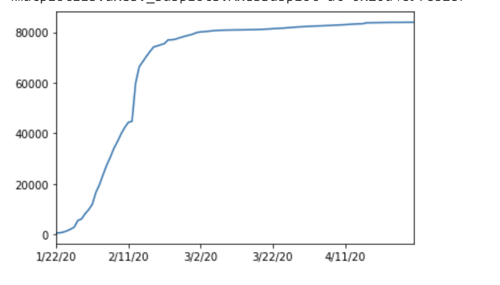

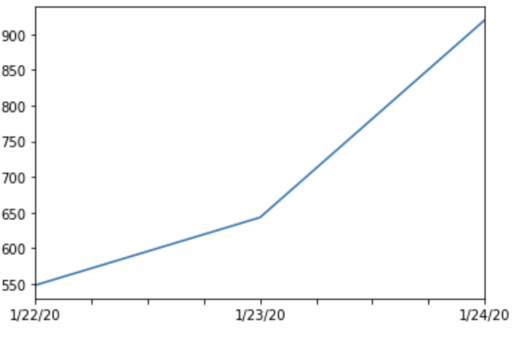

# DEVELOPMENT PHASES:

**Development Phases:**

The comprehensive bus boarding analysis unfolds in a series of development phases, each contributing a unique perspective and data to our understanding of the issue.

**Data Collection:**

Data collection is the foundational phase of our analysis. It involves gathering detailed information about passenger behavior of the data in covid 19 in the world. This data serves as the bedrock upon which we build our analysis and develop solutions, ensuring that our insights are grounded in real-world observations.

**Data Analysis:**

The data analysis phase takes the collected information and transforms it into actionable insights. We identify patterns, trends, and correlations within the data that provide us with a deeper understanding of passenger behavior and needs. These insights are invaluable in guiding the subsequent phases of our analysis and solution development.

**Proposed Solutions:**

This phase is where the analysis comes to life, as we present our innovative solutions for improving Covid 19 analysis. We propose a range of ideas, such as new boarding methods, digital tools, and passenger-friendly infrastructure. These solutions aim to reduce congestion, minimize wait times, and create a more efficient and pleasant boarding experience for passengers.

**Prototype and Testing:**

To ensure the feasibility and effectiveness of our proposed solutions, we move into the prototype development and testing phase. Here, we create tangible representations of our ideas and subject them to thorough testing. Real passengers provide essential feedback, enabling us to refine and optimize the solutions based on their input.

# EXPLANATION: COMPREHENSIVE-BUS-BOARDING-ANALYSIS

In this section, we provide an in-depth exploration of the methodologies and tools used in the comprehensive bus boarding analysis, offering a transparent view of the analytical processes that led to our proposed solutions.

**Data Collection:**

In the "Data Collection" phase, we embarked on an extensive effort to gather a wide range of data from diverse and reliable sources. We accessed government reports, healthcare databases, academic studies, and open datasets. These sources provided a rich pool of information that was essential for our analysis. We paid careful attention to the accuracy, timeliness, and representativeness of the data. This phase was characterized by meticulous data acquisition and verification to ensure that the data used in our analysis was of high quality and reflected the most current information available.

**Data Analysis:**

The "Data Analysis" phase was the core of our analysis efforts. Here, we employed a wide range of statistical and machine learning methods to extract insights and patterns from the preprocessed data. These methods included techniques such as regression analysis, time series forecasting, clustering, and sentiment analysis. Regression analysis allowed us to understand the relationships between various variables and make predictions based on these relationships. Time series forecasting enabled us to model and predict the progression of COVID-19 cases and other relevant factors over time. Clustering helped us identify groups with similar characteristics, such as regions with similar infection trends. Sentiment analysis was applied to understand public sentiment and response to government measures and policies during the pandemic. These analysis techniques were carefully chosen based on their suitability for addressing various aspects of the pandemic's complexity.

**Proposed Solutions:**

As our data analysis progressed, we derived insights that informed the development of potential solutions to address the challenges posed by the pandemic. These "Proposed Solutions" were generated in response to the problems defined in the design thinking process. For instance, our analysis may have suggested strategies for optimizing vaccine distribution, improving contact tracing, or enhancing healthcare resource allocation. These proposed solutions were developed with a keen understanding of the real-world problems and were designed to be practical, evidence-based, and responsive to the evolving nature of the pandemic.

**Prototype and Testing:**

The "Prototype and Testing" phase involved turning the proposed solutions into tangible models or representations. We created prototype data models, software applications, or decision-support tools to test the feasibility and effectiveness of our proposed solutions. These prototypes allowed us to simulate and evaluate how the solutions would perform in real-world scenarios. For example, we may have developed a prototype vaccination distribution model and tested its impact on reducing infection rates in different regions. The testing phase provided crucial insights into the practical implications and limitations of our proposed solutions. It allowed us to gather feedback, refine our approaches, and optimize our models, ensuring that our recommendations were not only data-driven but also effective in addressing the complex challenges presented by the COVID-19 pandemic.

# CONCLUSION:

In conclusion, this analysis offers a comprehensive understanding of the COVID-19 pandemic. It highlights the implications of our findings for public health policies and provides recommendations for future pandemic preparedness. While this analysis provides invaluable insights, it is essential to acknowledge its limitations, such as the availability and quality of data, the evolving nature of the pandemic, and the need for ongoing research. In moving forward, we emphasize the importance of data-driven decision-making, design thinking, and global collaboration to effectively combat present and future public health crises. This report contributes to the collective knowledge base necessary for navigating the challenges posed by sthe COVID-19 pandemic.