

|  |
| --- |
| Business Template  **Subject areas** |
|  |

Contents

1 Business Description 3

1.1 Business background 3

1.2 Problems. Current Situation 3

1.3 The benefits of implementing a database. Project Vision 3

2 Model description 3

2.1 Definitions & Acronyms 3

2.2 Logical Scheme 3

2.3 Objects 3

# 

# Business Description

## Business background

Our organization is dedicated to promoting and facilitating the sport of mountain climbing. We organize climbing expeditions, provide training and equipment, and maintain a community of climbers. As our operations have grown, managing climbing-related data has become increasingly challenging. We need a robust database solution to streamline our data management processes and support our growing community of climbers.

## Problems. Current Situation

Currently, our climbing-related data is scattered across various spreadsheets, documents, and systems. This fragmented approach to data management leads to several challenges:

Data Redundancy: The same information is often duplicated across multiple documents, leading to inconsistencies and errors.

Data Inconsistency: Without a centralized database, it's difficult to ensure the accuracy and consistency of our climbing data.

Limited Reporting and Analysis: Extracting meaningful insights from our climbing data is challenging due to the lack of a unified data repository.

Inefficient Processes: Manual data entry and retrieval processes are time-consuming and prone to errors, leading to inefficiencies in our operations.

## the Benefits of implementing a database. Project Vision

Implementing a dedicated climbing database offers several key benefits:

Data Repository: A database provides a centralized repository for all climbing-related data, ensuring data consistency and eliminating redundancy.

Centralized Data Repository: A database provides a centralized repository for all climbing-related data, ensuring data consistency and eliminating redundancy.

Improved Data Accuracy: With standardized data entry processes and validation rules, we can ensure the accuracy and integrity of our climbing data.

Enhanced Reporting and Analysis: A database enables us to perform advanced reporting and analysis, gaining valuable insights into climbing trends, participant demographics, and expedition outcomes.

Streamlined Operations: Automation of routine tasks and streamlined data retrieval processes improve operational efficiency and reduce the risk of errors.

Better Decision-Making: Access to timely and accurate climbing data empowers our organization to make informed decisions, allocate resources effectively, and optimize expedition planning.

Our vision for the climbing database project is to create a comprehensive, user-friendly database solution that meets the needs of our organization and the climbing community. Key elements of our project vision include:

Scalability: The database should be scalable to accommodate our growing volume of climbing data and support future expansion.

User-Friendly Interface: The database should have an intuitive user interface that allows climbers, instructors, and administrators to easily access and manage climbing data.

Data Security: Robust security measures should be implemented to protect sensitive climbing data and ensure compliance with privacy regulations.

Integration Capabilities: The database should support integration with other systems and tools used by our organization, such as expedition planning software and membership management systems.

Continuous Improvement: The database should be designed with flexibility and adaptability in mind, allowing for continuous improvement based on user feedback and evolving business requirements.

By implementing a dedicated climbing database, we aim to streamline our operations, enhance data-driven decision-making, and provide a more seamless experience for our climbing community.

# Model description

## Definitions & Acronyms

* **DB**: Database
* **LDM**: Logical Data Model
* **PK**: Primary Key
* **FK**: Foreign Key
* **VARCHAR**: Variable-length character string
* **INT**: Integer
* **DATE**: Date data type

## Logical Scheme

<image>

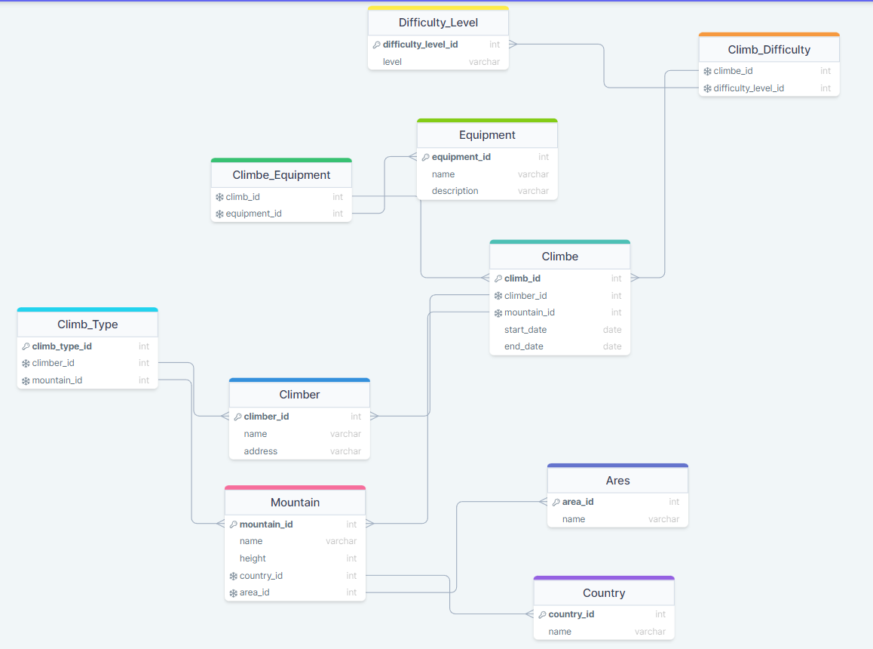

## Objects

Table Description

|  |  |  |  |
| --- | --- | --- | --- |
| Table Name | Field name | Field Description | Data Type |
| Mountain | mountain_id | <id of the mountain>, PK | Int |
| name | <name of the mountain> | Text |
| height | <the height of the mountain in meters> | Int |
| country_id | <the id of the country where the mountain is located>, FK | Int |
| area_id | <the id of the area where the mountain is located>, FK | Int |

Example with data

|  |  |  |  |  |
| --- | --- | --- | --- | --- |
| mountain_id | name | height | country_id | area_id |
| 1 | Everest | 8848 | 12 | 3 |