**1. Write a MongoDB query to display all the documents in the collection restaurants.**

db.restaurants.find().pretty [

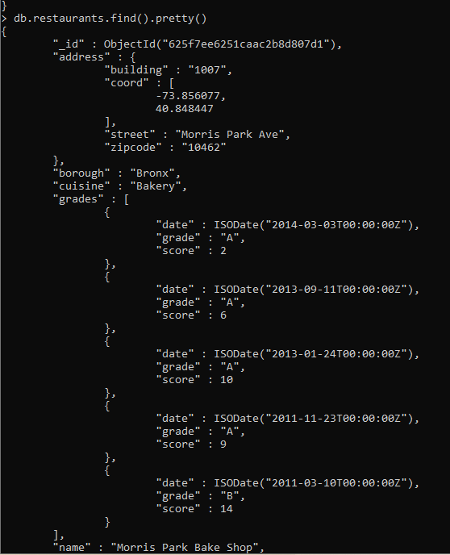

**2. Write a MongoDB query to display the fields restaurant_id, name, borough and cuisine for all the documents in the collection restaurant.**

> db.restaurants.find({},{'restaurant_id':1,name:1,brough:1,cuisine:1}).pretty()

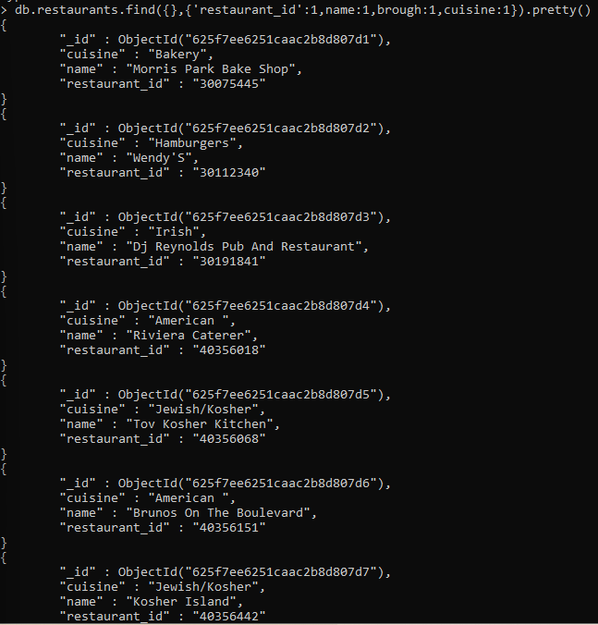

3. Write a MongoDB query to display the fields restaurant_id, name, borough and cuisine, but exclude the field _id for all the documents in the collection restaurant.

db.restaurants.find({},{"restaurant_id" : 1,"name":1,"borough":1,"cuisine" :1,"_id":0}).pretty()

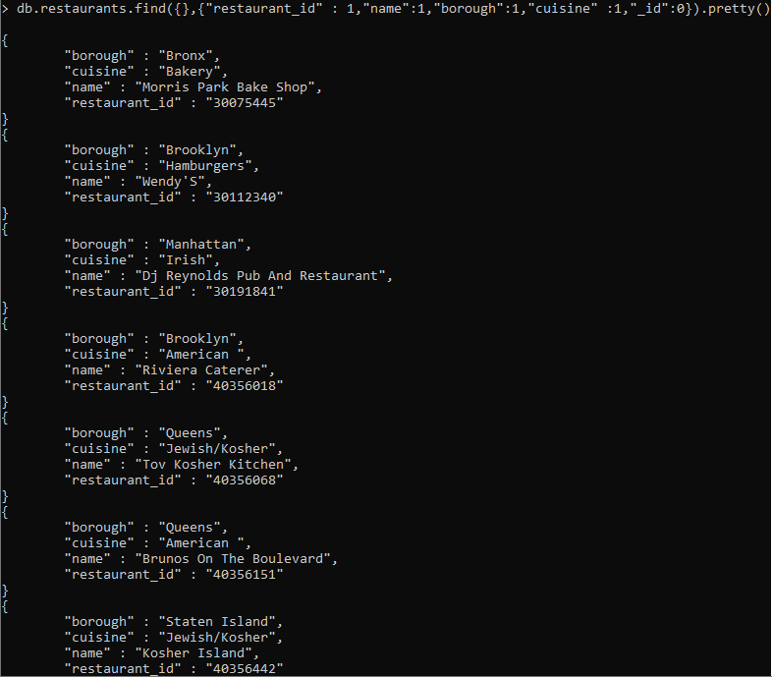

4. Write a MongoDB query to display the fields restaurant_id, name, borough and zip code, but exclude the field _id for all the documents in the collection restaurant.

db.restaurants.find({},{'restaurant_id':1,'name':1,'borough':1,'cuisine':1,'address.zipcode':1,_id:0}).pretty()

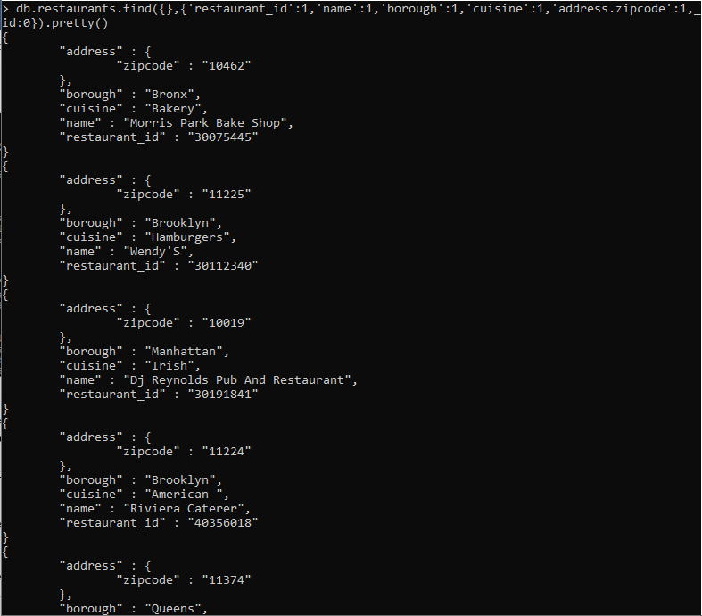

5. Write a MongoDB query to display all the restaurant which is in the borough Bronx.

db.restaurants.find({borough:"Bronx"}).pretty()

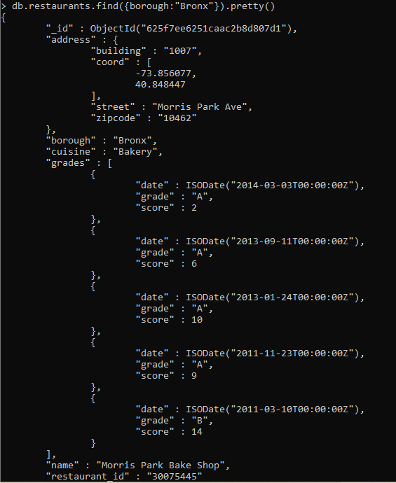

6. Write a MongoDB query to display the first 5 restaurant which is in the borough Bronx.

db.resto.find({borough:"Bronx"}).limit(5).pretty()

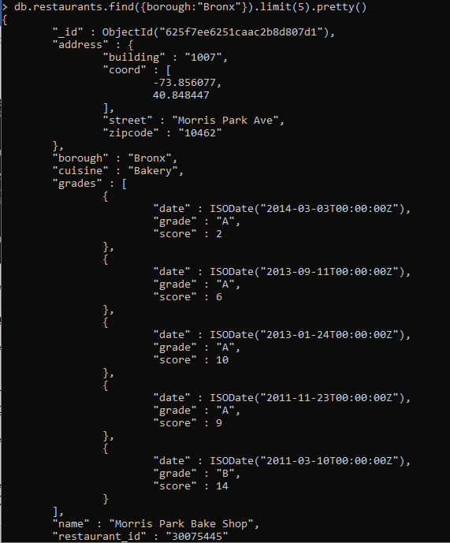

7.Write a MongoDB query to display the next 5 restaurants after skipping first 5 which are in the borough Bronx.

db.restaurant.find({"borough":"Bronx"}).limit(5).skip(5).pretty()

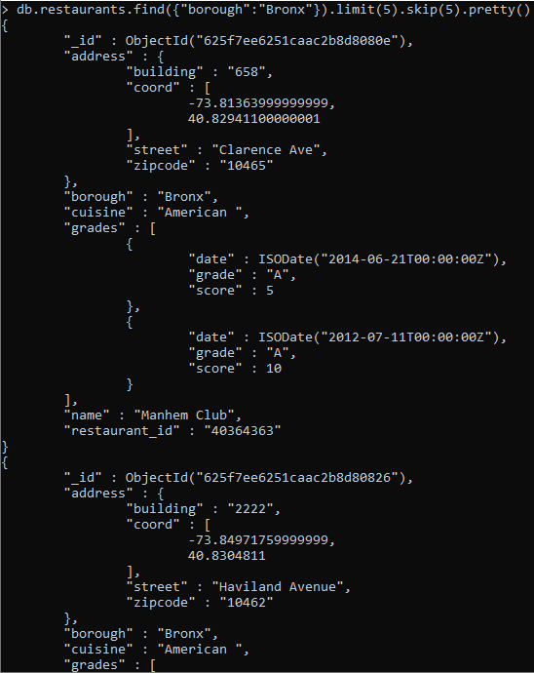

8. Write a MongoDB query to find the restaurants who achieved a score more than 90.

> db.restaurants.find({'grades.score':{$gt:90}}).pretty();

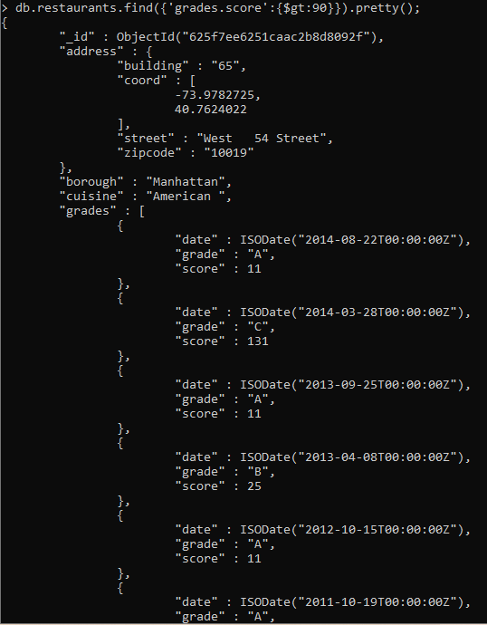

9. Write a MongoDB query to find the restaurants that achieved a score, more than 80 but less than 100.

db.restaurants.find({"grades.score":{$gt:80,$lt:100}}).pretty()

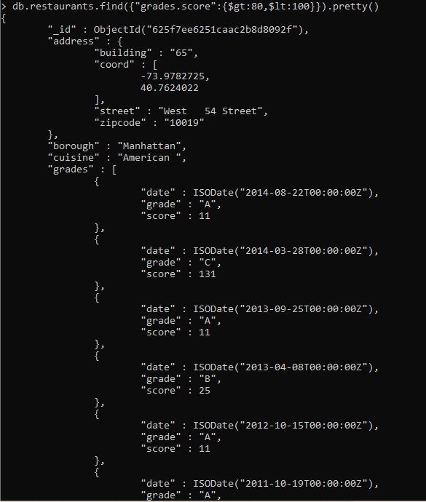

10. Write a MongoDB query to find the restaurants which locate in latitude value less than -95.754168.

db.restaurants.find({'address.coord.0':{$lt:-95.754168}}).pretty();

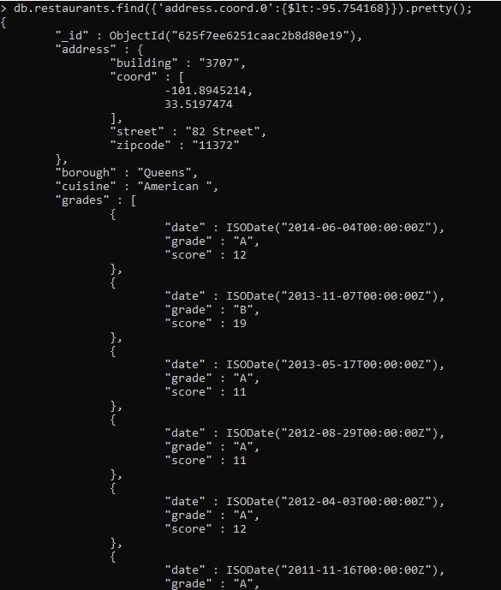

11. Write a MongoDB query to find the restaurants that do not prepare any cuisine of 'American' and their grade score more than 70 and latitude less than -65.754168.

>

12. Write a MongoDB query to find the restaurants which do not prepare any cuisine of 'American' and achieved a score more than 70 and located in the longitude less than -65.754168.

Note : Do this query without using $and operator.

db.restaurants.find({

"cuisine":{$ne:"American "},

"grades.score":{$gt:70},

"address.coord":{$lt:-65.754168}

}).pretty()

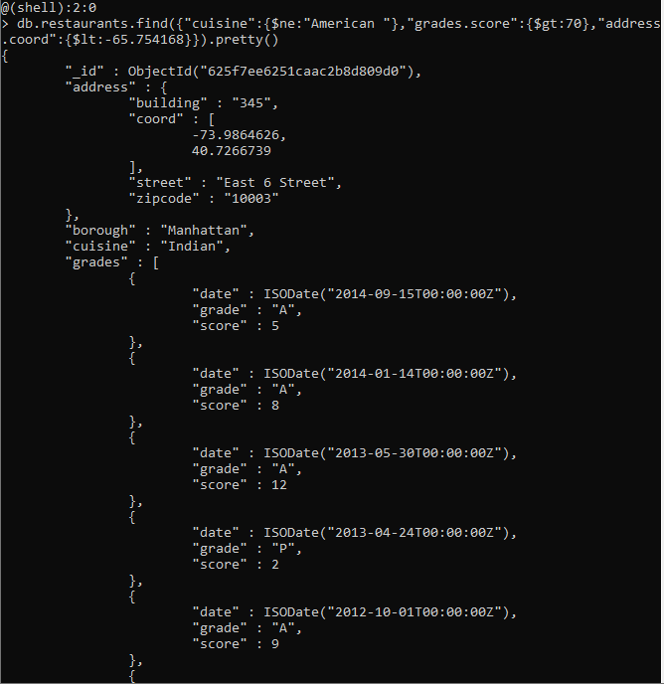

13. Write a MongoDB query to find the restaurants which do not prepare any cuisine of 'American ' and achieved a grade point 'A' not belongs to the borough Brooklyn. The document must be displayed according to the cuisine in descending order.

db.restaurants.find({$and

cuisine:{$ne:"American"},

"grades.grade":"A",

"borough":{$ne:"Brooklyn"}

}

).sort({"cuisine":-1}).pretty()

14. Write a MongoDB query to find the restaurant Id, name, borough and cuisine for those restaurants which contain 'Wil' as first three letters for its name.

15. Write a MongoDB query to find the restaurant Id, name, borough and cuisine for those restaurants which contain 'ces' as last three letters for its name.

16. Write a MongoDB query to find the restaurant Id, name, borough and cuisine for those restaurants which contain 'Reg' as three letters somewhere in its name.

17. Write a MongoDB query to find the restaurants which belong to the borough Bronx and prepared either American or Chinese dish.

18. Write a MongoDB query to find the restaurant Id, name, borough and cuisine for those restaurants which belong to the borough Staten Island or Queens or Bronxor Brooklyn.

19. Write a MongoDB query to find the restaurant Id, name, borough and cuisine for those restaurants which are not belonging to the borough Staten Island or Queens or Bronxor Brooklyn.

20. Write a MongoDB query to find the restaurant Id, name, borough and cuisine for those restaurants which achieved a score which is not more than 10.

21. Write a MongoDB query to find the restaurant Id, name, borough and cuisine for those restaurants which prepared dish except 'American' and 'Chinees' or restaurant's name begins with letter 'Wil'.

22. Write a MongoDB query to find the restaurant Id, name, and grades for those restaurants which achieved a grade of "A" and scored 11 on an ISODate "2014-08-11T00:00:00Z" among many of survey dates..

23. Write a MongoDB query to find the restaurant Id, name and grades for those restaurants where the 2nd element of grades array contains a grade of "A" and score 9 on an ISODate "2014-08-11T00:00:00Z".

24. Write a MongoDB query to find the restaurant Id, name, address and geographical location for those restaurants where 2nd element of coord array contains a value which is more than 42 and upto 52..

25. Write a MongoDB query to arrange the name of the restaurants in ascending order along with all the columns. 