**Assignment 5**

**SQL Exercise 1**

1. Create the table SEMP with the following structure:-

EMPNO CHAR(4)

EMPNAME CHAR(20)

BASIC FLOAT

DEPTNO CHAR(2)

DEPTHEAD CHAR(4)

* create table SEMP(EMPNO CHAR(4), EMPNAME CHAR(20), BASIC FLOAT, DEPTNO CHAR(2), DEPTHEAD CHAR(4));

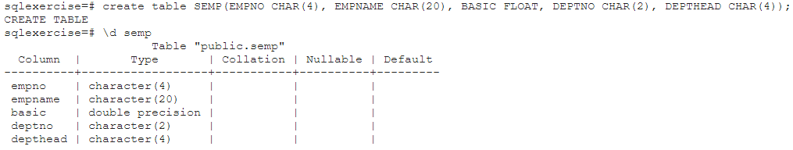

2. Create the table SDEPT with the following structure:-

DEPTNO CHAR(2)

DEPTNAME CHAR(15)

* create table sdept(DEPTNO CHAR(2), DEPTNAME CHAR(15));

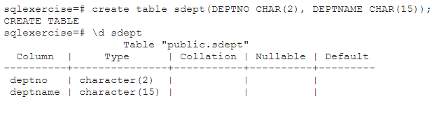

3. Insert into the SDEPT table the following values:-

10, Development

20, Training

-> insert into sdept values (‘10’, ‘Development’),(‘20’,’Training’);

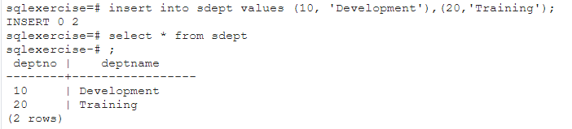

4. Insert into the SEMP table the following values:-

0001, SUNIL, 6000, 10

0002, HIREN, 8000, 20

0003, ALI, 4000, 10, 0001

0004, GEORGE, 6000, 0002

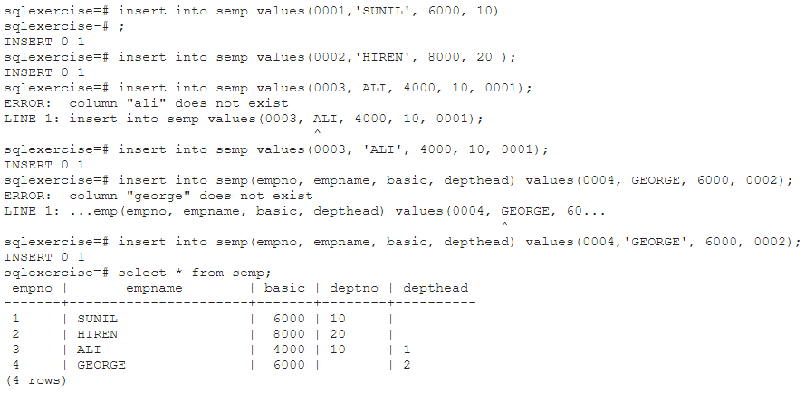

5.Create S, P, J, SPJ tables as specified below and insert a few rows in each table:-

SUPPLIER (S#, Sname, Status, City) - S

PARTS (P#, Pname, Color, Weight, City) - P

PROJECTS (J#, Jname, City) - J

SUPPLIER-PARTS-PROJECT (S#, P#, J#, Qty) - SPJ

Sample data for S# column:- ‘S1’, ‘S2’, ‘S3’, etc.

Sample data for P# column:- ‘P1’, ‘P2’, ‘P3’, etc.

Sample data for J# column:- ‘J1’, ‘J2’, ‘J3’, etc.

Sample data for Status column:- 10, 20, 30, etc.

Write the SELECT queries to do the following:-

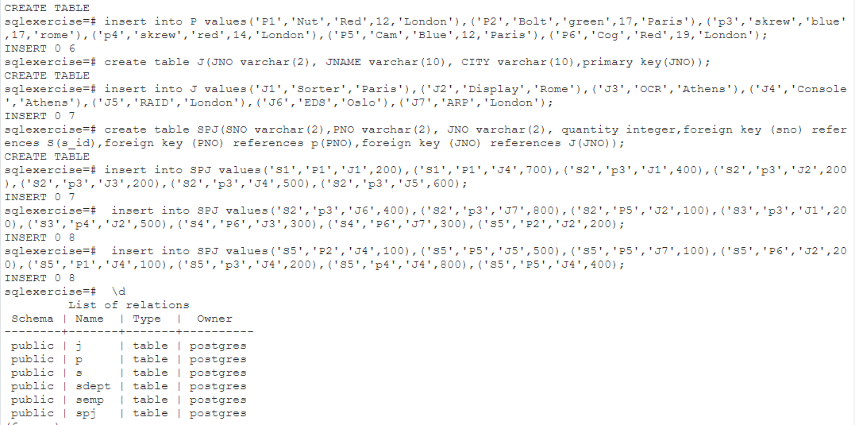

5. Display all the data from the S table.

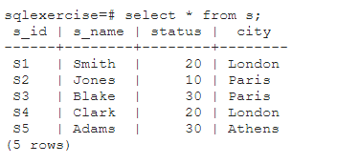

6. Display only the S# and SNAME fields from the S table.

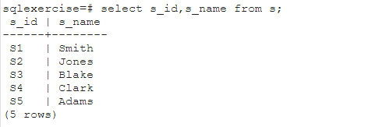

7. Display the PNAME and COLOR from the P table for the CITY=”London”.

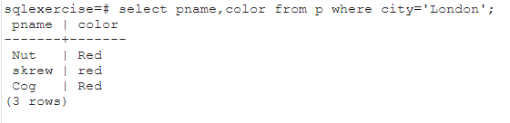

8. Display all the Suppliers from London.

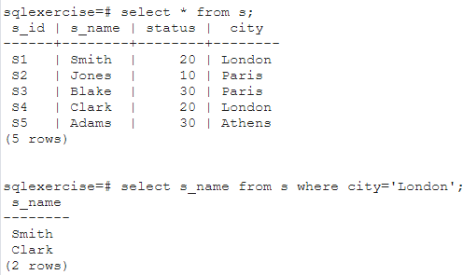

9. Display all the Suppliers from Paris or Athens.

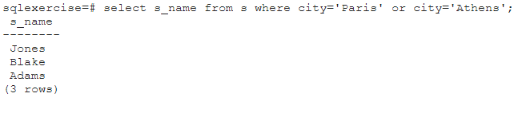

10. Display all the Projects in Athens.

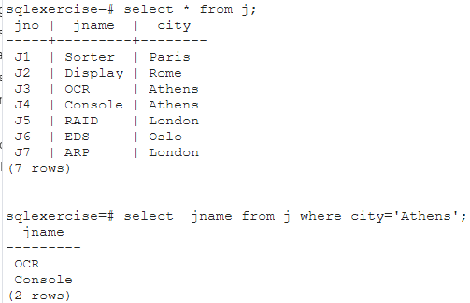

11. Display all the Partnames with the weight between 12 and 14 (inclusive of both).

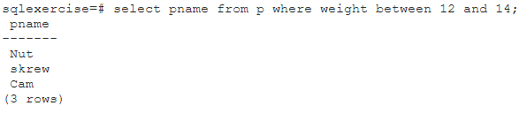

12. Display all the Suppliers with a Status greater than or equal to 20.

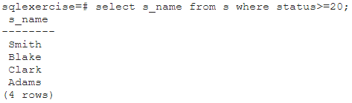

13. Display all the Suppliers except the Suppliers from London.

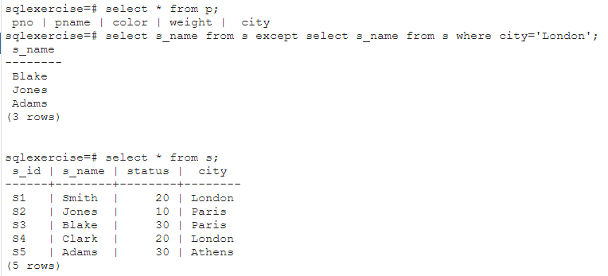

14. Display only the Cities from where the Suppliers come from.

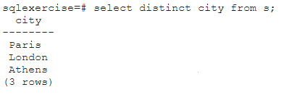

15. Assuming that the Part Weight is in GRAMS, display the same in MILLIGRAMS and KILOGRAMS.

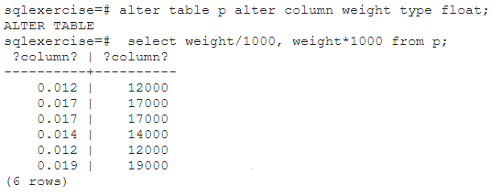

**SQL Exercise 2**

1. Display the Supplier table in the descending order of CITY.

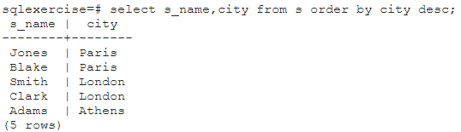

2. Display the Part Table in the ascending order of CITY and within the city in the ascending order of Part names.

3. Display all the Suppliers with a status between 10 and 20.

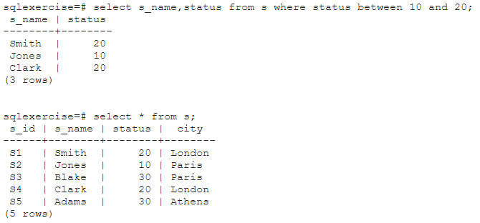

4. Display all the Parts and their Weight, which are not in the range of 10 and 15.

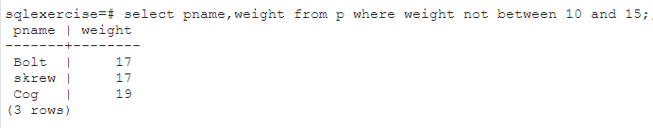

5. Display all the Part names starting with the letter ‘S’.

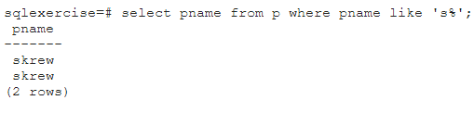

6. Display all the Suppliers, belonging to cities starting with the letter ‘L’.

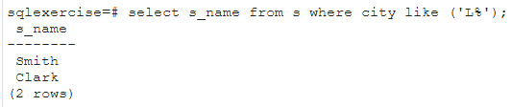

7. Display all the Projects, with the third letter in JNAME as ‘n’.

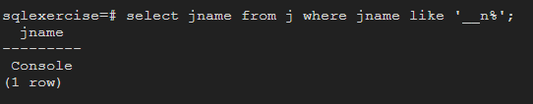

**SQL Exercise 3**

1. Display all the Supplier names with the initial letter capital.

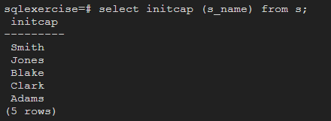

2. Display all the Supplier names in upper case.

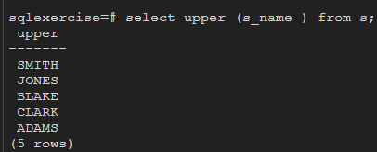

3. Display all the Supplier names in lower case.

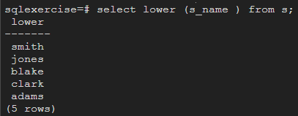

4. Display all the Supplier names padded to 25 characters, with spaces on the left.

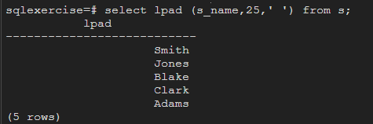

5. Display all the Supplier names (with ‘la’ replaced by ‘ro’). HINT: REPLACE.

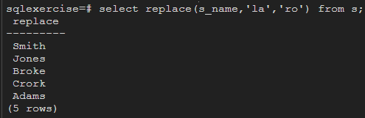

6. Implement the above command such that ‘l’ is replaced with ‘r’ and ‘a’ is replaced with ‘o’.

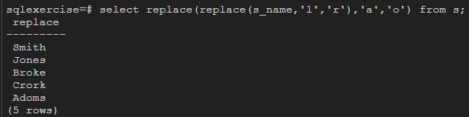

7. Display the Supplier names and the lengths of the names.

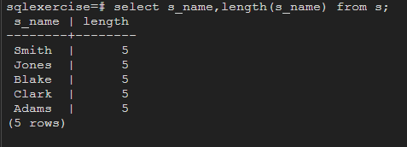

8. Use the soundex function to search for a supplier by the name of ‘BLOKE’.

9. Display the Supplier name and the status (as Ten, Twenty, Thirty, etc.).

10. Display the current day (e.g. Thursday).

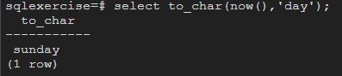

**SQL Exercise 4**

1. Display the minimum Status in the Supplier table.

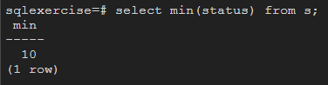

2. Display the maximum Weight in the Parts table.

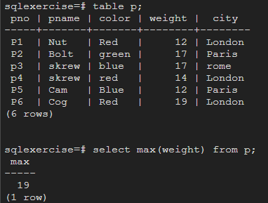

3. Display the average Weight of the Parts.

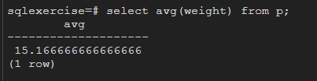

4. Display the total Quantity sold for part ‘P1’.

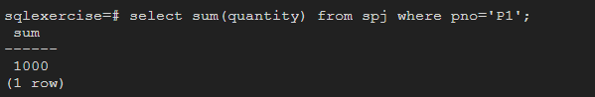

5. Display the total Quantity sold for each part.

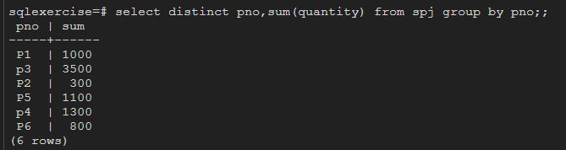

6. Display the average Quantity sold for each part.

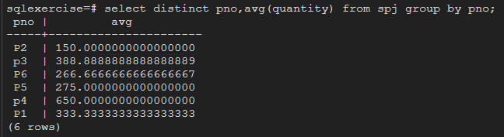

7. Display the maximum Quantity sold for each part, provided the maximum Quantity is greater than 800.

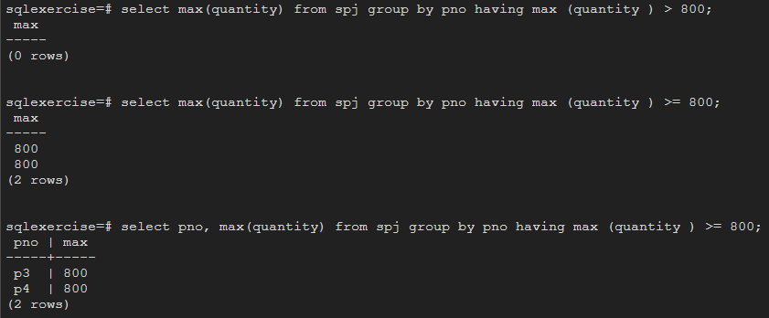

8. Display the Status and the count of Suppliers with that Status.

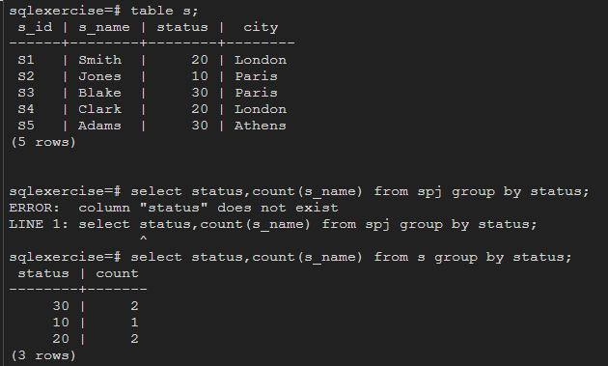

9. Display the count of Projects going on in different cities.

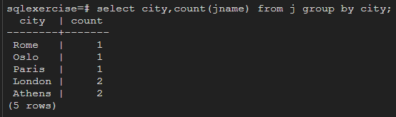

10. What is the difference between COUNT(Status) and COUNT(*) ?

11. Display the Status and the Count of Suppliers with that Status in the following format as shown below:- Status Count Ten 1 Twenty 2 Thirty 3

**SQL Exercise 5**

1. Display the Supplier name and the Quantity sold.

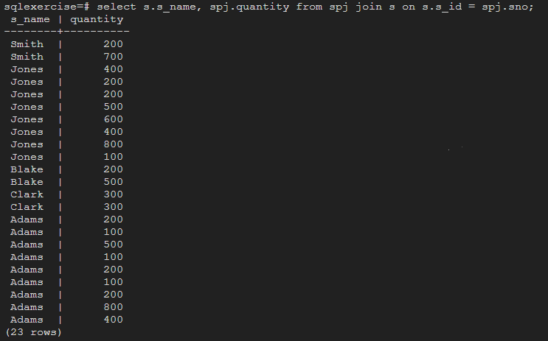

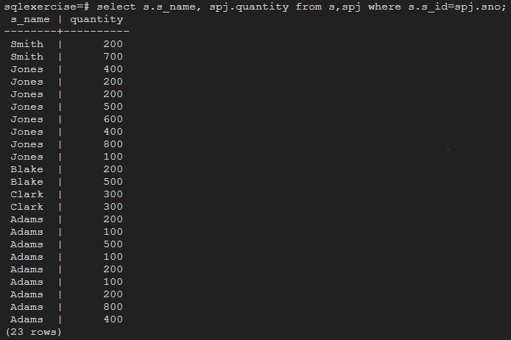

2. Display the Part name and Quantity sold.

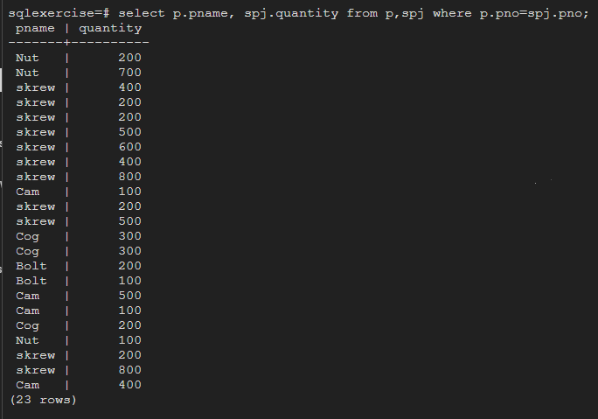

3. Display the Project name and Quantity sold.

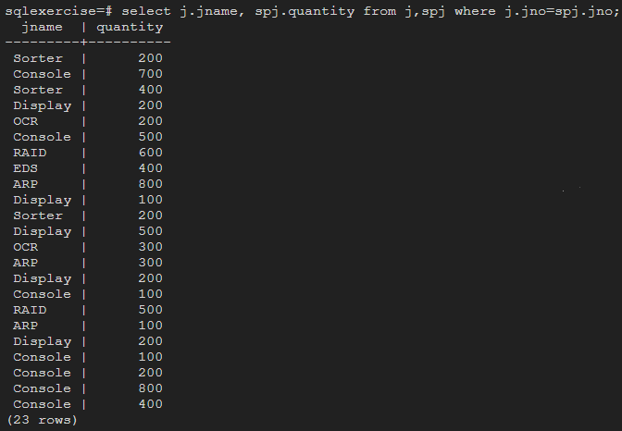

4. Display the Supplier name, Part name, Project name and Quantity sold.

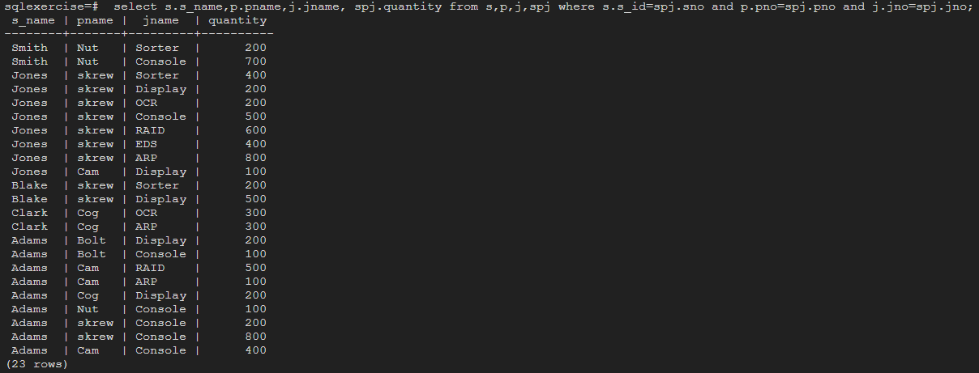

5. Display the Supplier name, Supplying Parts to a Project in the same City.

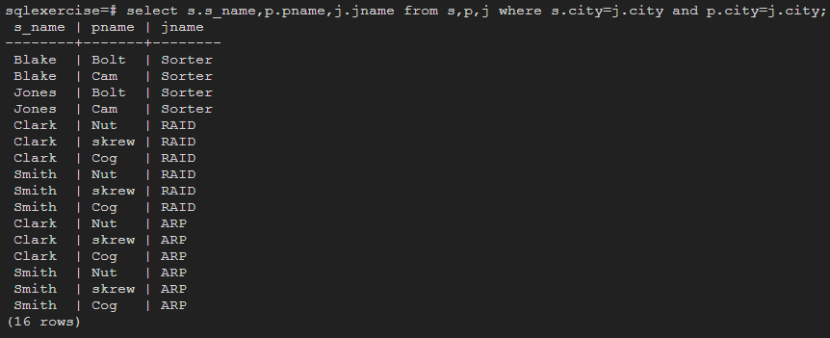

6. Display the Part name that is ‘Red’ is color, and the Quantity sold.

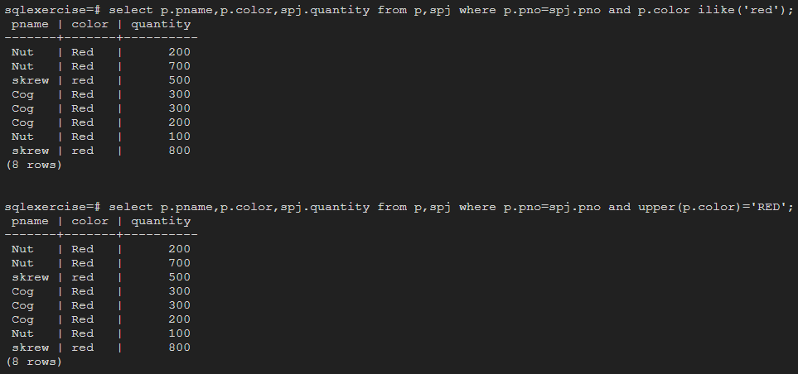

7. Display all the Quantity sold by Suppliers with the Status = 20.

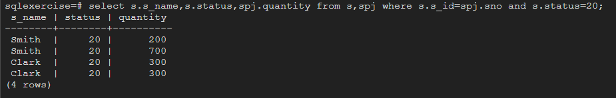

8. Display all the Parts and Quantity with a Weight > 14.

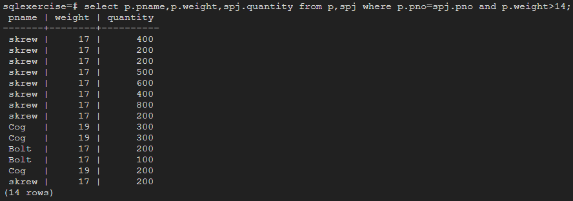

9. Display all the Project names and City, which has bought more than 500 Parts.

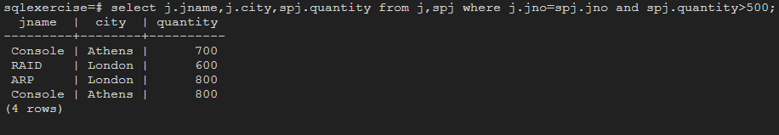

10. Display all the Part names and Quantity sold that have a Weight less than 15.

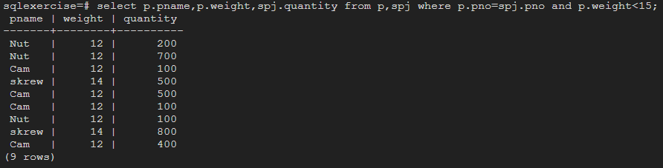

11. Display all the Employee names and the name of their Managers.

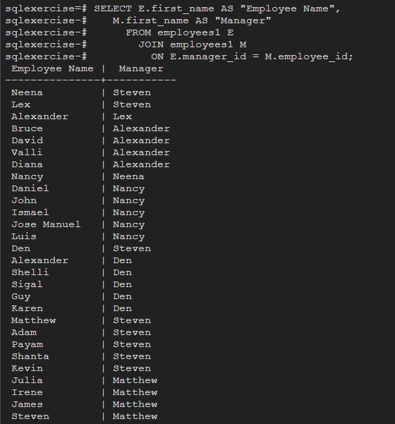

**SQL Exercise 6**

1. Display all the Suppliers with the same Status as the supplier, ‘CLARK’.

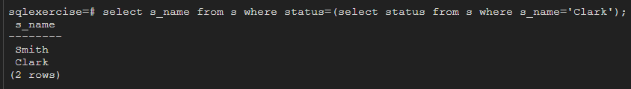

2. Display all the Employees in the same department as the employee ‘MILLER’.

3. Display all the Parts which have more Weight than all the Red parts.



4. Display all the Projects going on in the same city as the project ‘TAPE’.

5. Display all the Parts with Weight less than all the Green parts.

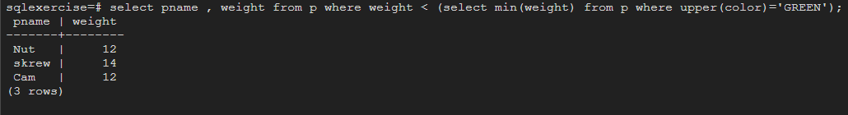

6. Display the name of the Supplier who has sold the maximum Quantity (in one sale).

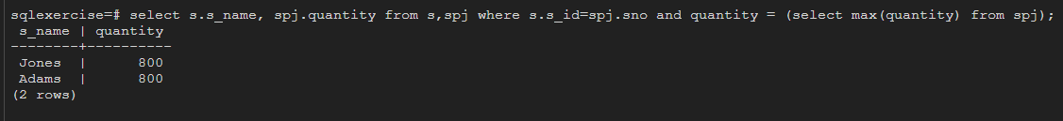

7. Display the name of the Employee with the minimum Salary.



8. Display the name of the Supplier who has sold the maximum overall Quantity (sum of Sales).

9. Display the name of the Department with the maximum number of Employees.