Question-1.

1. - use a command to show the current working directory

- list the directory contents in the short and long format (with file permissions, owner, size etc, ). Explore attributes given in long format e.g. file type, file permissions, file size, file owner etc.

- list all files along with hidden files in current working directory.

- list only hidden files in the directory (Hint : use pwd, ls, echo commands)

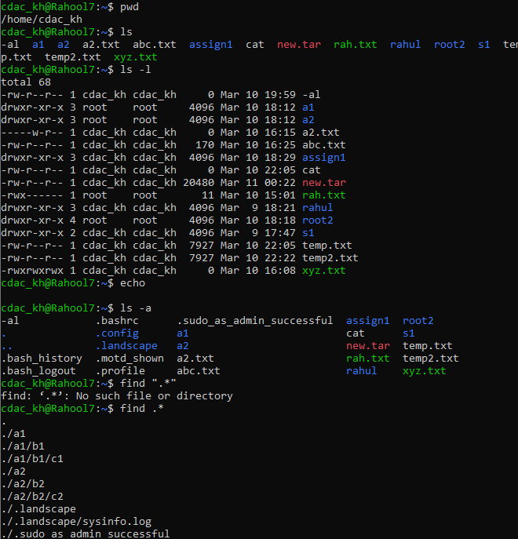

2.Make a directory and name it as cdac-dir and change the current working directory to the new directory.(Hint : use mkdir,cd commands). 3. Create following nested directories inside current directory by invoking single command for only one time. Note : here root_dir is current directory.

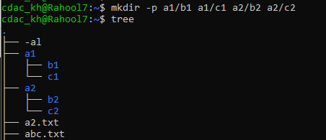

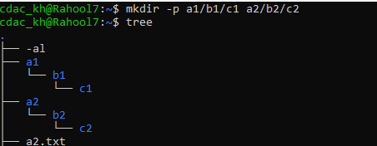

4. List the directories(folders), then remove the cdac-dir directory and list the folders again to show that it is no longer present.(Hint : use rm, ls command).

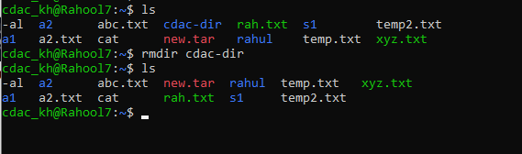

Question-2.

1. Display the man-page for ls, but redirect the output into temp.txt, then use the cat, less, and more commands to display the new file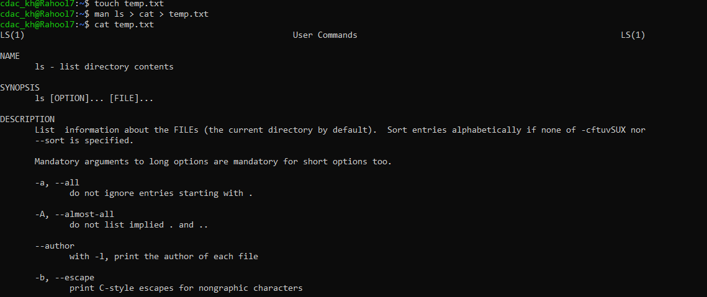

Que.2

2) Display the initial 10 lines and final 5 lines of temp.txt with the obvious Linux commands.(Hint: use head and tail commands).

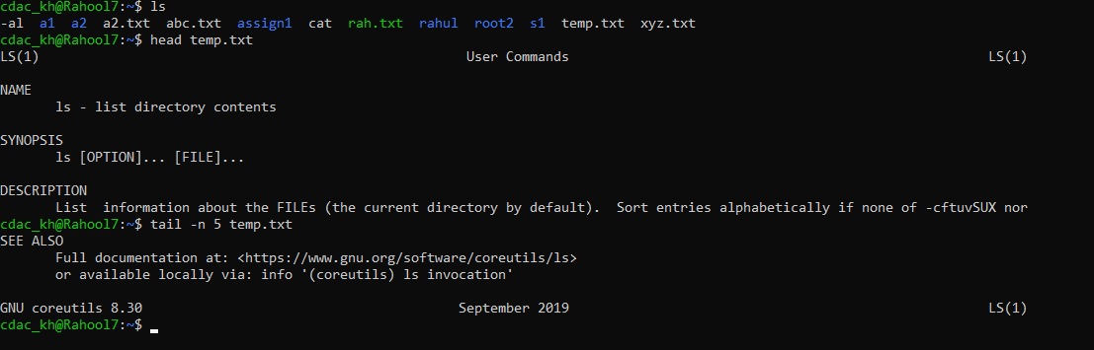

Que 2.

3.Copy temp.txt to another directory and rename it there. (Hint: use cp to copy and mv command to rename).

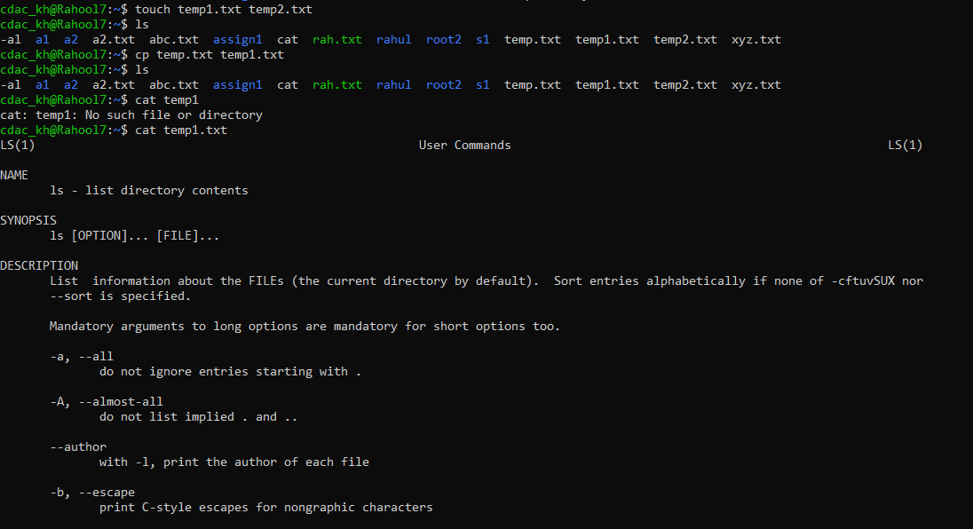

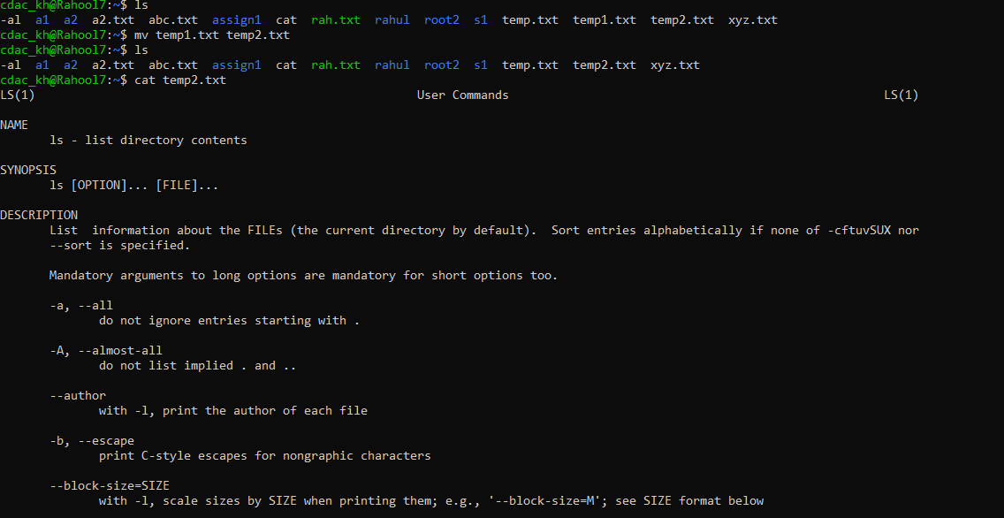

Que 2.

4) Display the number of lines, words and characters in file using Linux command (Hint: use wc command).

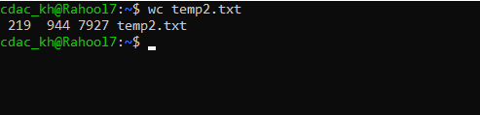

Que 2.

5. Use history command to display last 10 commands used. (Hint: use history command).

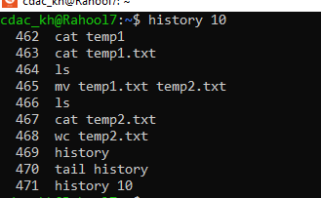

Question-3.

1. Create tar archive file of any directory present in your home directory. (Hint: use tar command) - list the contents of the archive file without extracting.

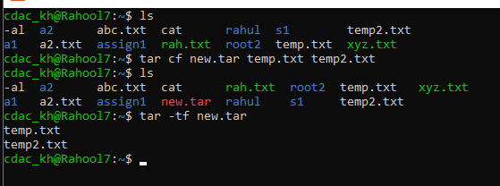

2. Create zip file of another directory. (Hint: use zip command) - list the contents of the zip file without extracting.

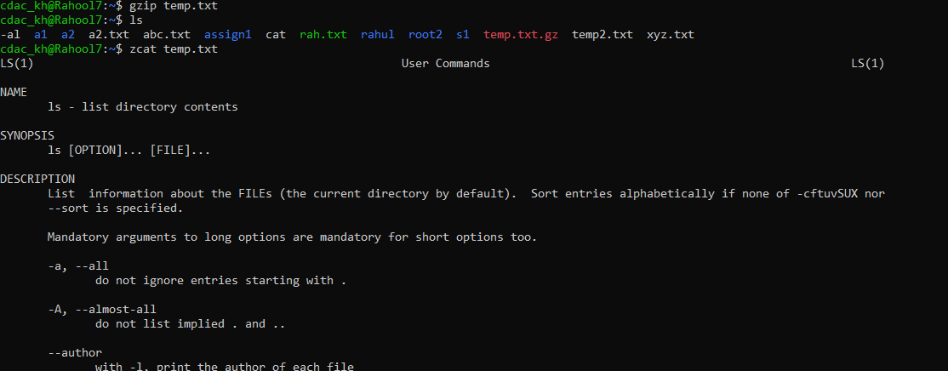

3. Give read, write & execute permissions to your file. (Hint: use chmod command)

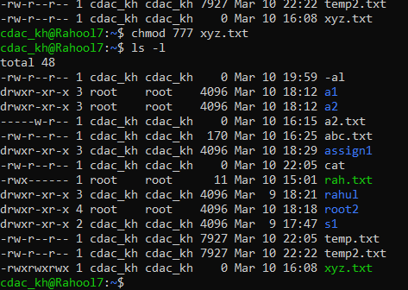

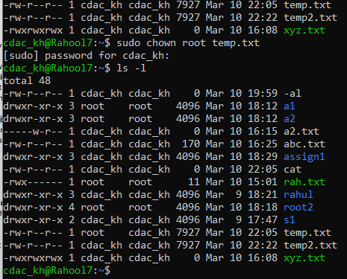

4. Change ownership of that file.(Hint: use chown command)

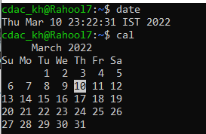

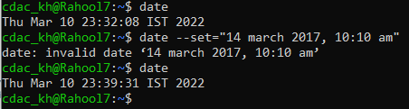

Que 4 3) Explore following commands who, whoami, whatis, whereis

