# 1. Write a R program to create a sequence of numbers from 20 to 50 and find the mean

# of numbers from 20 to 60 and sum of numbers from 51 to 91.

print("Sequence of numbers from 20 to 50 :")

print(seq(20,50))

print("mean of numbers from 20 to 60:")

print(mean(20:60))

print("sum of numbers from 51 to 91")

print(sum(51:91))

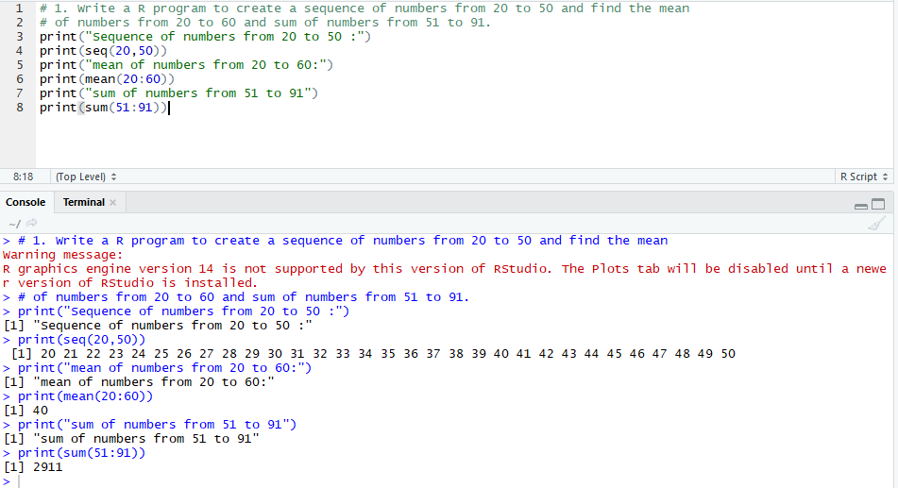

# 2. Write a R program to print the numbers from 1 to 100 and print "Fizz" for multiples

# of 3, print "Buzz" for multiples of 5, and print "FizzBuzz" for multiples of both.

for(n in 1:100){

if(n%%3==0 & n%%5==0){print("FizzBuzz")}

else if(n%%3==0){print("Fizz")}

else if(n%%5==0){print("Buzz")}

else print(n)

}

