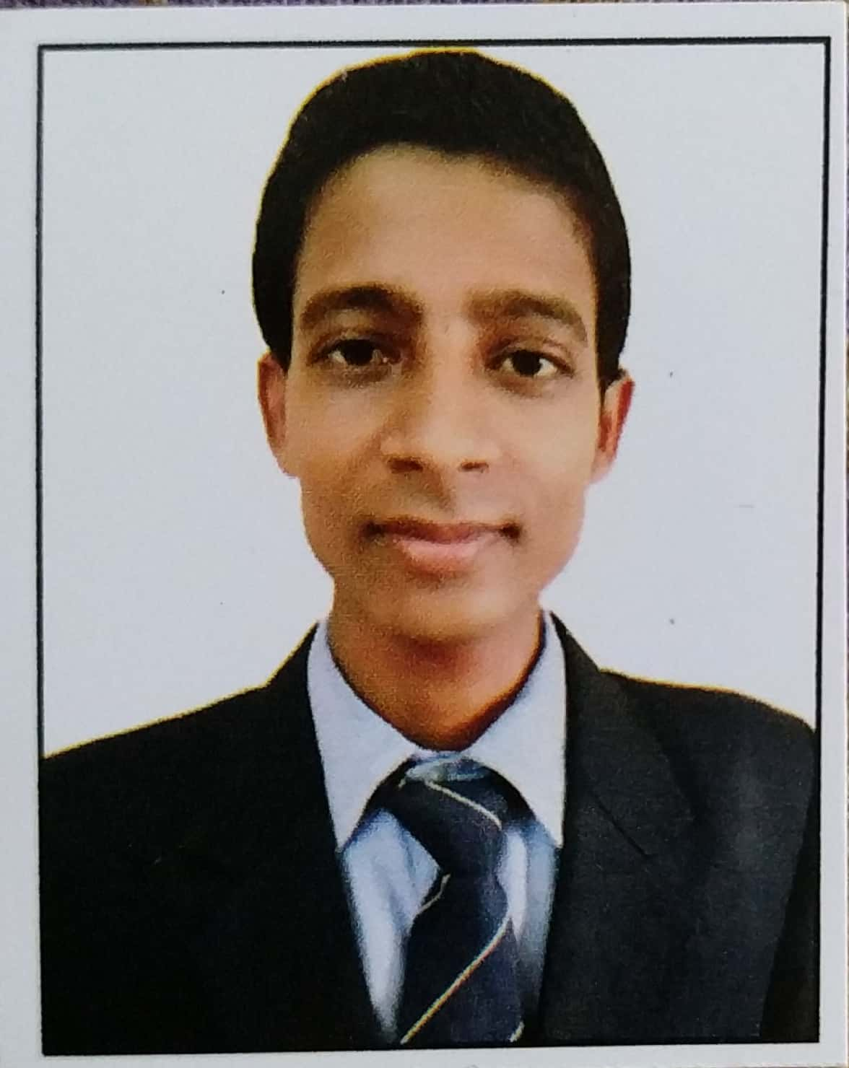  RAHUL KUMAR  Contact Information:-  +91-8093814451  +91-8809023301  Email:  rkumarrkrk73@gmail.com  Address:-  At/Po : -Dhanauli,  Via:- Anandpur,  Dist : -Darbhanga,  State: -Bihar,  Pin :847101  Technical Skills:-  - MS Word  - MS Excel  - MS Power Point  - Typing speed 50 WPM along with 90% Accuracy  Personal Data:-  Father name :- Tanuk Lal Mandal  DOB:- 07-July-1997  Sex:- Male  Nationality:- Indian  Languages Known:-  Hindi, English, Maithili, Bhojpuri, Odia  Marital Status: Single | Curriculum Vitae  Career Objective:-  To work in a challenging environment that promises growth as well as opportunity to learn more. To shoulder responsibilities effectively and contribute towards the growth of the organization with the skills I possess and have developed.  Professional Qualification:-  Job Experience:-  1.4 Year experience in Vertex Global Service as a customer Success Associate.  1 year experience in Sequential Technology International as a Process Associate  Role and Responsibilities:-  1.Process customer orders of products and services by entering orders into the computer system and ensuring that orders status.  2.Stay informed on all company services and products so customer inquiries can be answered correctly.  3.Set up customers with automatic orders to avoid late missing incomplete or forgotten orders.  4. customer information including payment options and record for future reference.  5.Handle customer complaints and questions regarding problems with orders.  6.Worded on CRM, Jeeves , 24/7, Ettore for ststus of complaint.
  Course | Discipline | College/ school | University / board | Passing year | %/  CGPA
  B.Tech | M.E | CEC, BBSR | BPUT, Rourkela | 2019 | 81.3
  12th Std. | Science | MLSM College | BSEB Patna | 2015 | 74
  10thStd. | Science | S S Y High School | BSEB Patna | 2013 | 67.4
Hobbies:-  - Reading Newspapers.  - Typing.  Rewards:-  An Employee of the Month. | - Ability to work in a team.  - Committed to work in project deadlines and schedules.  - Organized and well-structured at work.  - Ability to grasp and learn new technology quickly & accurately.  - Very enthusiastic and highly motivated with a Positive attitude.  - Flexibility & Adaptability.  Declaration:-  I confirm that the information provided by me is true to the best of my knowledge and belief.  Place : Gurugram Signature:-  Date : 16/03/2023 Rahul Kumar
  Job Skills:-
  Soft Skills:-

