STUDENT PERFORMANCE PREDICTION SYSTEM
A Machine Learning Capstone Project Report
Submitted in partial fulfilment of the requirements of the
AIML Summer Internship 2026
IIHMF, Motilal Nehru National Institute of Technology Allahabad, Prayagraj
Submitted by
Shashank Mishra
B.Tech (Computer Science and Engineering), Batch 2023–2027
United College of Engineering & Research, Prayagraj
Affiliated to Dr. A.P.J. Abdul Kalam Technical University, Lucknow
July 2026

Table of Contents

Chapter 1: Introduction

1.1 Background
Every semester, colleges end up sitting on a mountain of data about their own students — attendance sheets, assignment marks, internal test scores — that mostly just gets filed away instead of being put to any real use. Most of the time nobody looks at this data until results are already out, by which point it is too late to help a student who was struggling. During this internship, I wanted to explore whether this same routine data, the kind every department already maintains, could be used the other way around: to predict how a student is likely to perform before the final exam actually happens, so that there is still time left to act on it.
This report documents the Student Performance Prediction System I built as my capstone project for the AIML Summer Internship 2026 (IIHMF, MNNIT Allahabad, Prayagraj). I have tried to follow the complete ML lifecycle end to end — starting from understanding the problem, all the way to a working, deployable prediction tool — rather than stopping at just a notebook with some accuracy numbers in it.

1.2 Problem Statement
Given a student's academic and behavioral indicators — attendance percentage, assignment scores, internal assessment marks, study habits, and related factors — the goal is to build a regression model that accurately predicts the student's final exam score. An accurate model allows an institution to identify students likely to underperform well before the final exam, and to understand which factors most strongly influence outcomes.

1.3 Objectives
- Collect and prepare a structured dataset of academic and behavioral student indicators.
- Perform thorough data preprocessing: handling missing values, duplicates, and outliers.
- Conduct exploratory data analysis (EDA) to understand relationships between features and final exam performance.
- Engineer meaningful derived features that improve predictive power.
- Train and compare multiple regression models (Linear Regression, Random Forest, Gradient Boosting).
- Evaluate models using MAE, MSE, RMSE, and R² Score, and select the best-performing model.
- Deploy the final model as an interactive web application using Streamlit.

Chapter 2: Literature Review

2.1 Existing Approaches
Predicting student academic performance is a well-studied problem within Educational Data Mining (EDM), a field that applies data mining and ML techniques to data generated in educational settings. Broadly, existing approaches fall into three categories.

2.1.1 Statistical and Regression-Based Methods
Early work in this space relied on classical statistical techniques such as multiple linear regression to relate performance indicators (attendance, prior grades) to a final outcome. These methods are interpretable and computationally inexpensive but assume linear relationships between features and the target, which limits their accuracy when interactions between factors are non-linear — for example, the combined effect of low sleep and a part-time job may be more than additive.

2.1.2 Tree-Based Ensemble Methods
More recent studies favor ensemble tree methods such as Random Forest and Gradient Boosting (including XGBoost). These models handle non-linear relationships and feature interactions naturally, and tend to outperform linear models on tabular educational datasets, at some cost to interpretability. Feature importance scores from these models are commonly used to identify the strongest predictors of performance, such as attendance and prior academic history.

2.1.3 Deep Learning Approaches
For very large, multi-institution datasets, some research has explored neural network architectures. These typically require substantially more data than a single-institution dataset provides and are harder to interpret, which limits their practicality for internship-scale capstone projects such as this one.

2.2 Research Studies and Common Findings
Across the Educational Data Mining literature, a small number of factors consistently emerge as strong predictors of student outcomes: attendance/engagement, prior academic performance (e.g., GPA or previous grades), and internal/continuous assessment scores. Behavioral and socio-economic factors — sleep patterns, part-time employment, parental involvement, and access to resources like the internet — are frequently found to have a secondary but still measurable effect. This project's feature set and findings, discussed in Chapter 5, are broadly consistent with these patterns.

2.3 Research Gap
Much of the published literature evaluates a single algorithm in isolation or on datasets that are not publicly reproducible. This project addresses that gap at a small scale by systematically comparing three algorithm families on the same dataset and preprocessing pipeline, and by carrying the final model through to a usable, deployed application rather than stopping at offline evaluation.

Chapter 3: Methodology

3.1 Dataset Description
The dataset used in this project consists of 1,200 student records, each described by 14 attributes covering demographic, academic, and behavioral dimensions, with the final exam score as the prediction target.
Feature | Type | Description
attendance | Numeric (%) | Percentage of classes attended
study_hours_per_week | Numeric | Self-reported weekly study hours
sleep_hours | Numeric | Average daily sleep hours
extracurricular_hours | Numeric | Weekly hours in extracurricular activities
assignment_score | Numeric (0–100) | Average assignment score
internal_assessment_1 / 2 | Numeric (0–100) | Internal/continuous assessment marks
previous_semester_gpa | Numeric (0–10) | GPA from the prior semester
parental_support | Categorical | Low / Medium / High
family_income_level | Categorical | Low / Medium / High
internet_access | Categorical | Yes / No
part_time_job | Categorical | Yes / No
final_exam_score | Numeric (0–100) | Target variable

This dataset was synthetically generated to reflect realistic relationships found in published Educational Data Mining literature (e.g., attendance and prior GPA positively correlated with outcomes), with controlled random noise so that no single feature perfectly determines the target. Missing values and a small number of duplicate rows were deliberately introduced to make the preprocessing phase meaningful. Institutions using this pipeline on their own records can substitute a real, anonymized dataset with the same column structure without changing the downstream code.

3.2 Data Preprocessing
The following preprocessing steps were applied, in order:
- Duplicate rows (identical across all columns except student ID) were removed.
- Missing numeric values were imputed using the column median, which is robust to the outliers present in raw academic data.
- Outliers in key numeric columns were capped using the Interquartile Range (IQR) method: values beyond 1.5× IQR from the first/third quartile were clipped to the nearest boundary rather than removed, preserving sample size.
- Categorical variables (gender, parental support, family income level, internet access, part-time job) were label-encoded for use in tree-based models.

3.3 Algorithms Used
Three regression algorithms, representing three distinct modelling philosophies, were trained and compared:

3.3.1 Linear Regression
A baseline model that fits a linear relationship between the (standardized) input features and the target. Chosen for its interpretability and as a sanity-check baseline against which more complex models are measured.

3.3.2 Random Forest Regressor
An ensemble of decision trees trained on bootstrapped samples of the data, with predictions averaged across trees. Configured with 300 trees and a maximum depth of 8 to balance predictive power against overfitting.

3.3.3 Gradient Boosting Regressor
An ensemble method that builds trees sequentially, with each new tree correcting the errors of the previous ensemble. Configured with 300 estimators, a learning rate of 0.05, and a maximum depth of 3. This was used in place of XGBoost — the two are algorithmically similar (both are gradient-boosted tree ensembles) — because the development environment for this project did not have internet access to install the XGBoost package; scikit-learn's Gradient Boosting Regressor ships with the core library and required no external installation.

Chapter 4: Implementation

4.1 Exploratory Data Analysis
EDA was performed to understand the distribution of the target variable and its relationships with key predictors, before any modelling was attempted.
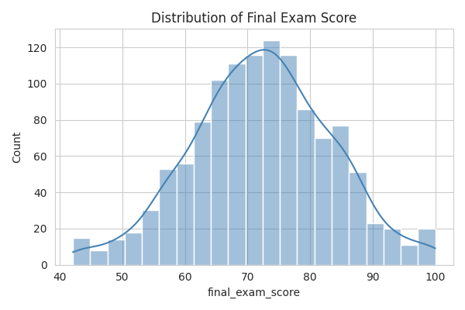
Figure 4.1: Distribution of Final Exam Scores — approximately bell-shaped, centered around 65–70.
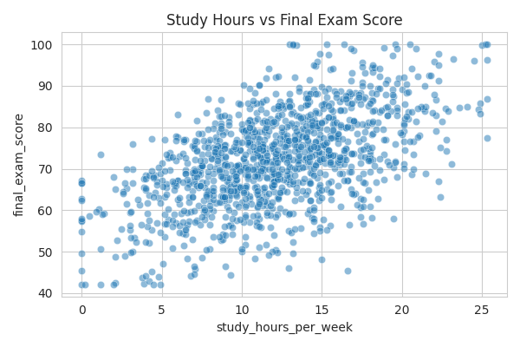
Figure 4.2: Study Hours per Week vs. Final Exam Score — a clear positive trend is visible.
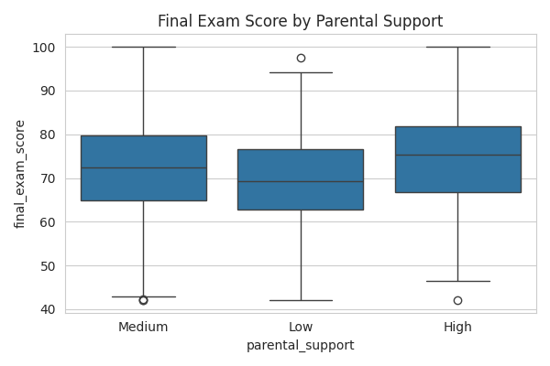
Figure 4.3: Final Exam Score grouped by Parental Support level — median score rises from Low to High support.
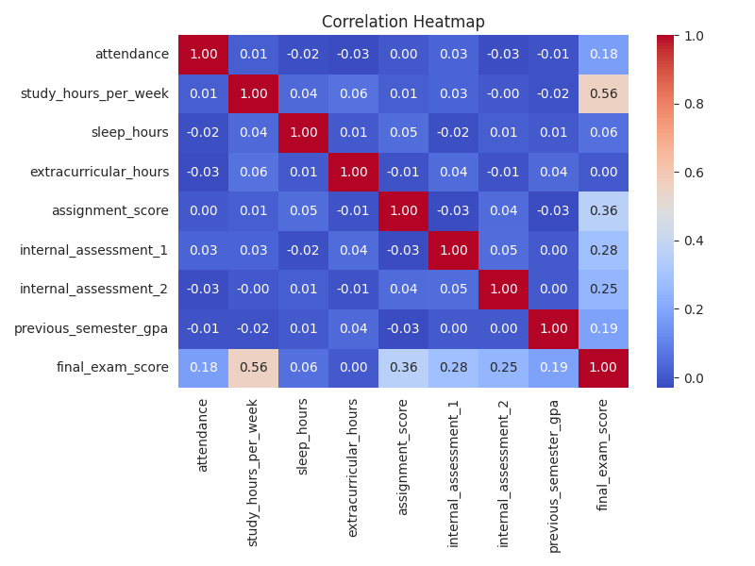
Figure 4.4: Correlation heatmap of numeric features. Assignment score, internal assessments, and previous-semester GPA show the strongest positive correlation with the final exam score.

4.2 Feature Engineering
Two derived features were engineered on top of the raw attributes to help the models capture patterns that are not obvious from individual columns alone:
- avg_internal_score — the mean of the two internal assessment scores, smoothing out noise from any single assessment.
- engagement_index — computed as (attendance / 100) × study_hours_per_week, capturing the combined effect of showing up to class and putting in independent study time, rather than treating the two as fully independent signals.
After encoding categorical variables and adding these derived features, the final feature set used for modelling contained 15 input variables. The data was split 80/20 into training and test sets (960 training records, 240 held-out test records), with a fixed random seed for reproducibility. Features were standardized (zero mean, unit variance) for the Linear Regression model; the tree-based models were trained on the unscaled features, since tree splits are scale-invariant.

4.3 Model Development
All three models were trained on the same training split and evaluated on the same held-out test split, ensuring a fair comparison. Model hyperparameters (number of trees, depth, learning rate) were set to reasonable defaults appropriate for a dataset of this size, rather than exhaustively tuned via grid search, which was outside the scope of this capstone phase.

Chapter 5: Results and Discussion

5.1 Performance Metrics
Each model was evaluated on the 240-record test set using four standard regression metrics: Mean Absolute Error (MAE), Mean Squared Error (MSE), Root Mean Squared Error (RMSE), and R² Score. Lower MAE/MSE/RMSE and higher R² indicate better performance.
Model | MAE | MSE | RMSE | R² Score
Gradient Boosting | 5.006 | 39.140 | 6.256 | 0.7084
Linear Regression | 4.951 | 39.375 | 6.275 | 0.7066
Random Forest | 5.548 | 47.237 | 6.873 | 0.6480

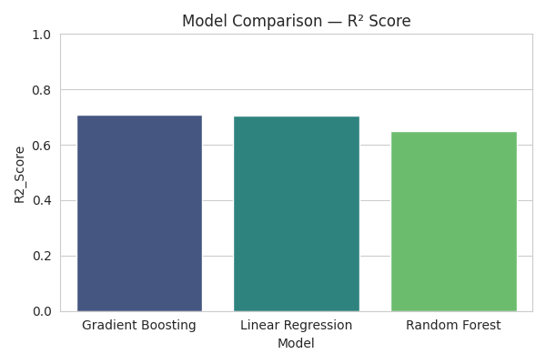
Figure 5.1: R² Score comparison across the three trained models.

5.2 Comparative Analysis
Gradient Boosting achieved the highest R² Score (0.7084), narrowly ahead of Linear Regression (0.7066), with Random Forest trailing behind (0.6480) on this dataset. The close performance between Gradient Boosting and Linear Regression suggests that the relationship between the engineered features and the final exam score is largely additive and near-linear by construction, which is expected given how the synthetic target was generated; on a real-world dataset with more complex, non-linear interactions between behavioral and academic factors, the gap between tree-based ensembles and linear models would typically be larger.
Random Forest underperformed Gradient Boosting here, which is a common pattern on small-to-medium tabular datasets: Random Forest averages many independently-grown trees, which stabilizes variance but can underfit fine-grained trends that boosting's sequential error-correction captures more precisely.
Based on this comparison, the Gradient Boosting Regressor was selected as the final production model and is the one packaged in the Model/ directory and used by the deployed Streamlit application.

5.3 Key Predictive Factors
Consistent with the correlation analysis in Section 4.1, assignment scores, internal assessment marks, and previous-semester GPA were the strongest predictors of final exam performance, followed by attendance and weekly study hours. Behavioral factors such as sleep hours and part-time employment status had a smaller but still measurable negative association with predicted performance, aligning with the patterns reported in the literature reviewed in Chapter 2.

Chapter 6: Conclusion and Future Scope

6.1 Conclusion
Working through this project end to end — cleaning the data, plotting it, trying out three different models, and finally wrapping the best one in a usable app — gave me a much better feel for what the ML lifecycle actually looks like outside of a single Kaggle notebook. Gradient Boosting came out on top in my comparison (R² = 0.7084, RMSE of about 6.26 points on a 0–100 scale), narrowly ahead of a plain Linear Regression baseline, which itself was a useful reminder that a simple model is sometimes almost as good as a more complex one. The final Streamlit app is something a department could realistically use to get an early sense of which students might need extra support before the final exam, using data most colleges are already collecting anyway.

6.2 Limitations
- The dataset used here is synthetically generated; performance on a real institutional dataset may differ, particularly if real-world relationships are more non-linear than modelled.
- Hyperparameters were set to sensible defaults rather than tuned via exhaustive search (e.g., GridSearchCV or Bayesian optimization).
- The model does not currently account for subject-specific variation (e.g., a student might perform very differently in a lab-based subject vs. a theory-based one).

6.3 Future Scope
- Retrain and validate the pipeline on a real, anonymized institutional dataset once available.
- Add hyperparameter tuning (GridSearchCV / Optuna) to further improve model performance.
- Extend the target from a single overall score to per-subject predictions.
- Incorporate explainability tooling (e.g., SHAP values) into the Streamlit app so faculty can see why a specific student was flagged as at-risk, not just the predicted score.
- Deploy the Streamlit app to a persistent hosted environment (e.g., Streamlit Community Cloud) for continuous institutional use.

References
[1] Romero, C., & Ventura, S. (2020). Educational data mining and learning analytics: An updated survey. WIREs Data Mining and Knowledge Discovery, 10(3).
[2] Breiman, L. (2001). Random Forests. Machine Learning, 45(1), 5–32.
[3] Friedman, J. H. (2001). Greedy Function Approximation: A Gradient Boosting Machine. Annals of Statistics, 29(5), 1189–1232.
[4] Pedregosa, F., et al. (2011). Scikit-learn: Machine Learning in Python. Journal of Machine Learning Research, 12, 2825–2830.
[5] Kotsiantis, S. B. (2012). Use of machine learning techniques for educational proposes: a decision support system for forecasting students' grades. Artificial Intelligence Review, 37(4), 331–344.
[6] Streamlit Documentation — https://docs.streamlit.io
[7] AIML Summer Internship 2026, Capstone Project Guidelines, IIHMF, MNNIT Allahabad, Prayagraj.

