# Music Store SQL Analysis Report

**Author:** Rahul Reddy  
**GitHub:** <https://github.com/RahuReddy/Music_Store_Sales_SQL_Analysis>

## Executive Summary

This report analyzes a music store’s sales and operations using SQL queries. The objective was to translate raw transactional data into actionable insights for marketing, sales, and management. Key findings highlight top-performing genres, customers, media formats, and employees. Recommendations are provided to improve marketing focus, content acquisition, and customer retention.

## 1. Introduction

This project leverages SQL to analyze sales and customer data from a music store. The aim is to identify trends in revenue, customer behavior, product performance, and sales operations. Insights generated from this analysis help shape data-driven business strategies.

## 2. Dataset & Schema

The dataset consists of multiple tables including Customer, Employee, Invoice, Invoice Line, Playlist, Playlist Track, Album, Artist, Track, Genre, and Media Type. These tables are linked through primary and foreign keys.

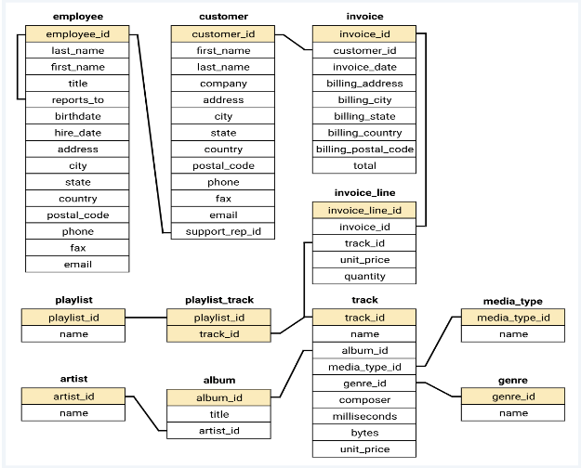

## 3. Methodology

The analysis followed these steps:

1. Data Exploration of all tables
2. Problem Formulation based on schema
3. SQL Querying using JOIN, GROUP BY, SUM, COUNT, and window functions like LAG
4. Insight Generation
5. Recommendation Development

## 4. Key Business Questions

* Which top 10 countries are generating the most revenue, and what are their key sales metrics?
* Which are the top 10 best performing cities based on revenue?
* What are the top 5 most popular genres and artists by sales volume?
* Which media formats are most popular and profitable?
* Who are the top 10 most valuable customers?
* Which sales support agents are driving the most revenue?
* What does sales performance look like over time (yearly and monthly)?
* Which top 10 albums and tracks are selling well?
* What is the purchasing behavior of repeat customers vs. less frequent customers?
* What is the total revenue generated by less repeated customers vs more repeated customers?
* What is the average customer lifetime value for each sales support agent?

## 5. Analysis & Results

This section presents the SQL queries generated from the dataset. Each subsection focuses on sales & customer insights, product & content insights, and employee & operational insights.

### Sales & Customer Insights

* The United States is the top revenue-generating country, with a total revenue of **$1,049.49** and **131 sales**, making it the most significant market.
* The top-performing city by revenue is **Prague** (**$273.24**), followed by Mountain View, London, and Berlin.
* The most valuable customers are **František Wichterlová** and **Helena Holy**, with lifetime revenues of **$144.54** and **$128.70** respectively.
* Repeat customers drive more revenue than new ones: **$3,268.98 (69.41%)** of total revenue comes from customers with more than 10 purchases.

### Content & Product Insights

* **Rock** is the most popular genre, generating **$2,608.65** in revenue (**64.71%** of total), followed by Latin and Metal.
* Top-selling artists: **Queen**, **Jimi Hendrix**, and **Nirvana**.
* The **MPEG audio format** is the most profitable, generating **$4,216.41**.
* Best-selling album: *Cake: B-Sides and Rarities*.
* Best-selling track: *War Pigs*.

### Employee & Operational Insights

* The top-performing sales agent is **Jane Peacock**, generating **$1,731.51** in revenue and achieving the highest average customer lifetime value.
* The year **2019** was the most profitable (**$1,221.66**), with **March** as the best-performing month.

## 6. Recommendations

### Strategic Marketing & Geographic Focus

* Prioritize the **US market** and top-performing cities (Prague, Mountain View, London).
* Explore new urban markets such as Berlin, Paris, São Paulo, Dublin, and Delhi.

### Customer Loyalty & Retention

* Launch a **tiered loyalty program** for high-value customers (e.g., František Wichterlová, Helena Holy).
* Offer **discounts for first-time customers** to encourage repeat purchases.

### Content & Inventory Management

* Acquire more **Rock, Metal, and Alternative/Punk** content.
* Focus on top artists (Queen, Jimi Hendrix) with exclusive content or promotions.
* Ensure new acquisitions are available in the **MPEG format**.

### Sales & Operational Efficiency

* Recognize and reward top-performing agents like Jane Peacock.
* Implement a **training program** to spread best practices from top performers.
* Use **customer lifetime value (CLV) per agent** as a performance metric.

## 7. Conclusion

This project demonstrates my ability to apply SQL in a complete, end-to-end data analysis workflow from problem formulation to actionable recommendations. The analysis provided tangible insights into the music store’s market dynamics, customer behavior, and operational efficiency, highlighting my technical skills and business acumen. These insights could further be used to build interactive dashboards or predictive models.

## 8. Limitations

* The dataset is static and may not reflect current or future market conditions.
* Results may vary in a real-world setting where additional external factors (marketing campaigns, economic shifts) influence sales.

## 9. Future Work

1. **Interactive Dashboards**

* Develop real-time dashboards in Power BI so stakeholders can filter revenue, customers, and products by country, genre, or sales agent.
* Business Value: Enables managers to spot opportunities and issues quickly without waiting for static reports.

1. **Cohort & Retention Tracking**

* Build monthly or quarterly cohort analysis to track how customer groups behave over time.
* Business Value: Provides insight into retention trends and the effectiveness of promotional activities.

## Appendix

* Full SQL scripts used in the analysis.
* Top 10 countries are generating the most revenue.

* Top 10 best performing cities based on revenue.

* Top 5 most popular genres and artists by sales volume.

* These Media formats are most popular and profitable.

* Top 10 most valuable customers.

* These sales support agents are driving the most revenue.

* Yearly and Monthly sales performance

* Best Selling top 10 albums and tracks.

* Purchasing behavior of repeat customers vs. less frequent customers.

* Total revenue generated by less repeated customers vs more repeated customers.

* Average customer lifetime value for each sales support agent.

* Additional query results not included in the main body.
* The Complete set of SQL queries is available in the GitHub Repository under Music_Store_Sales_Queries.sql