How to use Google Docs for hinglish typing?

## Introduction

I belong to a generation of Indians who have largely gotten separated from our roots. Large part of this is owing to the “English Medium” phenomenon where every success metric and qualification criteria has been judged against your fluency in English. But in addition to this , technology also plays a big role. Since everything is in english , we type in english , speak in english and communicate in English. Even when we have to communicate in Hindi , we type in English

Under these conditions , Google Doc has introduced a wonderful feature , where you can type in english which gets converted to hindi. So here is how you do it. When you open the interface this is what you see:-

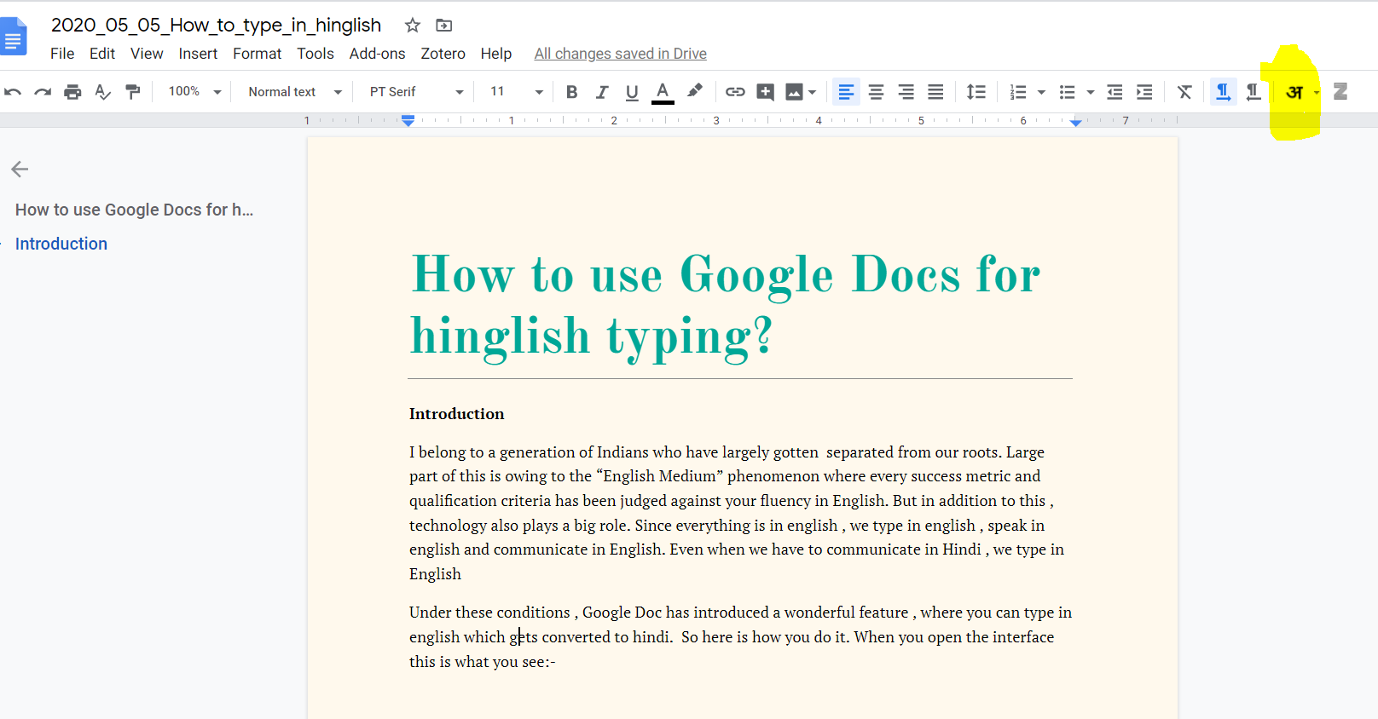

On the top right corner you should see a hindi vowel :aa . Click on it and see the magic. You can type words of hindi with english spelling and it will convert it correctly.

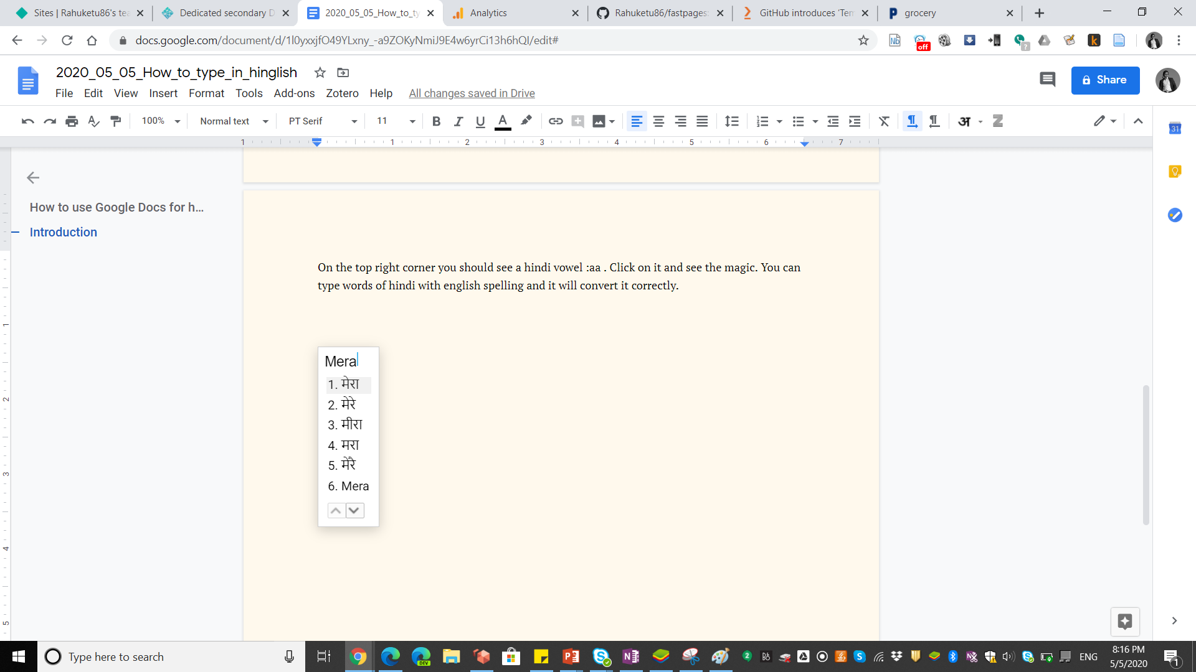

में इस feature से बहुत impress हुआ हूँ

## Conclusion

अपनी मातृभाषा में अपने बिचारों को रख पाना एक बहुत बहुमूलिया प्रतिभा है। इतने सालों तक इंडिया से बहार रहने के बाद मुझे व्यतीत होता है की मैं बात तो कर लेता हूँ लेकिन कन्विंस नहीं कर पाता। होपफ़ुल्ली थिस शुड हेल्प रेसोल्वे िट।