Why go Cashless??
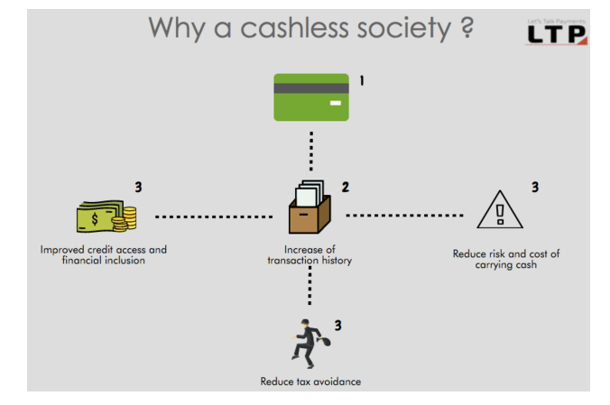

10 easy ways to go for cashless Transactions
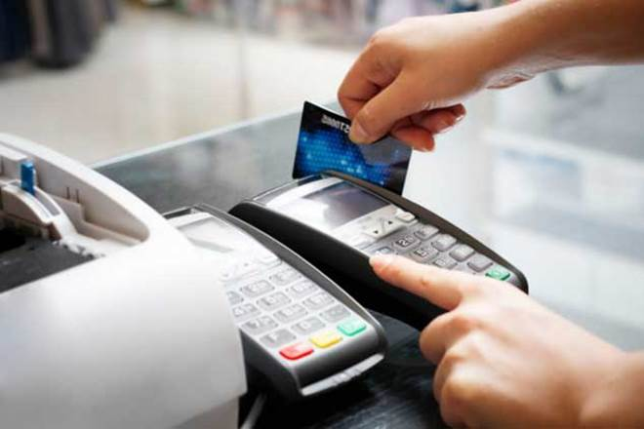

1) Net banking: It allows you to use your banking services from any place across the country. All you need is an internet connection, a username and a password to log in to your net banking website – and voila – ou are ready to use net banking. With the help of net banking, you can check your account balance, statements, you can pay your credit cards bills, electricity bills, do a wi-fi recharge…you can even recharge a mobile or any prepaid connections. It allows you to do third party payment transfer. From net banking, you can also apply for a loan. Purchase of mutual funds, insurance can also be executed through net banking. It is a very secure mode of carrying out multiple transactions. It comes with a range of transaction options such as IMPS, NEFT, RTGS.

2) Credit Card: Suppose you went to a shop and purchased grocery for Rs 5000 and on an agreed future date of payment in good faith, you made the payment on that particular day. Extending the same logic, why should you carry cash when you can simply use a credit card which serves the same purpose? The credit card saves your time as there is no need to go to banks or ATMs. You only need to swipe your card through a machine which shopkeepers and grocery stores normally keep these days. On every purchase made through credit cards, you get reward points which again can be used for the purchase of other products.

There is a misconception about credit cards that you will have to pay hefty charges, but if you are paying your bills within the time frame (due date) then there’s no credit involved. Credit is the grace period given by the banks for paying up the bill. You normally get a credit limit based on your income level, but that also depends on certain factors such as your past credit score, stable job, liabilities against any loan taken and various other payment dues. Some merchant outlets may charge up to 2.5% extra if credit card is used, so do watch out for that.

3) Debit Cards: They are just like credit cards, without the ‘credit’ element. Whenever you are in need of money, this card will provide you cash 24×7 through any ATM machine. There is no need to worry about bank timings, stand in queues for withdrawing cash – leaving out special circumstances like the one we are seeing right now. These are bank account-linked ATM cards, that are mainly used for withdrawing cash. As soon as the cash is taken out from an ATM machine, by swiping your card, the amount gets deducted from your bank account. An instant message is sent to your registered mobile phone providing you the details of cash withdrawal. These are widely accepted cards. Debit cards can be used for online transactions and at merchant outlets.

4) Gift/Forex Cards: These are prepaid cards which have certain cash limit assigned to them. These are readily accepted cards and can be used at any shop and can also be used for online purchase of products. Most of these cards are reloadable but they are reloaded only when the amount is either consumed or gets expired. You can request for this prepaid card through your net banking by going into the card section and selecting the option of ‘request for prepaid cards’ and with few verifications, you will get your card at your doorstep.



5) Digital Wallets: Instead of keeping money in your pocket, purse or physical wallet, you can keep money in e-wallets. These e-wallets are similar to your physical wallets which you keep in your pocket. It is a mobile based application which can be downloaded from any app store and can be accessed through your mobile phone. Transaction or transfer of funds through these wallets can be done across the country between person to person (usage of e-wallet app should be same between the end users). The only thing you need to do is to reload your wallet eacy time by transferring money into it through your bank account. These wallets are highly encrypted, so, there is no need to worry about security. Currently, e-wallets are offered by PayTm, Mobikwik, Freecharge, Oxigen, Reliance Money, etc. Even banks like SBI, HDFC Bank, AXIS, ICICI Bank, etc. have launched their e-wallets app viz a viz Buddy, Payzapp, Lime, Pocket respectively.

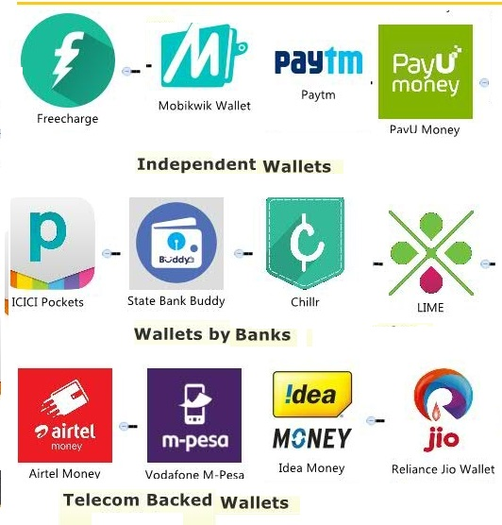

We can Interactive Image on it to understand Different types of wallet

# India's chaiwalas and paanwalas go cashless, rock demonetisation with e-banking

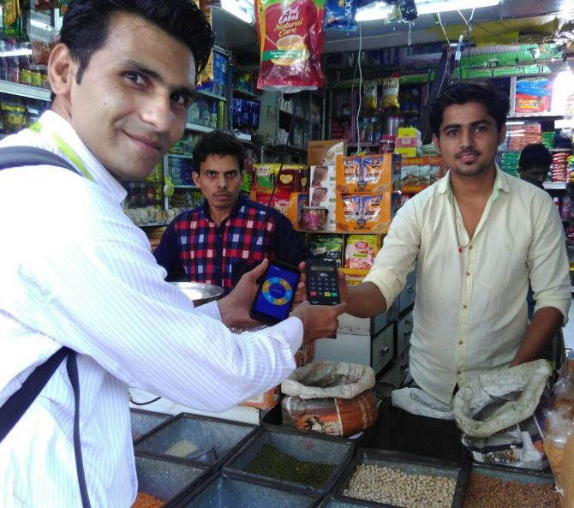

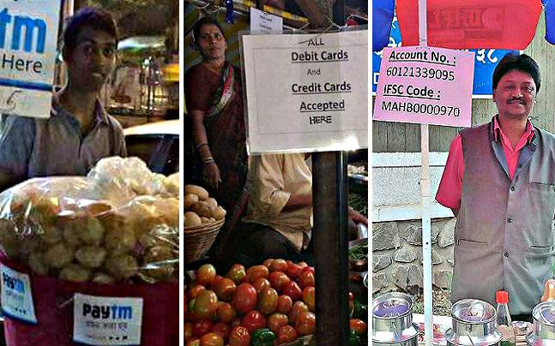

Video link-->https://www.youtube.com/watch?v=XESJXLgJgas
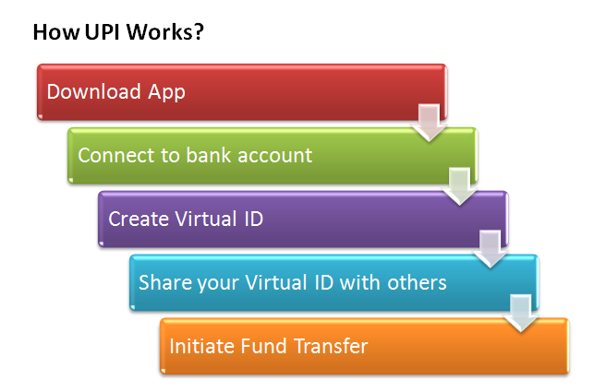
6) UPI (Unified Payment Interface): Simply put, it enables you to transfer money from one bank account to another. It is an infrastructure provided by NPCI’s (National payment Corporation of India) to all the public, private & cooperative banks where they can build their own interface and help the common man easily make micropayments with a maximum cap of Rs 1 lakh through various modes like virtual address (a single identifier code), account no with IFSC code, mobile number or adhar number. It will ease the e-commerce payment gateway where we do not have to share account number or any sensitive information between person to person. Moreover, UPI works 24×7 on real-
time fund transfer system.

7) E- Coupons: These electronic coupons are offered by various online mega stores. They are very helpful in taking discounts on purchase done through online shopping. We only need to enter the e-code and get the discount automatically. They do not require any printing or clipping. They carry unique identification code which can be accessed through the internet at particular sites. Some of the coupons which are available online are groupons, nearby coupons, shopping site coupons, etc.

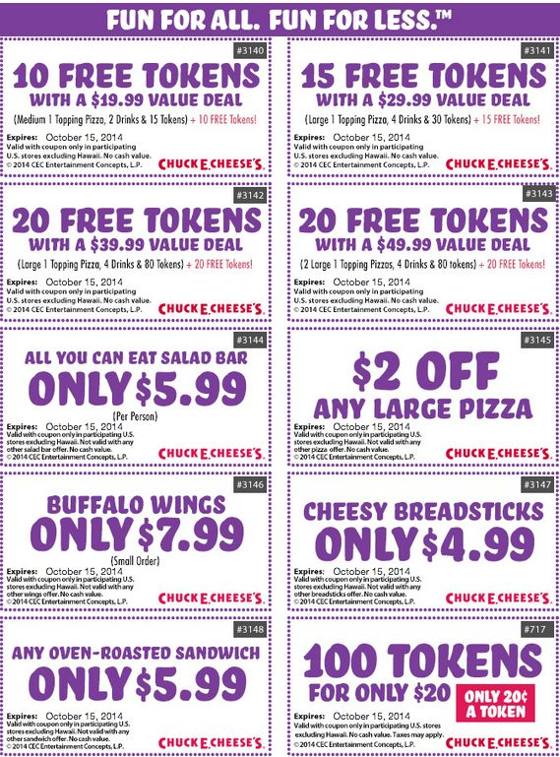

8) Physical coupons: These are paper coupons which come in small denominations of Rs 10 to Rs 50 with a validity of 6 months to 18 months. These are used by corporates to reward their employees. The best use of these coupons can be done in buying meals from places such as Pizza Hut, Dominoes, KFC, Big Bazaar, etc. Out of many, two big giants that are providing these coupons are Sodexo and Ticket Restaurants.

9) AEPS (Aadhaar Enabled Payment System): Going ahead, you can use Aadhaar cards as a debit card in various merchant stores. These cards have been already linked to your bank accounts. You will be provided with a finger scanner at the merchant’s store to do your payments. Aadhaar-cum debit cards will allow you to do micro-payments for not more than Rs 4000. However, there are several questions like which bank account will be taken into consideration for making payments.

10) Med Health Cards: These are discount cards specially designed to avail benefit from the healthcare sector. These cards provide various health care savings programs. These cards provide free OPD consultation service. You can use this card and get a health check up done.

Barter Economy Is Reborn in Villages as India Cancels Cash

What is Bartar System:
A barter system is an old method of exchange. Th is system has been used for centuries and long before money was invented. People exchanged services and goods for other services and goods in return.

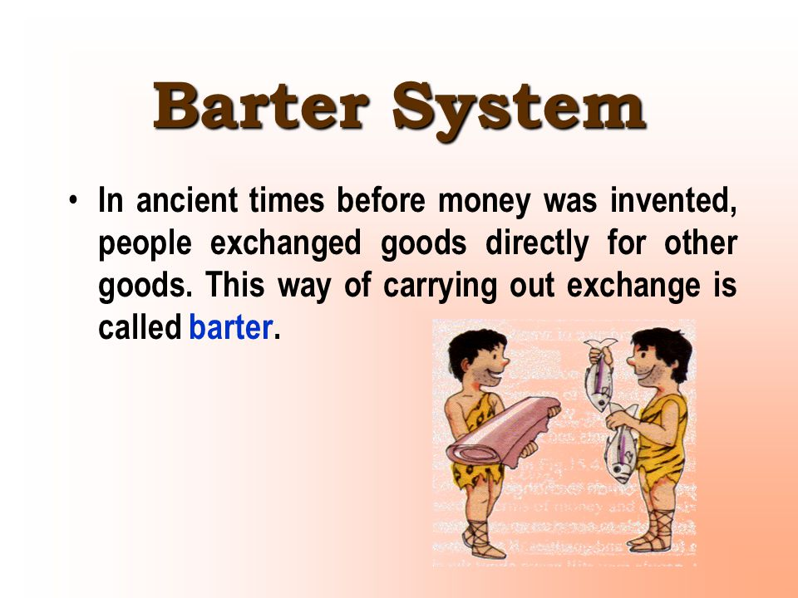

Whats Happening in Villages :
Rice, honey, leather , his neighbors were offering to barter whatever they had for his vegetables and spices at the weekly market.
“We have to feed our children,” said Anima Sandha, who helps run a small beauty parlor in Mr. Barik’s village of Khulia, in eastern Orissa state.
Mr. Barik traded one customer a kilogram of potatoes, cauliflower and tomatoes for half a liter of honey. That was a good deal, he says. In normal times, the honey would be 120 rupees in the market (around $1.80) and the vegetables 70 rupees.
But these are not normal times, not in Khulia or anywhere else in India.

