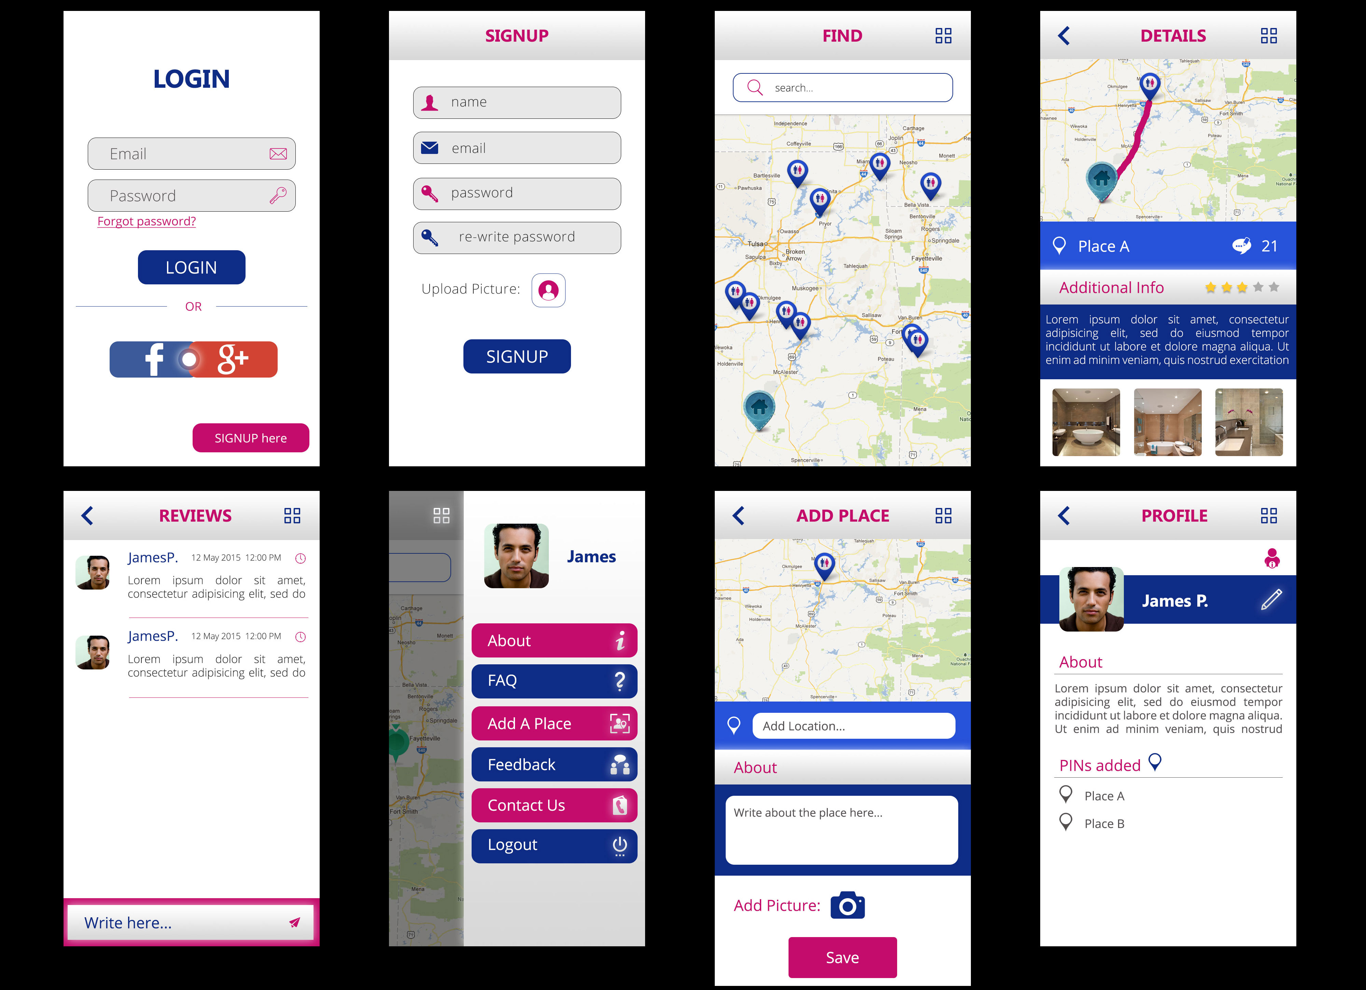

Task – SQL ShowCase-1 in
Databse name: db_showcase1

For the following relation schema:
1- tbl_place(Structure create base of all question)
2- tbl_place_image(Structure create base of all question)
3-tbl_review
4-tbl_user

1.Insert Query in table of user

-->INSERT INTO `tbl_user`(`user_id`, `name`, `email`, `password`, `profile_image`, `about`, `role`, `social_id`, `login_type`, `is_active`, `created_at`, `updated_at`) VALUES (8,'Virat','Virat@gmail.com',1234,'2.jpeg','text','User','imrahul11','G',1,'2022-07-26','2022-07-26');

2.Insert Query in table place

-->INSERT INTO `tbl_place`(`place_id`, `location`, `latitude`, `longitude`, `about`, `avg_rating`, `totalreview`, `is_active`, `created_at`, `updated_at`) VALUES (8,'Ahmedabad','1234678','87654321','text',5.0,1,0,'2022-07-26','2022-07-26');

3.Insert Query in table place of image

-->INSERT INTO `tbl_place_image`(`id`, `place_id`, `image`, `created_at`, `updated_at`) VALUES (6,5,'1.png','2022-07-25','2022-07-26');

4.insert Query in the table of review

-->INSERT INTO `tbl_review`(`review_id`, `user_id`, `place_id`, `is_active`, `created_at`, `updated`) VALUES (6,1,4,1,'2022-06-25','2022-05-25');

5.Insert Query in contact us table

-->INSERT INTO `tbl_contact_us`(`Contactus_Id`, `user_Id`, `name`, `phone`, `email`, `querry`, `is_active`, `inserted_at`, `updated_at`) VALUES (1,1,'Vijay','9998585416','vijay@gmail.com','Query1',1,'2022-07-26','2022-07-26');

6.update Query in table of user

--> UPDATE `tbl_user` SET `name`= 'Dinesh',`email`='Dinesh@gmail.com',`password`= 11111,`profile_image`='2.jpeg' WHERE user_id = 1;

7.Delete Query in the table place

-->DELETE FROM `tbl_user` WHERE user_id = 8;

8.Select Query in the table of place

-->SELECT `place_id`, `location`, `latitude`, `longitude`, `about`, `avg_rating`, `totalreview`, `is_active`, `created_at`, `updated_at` FROM `tbl_place` WHERE place_id = 8;

9.Display the recorde of user whose email id is Kishan@gmail.com and password is 8888

select * from tbl_user where email="Kishan@gmail.com" and password ="8888" and
is_active='1';
===============================================
10.Display the records of user who activate

select * from tbl_user where is_active='1';
===============================================
11.Find the users who role is User.

select * from tbl_user where role='User';
=============================================== 12.Find the user details who login in gmail

select * from tbl_user where login_type='G';
===============================================
13.count users who login using gmail and activate

select count(login_type ) from tbl_user where login_type='S' And is_active='1';

14.Need Email and Password for login

SELECT email, password FROM tbl_user WHERE email = email;

//Shikhar

// Login - Find Active User
SELECT user_name, email, profile_image, about FROM Screen_Design.tbl_user Where is_active = 1;

// Fatch Data Profile
SELECT user_name, email, profile_image, about FROM Screen_Design.tbl_user Where email = "dhruv@gmail.com" AND password="Abcd@123" AND is_active=1;

